Supplementary Information

Capillary electrophoresis as a fragment screening tool to cross-validate hits from chromogenic assay: application to FXIIa
C. Davoine, M. Fillet, L. Pochet

EXPERIMENTAL

Jump-dilution analysis
Jump-dilution analysis was performed at 100 nM nafamostat, 5 nM human β-FXIIa with and without a pre-incubation step at 10 µM nafamostat, 500 nM human β-FXIIa. The kinetic buffer was made up of 30 mM HEPES, 150 mM NaCl and 0.005% Triton-X-100, adjusted at pH 7.4 with 1 M NaOH. Nafamostat was diluted at 600 µM with DMSO and then 50-fold diluted with the kinetic buffer. First, 25 µL of 12 µM nafamostat were mixed with 5 µL of human β-FXIIa (3 µM) and incubated for 30 min at 37°C. To 2 µL of the latter, 198 µL of 252.5 µM S-2302 (diluted in the kinetic buffer with 1.67% DMSO) are added to start the reaction. The kinetic reaction without the jump dilution step were performed by mixing 10 µL of 2 µM nafamostat in 33.3% DMSO, 1 µL of human β-FXIIa (1 µM), and 169 µL of the kinetic buffer and incubating for 30 min at 37°C. 20 µL of 2.5 mM S-2302 are then injected to start the reaction. The release of para-nitro-aniline is recorded for 15 min at 405 nm. Between each absorbance read, the plate was shaken for 1 sec.

Impurity profiling by UHPLC-MS

Instrumentation
All UHPLC-MS experiments were performed on an Acquity UPLC H-Class® system (Waters Corporation, Milford, MA, USA) coupled to a Xevo TQ-S® mass spectrometer (Waters Corp., Milford, MA, USA) equipped with Electro Spray Ionization (ESI) source. Ionization was achieved using electrospray positive ionization mode. Parameters were set as follows: capillary voltage of 3 kV, cone voltage of 20 V, source temperature of 150°C, desolvation temperature of 650°C, cone gas flow of 150 L/h, and desolvation gas flow of 1200 L/h. The MS detection was carried out in scan mode and the MS scan signal was measured between 50 and 500 Da. MassLynx 4.1 software (Waters Corp., Milford, MA, USA) was used for instruments control and data treatment.

Chromatographic conditions
Separation was realized at 40°C using a Waters Acquity UPLC® High Strength Silica (HSS) Pentafluorophenyl (PFP) column (1.8 µm particle size, 2.1 x 100 mm) preceded by a security guard column with an in-line 0.2 µm stainless steel frit filter. The elution was performed in gradient mode using mobile phase A (0.1% formic acid, 0.01% trifluoroacetic acid in water) and B (0.01% trifluoroacetic acid in acetonitrile). The starting mobile phase was composed of 97% A and 3% B. The initial mobile phase is held constant for 1.5 min before changing linearly at 7 min to 35% A and 65% B. It remains 0.3 min before returning to the starting conditions for the next 2.7 min. The flow rate was set at 0.5 mL/min, and the total run time was 10 min. The samples were kept at 20°C in the autosampler and 1 µL was injected.

Sample preparation
Stock solution was diluted at 10 mM with DMSO. To 5 µL of the latter (or 5 µL of DMSO for the blank sample), 5 µL of water and 990 µL of mobile phase A:B (80:20) were added, leading to a final concentration of 50 µM. Each sample was tested in triplicate. Two blanks were run before analyzing the library and one blank was performed after each batch of 5 compounds.

Data treatment
To identify the peaks from the MS scan signal, the Total Ion Current (TIC) chromatogram of the sample was superposed to the TIC chromatogram of the latest blank. A peak was tagged if all the following criteria were fulfilled.
- The peak appeared in TIC chromatogram of the three sample injections and was not present in the TIC chromatogram of the blank.
- An extraction chromatogram of the identified mass-to-charge ratio (m/z) was performed and a peak should appear in the three sample injections but not in the blank.

SUPPLEMENTAL FIGURES
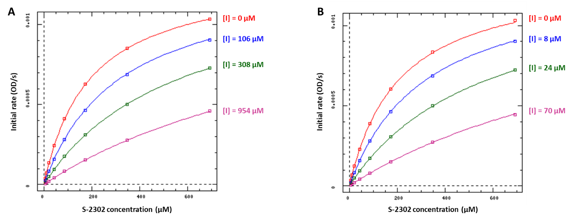
Figure S1. K_{i} determination of PABZM (A) and pentamidine (B) – Initial rates are plotted against the substrate concentration. Using DynaFit 4.08.148, the K_{i} of PABZM and pentamidine were determined at 12.4 ± 0.1 µM and 163.2 ± 0.5 µM, respectively. The mode of inhibition was competitive for the two compounds.
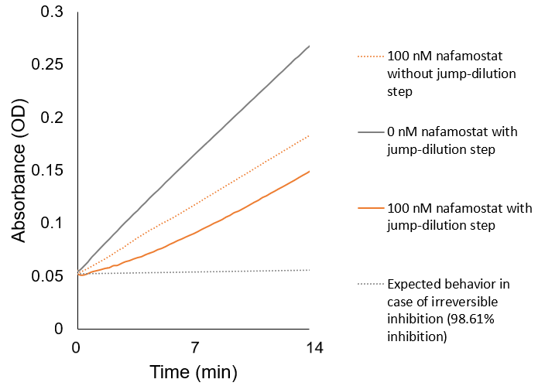
Figure S2. Jump-dilution analysis of nafamostat. A curvilinear progress curve is observed, meaning that the enzyme activity slowly recovers as nafamostat dissociates. Nafamostat acts as a slowly reversible inhibitor and do not have a fast-kinetic equilibrium.

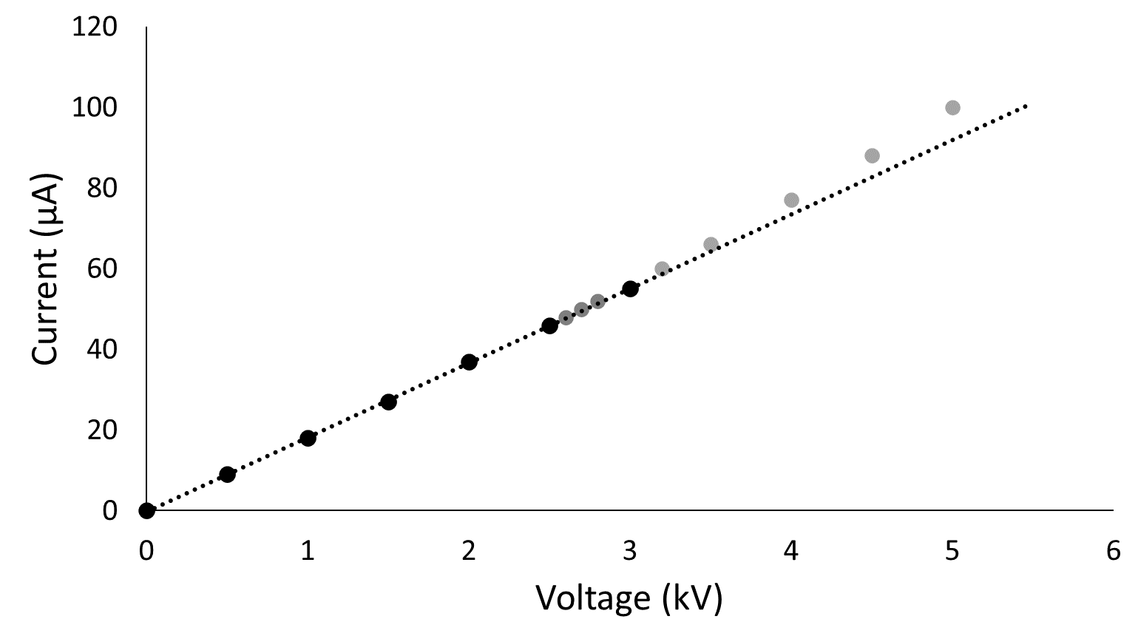
Figure S3. Ohm’s law plot shows the current generated in function of the applied voltage. The linearity of the plot indicates adequate heat dissipation. When the experimental values deviate from the linearity, there is excessive Joule heating and the heat dissipation of the system has been exceeded.

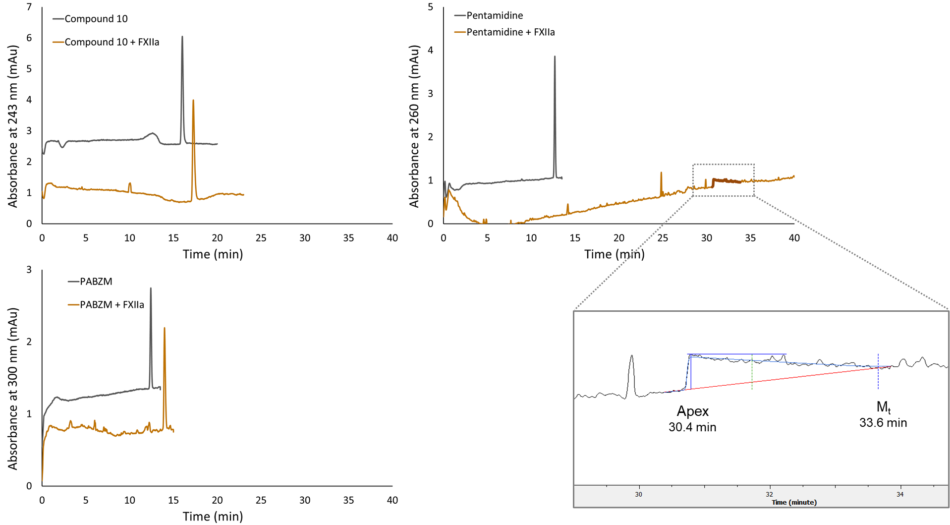

Figure S4. Electropherograms obtained with compound 10, PABZM, and pentamidine in presence (brown) and in absence (grey) of FXIIa in screening conditions (see Material and Methods). The insert shows the Haarhoff–Van der Linde fit on the distorted pentamidine peak. The pentamidine peak apex is 30.4 min and its migration time (M_{t}) extracted from the a1 term of the Haarhoff–Van der Linde function is 33.6 min.

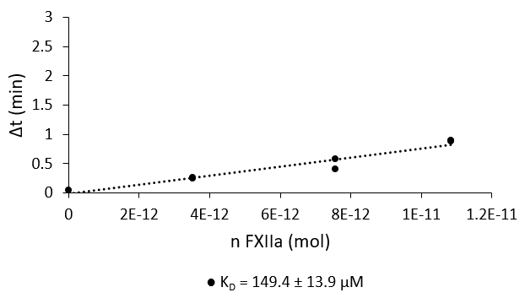

Figure S5. Determination of the dissociation constant for PABZM-FXIIa interaction by pf-ACE. The equation of the linear regression is y = 7.78.10¹⁰x – 0.01 and the R-square is 0.952. Based on the slope of this linear regression, K_{D} was determined at 149 ± 14 µM.
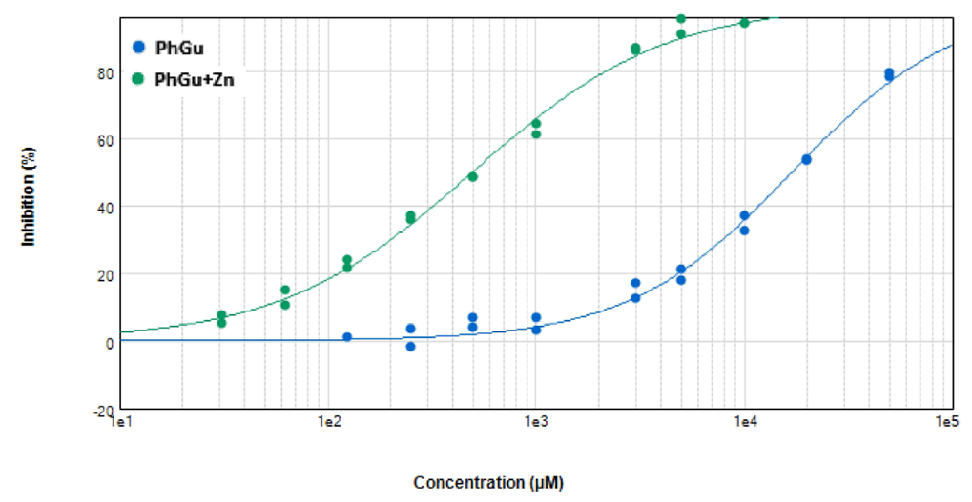
Figure S6. Shift in the IC₅₀ of PhGu by the introduction of 5% (w/w) Zn²⁺. The IC₅₀ of PhGu with (green) and without Zn²⁺ (blue) are, respectively, 16900 ± 667 µM (Hill slope = 1.110) and 495.1 ± 19.0 µM (Hill slope 0.940).

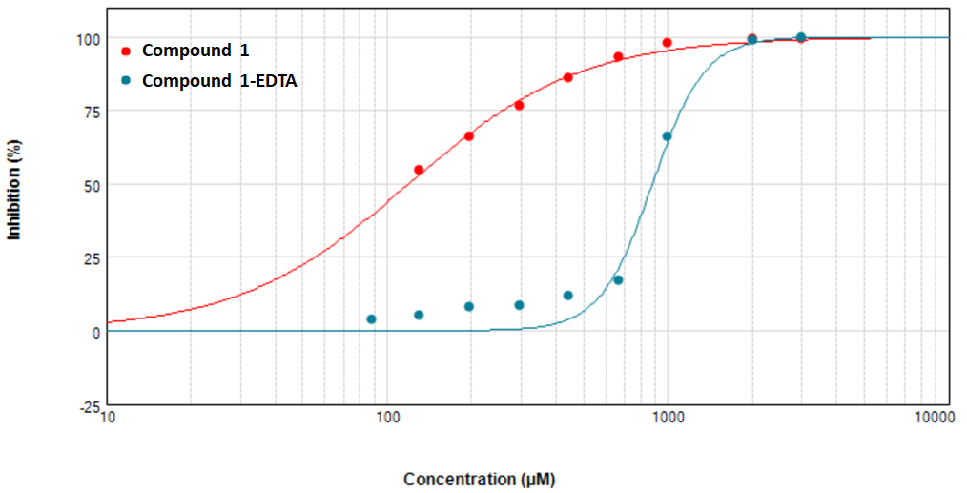
Figure S7. IC₅₀ of compound 1 with and without 1mM EDTA in the buffer. The IC₅₀ of compound 1 with (blue) and without 1 mM EDTA (red) are, respectively, 880.0 ± 40.3 µM (Hill slope = 4.679) and 119.3 ± 5.1 µM (Hill slope = 1.424).
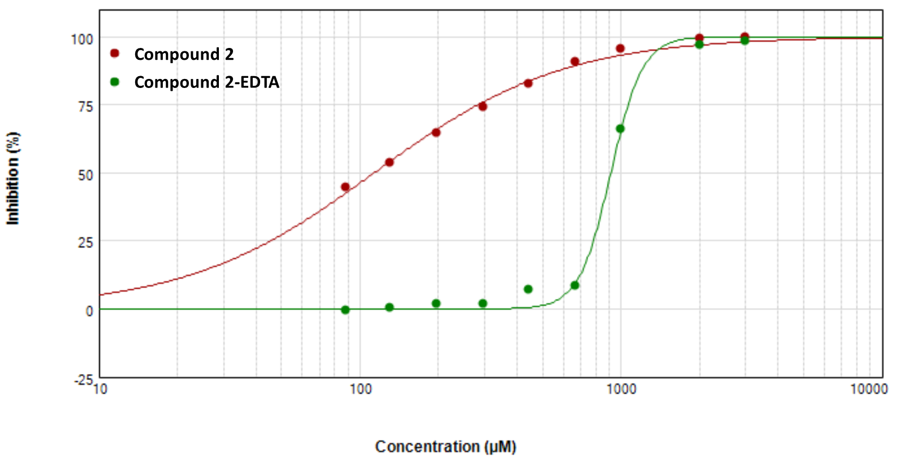
Figure S8. IC₅₀ of compound 2 with and without 1mM EDTA in the buffer. The IC₅₀ of compound 2 with (green) and without 1 mM EDTA (red) are, respectively, 913.1 ± 16.3 µM (Hill slope = 7.188) and 113.3 ± 4.7 µM (Hill slope = 1.199).

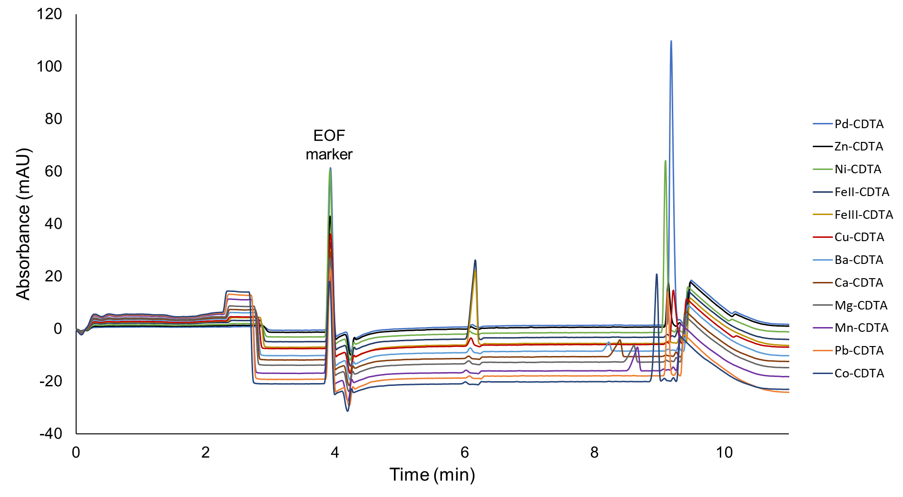
Figure S9. Electropherograms of the 12 metal elements tested. The first peak is DMF, the EOF marker.
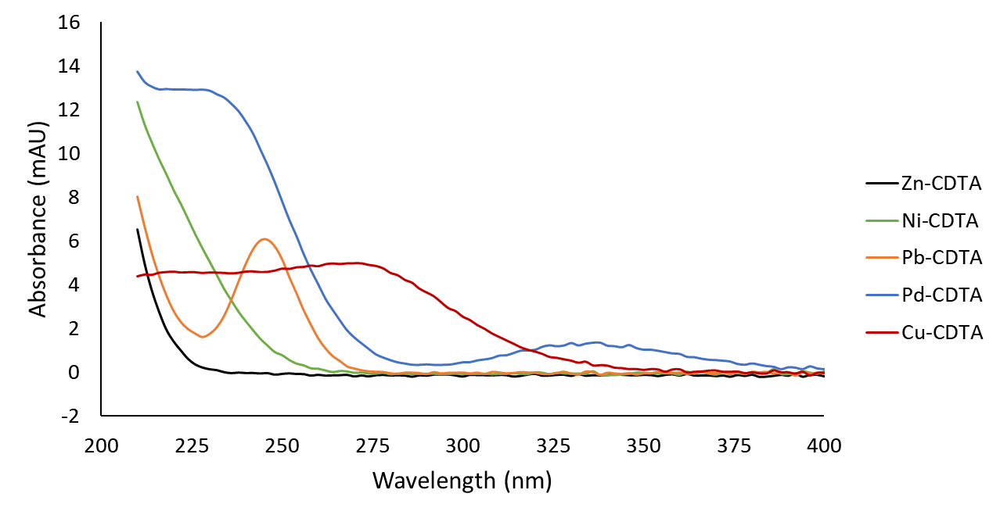
Figure S10. UV spectrum of Zn²⁺, Ni²⁺, Pb²⁺, Pd²⁺ and Cu²⁺ in complex with CDTA.

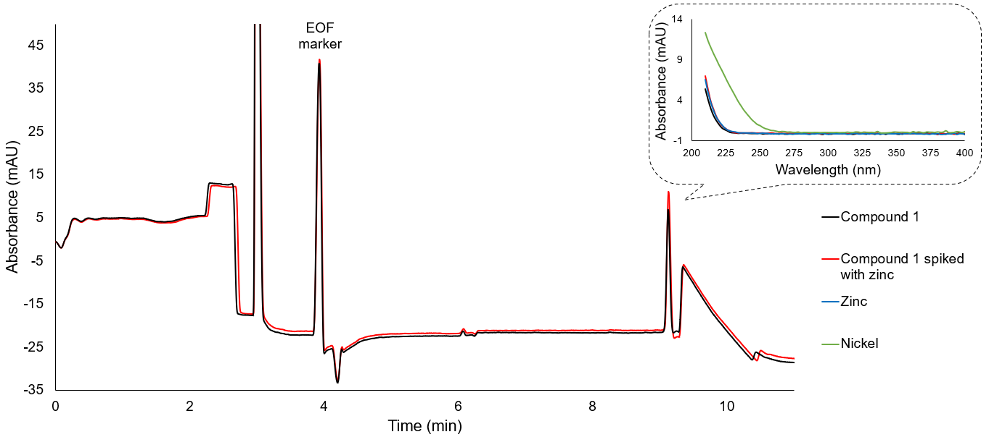
Figure S11. Electropherograms of compound 1 (in black) and compound 1 spiked with 1.5 mM Zn²⁺ (in red). The insert compares the UV spectrum of compound 1 (in black) and Zn²⁺-spiked compound 1 (in red) with those obtained with zinc (in blue) and nickel (in green).
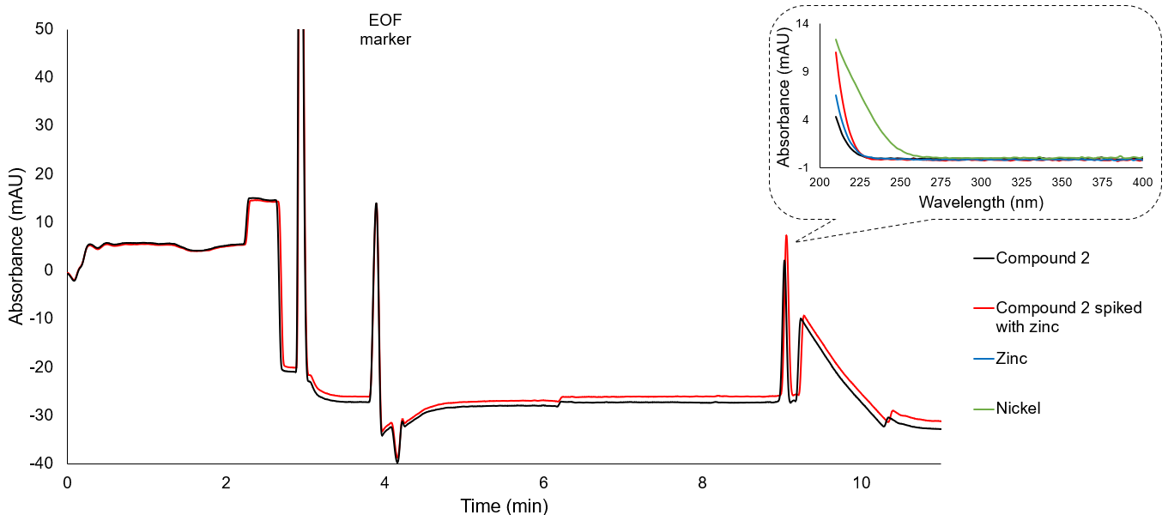
Figure S12. Electropherograms of compound 2 (in black) and compound 2 spiked with 1.5 mM Zn²⁺ (in red). The insert compares the UV spectrum of compound 2 (in black) and Zn²⁺-spiked compound 2 (in red) with those obtained with zinc (in blue) and nickel (in green).

SUPPLEMENTAL TABLES
Table S1. Evaluation of the introduction of 5% (w/w) Zn²⁺ and Cu²⁺ on the FXIIa enzyme assay and pf-ACE. The results showed that the enzyme assay is highly sensitive. Drastic increase in inhibition percentages are observed. In the pf-ACE method, the bound fraction is unaffected by the contamination.
Compounds | Inhibition at 1 mM ± S_{D} (%) |  |  | Bound fraction ± S_{D} (%)
 | Native sample | + 5% Zn²⁺ | + 5% Cu²⁺ | Native sample | + 5% Zn²⁺ | + 5% Cu²⁺
PABZM | 62.8  (± 4.6) | 83.1  (± 4.8) | 71.8  (± 6.9) | 7.8  (± 0.4) | 7.4  (± 1.0) | 7.8  (± 0.9)
PhGu | 3.0  (± 0.2) | 61.4  (± 4.1) | 61.7  (± 6.8) | -0.3  (± 0.3) | -1.2  (± 0.4) | -0.8  (± 0.4)

Table S2. Impurity profile of the library. §Majority peak whose m/z corresponds to the expected mass.
Compound | Expected mass | Retention time of tagged peaks
BZM | 121.1 | 1.62 min§, 2.04 min
PABZM | 136.1 | 1.22 min§
Pentamidine | 341.2 | 6.14 min§
PhGu | 136.1 | 2.08 min§
1 | 251.1 | 0.66 min, 3.81 min§, 4.40 min, 6.21 min
2 | 229.1 | 0.66 min, 4.75 min§
3 | 204.2 | 0.66 min, 1.29 min§
4 | 282.2 | 1.22 min, 4.19 min§
5 | 155.0 | 2.98 min§
6 | 172.1 | 4.59 min§
7 | 171.1 | 4.95 min§, 5.51 min
8 | 161.1 | 4.41 min§
9 | 122.1 | 0.84 min§
10 | 187.1 | 4.11 min§
11 | 150.1 | 0.80 min§, 3.36 min
12 | 150.1 | 0.83 min§
13 | 137.1 | 1.33 min§, 4.23 min
14 | 164.1 | 1.01 min§, 1.23 min, 1.34 min, 1.57 min, 1.94 min
15 | 218.2 | 1.74 min§, 3.43 min, 4.09 min
16 | 136.1 | 1.23 min§, 4.37 min
17 | 157.1 | 1.96 min§
18 | 161.1 | 0.94 min§
19 | 111.1 | 1.15 min§
20 | 197.1 | 5.87 min§
21 | 177.0 | 4.08 min§
22 | 142.0 | 1.73 min§
23 | 111.1 | 1.10 min§, 2.06 min
24 | 220.1 | 3.45 min, 3.69 min§

Table S3. Fragment library.
Compound | Structure | Inhibition at 1mM ± S_{D} (%) | Bound fraction ± S_{D} (%)
BZM | 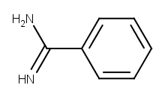 | 34.4  (± 0.8) | 1.6  (± 0.3)
PABZM | 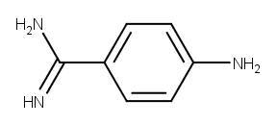 | 69  (± 7) | 8.0  (± 0.1)
Pentamidine | 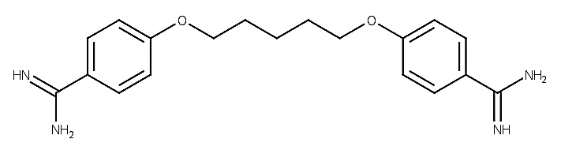 | 98  (± 7) | 66.3  (± 0.2)
PhGu | 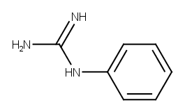 | 3.4  (± 0.1) | -0.34  (± 0.3)
1 | 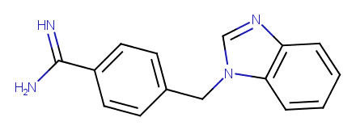 | 95  (± 11) | 4.4  (± 0.7)
2 | 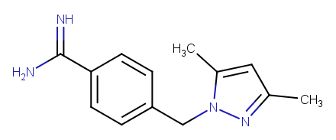 | 88  (± 6) | 1.1  (± 1)
3 | 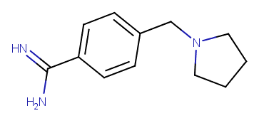 | 63  (± 3) | 3.3  (± 0.9)
4 | 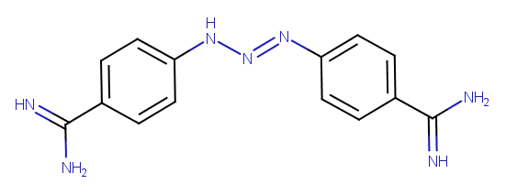 | 95  (± 31) | 21.1  (± 0.5)
5 | 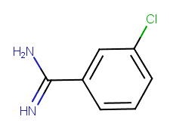 | 43  (± 1) | 4.1  (± 0.6)
6 | 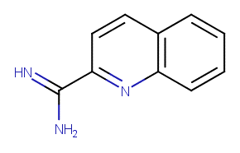 | 74  (± 4) | 10.2  (± 0.3)
7 | 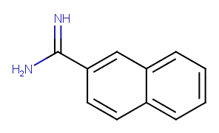 | 62  (± 5) | 8.3  (± 0.2)
8 | 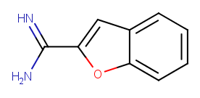 | 55  (± 2) | 7.7  (± 0.5)
9 | 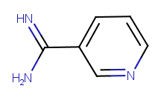 | 2.3  (± 0.1) | -0.30  (± 0.7)
10 | 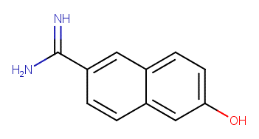 | 70  (± 3) | 11  (± 1)
11 | 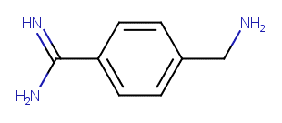 | 28.9  (± 0.6) | 4.7  (± 0.2)
12 | 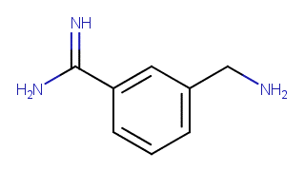 | 13.2  (± 0.9) | 2.3  (± 0.5)
13 | 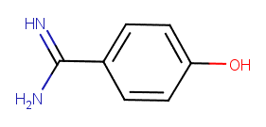 | 48  (± 2) | 3  (± 2)
14 | 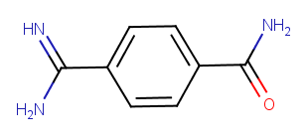 | 16  (± 0.8) | 2.3  (± 0.7)
15 | 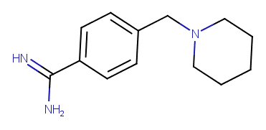 | 25.7  (± 0.8) | 1.3  (± 0.6)
16 | 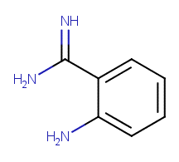 | 6.4  (± 0.4) | 2.1  (± 0.4)
17 | 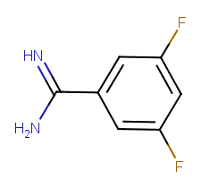 | 22  (± 1) | 2.2  (± 0.5)
18 | 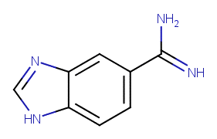 | 27.1  (± 0.9) | 3.4  (± 0.7)
19 | 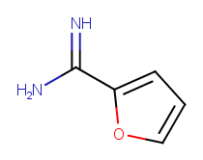 | 37  (± 1) | 4.9  (± 0.7)
20 | 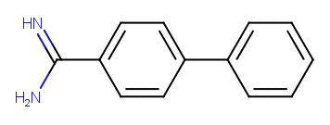 | 23.4  (± 0.3) | 3.9  (± 0.9)
21 | 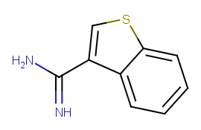 | 51  (± 2) | 3.0  (± 0.8)
22 | 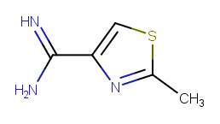 | 55  (± 2) | 1.2  (± 0.4)
23 | 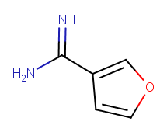 | 21.4  (± 0.8) | 2.9  (± 0.8)
24 | 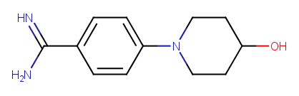 | 35  (± 2) | -0.3  (± 0.5)

