Estimation of the glomerular filtration rate in children and young adults by means of the CKD-EPI equation with age-adjusted creatinine values
Jonas Björk^{1,2}, Ulf Nyman³, Anders Larsson⁴, Pierre Delanaye^{5,6}, Hans Pottel⁷
¹ Division of Occupational and Environmental Medicine, Lund University, Lund, Sweden;
² Clinical Studies Sweden, Forum South, Skåne University Hospital, Lund, Sweden;
³ Division of Medical Radiology, Department of Translational Medicine, Lund University, Malmö, Sweden;
⁴ Clinical Chemistry, Department of Medical Sciences, Uppsala University, Uppsala, Sweden;
⁵ Department of Nephrology-Dialysis-Transplantation, Centre Hospitalier Universitaire Sart Tilman, University of Liège, Liège, Belgium;
⁶ Department of Nephrology-Dialysis-Apheresis, Hôpital Universitaire Caremeau, Nimes, France;
⁷ Department of Public Health and Primary Care, KU Leuven Campus Kulak Kortrijk, Kortrijk, Belgium.
Correspondence: Ulf Nyman, Division of Medical Radiology, Department of Translational Medicine, Lund University, SE-205 02 Malmö, Sweden. E-mail: ulf.nyman@bredband.net

Keywords: Chronic kidney disease; creatinine; glomerular filtration rate; kidney function tests; renal failure.
Abstract
The CKD-EPI creatinine-based estimation equation for glomerular filtration rate (GFR) cannot be used in children, overestimates GFR in young adults, and its combination with the KDIGO recommended pediatric CKiD (Schwartz bedside) equation causes implausible increases in estimated GFR when switching from pediatric to adult care. By establishing sex-specific creatinine growth curves for children and young adults, creatinine levels of children and young adults below age 40 years were adjusted with 40 as assigned age and applied in the CKD-EPI equation.
Validation was performed in 4005 children (2–17 years) and 3309 young adults (18–39 years) using metrics based on bias, precision, and accuracy including percentage of estimates within 30% (P₃₀) of measured GFR (mGFR).
Comparisons were made with the CKiD and Schwartz-Lyon equations in children. CKD-EPI with age-adjusted creatinine instead of actual age and creatinine led to extensive improvements in bias, precision, and accuracy at all ages, in both sexes and at all levels of mGFR. At mGFR below and above 75 mL/min/1.73m², the P₃₀ increased from 12% to 75% and 33% to 88% in children, respectively, and from 56% to 73% and 83% to 92% in young adults, respectively. In children adjusted CKD-EPI was more accurate than CKiD, especially above mGFR 75 mL/min/1.73m² (P30 88% vs. 82%), while Schwartz-Lyon was more accurate than adjusted CKD-EPI at mGFR below 75 mL/min/1.73m² (P30 81% vs. 75%). Thus, the proposed strategy based on age-adjusted creatinine in children and young adults makes the CKD-EPI equation applicable across the full spectrum of age and kidney function.

The Kidney Disease: Improving Global Outcomes guideline¹ recommends the creatinine based Chronic Kidney Disease Epidemiology Collaboration (CKD-EPI) equation² and the Chronic Kidney Disease in Children Study (CKiD, “Schwartz bedside”) equation³ for estimation of glomerular filtration rate (eGFR) in adults and children, respectively. Their use in clinical practice is now widespread but they have some drawbacks. Flawed increases in renal function have been observed when switching from the height-dependent CKiD in pediatric care to the age-dependent CKD-EPI in adults.⁴ Lack of height data in connection with creatinine analyses precludes automatic laboratory reporting of eGFR based on CKiD. In addition, the use of CKD-EPI is questionable in young adults owing to poor accuracy.^{5–8} Thus, there is a need for further development in the area of GFR estimation to extend the applicability of existing equations across the entire lifespan.
We recently demonstrated how creatinine growth curves can be used to recalculate (adjust) childhood levels of serum creatinine to corresponding adult levels.⁹ One advantage with this method is that it can be used with any preexisting adult equation to extend its applicability to children. We noted remarkable improvements in bias and accuracy of the Lund-Malmö Revised (LMR) equation when applying the equation on age-adjusted creatinine concentrations in children with CKD.⁹ Using the same approach, the aim of the present study was to investigate if age-adjustment of serum creatinine concentrations can make the CKD-EPI equation applicable in children (2–17 years) and increase accuracy in young adults (18–39 years).

Results
The adjustment of creatinine values in children and young adults to age 40 years are illustrated in Figure 1 and explained in detail in Methods. The age-adjusted creatinine values were used in the original CKD-EPI² equation for GFR estimation in children (2–17 years) and young adults (18–39 years) with 40 years as assigned age in the equation (hence denoted CKD-EPI40).
Basic characteristics of the included patients in the validation cohort are presented in Table 1 and the measurement procedures in Supplementary Table S1. Validation results stratified by age and measured GFR (mGFR) (< 75 and ≥ 75 ml/min per 1.73 m²) are presented in Table 2 and by a more detailed mGFR stratification in Supplementary Tables S2 and S3. Extensive improvements in bias, and precision and accuracy were observed for CKD-EPI40 in both children and young adults at all mGFR levels. For example, the proportions of estimation errors not exceeding 30% of mGFR (P30) increased from 12% to 75% in children and from 56% to 73% in young adults at mGFR < 75 ml/min per 1.73 m². Corresponding figures at mGFR ≥ 75 ml/min per 1.73 m² were increases from 33% to 88% in children and from 83% to 92% in young adults. The pediatric CKiD equation exhibited overestimations and was less accurate than CKD-EPI40 in children: 2.8 percentage points (pp) (95% confidence interval [CI] −0.2 to 5.8 pp) and 5.4 pp (95% CI 3.8 to 7.0 pp) lower P₃₀ at mGFR < 75 and ≥ 75 ml/min per 1.73 m², respectively. However, Schwartz-Lyon was the most accurate equation at mGFR < 75 ml/min per 1.73 m² in children with 9.0 pp (95% CI 6.9 to 11.2 pp) and 6.2 pp (95% CI 3.7 to 8.7 pp) higher P₃₀ accuracies than CKiD and CKD-EPI40, respectively. Schwartz-Lyon had a P₃₀ accuracy (87%) similar to CKD-EPI40 in children with mGFR ≥ 75 ml/min per 1.73 m² but was 4.6 pp (95% CI 3.5 to 5.8 pp) higher than CKiD.
Figure 1. Projections from creatinine growth curves. Patients with normal renal function (females: solid black line; males: dashed black line) and upwardly shifted growth curves to match patients with decreased renal function (females: solid gray line; males: dashed gray line). Adjusted creatinine (r) for the Chronic Kidney Disease Epidemiology Collaboration equation is obtained by following the projected curves until age 40 (marked with crosses; see Methods for details): example A: 2 children aged 10 years with normal creatinine levels (male 47 and female 45 µmol/L; black circles); example B: 2 young adults aged 20 years with elevated creatinine levels (male 114 and female 93 µmol/L; gray circles) indicating chronic kidney disease (CKD).
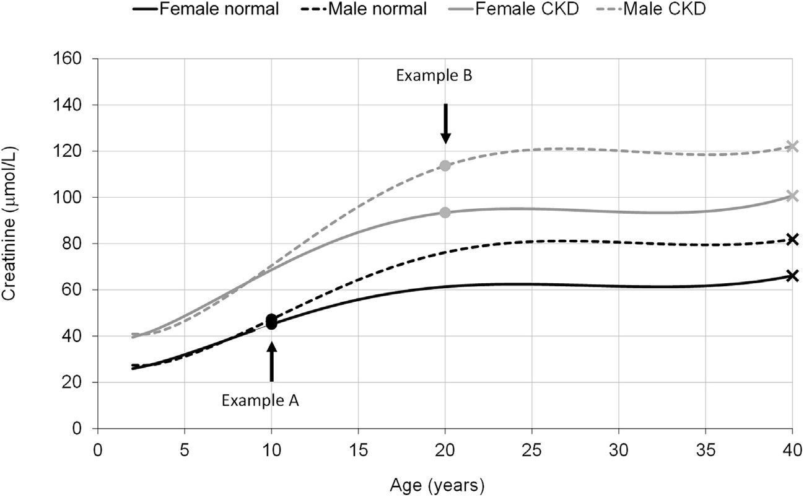

A more detailed assessment of accuracy across levels of mGFR showed that P₃₀ in children was > 75% at mGFR 55–160 ml/min per 1.73 m² for CKD-EPI40 but varied more than for Schwartz-Lyon (Figure 2a). CKD-EPI40 in young adults generally showed noticeable improvement in P₃₀ accuracy compared with the original CKD-EPI equation at all mGFR levels < 120 ml/min per 1.73 m² (Figure 2b).
The improvement in estimation performance of CKD-EPI40 was apparent in both females and males and in more detailed age stratifications (Supplementary Tables S4–S7). CKD-EPI40 exhibited P₃₀ accuracy that was stable at all ages from 40 down to 5 years, at mGFR both below and above 75 ml/min per 1.73 m² (Figure 3a and b). In contrast, the accuracy of the original CKD-EPI equation began to drop already below age 40 at mGFR < 75 ml/min per 1.73 m² and below age 30 at mGFR ≥ 75 ml/min per 1.73 m². Substandard accuracy in the youngest children was noted both for CKD-EPI40 and the two pediatric equations.
Additional validations also included LMR18, i.e., the LMR equation with age and creatinine values adjusted to 18 years in children (LMR18),⁹ and are presented in Supplementary Table S8. In CKD-EPI40, the age-adjustment of creatinine continues until age 40, whereas the adjustment stops at age 18 with LMR, which means that LMR18 yields the same estimates as the original LMR equation in all adults. Both CKD-EPI40 and LMR18 exhibited relatively low constant negative bias at all levels of eGFR in children, whereas increasing overestimations were observed at normal and high eGFR levels for both CKiD and Schwartz-Lyon (Supplementary Figure S1). Likewise, in young adults, CKD-EPI40 and LMR18 both had fairly constant and low bias at all levels of eGFR, whereas the overestimation of the original CKD-EPI increased at high eGFR-levels. However, the uncertainties of CKD-EPI40 and LMR18 were also substantial. For example, eGFR of 100 ml/min per 1.73 m² for a young adult according to the CKD-EPI40 has an 80% accuracy interval from −24 to +20 ml/min per 1.73 m², implying that true mGFR is between 80 and 124 ml/min per 1.73 m² with 80% probability (Supplementary Figure S1).
Table 1. Patient characteristics.
Characteristic | Children (2–17 yr; n = 4005) |  | Young adults (18–39 yr; n = 3309)
Characteristic | < 75 ml/min per 1.73 m² (n = 932) | ≥ 75 ml/min per 1.73 m² (n = 3073) | < 75 ml/min per 1.73 m² (n = 918) | ≥ 75 ml/min per 1.73 m² (n = 2391)
Female | 385 (41) | 1309 (43) | 400 (44) | 1156 (48)
Age, yr | 12.8 (2.9–17.7) | 12.0 (2.5–17.8) | 23 (18–39) | 24 (18–39)
Weight, kg | 41 (13–80) | 40 (13–84) | 63 (39–105) | 5 (42–105)
Height, cm | 149 (89–181) | 1.48 (90–184) | 168 (147–188) | 170 (150–189)
Body surface area, m² | 1.31 (0.54–1.96) | 1.29 (0.56–2.03) | 1.72 (1.30–2.22) | 1.76 (1.37–2.26)
Body mass index, kg/m² | 18 (13–30) | 18 (14–29) | 22 (16–35) | 22 (16–34)
Plasma/serum creatinine, µmol/L | 83 (37–275) | 48 (20–91) | 116 (61–339) | 69 (42–107)
Adjusted plasma/serum creatinine to age 40, µmol/L | 120 (67–429) | 74 (38–121) | 122 (65–351) | 74 (44–113)
Measured GFR, ml/min per 1.73 m² | 58 (17–74) | 104 (77–172) | 55 (17–73) | 103 (77–143)
Measured GFR, ml/min per 1.73 m²
<30 | 95 (10) |  | 107 (12)
30–44 | 134 (14) |  | 187 (20)
45–59 | 264 (28) |  | 265 (29)
60–74 | 439 (47) |  | 359 (39)
75–89 |  | 679 (22) |  | 541 (23)
90–119 |  | 1606 (52) |  | 1447 (61)
≥ 120 |  | 788 (26) |  | 403 (17)
GFR, glomerular filtration rate.
Values are presented as n (%) or median (2.5th to 97.5th percentiles).

Discussion
Our novel method based on sex-specific creatinine growth curves makes it possible to adjust creatinine values during childhood and young adulthood to corresponding levels of a certain adult age. Using adjustment to age 40 years, our independent validation results suggest that this approach makes the CKD-EPI equation applicable for the full age spectrum, including young children, adolescents, and young adults regardless of their renal function. In fact, CKD-EPI40 generally outperformed the dedicated pediatric CKiD equation recommended by Kidney Disease: Improving Global Outcomes¹ in all age groups, and without using data on height. The accuracy of CKD-EPI40 was similar to the LMR18-year equation when validated in the same pediatric cohort.⁹ CKD-EPI40 exhibited ≥ 75% P₃₀ accuracy at mGFR 55–160 ml/min per 1.73 m², which included 87% of the children referred for GFR measurements in this pediatric nephrology setting. The estimated P₃₀ accuracy was 86% at suggested CKD threshold for children of 75 ml/min per 1.73 m².¹⁰ Including height can improve precision and accuracy in children of all ages with CKD.¹¹ This was noted to some extent with the Schwartz-Lyon equation in the present study, but that equation also reached substandard P₃₀ accuracy (< 75%) when mGFR was < 35 ml/min per 1.73 m². Previous validation studies suggest that cystatin C–based GFR equations are more reliable than creatinine-based equations in children with severe CKD.¹² Caution is also warranted if eGFR(creatinine) is used in the youngest children age 2–5, for whom both CKD-EPI40 and the two pediatric equations exhibited substandard accuracy.
Table 2. Bias, precision, and accuracy of GFR estimating equations in children aged 2.0 to 17 years and adults aged 18 to 39 years stratified for mGFR < 75 and ≥ 75 ml/min per 1.73 m².
Equation | Bias | Precision | Absolute % error | P₁₀, % | P₃₀, %
Children, 2.0 to 17 years
MGFR < 75 ml/min per 1.73 m² (n = 932)
Schwartz-Lyon | 2.3 (1.5 to 3.1) | 14.7 | 13.0 (12.1 to 14.0) | 39.8 (36.7 to 42.9) | 80.8 (78.3 to 83.3)
CKiD | 7.4 (6.2 to 8.3) | 18.0 | 16.2 (15.1 to 17.8) | 32.7 (29.7 to 35.7) | 71.8 (68.9 to 74.7)
CKD-EPI40 | 0.0 (−0.8 to 1.1) | 18.5 | 16.1 (15.0 to 17.2) | 33.4 (30.3 to 36.4) | 74.6 (71.8 to 77.4)
CKD-EPI | 50.7 (46.7 to 54.5) | 47.2 | 90.4 (85.4 to 95.5) | 2.6 (1.6 to 3.6) | 12.2 (10.1 to 14.3)
MGFR ≥ 75 ml/min per 1.73 m² (n = 3073)
Schwartz-Lyon | −5.6 (−6.4 to –4.6) | 26.2 | 13.8 (13.3 to 14.3) | 37.7 (36.0 to 39.5) | 86.7 (85.5 to 87.9)
CKiD | 3.4 (2.4 to 4.4) | 30.3 | 14.5 (13.9 to 15.0) | 36.1 (34.4 to 37.8) | 82.1 (80.7 to 83.5)
CKD-EPI40 | −7.8 (−8.6 to −7.2) | 26.2 | 13.3 (12.8 to 13.8) | 39.2 (37.5 to 40.9) | 87.5 (86.3 to 88.7)
CKD-EPI | 44.8 (43.6 to 45.9) | 38.8 | 43.0 (41.7 to 44.2) | 8.3 (7.3 to 9.2) | 33.4 (31.8 to 35.1)
Young adults, 18 to 39 years
mGFR <75 ml/min per 1.73 m² (n = 918)
CKD-EPI40 | 3.3 (2.1 to 4.0) | 16.3 | 16.1 (14.7 to 17.1) | 34.4 (31.3 to 37.5) | 75.6 (72.2 to 79.0)
CKD-EPI | 12.6 (11.3 to 13.9) | 21.6 | 26.1 (24.3 to 28.1) | 19.9 (17.4 to 22.5) | 55.6 (51.7 to 59.5)
MGFR ≥ 75 ml/min per 1.73 m² (n = 2391)
CKD-EPI40 | −4.9 (−5.6 to −4.1) | 22.9 | 11.3 (10.7 to 11.8) | 45.0 (43.0 to 47.0) | 91.9 (90.6 to 93.1)
CKD-EPI | 10.3 (9.4 to 11.4) | 24.5 | 14.0 (13.2 to 14.6) | 37.6 (35.7 to 39.6) | 83.3 (81.6 to 85.0)
CKD-EPI, Chronic Kidney Disease Epidemiology Collaboration original equation without adjustments; CKD-EPI40, CKD-EPI with age and creatinine values adjusted to 40 years for patients < 40 years; CKiD, Chronic Kidney Disease in Children equation; eGFR, estimated glomerular filtration rate; GFR, glomerular filtration rate; mGFR, measured GFR. Median bias (eGFR – mGFR) and precision (interquartile range of eGFR – mGFR) are expressed in ml/min per 1.73 m², accuracy as median absolute percentage error |eGFR – mGFR)|/mGFR, and P₁₀ and P₃₀ accuracy as percentage of GFR estimates within ±10% and ±30% of mGFR.
Values in parentheses are 95% confidence intervals.

Figure 2. P₃₀ accuracy in relation to measured GFR. (a) Chronic Kidney Disease Epidemiology Collaboration equation (CKD-EPI)40 compared with Schwartz-Lyon and Chronic Kidney Disease in Children (CKiD) equations in children (2–17 years; n = 4005); (b) CKD-EPI40 equation compared with original CKD-EPI equation in young adults (18–39 years; n = 3309). Curves truncated at 2.5th and 97.5th percentiles of measured glomerular filtration rate (GFR) values.
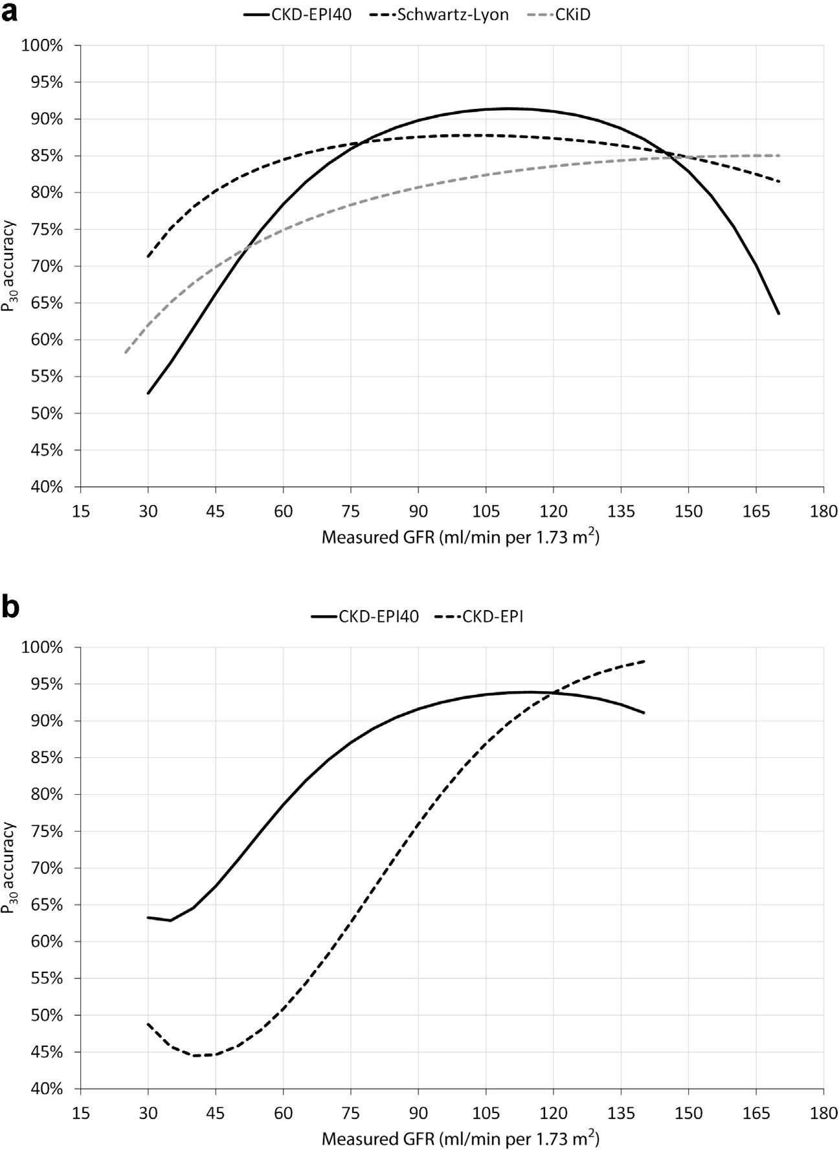

CKD-EPI40 exhibited increased accuracy that was similar to LMR in young adults, owing to both reduced bias and improved precision. The reason for the overestimation when the CKD-EPI equation is used without age-adjusted creatinine values among young adults is the GFR decline of 0.7% per year across the entire lifespan implicated by the equation at a given creatinine level. However, renal function only starts to decline after age 40,¹³ but with the CKD-EPI equation an individual of age 18 will have 17% higher eGFR than an individual of age 40 with the same creatinine level. An obvious improvement of the original CKD-EPI equation is therefore to set age equal to 40 years in the equation for all patients younger than this threshold. It is less obvious which age should be chosen as to represent the plateau level of creatinine growth. We chose to recalculate creatinine levels to age 40 for simplicity reasons, although the empirical creatinine growth curves reached plateau levels already at age 25 for both males and females (Figure 1).
Figure 3. P₃₀ accuracy in relation to age for Chronic Kidney Disease Epidemiology Collaboration equation (CKD-EPI)40 compared with original CKD-EPI, Schwartz-Lyon, and Chronic Kidney Disease in Children (CKiD) equations in the combined cohort of children and young adults. (a) Measured glomerular filtration rate (GFR) <75 ml/min per 1.73 m² (n = 1850); (b) measured GFR ≥ 75 ml/min per 1.73 m² (n = 5464).
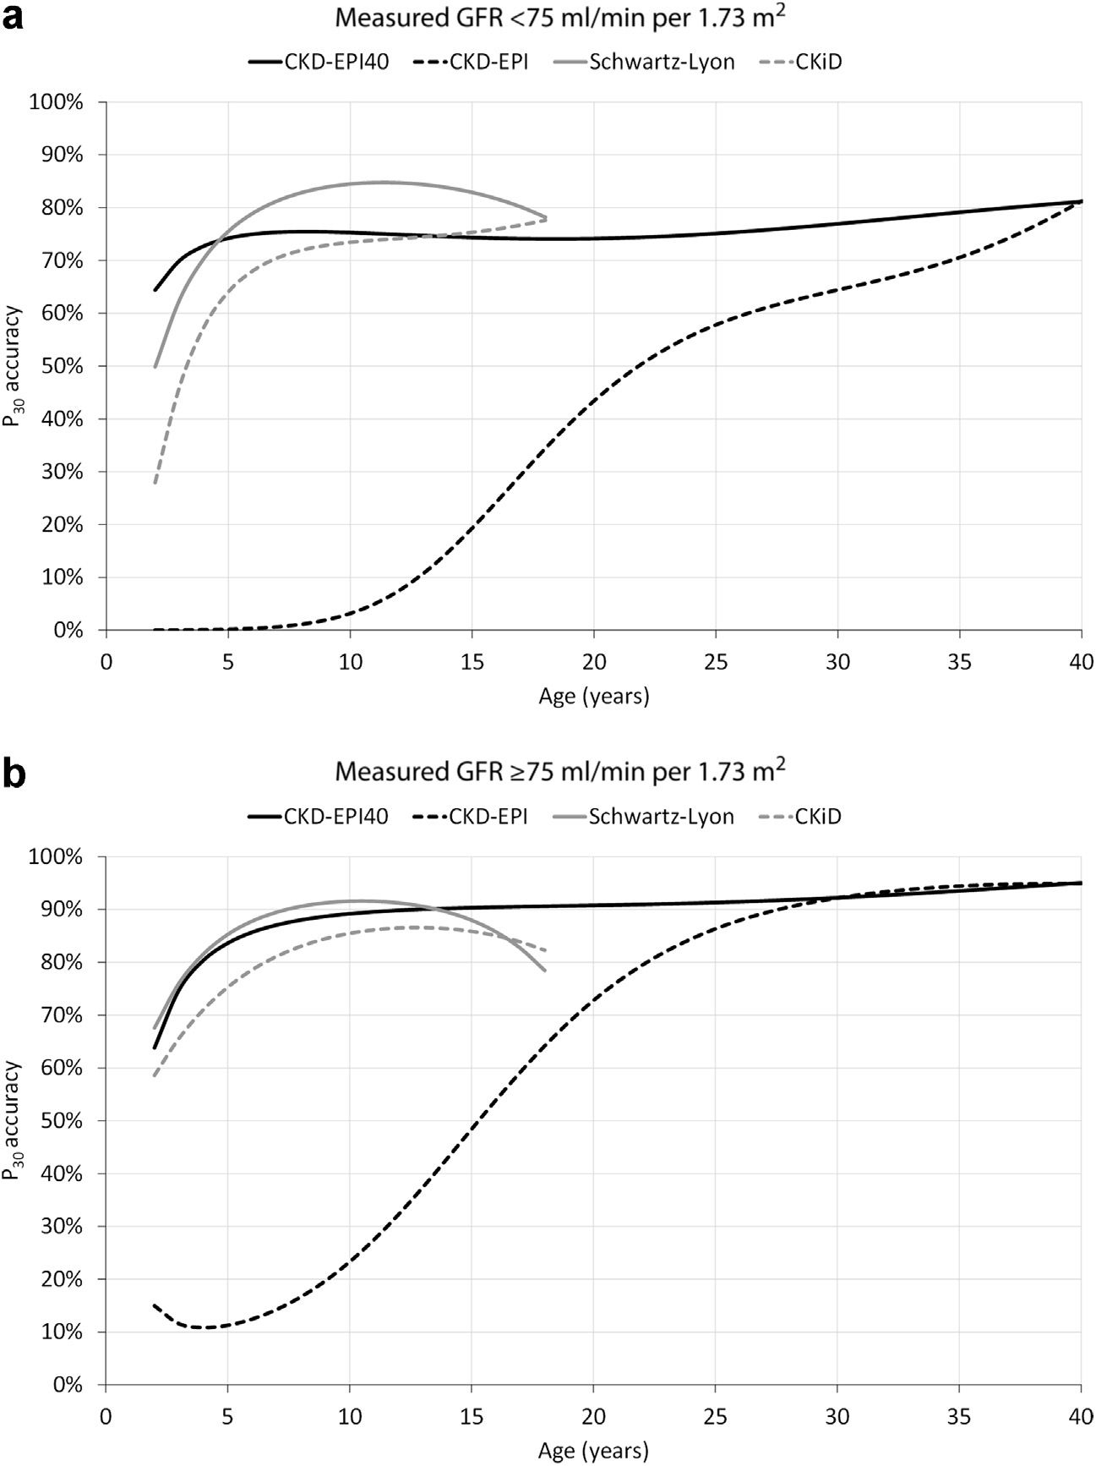

Our proposed adjustment strategy for creatinine during childhood and young adulthood is generally applicable⁹. It has 4 important strengths: (i) the original coefficients of the GFR equation can be used, (ii) the same equation can be used for most patients across the entire lifespan without artificial changes in eGFR, e.g., when a child reaches adolescence or is transferred from pediatric to adult care, (iii) height is not necessary in the GFR estimation for most children, which renders it possible to automatically report eGFR by the laboratories, and (iv) well-established creatinine reference intervals for adults may be used if not available for children at certain age intervals.
A specific strength of the present study was that the validation of eGFR was done in patients that were separate from the data used when the creatinine growth curves were established. The size of the validation cohort (4005 children and 3309 young adults) led to narrow CIs in the overall performance metrics (e.g., the statistical uncertainty in the estimated P₃₀ accuracy was at most ±3 pp). The individual cohorts used for validation mainly included patients from 4 different European countries (Belgium, France, the Netherlands, and Sweden). Thus, we do not know to what extent the creatinine growth curves and the reported improvements in estimation accuracy for CKD-EPI40 are generalizable to non-European populations or specific ethnic groups. However, the same approach should be possible to use for other population groups and may render correction factors for ethnicity unnecessary. This would require that creatinine growth curves are established that take population-specific patterns of growth in muscle mass and creatinine levels during childhood and emerging adulthood into account. Another study limitation was the low proportion of patients with mGFR < 60 ml/min per 1.73 m²: 12% among children and 17% among young adults. This most likely reflects the low population prevalence of CKD in these age groups, as the validation data were obtained from consecutive referrals for clearance measurements. Still, the 493 children with mGFR < 60 ml/ min per 1.73 m² in the present study is far more than the 168 children used in the CKiD validation set,³ and the 559 young adults at this mGFR level is more than twice the 256 young adults in the CKD-EPI external validation cohort.¹⁴ The creatinine growth curves were mainly established based on patients with normal renal function. An implicit assumption is that the shape of the growth curves will be the same but shifted upward in patients with reduced renal function. The observed performance of CKD-EPI40 when validated in patients with decreased mGFR suggests that this assumption is reasonable.
In conclusion, the present study shows how age-adjustment of creatinine in children and young adults can make the widely used CKD-EPI equation applicable across the full spectrum of age and renal function without changing its coefficients.

Methods

Creatinine growth curves
Based on a general method for taking population differences in creatinine levels into account first suggested by Hoste et al.,¹⁵ we have previously established creatinine growth curves from a pooled reference cohort of patients aged 2–40 years obtained from non-nephrology units at 3 different hospitals: (i) Kortrijk, Belgium, in 2005–2007 (n = 9634), (ii) Liege, Belgium, in 2019 (n = 9123), and (iii) Uppsala, Sweden, in 2015–2019 (n = 64,410).⁹ The pooled reference cohort included 83,157 samples in total (46,601 females and 36,556 males. median age 27 years). Median (2.5th, 97.5th percentiles) serum creatinine values for females and males at 40 years of age were 63 µmol/L (44, 103 µmol/L) and 80 µmol/L (58, 116 µmol/L), respectively. The creatinine growth curves were fitted separately for males and females using linear regression with fractional polynomials of age as independent variable (Figure 1):
Males: ln(Cr) = 3.200 + 0:259 × Age − 0.543
× ln(Age) − 0.00763 × Age² + 0.0000790
× Age³
Females: ln(Cr) = 3.080 + 0.177 × Age − 0.223
× ln(Age) − 0.00596 × Age² + 0.0000686
× Age³,
where Cr is the actual creatinine value measured in µmol/L and ln is the natural logarithm.
The estimated geometric means of plasma/serum creatinine concentrations at each age obtained from the growth curves for both males and females were consistently within the laboratory-specific reference intervals for plasma/serum creatinine (Supplementary Table S9).
The creatinine growth curves can be used to adjust actual creatinine values (Cr) of children and young adults to an equivalent adult level at a particular threshold age, referred to as age-adjusted creatinine (denoted r). In the present study, we used age 40 years as threshold in the CKD-EPI equation in order to remediate the overestimation of GFR noted in the transition to young adulthood.⁴ The plasma/serum creatinine median values (2.5, 97.5 percentiles) for women (n = 945) and men (n = 778) aged 40 years in the pooled reference cohort were 63 (44, 103) µmol/L and 80 (58, 116) µmol/L, respectively. The recalculation of creatinine among children and young adults (2–39 years) to age 40 was done using the following expressions derived from the creatinine growth curves:
Males: ln(r) = ln(Cr) + 0.259 × (40 − Age) − 0.543
× ln(40 / Age) − 0.00763 × (40² − Age²)
+ 0.0000790 × (40³ − Age³)
Females: ln(r) = ln(Cr) + 0.177 × (40 − Age) − 0.223
× ln(40 / Age) − 0.00596 × (40² − Age²)
+ 0.0000686 × (40³ − Age³).
For patients younger than 40 years, age = 40 was used in the adjusted CKD-EPI equation (CKD-EPI40), i.e., GFR was estimated as though the patient was age 40 regardless of his or her actual age. For patients aged ≥ 40 years, actual age and creatinine (i.e. r = Cr) are used, which means that CKD-EPI40 yields the same estimates as the original CKD-EPI equation. Thus, CKD-EPI40 uses the original CKD-EPI coefficients² and can be expressed in the following way:
Female r ≤ 62 µmol / L: 144 × (r/62)^{−0.329} × 0.993^{max(Age;40)}
Female r ≤ 62 µmol / L: 144 × (r/62)^{−1.209} × 0.993^{max(Age;40)}
Male r > 80 µmol / L: 141 × (r/80)^{−0.411} × 0.993^{max(Age;40)}
Male r > 80 µmol / L: 141 × (r/80)^{−1.209} × 0.993^{max(Age;40)},
where r represents age-adjusted creatinine (age 2–39) or actual creatinine (age ≥ 40) and max(Age;40) represents the maximum of actual age and 40 years.

Validation cohort
Data on plasma or renal clearance of external biomarkers as a measure of GFR (mGFR), plasma/serum creatinine, age, sex, height, and weight were obtained by the European Kidney Function Consortium (EKFC) from cohorts used in cross-sectional and longitudinal studies; 6 child cohorts¹² from the Netherlands (Amsterdam^{16–20}), Belgium (Leuven²¹), France (Lyon^{21,22}), and Sweden (Lund,¹⁹ Stockholm,¹² and Örebro¹²) and 7 adult cohorts⁸ from France (Bordeaux, Clement-Ferrand, Grenoble, Lyon, Nantes, Paris-Neckar, Saint Etienne, and Toulouse^{23,24}), Sweden (Lund,^{5,19,25} Stockholm,⁸ and Örebro⁸), and the United States (Rochester, white community based,²⁶ and Chronic Renal Insufficiency Cohort [CRIC], excluding African Americans^{21,22,27,28}). For this study, we selected a subset (n = 7314) of all available data from the EKFC database, restricted to the first available measurement of GFR in children 2–17 (n = 4005) and adults 18–39 (n = 3309) full years of age (Table 1; Supplementary Table S1). The 86 adult patients from the CRIC cohort were also included in the development, internal validation, or external validation set when developing the original CKD-EPI equation.²
The present pediatric cohort is identical to the validation cohort in our original manuscript when the creatinine growth curves were established and used to validate the LMR18 equation.⁹ To the best of our knowledge, it is the largest cohort so far used for validation of GFR equations in children and young adults.
Patient data were pooled in an anonymous database at Lund University, Sweden, for the present study. All procedures involving subjects and data followed the ethical principles for medical research involving human subjects established in the World Medical Association Declaration of Helsinki of 1975 and revised in 2000. For this type of retrospective study, all extracted data were fully anonymous without any personal information, so informed consent was not required according to the Regional Ethical Board approval in Lund, Sweden, which approved the study (Dnr 2018/220).

Laboratory methods
Clearance methods for determination of mGFR included renal clearance of inulin, iothalamate, and ⁵¹Cr-EDTA and plasma clearance of inulin, iohexol, and ⁵¹Cr-EDTA (Supplementary Table S1), all considered acceptable as reference test.²⁹ All centers used plasma/serum creatinine assays traceable to isotope dilution mass spectrometry and standardized against primary reference material (National Institute of Standards and Technology Standard Reference Material 967; Supplementary Table S1).

GFR equations
Validation results for the adjusted CKD-EPI40 equation were compared with the original CKD-EPI equation (without adjustment of age and creatinine values) and 2 pediatric equations with creatinine expressed in µmol/L and body height in cm:
CKiD (“Schwartz bedside”) equation³:
41.3 × (height / 100) ÷ (Cr / 88:4) = 36.5 × height/Cr, and
Schwartz-Lyon equation³⁰:
Girls < 18 years and boys < 13 years: 32.5 × height/Cr
Boys ≥ 13 to 17 years: 36.5 × height/Cr.
Note that when Schwartz-Lyon is applied in boys, there is for a given height/Cr ratio a shift in eGFR of 14% (36.5/32 ≈ 1.14) at age 13, after which Schwartz-Lyon and CKiD are identical.
In supplementary analyses, validation results in children and young adults for CKD-EPI40 were further compared with the LMR18 equation.⁹

Statistical analysis
The validation of eGFR against mGFR focused on bias, precision, and accuracy.³¹ Bias was assessed as the median of eGFR – mGFR, and precision was assessed as the interquartile range of eGFR – mGFR. Accuracy was assessed from the absolute error |eGFR – mGFR|/mGFR and summarized as the median absolute percentage difference (absolute accuracy) and as the percentage of estimates within ±10% and ±30% of mGFR (P₁₀ and P₃₀). P₃₀ accuracy of ≥ 75% is considered to be “sufficient for good clinical decision making” by the National Kidney Foundation, but the benchmark is to reach P₃₀ > 90%.³² Differences in P₃₀ accuracy were evaluated statistically with the use of 95% CIs for paired proportions.
All validation results were presented separately for children and young adults. Main results were further stratified for mGFR below and above 75 ml/min per 1.73 m², since a GFR below 75 ml/min per 1.73 m² has been suggested as a criteria for the diagnosis of CKD in children and in adult individuals younger than 40 years.¹⁰ More detailed stratifications with respect to mGFR, sex, and age were also investigated. We illustrated how P₃₀ varies across the full range of mGFR and across age with the use of logistic regression with fractional polynomials of the independent variable (linear, logarithmic, and quadratic terms). A cubic term was added to the regression model when necessary to improve agreement with the corresponding categoric results stratified by mGFR or age.
A supplementary analysis was also made regarding diagnostic predictiveness, i.e., estimation errors stratified by estimated GFR.³³ Accuracy diagrams were constructed with the use of quantile regression with fractional polynomials (linear, logarithm, and square) as input to illustrate how the estimation errors varied across eGFR for each equation.³⁴ In the diagrams we expressed estimation errors in ml/min per 1.73 m² using the quantiles (percentiles) Q₁₀, Q₅₀ (median bias), and Q₉₀, where the accuracy interval (Q₁₀ – Q₉₀), reflects the largest estimation error with 80% certainty. The presentation was limited to the 2.5th to 97.5th percentile range of the estimated GFR values for each equation to limit the statistical uncertainty in the tails of the quantile curves.

Disclosure
UN and JB have received reimbursement for letting GE Healthcare distribute the computer program OmniVis in radiology departments for estimation of GFR based on the creatinine equations presented in this paper with no special preference of any of the included equations. UN has received lecture fees from GE Healthcare. All the other authors declared no competing interests.

Data availability
The EKFC dataset used in this study is hosted by the Lund University Population Research Platform. Legal and ethical restrictions prevent public sharing of the dataset. Data can be made available for collaborations on request from interested researchers but would generally require a new ethical permission and the permission of each of the data owners. You can find contact information for the data host at https://www.lupop.lu.se.

Acknowledgments
Funded by the Swedish Research Council (Vetenskapsrådet grant no. 2019-00198).
The Chronic Renal Insufficiency Cohort (CRIC) study was conducted by the CRIC Investigators and supported by the National Institute of Diabetes and Digestive and Kidney Diseases (NIDDK). The data from the CRIC study reported here were supplied by the NIDDK Central Repositories. This manuscript was not prepared in collaboration with investigators of the CRIC study and does not necessarily reflect the opinions or views of the CRIC study, the NIDDK Central Repositories, or the NIDDK.
We are grateful to the following collaborators who provided data and valuable input for the study: Ulla Berg, Magnus Hansson, Karin Littmann, and Kajsa Åsling-Monemi (Karolinska University Hospital Huddinge, Stockholm, Sweden), Arend Bökenkamp (Emma Children’s Hospital, Amsterdam University Medical Center, The Netherlands), Marie Courbebaisse (Georges Pompidou European Hospital, France), Lionel Couzi (Centre Hospitalier Universitaire de Bordeaux, France), Laurence Dubourg (Hospices Civils de Lyon, Université Claude Bernard, France), Francois Gaillard and Christophe Legendre (Hôpital Necker, Paris, France), Cyril Garrouste (University Hospital, Clermont-Ferrand, France), Karolien Goffin (University Hospital, Leuven, Belgium), Anders Grubb and Veronica Lindström (Lund University, Sweden), Lola Jacquemont (Centre Hospitalier Universitaire de Nantes, France), Nassim Kamar (Centre Hospitalier Universitaire Rangueil, Toulouse, France), Veronica Lindström (Lund University, Sweden), Christophe Mariat (Hôpital Nord, Centre Hospitalier Universitaire de Saint-Etienne, France), Lionel Rostaing (Hôpital Michallon, Centre Hospitalier Universitaire Grenoble-Alpes, France), Andrew D. Rule and Stephen Turner (Mayo Clinic, Rochester, Minnesota), and Per-Ola Sundin (Örebro University, Sweden). We also thank physiologists Marion Vallet and Renaud de la Faille for measuring GFR at Toulouse and Bordeaux University Hospitals, respectively.

Supplementary material
Supplementary File (PDF) [https://doi.org/10.1016/j.kint.2020.10.017]
Table S1. Laboratory methods.
Table S2. Bias and accuracy (P₃₀) stratified by mGFR in children aged 2 to 17 years.
Table S3. Bias and accuracy (P30) stratified by mGFR in young adults aged 18 to 39 years.
Table S4. Bias and accuracy (P₃₀) stratified by sex and mGFR in children aged 2 to 17 years.
Table S5. Bias and accuracy (P₃₀) stratified by sex and mGFR in young adults aged 18 to 39 years.
Table S6. Bias and accuracy (P₃₀) stratified by age and mGFR < 75 ml/ min per 1.73 m².
Table S7. Bias and accuracy (P₃₀) stratified by age and mGFR ≥ 75 ml/ min per 1.73 m².
Table S8. Bias, precision, and accuracy of CKD-EPI40 and LMR18.
Table S9. Age- and sex-specific reference intervals for creatinine in Kortrijk, Liege, and Uppsala compared with the estimated geometric means from the creatinine growth curves.
Figure S1. Accuracy diagrams stratified for eGFR in children and young adults.

References
1. Kidney Disease: Improving Global Outcomes (KDIGO) CKD Work Group. KDIGO 2012 clinical practice guideline for the evaluation and management of chronic kidney disease. Kidney Int Suppl. 2013;3:1–150.
2. Levey AS, Stevens LA, Schmid CH, et al. A new equation to estimate glomerular filtration rate. Ann Intern Med. 2009;150:604–612.
3. Schwartz GJ, Munoz A, Schneider MF, et al. New equations to estimate GFR in children with CKD. J Am Soc Nephrol. 2009;20:629–637.
4. Pottel H, Björk J, Bökenkamp A, et al. Estimating glomerular filtration rate at the transition from pediatric to adult care. Kidney Int. 2019;95:1234–1243.
5. Nyman U, Grubb A, Larsson A, et al. The revised Lund-Malmö GFR estimating equation outperforms MDRD and CKD-EPI across GFR, age and BMI intervals in a large Swedish population. Clin Chem Lab Med. 2014;52:815–824.
6. Selistre L, de Souza V, Cochat P, et al. GFR estimation in adolescents and young adults. J Am Soc Nephrol. 2012;23:989–996.
7. Selistre L, Rabilloud M, Cochat P, et al. Comparison of the Schwartz and CKD-EPI equations for estimating glomerular filtration rate in children, adolescents, and adults: a retrospective cross-sectional study. PLoS Med. 2016;13:e1001979.
8. Björk J, Nyman U, Courbebaisse M, et al. Prospects for improved GFR estimation based on creatinine—results from a transnational multicentre study. Clin Kidney J. 2020;13:674–683.
9. Björk J, Nyman U, Delanaye P, et al. A novel method for creatinine adjustment makes the revised Lund-Malmö GFR equation applicable in children. Scand J Clin Lab Invest. 2020;80:456–463.
10. Delanaye P, Jager KJ, Bokenkamp A, et al. CKD: a call for an age-adapted definition. J Am Soc Nephrol. 2019;30:1785–1805.
11. Schwartz GJ. Height: the missing link in estimating glomerular filtration rate in children and adolescents. Nephrol Dial Transplant. 2014;29:944–947.
12. Björk J, Nyman U, Berg U, et al. Validation of standardized creatinine and cystatin C GFR estimating equations in a large multicentre European cohort of children. Pediatr Nephrol. 2019;34:1087–1098.
13. Pottel H, Hoste L, Yayo E, et al. Glomerular filtration rate in healthy living potential kidney donors: a meta-analysis supporting the construction of the full age spectrum equation. Nephron. 2017;135:105–119.
14. Stevens LA, Schmid CH, Greene T, et al. Comparative performance of the CKD Epidemiology Collaboration (CKD-EPI) and the Modification of Diet in Renal Disease (MDRD) study equations for estimating GFR levels above 60 mL/min/1.73 m². Am J Kidney Dis. 2010;56:486–495.
15. Hoste L, Dubourg L, Selistre L, et al. A new equation to estimate the glomerular filtration rate in children, adolescents and young adults. Nephrol Dial Transplant. 2014;29:1082–1091.
16. Blufpand HN, Tromp J, Abbink FC, et al. Cystatin C more accurately detects mildly impaired renal function than creatinine in children receiving treatment for malignancy. Pediatr Blood Cancer. 2011;57:262–267.
17. Blufpand HN, Westland R, van Wijk JA, et al. Height-independent estimation of glomerular filtration rate in children: an alternative to the Schwartz equation. J Pediatr. 2013;163:1722–1727.
18. Westland R, Abraham Y, Bokenkamp A, et al. Precision of estimating equations for GFR in children with a solitary functioning kidney: the KIMONO study. Clin J Am Soc Nephrol. 2013;8:764–772.
19. Grubb A, Horio M, Hansson LO, et al. Generation of a new cystatin C–based estimating equation for glomerular filtration rate by use of 7 assays standardized to the international calibrator. Clin Chem. 2014;60:974–986.
20. den Bakker E, Gemke R, van Wijk JAE, et al. Accurate eGFR reporting for children without anthropometric data. Clin Chim Acta. 2017;474:38–43.
21. Pottel H, Delanaye P, Schaeffner E, et al. Estimating glomerular filtration rate for the full age spectrum from serum creatinine and cystatin C. Nephrol Dial Transplant. 2017;32:497–507.
22. Pottel H, Hoste L, Dubourg L, et al. An estimated glomerular filtration rate equation for the full age spectrum. Nephrol Dial Transplant. 2016;31:798–806.
23. Gagneux-Brunon A, Delanaye P, Maillard N, et al. Performance of creatinine and cystatin C–based glomerular filtration rate estimating equations in a European HIV-positive cohort. AIDS. 2013;27:1573–1581.
24. Gaillard F, Courbebaisse M, Kamar N, et al. Impact of estimation versus direct measurement of predonation glomerular filtration rate on the eligibility of potential living kidney donors. Kidney Int. 2019;95: 896–904.
25. Björk J, Jones I, Nyman U, et al. Validation of the Lund-Malmö, Chronic Kidney Disease Epidemiology (CKD-EPI) and Modification of Diet in Renal Disease (MDRD) equations to estimate glomerular filtration rate in a large Swedish clinical population. Scand J Urol Nephrol. 2012;46:212–222.
26. Rule AD, Bailey KR, Lieske JC, et al. Estimating the glomerular filtration rate from serum creatinine is better than from cystatin C for evaluating risk factors associated with chronic kidney disease. Kidney Int. 2013;83: 1169–1176.
27. Feldman HI, Appel LJ, Chertow GM, et al. The Chronic Renal Insufficiency Cohort (CRIC) study: design and methods. J Am Soc Nephrol. 2003;14: S148–S153.
28. Anderson AH, Yang W, Hsu CY, et al. Estimating GFR among participants in the Chronic Renal Insufficiency Cohort (CRIC) study. Am J Kidney Dis. 2012;60:250–261.
29. Soveri I, Berg UB, Björk J, et al. Measuring GFR: a systematic review. Am J Kidney Dis. 2014;64:411–424.
30. de Souza VC, Rabilloud M, Cochat P, et al. Schwartz formula: is one k-coefficient adequate for all children? PLoS One. 2012;7:e53439.
31. Stevens LA, Zhang Y, Schmid CH. Evaluating the performance of equations for estimating glomerular filtration rate. J Nephrol. 2008;21:797–807.
32. National Kidney Foundation. K/DOQI clinical practice guidelines for chronic kidney disease: evaluation, classification, and stratification. Part 5. Evaluation of laboratory measurements for clinical assessment of kidney disease. Guideline 4. Estimation of GFR. Am J Kidney Dis. 2002;39:S76–S92.
33. Björk J, Grubb A, Sterner G, et al. Performance of GFR estimating equations stratified by measured or estimated GFR: Implications for interpretation. Am J Kidney Dis. 2015;66:1107–1108.
34. Björk J, Grubb A, Sterner G, et al. Accuracy diagrams: a novel way to illustrate uncertainty of estimated GFR. Scand J Clin Lab Invest. 2017;77: 199–204.

