Supplementary Materials for

Are Dawn Storms Jupiter’s auroral substorms?

B. Bonfond¹*†, Z. H. Yao^{2,1}†, G. R. Gladstone³, D. Grodent¹, J.-C. Gérard¹, J. Matar¹, B. Palmaerts¹, T. K. Greathouse³, V. Hue³, M. H. Versteeg³, J. A. Kammer³, R. Giles³, C. Tao⁴, M. F. Vogt⁵, A. Mura⁶, A. Adriani⁶, B. H. Mauk⁷, W. S. Kurth⁸, S. J. Bolton³

Correspondence to: b.bonfond@uliege.be

This PDF file includes:

Figs. S1 to S9

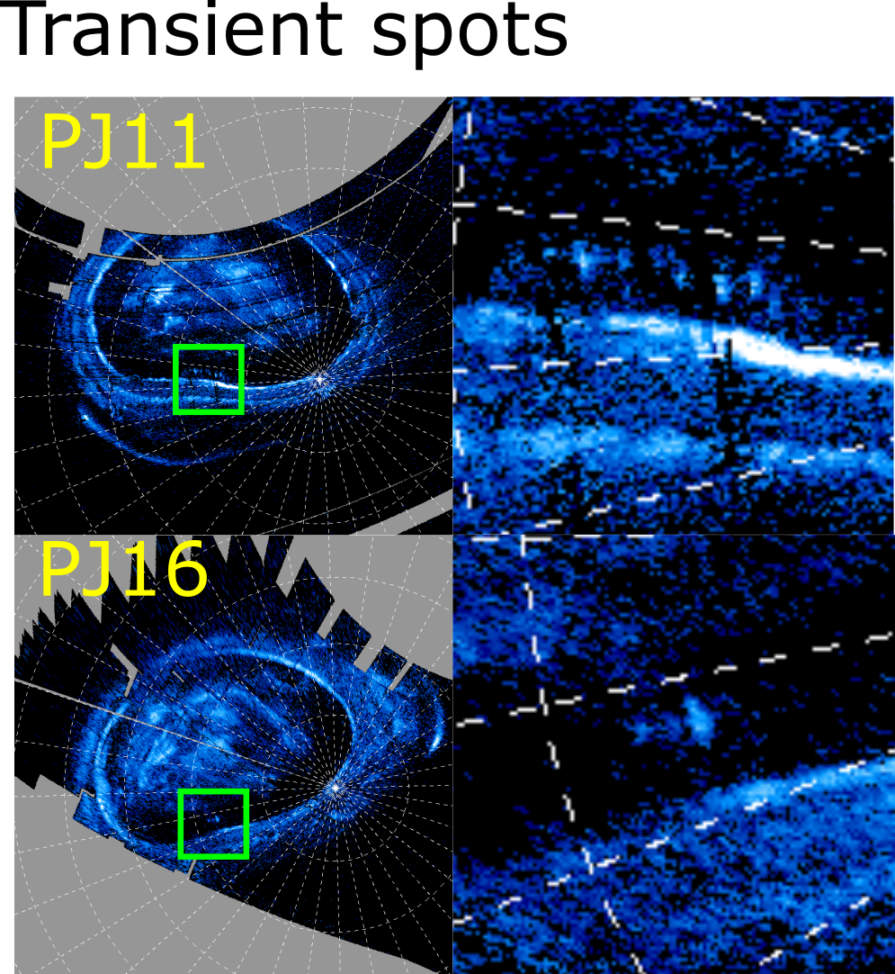
Figure S1
Polar projections and zoom on the transient spots observed during PJ11 and PJ16
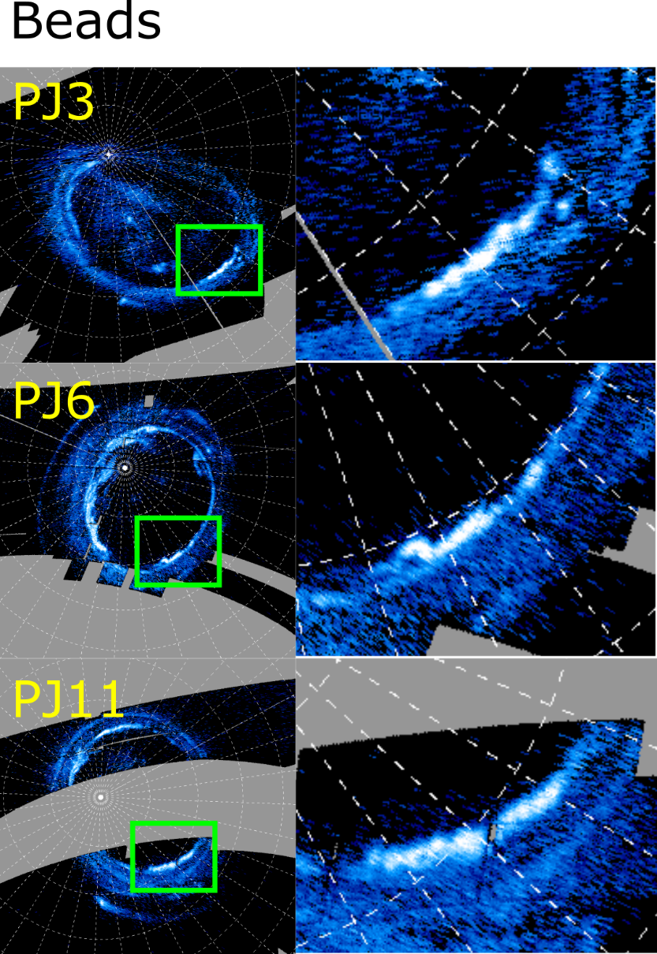
Figure S2
Polar projection and zoom on the beads-like features observed during PJ3, PJ6 and PJ11.
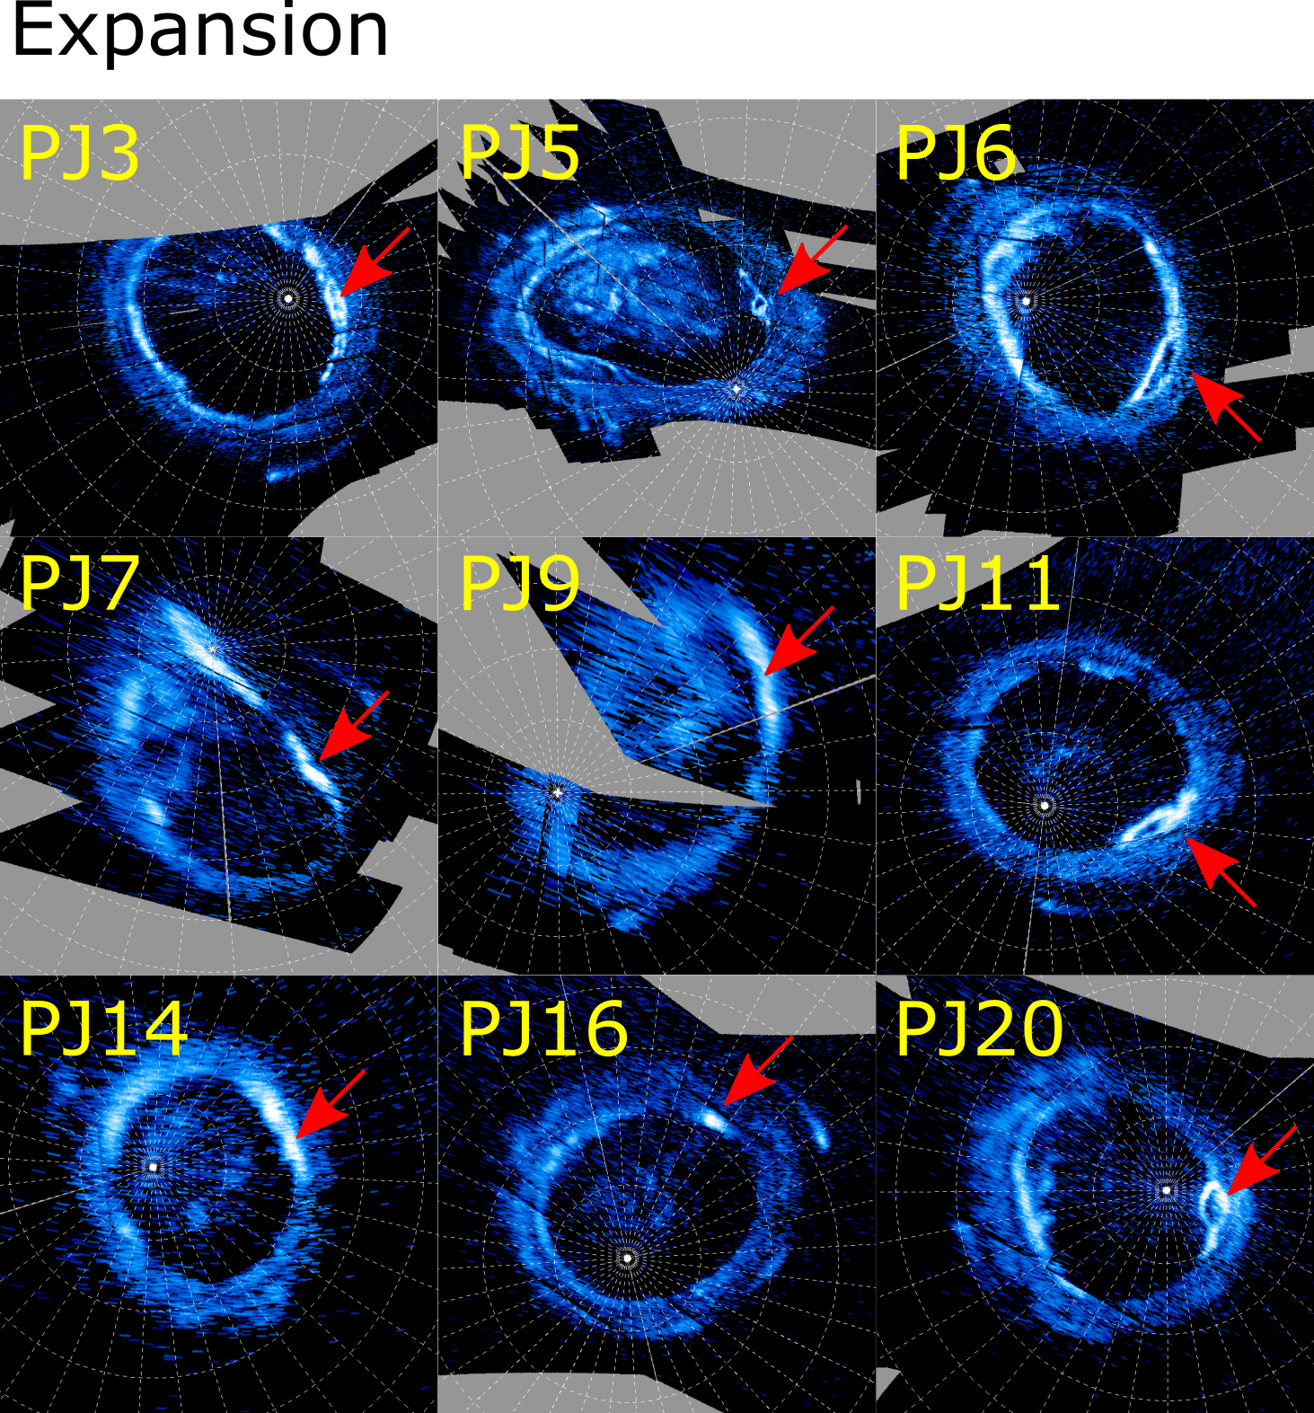
Figure S3
Polar projection of the expansion phase of the dawn storm observed during PJ3, PJ5, PJ6, PJ7, PJ9, PJ11, PJ14, PJ16 and PJ20.
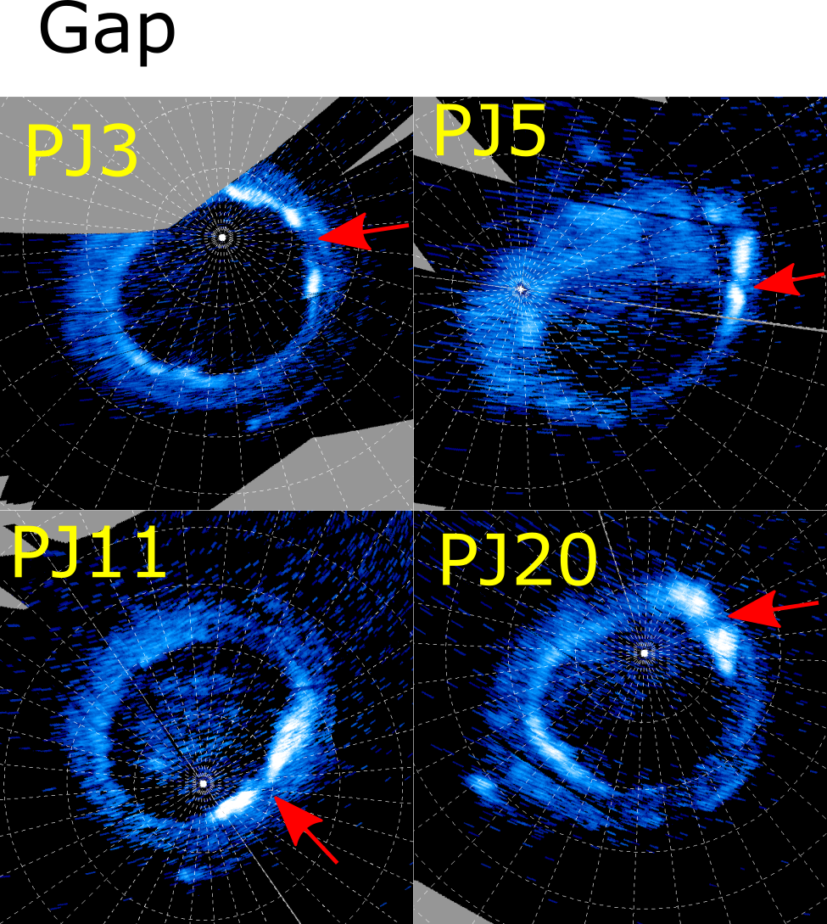
Figure S4
Polar projection of the dawn storm longitudinal gaps observed during PJ3, PJ5, PJ11 and PJ20.
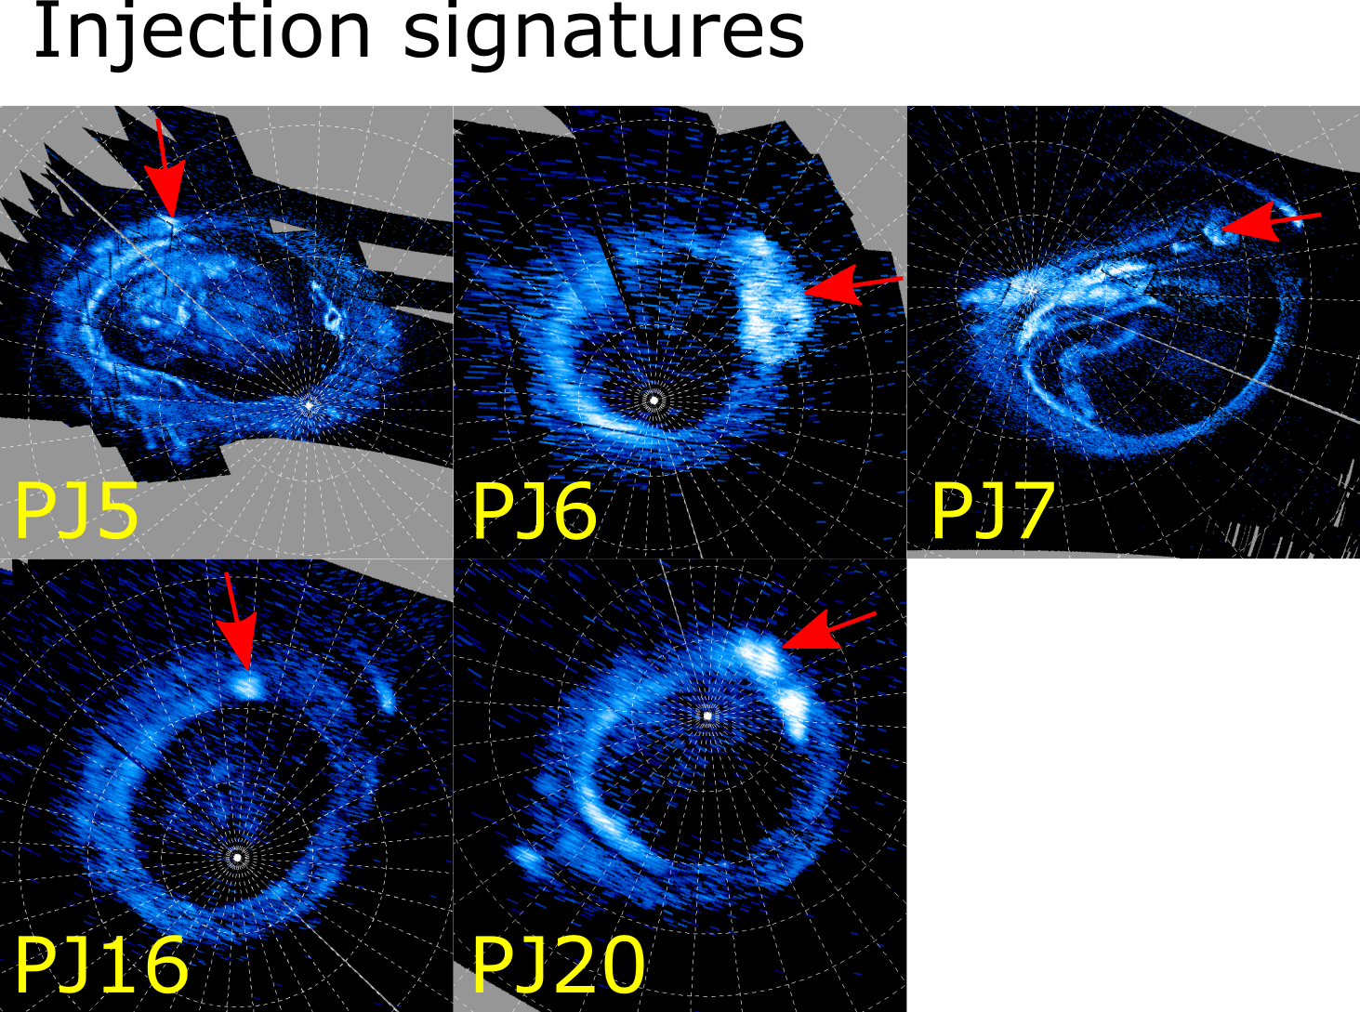
Figure S5
Polar projection of the auroral injection signatures observed during PJ5, PJ6, PJ7, PJ16 and PJ20.

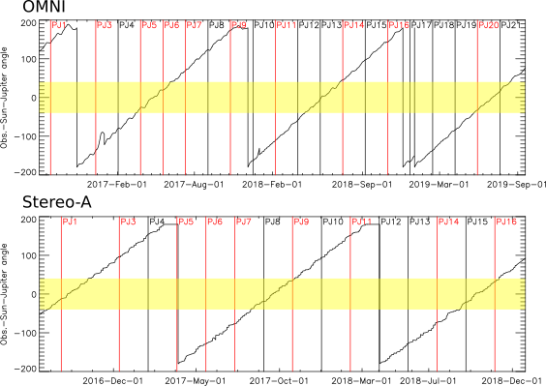

Figure S6.
Angle between the Earth-based solar wind observatories (top) or Stereo-A (bottom) and Jupiter as seen from the Sun. The yellow regions highlight the time intervals during which Jupiter was less than 40° away from the solar wind observatories under consideration. The vertical lines correspond to the perijove times and those in red correspond to the one during which dawn storms were identified.

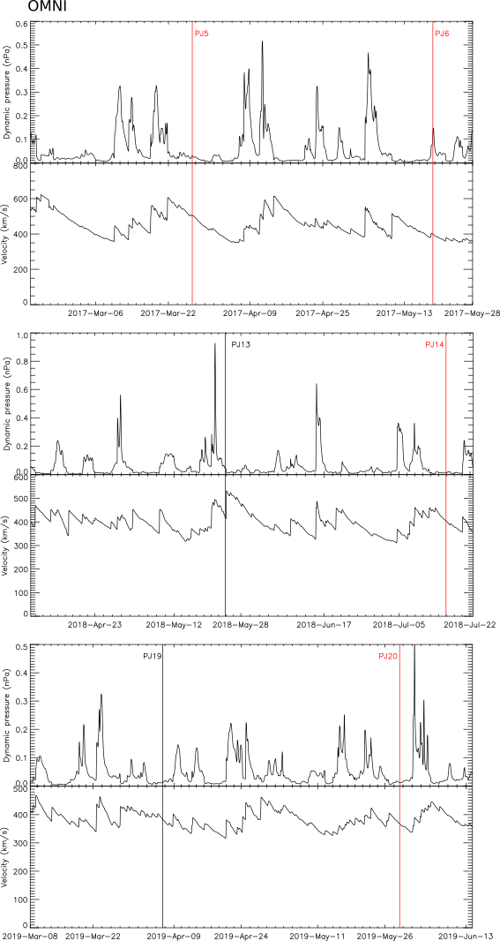

Figure S7.
Outputs of the Tao et al. (2005) model extrapolating the solar wind properties to Jupiter’s distance based on measurements from Earth-bound satellites (obtained from the AMDA website http://amda.irap.omp.eu/) for the three time intervals during which the Earth and Jupiter were aligned within 40°. The vertical lines show the times of the perijoves during these intervals and the red line identify perijoves during which a dawn storm was observed. For each interval, the top plot shows the dynamic pressure and the bottom plot shows the radial velocity. It can be seen that the solar wind was quiet during PJ5, PJ14 and PJ20, even if we account for a timing uncertainty of 1-2 days. PJ6 may have been concurrent with a limited solar wind enhancement.

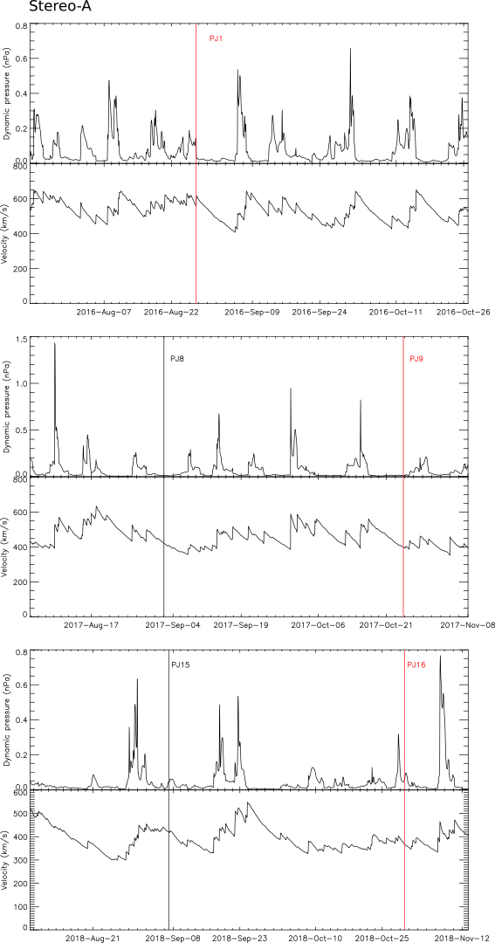

Figure S8.
Same as for figure S7, but based on Stereo A solar wind measurement instead of measurements from Earth-based satellites. The solar wind was quiet during the dawn storm observed on PJ9. Acknowledging a 1-2 days propagation uncertainty, PJ1 and PJ16 may have been concurrent with some solar wind enhancements.

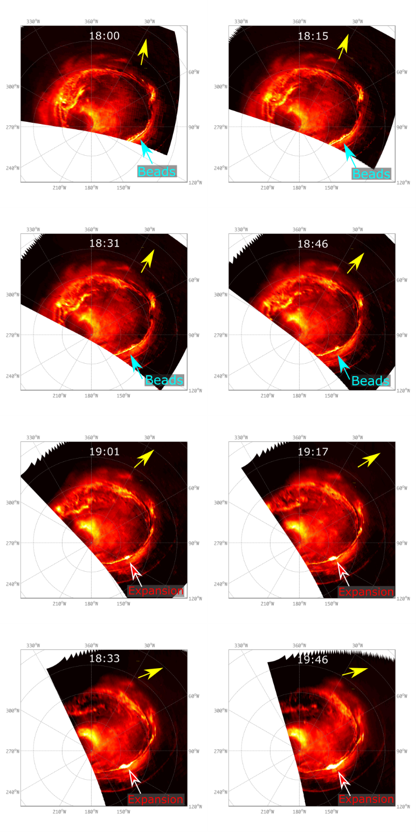

Figure S9.
Polar projections of the southern aurorae observed by the JIRAM infrared instrument (Adriani et al., 2017) after the last Juno-UVS observations of the first perijove (PJ1) (Mura et al., 2017). During this sequence, the post-midnight/dawn part of the main emission becomes irregular. The main emission then strongly brightens and this bright section expands both in longitude and latitude. These might correspond to the onset and beginning of the expansion of a dawn storm.

