Development And Validation Of A Method For Determining Estrogenic Compounds In Surface Water At The Ultra-Trace Level Required By The EU Water Framework Directive Watch List

Alex Glineur ^{a,b}, Katherine Nott ^{b}, Philippe Carbonnelle ^{b}, Sébastien Ronkart^{b},
Giorgia Purcaro^{a,∗}

ª Laboratory of Analytical Chemistry, Gembloux Agro-Bio Tech, University of Liège, Passage des Déportés 2, 5030 Gembloux, Belgium
^{b} La Société Wallonne des Eaux, Rue de la Concorde 41, 4800 Verviers, Belgium

Keywords: Estrogenic compounds EU surface water Watch List LC-ESI-MS/MS SPE disk Surface water Method Validation

Abstract
Natural estrogens (estrone: E1, 17β-estradiol: E2, estriol: E3) and the synthetic estrogen (17α- ethinylestradiol: EE2) are endocrine disruptors harmful to aquatic wildlife. The European Commission included these molecules in the surface water Watch Lists issued in 2015 and 2018 under the Water Framework Directive regarding emerging aquatic pollutants, proposing maximum detection limits (LOD) of 0.035 ng/L for EE2 and 0.4 ng/L for E1 and E2. Attaining these limits represents a challenge even with the most up-to-date analytical tools, in particular in surface water. A two-step sample preparation, involving a preliminary extraction of a whole water sample on a solid-phase extraction (SPE) disk and further purification on a Florisil SPE cartridge, was optimized. The purified extract was derivatized subsequently and quantified by LC-MS/MS. The main goal was to maximize the recoveries to achieve the very low LODs required by the European Watch Lists. The method was fully validated in seven surface water. The LODs calculated were below the maximum acceptable limits required by the European Commission.

∗ Corresponding author. Gembloux Agro-Bio Tech, University of Liège, Bât. G1 Chimie des agro-biosystèmes, Passage des Déportés 2, 5030 Gembloux, Belgium
E-mail address: gpurcaro@uliege.be (G. Purcaro).

Introduction

The presence of endocrine-disrupting chemicals (EDCs) in the environment is a growing concern considering their potential ad- verse effects on wildlife and human populations [1,2]. Among EDCs, estrogenic compounds, and in particular 17α-ethinylestradiol (EE2), 17β-estradiol (E2), and estrone (E1) exhibit high disrupting effects at very low concentrations [1,3–6]. E2 is a natural estrogen and has two main metabolites, E1 and estriol (E3), excreted by hu- mans and other mammals [7,8]. EE2 is a synthetic estrogen, commonly part of the contraceptive pill formulation and used for hormone therapy [2]. Natural and synthetic estrogenic compounds are excreted through urine and feces of humans and animals, mainly as biologically inactive conjugates [1,9,10]. However, free active forms have been observed in wastewater treatment plant effiuents and in surface water indicating that enzymatic deconjugation due to the activity of microorganisms may occur [1,8,11,12].
These compounds have been included within the 10 substances (or group) to be monitored in surface water as required in the Watch List (WL) published by the European Union (EU) in 2015, setting very low maximum acceptable method detection limits (MDL): 0.035 ng/L for EE2 and 0.4 ng/L for E1 and E2 [13]. Due to such low MDLs, the monitoring campaign of EE2, E1 and E2 required by the EU [13,14] failed. Sixteen Member States did not reach the sensitivity required for EE2 and 8 Member States the one for E2 [15]. Therefore, the three estrogenic compounds (EE2, E1 and E2) have been maintained in the revised WL published in 2018 [16] and the challenge is still open. It appears evident that the implementation of more sensitive and robust methods is essential. A substantial improvement is required on the sample preparation step to maximize the recovery and minimize the matrix effect, and thus reach the sensitivity that even up-to-date routine analytical methods have failed to achieve up to now [17].

Table 1
Characterization of the water samples studied: pH, suspended particulate matter (SPM) (mg/L), total organic carbon (TOC) (mgC/L), total concentrations of a selection of 43 pharmaceutical residues (PR, ng/L), 4 agricultural tracers (AT, ng/L) and 2 domestic activities tracers (DAT, ng/L). For SWs and GW, river or water resource, as well as the sampling location are reported.
Water |  | SPM | TOC | PR b,§ | AT c,§ | DAT d,§
sampleª River/ water resource Sampling location | pH | (mg/L) | (mgC/L) | (ng/L) | (ng/L) | (ng/L)
SW 1 Sambre Namur | 8.0 | 48.8 | 13.10 | 4733.1 | 17.41 | 1188.3
SW 2 Ry de Rome Ry de Rome dam. Couvin | 7.4 | 1.86 | 3.86 | 4.2 | 4.6 | 197.4
SW 3 Ourthe Nisramont dam. Roche-en-Ardenne | 7.3 | 6.4 | 2.92 | 75.5 | 38.5 | 556.1
SW 4 La Lhomme La Lhomme dam. Libramont-Chevigny | 6.9 | 3.53 | 2.65 | 72.6 | 4.7 | 778.2
SW 5 Warche Robertville dam. Waimes | 8.1 | 0.7 | 2.91 | 45.6 | 2.0 | 67.6
SW 6 Vesdre Vesdre dam. Eupen | 5.1 | 0.86 | 7.23 | <LOQ | 1.3 | <LOQ
SW 7 Gileppe Gileppe dam. Jalhay | 5.5 | 0.9 | 7.07 | <LOQ | 3.3 | <LOD
MW / / | 7.1 | / | 0.60 | / | / | /
GW 1 Houte outlet Gesves | 7.4 | / | 0.40 | / | / | /
ª mineral (MW). ground (GW) and surface (SW) water
^{b} sum of the concentration measured for 43 pharmaceutical residues (analgesics. cardiovasculars. neuroleptics. antibiotics. diuretics)
^{c} sum of the concentration measured for 4 agricultural tracers (bentazone. 2.6-dichlorobenzamide. isoproturon. 2-methyl-4-chlorophenoxyacetic acid)
^{d} sum of the concentration measured for 2 tracers of domestic activities (caffeine and cotinine)
§ determined by an SWDE internal validated method using SPE followed by LC-MS/MS (positive and negative electrospray ionization)

Analytical methods developed for the analysis of estrogenic compounds in aqueous samples usually involve an extraction step using solid-phase extraction (SPE) [2,8,18]. A second clean-up step to mitigate the matrix effect during the final analytical determination and increase the sensitivity has also been proposed [7,8] using NH2 [7,19], Florisil [20–23] or Silica cartridges [24]. For the first SPE extraction step, the most employed sorbent is a hydrophiliclipophilic balanced copolymer, OASIS HLB developed and commercialized by Waters Corporation, other alternative polymeric-based sorbents have been proposed, such as Strata-X from Phenomenex and styrene-divinylbenzene (DVB) based sorbent from several sup- pliers [2,8]. Cartridges containing silica-based sorbent like octadecylsilane C18 has also been used [2,8,18]. The latter has been used as sorbent for SPE disk format, which enables the analysis of whole water samples, avoiding the filtration step (carried out when SPE cartridges are used) that could lead to losses of analytes bound to suspended particulate matter (SPM) [19,25], and thus also comply with the request of the EU directive 2008/105/EC (amended by Directive 2013/39/EU) to analyze whole water. Most of the methods reported in the literature involving an SPE disk extraction, do not use any additional clean-up step [25–31]. None of these methods reached the LOD required by the EU for EE2, but most of these methods were multi-residual and not specifically optimized for estrogenic compounds [26–31]. Lardy-Fontan et al. [19] proposed a first extraction on an H2O-philic DVB SPE disk followed by a clean-up with an NH2 cartridge, achieving the required sensitivity but with relatively low accuracy and reliability at the LOD for EE2. Tavazzi et al. [32] developed a multi-residual SPE-LC-MS/MS method for substances included in the first WL. They reported a LOD of 0.03, 0.04 and 0.09 ng/L for EE2, E2 and E1, respectively, calculated on one surface water sample. However, the authors suggested always to verify the sensitivity since it is highly matrix dependent.
In our previous work, a one-step procedure using an Oasis HLB cartridge was validated for the analysis of ground water (GW). However, when applied to surface water (SW), filtration of the sample was necessary to avoid clogging of the SPE cartridge. Moreover, to reach satisfactory LOQs, an additional clean-up step using a Florisil cartridge was carried out before the final LC separation on the biphenyl column and ESI(+)-MS/MS detection [23]. Such a modification was time-consuming and it was not validated. The present work aims to reach several goals, namely increase the sample throughput for SW analysis, analyze whole water samples (no
filtration [14]), and reach the sensitivity required [16]. A two-step extraction and purification procedure was optimized and fully validated for the analysis of E1, E2, EE2, and E3 in SW. Different sorbents were compared for the initial SPE disk extraction (H2O-philic DVB and C18) and the following clean-up step (NH2 and Florisil). The final determination was carried out by LC-MS/MS after derivatization as reported by Glineur et al. [23].

Materials and methods

SAMPLES

One mineral water (MW), one GW, and seven SW samples were studied. The MW sample was bought from a local market; it is produced from a French water source and is one of the most consumed in Wallonia. The GW and the 7 SW samples were collected in Belgium from different sampling points to represent various sample types concerning pH, particulate matter and total organic carbon (Table 1).

CHEMICALS AND REAGENTS

E2 and EE2 were bought from MilliporeSigma (Overijse, Belgium) and E1 and E3 from LGC (Köln, Germany). The EE2- d4, E1-d4, E2-d5, and E3-d3 deuterated internal standards (DIS) were purchased from Alsachim (Shimadzu group company, Illkirch- Graffenstaden, France). The standards were dissolved in acetone to prepare a single stock solution at 100 mg/L for EE2, E2 and E3 and 400 mg/L for E1, divided into six aliquots. The stock solutions were stored for one year; no significant variation was observed. Working solutions were freshly prepared for each sequence of analysis by diluting adequate volumes of the stock solution in acetone. All solutions were stored in amber glass tubes at 4°C for not more than 7 days.
Sodium hydrogen carbonate and pyridine-3-sulfonyl chloride (PS-Cl) were bought from MilliporeSigma (Overijse, Belgium). Sodium hydrogen carbonate was dissolved in ultrapure water at 0.1 mol/L, and the pH was adjusted to 10.5 with NaOH at 1 mol/L. PS- Cl was dissolved in acetone at 1 mg/mL.
Absolute methanol (MeOH), acetonitrile (CH3CN) and wa- ter ULC/MS grade were bought from Biosolve (Dieuze, France). Dichloromethane (DCM) (stab. amylene) LV-GC SuperTrace grade and n-heptane HPLC grade were also purchased from Biosolve. Acetone Pestinorm® capillary GC was bought from VWR chemi- cals (Leuven, Belgium). Formic acid and ammonium formate were from MilliporeSigma (Overijse, Belgium). Ultrapure water used for sample preparation was produced by a Millipore system (Overijse, Belgium).
H2O-philic DVB and C18 SPE disks were from Baker (J.T. Bak- er® Bakerbond SpeediskTM). Florisil and NH2 SPE cartridges were purchased from MilliporeSigma (Overijse, Belgium)

SAMPLE EXTRACTION AND CLEAN-UP

Water samples were collected in amber 1 L glass bottles. Glass bottles were stored in the dark at 4°C and samples were extracted within 24 hours after sampling.

SPE-disk extraction
The DISs (1 ng/L each) were added to the water sample before any manipulation. Extraction was performed with a manual SPE disk extraction station (J.T. Baker® Bakerbond SpeediskTM) coupled to a vacuum pump. First, the disk was washed with two aliquots of 10 mL of elution solvent (MeOH for the H2O-philic DVB or CH3CN for the C18 disk). Subsequently, the SPE disk was conditioned with 10 mL of MeOH, (soaked for 1 min), and rinsed twice with 10 mL of ultrapure water. The water sample (1 L or 250 mL) was percolated through the SPE disk at a flow rate of about 150 mL/min. The SPE disk was dried for 10 min by applying the maximum vacuum. Finally, analytes were eluted with 3 aliquots of 5 mL of MeOH for the H2O-philic DVB SPE disk or with 3 aliquots of 10 mL of CH3CN for the C18 SPE disk.
The extract from the disk was evaporated under a flow of nitro- gen at 50°C (TurboVap II from Zymark, Hopkinton, USA) to 1 mL or dryness according to the following clean-up step.

SPE clean-up step using Florisil cartridge: the flow rate was maintained at about 2-3 mL/min (droplets flow). The cartridge was conditioned with 6 mL of n-heptane. After 5 minutes soaking, the dry extract re-dissolved in 6 mL of n-heptane/DCM (1:1, v/v) was quantitatively loaded onto the cartridge and let percolate. Then 6 mL of n-heptane/DCM (1:1, v/v) were used to wash the cartridge. EE2, E1 and E2 were eluted with 6 mL of acetone/DCM (1:9, v/v), while E3 was eluted with an additional 6 mL of MeOH/acetone (5:95, v/v). The eluates were collected in amber glass tubes.

SPE clean-up step using NH 2 cartridge: the flow rate was adjusted to about 2-3 mL/min (droplets flow). The cartridge was conditioned with 4 mL of MeOH. The extract (1 mL MeOH) was quantitatively transferred to the NH2 cartridge. The sample volume (1 mL) was collected in an amber glass tube along with an additional 4 mL of MeOH used to elute the analytes.

Final procedure validated: 250 mL of water sample spiked be- forehand with DISs were extracted on C18 SPE disk. Analytes were eluted with 3 aliquots of 10 mL of CH3CN. The solvent was evaporated to dryness, re-dissolved in 6 mL of n-heptane/DCM (1:1, v/v) and further purified on a Florisil SPE cartridge previously conditioned with 6 mL of n-heptane. After loading the sample, the cartridge was washed with 6mL of n-heptane/DCM (1:1, v/v). 6 mL of acetone/DCM (1:9, v/v) were used to elute EE2, E1 and E2 and additional 6 mL of MeOH/acetone (5:95, v/v). for E3.

DERIVATIZATION

The derivatization procedure was carried out according to Glineur et al. [23]. Briefly, the purified extract was evaporated to dryness under a flow of nitrogen at 50°C (TurboVap®). The evaporation tube was rinsed with 1 mL of acetone and evaporated again before the addition of 100 μL of an aqueous sodium hydrogen carbonate solution (0.1 mol/L, pH adjusted to 10.5) and 100 μL of PS- Cl (1 mg/mL). A glass Pasteur pipette was used to homogenize and transfer the extract to a 200 μL insert in an amber screw-top HPLC vial. The vial was sealed and put in an oven at 60°C for 5 min, then cooled on ice for 10 min. The vial was centrifuged at 4000 × g for 10 min, and the supernatant was transferred to a new insert and stored at 4°C before injection.

LC AND MS/MS PARAMETERS

The liquid chromatographic system was an Agilent 1270 Infinity LC device. UHPLC parameters were as in Glineur et al. [23]. The autosampler was maintained at 4°C and the injection volume was 20 μL. Chromatographic separation was performed on a Kinetex biphenyl column (50 mm x 2.1 mm, 2.6 μm; Phenomenex, Nether- lands) at a flow rate of 0.4 mL/min in gradient mode. Solvent A was water and solvent B was MeOH, both containing 0.1 % (v/v) formic acid and 0.6 g/L of ammonium formate. Gradient: 0 min, 50% B; 3 min, 62 % B; 6 min, 65 % B; 10.5 min, 70 % B; 12 min, 75% B; 16 min, 100 % B. From 0 to 3 min, eluent was sent to waste to avoid sending excess reagent and salt to the MS ion source. At the end of each analysis sequence, the chromatographic column was rinsed with 50 % of solvent A for 10 min and then with 100 % of solvent A for 10 min at 0.4 mL/min. Moreover, the system was carefully cleaned by washing the channel from the autosampler needle to the entrance of the chromatographic column with 100 % solvent A for 10 min at 2 mL/min to avoid deposition of salt from the derivatization mixture used.
The detector was a tandem mass spectrometer (Agilent 6490). Source and ion funnel parameters, as well as the precursor and product ions monitored, were as in Glineur et al. [23], supplementary table S1. Briefly, the ions herein monitored were: EE2 (pre- cursor ion: 438.2 m/z) 213.2 (Quantifier ion (Q)), 160.1 (Qualifier ion (q)) and 157.0 (q); E1 (precursor ion: 412.2 m/z) 348.2 (Q) and 185.1 (q); E2 (precursor ion: 414.2 m/z) 350.2 (Q) and 213.1 (q); E3 (precursor ion: 430.2 m/z) 366.2 (Q) and 146.1 (q).

VALIDATION OF THE ANALYTICAL PROCEDURE

The external calibration function was built using 6 concentration levels (ranging from 125 to 6250 ng/L for EE2, E2, and E3 and from 500 to 25000 ng/L for E1, concentrations in the vial) and it was run daily. The lowest level of the calibration function (125 ng/L) corresponds to a concentration of 0.1 ng/L in the water sample (LOQ derived from the maximal acceptable detection limit for EE2 of 0.035 ng/L [16]), considering a concentration factor of 1250 from the initial water sample (250 mL to the final volume of 200 μL). The pure standard solutions were prepared by adding appropriate volumes of working solutions (analytes and DISs) in an insert followed by evaporation to dryness and derivatization as described previously (see section 2.4). During the optimization of the procedure, a standard solution at 1250 ng/L for EE2, E2 and E3 (5000 ng /L for E1) and at 1250 ng/L for DISs was used for recovery assessment. Absolute recoveries (also defined as= overall process eﬃciency, [33]) were assessed by calculating the ratio between the area of the analyte recovered from the entire procedure and the area of the analyte in a standard solution corresponding to the theoretical 100 % recovery. The LODs and LOQs, calculated based on a signal-to-noise ratio (S/N) of 3 and 10 respectively, were evaluated on the samples spiked at the lowest level of spiking (0.1 ng/L for EE2, E2 and E3, 0.4 ng/L for E1).
Validation was carried out according to the French NF T90-210 standard, as briefly described below [34]. The external calibration functions were calculated on five different days for evaluating the intermediate precision. The relative difference between the con- centration calculated from the calibration function and the target one (based on the theoretical concentration of the stock solution) was calculated for each assay (relative bias). The accuracy of the method was assessed at three spiking levels (0.1, 0.5 and 2 ng/L for EE2, E2 and E3; 0.4, 2 and 8 ng/L for E1) on seven different SW samples analyzed on different no-consecutive days to evaluate the intermediate precision as well (over a period of roughly 1 month). On each day, two repetitions were carried out. Two equations, i.e., (1) and (2), were verified:

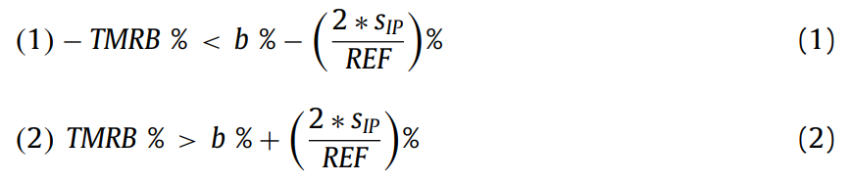

Where TMRB % is the tolerable maximum relative bias, b % is the relative bias, sIP is the intermediate precision standard deviation, and REF is the conventionally true value corresponding in this study to the spiking level.
Seven SW samples were selected as representative of the variety of samples to which the validated method will be applied during routine monitoring (Table 1). An MW blank following the whole procedure was processed each day as quality control. In total, each sample was analyzed 8 times: two repetitions of the native sample (to assess the possible contamination of the environment) and two repetitions at each of the three spiking levels.

To confirm the identity of the analytes, all the following criteria had to be met:

- the absolute retention time difference between the analyte detected in a sample and the standard solution has to be of maximum ± 0.1 min [35];
- the ratio between the retention time of the analyte and the retention time of the DIS in a sample has to be the same as the ratio in the standard solution with a tolerance of 2.5 % [36];
- the ratios for the product ions (two product ions are required for each compound [35,36]) have to be within the limits specified by the EC Decision 2002/657/EC. For EE2, three product ions were selected (one quantifier and two qualifiers) as the surface water WL requires for this compound a lower LOD. The S/N ratio should be above 3 for all the product ions.

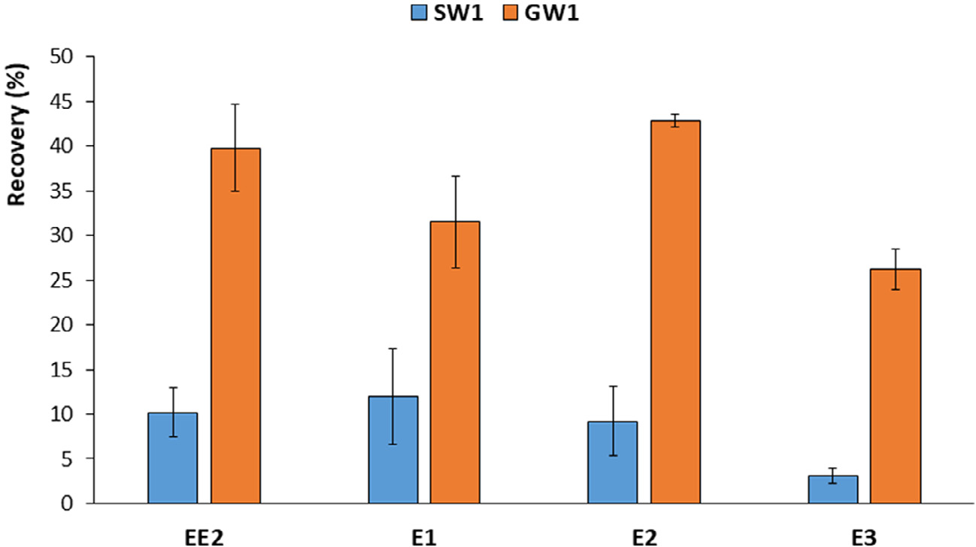
Fig. 1. Recoveries (calculated for the DISs, spiked at 1 ng/L in water, n=4) obtained for the analysis of 1 L of water (SW1 or GW1) after extraction on a H2 O-philic DVB SPE disk and clean-up on an NH2 cartridge (see Table 1 for samples details).

Results and discussion

Compared to the previous work where the focus was on the optimization of the final LC-MS/MS determination and the derivatization step, this work focused on the optimization of an effective sample preparation step for SW and its full validation. Particular attention was devoted to maximizing the absolute recovery of the overall procedure to improve the sensitivity. Although the surface water WL does not include E3, it was included in this study as it is often detected in surface water [11,28,37].
Compared to our previous method [23], the first time- consuming step on the HLB cartridge (~2h) was replaced with an SPE disk extraction, which allows to perform a rapid extraction (~20min) of a large amount of whole water sample (1 L), at a high flow rate, and without the need of a prior filtration step. Large volume extraction was suggested in the WL [16] as well as in a JRC report [38] to address the sensitivity problem for EE2.
The protocol proposed by Lardy-Fontan et al. [19] was our starting point, consisting of the first extraction on an H2O-philic DVB SPE disk followed by a clean-up with an NH2 cartridge.
Recovery performances using this protocol were evaluated on two different types of matrices, ground- and surface water, using the sample GW1 and SW1. GW1 was considered as a “clean” water sample, while SW1 was considered as a “complex” water sample. This distinction was primarily based on the total organic carbon (TOC) content (Table 1). Surprisingly, recoveries (based on a spike of 1 ng/L of DISs, 1 L water sample) were much lower than those reported by Lardy-Fontan et al. [19] for both types of water, with values for SW1 (~10 % for EE2, E1 and E2 and ~3 % for E3) lower than those for GW1 (~40 % for EE2, E1 and E2 and ~25 % for E3) (Fig. 1).
It was hypothesized that the difference of recoveries between the two samples was mainly due to matrix effects affecting the final ionization yield and/or to overloading of either the SPE disk and/or the NH2 cartridge with the matrix. To understand the origin of these low recoveries and improve them, further investigations were carried out.

COMPARISON OF THE NH2 AND FLORISIL PURIFICATION

Both NH2 and Florisil cartridges were tested and compared. The latter purification was based on the previous method developed by Glineur et al. [23]. SW1 was chosen as the worst-case scenario in terms of matrix load (the highest TOC and SPM). A volume of 1.5 L was spiked with the working standard solutions (1 ng/L for EE2, E2, and E3; 4 ng/L for E1; 1 ng/L for DISs) and loaded onto the H2O-philic DVB SPE disk (n=2). Then, the eluate of each SPE disk (15 mL of MeOH) was divided into 3 portions and each loaded onto the NH2 or the Florisil SPE cartridge (n=3 for each SPE cartridge). In this way, the same matrix load was loaded onto the SPE cartridges and the differences observed can only be ascribed to the clean-up step.

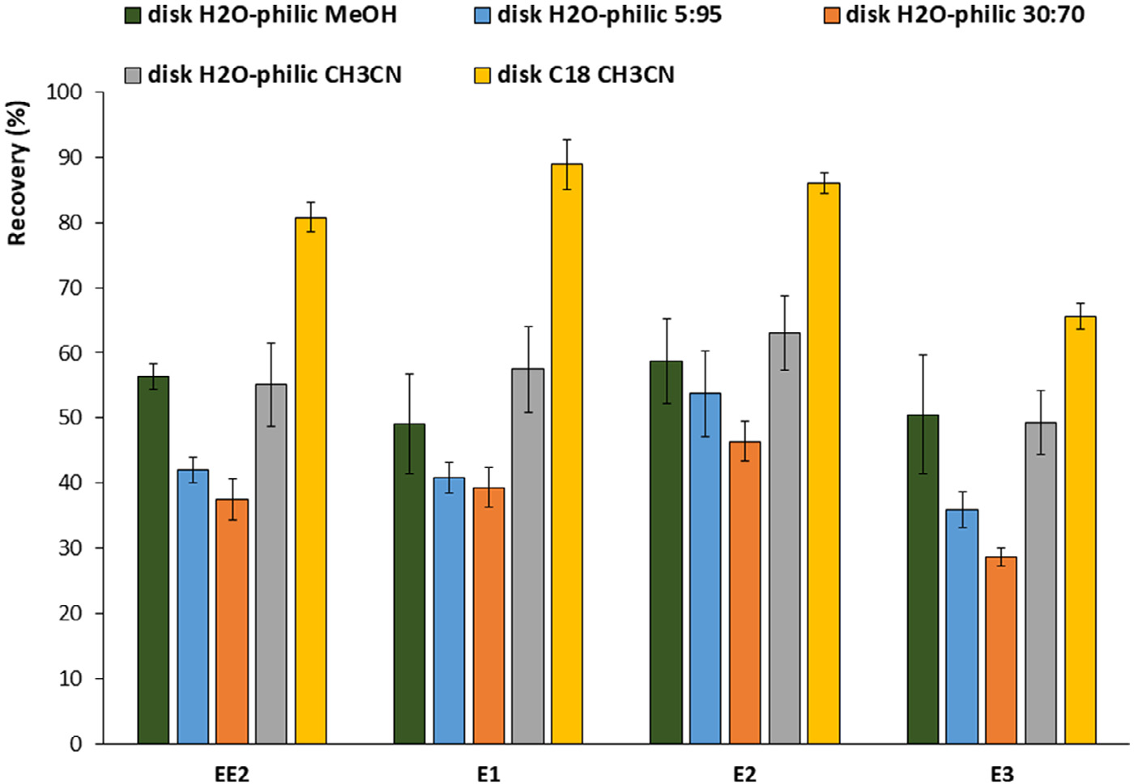
Fig. 2. Study of the recoveries of the two consecutive steps (extraction of a mineral water on SPE disk and evaporation to dryness). Different mixtures of MeOH/CH3 CN (5:95; 30:70) and 100 % CH3 CN and MeOH were tested and two different stationary phases for the SPE disk (H2 O-philic and C18) are compared. (Spiking levels: 1 ng/L for EE2, E2 and E3; 4 ng/L for E1).
Recoveries were significantly higher (p<0.05) with Florisil clean-up compared to NH2 clean-up, although not satisfactory in both cases (<45 %; Supplementary Table S2). E3 is not reported here due to too low recoveries (<LOQ). Although, at this stage, we cannot distinguish between a matrix effect or recovery issue, it is evident that insuﬃcient elimination of interfering compounds may cause an overload of the clean-up SPE cartridge and/or important matrix effects during electrospray ionization. In fact, previously, recoveries over 90 % were reported on Florisil and no significant losses were observed during the subsequent evaporation [23]. Therefore, most of the eﬃciency loss might not be due to the SPE clean-up itself, but most probably to the previous steps: ex- traction on the H2O-philic DVB SPE disk and/or subsequent evaporation. Both steps were investigated further and the results are discussed below.

INVESTIGATION OF THE DIFFERENT STEPS USING MINERAL WATER

To study the possible losses during the sample preparation steps, minimizing other confounding variables, such as the matrix effect, an MW was chosen for further investigation.
As a first test, the recoveries for the H2O-philic DVB SPE disk extraction and the NH2 clean-up steps were assessed separately (n=3 each, spiked with 1 ng/L of EE2, E2, and E3; 4 ng/L of E1). Almost quantitative results were obtained for all the analytes of interest for the SPE disk (i.e. 100.7 %, 97.1 %, 100.6 % and 93.6 % for EE2, E1, E2 and E3, respectively), as well as for the NH2 clean- up (i.e. 98.4 %, 93.4 %, 107.4 % and 101.3 % for EE2, E1, E2 and E3,
respectively). Consequently, the two successive evaporation steps of the MeOH eluent were suspected to be a possible cause of the poor recoveries.
15 mL of MeOH (corresponding to the volume of elution from the H2O-philic DVB SPE disk, i.e., 3 × 5 mL) spiked with 20 ng/L of EE2, E2, and E3 and 80 ng/L of E1 were evaporated to dryness. An average recovery below 60 % was observed (Supplementary Figure S1), characterized by a high inter-day variability (RSD between 15.1 % for E3 and 21.2 % for E1). The evaporation of 5 mL of MeOH (which corresponds to the elution volume for the NH2 SPE purification) spiked at the same levels led to better recoveries, ranging from 73 % for E2 to 77 % for E3, but remained unsatisfactory.
CH3CN was tested as an alternative elution solvent. Evaporation of 15 mL of spiked CH3CN to dryness led to higher recovery (> 84%, Supplementary Figure S1) compared to MeOH for each analyte considered, with a lower inter-day variability (RSD between 3.4 % for E1 and 11.9 % for E3). Different evaporation systems were also compared for each solvent (i.e., TurboVap® and Rotavapor®), with no significant differences (data not shown).

STUDY OF THE SPE DISK

SPE DISK ELUTION CONDITIONS SELECTION

Considering the reduced losses observed during evaporation us- ing CH3CN, the latter was tested as the elution solvent for the H2O-philic DVB SPE disk (3 × 5mL). The elution yield was significantly reduced using CH3CN (76.9 %, 76.7 %, 80.5 % and 66.8 % for EE2, E1, E2 and E3, respectively) compared to MeOH (i.e. 100.7 %, 97.1 %, 100.6 % and 93.6 % for EE2, E1, E2 and E3, respectively). Assuming that analytes were still retained on the SPE disk, an additional volume of eluting solvent was added (3 × 5 mL), but the recoveries improved by only 4 %.
Considering that elution with MeOH provided quantitative recoveries, we hypothesized that the addition of a small amount of MeOH in CH3CN could help the elution of compounds from the SPE disk without a significant loss during the evaporation step. Therefore, different mixtures of MeOH/CH3CN (i.e. 100/0; 30/70; 5/95; 0/100; v/v) were tested. Fig. 2 shows the recoveries obtained (integrating both the SPE disk and evaporation steps) for the different solvent mixtures used.
With the H2O-philic disk, global recoveries (disk extraction and evaporation steps) with pure CH3CN were overall comparable with the recoveries obtained with pure MeOH and better than those obtained for the MeOH/CH3CN mixtures (Fig. 2). This behavior may be correlated to multiple effects. MeOH and CH3CN form an azeotrope (b.p. 63.5°C versus MeOH: 64.7°C and CH3CN: 82.0°C) and an enhancement of the hydrogen bond interactions has been reported in MeOH/CH3CN mixtures, which may have led to an increase of the losses observed during evaporation of only MeOH (probably due to a stripping effect) [39,40].

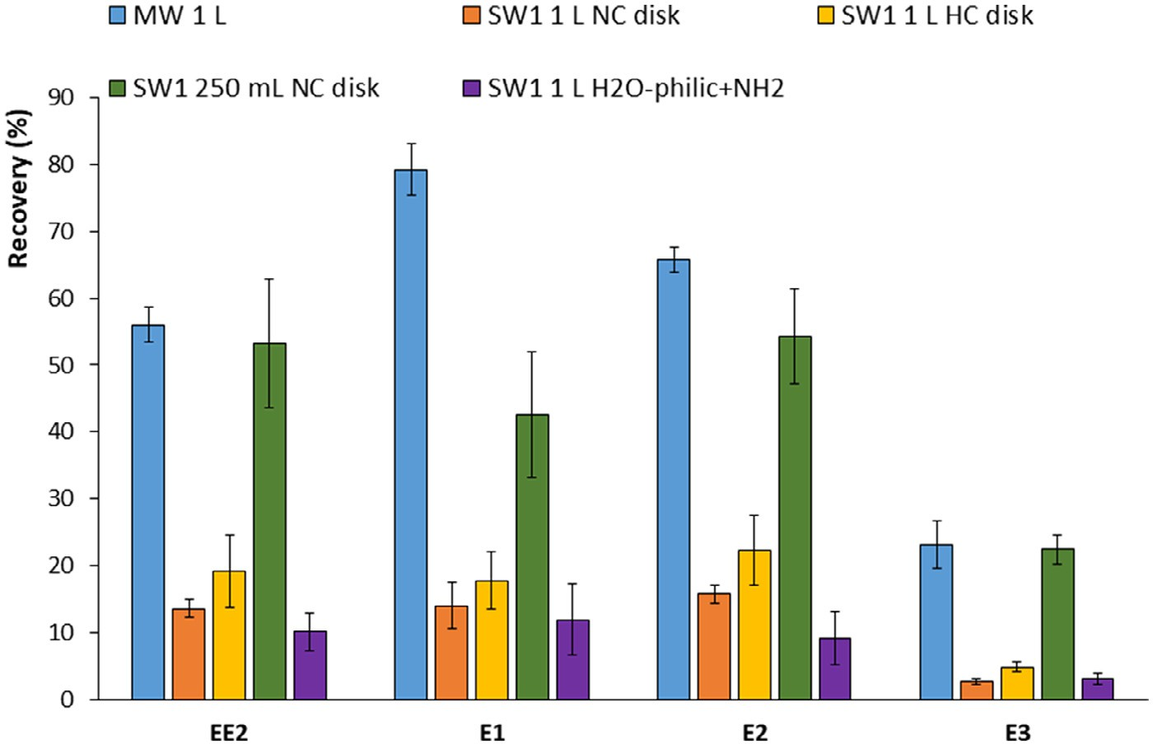
Fig. 3. Study of the recoveries for the C18 disk extraction + Florisil clean-up for 1 L of mineral water using the normal capacity disk (MW 1 L NC), for 1 L of SW1 using the normal capacity disk (SW1 1 L NC disk) or the high capacity disk (SW1 1 L HC disk), and for 250 mL of SW1 with the normal capacity disk (SW1 250 mL NC disk). The results obtained using H2 O-philic SPE Disk + NH2 clean-up for SW1 (1 L) are reported for comparison purposes.

Considering the challenging LODs required, recoveries of these two steps (SPE disk and evaporation to dryness) should be maximized. Therefore, an alternative stationary phase for the SPE disk, i.e., C18, was tested. Such an SPE disk phase was used by Sun et al. [27] for the analysis of 15 hormones in deionized water, obtaining recoveries ~ 90 % for EE2, E1, E2 and E3, using CH3CN as elution solvent. Comparable recoveries were obtained here on MW (spiked with 1 ng/L for EE2,E2 and E3; 4 ng/L for E1;) for the C18 SPE disk step only (no evaporation; 94.9 %, 88.8 %, 92.2 % and 86.5 %, respectively for EE2, E1, E2 and E3). These values were slightly lower than those reached with the H2O-philic DVB SPE disk (i.e. 100.7 %, 97.1 %, 100.6 % and 93.6 % for EE2, E1, E2 and E3, respectively) but higher when combined with the following evaporation step (C18 Disk: 80.8 %, 88.9 %, 86.1 % and 65.6 %; H2O-philic disk: 56.4 %, 49.1 %, 58.7 %, and 50.5 % for EE2, E1, E2 and E3, respectively) (Fig. 2). The simpler procedure involving only the C18 SPE disk step (with no clean-up on an SPE cartridge) was tested on SW1. How- ever, as expected, recoveries were drastically low (3.0 %, 5.2 %, 3.3%, and 0,4 %, for EE2, E1, E2, and E3, respectively) underlying the importance of the clean-up step.

STUDY OF THE C18 SPE DISK AND CLEAN-UP WITH FLORISIL

The C18 SPE disk was then used in combination with the Florisil cartridge clean-up step. The entire procedure was tested on 1 L of an MW and SW1. Recoveries (calculated for the DISs, 1 ng/L) for the MW were 56.0 %, 79.2 %, 65.7 % and 23.1 % for EE2, E1, E2, and E3, respectively (Fig. 3), while they drastically dropped when SW1 was analyzed (13.6 %, 14.0 %, 15.8 % and 2.7 % for EE2, E1, E2, and E3, respectively), although slightly better than those obtained using H2O-philic DVB SPE disk and clean-up on NH2 cartridge, except for E3 (Fig. 3).
Such a drastic change in the recoveries could be explained by matrix effect and/or overloading of the SPE disk or Florisil cartridge. To improve the recoveries for complex SW samples, two approaches were investigated: I) use of a higher sorbent mass SPE disk (high capacity (HC) SPE disk); II) extraction of a lower volume of SW (250 mL) to decrease the amount of compounds from the matrix.
Using the first approach, recoveries for 1 L of SW1 were slightly improved (19.2 %, 17.8 %, 22.4 % and 4.9 % for EE2, E1, E2 and E3, respectively, Fig. 3) compared to those obtained with the normal capacity SPE disk (NC SPE disk) for the same volume extracted. On the other hand, the second approach provided a significant improvement of the recoveries (53.2 %, 42.5 %, 54.2 % and 22.5 %, respectively for EE2, E1, E2 and E3), leading to values similar to the ones obtained extracting MW, except for E1. A recovery loss in a SPE purification is generally related to a breakthrough or a too strong retention. However, if we consider the elution order, as re- ported in ref [23], in a C18 sorbent E1 should elute very close to E2 and EE2 and rather later than E3. Therefore, a similar recovery loss would have been observed in the earliest (i.e., E3) or the latest eluted compound (i.e., EE2). A more likely explanation is that E1 may be subjected to higher ion suppression due to co-elution in the chromatographic run with matrix components. The use of high sample volume (i.e., 1 L vs 250 mL), although suggested as a strategy to increase the signal intensity and hence reach better LOQs, impaired the performance of the method (due to matrix effect and/or matrix overload in the SPE steps), as also underlined by [10]. With the extraction of lower water volume, a rough estimation of the S/N ratio showed that the target sensitivity could be obtained in SW1 (LOQ ~ 0.030 ng/L for EE2 and ~ 0.060 ng/L for E1, E2, and E3, respectively). Therefore, this approach was run through the validation procedure and the results obtained are detailed below.

VALIDATION

The final procedure (reported in section 2.3) was validated ac- cording to the NF T90-210 standard. The external calibration (six concentration levels) was determined on 5 different days and using independent solutions. The intermediate precision was calculated over no-consecutive 5 days (roughly 1 month) for each level (Table 2): inter-day relative standard deviations (RSDs) for the different concentration levels ranged between 0.6 and 3.2 %, 0.7 and 2.5 %, 0.6 and 3.2 %, and 0.3 and 1.3 % for EE2, E1, E2 and E3, respectively (Table 2). The relative biases (a measure of trueness) were calculated for each level of the calibration for EE2, E1, E2 and E3 (Table 2). The tolerable maximum relative bias of 10 % was verified.
According to the NF T90-210 standard, the accuracy should be tested on at least six samples
Table 2
Study of the intermediate precision (RSDs, inter-day, n=5) and trueness (relative biases, inter-day, n=5) for the external calibration (6 concentration levels).
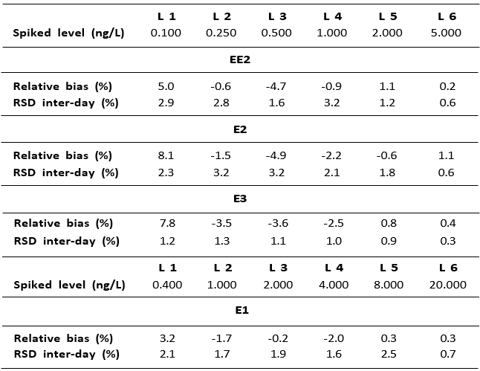

Table 3
Study of the intermediate precision (RSDs, inter-day) and the trueness of the method (relative biases, inter-day) by analyzing 7 SW samples (n=7) at three different spiking levels. The final procedure used during validation is described in section 2.3
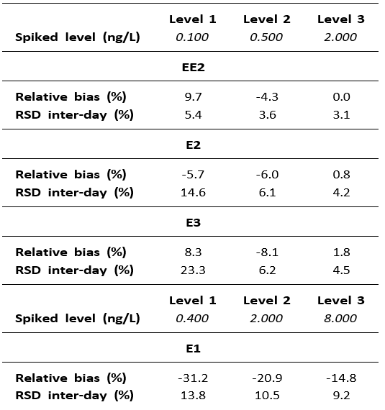

representative of the field of application. Here, the entire analytical procedure was validated on seven different SW samples. One SW (SW1) was representative of large rivers that run through highly populated regions and 6 SW (SW2 to 7) representative of the different SW used in Wallonia to produce drinking water (Table 1). Trace amounts of the E1 and E2 were found in four out of seven samples. The SW samples were spiked at three concentration levels (~ LOQ required, 5-times and 20-times the LOQ required). The validation of such different samples enabled to assess the robustness/ruggedness [41] of the pro- posed protocol. The lowest concentration level tested was at the required LOQ for EE2 (0.1 ng/L). E2 and E3 were validated at the same concentration levels than EE2 considering they are usually measured at very low concentrations in the environment, while E1 is generally found at higher concentrations thus, it was vali- dated at 0.4 ng/L as the lowest concentration level [7,22]. The identity of each component was first verified according to the criteria reported in section 2.6. The absolute retention time difference of each compound to the standard retention time (criteria I) was far below the 0.1 min allowed (generally lower than 0.085 in absolute value), as well as the bias in the retention time ratio (criteria II) was <0.6 % (maximum allowed 2.5 %). The ratios for the qualifier ions were all within the limits specified by the EC Decision 2002/657/EC (Supplementary Figure S2).

Table 4
Estimated LODs and LOQs (S/N= 3 and 10, respectively) and concentrations found in the SW samples. The final procedure used during validation is described in section 2.3.
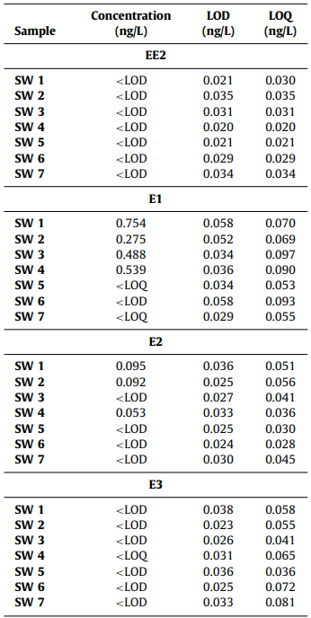
Accuracy parameters (bias and inter-day RSD) for each targeted analyte are presented in Table 3. EE2 showed excellent results with a bias lower than 10 % and an inter-day RSD lower than 6 % at each concentration level. E2 and E3 showed comparable results with a bias below 10 % at each concentration level and an inter-day RSD between 4.2 and 23.3 %, with a higher value for the lowest concentration level, as expected. E1 showed slightly higher values of bias, with a bias of ~ 30 % at the lowest concentration level but good intermediate precision, lower than 15 % for all the concentration levels. Since a regulation defining the performance parameters is not in place yet for these specific compounds, the tolerable maximum relative biases, calculated as for the equations (1) and (2) reported in section 2.6, were fixed at 60 % at the lowest concentration level (corresponding to the LOQ required for EE2) and at 40 % for the other two spiking levels (Fig. 4) as for [34].

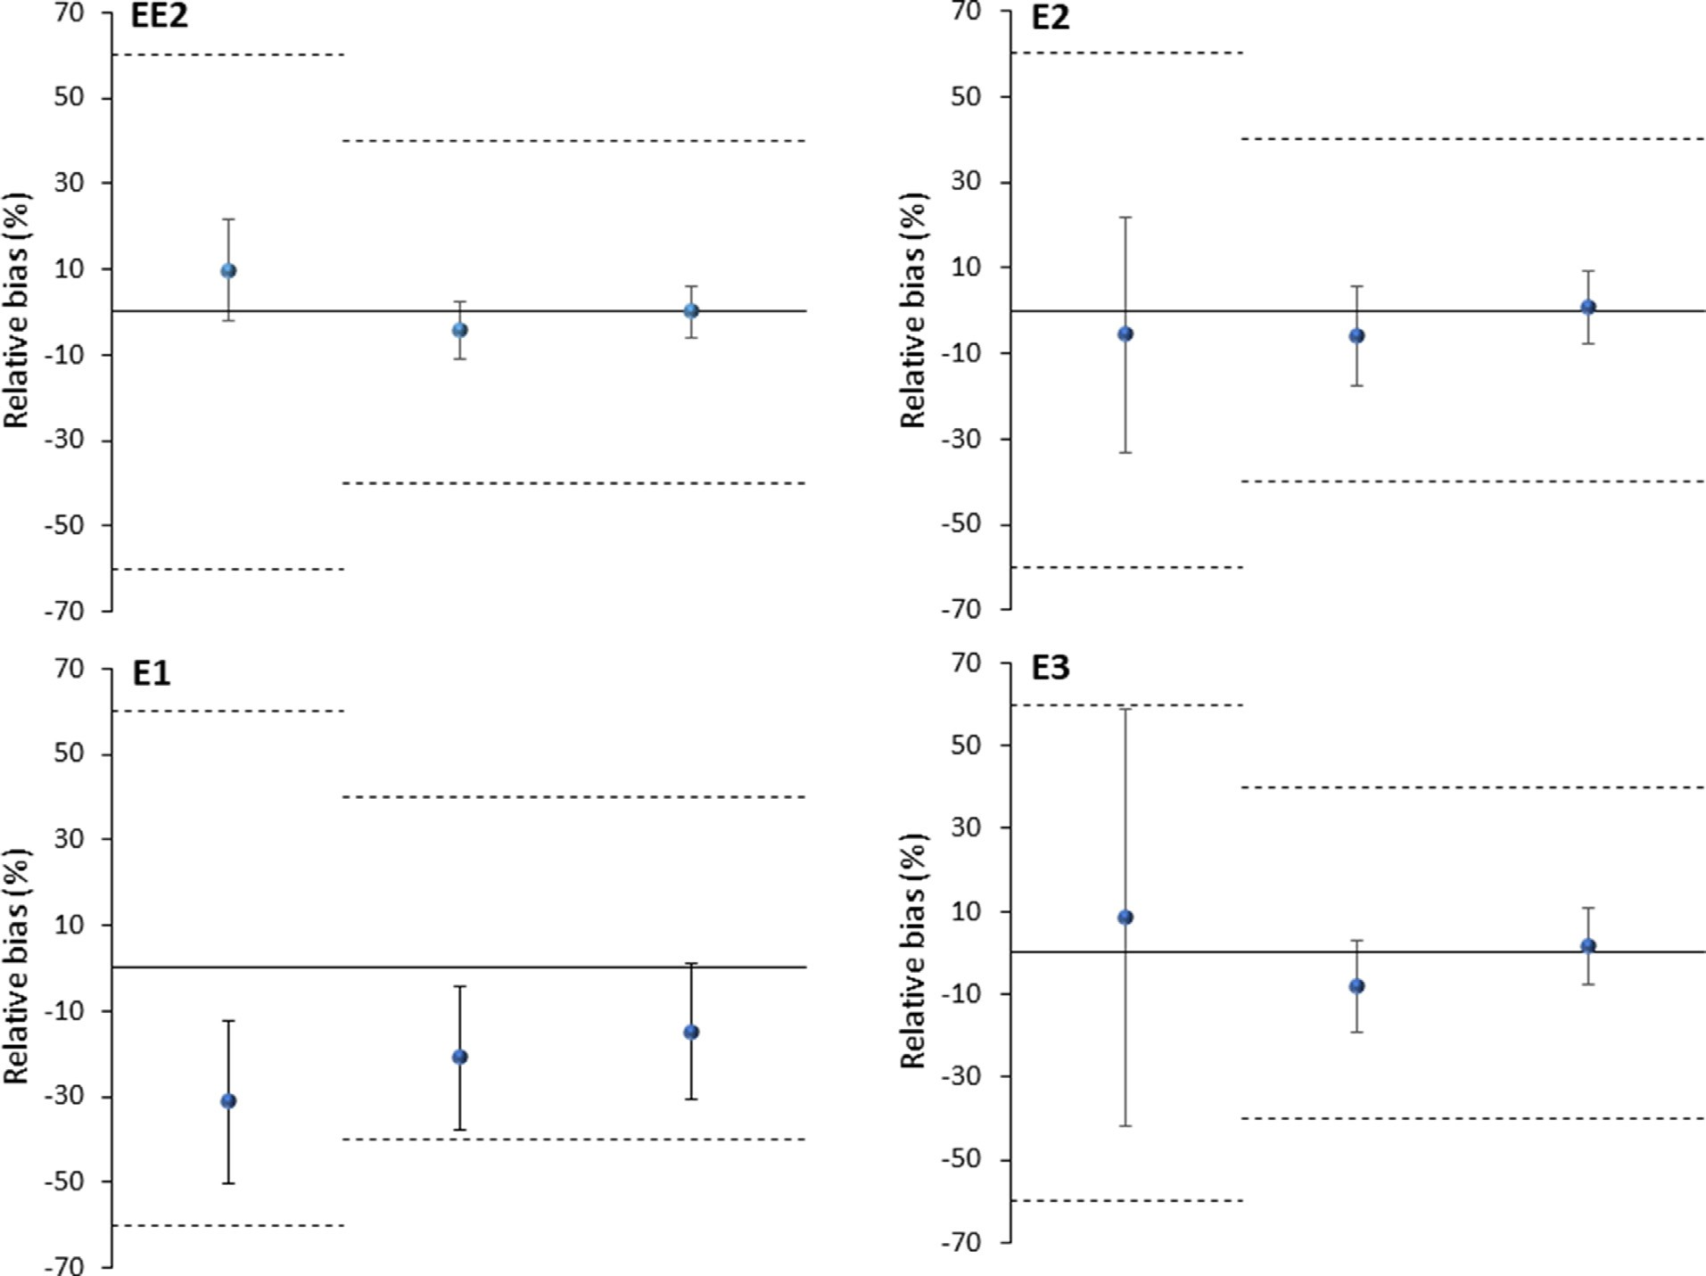
Fig. 4. Study of the accuracy at the three spiking levels (from left to right: 0.1, 0.5 and 2 ng/L for EE2, E2 and E3 and 0.4, 2 and 8 ng/L for E1), the equations (1) and (2) are represented in this graph and the tolerable maximum relative bias is 60 % at the lowest level of spiking and 40 % at the higher levels. The final procedure used during validation is described in section 2.3.

Concentrations of the estrogenic compounds in the initial samples, as well as LOQs and LODs, estimated for the seven SW samples, are presented in Table 4. LOD calculation was based on the qualifier transition that should present a S/N ratio of 3. For the LOQ, the quantifier transition has to present a S/N ratio of 10 and the qualifier a S/N ratio of 3. EE2 was never found in the SW samples analyzed, while E1 was present in six out of the seven samples (mean concentration for the quantified samples of 0.514 ng/L). E2 was found in 3 samples (mean concentration for the quantified samples of 0.08 ng/L) and E3 was detected in SW4 but was be- low the LOQ. Recoveries (average of the 7 samples) were >58% for EE2 and E2, slightly lower recoveries were obtained for E1 (~50%). SW6 and SW7 always showed lower recoveries probably due to particular matrix components or their lower value of pH, which can influence the retention of some matrix components competing with target analytes on the retention sites of the disk. The correction of the pH value in the initial sample can be further investigated in future work. However, the calculated LODs were, in all cases, lower than the values recommended by the EU WL (0.035 ng/L for EE2 and 0.4 ng/L for E1 and E2) [16] for all the target com- pounds. The chromatograms (the quantifier as well as the qualifier transitions) of SW1 spiked at 0.1 ng/L for EE2 is presented in Fig. 5.

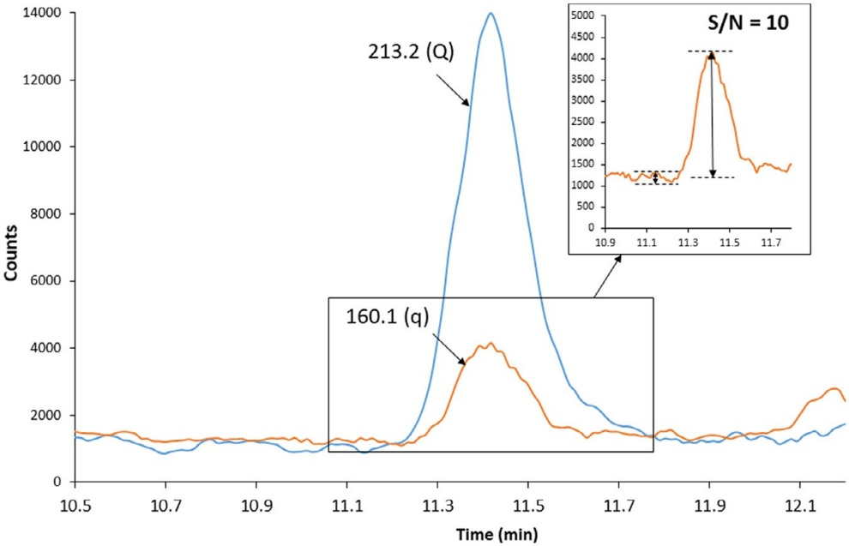
Fig. 5. MRM signal obtained for EE2 analyzing SW1 fortified at 0.1 ng/L. Precursor ion: 438.2 m/z; product ions: 213.2 (Q), 160.1 (q). The S/N ratio of the qualifier is highlighted in the expanded box.

Conclusion

A method dedicated to the analysis of EE2, E1, E2, and E3 in surface water was successfully optimized and validated. This method includes the extraction on an SPE disk, an SPE clean-up, derivatization using PS-Cl and the final analysis by LC-MS/MS. The method was fully validated and proved to be robust and sensitive. The challenging LODs recommended by the EU Watch List (0.035 ng/L for EE2 and 0.4 ng/L for E1 and E2) were achieved in the different SW. The present method is suitable for a survey of SW in Europe to evaluate the exposition of the aquatic environment and the associated risks for the ecosystem.
The validated method could also be used to monitor E2 in water intended for human consumption and contribute to the evaluation of the risks for human health. Indeed, the 98/83/EC Directive is currently being recast, and it is proposed to set a parametric value of 1 ng/L for E2 in drinking water (COM/2017/0753).

Compliance with ethical standards

Note: The authors declare no competing financial interest. Ethical Approval: The authors have declared that no ethical issues exist.

Declaration of interests

The authors declare that they have no known competing financial interests or personal relationships that could have appeared to influence the work reported in this paper.

CRediT authorship contribution statement

Alex Glineur: Conceptualization, Methodology, Visualization, Validation, Data curation, Writing - original draft, Investigation, Funding acquisition. Katherine Nott: Conceptualization, Methodology, Visualization, Supervision, Writing - review & editing, Project administration, Funding acquisition. Philippe Carbonnelle: Supervision, Writing - review & editing, Project administration. Sébastien Ronkart: Supervision, Writing - review & editing, Project administration, Funding acquisition. Giorgia Purcaro: Conceptualization, Methodology, Visualization, Supervision, Writing - review & editing, Project administration, Funding acquisition.

Acknowledgments

This work was carried out in the framework of the DIADEM project (Développement d’une Approche Intégrée pour le Diagnostic de la qualité des Eaux de la Meuse) and was supported by the Interreg France-Wallonia-Vlaanderen Programme (European Regional Development Fund) and by the Public Service of Wallonia (SPW). The authors thank Michaël Gillet for his technical assistance. This work was also achieved thanks to the funds Ernest du Bois managed by the “Roi Baudouin foundation” (2018-F2812650- 211494). This article is based upon work from the Sample Preparation Task Force and Network, supported by the Division of Analytical Chemistry of the European Chemical Society.

Supplementary materials

Supplementary material associated with this article can be found, in the online version, at doi:10.1016/j.chroma.2020.461242

References
- H. Hamid, C. Eskicioglu, Fate of estrogenic hormones in wastewater and sludge treatment: A review of properties and analytical detection techniques in sludge matrix, Water Res 46 (2012) 5813–5833, doi:10.1016/j.watres.2012.08.002.
- L. Barreiros, J.F. Queiroz, L.M. Magalhães, A.M.T. Silva, M.A. Segundo, Analysis of 17-β-estradiol and 17-α-ethinylestradiol in biological and environmental matrices - A review, Microchem. J. 126 (2016) 243–262, doi:10.1016/j.microc.2015. 12.003.
- M. Adeel, X. Song, Y. Wang, D. Francis, Y. Yang, Environmental impact of estro- gens on human, animal and plant life: A critical review, Environ. Int. 99 (2017) 107–119, doi:10.1016/j.envint.2016.12.010.
- C.G. Campbell, S.E. Borglin, F.B. Green, A. Grayson, E. Wozei, W.T. Stringfellow, Biologically directed environmental monitoring, fate, and transport of estrogenic endocrine disrupting compounds in water: A review, Chemosphere. 65 (2006) 1265–1280, doi:10.1016/j.chemosphere.2006.08.003.
- D.P. Grover, Z.L. Zhang, J.W. Readman, J.L. Zhou, A comparison of three analytical techniques for the measurement of steroidal estrogens in environmental water samples, Talanta. 78 (2009) 1204–1210, doi:10.1016/j.talanta.2008.12.049.
- L.J. Mills, C. Chichester, Review of evidence: Are endocrine-disrupting chemicals in the aquatic environment impacting fish populations? Sci. Total Environ. 343 (2005) 1–34, doi:10.1016/j.scitotenv.2004.12.070.
- V. Kumar, N. Nakada, M. Yasojima, N. Yamashita, A.C. Johnson, H. Tanaka, Rapid determination of free and conjugated estrogen in different water matrices by liquid chromatography-tandem mass spectrometry, Chemosphere. 77 (2009) 1440–1446, doi:10.1016/j.chemosphere.2009.08.052.
- H. Tomšíková, J. Aufartová, P. Solich, L. Nováková, Z. Sosa-Ferrera, J.J. Santana- Rodríguez, High-sensitivity analysis of female-steroid hormones in environ- mental samples, TrAC - Trends Anal. Chem. 34 (2012) 35–57, doi:10.1016/j.trac. 2011.11.008.
- A.C. Johnson, J.P. Sumpter, Removal of endocrine-disrupting chemicals in activated sludge treatment works, Environ. Sci. Technol. 35 (2001) 4697–4703, doi:10.1021/es010171j.
- A.D. LaFleur, K.A. Schug, A review of separation methods for the determination of estrogens and plastics-derived estrogen mimics from aqueous systems, Anal. Chim. Acta. 696 (2011) 6–26, doi:10.1016/j.aca.2011.03.054.
- W.F. Jardim, C.C. Montagner, I.C. Pescara, G.A. Umbuzeiro, A.M. Di Dea Bergamasco, M.L. Eldridge, F.F. Sodré, An integrated approach to evaluate emerging contaminants in drinking water, Sep. Purif. Technol. 84 (2012) 3–8, doi:10. 1016/j.seppur.2011.06.020.
- M. Pedrouzo, F. Borrull, E. Pocurull, R.M. Marcé, Estrogens and their conjugates: Determination in water samples by solid-phase extraction and liquid chromatography-tandem mass spectrometry, Talanta. 78 (2009) 1327–1331, doi:10.1016/j.talanta.2009.02.005.
- EC Decision 2015/495, Commission Implementing Decision (EU) 2015/495 of 20 March 2015 establishing a watch list of substances for Union-wide monitoring in the field of water policy, Off. J. Eur. Union. 78 (2015) 40–42.
- EU Directive 2008/105/EC, Directive 2008/105/EC of the European Parliament and of the Council of 16 December 2008 on environmental quality standards in the field of water policy, Off. J. Eur. Union. 348 (2008) 84–97.
- R. Loos, D. Marinov, I. Sanseverino, D. Napierska, T. Lettieri, Review of the 1st Watch List under the Water Framework Directive and recommendations for the 2nd Watch List, 2018. doi:10.2760/614367.
- EC Decision 2018/840, Commission Implementing Decision (EU) 2018/840 of 5 June 2018 establishing a watch list of substances for Union-wide monitoring in the field of water policy, Off. J. Eur. Union. 141 (2018) 9–12.
- S. Könemann, R. Kase, E. Simon, K. Swart, S. Buchinger, M. Schlüsener, H. Hollert, B.I. Escher, I. Werner, S. Aït-Aïssa, E. Vermeirssen, V. Dulio, S. Valsecchi, S. Polesello, P. Behnisch, B. Javurkova, O. Perceval, C. Di Paolo, D. Olbrich, E. Sychrova, R. Schlichting, L. Leborgne, M. Clara, C. Scheffknecht, Y. Marneffe, C. Chalon, P. Tušil, P. Soldàn, B. von Danwitz, J. Schwaiger, M.I. San Martín Becares, F. Bersani, K. Hilscherová, G. Reifferscheid, T. Ternes, M. Carere, Effect-based and chemical analytical methods to monitor estrogens under the European Water Framework Directive, TrAC - Trends Anal. Chem. 102 (2018) 225–235, doi:10.1016/j.trac.2018.02.008.
- G. Streck, Chemical and biological analysis of estrogenic, progestagenic and androgenic steroids in the environment, TrAC - Trends Anal. Chem. 28 (2009) 635–652, doi:10.1016/j.trac.2009.03.006.
- S. Lardy-Fontan, V. Le Diouron, C. Fallot, S. Vaslin-Reimann, B. Lalere, Toward the determination of estrogenic compounds in the framework of EU watch list: validation and implementation of a two-step solid phase extraction–liquid phase chromatography coupled to tandem mass spectrometry method, Ac- credit. Qual. Assur. 23 (2018) 285–295, doi:10.1007/s00769-018-1346- 4.
- D. Mateǰíček, V. Kubáň, Enhancing sensitivity of liquid chromatographic/ion- trap tandem mass spectrometric determination of estrogens by on-line pre- column derivatization, J. Chromatogr. A. 1192 (2008) 248–253, doi:10.1016/j. chroma.2008.03.061.
- C. Miège, P. Bados, C. Brosse, M. Coquery, Method validation for the analysis of estrogens (including conjugated compounds) in aqueous matrices, TrAC - Trends Anal. Chem. 28 (2009) 237–244, doi:10.1016/j.trac.2008.11.005.
- H. Chang, Y. Wan, S. Wu, Z. Fan, J. Hu, Occurrence of androgens and progestogens in wastewater treatment plants and receiving river waters: Comparison to estrogens, Water Res. 45 (2011) 732–740, doi:10.1016/j.watres.2010.08.046.
- A. Glineur, B. Barbera, K. Nott, P. Carbonnelle, S. Ronkart, G. Lognay, E. Tyteca, Trace analysis of estrogenic compounds in surface and groundwater by ultra high performance liquid chromatography-tandem mass spectrometry as pyridine-3-sulfonyl derivatives, J. Chromatogr. A. 1534 (2018) 43–54, doi:10. 1016/j.chroma.2017.12.042.
- J. Li, J. Fu, H. Zhang, Z. Li, Y. Ma, M. Wu, X. Liu, Spatial and seasonal variations of occurrences and concentrations of endocrine disrupting chemicals in unconfined and confined aquifers recharged by reclaimed water: A field study along the Chaobai River, Beijing, Sci. Total Environ. 450–451 (2013) 162–168, doi:10.1016/j.scitotenv.2013.01.089.
- C.Y. Chen, T.Y. Wen, G.S. Wang, H.W. Cheng, Y.H. Lin, G.W. Lien, Deter- mining estrogenic steroids in Taipei waters and removal in drinking water treatment using high-flow solid-phase extraction and liquid chromatography/tandem mass spectrometry, Sci. Total Environ. 378 (2007) 352–365, doi:10.1016/j.scitotenv.2007.02.038.
- S. Huysman, L. Van Meulebroek, F. Vanryckeghem, H. Van Langenhove, K. Demeestere, L. Vanhaecke, Development and validation of an ultra-high perfor- mance liquid chromatographic high resolution Q-Orbitrap mass spectrometric method for the simultaneous determination of steroidal endocrine disrupting compounds in aquatic matrices, Anal. Chim. Acta. 984 (2017) 140–150, doi:10.1016/j.aca.2017.07.001.
- Sun, W. Yong, X. Chu, J.M. Lin, Simultaneous determination of 15 steroidal oral contraceptives in water using solid-phase disk extraction followed by high performance liquid chromatography-tandem mass spectrometry, J. Chromatogr. A. 1216 (2009) 5416–5423, doi:10.1016/j.chroma.2009.05.041.
- G.-W. Lien, C.-Y. Chen, G.-S. Wang, Comparison of electrospray ionization, atmospheric pressure chemical ionization and atmospheric pressure photoionization for determining estrogenic chemicals in water by liquid chromatography tandem mass spectrometry with chemical derivatizations., J. Chromatogr. A. 1216 (2009) 956–966, doi:10.1016/j.chroma.2008.12.023.
- W. Chen, G. Wang, J. Gwo, C. Chen, Ultra-high performance liquid chromatography / tandem mass spectrometry determination of feminizing chemicals in river water, sediment and tissue pretreated using disk-type solid-phase ex- traction and matrix solid-phase dispersion, Talanta 89 (2012) 237–245, doi:10. 1016/j.talanta.2011.12.020.
- M. Caban, E. Lis, J. Kumirska, P. Stepnowski, Science of the Total Environment Determination of pharmaceutical residues in drinking water in Poland using a new SPE-GC-MS (SIM) method based on Speedisk extraction disks and DIMETRIS derivatization, Sci. Total Environ. 538 (2015) 402–411, doi:10.1016/j. scitotenv.2015.08.076.
- M. Česen, E. Heath, Disk-based solid phase extraction for the determination of diclofenac and steroidal estrogens E1, E2 and EE2 listed in the WFD watch list by GC – MS, Sci. Total Environ. 591 (2017) 832–837, doi:10.1016/j.scitotenv. 2017.02.222.
- S. Tavazzi, G. Mariani, S. Comero, M. Ricci, B. Paracchini, H. Skejo, B.M. Gawlik, Analytical method for the determination of compounds selected for the first Surface water watch list, (2016). doi:10.2788/85401.
- F. Gosetti, E. Mazzucco, D. Zampieri, M.C. Gennaro, Signal suppression/enhancement in high-performance liquid chromatography tandem mass spectrometry, J. Chromatogr. A. 1217 (2010) 3929–3937, doi:10.1016/j.chroma.2009.11.060.
- AFNOR NF T 90-210, Qualité de l’eau-Protocole d’évaluation initiale des performances d’une méthode dans un laboratoire, (2018).
- EC Sante/11813/2017, Analytical quality control and method validation procedures for pesticide residues analysis in food and feed, (2017).
- EC Decision 2002/657/EC, Commission Decision of 12 August 2002 implementing Council Directive 96/23/EC concerning the performance of analytical methods and the interpretation of results, Off. J. Eur. Union. 221 (2002) 8–36.
- J. Aufartová, C. Mahugo-Santana, Z. Sosa-Ferrera, J.J. Santana-Rodríguez, L. Nováková, P. Solich, Determination of steroid hormones in biological and environmental samples using green microextraction techniques: An overview, Anal. Chim. Acta. 704 (2011) 33–46, doi:10.1016/j.aca.2011.07.030.
- R. Loos, Analytical methods for possible WFD 1st watch list substances., 2015. doi:10.2788/723416.
- A.P. Jogdand, D.P.L. Kadam, Dielectric behavior of acetonitrile + methanol binary mixtures at microwave frequency, IOSR J. Appl. Phys. 6 (2014) 14–22, doi:10.9790/4861-06121422.
- G..P. Cunningham, G.A. Vidulich, R.L. Kay, Several Properties of Acetonitrile-Water, Acetonitrile-Methanol, and Ethylene Carbonate-Water Systems, J. Chem. Eng. Data. 12 (1967) 336–337.
- A. Kruve, R. Rebane, K. Kipper, M.L. Oldekop, H. Evard, K. Herodes, P. Ravio, I. Leito, Tutorial review on validation of liquid chromatography-mass spectrometry methods: Part I, Anal. Chim. Acta. 870 (2015) 29–44, doi:10.1016/j. aca.2015.02.017.

