Exploring multiple-cumulative trapping solid-phase microextraction for olive oil aroma profiling

Steven Mascrez, Giorgia Purcaro

Gembloux Agro-Bio Tech, University of Liège, Gembloux, Belgium

Keywords: extra-virgin olive oil, gas chromatography–mass spectrometry, headspace solid-phase microextraction, multiple-cumulative trapping solid-phase microextraction

Abstract
Headspace solid-phase microextraction is a solvent-free sample preparation technique that is based on the equilibrium among a three-phase system, i.e., sample-headspace-fiber. A compromise between sensitivity and extraction time is usually needed to optimize the sample throughput, especially when a large number of samples are analyzed, as usually the case in cross-samples studies. This work explores the capability of multiple-cumulative trapping solid-phase microextraction on the characterization of the aroma profiling of olive oils, exploiting the automation capability of a novel headspace autosampler. It was shown that multiple-cumulative solid-phase microextraction has the potential to improve the overall sensitivity and burst the level of information for cross-sample studies by using cumulative shorter extraction times.

Introduction

Headspace (HS) SPME is a solvent-free sample preparation method, which has had an exponential diffusion in many fields of applications (i.e. clinical [1,2], environmental [3,4], and food [5–7]) since its introduction in the 1990s exploiting adsorption mechanisms, where competition may occur, reducing the extraction yield [9,10]. Nevertheless, the amount extracted by SPME (n) is proportional to the initial concentration (C0) in the sample both under equilibrium and non-equilibrium conditions, according to equation (1):

$n= \frac{K_{hS}K_{fh}V_{f}V_{S}C_{0}}{K_{hS}K_{fh}V_{f}+K_{hS}V_{h}+V_{S}}$ (1)

Giorgia Purcaro, Gembloux Agro-Bio Tech, University of Liège,Bât. G1 Chimie des agro-biosystèmes, Passage des Déportés 2, 5030 Gembloux, Belgium.
Email: gpurcaro@uliege.be
where, C0 is the initial concentration; Khs and Kfh are distribution coefficients of sample/HS and fiber/HS, respectively; Vs, Vh, and Vf are the volumes of the samples, the HS, and the fiber coating, respectively.
At present, most of the applications involving HS-SPME are aiming to fingerprinting and profiling the HS of the samples for cross-sample comparison, pattern recognition, or biomarkers extrapolation [11–15]. Samples are usually characterized by a complex HS profile containing hundreds of compounds, each one characterized by its own Khs and Kfh. The most volatile compounds usually reach equilibrium rather quickly, while semi-volatiles require longer time. Therefore, a compromise between sensitivity and extraction time is usually needed to optimize the sample throughput, especially when a large number of samples are analyzed, as usually the case in cross-samples studies. Moreover, the additional diversion from the theory, observed when adsorption-type fibers are used (as the most employed divinyl- benzene/carboxen/polydimethylsiloxane [DVB/CAR/PDMS] [16]) complicates the scenario even more.
Different strategies have been applied to maximize the extraction yields and, at the same time, improving the kinetics and thus the sample throughput. Apart from stirring and increasing the temperature (the latter has to be used with care to avoid artifacts formation), a powerful approach is the use of reduced pressure condition inside the sampling vial, a technique termed Vac-HS-SPME by Psillakis et al., who systematically investigated it and formulated the underlying principle [17–21]. But other approaches have been proposed over the time, although not systematically investigated. Oliver-Pozo et al. [22] developed a dynamic HS sampling system to facilitate analytes accumulation into the SPME fiber. Another interesting alternative was presented by Lipin- ski [23] using multiple cumulative direct immersion-SPME to enhance the sensitivity for analysis of pesticides in water; a stop-flow approach was used to focalize the compounds at the front of the cool GC column (40◦C) before the GC separation. The same idea was exploited by Chin et al. [24] to maximize the odor detection limit in GC-olfactometry screenings of wine aroma. The HS-SPME mode was used, and the compounds were focalized using a cold trap at the head of the column. Different fiber-coating combinations were tested, providing a more comprehensive fingerprinting and higher sensitivity. The work was mainly focused on the optimization of the trapping condition at the head of the column, while little attention was devoted on the SPME sampling potentiality.
This work aims to explore the capability of multiple- cumulative trapping SPME (from now on, MC-SPME) on the characterization of the aroma profile of olive oils, exploiting the automation capability of a novel HS autosampler.
The fingerprinting of olive oil is a challenging task of inter- est for quality and authenticity assessment. Investigation of the volatile fraction is an informative and diagnostic tool for olive oil characterization and sensory evaluation [11,25–27]; thus, the possibility to enhance the extractable information for gaining a higher level of understanding is highly desir- able. As a first investigation of the MC-SPME mode, the DVB/CAR/PDMS fiber was used as the most common fiber for the analysis of volatile in edible oils [16].

Materials and methods

CHEMICALS AND REAGENTS

Hexane GC grade (MilliporeSigma®, USA) was used to dilute normal alkanes (C7-C30) mixture (Supelco, PA, USA) used for calculating the linear retention index (LRI) for confirming peak identity.
The divinylbenzene/carboxen/polydimethylsiloxane (DVB/CAR/PDMS) df 50/30 μm/ 1 cm length fiber was kindly provided by MilliporeSigma (Bellefonte, PA, USA).

OLIVE SAMPLES

An extra-virgin olive oil sample was purchased from a local supermarket (Gembloux, Belgium) for the first part of the investigation regarding the profile using one single extraction or multiple-cumulative extractions.
Extra-virgin (EVO), virgin (VO), and lampante (LO) olive oils characterized by their sensory evaluation (internal panel) [28] and of certain cultivar and geographical origin were kindly provided by Carapelli Firenze SpA - Italy (Deoleo group). A detailed list of samples is reported in Supporting Information Table S1.

HEADSPACE SPME PROCEDURE

Samples (1.50 ± 0.05 g) were weighed in a 20 mL screw top vials, metallic caps with a hole, and polytetrafluoroethylene (PTFE)/silicone septa (Restek, USA). The SPME extraction was automated in a Centri Autosampler (Markes International Ltd, UK). The sample, under agitation (300 rpm), was equilibrated for 5 min at 43◦C before exposing the fiber for 10 or 30 min. The fiber was conditioned as suggested by the manufacturer prior to the first use.
The fiber was then thermally desorbed at 250◦C for 2 min in split mode with a trap flow of 50 mL/min. The trap (U-T12ME-2S, Markes International, general purpose in the C4- C32 volatile range) was cooled at 0◦C during desorption of the fiber in the injector, then 1 min purge at 50 mL/min was performed before heating the trap to 300◦C. A 1:5 split was applied after the trap to facilitate the transfer of the analytes into the head of the GC column. When MC-SPME were per- formed, a 5 min enrichment delay was allowed before the following extraction. Three and six cumulative extractions were performed from the same vial. All experiments for investigating the trend of the MC-SPME were run in triplicate. Real- word samples were analyzed in single. Before starting any sample batch, an SPME fiber blank was performed, and was also performed periodically to ensure the absence of carryover between runs.

GC-MS ANALYSIS

Injections were performed using a Centri autosampler (Markes International) integrated to a Shimadzu GCMS- TQ8050 NX (Japan), consisting of a GC2030 coupled to triple-quadrupole mass spectrometer detector (TQ-MS) (Shimadzu, Germany). The separation was performed on a 30 m × 0.25 mm i.d. × 0.5 μm df SLB-5 ms capillary column (silphenylene polymer, practically equivalent in polarity to poly(5%diphenyl/95% methylsiloxane) kindly obtained from MilliporeSigma (USA). GC oven temperature program: 30◦C for 5.5 min to 310◦C at 10◦C/min. Elution was performed using helium in constant linear velocity mode at 35.9 cm/s, corresponding to an initial inlet overpressure of 45.6 kPa. The MS was operated in single-quadrupole mode, in EI mode at 70 eV. The ion source and transfer line temperatures were 200 and 280◦C, respectively. The scan range was set to 50–450 m/z with an acquisition frequency of 10 Hz. Data were acquired using Shimadzu GCMSolution ver 4.45 (Shimadzu, Japan). NIST17s and FFNSC 3.0 MS commercial libraries were used for identification. Putative identification was based on the combination of a dual filter, namely: (1) the MS similarity with the NIST17 library and the FFNSC library (Shimadzu) (≥80%) and, (2) the experimental LRI within a ±15 units range.

DATA ELABORATION AND STATISTICAL ANALYSIS

The data matrix resulting from the olive oil samples analysis was first normalized using Probabilistic Quotient Normalization (PQN). The data underwent a logarithmic transformation to stabilize the variance and making the distribution of the variables closer to normal [29].
The number of features still outweighed the number of samples; therefore, to overcome this limitation, a machine learning algorithm was applied to build a three-class model and select the most discriminatory core volatile analytes. The Random Forest (RF) algorithm was used for this purpose as it can deal with highly collinear data, and the effect of outliers is kept under control [30]. The algorithm provides a ranking of the features, expressed as mean decrease accuracy, based on the influence of each feature, after permutation, on the overall accuracy of the model obtained averaging the prediction from a multitude of de-correlated decision trees.
The separation performances of the different conditions were evaluated, measuring the intergroup Euclidean distance [29].
All statistical analyses were performed using R version 3.6.1 (R Foundation for Statistical Computing, Vienna, Austria), Excel® (Microsoft Office, version 2016), and Morpheus® (https://software.broadinstitute.org/morpheus/).

Results and discussion

The novel autosampler employed in this study allows, after desorption of the SPME fiber into the inlet, to either direct the compounds into the column (called “direct mode”), or trapping the compounds on a cooled trap before rapidly desorbing and injecting them into the analytical column (called “trapping mode”). In the former case, the trap is bypassed with a system of valves. A slight improvement was observed in terms of peak focalization, shape, and resolution (Supporting Information Figure S1). Therefore, the entire experimental design was carried out using the trapping option, also when a single extraction was performed.
Forty-nine compounds were selected over the entire chromatogram covering a wide range of polarity and volatility, focusing mainly (but not exclusively) on previously reported compounds in extra-virgin olive oil aroma characterization [11,22,31–33].
The list of the 49 selected compounds is reported in Supporting Information Table S2, along with their LRI (experimental and reported in the literature), CAS number, and similarity match (MS%).

STUDY OF THE MC-SPME CONDITIONS

The same EVO collected from the market was extracted multiple times (i.e. three and six times), maintaining the cold trap between the injector and the analytical column cold for the duration of all the multiple extractions. The cold trap was then rapidly heated to release all the retained analytes into the analytical column. The MC-SPME mode was compared with the data obtained with a traditional single extraction. An amount of 1.5 g of the sample was used, as previously reported in similar studies, as well as 43◦C as the extraction temperature [11,21,34]. When porous fibers are used (as DVB/PDMS/CAR), shorter extraction time is suggested to reduce the competitive adsorption [10,35]. Therefore, different extraction times were tested, namely 10 and 30 min.
The extraction profile obtained for the 49 selected com- pounds is shown in Figure 1.
The trends of each targeted analyte at different repeated MC-SPME (1, 3, and 6), at both 10 and 30 min, are reported in the bar plots in Supporting Information Figure S2. As expected, the increment was proportional to the number of extractions at both times. The gain in sensitivity using MC- SPME was evaluated by normalizing the results to the amount obtained after a single extraction. Theoretically, a linear cumulative increment (i.e. three and six times higher signal when three and six extractions are performed, respectively) can be observed when the HS is saturated with the analyte of interest, which means that the quantity extracted is depending on Kfh and that it is easily replenished in the subsequent equilibration time.
Considering the overall trend, extracting for 10 min three and six times, an average of three- and six-fold (median of 3.0 and 5.9, respectively) increment compared to the single extraction was recorded, respectively; while a decrease in the cumulative uptake was observed when extracting 30 min with an average of 2.6 and 5.4 (median of 2.7 and 5.4, respectively) when trapping three and six times, respectively. These results indicate that the HS is most probably saturated and that when extracting only 10 min, the HS is quickly replenished in the subsequent equilibrations with the compounds coming from the matrix. On the other hand, exposing the fiber to the HS for 30 min removed a higher amount of compounds at each extraction, leading to a decrease in the cumulative response. Most probably, this indicates that after a certain number of extractions, the HS is not saturated anymore and an exponential decrease of the response occurs, as expected from the theory [36], which translated in a nonlinear cumulative increment.

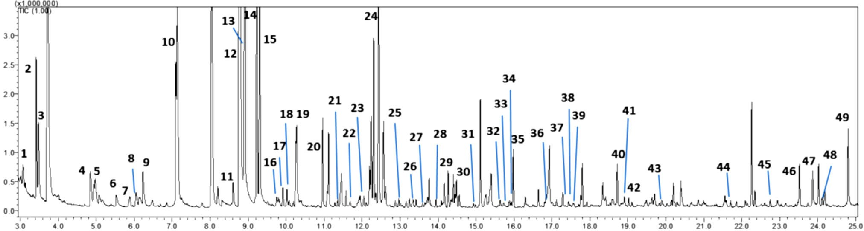
FIGURE 1 Total ion chromatogram of an EVO sample (1.5 g in a 20 mL vial, extracted for 10 min at 43◦C). Compounds name code as given in Supporting Information Table S2

It is also interesting to notice that extended extraction time (30 min) did not necessarily provide better results than shorter extraction time (10 min). This is more evident for the semi- volatile compounds, for which, in some cases, 10 min extraction provided a higher extraction yield, as for instance for compounds 43, 44, and 45 (Figure 2). Comparing the ratio between the amount extracted in 10 and 30 min at a single extraction, three and six cumulative extractions, a clear trend was observed despite the number of extraction per- formed. In fact, the early eluted compounds showed a higher uptake when sampling for 30 min (ratio > 1, generally ≈ 2.0– 2.5), while for less volatile compounds a ratio ≤ 1 was recorded (blueish color in the heat map of Figure 3; the lowest was 0.5 for #33).
This means, contrarily to what is reported in the literature (extraction time usually in the 30–60 min range [13,21]), that sampling for a shorter time allows providing a bet- ter fingerprint of the volatile profile of extra virgin olive oil, covering a more comprehensive range of compounds, although at the expense of a lower sensitivity for the most volatile compounds. Moreover, it is important to notice that comparing the response obtained with three cumulative extractions for 10 min and a single extraction for 30 min (which means the same overall extraction time), a higher signal was obtained for the three cumulative extractions for all the compounds (ratio > 1; median: 1.5; min: 0.8; max: 6.3), except for compound #8, #21, and #41 with a 0.9, 0.8, and 0.9 ratio, respectively (Figure 2). This was also observed in cumulative DI-SPME by Lipinski [23], concluding that for the same overall extraction time, MC-SPME is preferable for gaining in sensitivity.
It is important to highlight that the sampling strategy is the first important step in the analytical flowchart that may alter the fingerprint profile based on one or more specific characteristics of the compounds (such as polarity or volatility) altering the final potential results. This is particularly true when SPME is used; in fact, the fiber represents a first selective filter toward molecules affine to the fiber sorbent phase rather than giving a real image of the HS content. Moreover, the profile is altered even more when competitive adsorption processes occur, which are strictly related to the extraction time (i.e. longer extraction time facilitates the occurrence of the displacement effect) [10,35,37]. This means that sampling is a fundamental step for ameliorating or weakening the level of information and that there is still a broad space for improvement.

APPLICATION OF MC-SPME FOR PATTERN RECOGNITION

In the context of cross-sample comparison and pattern recognition analysis, the GC–MS peak area information is usually treated as a concentration indicator for the compound of interest in the sample (for a batch of homogenous samples where the same matrix effect occurs) [13]. This generally accepted approach can be misleading, in particular when the quantification of compounds is less straightforward as in SPME. When working with SPME, two equilibria are involved, as mentioned in Section 1. For the same compound, the Kfh determines the maximum fiber capacity, while Khs guides the difference in the HS concentration when the amount of the compounds between two samples is different. When the HS is saturated, differences in C0 are hindered by the maximum capacity of the HS. This means that when working under HS saturated condition, the information obtainable are flawed. The most frequent amount of sample used in the literature is 1.5 g (or more) [11,32,34,38,39], which saturates the HS (as shown before) for most of the compounds. The use of MC-SPME should improve the cross-sample comparison amplifying the differences and maximizing the signal of the analytes of interest, thus simultaneously improving the sensitivity and the level of information obtainable. In fact, when the HS is not saturated, an exponential decrease in the signal is expected. Therefore, it is expected that while some compounds will saturate the HS for all the six extractions leading to a linear increment of their signal; other will not saturate the HS for all the six extractions performed (some not even during the first extraction), thus amplifying the differences in the overall profile after MC-SPME.
As a proof-of-concept, 11 samples of olive oils (five extra-virgins, two virgins, and four

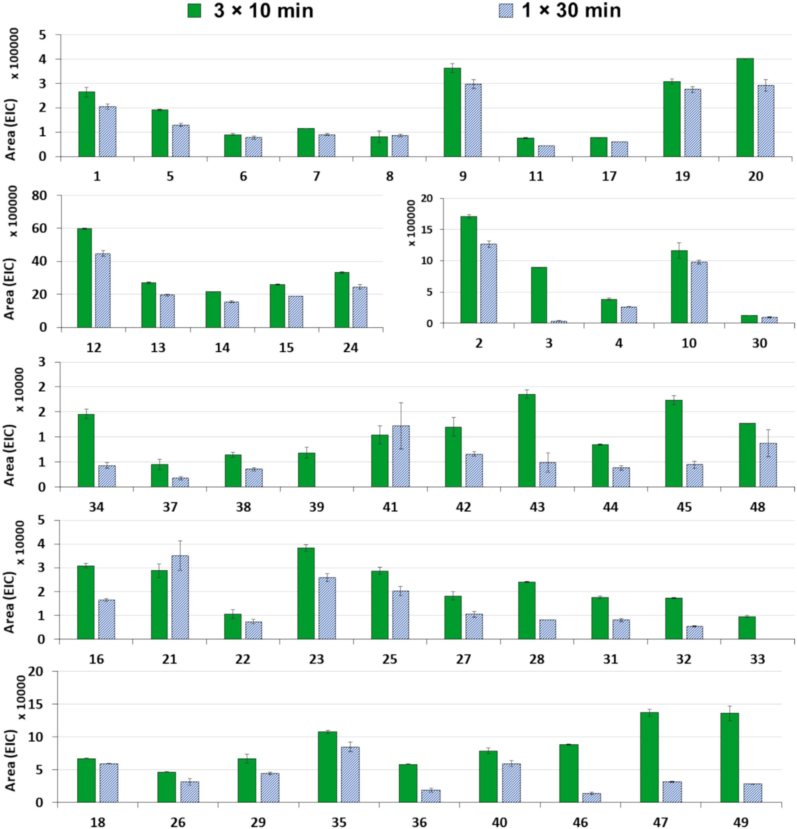
FIGURE 2 Extraction yield for 3 × 10 min-MC-SPME and 30 min single extraction time. Compounds grouped according to comparable absolute intensity. Compounds name code as for Supporting Information Table S2

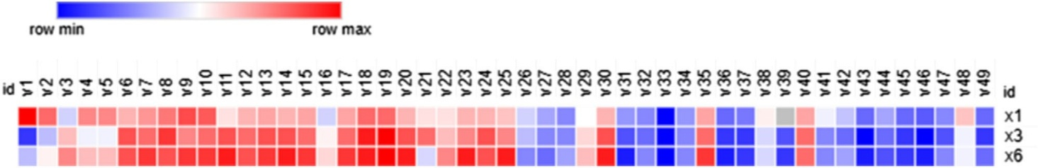

FIGURE 3 Normalized response ratio (30 min/10 min) for single (×1) and normalized response ratio for MC-SPME [× 3-(30 min/10 min) and × 6-(30 min/10 min)]. Compounds name code as given in Supporting Information Table S2

lampante oils; Supporting Information Table S1) were analyzed. A single trapping extraction was compared with six multiple SPMEs performed for 10 min. In this context, the use of shorter extraction time (10 min rather than 30 min), allows improving the response of the analytes limiting the loss of information due to competitive effects, as highlighted before.
The results were aligned, obtaining 183 analytes in total. The two data matrices obtained were cleaned independently to remove siloxane. Further reduction was based on a frequency of observation cutoffs of 50% within at least a group. The final data matrices contained 115 and 148 features for the samples undergone to one single trapping extraction and six multiple SPMEs, respectively.
The choice of the further data mining approach was based on the results previously reported by Purcaro et al. [12]. Unpredictable systematic variation was minimized by per- forming PQN normalization. Logarithmic transformation was applied to stabilize the variance, normalize the distribution of the variables, and reduce the weight of very intense com- pounds over much lower ones. A first comparison was carried out at this stage, but also an additional feature reduction was applied to avoid that features outweighed the number of samples. RF was chosen over other feature reduction methods as proved very consistent in several works reported in the literature, despite the previous data treatment [12,30]. The features were selected according to the mean decrease accuracy values obtained from the RF algorithm. Heat maps with hierarchical clustering analysis were used to visualize the pattern obtained after feature reduction (Supporting Information Figure S3). Although the vastness of the sampling is limited, some trends can be discussed. EVOs were well separated from LOs only when MC-SPME was used, while, in both cases, VOs are confused either with EVOs or LOs, as for their same definition. In fact, VOs are samples that, differently from EVO, present some defects, but not as strong as LOs and still maintain important positive attributes.
For a more numerical comparison, the pair-wise Euclidean distance between groups was calculated (Table 1).

T A BLE 1
Pair-wise Euclidean distances with and without features selection
N trapping Feature Euclidean distance
Extraction | selection | EVO–VO | EVO–LO | VO–LO
1 | NO | 17.7 | 18.3 | 17.3
1 | Yes | 3.2 | 3.7 | 1.5
6 | NO | 21.9 | 24.0 | 20.9
6 | Yes | 4.7 | 6.8 | 3.1

Using a six-cumulative extraction, the Euclidean distances between groups increased, either applying or not the additional features selection step, for all the three distances considered, namely EVO-VO, EVO-LO, and VO-LO. The features selected using the RF algorithm were different for the two datasets, except for one common compound, namely undecan-2-one. Two compounds were not detected when a single extraction was performed, namely cyclododecanol and octacosane, two later eluted compounds. The list of the selected features is reported in Supporting Information Table S3. Although a larger number of samples is needed for a proper statistical elaboration, it can be hypothesized that the role of semi-volatile compounds is highly important for pattern recognition purposes.

Conclusion

This work investigated the potential of MC-SPME for the characterization of the olive oil aroma profile. It was shown that MC-SPME has the potential to improve the overall sensitivity and burst the level of information for cross-sample studies. The use of MC-SPME using shorter extraction time is preferable compared to equivalent single extraction time, both in terms of overall signal and for limiting the competitive mechanism that occurs when adsorption-type fibers are used. The cumulative increment is linearly proportional to the number of extraction when the HS is saturated. Although this is a general limitation for “semi-quantitative” cross-sample analysis [13], it can be overcome by MC-SPME leading to a higher overall signal meanwhile amplifying the differences among samples.
Further studies are ongoing to investigate the impact of MC-SPME when the HS is not saturated.

Acknowledgments

This article is based upon work from COST Action CA 16215, supported by COST (European Cooperation in Science and Technology, http://www.cost.eu). The authors thank Supelco (MilliporeSigma) for providing the SPME fibers and Markes International and Shimadzu for their support.

CONFLICT OF INTEREST

The authors have declared no conflict of interest.

ORCID

Giorgia Purcaro https://orcid.org/0000-0002-8235-9409

SUPPORTING INFORMATION

Additional supporting information may be found online in the Supporting Information section at the end of the article.

References
- Souza-Silva, É. A., Reyes-Garcés, N., Gómez-Ríos, G. A., Boyaci, E., Bojko, B., Pawliszyn, J., A critical review of the state of the art of solid-phase microextraction of complex matrices III. Bioanalytical and clinical applications. TrAC - Trends Anal. Chem. 2015, 71, 249–264.
- Roszkowska, A., Miękus, N., Bączek, T., Application of solid-phase microextraction in current biomedical research. J. Sep. Sci. 2019, 42, 285–302.
- Souza-Silva, É. A., Gionfriddo, E., Pawliszyn, J., A critical review of the state of the art of solid-phase microextraction of complex matrices I. Environmental analysis. TrAC - Trends Anal. Chem. 2015, 71, 236–248.
- Llompart, M., Celeiro, M., García-Jares, C., Dagnac, T., Environ- mental applications of solid-phase microextraction. TrAC - Trends Anal. Chem. 2019, 112, 1–12.
- Xu, C. H., Chen, G. S., Xiong, Z. H., Fan, Y. X., Wang, X. C., Liu, Y., Applications of solid-phase microextraction in food analysis. TrAC - Trends Anal. Chem. 2016, 80, 12–29.
- Tranchida, P. Q., Maimone, M., Purcaro, G., Dugo, P., Mondello, L., The penetration of green sample-preparation techniques in compre- hensive two-dimensional gas chromatography. TrAC - Trends Anal. Chem. 2015, 71, 74–84.
- Tranchida, P. Q., Purcaro, G., Maimone, M., Mondello, L., Impact of comprehensive two-dimensional gas chromatography with mass spectrometry on food analysis. J. Sep. Sci. 2016, 39, 149–161.
- Pawliszyn, J., Arthur, C. L., Solid phase microextraction with thermal desorption using fused silica optical fibers. Anal. Chem. 1990, 62, 2145–2148.
- Pawliszyn, J., Theory of solid-phase microextraction. J. Chro- matogr. Sci. 2000, 38, 270–278.
- Górecki, T., Yu, X., Pawliszyn, J., Theory of analyte extraction by selected porous polymer SPME fibres. Analyst 1999, 124, 643–649.
- Purcaro, G., Cordero, C., Liberto, E., Bicchi, C., Conte, L. S., Toward a definition of blueprint of virgin olive oil by comprehensive two-dimensional gas chromatography. J. Chromatogr. A 2014, 1334, 101–111.
- Purcaro, G., Stefanuto, P. H., Franchina, F. A., Beccaria, M., Wieland-Alter, W. F., Wright, P. F., Hill, J. E., SPME-GC×GC- TOF MS fingerprint of virally-infected cell culture: Sample preparation optimization and data processing evaluation. Anal. Chim. Acta 2018, 1027, 158–167.
- Stilo, F., Cordero, C., Sgorbini, B., Bicchi, C., Liberto, E., Highly informative fingerprinting of extra-virgin olive oil volatiles: the role of high concentration-capacity sampling in combination with comprehensive two-dimensional gas chromatography. Separations 2019, 6, 34.
- Purcaro, G., Rees, C. A., Wieland-alter, W. F., Schneider, M. J., Wang, X., Stefanuto, P., Wright, P. F., Enelow, R. I., Hill, J. E.,States, U., States, U., Volatile fingerprinting of human respiratory viruses. J. Breath Res. 2017, 12, 026015.
- Purcaro, G., Rees, C. A., Melvin, J. A., Bomberger, J. M., Hill, J. E., Volatile fingerprinting of Pseudomonas aeruginosa and respiratory syncytial virus infection in an in vitro cystic fibrosis co-infection model. J. Breath Res. 2018, 12, 046001.
- Sghaier, L., Vial, J., Sassiat, P., Thiebaut, D., Watiez, M., Breton, S., Rutledge, D. N., Cordella, C. B. Y., An overview of recent developments in volatile compounds analysis from edible oils: technique- oriented perspectives. Eur. J. Lipid Sci. Technol. 2016, 118, 1853– 1879.
- Psillakis, E., Yiantzi, E., Sanchez-Prado, L., Kalogerakis, N., Vacuum-assisted headspace solid phase microextraction: Improved extraction of semivolatiles by non-equilibrium headspace sampling under reduced pressure conditions. Anal. Chim. Acta 2012, 742, 30–36.
- Psillakis, E., Mousouraki, A., Yiantzi, E., Kalogerakis, N., Effect of Henry’s law constant and operating parameters on vacuum-assisted headspace solid phase microextraction. J. Chromatogr. A 2012, 1244, 55–60.
- Yiantzi, E., Kalogerakis, N., Psillakis, E., Design and testing of a new sampler for simplified vacuum-assisted headspace solid-phase microextraction. Anal. Chim. Acta 2016, 927, 46–54.
- Psillakis, E., Vacuum-assisted headspace solid-phase microextraction: a tutorial review. Anal. Chim. Acta 2017, 986, 12–24.

- Mascrez, S., Psillakis, E., Purcaro, G., A multifaceted investigation on the effect of vacuum on the headspace solid-phase microex- traction of extra-virgin olive oil. Anal. Chim. Acta 2020, 1103, 106–114.
- Oliver-Pozo, C., Trypidis, D., Aparicio, R., Garciá-González, D. L., Aparicio-Ruiz, R., Implementing dynamic headspace with SPME sampling of virgin olive oil volatiles: optimization, quality analytical study, and performance testing. J. Agric. Food Chem. 2019, 67, 2086–2097.
- Lipinski, J., Automated multiple solid phase micro extraction. An approach to enhance the limit of detection for the determination of pesticides in water. Fresenius. J. Anal. Chem. 2000, 367, 445–449.
- Chin, S. T., Eyres, G. T., Marriott, P. J., Cumulative solid phase microextraction sampling for gas chromatography-olfactometry of Shiraz wine. J. Chromatogr. A 2012, 1255, 221–227.
- Angerosa, F., Servili, M., Selvaggini, R., Taticchi, A., Esposto, S., Montedoro, G., Volatile compounds in virgin olive oil: occurrence and their relationship with the quality. J. Chromatogr. A 2004, 1054, 17–31.
- Romero, I., García-González, D. L., Aparicio-Ruiz, R., Morales, M. T., Validation of SPME-GCMS method for the analysis of virgin olive oil volatiles responsible for sensory defects. Talanta 2015, 134, 394–401.
- Aparicio, R., Morales, M. T., Aparicio-Ruiz, R., Tena, N., García- González, D. L., Authenticity of olive oil: Mapping and comparing official methods and promising alternatives. Food Res. Int. 2013, 54, 2025–2038.
- IOC, Sensory Analysis of Olive Oil - Method for the Organoleptic Assessment of Virgin Olive Oil. International Olive Council, Madrid, Spain 2018.
- Massart, D., Chemometrics : A Textbook. Elsevier Science, New York, NY 1988.
- Smolinska, A., Hauschild, A.-C., Fijten, R. R. R., Dallinga, J. W., Baumbach, J., van Schooten, F. J., Current breathomics—a review on data pre-processing techniques and machine learning in metabolomics breath analysis. J. Breath Res. 2014, 8, 027105.
- Stilo, F., Liberto, E., Reichenbach, S. E., Tao, Q., Bicchi, C., Cordero, C., Untargeted and targeted fingerprinting of extra vir- gin olive oil volatiles by comprehensive two-dimensional gas chromatography with mass spectrometry: challenges in long-term stud- ies. J. Agric. Food Chem. 2019, 67, 5289–5302.
- Oliver-Pozo, C., Aparicio-Ruiz, R., Romero, I., García-González, D. L., Analysis of volatile markers for virgin olive oil aroma defects by SPME-GC/FID: possible sources of incorrect data. J. Agric. Food Chem. 2015, 63, 10477–10483.
- Mascrez, S., Psillakis, E., Purcaro, G., A multifaceted investigation on the effect of vacuum on the headspace solid-phase microextraction of extra-virgin olive oil. Anal. Chim. Acta 2019, https://doi.org/10.1016/j.aca.2019.12.053.
- Magagna, F., Valverde-Som, L., Ruíz-Samblás, C., Cuadros- Rodríguez, L., Reichenbach, S. E., Bicchi, C., Cordero, C., Combined untargeted and targeted fingerprinting with comprehensive two-dimensional chromatography for volatiles and ripening indica- tors in olive oil. Anal. Chim. Acta 2016, 936, 245–258.
- Trujillo-Rodríguez, M. J., Pino, V., Psillakis, E., Anderson, J. L., Ayala, J. H., Yiantzi, E., Afonso, A. M., Vacuum-assisted headspace-solid phase microextraction for determining volatile free fatty acids and phenols. investigations on the effect of pressure on competitive adsorption phenomena in a multicomponent system. Anal. Chim. Acta 2017, 962, 41–51.
- Kolb, B., Ettre, L. E., Static Headspace-Gas Chromatography: The- ory and Practice. Wiley-VHC, New York, NY 2006.
- Zhang, Z., Pawliszyn, J., Headspace solid-phase microextraction. Anal. Chem. 1993, 65, 1843–1852.
- Cerretani, L., Salvador, M. D., Bendini, A., Fregapane, G., Relation- ship between sensory evaluation performed by Italian and spanish official panels and volatile and phenolic profiles of virgin olive oils. Chemosens. Percept. 2008, 1, 258–267.
- Cavalli, J. F., Fernandez, X., Lizzani-Cuvelier, L., Loiseau, A. M., Comparison of static headspace, headspace solid phase

