Preparation and characterization of a thermal insulating carbon xerogel - epoxy composite adhesive for electronics applications
J.-F. Fagnard ∗, S. Stoukatch, P. Laurent, F. Dupont, C. Wolfs, S. D. Lambert, J.-M. Redouté
Abstract— In some specific microelectronic applications, there is a demand for adhesive materials (glues / encapsulants) having very good thermal insulation properties. We have studied the properties obtained on epoxy-based samples loaded by several levels of xerogel filling. The thermal conductivity of these materials depends on the exact chemical composition and their manufacturing process. As a result, the thermal conductivity given in the manufacturer's specifications or in the literature generally exhibits some dispersion. Therefore, we have developed a straightforward experimental rig, based on a vacuum chamber and miniature Pt100 sensors measurements, to precisely know the thermal conductivity of the various insulating materials used in the development and the assembly of select microsensors and microsystems. The results showed a decrease in the thermal conductivity of our xerogel-epoxy composites up to 35.8% compared to the value of the unfilled epoxy, corresponding to a thermal conductivity value of 0.108 W m⁻¹ K⁻¹. In addition, cross-sectional images were observed by optical microscopy to characterize the specific microstructure of each sample in order to relate these observations to improvements in thermal conductivity.
Index Terms — Composite materials, microassembly, microsensors, microsystems, thermal conductivity measurements

INTRODUCTION
Dealing with thermal management issues is frequent in all fields of engineering from large scale to microscale devices. Mitigation strategies are usually divided into two categories: (i) to conduct the heat through high thermal conductivity materials to heat sinks or parts that do not suffer from the heat and (ii) to protect the heat sensitive parts of the device from the heat flux with a thermal insulation made of a very low thermal conductivity material.
The first strategy using high thermal conductivity materials (metallic except if an electrical insulation has to be provided as well) is the most common approach in large-scale applications like aerospace thermal management [1] and heat exchangers in vehicles [2], both requiring low-density materials. This strategy is also well known in small-scale applications like electronics [3], where processors, LEDs, MOSFETs, and power electronics components often generate heat that must be dissipated and/or redirected, for instance using heat sinks [4-7]. Many high thermal conductivity materials are used for thermal management in microelectronics, from metals to carbon and graphite and their composites with ceramics [8, 9].
Conversely, while low thermal conductivity materials are obviously often used in large-scale applications such as in the building industry to reduce the effects of external thermal fluctuations on internal temperatures [10], using low thermal conductivity materials is more challenging in small-scale applications. In order to act as thermal barrier for electronics, metal-oxide like yttrium stabilized zirconia (YSZ) can be used as coating [11]; however, as it requires a high temperature treatment, alternative metal-oxides are recently studied such as WO₃ coatings [12]. In the field of data storage, efficient thermal memory storage devices using phase‐change materials require low thermal conductivity materials to increase the data density by reducing the thermal losses to the surroundings and, doing so, acting on smaller areas [13]. Moreover, the required power to activate the phase-change of the material is also reduced [14]. One of the most common small-scale applications of low thermal conductivity materials is thermoelectric energy conversion. Energy harvesting designs using thermoelectric material-based devices take advantage of existing temperature gradients in the system by converting the latter into a potential (Seebeck effect). The thermoelectric material achieves higher performances with large thermopower, high electrical conductivity and necessarily low thermal conductivity to maintain the thermal gradient [15]. However, the two latter properties are not easy to find simultaneously in a material, and are usually obtained either in naturally complex and disordered structures having a large molecular weight, or by a nanostructuring process [16]. In microsystems (MS), i. e. miniature electronics, or in integrated circuits (IC), some parts of the electronic device are thermally sensitive [17], and low thermal conductivity materials can protect these sensitive parts from damage or loss of their initial functionality because of an increased temperature occurring during the entire life cycle of the device or during a specific life span. In the large family of metal-oxide (MOX) gas sensors [18], where a sensing layer is heated to an elevated temperature, the low thermal conductivity material can also act in reducing the system’s overall power consumption [19].
As a response to continuous electronic device miniaturization, integration and increase in generated power density, low thermal conductivity interface materials for electronics packaging become a key solution to address thermal management issues [4]. Additionally, to low thermal conductivity, these materials are generally used as good electrical insulators (volume resistivity higher than 10¹⁴ Ω.m) [20]. The material would be preferably a single component adhesive, applied by dispensing or screen printing [20, 21], that withstands both the curing process and an exposure to constant temperatures as high as 300°C during the entire life cycle of the devices [18].
The most common adhesives used in semiconductors applications can be classified, based on the chemistry, in 3 main groups: epoxy-, polyimide- and silicone-based materials. The epoxy- and silicone- based material have a good resistance to elevated temperatures up to 260°C. The polyimide-based adhesive has a slightly better thermal resistance but requires a higher curing temperature (250°C and above [9]) than for epoxy- and silicone-based material. In this paper, the pristine adhesive material is chosen to be epoxy-based adhesive as its thermal conductivity typically ranges between 0.15 and 0.25 W m⁻¹ K⁻¹ [20, 22].
In order to modify (e. g. lower) the thermal conductivity of the adhesive material (e. g. epoxy resin), to improve its performances, a filling material having a different (e. g. lower) thermal conductivity can be used to obtain a homogeneous composite material having an effective thermal conductivity. The effective thermal conductivity is necessarily comprised between those of the matrix and the filler but the impact of the filler content strongly depends on its nature (conductive or insulating), its shape (spheres, ellipsoids…), and its size as well as spatial distribution. Given the complexity of this problem, there are countless analytical models. An extensive review of the most common models can be found in [23] which presents classical models such the “effective medium theory” [24] assuming a random distribution of matrix and filler, or the Lewis and Nielsen Semi-Theoretical Model [25] that considers the shape and the orientation of the filler particles. Recently reported models and modified versions of existing models [26] as well as numerical simulation-based models [27, 28] are constantly published to address specific features of the composite material. The complete discussion of these models is beyond the scope of this work
This paper deals with the process and the characterization of samples made of epoxy-based material that are mixed with a very low thermal conductivity filler, i. e. amorphous carbon xerogel, in order to reduce its thermal conductivity and improve the thermal insulation in the particular case of a MOX gas sensor. The use of a reduced thermal conductivity material will allow (i) a better thermo-mechanical protection of the sensor holder as the ceramic die heater can reach up to 300°C during operation and (ii) a reduction in the power consumption of the device. This paper is structured as follows. Section II is dedicated to the sample’s preparation and section III describes the experimental setup and corresponding preliminary measurements. In section IV, we present the thermal conductivity results obtained on our samples, and the morphology of these samples is analyzed in section V. Finally, a conclusion is given in section VI.

Materials and Methods

Material
Among the epoxy-based adhesives we initially selected IQ-BOND 2176 (Roartis). IQ-BOND 2176 is a solvent-free, one-component, pre-mixed, very high flow, thermoset epoxy-based adhesive, developed for very small gap (under) fill applications. The adhesive is unfilled, and has a very low viscosity. This adhesive withstands temperatures above 250°C for continuous operation. The most important physical properties of the pre-selected adhesive are shown in Table I.

TABLE I
Physical properties of epoxy based adhesive
Parameter | IQ-BOND 2176
Service temperature range, °C | -50…+250
T_{g} (glass transition T), °C | 190, 205, 250*
Maximum T, °C | 300
Viscosity at 25° C, cps | 350
Tensile strength, psi/MPa | 2845/19.6
Hardness, Shore D | 89
Volume Resistivity, Ωm | > 10¹⁵
Density, kg/m³ | 1100
*: T_{g} depends of curing schedule

The aim of our work is to mix an extremely low thermal conductivity material (filler) in the pristine epoxy-based adhesive (matrix) and to study the decrease of the thermal conductivity of the composite compound. For this filler, we use an amorphous carbon xerogel which can have a thermal conductivity as low as 0.035 W m⁻¹ K⁻¹ [29]. The obtained composite material will be referred to as the thermal insulating material in the remainder of the text. The carbon xerogel (further called xerogel) is an experimental product synthesized at the NCE lab, part of the Chemical Engineering Department of University of Liège, Belgium [30].
To obtain amorphous carbon xerogel, 1.73 mol of resorcinol is dissolved in 20 mol of deionized water; 2.31$⋅$10⁻³ mol of Na₂CO₃ is added as catalyst. After complete dissolution, 3.45 mol of formaldehyde is added as a 37 wt.% formaldehyde solution. The sol is aged in a sealed test tube for 72 h at 85°C, after which it becomes a solid, brownish gel. The chemistry of this process is illustrated in Fig. 1 [31-32]. After unsealing the test tube, the gel is dried at 60°C under a decreasing pressure ramp, starting at 800 mbar and reaching 20 mbar after 6 h. The temperature is finally raised to 150°C for 24 h. The carbon xerogel structure is arranged in sheets similarly to graphene but the sheets are short and randomly oriented.
The synthesized xerogel is ground using a mortar and pestle method. An average particle size of 8 µm is measured by optical microscopy, with 95% of particles lying in the range of 5 to 10 µm. Its skeletal density is measured by Helium Pycnometry. Then, the corresponding bulk density is calculated via:
$ρ_{s}\left(1-ϵ\right)=ρ_{b}$ (1)
where $ρ_{s}$ is the measured skeletal density, $ϵ$ is the void fraction (method of measurement given in [33]), and $ρ_{b}$ is the bulk density. Based on the experimental results on material density of 𝜌_{s} = 1.56 g/cm³ and ε = 0.52, we determine 𝜌_{b} = 0.75 g/cm³ and considering Rey-Raap et al. [29], a thermal conductivity of 0.065 W m⁻¹ K⁻¹ for the xerogel is expected.

Methods

Mixing procedure
To measure the weight of the components, we use a KERN PCB 1000-2 precision scale, with an accuracy of 0.01 g. The first sample (C1) is prepared by mixing 5.08 g of IQ-BOND 2176 with xerogel in 0.2 g increments before the mixture could no longer be considered, by visual observation, homogeneous and agglomerates of filler appear. The maximum amount of xerogel in the composite sample C1 reaches 1.2 g, i. e. a filling fraction of 19.1% by weight (cf. Table II).
We also test if adding a solvent to the mixture could increase the filling ratio. Based on the manufacturing recommendation of IQ-BOND 2176 adhesive, the solvent under the trade name IQ-CLEANER 9500 (Roartis) is selected. The product is formulated and generally used to remove uncured epoxy-based materials. It has a flashpoint of 98°C, and therefore can be easily removed from the mixture by drying at temperature range of about 100°C - 110°C.
We gradually add the solvent to the mixture in 1% by weight increments, which has the effect of reducing the viscosity of the mixture. This allows us to add an additional amount of xerogel until complete saturation. After that, we evaporate the solvent at 110°C. However, the mixture becomes too viscous and not suitable for dispensing through a syringe below a 0.5 mm diameter aperture. Thus, to mold sample C2, we print the mixture obtained in the mold using a squeegee. After that, we add 2% by weight of adhesive to the mixture to make it suitable for dispensing again. Based on that composition, we mold sample C3.
Since there is no chemical reaction between the adhesive and the solvent which could produce (potentially gaseous) by-products, the filling fractions of the composite samples are calculated and summarized in Table II.

Sample preparation
The prepared mixture is used to mold samples of lateral dimensions specified for thermal conductivity characterization. The prepared mixture is poured into a custom-made mold made of PTFE and having a diameter of 14 mm and a height of 3 mm.
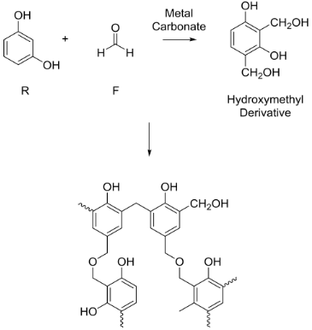

Fig. 1. Syntheses of amorphous carbon xerogel.

TABLE II
Sample Composition
Sample # | Xerogel, % weight
C1 | 19.1
C2 | 24.4
C3 | 22.7

After filling the mold with the corresponding mixture, the samples are cured according to the following curing program recommended by the manufacturer: 2 h at 90°C then 3 h at 150°C and finally 6 h at 230°C to reach the highest thermal resistance at a constant operating temperature of 300°C.
After the curing, the samples are easily released from the PTFE mold. The back and front sides of the samples are sequentially polished with #4000 mesh sand paper. Finally, the prepared samples are submitted for thermal conductivity characterization.

Experimental setup for thermal conductivity measurements
Many experimental methods exist for measuring the thermal
conductivity of insulating materials [34]. These are generally divided in two classes: (i) steady-state methods such as a hot guarded plate [35] or a heat flow meter [36] techniques and (ii) transient methods like hot wire [37] or laser flash [38] techniques. The choice of one technique or another depends, amongst other experimental parameters, on the type of material, the available size and the shape of the samples, and the measurement time. The main distinction between both classes of methods is that steady-state methods are usually more accurate and straightforward but more time consuming while transient methods are faster but the thermal conductivity is obtained from the thermal diffusivity measurement and therefore involves more error sources.
As the measurement time is not an issue in this study, we turn to a steady-state method to have an accurate and direct determination of the thermal conductivity. Moreover, our technique does not necessitate a large amount of material as the sample has a surface of ~1 cm² and is only 2-3 mm thick.

Description of the setup
Our thermal conductivity measurement setup is based on a steady-state method where the system is reduced to a one-dimensional problem where a well-known heat flow is directed only through the sample with a well-defined heat transfer area and thickness. This unidirectional heat flux is obtained by performing the thermal conductivity measurement inside a high vacuum experimental chamber. As we intend to measure insulating samples, the geometry of the sample is a disk with its diameter larger than its thickness. The thermal conductivity k of the sample is obtained from the measurement of the temperature difference ΔT across the sample by:
$k=\frac{Qd}{A ∆T}$ (2)
where Q is the heat flow, d the thickness of the sample and A the heat transfer area.
As illustrated in Fig. 2(a), a 11 Ω - 2 W ceramic resistor heater is placed inside a Ø 14 mm cylindrical brass block (for temperature uniformity thanks to its thermal conductivity around 120 W m⁻¹ K⁻¹ at room temperature depending the exact alloy composition [39]). The heater is fed with a given electrical power by a sourcemeter (2400, Keithley), having an accuracy of 0.02%, acting as current source and measuring the voltage across the resistor (accuracy of 0.012% + 300 μV). The measured insulating sample is shaped as a cylinder with an identical diameter sandwiched between the heated brass block and a second brass block acting as heat sink. In order to reduce the thermal interface resistance between the sample and the brass blocks, we positioned the insulating sample to the brass sample holder with a very thin silver paste layer (Electrodag 1415, Agar Scientific). Two Ø 1.5 mm × 8 mm Pt100 RTD sensors (XF-988-FAR, Labfacility) are placed within the brass block on both sides of the sample. According to their class (Class A), the temperature sensors have an accuracy of 0.15°C + 0.2% of the measured absolute value in °C, |T_{meas}|, in a range spanning from 100°C to 450°C.
The assembly is placed inside a vacuum chamber in order to suppress the conduction and convection losses through air from the lateral and top surfaces of the heated brass block and from the lateral surface of the sample. The radiation losses are minimized by a surrounding radiation shield consisting in two semi-closed cylinders made of shiny brass foils. Both temperature readings from the platinum resistors are monitored through a dual input channel temperature controller (331, Lakeshore). All Pt100 RTD sensors and heater wires are integrated into a house vacuum feedthrough made of epoxy on a pierced aluminum blank flange.
The vacuum inside the experimental chamber is obtained with a turbopump group consisting in a primary pump (Trivac E2, Leybold) and a turbomolecular pump (Turbovac 50, Leybold). The pressure inside the vacuum chamber is measured with a full-range gauge (Ionivac ITR 90, Leybold) which has a reported measurement uncertainty [40] of 15% of the measured value in the range 10⁻⁸ – 10⁻² mbar and a reproducibility of 5% of the measured value in the same range. The pressure sensor is connected to a vacuum indicator (Center One, Leybold). Pressures as low as 4 10⁻⁹ mbar are reached after degassing for several tens of hours.
The sourcemeter and the temperature controller are connected to a computer through a GPIB interface. The measurements of the injected power and both temperature readings are recorded through a user Labview program. The experimental setup, consisting of the measured sample placed in its brass holder, the heater, the Pt100 RTD sensors, and the double radiation shield, is shown in Fig. 2(b-d) and an overview of the experimental chamber is shown in Fig. 2(e).

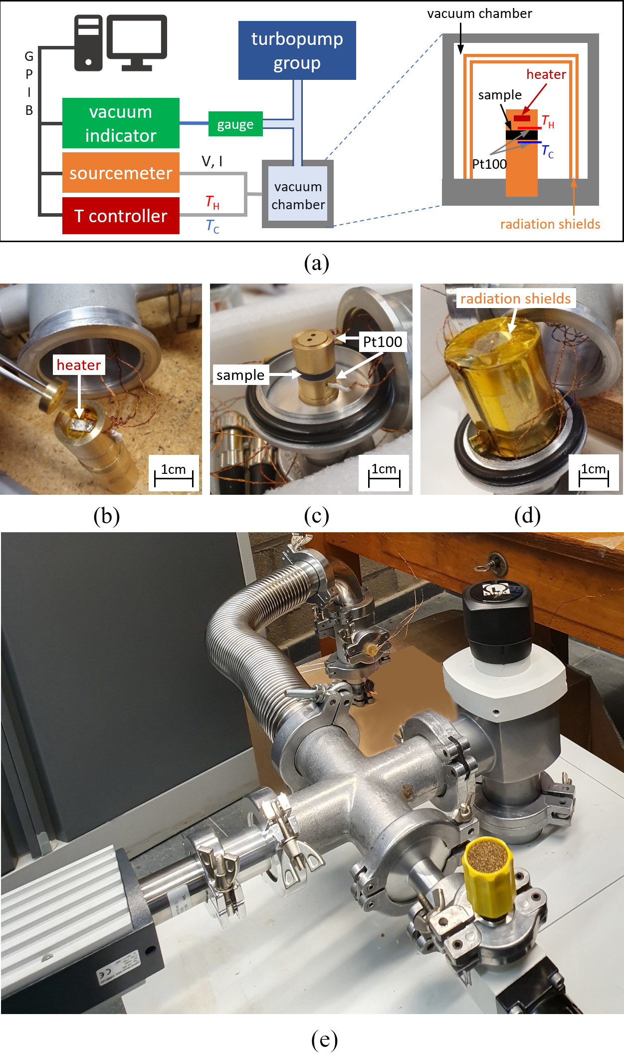
Fig. 2. (a) Schematic of the experimental setup, photographs of the (b) ceramic resistor heater embedded in the top part of the sample holder, (c) the thermal insulating sample sandwiched between the two parts of the brass sample holder and Pt100 RTD sensors, (d) two-fold brass radiation shield and (e) overview of the experimental chamber.

Measurement in absence of insulating sample
Due to the volume of the Pt100 RTD sensors, there is an unavoidable brass layer between these sensors and the interface on both sides of the measured sample. Because of the finite thermal conductivity of brass, a temperature difference exists even when both parts of the holder are fixed, and contacted with silver paste. However, this temperature difference is small as verified for two values of the generated heating powers, i.e. 122 mW and 244 mW, as shown in Fig. 3.
When the power generated by the heater reaches a thermal equilibrium with all the dissipation processes through the remaining air in the experimental chamber, and by establishing a thermal gradient within the brass cylindric holder, the temperature difference stabilizes between the Pt100 RTD sensors. In any case, the radiation losses, which are proportional to the difference between the fourth power of the heated brass block temperature and that of the experimental chamber walls, do not need to be considered. First, because these temperatures are close to low values of the generated heating power, second, because the radiation heat transfer is strongly reduced by the presence of the radiation shields having an estimated emissivity ε _{brass polished} = 0.05 [41]. Indeed, each brass foil adds a thermal resistance on the radiation heat transfer [42].
However, the conduction and the convection in air through the top and the lateral surfaces of the heated brass block are not negligible. Indeed, a part of the generated heat is transferred outside of the brass holder and does no longer contribute to the establishment of the measured temperature difference. In vacuum, this part of the dissipated heat in the environment is strongly reduced because of the decrease of the number of gas molecule in the experimental chamber and the corresponding increase of the mean free path. At room temperature and ambient pressure (1013 mbar), according to the kinetic theory of gases [43], the density of molecules is 2.7 10¹⁹ molecule/cm³ and the mean free path of the gas molecules is 68 nm. However, at ultra-high vacuum (e. g. 10⁻⁸ mbar) the density is only 10⁸ molecules/cm³ and the mean free path of the gas molecules is 10 km. With these values, both conduction and convection losses in the surrounding air are negligible in comparison to the heat transfer by conduction through the brass and the sample.
In our experimental setup, when the brass block containing the heater and the second brass block, acting as thermal reservoir, are directly contacted with silver paste without any insulating sample between them, the temperature difference between the two Pt100 RTD sensors for a generated power of 2 W is 2.08°C, 2.54°C 2.73°C and 2.78°C respectively for 1000, 4, 2 10⁻⁶ and 3 10⁻⁷ mbar. Between 2 10⁻⁶ and 3 10⁻⁷ mbar, the temperature difference is 0.05°C which is below the measurement uncertainty of the Pt100 RTD sensors, calculated from the sensor’s class at 20°C, i.e. 0.19°C. Other measurements (not shown in this paper) carried out with an insulating sample between the two brass blocks show that no significant variation with pressure of the measured temperature difference is observable when reaching very low pressures (<10⁻⁸ mbar). Then both conduction and convection through the external surface are negligible in comparison to the conduction through the sample and the brass blocks.

Measurements on a known insulating material: PTFE
A first test of the measurement setup with an insulating sample is carried out on a polytetrafluoroethylene (PTFE) sample (Ø 13.84 ± 0.02 mm × 3 ± 0.01 mm thick). The thermal conductivity provided in the datasheet lies between 0.2 and 0.25 W m⁻¹ K⁻¹. Figure 4 presents the temperature difference as a function of time for a generated power of 244 mW when a 7 10⁻⁹ mbar vacuum is applied in the experimental chamber. When stabilized, the temperature difference reaches 24.05°C. Using (2) and correcting for the serial temperature difference across the brass layers, i. e. 0.58°C for Q = 244 mW, we calculate the thermal conductivity of the PTFE layer, i. e. k_{PTFE} = 0.207 W m⁻¹ K⁻¹ ± 0.02 W m⁻¹ K⁻¹ considering the error on the measured dimensions and the accuracies of the sensors and source/meter devices.

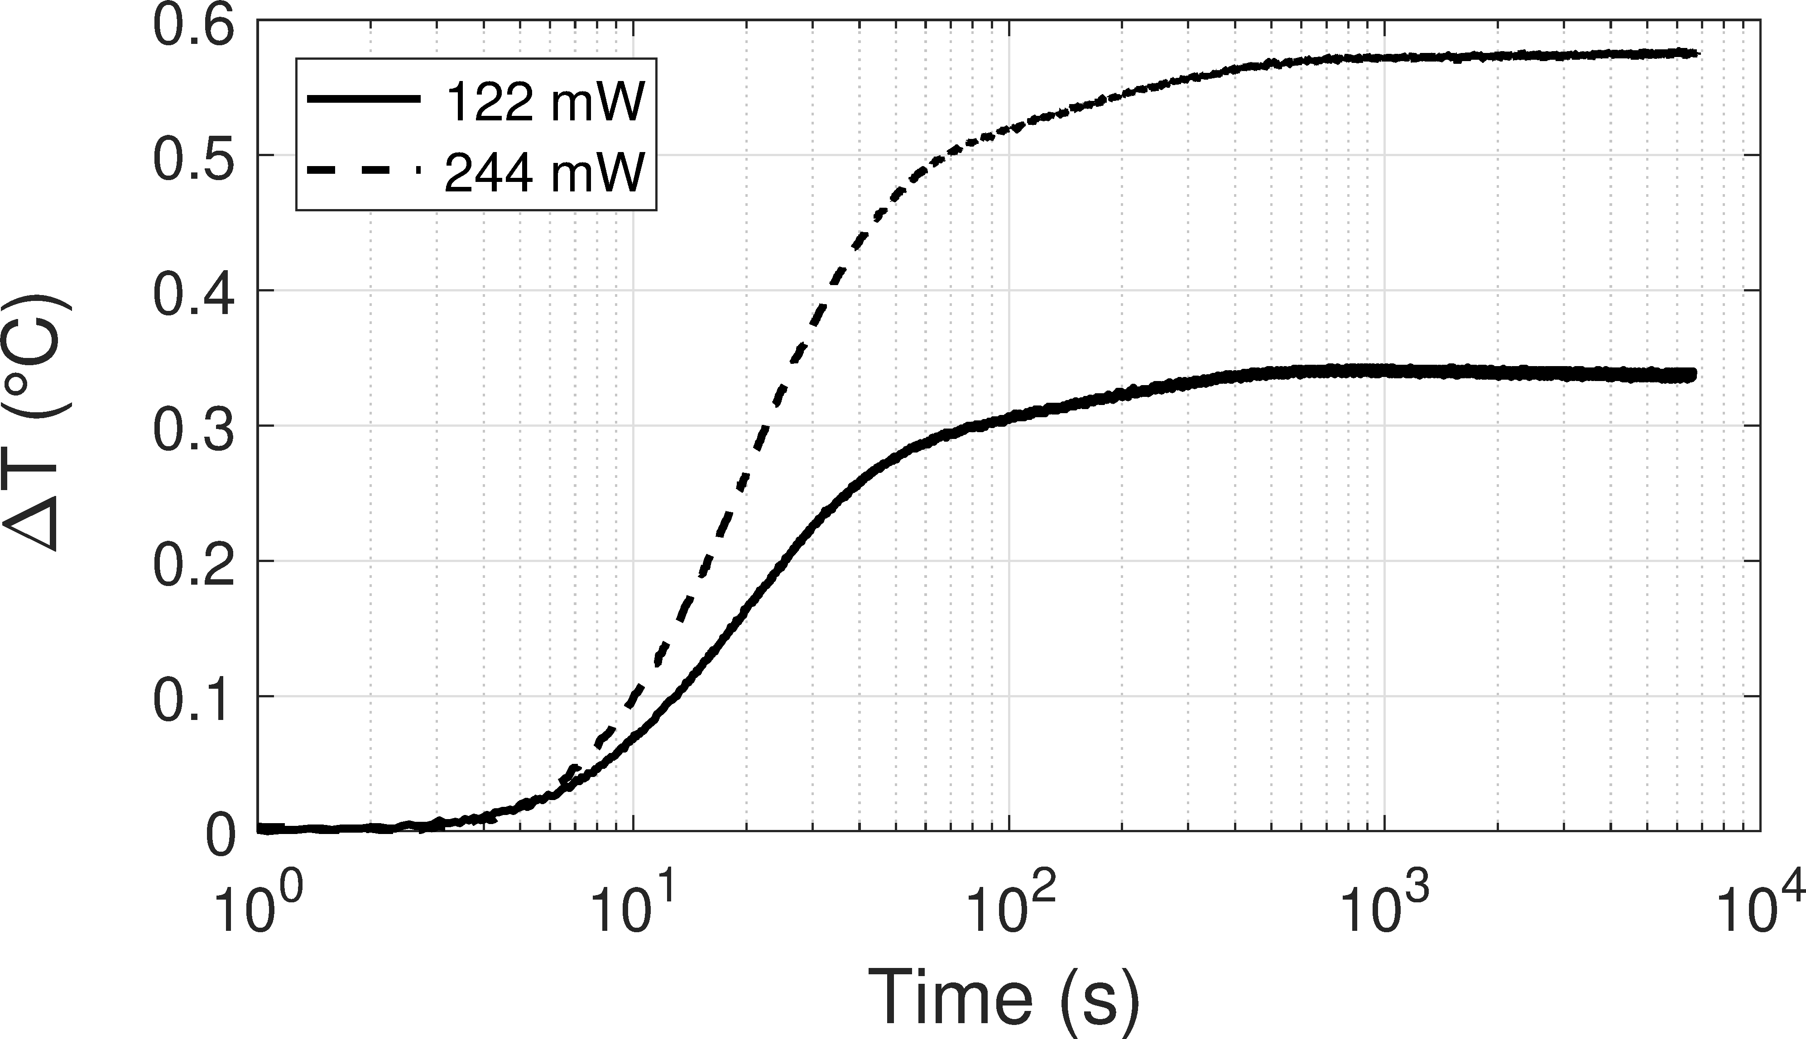

Fig. 3. Temperature difference measured at p = 2 10⁻⁸ mbar between both Pt100 RTD sensors without sample for heating powers of 122 and 244 mW.

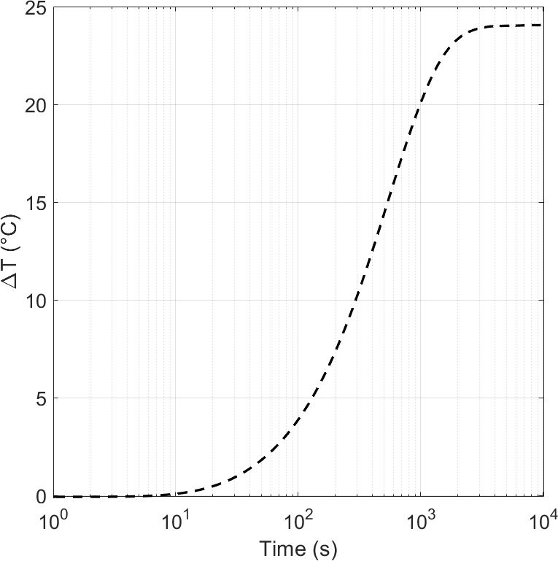

Fig. 4. Temperature difference measured at p = 7 10⁻⁹ mbar across a Ø 13.84 ± 0.02 mm × 3 ± 0.01 mm thick PTFE sample for a heating power of 244 mW.
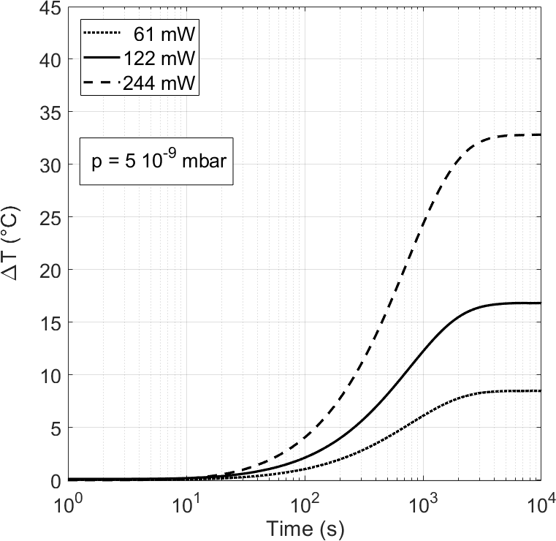

Fig. 5: Temperature difference as a function of time measured on a Ø 13.83 ± 0.02 mm × 3.40 ± 0.01 mm thick epoxy sample. The measurements are carried out for heating powers of 61, 122, and 244 mW at p = 5 10⁻⁹ mbar.

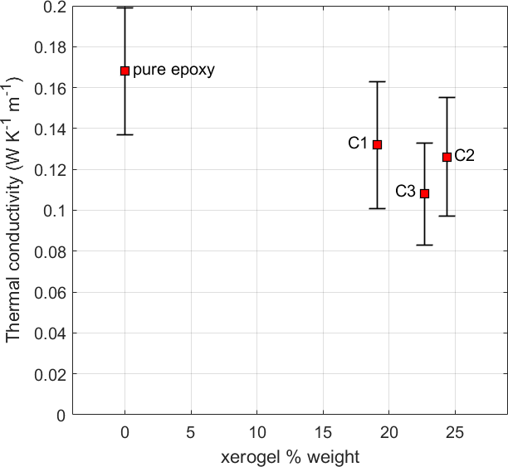
Fig. 6: Thermal conductivity measured on epoxy-xerogel composite samples having various xerogel content percentages. The measurements are carried out for heating powers of 61, 122, and 244 mW at p = 7 10⁻⁹ mbar. These results are compared to these obtained on a pure epoxy sample (refer to the data displayed in Fig. 5).

Results

Thermal conductivity of pure epoxy
Measurements are carried out on a Ø 13.83 ± 0.02 mm × 3.40 ± 0.01 mm thick pure epoxy sample, at p = 5 10⁻⁹ mbar. Figure 5 shows results obtained for power ratings of 61, 122, and 244 mW. Using (2) and correcting for the serial temperature difference across the brass layers, we calculate the thermal conductivity for the pure epoxy sample of 0.168 W m⁻¹ K⁻¹. We determine that the average <$σ_{\hat{k}}$> of the uncertainties obtained for each measurement of thermal conductivity considering the error on the measured dimensions and the accuracies of the sensors and source/meter devices is 0.031 W m⁻¹ K⁻¹.
We can notice here that the individual measurement uncertainty decreases with increasing power ratings, i.e. 0.05, 0.027 and 0.015 W m⁻¹ K⁻¹ respectively for 61, 122 and 244 mW because of the decreasing contribution of the temperature measurement uncertainty in the error propagation of formula (2). In addition, we see that the standard deviation, i. e. σ(k_{61mW}, k_{122mW},$\hat{k}$_{244mW}) = 0.004 W m⁻¹ K⁻¹, is well below <σk>.

Thermal conductivity of xerogel-epoxy composites
Thermal conductivity is calculated from measurements carried out on epoxy-xerogel composite samples C1, C2 and C3 having various xerogel content percentages (see Table II). The measurements are carried out at 7 10⁻⁹ mbar for three values of the generated heating power, i. e. 61, 122, and 244 mW and the obtained average values with their respective average measurement uncertainties are shown in Fig. 6 with the value obtained for the pure epoxy sample.
The results show that for sample C1, which has a xerogel content of 19.4% weight, the thermal conductivity is reduced to 78.4% in comparison to that of pure epoxy. Adding more xerogel to make sample C2 gives a lower thermal conductivity (74.9% of the pure epoxy value). We measure a larger standard variation σ($\hat{k}$_{61mW},$\hat{k}$_{122mW},$\hat{k}$_{244mW}) = 0.003 W m⁻¹ K⁻¹ for sample C2 than for samples C1 and C3, i. e. 0.001 W m⁻¹ K⁻¹. However, these values are one order of magnitude below the measurement uncertainty due to the temperature measurement and the accuracies of our devices, i. e. <$σ_{\hat{k}}$> = 0.031, 0.028 and 0.025 W m⁻¹ K⁻¹ respectively for sample C1, C2 and C3. The larger standard deviation for sample C2 can be linked to the heterogeneity of the sample as confirmed by cross-sectional images of the cut sample (see discussion in the next section). The addition of fluid epoxy to the same mixture of sample C2 in order to prepare sample C3 makes it more homogeneous. As a result, the standard deviation for sample C3 is the same as that for sample C1. Unexpectedly, even if the final xerogel content is lower for sample C3 in comparison to sample C2, (respectively 22.7% and 24.4%), the thermal conductivity of sample C3 reaches 64.2% of the pure epoxy value, i. e. 0.108 ± 0.025 W m⁻¹ K⁻¹.
This low thermal conductivity value for a composite material made of epoxy mixed with a very low thermal conductivity filler such as carbon xerogel is similar to results obtained on composite materials made of epoxy filled with silica aerogel, i. e. 0.105 W m⁻¹ K⁻¹ [44]. These epoxy-based composites with lowered thermal conductivity can advantageously play the role of thermal barriers in MS architecture [17] and reduce the power consumption of micro-fabricated sensors as shown by [45] which presents the results of energy consumption and performance of devices deposited on different substrates. They show that the lower the thermal conductivity of the substrate (glass versus silicon), the lower the energy consumption. However, they point out that integrating multiple sensors on lab-on-a-chip devices might require more complex integration involving both low and high thermal conductivity materials. Therefore, expanding the range of thermal conductivity of materials like epoxy with either very thermally insulating fillers like carbon xerogel [??? Do we give a ref concerning xerogel from Uliege + Portugal or is it too much (I have already added 3 new refs which should be enough to satisfy the reviewer) ? rem : in the next sentence I give a ref for CNT because it is about thermal conductivity of these composite (like our paper should be for xerogel composite)] or very thermally conductive materials like carbon nanotubes [46] improves the possibilities for optimizing the strategies of heat management and power savings in microsystems requiring epoxy-based adhesives.

Morphology Analyses
In section II we described the samples’ composition, in section IV we discussed the samples’ thermal conductivity, and we found a correlation between the xerogel concentration and thermal conductivity. In this section, we describe the samples’ microstructure and morphology by means of optical microscopy only as no scanning electron microscopy analysis is possible due to epoxy outgassing when being processed in vacuum chamber. Each sample of 14 mm diameter and 3 mm thick is cut and equally cross-sectioned on 4 sides to a square parallelepiped of 9.5 mm² with an identical thickness of 3 mm. We sequentially polish the 4 sides of each sample using a sand paper starting from #600 up to #4000 mesh, and finish it with diamond suspension of 3 µm and finally with 1 µm. Each side of the sample is analyzed using a Leica Z6APO optical microscope in reflective mode, a magnification up to 225 x.
For reference purposes, we analyze a sample molded from pure epoxy-based adhesives IQ-BOND 2176, which contains no filler nor any additives. All 4 sides of the sample are identical and the most representative cross-sectioned image is presented on Fig. 7a.
The morphology of the unfilled sample is uniform and the sample has little or no inclusions or any sort of irregularities. The sample is described as a homogenous material.
Using the same technique, we also analyze samples C1, C2 and C3 filled with xerogel at different concentration levels: the results of analyses are presented on Fig. 7 a-d.
All those 3 composite samples are inhomogeneous, and each of them has its specific, individual and distinguishable morphology. The morphology is made up of different features such as inclusions of different natures: air bubbles and xerogel agglomerates. The air bubbles differ in shape (spherical or having an irregular shape) and in size. The xerogel agglomerates, when present, also differ from sample to sample.
Sample C1, the least loaded with xerogel (the concentration of xerogel is 19.1% by weight), is the most homogeneous. The C1 sample reveals only regular spherical air bubbles with diameters ranging from 150 to 320 µm. As the xerogel particles are distributed within the epoxy-based matrix evenly, we did not detect a significant xerogel agglomeration. In the field of view of 4.5 × 2.5 mm² there are only 9 air inclusions. In the sample C2, with the highest xerogel concentration of 24.4% by weight there are 20 inclusions, which is more than double as for C1. The air bubbles have also a regular spherical shape, but have a smaller diameter than in C1, the diameter is 100-200 µm. Remarkably, there are several large xerogel agglomerates of 30-40 µm. Such agglomerates represent up to 4-6 individual xerogel particles of 5-10 µm diameter. The sample C3 (22.7% weight) reveals no spherical air bubbles, but prolonged air voids of 400-600 µm long and 200-300 µm width, with or without combination of xerogel particles agglomerated on its borders. Sample C3 comprises also individual xerogel agglomerates in the range of 15-30 µm. Such agglomerates represent up to 2-3 individual xerogel particles.
To conclude, we observe that the epoxy-based sample is homogeneous, while the samples comprising xerogel exhibit detectable inhomogeneities. Each sample filled with xerogel has its specific, individual and distinct morphology. The morphology includes different features, such as air bubbles and xerogel agglomerates, and depends on the concentration of xerogel. A concentration of xerogel greater than 20% by weight results in partial agglomeration of xerogel. By comparing the morphology of sample C2 (24.4% by weight) with respect to sample C3 (22.7% by weight), we observe that the higher the concentration of xerogel, the greater the risk of xerogel agglomeration and the larger the dimensions of the xerogel agglomerates (from 15-30 μm for sample C3 to 30-40 μm for sample C2). This coincides with our observation that the mixture for the casting of sample C2 has a higher viscosity compared to the mixture for sample C3.
The agglomeration of xerogel results in an uneven distribution of xerogel in the epoxy matrix. Some parts of the sample have a high concentration of xerogel while other parts have a lower concentration of xerogel. Cross-sectional images reveal the largest xerogel agglomerates observed on sample C2.

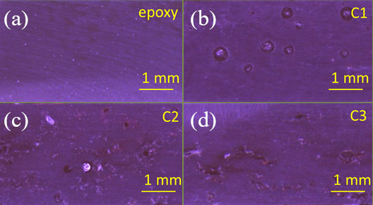

Fig. 7: Cross-sectional image on (a) unfilled and xerogel filled samples (b) C1, (c) C2 and (d) C3.

Compared to the other samples, sample C2 appears less homogeneous. Since the parts with a lower concentration of xerogel have a higher thermal conductivity, heat is easily transferred through those parts (acting as thermal bridges) which are larger and numerous in sample C2. As a result, sample C2 has a slightly higher thermal conductivity despite its higher xerogel concentration.

Conclusion
We measure the thermal conductivity of xerogel-epoxy composite adhesive materials by using a bespoke experimental rig based on a vacuum chamber, allowing us to provide an unidirectional heat flux through the samples’ thickness. We detail the manufacturing process of the composite samples: microstructure observations are carried out to understand the relative discrepancy between the thermal conductivity values considering the presence of air bubbles and xerogel agglomerations. Therefore, we demonstrate that we can obtain a composite sample, having a 22.7% weight in xerogel content, suitable for dispensing and whose thermal conductivity is only 64.2% of the pure epoxy value, i. e. 0.108 W m⁻¹ K⁻¹.
In our future work, we intend to improve the preparation method in order increase the filling fraction of carbon xerogel in the composite material and to improve its homogeneity. We will use the obtained low thermal conductivity material for packaging MOX gas sensors. The material will act as a thermally insulating medium between a heated sensor die and a standard commercial package to prevent the package from thermally induced degradation or damage.

References
- Z. Lei, J. Cao, L. Dong, J. Dong, and Z. Bi, “Study on Application of High Thermal Conductivity Materials in Aerospace Thermal Management,” Materials China. 37, 2018, pp. 1039-1046. DOI: 10.7502/j.issn.1674-3962.2018.12.12.
- W. Lin, B. Sundén, “Graphite foam heat exchanger for vehicles,” Vehicle Thermal Management Systems Conference and Exhibition (VTMS10), Woodhead Publishing, 2011, pp. 81-90. DOI: 10.1533/9780857095053.2.81.
- G. Jiang, L. Diao, and K. Kuang, “Advanced thermal management material”, New York, NY: Springer, 2013.
- Y. Cui, M. Li, and Y. Hu, “Emerging interface materials for electronics thermal management: experiments, modeling, and new opportunities,” J. Mater. Chem. C, 2020, 8, pp. 10568-10586. DOI: 10.1039/C9TC05415D.
- M. T. Demko et al., “Thermal and mechanical properties of electrically insulating thermal interface materials,” 2017 16th IEEE Intersociety Conference on Thermal and Thermomechanical Phenomena in Electronic Systems (ITherm), Orlando, FL, 2017, pp. 237-242. DOI: 10.1109/ITHERM.2017.7992477.
- I. Hu, J. Ho, J. Yang, M. Shih, D. Tarng and C. Hung, “High Thermal Performance Package with Anisotropic Thermal Conductive Material,” 2017 IEEE 67th Electronic Components and Technology Conference (ECTC), Orlando, FL, 2017, pp. 1348-1354. DOI: 10.1109/ECTC.2017.115.
- M. Lu, “Design Architectures for Compliant High Temperature Thermal Interface Materials,” 2018 17th IEEE Intersociety Conference on Thermal and Thermomechanical Phenomena in Electronic Systems (ITherm), San Diego, CA, 2018, pp. 126-133. DOI: 10.1109/ITHERM.2018.8419592.
- J. Hansson, C. Zandén, L. Ye, and J. Liu, “Review of current progress of thermal interface materials for electronics thermal management applications,” 2016 IEEE 16th International Conference on Nanotechnology (IEEE-NANO), Sendai, 2016, pp. 371-374. DOI: 10.1109/NANO.2016.7751383.
- D. D. L Chung, “Materials for thermal conduction”, Applied Thermal Engineering, 21 (16), 2001, pp. 1593-1605. DOI: 10.1016/S1359-4311(01)00042-4.
- T. R. Whiffen, and S.B. Riffat, “A review of PCM technology for thermal energy storage in the built environment: Part I,” International Journal of Low-Carbon Technologies, 8 (3), 2013, pp. 147–158. DOI: 10.1093/ijlct/cts021.
- D. R. Clarke, and S. R. Phillpot, “Thermal barrier coating materials,” Materials Today, 8 (6), 2005, pp. 22-29. DOI: 10.1016/S1369-7021(05)70934-2.
- A.S. Haynes, and R. Sadangi, “Novel thermal barrier oxides for electronics thermal management: an assessment of WO3,” J. Mater. Sci.: Mater. Electron. 28, 2017, pp. 16021–16025. DOI: 1007/s10854-017-7501-6.
- C. Ahn, S. W. Fong, Y. Kim, S. Lee, A. Sood, C. M. Neumann, M. Asheghi, K. E. Goodson, E. Pop, and H.-S. P. Wong, “Energy-Efficient Phase-Change Memory with Graphene as a Thermal Barrier”, Nano Letters 15 (10), 2015, pp. 6809-6814. DOI: 10.1021/acs.nanolett.5b02661.
- T. Matsunaga, N. Yamada, R. Kojima, S. Shamoto, M. Sato, H. Tanida, T. Uruga, S. Kohara, M. Takata, P. Zalden, G. Bruns, I. Sergueev, H. C. Wille, R. P. Hermann, and M. Wuttig, “Phase‐Change Materials: Vibrational Softening upon Crystallization and Its Impact on Thermal Properties,” Adv. Funct. Mater., 21, 2011, pp. 2232-2239. DOI: 10.1002/adfm.201002274.
- X. Zhang, and L.-D. Zhao, “Thermoelectric materials: Energy conversion between heat and electricity,” Journal of Materiomics, 1 (2), 2015, pp. 92-105. DOI: 10.1016/j.jmat.2015.01.001.
- K. Biswas, J. He, I. Blum, et al. “High-performance bulk thermoelectrics with all-scale hierarchical architectures,” Nature 489, 2012, pp. 414-418. DOI: 10.1038/nature11439.
- S. Stoukatch, F. Dupont, and M. Kraft, “Low-Temperature Packaging Methods as a Key Enablers for Microsystems Assembly and Integration,” CAS 2018, International Semiconductor Conference, IEEE-EDS, 10-12 Oct. 2018, Sinaia, Romania, pp. 115-118. DOI: 10.1109/SMICND.2018.8539847.
- Y. Luo, C. Zhang, B. Zheng, X. Geng, and M. Debliquy, “Hydrogen sensors based on noble metal doped metal-oxide semiconductor: a review,” International Journal of Hydrogen Energy, 42, 2017, pp. 20386-20397. DOI: 10.1016/j.ijhydene.2017.06.066.
- A. Helwig, G. Müller, G. Sberveglieri, M. Eickhoff, "On the Low-Temperature Response of Semiconductor Gas Sensors", Journal of Sensors, 2009, 620720. DOI: 10.1155/2009/620720.
- J. J. Licari, and D. W. Swanson, “Adhesives Technology for Electronic Applications: Materials, Processing, Reliability,” William Andrew Publishing, 2011, p. 512.
- H. Lee, and K. Neville, “Handbook of Epoxy Resins,” McGraw Hill: New York, NY, USA, 1982, pp. 14–24.
- H. Ardebili, and M. G. Pecht, “Encapsulation Technologies for Electronic Applications”, William Andrew Publishing, 2009, p. 504
- R. C., Progelhof, J. L. Throne, and R. R. Ruetsch, “Methods for Predicting the Thermal Conductivity of Composite Systems: A Review,” Polymer Engineering & Science, 16 (9), 1976, pp. 615–25. DOI: 10.1002/pen.760160905.
- R. Landauer, “The Electrical Resistance of Binary Metallic Mixtures,” Journal of Applied Physics 23 (7), 1952, pp. 779–84. DOI: 10.1063/1.1702301.
- T. Lewis, and L. Nielsen, “Dynamic Mechanical Properties of Particulate-Filled Polymers,” J. Appl. Polym. Sci., 14, 1970, p. 1449. DOI: 10.1002/app.1970.070140604.
- X. Yang, L. Tianjian, and K. Tongbeum, “Effective Thermal Conductivity Modelling for Closed-Cell Porous Media with Analytical Shape Factors.” Transport in Porous Media, 100 (2), 2013, pp. 211–24. DOI: 10.1007/s11242-013-0212-4.
- I. Belova, and G. Murch, “Monte Carlo simulation of the effective thermal conductivity in two-phase material,” Journal of Materials Processing Technology, 153, 2004, 741–745. DOI: 10.1016/j.jmatprotec.2004.04.191.
- M. Wang, J. Wang, N. Pan, S. Chen, and J. He, “Three-dimensional effect on the effective thermal conductivity of porous media.” J. Phys. D Appl. Phys. 40(1), 2006, 260. DOI: 10.1088/0022-3727/40/1/024.
- N. Rey-Raap, E. G. Calvo, J. A. Menéndez, and A. Arenillas, “Exploring the potential of resorcinol-formaldehyde xerogels as thermal insulators,” Microporous and Mesoporous Materials, 244, 2017, pp. 50-54. DOI: 10.1016/j.micromeso.2017.02.044.
- J. G. Mahy, C. Wolfs, C. Vreuls, S. Drot, S. Dircks, A. Boergers, J. Tuerk, S. Hermans, and S. D. Lambert, “Advanced oxidation processes for waste water treatment: From lab-scale model water to on-site real waste water,” Environmental Technology, 2020, p. 1797894. DOI: 10.1080/09593330.2020.1797894.
- N. Job, S. D. Lambert, A. Zubiaur, C. Cao, J.-P. Pirard, “Design of Pt/carbon xerogel catalysts for PEM fuel cells,” Catalysts, 5, 2015, pp. 40-57. DOI: 10.3390/catal5010040.
- M. Prostredný, M. G. M. Abduljalil, P. A. Mulheran, A. J. Fletcher, “Process Variable Optimization in the Manufacture of Resorcinol–Formaldehyde Gel Materials,” Gels, 4, 2018, p. 36. DOI: 10.3390/gels4020036.
- S. Douven, J. G. Mahy, C. Wolfs, C. Reyserhove, D. Poelman, F. Devred, E. M. Gaigneaux, S. D. Lambert, “Efficient N, Fe Co-Doped TiO2 Active under Cost-Effective Visible LED Light: From Powders to Films,” Catalysts, 10, 2020, p. 547. DOI: 10.3390/catal10050547.
- H. Czichos, T. Saito, and L. E. Smith, “Handbook of Materials Measurement Method,” New York: Springer Science & Business Media, 2006, p. 1208. DOI: 10.1007/978-3-540-30300-8.
- D. Salmon, “Thermal conductivity of insulations using guarded hot plates, including recent developments and sources of reference materials,” Measurement Science & Technology, 12(12), 2001 pp. R89–R98. DOI: 10.1088/0957-0233/12/12/201.
- G. Girardi, P. Mukhopadhyaya, and E. Zalok, “Thermal conductivity measurement of smaller insulation specimens using standard heat flow meter,” J. Test. Eval., 49, 2019, pp. 585-601. DOI: 10.1016/j.enbuild.2019.109445.
- J. J. Healy, J. J. de Groot, and J. Kestin, “The theory of the transient hot-wire method for measuring thermal conductivity,” Physica B+C, 82(2), 1976, pp. 392-408. DOI: 10.1016/0378-4363(76)90203-5.
- V. Khuu, M. Osterman, A. Bar-Cohen, and M. Pecht, “Considerations in the Use of the Laser Flash Method for Thermal Measurements of Thermal Interface Materials,” IEEE Transactions on Components, Packaging and Manufacturing Technology, 1(7), 2011, pp. 1015-1028. DOI: 10.1109/TCPMT.2011.2112767.
- G. Murray, “Handbook of Materials Selection for Engineering Applications,” CRC Press, 2019.
- https://www.leyboldproducts.com/products/measuring-and-analysis-instruments/pressure-measurement/active-sensors/ionivac-combi-transmitters/ionivac-itr-90-pb/
- J.R. Singham, "Tables of emissivity of surfaces," International Journal of Heat and Mass Transfer, 5(1–2), 1962, pp. 67-76. DOI: 10.1016/0017-9310(62)90102-3.
- M. Thirumaleshwar, “Fundamentals of Heat and Mass Transfer,” Pearson India, 2006.
- W. G. Vincenti, and C. H. Kruger, “Introduction to physical gas dynamics,” Krieger Publishing Company, 1965, p. 414.
- J. Zhao, D. Ge, S. Zhang, and X. Wei, Studies on Thermal Property of Silica Aerogel/Epoxy Composite, Mater. Sci. Forum, 546–549, 2007, pp. 1581–1584. DOI: 10.4028/www.scientific.net/msf.546-549.1581.
- F. Shaun, E. Nefzaoui, F. Marty, W. Cesar, and T. Bourouina, “Micro-fabricated thermal flow-rate sensors: the substrate material impact on the device performance and power consumption,” Microsyst. Technol., 2018. DOI: 10.1007/s00542-018-4098-5A.
- Caradonna, C. Badini, E. Padovano, and M. Pietrolungo, “Electrical and Thermal Conductivity of Epoxy-Carbon Filler Composites Processed by Calendaring,” Materials, 12, 2019, p. 1522. DOI: 10.3390/ma12091522.

Jean-François Fagnard received, in 2011, his Ph.D. degrees in engineering sciences from the University of Liège and in applied sciences from the Royal Military Academy, Brussels, Belgium.
From 2000 to 2007, he was Research Engineer and from 2007 to 2008, he was Teaching Assistant in the Department of Electrical Engineering and Computer Science at the University of Liège, Belgium. From 2008 to 2012, he was Research Engineer with the Royal Military Academy, Belgium. In 2013 he was a Research Associate for 6 months with the University of Cambridge, United Kingdom. He is now Research Associate with the Department of Electrical Engineering and Computer Science at the University of Liège, Belgium. His main research interests are magnetic and transport properties of high-temperature superconductors for engineering applications (magnetic energy storage, magnetic shielding, crossed field effect) and include also the properties of materials like magnetocaloric materials, colossal magneto-resistive compounds, the study of flash sintering in ceramic materials and thermal properties of insulating materials.


Serguei Stoukatch, Ph.D. in Electrical Engineering has 20+ years’ experience in micro-assembly, packaging and Interconnect Technology, among them: 4 years post-doctoral research at University of Gent, Belgium, 8 years at Interuniversity Microelectronics Centrum (IMEC), Leuven, Belgium, there he followed the career track starting from Process Engineer to Assembly Technology Section Head and Senior Scientist. Currently he is a Senior Scientist at Microsys Laboratory, Liege University. He holds 2 patents and author/co-author more than 80 publications for professional conferences and technical journals. He is specializing in IC, micro-system, MEMS and biochip packaging; interconnect technology, and 3D integration.


Philippe Laurent is graduated from the University of Liège (Belgium) in 2002 as an electromechanical engineer. Then, he did his PhD on measurement and instrumentation, focusing on thermal effects in superconductors.
After, he worked as Materials and Process Engineer in aeronautics at Safran Aero Booster. He then returned to the University of Liège (2010) as a research engineer at the Microsys Lab. Currently, Philippe Laurent is doing research in Ultra-Low-Power IoT.
In March 2016, he was part of the team won the $1 million prize for the Little Box Challenge, an engineering competition run by Google and the IEEE's Power Electronics Society. In June 2016, he won first prize at the 5G World 2016 Innovation Accelerator (London).

Francois Dupont received a MSc degree in Electrical and Electronics Engineering from the University of Liege, Belgium, in 2007.
He subsequently joined the Microsys laboratory, University of Liege, as a research engineer in 2008. Since then, he has participated in about ten projects whose objectives were the integration/miniaturization of sensor systems. He is currently team leader of Microsys laboratory, whose research topics are energy harvesting, connected sensors system and advanced packaging. His core competence is the design of miniaturized and ultra-low power electronic circuits.


Cédric Wolfs received a degree in chemistry and materials science engineering at the University of Liège in 2016.
He joined the “Nanomaterials, Catalysis, Electrochemistry” lab at the University of Liège as a Research Engineer in 2016, and also became Teacher Assistant in 2017. He has since been working as a Ph.D. student on syntheses of inorganic materials for environmental applications, including TiO₂ and carbon xerogels.
His master’s thesis about porous properties of hydrated lime was awarded the Fondation de Bay’s award.

Prof. Dr. Ir. Stéphanie D. Lambert is an associate professor and a FRS‐FNRS senior research associate in the Department of Chemical Engineering of the University of Liege (Belgium) since 2009. She obtained her Ph.D. in Applied Sciences in 2003. After an engineer position in a Belgian chemical company (Nanocyl) (2004‐2005), and two postdoctoral stays at the Department of Chemical Engineering of the University of Illinois at Chicago in 2006, and at the Institute Charles Gerhardt in Montpellier in 2007, she joined the team “Nanomaterials, Catalysis, Electrochemistry” of the University of Liege, in which she develops heterogeneous catalysts for sustainable chemistry (tars reforming, treatments of chlorinated compounds, photocatalysis,..) and inorganic biomaterials for medical devices. She is vice‐chair of the Chemical Engineering Unit Research since early 2019.
S. D. Lambert’s awards and honors include “Prizewinner of the "Prix Frédéric Swarts" delivered by the Royal Belgian Academy of Sciences, Literature and Fine Arts, 2004”; “Prizewinner of the "Three-year Prize Jules Delruelle” delivered by the Association of engineers from the University of Liège, 2005”; “Prizewinner of the "Annual Prize André Leroux delivered by the "University of Liège's friends", 2005”; Fulbright grant-in-aid delivered by the Commission for Educational Exchange between The United States of America, Belgium and Luxembourg, for the post-doctoral stay at the University of Illinois at Chicago, 2006”; Three grants-in-aid delivered by the European Framework of Excellence "FAME : Functionalized Advanced Materials and Engineering: Hybrids and Ceramics", 2007, 2008 and 2010”.
S. D. Lambert has published over 95 publications, 12 book chapters, holds 1 patent and has an h‐index of 24. She is Guest editor for 1 special issue of Journal of Sol-Gel Science and Technology, Volume 89, Issue 1, January 2019. She also received 21 Invited lectures.

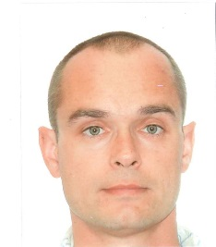
Jean-Michel Redouté (M’09-SM’12) received the degree of M.S. in electronics at the University College in Antwerp (1998), and the degree of M.Eng. in electrical engineering at the University of Brussels (2001).
In August 2001, he started working at Alcatel Bell in Antwerp, where he was involved in the design of analog microelectronic circuits for telecommunications systems. In January 2005, he joined the University of Leuven as a Ph. D. research assistant. In May 2009, he presented his Ph. D. entitled "Design of EMI resisting analog integrated circuits". In September 2009, he started working at the Berkeley Wireless Research Center at the University of California, at Berkeley: this research was funded by the Belgian American Educational Foundation (BAEF). In September 2010, he joined Monash University, Melbourne, as a senior lecturer. In July 2018, he started working at the University of Liège as an Associate Professor. His research is concentrated on miniaturized and low-power sensor interfaces, robust mixed-signal integrated circuit (IC) design with a high immunity to electromagnetic interference (EMI), biomedical (integrated and non-integrated) circuit design, energy harvesting and integrated imagers.
Jean-Michel Redouté is an Associate Editor of the IEEE Sensors Journal.

The work was supported by the Microsystème_ULg Microsys project, funded by the Wallonia (Belgium), and the Micro+ project co-funded by the European Regional Development Fund (ERDF) and Wallonia (Belgium). Jean-Francois Fagnard, Serguei Stoukatch, Philippe Laurent, François Dupont and Jean-Michel Redouté are with the Microsys Laboratory, Department of Electrical Engineering and Computer Science, University of Liège, rue du Bois Saint-Jean 15-17, 4102 Seraing, Belgium (corresponding e-mail: JF.Fagnard@uliege.be). Cédric Wolfs and Stéphanie D. Lambert are with the Department of Chemical Engineering, Nanomaterials, Catalysis & Electrochemistry, University of Liège, B6a, Quartier Agora, Allée du six Août 11, 4000 Liège, Belgium.

