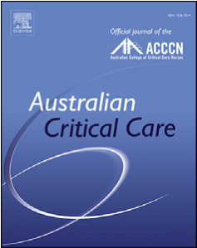
Research paper
Contents lists available at
ScienceDirec
t
Australian Critical Care
journal homepage:
www.elsevier.com/locate/auc
c
Australian Critical Care xxx (xxxx) xx
x
Quadriceps strength in intensive care unit survivors: Variability and influence of preadmission physical activity
Arielle Blanjean, MD ª
Isabelle Kellens, PT, PhD ^{b}
Benoit Misset, MD ^{b}
Jean Joris, MD, PhD ª
Jean-Louis Croisier, PT, PhD ^{c}
Anne-Françoise Rousseau, MD, PhD ^{b, *}
- ege, Liege, Belgium
Anaesthesiology Department, University Hospital, University of Li
- ege, Liege, Belgium
Intensive Care Department and Burn Centre, University Hospital, University of Li
- ege, Liege, Belgium
Department of Sport Sciences and Rehabilitation, University of Li

a r t i c l e i n f o r m a t i o n | a b s t r a c t

Article history:  Received 18 May 2020  Received in revised form  23 September 2020 Accepted 10 October 2020  Keywords:  Autonomy  Critical illness  Quadriceps  Muscle strength  Physical recovery | Background: Muscle weakness is common in patients who survive a stay in the intensive care unit (ICU). Quadriceps strength (QS) measurement allows evaluation of lower limb performances that are associated with mobility outcomes.  Objectives: The objective of the study was to characterise the range of QS in ICU survivors (ICUSs) during their short-term evolution, by comparing them with surgical patients without critical illness and with healthy participants. The secondary aim was to explore whether physical activity before ICU admission influenced QS during that trajectory.  Methods: Patients with length of ICU stay 2 days, adults scheduled for elective colorectal surgery, and young healthy volunteers were included. Maximal isometric QS was assessed using a handheld dynamometer and a previously validated standardised protocol. The dominant leg was tested in the supine position. ICUSs were tested in the ICU and 1 month after ICU discharge, while S patients were tested before and on the day after surgery, as well as 1 month after discharge. Healthy patients were tested once only. Patients were classified as physically inactive or active before admission from the self-report.  Results: Thirty-eight, 32, and 34 participants were included in the ICU, surgical, and healthy groups, respectively. Demographic data were similar in the ICUS and S groups. In the ICU, QS was lower in the ICU group than in the surgical and healthy groups (3.01 [1.88e3.48], 3.38 [2.84e4.37], and 5.5 [4.75e6.05] N/ kg, respectively). QS did not significantly improve 1 month after ICU discharge, excepted in survivors who were previously physically active (22/38, 56%): the difference between the two time points was 6.6 [27.1 to 1.7]% vs 20.4 [3.4 to 43.3]%, respectively, in physically inactive and active patients (p ¼ 0.002).  Conclusions: Patients who survived an ICU stay were weaker than surgical patients. However, a huge QS heterogeneity was observed among them. Their QS did not improve during the month after ICU discharge. Physically inactive patients should be early identified as at risk of poorer recovery.  © 2020 Australian College of Critical Care Nurses Ltd. Published by Elsevier Ltd. All rights reserved.

* Corresponding author at: Intensive Care Department and Burn Center University Hospital Sart-Tilman B35, Hippocrate Avenue 1, B-4000, Liege, Belgium. Tel.: þ32 4 3667495.
E-mail address: afrousseau@chuliege.be (A.-F. Rousseau).
https://doi.org/10.1016/j.aucc.2020.10.007
1036-7314/© 2020 Australian College of Critical Care Nurses Ltd. Published by Elsevier Ltd. All rights reserved.

Introduction
The final objective of critical care is no longer survival only. The other role of medical and paramedical teams should be to restore functional capacities, autonomy, and quality of life [1,2].
Muscle changes occur early in patients with critical illness and are caused by many different pathophysiological mechanisms, leading to a loss of muscle mass [3] and a decrease in muscle force [4]. Consequently, these patients experience muscle weakness and physical impairments that can persist for a long time in survivors [5,6]. What has been call “intensive care uniteacquired weakness” (ICU-AW) is associated with acute and long-term increased mortality, prolonged length of stay (LOS) in the ICU and hospital, prolonged duration of mechanical ventilation, altered quality of life in survivors, and increased health-related costs [7]. Early physical therapy in the ICU has been shown to prevent muscle atrophy [8] and to improve muscle strength [9] or walking ability at hospital discharge [10], when compared with usual care. However, some results may be conflicting [8] and benefits may be unclear [11,12]. The same conflicting observations may be noticed with regard to post-ICU physical rehabilitation [13,14]. This is, in part, due to inclusion of patients with dissimilar muscle status and trajectories
[15].
Determining subgroups that may maximally benefit from follow-up and rehabilitation would be highly valuable [16]. The prerequisite is to measure physical status. Several methods aiming to assess muscle mass, muscle strength, or physical function are described. Manual muscle testing using the Medical Research Council (MRC) scale is still the most commonly used tool to diagnose ICU-AW [17,18]. A score of less than 48 out of 60 is diagnostic of ICU-AW [7,19]. Manual testing is classified by some authors as subjective owing to the potential variability between clinicians in both application of the testing and the interpretation of the results [18]. Moreover, doubts remain about its suitability as a screening tool: the MRC scale is limited by its sensitivity at higher grades [20].
Dynamometry is an objective alternative and one of the most accurate clinimetric tools to assess muscle strength [17]. Handgrip dynamometry has become another standard for ICU-AW diagnosis, and cut-off scores have been described for men and women [21,22]. However, grip dynamometry may not be suitable to characterise lower limb strength [23e25]. Quadriceps is essential for standing, sitting, and walking, so its strength has been related to limb function [26,27]. Considering quadriceps strength as a relevant physical outcome thus does make sense [23].
To the best of our knowledge, the few published studies reporting quadriceps strength in ICU patients are very heterogeneous in terms of devices, patient positioning, and measurement [28e31] (Table S1, supplementary online material). These elements of protocols influence measurement quality [32] and reproducibility. The lack of standardisation of quadriceps strength measurement in the ICU and of reporting prevents any comparison between data. To overcome these pitfalls, we recently proposed and validated a highly standardised protocol of quadriceps strength measurement [33]. This isometric testing performed in the supine position is easily feasible either in the ICU or in a follow-up clinic, well tolerated, reproducible, and highly reliable.
The primary objective of the present study was to describe ranges of quadriceps strength in patients who survived critical illness ICU survivors during their short-term evolution, by comparing them with patients who underwent colorectal surgery (S) without critical illness and with healthy (H) participants (the latter should be considered as a benchmark group). The longitudinal post-discharge measurements bring information about recovery trajectories. The second aim of the study was thus to explore whether physical activity before ICU admission influenced quadriceps performances during that trajectory.

Methods
This observational study was conducted in 2016, 2017, and 2018 in a tertiary hospital after approval by the local ethics committee of our university hospital (National Ref: B707201525790, Local Ref: 2015/231, 2nd November 2015 and 28th July 2016 for the amended version). Informed consent was obtained before enrolment from the patients or their relatives.

Participants
Patients with critical illness were recruited in a 28-bed tertiary adult mixed medical and surgical ICU. Patients who spent a minimum of 48 h in the ICU were enrolled and included in the ICU survivor group. The exclusion criteria were as follows: a score >1 or <1 as per the Richmond Agitation and Sedation Scale; coma; total hip or knee arthroplasty in the dominant limb; standing impossible or unauthorised; open wound located at the ankle's anterior face of the dominant leg; a documented history of neurological, neuromuscular, or muscular wasting diseases; spinal injury or hemiplegia; or refusal. One patient could not be included twice in the study, such as if readmitted later in the ICU.
During ICU stay, all patients with critical illness benefited from local standard care procedures. Nutrition was administered by the oral, enteral, or parenteral route according to the patient's status, aiming to obtain daily intakes of 20e25 kcal per kilogram and 1.2e1.5 g of proteins per kilogram. Continuous intravenous insulin was administered to maintain the blood glucose level between 0.8 and 1.8 g/l. All patients had two physiotherapy (PT) sessions a day, during working days. They benefited from an early mobilisation strategy, including passive or active cycling, passive or active range of motion, sitting out of bed, transfers, ambulation, and other mobilisation techniques, as appropriate based on the level of consciousness [34].
Patients scheduled for elective colorectal surgery were included in the surgical group. The exclusion criteria were the same as for critically ill patients. Standard care at the research site was consistent with a standardised enhanced rehabilitation after the surgery pathway [35,36]. All the included surgical patients thus benefited from the following measures [37,38]: preoperative information and education, preoperative oral immune nutrition (Oral Impact®; Nestle Health Science, Brussels, Belgium) in patients with malnutrition, preoperative carbohydrate load but no premedication, intraoperative restrictive fluid strategy, infusion of intravenous lidocaine during surgery, no abdominal drain, no nasogastric tube, intraoperative administration of dexamethasone, early feeding, and mobilisation at day 0.
Healthy volunteer participants were recruited among the medical and paramedical ICU staff members. The participants were excluded in case of total hip or knee arthroplasty in the dominant limb or if they suffered from pre-existing myopathy or polyneuropathy.
In each of the three groups, the recruitment method was convenience sampling.

Procedure
Patients with critical illness still in the ICU on day 3 after admission were systematically and daily assessed for awakening and cooperation based on their responses to orders (“Open or close your eyes”, “Look at me”, “Open your mouth and put out your tongue”). They were tested for muscle strength as soon as they were able to collaborate and understand the instructions (time point: ICU) and 1 month after ICU discharge (M1 post ICU). The surgical patients were tested during the preoperative anaesthesiology consultation (preop), the day after surgery (postop), and 1 month after hospital discharge (M1 postop). In the healthy group, quadriceps strength was assessed once.

Quadriceps strength testing
Maximal isometric voluntary quadriceps contraction was assessed using a handheld dynamometer (MicroFet2®; Hoggan Health Industries, West Jordan, UT, USA) with a curved transducer pad. The same three examiners (PT students in their final year) performed all strength measurements. They received the same training on the measurement protocol execution. The highly standardised protocol is detailed in a previously published validation study [33]. Intraobserver reliability has been demonstrated in the princeps study including patients with critical illness [33], whereas other studies validated the interobserver reliability of such devices in similar patients and in the geriatric population [30,39]. Measurements were performed at the bedside with the patient lying in the supine position (Fig. 1). Limb position during measurement was standardised using an adjustable system of vertical and horizontal traction plain bars and clamp bars, aiming to get a 45 hip flexion and a 40 knee flexion and to maintain the mandatory position during all the procedures. Such a position places the quadriceps muscle in a suitable length range for optimal efficiency in torque development. Correct limb position was confirmed using a long arm goniometer. The dominant limb (defined as the reported kicking leg [40]) was tested using a “make” technique. The operator was positioned in front of the patient, at the foot of the bed. The MicroFET2 was localised at the anterior face of the ankle, two centimetres above the external malleolus level. The protocol consisted of three consecutive maximal contractions, preceded by three progressively intensified warm-up trials. The participants were first shown the movement to be tested (“push against the dynamometer by attempting to straighten the knee”) and then asked to perform it to confirm their understanding, and they finally did the warm-up. The three measurements were then performed at 30-s intervals between contractions. The participants were asked to gradually increase their muscle force to a maximum effort that had to be sustained for 6 s. The operator provided standardised encouragements (“Ready? Push! Build it up! Push harder! Harder! Harder! Harder! Stop! e with one order per second) to ensure maximal effort during each trial. As the protocol aimed to give the patient the chance to reach his/her maximal strength and not to test the capacity to repeat a muscular effort, the best performance of the three measurements was considered for the analysis. Muscle strength was expressed as newton (N). To reduce interindividual variability and minimise the effect of the participant's weight on muscle strength, absolute strength was normalised based on actual body weight (expressed as N/kg).

Physical testing
Global muscle strength and functional status were assessed using the MRC sum score (a manual evaluation) [18] and the 4item Physical Function Intensive care Test (PFIT-s) [41], respectively. Both tests require the patient to be collaborative. Independence for daily living activities was evaluated using the Barthel Index [42]. These three tests were performed at the same time points than quadriceps strength measurement. Moreover, the preICU admission Barthel Index score was also calculated based on the patient's anamnesis performed during the ICU stay.

Other descriptive data
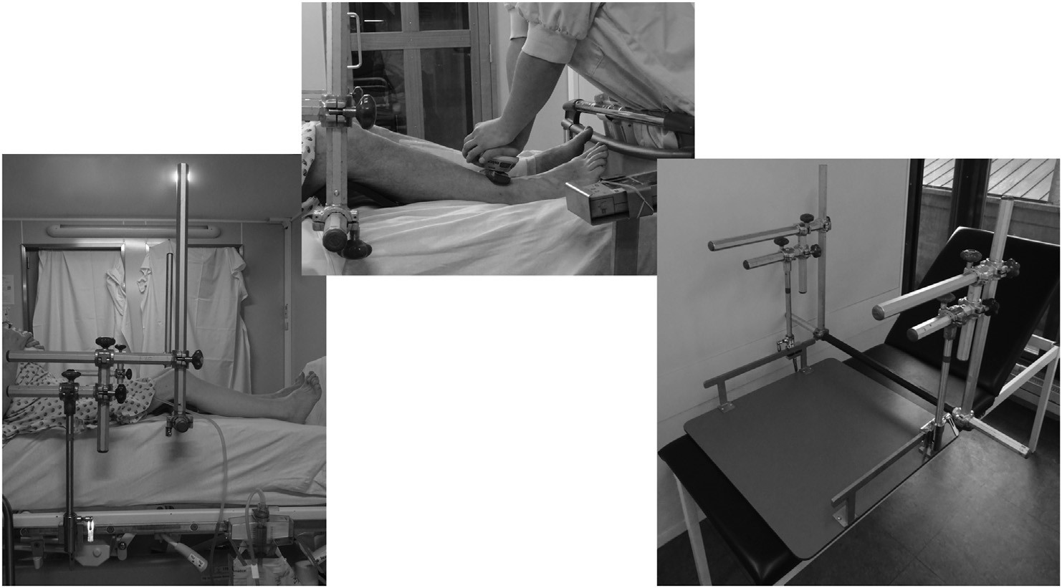
Figure 1. Illustration of the testing structure, patient positioning, and operator positioning.
Age, gender, weight, height, and body mass index (BMI) were recorded. Physical activity status (before admission for ICUSs and S patients) was also characterised according to the patient's selfreport: patients who reported recreational physical activity or sports activity for 4 or more hours per week were considered physically active, whereas patients who did not achieve this were considered physically inactive. Severity of clinical condition was scored using the Simplified Acute Physiology Score II in the ICUS group and American Society of Anaesthesiologists physical status in the surgical group. The peak C-reactive protein (CRP) level during the ICU or hospital stay was recorded in both the ICU survivor and surgical groups. CRP levels were assayed using the Cobas® automate (Roche, Mannheim, Germany) (normal range ¼ 0e6 mg/L). Finally, any prescription of PT after hospital discharge was noted.

Study size
Given the descriptive setting, no sample size was calculated. Moreover, no relevant and comparable previous data about quadriceps strength were available, neither in ICU survivors during their short-term evolution (i.e., reproducibility and comparisons issues with the published data) nor in patients after surgery (i.e., lack of data about quadriceps strength in this population).

Analysis
Statistical analysis was performed using GraphPad Prism (version 6.0 for Mac OSX, GraphPad Inc., San Diego, CA, USA). Normality was assessed using the ShapiroeWilk test. The results are expressed as medians with interquartile ranges [25e75] for quantitative parameters or as counts and proportions for qualitative parameters. Categorical variables were compared using Fisher's exact test. Paired data were compared using the Wilcoxon signedrank test. Unpaired data were analysed using the Student t-test, ManneWhitney test, KruskaleWallis test (with multiple comparisons), and Friedman test, as required. A p value <0.05 was considered to be statistically significant. This study was registered on Clinicaltrials.gov under the identifier NCT03922113.

Results
During a 7-month period in 2016 and 2017, 101 patients with LOS >48 h in the ICU met the inclusion criteria and were enrolled in the ICU survivor group. In the surgical group, 50 patients over 6 months in 2017 met the inclusion criteria and were enrolled in the study. Several patients have been lost between hospital measurement and follow-up testing: the reasons for loss of follow-up are outlined in Fig. 2. Finally, 38 and 32 patients were analysed in the ICU survivor group and surgical group, respectively. In the healthy group, 34 participants were from included during a single day in 2018 (Fig. 2).
Patients in the ICUS group were treated for complicated major surgery (n ¼ 19, 50%), major sepsis or septic shock (n ¼ 15, 39%), and severe medical disease (n ¼ 4, 11%). In the surgical group, the majority of surgeries were performed by laparoscopy (n ¼ 24, 75%), mainly treating cancer (n ¼ 20, 63%), diverticulitis (n ¼ 8, 25%), or inflammatory bowel disease (n ¼ 4, 12%). Descriptive characteristics of the included participants are detailed in Table 1. ICU survivors and surgical patients differed in terms of height (p ¼ 0.028) and inflammatory status (p < 0.001): the peak CRP level was much higher in ICUs survivors than in surgical patients. Healthy participants were younger and had lower weight and BMI than ICU survivors (p < 0.001 for each comparison).
In the ICUS group, testing in the ICU occurred 4 [3e6] days after ICU admission, while “M1 post ICU” testing occurred 37 [26e46] days after ICU discharge. The “M1 postop” evaluation in the surgical group was performed 33 [30e38] days after surgery.

Comparisons between groups
At the ICU time point, ICU survivors were significantly weaker than surgical patients (p ¼ 0.032 for raw strength and p ¼ 0.017 for relative strength). One month after ICU discharge, patients were still weaker than surgical patients (for raw strength: p ¼ 0.004 and for relative strength: p ¼ 0.004) (Table 2). Healthy participants had higher raw and relative quadriceps strength than ICU survivors and surgical patients (p < 0.001) for each comparison. A huge heterogeneity in quadriceps strength was observed in the three groups, particularly in the ICU survivor group (Fig. 3). Thereby, some ICU survivors had greater quadriceps strength than the strongest surgical patients or even than the strongest healthy participants. The preadmission Barthel Index score was 100 [100e100] in the ICUS group. It was not statistically different from the preoperative index in the surgical group (Table 2). However, 1 month after discharge,

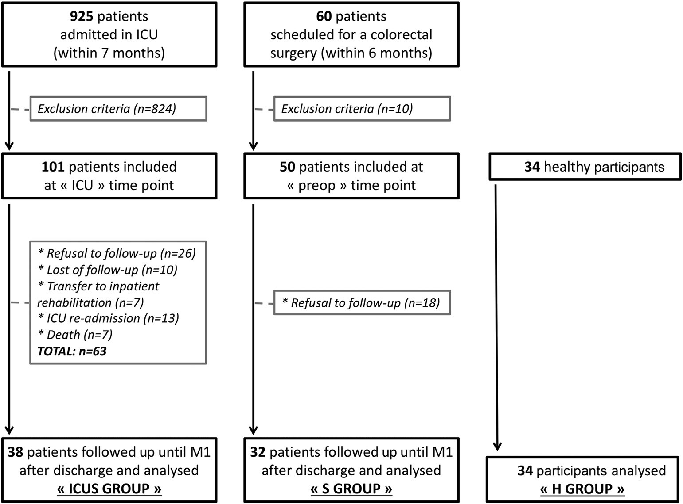
Figure 2. Flow of patients throughout the study in the three groups. ICU, intensive care unit; preop, preoperative; ICUS, intensive care unit survivor.
Table 1
Demographic, clinical characteristics, and outcomes of the included patients in the three groups.
Data | ICU survivors group (n ¼ 38) | Surgical group (n ¼ 32) | Healthy group (n ¼ 34)
Age, years | 59 [47e67] | 62 [50e66] | 34 [28e42]
Male, n (%) | 28 (74) | 18 (56) | 14 (41)
Weight, kg | 80 [65e91] | 77.5 [61e91] | 70 [61e80]
Height, cm | 173 [168e180] | 169 [163e177] | 173 [168e178]
BMI, kg/m² | 27.1 [22.5e29.8] | 27.1 [22.9e30.7] | 23.2 [20.9e24.7]
Physical inactivity, n (%) | 16 (42) | 15 (47) | 5 (14)
SAPS II | 27 [21e32] | e | e
ASA, n (%) | e |  | e
ASA 1 |  | 4 (12)
ASA 2 |  | 26 (82)
ASA 3 |  | 2 (6)
Peak CRP level, mg/L | 199.5 [144.8e298.5] | 53.2 [32.8e86.2] | e
Outcomes LOS in the ICU, d | 5 [3e7] | e
LOS in the hospital, d | 11 [9e35] | 4 [2e5]
Mechanical ventilation for >12 h, n (%) | 8 (21) | e
Ventilation duration, d | 3 [1e11] | e
ICU-AW based on the MRC score, n (%) | 13 (34) | e | e
Patients receiving PT after discharge, n (%) | 17 (45) | 0 (0) | e
ASA, American Society of Anesthesiologists; BMI, body mass index; CRP, C-reactive protein; CVVH, continuous veno-venous hemofiltration; ICU-AW, intensive care uniteacquired weakness; LOS, length of stay; MRC, Medical Research Council; PT, physiotherapy; SAPS II, Simplified Acute Physiology Score II.

Data are expressed as median and interquartile ranges.
ICU survivors were more dependent than surgical patients (p < 0.001) (Table 2).

Comparisons between time points
In both the ICU survivor and surgical groups, no significant changes were observed for quadriceps strength between ICU or preop test and M1 testing (Table 2, Fig. 3). No PT was prescribed at home to surgical patients in this interval. In the ICU survivor group, 17 patients (45%) benefited from locomotor PT after hospital discharge (outpatient care).
After 1 month, performances as per the MRC scale, PFIT-s, and Barthel Index significantly improved in the ICU survivor group (p < 0.001 for each of the three comparisons) (Table 2). In the surgical group, PFIT-s and Barthel Index scores were significantly lower at the postop time point than at the preop time point (p < 0.001), while no change was observed in MRC scores (Table 2).

IUCS group analysis
The 63 ICUS patients initially enrolled but who were not followed up until M1 post discharge were analysed separately (Fig. 2). They did not differ from the 38 patients who completed the study only in terms of BMI and LOS in the ICU. MRC, Barthel Index, and PFIT-s scores were also similar. However, they were older and more
Table 2
Muscle and physical parameters in the three groups.
severely ill than the 38 remaining patients: their age was 68 [53e74] years, and their Simplified Acute Physiology Score II was 33 [27e44]. The raw and relative strength in the ICU were significantly lower in the 63 excluded patients: 136 [71e194] N and 1.69 [0.93e2.6] N/kg, respectively. Their performance in the PFIT-s was also significantly lower (4.4 [3.9e5.4]).
In the ICU, only 13 of 38 patients (34%) had an MRC score <48 and were then diagnosed with ICU-AW. However, their quadriceps strength was not significantly lower than the strength measured in patients with an MRC score 48, 2.69 [1.66e3.4] N/kg and 3.13 [2.14e3.72] N/kg (p ¼ 0.191), respectively.
One month after discharge, 45% (17/38) of ICU survivors reached 100 in the Barthel Index and were considered fully independent.
When considering preadmission physical activity in the ICU survivor group, physically active patients (22/38, 56%) showed better improvement in their quadriceps strength between ICU and M1 post ICU testing, than physically inactive patients: the difference between the two time points was 20.4 [3.4 to 43.3]% vs 6.6 [27.1 to 1.7]% (p ¼ 0.002), respectively (Fig. 4).

Discussion
This pragmatic study used a novel and reliable method of quadriceps strength assessment to describe and compare the ICU survivor group with surgical and healthy patient groups, early in

Parameters
ICU survivor group (n
¼
38)
Surgical group (n
¼
32)
Healthy group (n
¼
34)
 | ICU | M1 post ICU | Preop | Postop | M1 postop
Quadriceps strength, N/kg | 3.01 [1.88e3.48]^{b} | 2.96 [1.92e3.49]^{b} | 3.6 [3.17e4.36] | 3.4 [2.8e4.37] | 3.75 [2.9e4.24] | 5.5 [4.75e6.05]^{c}
MRC (out of 60) | 51 [3.7e60]^{b} | 59.5 [16e60]^{a,b} | 6 [60e60] | 60 [60e60] | 60 [60e60] | 60
PFIT-s (out of 10) | 5.4 [4.4e7.1]^{b} | 10 [7.1e10]^{a,b} | 10 [10e10] | 10 [8.8e10]ª | 10 [10e10] | 10
Barthel Index (out of 100) | 10 [10e40]^{b} | 95 [87e100]^{a,b} | 100 [100e100] | 90 [77.5e100]ª | 100 [100e100] | 100
MRC, Medical Research Council; PFIT-s, Physical Function Intensive care Test; ICU, intensive care unit; ICUS, intensive care unit survivor; M1 post ICU, 1 month after intensive care unit discharge; Preop, preoperative; Postop, the day after surgery; M1 postop, 1 month after hospital discharge.
Data are expressed as median and interquartile ranges.
- Significant statistical difference between two time points in a same group.
- Significant statistical difference between the ICUS group and S group, comparing one of the time points. ^{c} Significant statistical difference between the H group and both the ICUS and S groups at any time point.
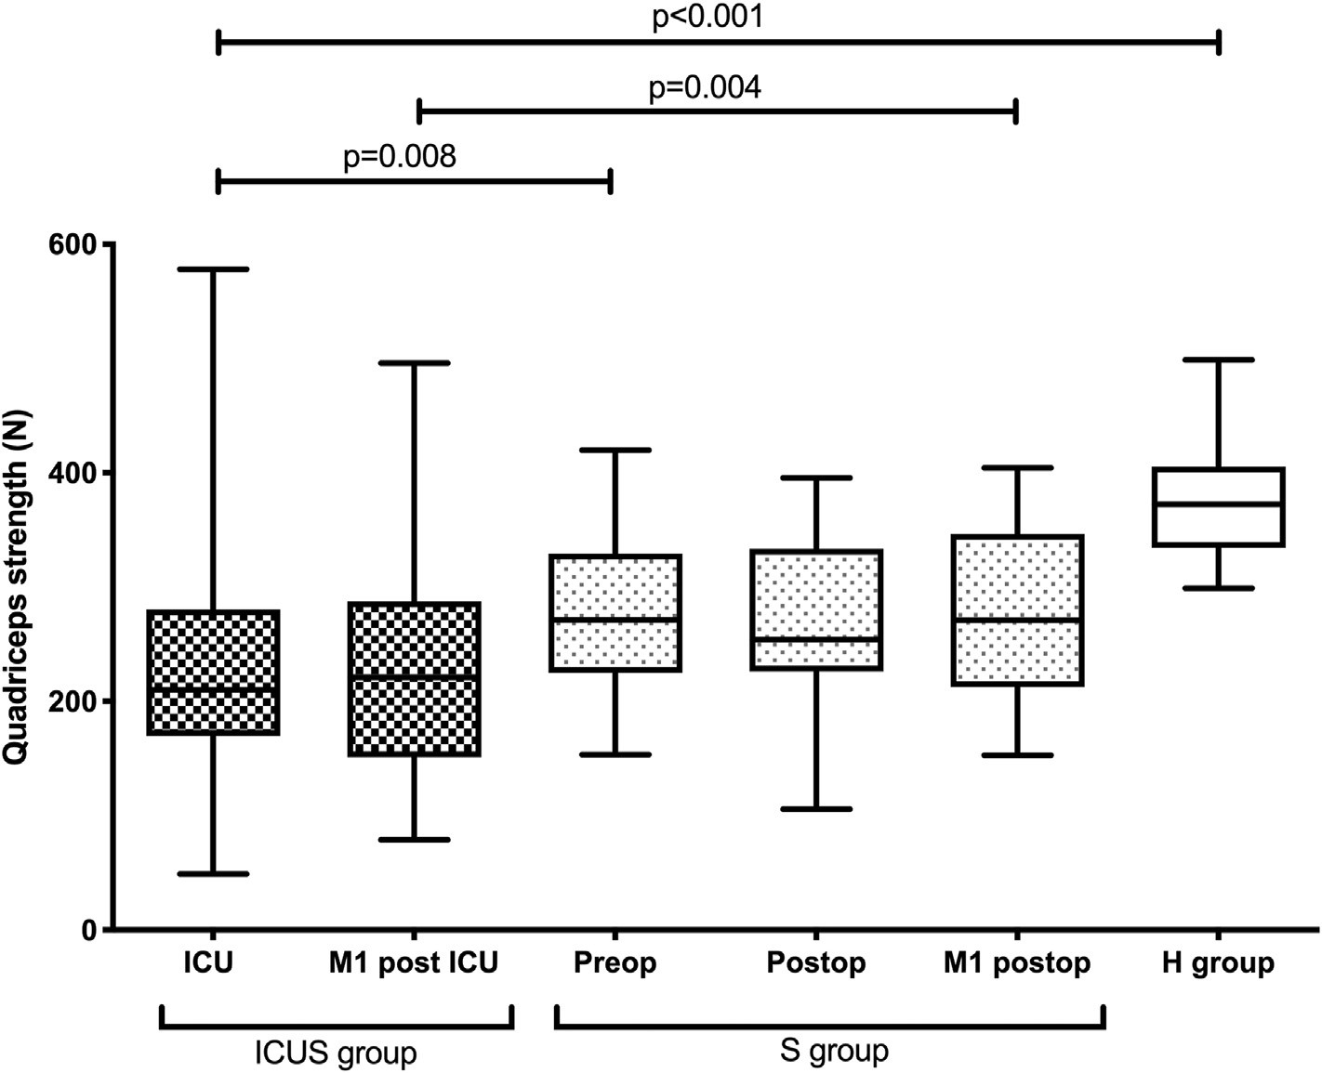
Figure 3. Quadriceps strength (expressed as N) in the three groups, at different described time points. ICU, intensive care unit; M1 post ICU, 1 month after ICU discharge; Preop, preoperative; Postop, the day after surgery; M1 postop, 1 month after hospital discharge; ICUS, intensive care unit survivor.

the recovery trajectory. sICU survivors had significantly lower strength than surgical patients, and strength recovery may be influenced by preadmission physical activity. This study also describes the first normative healthy participants data with our
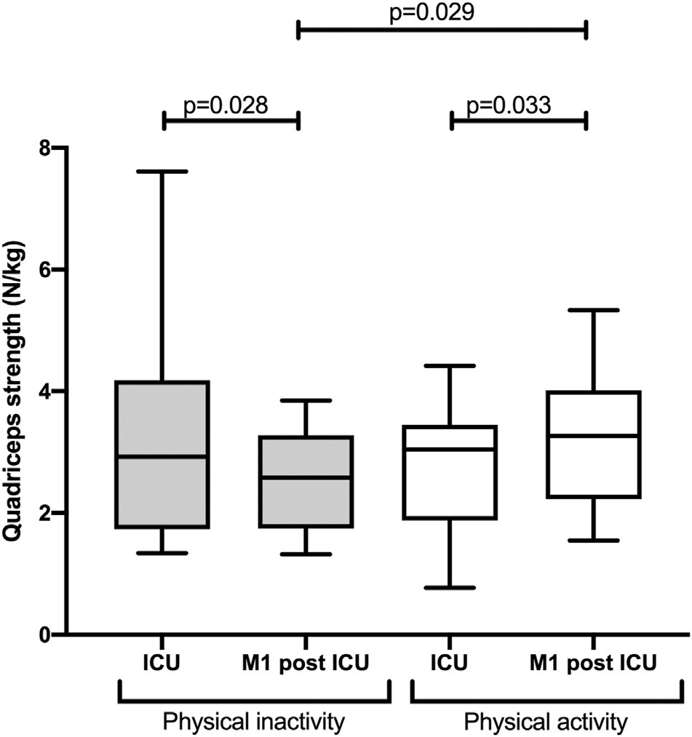
Figure 4. Quadriceps strength (expressed as N/kg) in the ICUS group at the two described time points (ICU and M1 post ICU), based on the preadmission physical activity status (physical inactivity or activity). ICU, intensive care unit; ICUS, intensive care unit survivor; M1 post ICU, 1 month after ICU discharge.
standardised strength testing protocol. A substantial heterogeneity in quadriceps strength was observed among ICU survivors: some patients were extremely weak, whereas some others were even stronger than surgical or healthy patients. Other authors already highlighted this concern in a previous publication [43]. This huge heterogeneity reinforces the concept “one size does not fit all” and assumes a need for individualised and tailored strategies of rehabilitation. A thoughtful and integrative rehabilitation strategy (based at least on PT, exercises, and adequate nutrition and adapted to the patient's clinical condition) should help weakest patients to gain muscle strength as early as possible to recover autonomy after ICU discharge [44]. Such a combined strategy is still poorly studied during and after critical care, but has been proved beneficial in chronic obstructive pulmonary disease, chronic kidney disease, or heart failure [45].
Quadriceps strength did not significantly increase 1 month after discharge, compared with ICU measurement. This observation is not surprising as recovery from ICU-related complication still takes time: reduced physical activity and muscle strength may persist from 3 months [46] to even 5 years after hospital discharge [5]. Numerous factors may contribute to slow or incomplete physical recovery, such as impaired muscle regrowth due to a decrease in satellite cell content [47], persistent catabolism and anabolic resistance [48,49], availability of rehabilitation resources, effectiveness of the rehabilitation program and its consistency with the patient's profile [50], untreated pain, or other associated dysfunction in postural control [51], coordination, endurance, or cognitive status [50]. However, the recovery was better in patients who were physically active before ICU admission. Physically inactive patients should thus be early identified as at risk of poorer recovery.
We did not observe any difference in quadriceps strength in patients with critical illness during the ICU stay whether the diagnosis of ICU-AW, based on the MRC definition, was made or not. Moreover, at M1, MRC score, but not quadriceps strength, improved. This may confirm the low sensitivity of the MRC scale at high grades [20]. Overall, suitability and accuracy of the MRC scale in weakness assessment may be questioned. Diagnostic criteria for ICU-AW, still based on the MRC scale, need to be improved. The diagnostic approach should probably be multimodal, using the most objective methods, and should include the three aspects of muscle status: mass, strength, and function [52]. Strength and function assessments require the patient to be collaborative: this is probably their main limitation. As shown in the present results, evolution of quadriceps strength and PFIT-s score were not similar in ICU survivors: quadriceps strength did not improve, whereas PFIT-s score significantly improved 1 month after discharge. Strength and function assessments are two different ways to explore physical status after ICU discharge, with different sensitivity and specificity. Muscle strength measurement reflects the analytical analysis of physical status. Physical function, as explored by the PFIT-s, depends only partly on muscle strength and represents the ultimate goal of recovery. Analysing both muscle strength and function should be seen as complementary.
Quadriceps strength was lower in the cohort of 63 patients who were initially included but did not complete the follow-up than in the cohort of 38 patients who completed the study. Loss to followup probably set apart the sickest patients and selected unintentionally the patients with less deep weakness or less autonomy. This could explain the surprisingly high scores in the Barthel Index 1 month after discharge, unlike other previously published data on later outcomes [53]. This bias is also encountered in post-ICU follow-up clinics and is part of real life, wherein the sickest patients die, have prolonged hospitalisation, or are discharged to nursing facilities [54].
The present study has some other limitations. First, cohorts were quite small. These results should be therefore considered as the basis for further reflections and investigations. Second, the healthy group was not matched withthe other two groups in terms of age. However, the normative range of quadriceps strength in young healthy participants represents important information. Third, nutrition, physical activity, and PT were not standardised during the month after ICU discharge. Fourth, pre-ICU status evaluation is, by definition, challenging as ICU admissions are usually unexpected. Thus, baseline strength is generally not assessable. In the present study, preadmission autonomy and physical activity was approached retrospectively using a self-report. This could have led to an overestimation or underestimation of the status. Furthermore, physical activity was crudely described without using validated tools. However, such tools are often not suitable for ICU survivors or time-consuming (such as tables of the metabolic equivalent of task). Fifth, comorbidities or frailty that may have affected muscle strength and its evolution was not taken into account in the present observational study. Finally, quadriceps strength measurement assesses only the performances of asingle-musclegroup.Thisdoesnotreflectothermuscles'strengthor even physical function.
In conclusion, quadriceps strength was lower in ICU survivors than in surgical patients or healthy participants. However, a huge heterogeneity in terms of quadriceps strength was observed among ICU survivors. Surprisingly, they were all not weaker than surgical patients, but some patients were extremely weak. Patients who were physically active before ICU admission had a better recovery in terms of quadriceps strength at 1 month after discharge than physically inactive patients. The heterogeneity and the different trajectories in ICU survivors assume a need for individualised rehabilitation programs. Measuring quadriceps strength early during ICU stay could allow clarification of the diagnosis of ICU-AW and could be part of a multimodal physical assessment.

Funding
This research did not receive any specific grant from funding agencies in the public, commercial, or not-for-profit sectors.
Conflict of Interest
All authors declare that they have no competing interests.

CRediT authorship contribution statement
Arielle Blanjean: Visualization, Writing-Original draft preparation, Investigation. Isabelle Kellens: Conceptualization, Methodology, Software, Investigation. Jean Joris: Conceptualization, Methodology, Software, Investigation, Supervision, Reviewing and Editing. Jean-Louis Croisier: Conceptualization, Methodology, Software, Supervision, Reviewing and Editing. Anne-Françoise Rousseau: Conceptualization, Methodology, Software, Visualization, Writing-Original draft preparation, Investigation, Supervision, Reviewing and Editing.

Acknowledgements
The authors want to thank Coraline Flechet, Lucie Bindelle, Marine Stock, Camille Pinchard, and Camille Vancraybex, former students at the University of Liege, for their valuable contribution in data recording.

Appendix A. Supplementary data
Supplementary data to this article can be found online at https://doi.org/10.1016/j.aucc.2020.10.007.

References
- Denehy L, Elliott D. Strategies for post ICU rehabilitation. Curr Opin Crit Care 2012;18:503e8.
- Wischmeyer PE, San-Millan I. Winning the war against ICU-acquired weakness: new innovations in nutrition and exercise physiology. Crit Care 2015;19(Suppl 3):S6.
- Puthucheary ZA, Rawal J, McPhail M, Connolly B, Ratnayake G, Chan P, et al. Acute skeletal muscle wasting in critical illness. J Am Med Assoc 2013;310: 1591e600.
- Batt J, Mathur S, Katzberg HD. Mechanism of ICU-acquired weakness: muscle contractility in critical illness. Intensive Care Med 2017;43:584e6.
- Herridge MS, Tansey CM, Matte A, Tomlinson G, Diaz-Granados N, Cooper A, et al. Functional disability 5 years after acute respiratory distress syndrome. N Engl J Med 2011;364:1293e304.
- Hermans G, Van Mechelen H, Clerckx B, Vanhullebusch T, Mesotten D, Wilmer A, et al. Acute outcomes and 1-year mortality of intensive care unitacquired weakness. A cohort study and propensity-matched analysis. Am J Respir Crit Care Med 2014;190:410e20.
- Hermans G, Van den Berghe G. Clinical review: intensive care unit acquired weakness. Crit Care 2015;19:274.
- Wollersheim T, Grunow JJ, Carbon NM, Haas K, Malleike J, Ramme SF, et al. Muscle wasting and function after muscle activation and early protocol-based physiotherapy: an explorative trial. J Cachexia, Sarcopenia Muscle 2019;10: 734e47.
- Tipping CJ, Harrold M, Holland A, Romero L, Nisbet T, Hodgson CL. The effects of active mobilisation and rehabilitation in ICU on mortality and function: a systematic review. Intensive Care Med 2017;43:171e83.
- Castro-Avila AC, Seron P, Fan E, Gaete M, Mickan S. Effect of early rehabilitation during intensive care unit stay on functional status: systematic review and meta-analysis. PloS One 2015;10:e0130722.
- Moss M, Nordon-Craft A, Malone D, Van Pelt D, Frankel SK, Warner ML, et al. A randomized trial of an intensive physical therapy program for patients with acute respiratory failure. Am J Respir Crit Care Med 2016;193:1101e10.
- Maffiuletti NA, Roig M, Karatzanos E, Nanas S. Neuromuscular electrical stimulation for preventing skeletal-muscle weakness and wasting in critically ill patients: a systematic review. BMC Med 2013;11:137.
- Aitken LM, Burmeister E, McKinley S, Alison J, King M, Leslie G, et al. Physical recovery in intensive care unit survivors: a cohort analysis. Am J Crit Care 2015;24:33e9. quiz 40.
- Taito S, Yamauchi K, Tsujimoto Y, Banno M, Tsujimoto H, Kataoka Y. Does enhanced physical rehabilitation following intensive care unit discharge improve outcomes in patients who received mechanical ventilation? A systematic review and meta-analysis. BMJ Open 2019;9:e026075.
- Hodgson CL, Berney S, Harrold M, Saxena M, Bellomo R. Clinical review: early patient mobilization in the ICU. Crit Care 2013;17:207.
- Parry SM, Nydahl P, Needham DM. Implementing early physical rehabilitation and mobilisation in the ICU: institutional, clinician, and patient considerations. Intensive Care Med 2018;44:470e3.
- Parry SM, Granger CL, Berney S, Jones J, Beach L, El-Ansary D, et al. Assessment of impairment and activity limitations in the critically ill: a systematic review of measurement instruments and their clinimetric properties. Intensive Care Med 2015;41:744e62.
- Bittner EA, Martyn JA, George E, Frontera WR, Eikermann M. Measurement of muscle strength in the intensive care unit. Crit Care Med 2009;37:S321e30.
- Kress JP, Hall JB. ICU-acquired weakness and recovery from critical illness. N Engl J Med 2014;370:1626e35.
- Bohannon RW. Manual muscle testing: does it meet the standards of an adequate screening test? Clin Rehabil 2005;19:662e7.
- Ali NA, O'Brien Jr JM, Hoffmann SP, Phillips G, Garland A, Finley JC, et al. Acquired weakness, handgrip strength, and mortality in critically ill patients. Am J Respir Crit Care Med 2008;178:261e8.
- Piva S, Fagoni N, Latronico N. Intensive care unit-acquired weakness: unanswered questions and targets for future research. F1000Research; 2019. p. 8.
- Chan OY, van Houwelingen AH, Gussekloo J, Blom JW, den Elzen WP. Comparison of quadriceps strength and handgrip strength in their association with health outcomes in older adults in primary care. Age 2014;36:9714.
- Bohannon RW. Dynamometer measurements of grip and knee extension strength: are they indicative of overall limb and trunk muscle strength? Percept Mot Skills 2009;108:339e42.
- Vanpee G, Hermans G, Segers J, Gosselink R. Assessment of limb muscle strength in critically ill patients: a systematic review. Crit Care Med 2014;42: 701e11.
- Moxley Scarborough D, Krebs DE, Harris BA. Quadriceps muscle strength and dynamic stability in elderly persons. Gait Posture 1999;10:10e20.
- Schilling BK, Karlage RE, LeDoux MS, Pfeiffer RF, Weiss LW, Falvo MJ. Impaired leg extensor strength in individuals with Parkinson disease and relatedness to functional mobility. Park Relat Disord 2009;15:776e80.
- Baldwin CE, Paratz JD, Bersten AD. Muscle strength assessment in critically ill patients with handheld dynamometry: an investigation of reliability, minimal detectable change, and time to peak force generation. J Crit Care 2013;28: 77e86.
- Baldwin CE, Bersten AD. Alterations in respiratory and limb muscle strength and size in patients with sepsis who are mechanically ventilated. Phys Ther 2014;94:68e82.
- Vanpee G, Segers J, Van Mechelen H, Wouters P, Van den Berghe G, Hermans G, et al. The interobserver agreement of handheld dynamometry for muscle strength assessment in critically ill patients. Crit Care Med 2011;39: 1929e34.
- Burtin C, Clerckx B, Robbeets C, Ferdinande P, Langer D, Troosters T, et al. Early exercise in critically ill patients enhances short-term functional recovery. Crit Care Med 2009;37:2499e505.
- Keating JL, Matyas TA. The influence of subject and test design on dynamometric measurements of extremity muscles. Phys Ther 1996;76:866e89.
- Rousseau AF, Kellens I, Freycenon G, Dardenne N, Bruyere O, Damas P, et al. Highly standardized quadriceps dynamometry of critically ill adults at bedside: a step towards individualized rehabilitation. Acta Anaesthesiol Belg 2018;69:159e64.
- Sommers J, Engelbert RH, Dettling-Ihnenfeldt D, Gosselink R, Spronk PE, Nollet F, et al. Physiotherapy in the intensive care unit: an evidence-based, expert driven, practical statement and rehabilitation recommendations. Clin Rehabil 2015;29:1051e63.
- Gustafsson UO, Scott MJ, Schwenk W, Demartines N, Roulin D, Francis N, et al. Guidelines for perioperative care in elective colonic surgery: enhanced Recovery after Surgery (ERAS(R)) Society recommendations. Clin Nutr 2012;31:783e800.
- Daenen C, Coimbra C, Hans G, Joris J. Labelling as reference Centre of GRACE (Groupe francophone de Rehabilitation Amelioree apres ChirurgiE) for colorectal surgery: its impact on the implementation of enhanced recovery programme at the University Hospital of Liege. Acta Chir Belg 2018:1e5.
- Slim K, Delaunay L, Joris J, Leonard D, Raspado O, Chambrier C, et al. How to implement an enhanced recovery program? Proposals from the Francophone Group for enhanced recovery after surgery (GRACE). J Vis Surg 2016;153: S45e9.
- Alfonsi P, Slim K, Chauvin M, Mariani P, Faucheron JL, Fletcher D, et al. French guidelines for enhanced recovery after elective colorectal surgery. J Vis Surg 2014;151:65e79.
- Buckinx F, Croisier JL, Reginster JY, Dardenne N, Beaudart C, Slomian J, et al. Reliability of muscle strength measures obtained with a hand-held dynamometer in an elderly population. Clin Physiol Funct Imag 2017;37:332e40.
- van Melick N, Meddeler BM, Hoogeboom TJ, Nijhuis-van der Sanden MWG, van Cingel REH. How to determine leg dominance: the agreement between self-reported and observed performance in healthy adults. PloS One 2017;12:
e0189876.
- Denehy L, de Morton NA, Skinner EH, Edbrooke L, Haines K, Warrillow S, et al. A physical function test for use in the intensive care unit: validity, responsiveness, and predictive utility of the physical function ICU test (scored). Phys Ther 2013;93:1636e45.
- Mahoney FI, Barthel DW. Functional evaluation: the Barthel index. Md State Med J 1965;14:61e5.
- Fan E, Cheek F, Chlan L, Gosselink R, Hart N, Herridge MS, et al. An official American Thoracic Society Clinical Practice guideline: the diagnosis of intensive care unit-acquired weakness in adults. Am J Respir Crit Care Med 2014;190:1437e46.
- Heyland DK, Stapleton RD, Mourtzakis M, Hough CL, Morris P, Deutz NE, et al. Combining nutrition and exercise to optimize survival and recovery from critical illness: conceptual and methodological issues. Clin Nutr 2016;35: 1196e206.
- Di Girolamo FG, Guadagni M, Fiotti N, Situlin R, Biolo G. Contraction and nutrition interaction promotes anabolism in cachectic muscle. Curr Opin Clin Nutr Metab Care 2019;22:60e7.
- Borges RC, Carvalho CR, Colombo AS, da Silva Borges MP, Soriano FG. Physical activity, muscle strength, and exercise capacity 3 months after severe sepsis and septic shock. Intensive Care Med 2015;41:1433e44.
- Dos Santos C, Hussain SN, Mathur S, Picard M, Herridge M, Correa J, et al. Mechanisms of chronic muscle wasting and dysfunction after an intensive care unit stay. A pilot study. Am J Respir Crit Care Med 2016;194:821e30.
- Wischmeyer PE, Suman OE, Kozar R, Wolf SE, Molinger J, Pastva AM. Role of anabolic testosterone agents and structured exercise to promote recovery in ICU survivors. Curr Opin Crit Care 2020;26:508e15.
- Morton RW, Traylor DA, Weijs PJM, Phillips SM. Defining anabolic resistance: implications for delivery of clinical care nutrition. Curr Opin Crit Care 2018;24:124e30.
- Latronico N, Herridge MS. Unraveling the myriad contributors to persistent diminished exercise capacity after critical illness. Intensive Care Med 2015;41: 1854e6.
- Kiriella JB, Araujo T, Vergara M, Lopez-Hernandez L, Cameron JI, Herridge M, et al. Quantitative evaluation of muscle function, gait, and postural control in people experiencing critical illness after discharge from the intensive care unit. Phys Ther 2018;98:8e15.
- Hodgson CL, Denehy L. Measuring physical function after ICU: one step at a time. Intensive Care Med 2017;43:1901e3.
- Deschka H, Schreier R, El-Ayoubi L, Erler S, Alken A, Wimmer-Greinecker G. Survival, functional capacity, and quality of life after cardiac surgery followed by long-term intensive care stay. Thorac Cardiovasc Surg 2013;61:696e700.
- Bakhru RN, Davidson JF, Bookstaver RE, Kenes MT, Peters SP, Welborn KG, et al. Implementation of an ICU recovery clinic at a tertiary care academic center. Crit Care Explor 2019;1:e0034.

