Characteristics and processing challenges of camel milk cream

Islem Mtibaaª, Giorgia Purcaro^{b}, Hamadi Attia^{c}, Mohamed Ali Ayadi^{d}, and Sabine Danthine^{e}

a National Engineering School of Sfax (Tunisia). Her doctoral research investigates the production of butter from camel milk cream.
b Gembloux Agro-Bio Tech, University of Liège, Belgium.
c LAVASA laboratory at Sfax University (Tunisia).
d Sfax University (Tunisia).
e Department of Food Science and Formulation at Gembloux Agro-Bio Tech, University of Liège, Belgium.

In some tropical and sub-tropical arid as well as semi-arid regions of Africa and Asia, camel milk is regarded as an essential source of nutrients in the human diet. Indeed, camel milk is popular for its nutritional and therapeutic properties thanks to its high content of essential fatty acids (C18:2, C18:3) and bioactive substances (immunoglobulins, lactoferrin, lysozymes, among others).

Camel milk fat is dispersed in milk in the form of small droplets called fat globules. These camel fat globules present two main particularities when compared to those of cow milk. First, camel milk has a higher proportion of smaller globules and a lower mean fat globule diameter (2.6 micrometer vs 3.6 micrometer, for camel and cow, respectively). Second, the membrane surrounding camel milk fat globules—known as the milk fat globule membrane (MFGM)—is thicker than that of cow milk fat globules. In addition, studies of camel MFGMs showed that it is poor in proteins but rich in neutral lipids and in phospholipids. These particular properties lead to difficulties in milk skimming by centrifugation and a slow rate of spontaneous creaming during storage. Moreover, some authors have attributed the low spontaneous creaming of camel milk cream to the absence of agglutinin. In cow milk, this whey protein adsorbs itself at the surface of cold fat globules and facilitates their clustering.
The rheological properties of camel milk are also affected by the globule size, distribution, and by the properties of the globule mem- brane. In fact, camel milk cream is more viscous than cow cream due to the higher thickness of the globule membrane and to the relatively higher amount of phospholipids.
At ambient temperatures (20°C–25°C), camel cream appears to be stickier and more greasy than cow cream. These characteristics can be explained by an important solid to liquid ratio in camel milk fat.
Analysis of the fatty acids (FA) composition shows great differences between camel and bovine milk fats (Table 1). The FA profile of camel milk fat varies as a function of geographic location as well as environ- mental and physiological factors (e.g., diet, stage of lactation, and genetic differences). Several authors indicated that camel milk fat contains a lower amount of short-chain FA (C4-C12) and less saturated FA as compared to bovine milk (2.47% vs 12.01%, respectively).
The cause of this low amount of short-chain FA is not adequately explained: Some authors suggest that it is due to the rapid metabolizing of these fatty acids by camel tissues before being excreted in the milk; some other authors correlate it with the nature of camel feeding.
The most abundant saturated fatty acids identified in camel milk fat are C14:0, C16:0, and C18:0. The comparative amounts of these saturated FA in camel and cow milk fat is still discussed by authors. Furthermore, several researchers have found a higher proportion of unsaturated fatty acids in camel milk fat as compared to cow milk fat, especially with respect to C16:1 and C18:1. Some authors found a higher percentage of C18:3ω3 and traces of arachidonic acid, which is interesting from a nutritional point of view.
Camel milk fat has a very different triacylglycerols (TAG) composition than cow milk fat. Some studies revealed a lower percentage of CN22-CN34 TAGs, due to the low level of short- chain fatty acids. The most predominant TAGs found in camel milk fat are CN46, CN48, CN50, and CN52, with a maximum level for CN48.
The differences in fatty acid and TAG composition imply differences in the melting profile and crystallization behavior. Camel milk fat has a broad melting range, and thermograms show that it presents more melting peaks than cow fat, which is consistent with the differences in their TAG compositions (Fig. 1, page 26). Melting of the camel milk fat starts around
–26°C and is completed at about 43°C. The final melting temperature and the thermal enthalpy are higher in camel milk fat.

TABLE 1.
Fatty acid composition (w/w %) of camel and cow milk fat

Fatty acids | camel | cow
C4:0 | 0.60 | 2.60
C6:0 | 0.22 | 1.65
C8:0 | 0.21 | 1.12
C10:0 | 0.25 | 2.75
C12:0 | 1.19 | 3.89
C14:0 | 13.11 | 13.05
C14:1 | 0.70 | 1.70
C15:0 | 0.10 | 1.50
C16:0 | 31.45 | 38.59
C16:1 | 11.62 | 2.30
C18:0 | 16.12 | 8.65
C18:1 | 20.70 | 20.52
C18 :2 | 1.19 | 1.92
C18 :3 | 1.33 | 1.34
C20:0 | 0.49 | 0.49
C4-C12 | 2.47 | 12.01
unsaturated fatty acids | 35.54 | 27.78

These characteristics are consistent with the relatively higher proportion of long-chain fatty acids that represent an important fraction of high melting point TAG and a lower percentage of triacylglycerol that melt in the medium range.
From a technological point of view, these specific characteristics of camel milk fat lead to some butter-making difficulties. These difficulties are attributed to the higher proportion of small fat

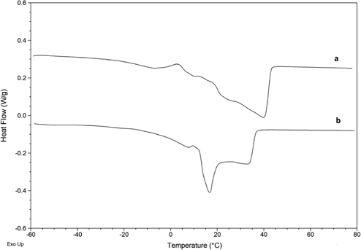
FIG. 1 Melting curves of camel milk fat (a) and cow milk fat (b)

globules and the fat globules membrane thickness.
It is thus difficult to produce butter from camel milk fat using the same technology as for butter from bovine milk. Few studies have dealt with the possibility of making butter from camel milk. It was found that it is necessary to use a churning temperature close to 25°C to facilitate the phase inversion. This churning temperature is higher than that usually found for cow cream (10–15°C); this can be explained by the higher level of high melting point TAG in camel milk fat, as just described.
Sensory analysis showed that camel milk butter is white, which is probably attributed to the low betacarotene content of camel milk (Fig. 2). Its flavor is also less intense compared to that of butter made from cow milk. This can be explained by the lower proportion of short-chain fatty acids, which play an important role in butter’s flavor.

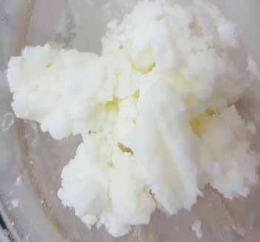
FIG. 2 Washed camel butter

Although camel milk fat can be considered to be more nutritional than cow milk fat, studies on the butter-making process from camel cream are still scarce. Hence, more detailed studies regarding butter-making technology are needed to enhance the utilization of camel milk fat.
As cream ripening is one of the most crucial steps of butter manufacturing, we are currently investigating the effects of ripening conditions on camel cream crystallization related to the churning process.

Further reading

Attia, H., N. Kherouatou, N. Fakhfakh, T. Khorchani, and N. Trigui, Dromedary milk fat: biochemical, microscopic, and rheological characteristics, J. Food Lipids 7: 95–112, 2000.
Berhe, T., E. Seifu, and M.Y Kurtu, Physicochemical properties of butter made from camel milk, Int. Dairy J. 31: 51-54, 2013.
Karray, N., C. Lopez, M. Ollivon, and H. Attia, La matière grasse du lait de dromadaire: composition, microstructure, et polymorphisme. Une revue, Oléagineux, Corps gras, Lipides 12: 439–446, 2005.
Karray, N., S. Danthine, and C. Blecker, et al., Contribution to the study of camel milk fat globule membrane, Int. J. Food Sci. Nutr. 57: 382–390, 2006.
Haddad, I., M. Mozzon, R. Strabbioli, and N.G. Frega, Stereospecific analysis of triacylglycerols in camel (Camelus dromedarius) milk fat, Int. Dairy J. 20: 863–867, 2010.
Smiddy, M.A., T. Huppertz, and S.M. van Ruth, Triacylglycerol and melting profiles of milk fat from several species, Int. Dairy J. 24: 64–69, 2012.

