**Semantic and perceptual encoding lead to decreased fine mnemonic discrimination following multiple presentations**

Emma Delhaye1,2 & Christine Bastin1,2

1 GIGA-CRC In-Vivo Imaging, Liege University

2 PsyNCog Research Unit, Faculty of Psychology, Liege University

Running head: Influence of repetition and type of encoding on memory fidelity

Corresponding author: Emma Delhaye

Allée du Six Août, 8, B30

4000 Liege, Belgium

[emma.delhaye@uliege.be](mailto:emma.delhaye@uliege.be)

Word count (including abstract and references): 3393 words

**Abstract**

Competitive trace theory holds that semanticization following reactivation is characterized by a fidelity loss in the memory representation due to the competition between different traces formed after each occurrence of a given stimulus. This is manifested in the Mnemonic Similarity Task as an increase in hits and in false recognition of similar lures. We tested this account across two encoding conditions emphasizing the perceptual versus semantic features of the items, which were presented either once or three times. Our results supported the hypothesis that semanticization following repetition occurs regardless of the type of encoding induced.

Keywords: Mnemonic discrimination, memory consolidation

**Introduction**

How are memories organized in the brain with the passage of time and new experiences with previously encountered information? Classical models of memory consolidation suggest that, while the encoding of new memories initially depends on the hippocampus, memories gradually become less dependent on the hippocampus over time, as more permanent memories develop in the neocortex (McGaugh, 2000; for more recent reviews, see Dudai, 2012; Squire et al., 2015).

Standard Consolidation Theory (SCT) holds that both the hippocampus and the neocortex are responsible for the initial storage of the memory trace, and that the hippocampus guides a process of reorganization and stabilization whereby information in the neocortex eventually becomes independent of the hippocampus, so that a memory can be retrieved without recourse to the hippocampus (McClelland et al., 1995; Squire & Alvarez, 1995). The repetition of an existing memory trace triggers the reactivation and strengthening of that trace in the neocortex, making its representation more stable, while the initial hippocampal trace decays. Importantly, the SCT does not distinguish between what happens to different types of declarative memories over time; the same process applies to context-rich episodic memories and more generic semantic memories. In contrast, in Multiple Trace Theory (MTT; Nadel & Moscovitch, 1997), the hippocampus is always necessary to encode *and* retrieve context-rich episodic information, as are relevant neocortical regions for which it acts as an index. The repetition of identical information leads to a different hippocampally mediated memory trace each time, thereby reinforcing the memory, as the number of traces represents the strength of the memory. As episodic information is repeated and becomes established in memory, statistical regularities are abstracted from its repeated presentations and used to form a schematic (or semantic) version of the memory capturing its essential features; this version becomes independent of the initial trace and is thought to be represented in neocortical regions (for a review, see Moscovitch et al., 2005). The Transformation Hypothesis extends the MTT to posit that, over time and experience, a schematic version of the hippocampus-dependent episodic memories – characterized by rich contextual content – is developed in the neocortex, where the memory retains its essential features and meaning but few of its contextual details. This less detailed schematic memory can be accessed independently of the episodic memory, so that the episodic and more generic traces of the memory coexist. Memories that maintain strong contextual details over time continue to be represented in the hippocampus (Winocur & Moscovitch, 2011; Winocur et al., 2010).

More recently, Yassa and Reagh (2013) introduced the concept of pattern separation within theories of memory consolidation. Pattern separation refers to specific computations supported by the hippocampus that are particularly important to distinguish close or overlapping information, since they “orthogonalize” overlapping inputs (Yassa & Stark, 2011). The authors proposed a Competitive Trace Theory (CTT) whereby, when a memory is encountered again, its central features are reactivated, whereas some individual contextual features differ from one encounter to another. Through pattern separation in the hippocampus, the reactivation of information creates a new trace with each encounter; new traces overlap the original memory due to the reactivation of central features but lead to somewhat dissimilar representations due to their non-overlapping contextual features. In that framework, with every reactivation, the overlapping elements are strengthened and semanticized to become hippocampus-independent, while the non-overlapping ones are thought to compete with one another, with the following possible consequences: (1) mutual inhibition leading to the forgetting of these contextual details and the decontextualization of the memory trace, or (2) insertion of specific contextual details at any reactivation event. In both scenarios, there should be a change in the fidelity of the representation of the memory: as the number of encounters increases, semantic memory is consolidated, but actual episodic details are lost.

Empirical support for this hypothesis was provided by a study by Reagh and Yassa (2014) using the Mnemonic Similarity task (MST), in which participants took part in an incidental encoding task in which they had to judge stimuli as being more commonly found “indoors” or “outdoors”, and then had to discriminate between target objects that were identical to those previously studied (“old”), and similar lures consisting of objects that were perceptually similar to the studied ones, as well as new foils consisting of clearly different new objects (“new”). The results of that study showed better recognition of targets and worse lure rejection for similar lures following repetition (Reagh & Yassa, 2014; see also Reagh et al., 2016). However, in that study, processing at the semantic level was induced by incidental “indoor”/”outdoor” encoding instructions. This may have, to some extent, focused participants’ attention on general traits of the objects at the expense of specific contextual details. Nevertheless, according to the CTT, the same pattern of results (i.e., better target recognition and increased false recognitions of similar lures, indicating a decline in the quality of the representation due to semanticization and weakening of the non-overlapping elements following repetition) should hold if the encoding instructions promoted stimulus processing at a more perceptual level, for example by emphasizing perceptual details and the processing of specific characteristics of objects, more than at a semantic level (although it is likely that stimulus processing does not occur in a process-pure fashion in any case). This is the hypothesis that we assessed in the study described below.

**Methods**

***Participants***

Two groups of 24 young adults performed the MST under two different encoding conditions (inducing the processing of either perceptual or semantic features) but using the same materials (between-subjects design). An a priori power analysis indicated that a sample size of 14 participants would allow us to replicate the significant repetition by lure bin interaction on lure discrimination scores described by Reagh and Yassa (2014), with an effect size of ƞ2p= 0.147 and a power of 0.90 at an alpha level of 0.05 in a repeated-measures ANOVA. All participants were native French speakers with no history of neurological or psychiatric disorders. In the perceptual encoding condition, participants (12 women) had a mean age of 22.25 years (SD=3.35) and a mean education level of 14.5 years (SD=2.47). In the semantic encoding condition, subjects (12 women) had a mean age of 22.92 years (SD=3.05) and a mean of 14.62 years of education (SD=1.64). There was no significant difference in age, t(46)=–0.72; *p*=.47, or education, W[1]=–0.21; *p*=.84, between the two groups.

***Materials***

Three hundred and sixty pictures representing coloured objects were randomly selected from the MST materials (selected in equal numbers from stimulus sets 1 to 6; see Stark et al., 2013) across target-lure similarity bins 2, 3 and 4. In Stark et al.’s (2013) study, lure bins were derived from behavioural performance: bin 1 represented the greatest similarity between target and lure and bin 5 the least similarity. Stimuli from bins 1 and 5 were not included in our design since no effect was reported for these bins in the study by Reagh and Yassa (2014). Twelve versions of the task were created to ensure full counterbalancing.

***Procedure***

Subjects were tested individually on a laptop computer. The task was programmed on PsychoPy stimulus presentation software. During the incidental encoding phase, 180 pictures were displayed one by one for 2500 ms each, with a 500 ms interstimulus blank screen; 90 of them were presented once, and 90 three times. Different orienting tasks were given in two between-subject conditions. In the perceptual condition, the instruction was to indicate whether the object had “three colours or fewer” versus “more than three colours”. This orienting question is thought to focus attention on specific perceptual details of objects (Barbeau et al., 2004). In the semantic condition, the instruction was to indicate whether the object was more commonly found “indoors” or “outdoors”, using the original instructions from Reagh and Yassa (2014). In the recognition phase, following a 30-second break filled with conversation, the stimuli comprised 90 target pictures (45 of them were shown once at encoding and 45 were shown three times), 90 lure pictures (45 matching a target previously shown once and 45 matching a target previously shown three times) from three levels of similarity (bins 2, 3 and 4), and 90 new pictures. Participants had to discriminate between old and new stimuli, with the specific instruction to endorse similar lures as “new”. Participants had 2500 ms to answer. The interstimulus interval was 500 ms.

**Results**

The proportion of correct target identifications (i.e., hits) was analysed using a mixed repeated-measures 2 (type of encoding: perceptual, semantic) x 2 (number of presentations: 1, 3) ANOVA, with type of encoding as between-subjects factor and number of presentations at encoding as within-subject factor. A main effect of number of presentations was found, F(1,46)=91.25; *p*<.001; η²p=0.66; 95% CI [–0.23, –0.15], with a greater hit rate following repetition. There was no main effect of type of encoding, F(1,46)=1.04; *p*=.31; η²p=0.02; 95% CI [–0.08, 0.03], but there was a significant interaction between type of encoding and number of presentations, F(1,46)=5.78; *p*=.02; η²p=0.11, indicating that, although there was no effect of type of encoding when the items were presented three times (*p*holm=.55, Cohen’s d=0.09, 95% CI [–0.07, 0.11]), there was a trend towards a greater hit rate in the semantic (vs. perceptual) encoding condition for items that were presented only once (*p*holm=.055, Cohen’s d=–0.32, 95% CI [–0.17, 0.01]). Means for hits and correct rejections are presented in Table 1.

[insert Table 1 about here]

Target recognition and lure discrimination were further analysed with discrimination indices (Figure 1) (Reagh & Yassa, 2014). First, we ran a mixed repeated-measures 2 (type of encoding) x 2 (number of presentations) ANOVA on the *d'* discrimination index calculated using the distributions of correct and incorrect “old” responses to targets vs. new foils. Following Reagh and Yassa’s (2014) methods, hits were pooled across one- and three-exposure targets, yielding a single value correcting lure discrimination. The analysis of this measure showed better performance after three presentations than after one, F(1,46)=163.30; *p*<.001; η²p=0.78; 95% CI [–0.98, –0.70], but no main effect of type of encoding, F(1,46)=0.61; *p*=.44; η²p=0.01; 95% CI [–0.24, 0.55]. However, there was a significant interaction between number of presentations and type of encoding, F(1,46)=7.84; *p*=.007; η²p=0.15. Post hoc tests showed that the interaction was drawn by variable effect sizes; the difference in performance according to type of encoding was not significant, either after one (*p*holm=.88, Cohen’s d=–0.02, 95% CI [–0.60, 0.54]) or after three presentations (*p*holm=.22, Cohen’s d=0.23, 95% CI [–0.23, 0.91]). Performance was better after three presentations than after one for both perceptual (*p*holm<.001, Cohen’s d=–1.59, 95% CI [–1.28, –0.77]) and semantic encoding (*p*holm<.001, Cohen’s d=–1.02, 95% CI [–0.91, –0.40]).

We also analysed a *C* index of bias, calculated using distributions of correct and incorrect “old” responses to targets versus new items. A mixed repeated-measures 2 (type of encoding) x 2 (presentations at encoding) ANOVA indicated that participants applied a more liberal bias following three presentations at encoding, F(1,46)=163.30; *p*<.001; η²p=0.78, 95% CI [0.35, 0.49]. There was no main effect of type of encoding, F(1,46)=3.42; *p*=.07; η²p=0.07, 95% CI [–0.01, 0.33], but there was a significant interaction between number of presentations and type of encoding, F(1,46)=7.84; *p*=.007; η²p=0.15; participants were more conservative after perceptual than after semantic encoding following one presentation (*p*holm=.02, Cohen’s d=0.39, 95% CI [0.01, 0.50]), but there was no difference in this regard following three presentations (*p*holm=.48, Cohen’s d=0.10, 95% CI [–0.18, 0.31]). Both groups became more liberal following three presentations than one (all *ps*holm<.001, perceptual encoding: Cohen’s d=1.59, 95% CI [0.38, 0.64]; semantic encoding: Cohen’s d=1.02, 95% CI [0.20, 0.46]).

We assessed lure discrimination by calculating the *d'* indicesusing the distributions of correct and incorrect “old” responses to targets vs. similar lures.[2] We performed a mixed repeated-measures 2 (type of encoding) x 2 (number of presentations of the associated target at encoding) ANOVA on the *d'* indices. Discrimination was better after one presentation of the target at encoding than after three, F(1,46)=8.20; *p*=.006; η²p=0.15, 95% CI [0.07, 0.40], but there was no main effect of type of encoding, F(1,46)=2.26; *p*=.14; η²p=0.05, 95% CI [–0.14, 0.94], and no interaction between number of presentations and type of encoding, F(1,46)=1.75; *p*=.19; η²p=0.04.

Finally, the *C* index of bias related to that measure was analysed using a mixed repeated-measures 2 (type of encoding) x 2 (number of presentations of the associated target at encoding) ANOVA. Participants were more liberal after one presentation of the target at encoding than after three, F(1,46)=8.20; *p*=.006; η²p=0.15, 95% CI [0.03, 0.20]. There was also a main effect of the type of encoding, F(1,46)=4.13; *p=*.048; η²p=0.08, 95% CI [0.01, 0.69], with semantic encoding leading to a more liberal response bias. The interaction between these variables was not significant, F(1,46)=1.75; *p*=.19; η²p=0.04.

[insert Figure 1 about here]

**Discussion**

In this study, we tested a hypothesis from the CTT (Yassa & Reagh, 2013) that each reactivation of the same information creates a new mnemonic trace due to pattern separation performed in the hippocampus, where the overlapping central elements are strengthened and semanticized, while the individual episodic contextual details associated with one specific occurrence lead to similar but not identical representations of information, which compete with one another so that most of these episodic details are lost from the representation. Importantly, then, one assumption of the CTT is that greater reactivation of information should induce a decrease in the fidelity of the memory representation, as a consequence of the competition between the multiple memory traces, which induces either the decontextualization of the memory, or the insertion of non-veridical episodic details into the memory. This prediction was supported by a study using the MST and showing that repeated exposure to object pictures led to enhanced target recognition and poorer discrimination of similar lures compared to a single exposure (Reagh & Yassa, 2014). With the idea that that previous study had induced information processing mainly (though not exclusively) at a semantic level during encoding, we challenged this hypothesis by assessing whether the type of processing – perceptual versus semantic – induced during encoding modulated the quality of the consolidated memory trace. We hypothesized that, if the CTT was accurate, the pattern of semanticization should be the same across different types of processing induced at encoding and should therefore lead to similar increases in target recognition and in false recognitions of lures in the MST following three presentations, as opposed to one (cf. Reagh & Yassa, 2014).

In accordance with this hypothesis, we observed better target recognition and worse lure discrimination following three presentations of the target during encoding than following just one. Importantly, these results hold true regardless of the type of processing that was induced. This pattern of results suggests a loss in the fidelity of the memory representation following repetition, as predicted by the CTT. The response bias results also support this idea, since they indicated that, while the participants who received perceptual encoding instructions behaved more conservatively after one presentation than those who were given semantic instructions, they acquired a more liberal bias following three repetitions, so that they behaved similarly to the participants who received semantic instructions: both groups became markedly more liberal after three exposures.

Together, the results provide additional support for the CTT’s claim that semanticization is accompanied by a loss of fidelity in the memory representation, leading to increased false recognitions of similar lures, regardless of whether the information was initially processed perceptually or more semantically. This is important for the generalizability of the hypothesis, as everyday events are likely to be encoded in many different ways and the CTT predicts that consolidation will act similarly for all events. Yet we do not reject alternative interpretations of these findings (nor the interpretation in Reagh & Yassa, 2014). For instance, repetition could modulate the forgetting rate of the targets, so that correct lure rejections would be partly related to the quality of the memory for the corresponding target in addition to reliance on the semanticized content. In other words, if behavioural pattern separation involves memory for both the gist and the details (Loiotile & Courtney, 2015), correct rejections of the lures may be associated with forgetting of the corresponding targets if they have been shown only once, whereas they may be associated with a detailed memory of the corresponding targets after three exposures (Zhang & Hupbach, 2019).

**Funding**

This work was supported by the FRS-FNRS (Emma Delhaye is funded by a FRS-FNRS Postdoctoral Fellowship and Christine Bastin is a FRS-FNRS Research Associate), and the Léon Frédéricq Foundation

**Disclosure statement**

All authors have read and approved the manuscript in its current form and declare that they have no conflict of interest.

**References**

Barbeau, E., Didic, M., Tramoni, E., Felician, O., Joubert, S., Sontheimer, A., Ceccaldi, M., & Poncet, M. (2004). Evaluation of visual recognition memory in MCI patients. *Neurology*, *62*(8), 1317–1322.

Dudai, Y. (2012). The restless engram: Consolidations never end. *Annual Review of Neuroscience*, *35*(1), 227–247. https://doi.org/10.1146/annurev-neuro-062111-150500

Loiotile, R. E., & Courtney, S. M. (2015). A signal detection theory analysis of behavioral pattern separation paradigms. *Learning & Memory*, *22*(8), 364–369. https://doi.org/10.1101/lm.038141.115

McClelland, J. L., McNaughton, B. L., & O’Reilly, R. C. (1995). Why there are complementary learning systems in the hippocampus and neocortex: Insights from the successes and failures of connectionist models of learning and memory. *Psychological Review*, *102*(3), 419–457.

McGaugh, J. L. (2000). Memory – A century of consolidation. *Science*, *287*(5451), 248–251. https://doi.org/10.1126/science.287.5451.248

Moscovitch, M., Rosenbaum, R. S., Gilboa, A., Addis, D. R., Westmacott, R., Grady, C., McAndrews, M. P., Levine, B., Black, S., Winocur, G., & Nadel, L. (2005). Functional neuroanatomy of remote episodic, semantic and spatial memory: A unified account based on multiple trace theory. *Journal of Anatomy*, *207*(1), 35–66. https://doi.org/10.1111/j.1469-7580.2005.00421.x

Nadel, L., & Moscovitch, M. (1997). Memory consolidation, retrograde amnesia and the hippocampal complex. *Current Opinion in Neurobiology*, *7*, 217–227.

Reagh, Z. M., Ho, H. D., Leal, S. L., Noche, J. A., Chun, A., Murray, E. A., & Yassa, M. A. (2016). Greater loss of object than spatial mnemonic discrimination in aged adults: Selective object memory deficits in aging. *Hippocampus*, *26*(4), 417–422. https://doi.org/10.1002/hipo.22562

Reagh, Z. M., & Yassa, M. A. (2014). Repetition strengthens target recognition but impairs similar lure discrimination: Evidence for trace competition. *Learning & Memory*, *21*(7), 342–346. https://doi.org/10.1101/lm.034546.114

Squire, L. R., & Alvarez, P. (1995). Retrograde amnesia and memory consolidation: A neurobiological perspective. *Current Opinion in Neurobiology*, *5*(2), 169–177. https://doi.org/10.1016/0959-4388(95)80023-9

Squire, L. R., Genzel, L., Wixted, J. T., & Morris, R. G. (2015). Memory consolidation. *Cold Spring Harbor Perspectives in Biology*, *7*(8), Article a021766. https://doi.org/10.1101/cshperspect.a021766

Stark, S. M., Yassa, M. A., Lacy, J. W., & Stark, C. E. L. (2013). A task to assess behavioral pattern separation (BPS) in humans: Data from healthy aging and mild cognitive impairment. *Neuropsychologia*, *51*(12), 2442–2449. https://doi.org/10.1016/j.neuropsychologia.2012.12.014

Winocur, G., & Moscovitch, M. (2011). Memory transformation and systems consolidation. *Journal of the International Neuropsychological Society*, *17*(05), 766–780. https://doi.org/10.1017/S1355617711000683

Winocur, G., Moscovitch, M., & Bontempi, B. (2010). Memory formation and long-term retention in humans and animals: Convergence towards a transformation account of hippocampal–neocortical interactions. *Neuropsychologia*, *48*(8), 2339–2356. https://doi.org/10.1016/j.neuropsychologia.2010.04.016

Yassa, M. A., & Reagh, Z. M. (2013). Competitive trace theory: A role for the hippocampus in contextual interference during retrieval. *Frontiers in Behavioral Neuroscience*, *7,* Article 107. https://doi.org/10.3389/fnbeh.2013.00107

Yassa, M. A., & Stark, C. E. L. (2011). Pattern separation in the hippocampus. *Trends in Neurosciences*, *34*(10), 515–525. https://doi.org/10.1016/j.tins.2011.06.006

Zhang, M., & Hupbach, A. (2019). Repeated exposure does not lead to poor trace discriminability. *Proceedings of the Psychonomic Society Annual Meeting*, *101*.

**Tables**

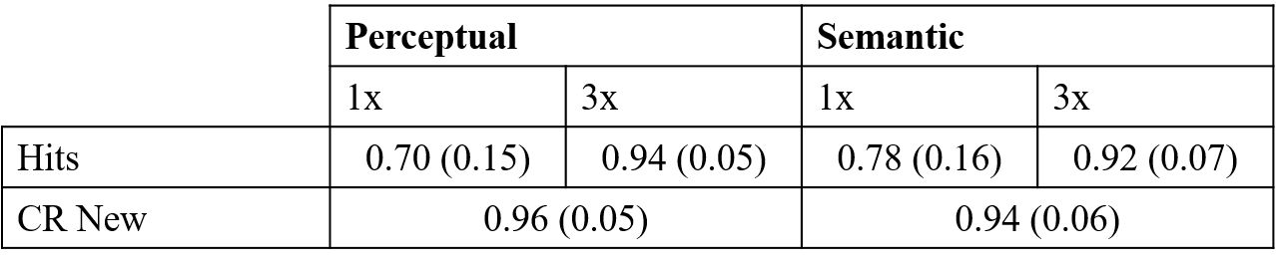

Table 1. Means and standard deviations (in parentheses) across encoding conditions and number of presentations for correct recognitions of targets (hits) and correct rejections (CR) of new foils.

**Figures**

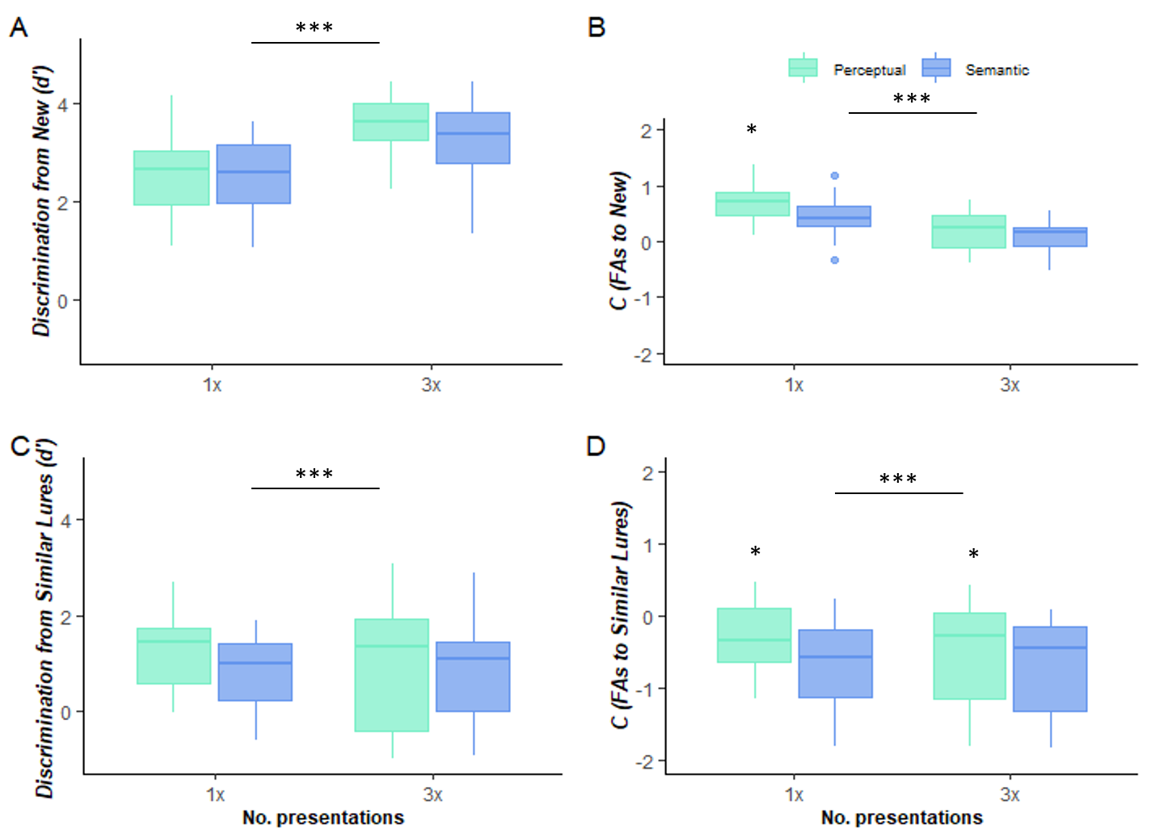

**Figure captions**

Figure 1. Boxplots of *d'* (A, C) and *C* index of bias (B, D) calculated using the false alarm rates (FAs) to new foils (A, B) or to similar lures (C, D); displayed across encoding conditions (perceptual or semantic) and number of presentations (“No. of presentations”: 1 or 3) of the target during encoding.

1. We used Welch’s independent t-test because of a violation of the equal variance assumption
2. The pattern of results using the LDI (Lure Discrimination Index; Reagh & Yassa, 2014) was highly similar to the one shown for this *d'* index