Appendix A: Supplementary material
Response of ammonia-oxidizing bacteria and archaea abundance and activity to land use changes in agricultural systems of the Central Andes
Authors: Alejandro Coca-Salazar, Agnes Richaume, Alessandro Florio, Monique Carnol
Figure A.1 Relative importance of AOB and AOA. Average contribution of AOB and AOA (A) to total potential nitrification rates (PNR), and (B) to total number of amoA gene copies in the three land uses.
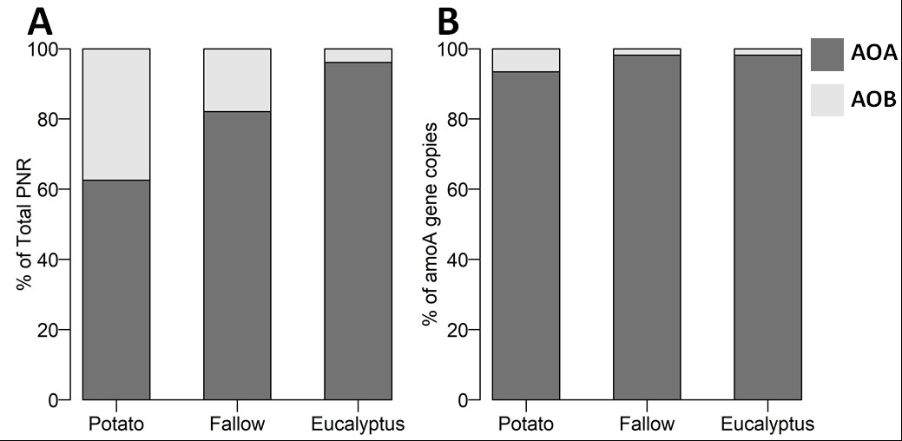

Figure A.2 Relationships of amoA gene copy numbers of A: ammonia oxidizing bacteria and B: ammonia oxidizing archaea with total potential nitrification rates (PNR). The thick lines were fitted for all data points (n= 24) and thin lines were fitted for each land use separately (n= 8), points represent soils under potato (●), fallow (○) and eucalyptus (▲) land use.
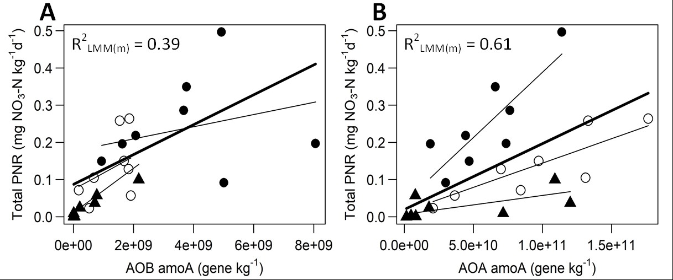

Table A.1 Results of the linear mixed effects models of the relationship between total potential nitrification rates and amoA gene copy numbers of AOA and AOB in each land use. The intercepts, estimated slopes and regression coefficients R² are presented for each land use (* P< 0.05, **P<0.01).
Explanatory variable | Land use | Intercept | Slope | R²
amoA-AOB | Potato | 0.18 | 8.5×10⁻⁰⁹ | 0.00
 | Fallow | 0.07 | 6.8×10⁻⁰⁸ | 0.17
 | Eucalyptus | 0.01 | 4.6×10⁻⁰⁸ ** | 0.94
amoA-AOA | Potato | 0.04 | 3.5×10⁻⁰⁹ ** | 0.64
 | Fallow | 0.01 | 1.3×10⁻⁰⁹ ** | 0.69
 | Eucalyptus | 0.00 | 5.1×10⁻¹⁰ | 0.22

Table A.2 Results of the linear mixed effects models of the relationship between AOA and AOB potential nitrification rates with their respective amoA gene copy numbers in each land use. The intercepts, estimated slopes and regression coefficients R² are presented for each land use (* P< 0.05, **P<0.01).
Explanatory variable | Land use | Intercept | Slope | R²
amoA-AOB | Potato | 0.03 | 1.8×10⁻⁰⁸ | 0.01
 | Fallow | 0.001 | 2.1×10⁻⁰⁸ * | 0.14
 | Eucalyptus | 0.001 | 2.1×10⁻⁰⁸ ** | 0.86
amoA-AOA | Potato | 0.03 | 1.7×10⁻⁰⁹ * | 0.50
 | Fallow | 0.02 | 1.0×10⁻⁰⁹ ** | 0.86
 | Eucalyptus | 0.03 | 1.1×10⁻¹⁰ | 0.23

Table A.3 Results of the linear mixed effects models of the relationship between total, AOA and AOB potential nitrification rates (PNR) with soil pH_{KCl} in each land use. The intercepts, estimated slopes and regression coefficients R² are presented for each land use (*P < 0.05, **P<0.01).
 |  | Intercept | Slope | R²
Total PNR | Potato | -0.41 | 0.16* | 0.14
 | Fallow | -0.22 | 0.09 | 0.10
 | Eucalyptus | 0.09 | -0.02 | 0.00
AOB-PNR | Potato | -0.53 | 0.15* | 0.37
 | Fallow | -0.17 | 0.05* | 0.16
 | Eucalyptus | 0.01 | 0.00 | 0.00
AOA-PNR | Potato | 0.12 | 0.01 | 0.00
 | Fallow | -0.01 | 0.03 | 0.00
 | Eucalyptus | 0.13 | -0.02 | 0.00

