
Received: 23 December 2019
|
Revised: 16 February 2020
|
Accepted: 18 February 2020
DOI: 10.1111/myc.13068
ORIGINAL ARTICLE

Outcome and characteristics of invasive fungal infections in critically ill burn patients: A multicenter retrospective study
Véronique Maurel¹ | Blandine Denis² | Matthieu Camby¹ | Mathieu Jeanne³ |
Aline Cornesse⁴ | Boris Glavnik⁵ | Alexandre Alanio^{6,7,8} | Anne-Françoise Rousseau⁹ |
Ronan Lefloch¹⁰ | Marie Lagrange-Xelot¹¹ | Julien Textoris^{12,13} | Sandrine Wiramus¹⁴ |
Christian de Tymowski¹ | Matthieu Legrand^{1,8,15} for the PRONOBURN group
¹Department of Anesthesiology and Critical Care and Burn Unit, AP-HP, St-Louis Hospital, Paris, France
²Department of Infectious Diseases, AP-HP, St-Louis Hospital, Paris, France
³Department of Anesthesiology and Intensive Care, CHU Lille, Lille, France
⁴Department of Anesthesiology and Critical Care and Burn Unit, CHU Toulouse, Toulouse, France
⁵Department of Anesthesiology and Critical Care and Burn Unit, Mercy Hospital, Metz, France
⁶Molecular Mycology Unit, Institut Pasteur, CNRS, UMR2000, Paris, France
⁷Laboratoire de Parasitologie-Mycologie, Groupe Hospitalier Saint-Louis-Lariboisière-Fernand-Widal, Hôpital Saint-Louis, Assistance Publique-Hôpitaux de
Paris (AP-HP), Paris, France
⁸Sorbonne Paris Cité, Université Paris Diderot, Paris, France
⁹Burn Intensive Center, CHU Sart-Tilman, Liège, Belgium ¹⁰Burn Intensive Care Unit, CHU Nantes, Nantes, France
¹¹Department of Infectious Diseases, CHU Félix Guyon, La Reunion, France
¹²Department of Anesthesiology and Intensive Care, Edouard Herriot Hospital, Hospices Civils de Lyon, Lyon, France
¹³EA7426 P13 “Pathophysiology of Injury-Induced Immunosuppression”, Hospices Civils de Lyon, bioMérieux, Université Claude Bernard Lyon-1, Lyon, France
¹⁴Department of Anesthesiology and Critical Care and Burn Unit, AP-HM, Conception Hospital, Marseille, France
¹⁵UMR INSERM 942, Institut National de la Santé et de la Recherche Médicale (INSERM), F-CRIN INI-CRCT Network, Paris, France
Summary
Background: Characteristics and outcome of invasive fungal infection (IFI) in critically ill burn patients have been poorly explored.
Objectives: We report the factors associated with 90-day mortality in a multicentre retrospective European study.
Patients/Methods: All burn patients with confirmed IFI admitted between 1 January 2010 to 31 December 2015 in 10 centres in France and Belgium were included. Results: Ninety-four patients were enrolled with 110 cases of IFIs: 79 (71.8%) were yeasts IFI and 31 (28.2%) filamentous IFI. Incidence was 1% among admitted patients. The 90-day mortality was 37.2% for all IFIs combined, 52% for filamentous infection and 31.9% for yeast infection. Patients with more than one IFI had a higher 90-day mortality than patients with only one episode (61.5% vs 33.5% (P = .006)). In multivariate analysis, higher Simplified Acute Physiology Score II (OR = 1.05 (95% CI:
1.02-1.09) P = .003), bacterial co-infection (OR = 3.85 (95% CI: 1.23-12.01), P = .014)

Correspondence
Matthieu Legrand, Department of
Anesthesiology and Perioperative Care, University of California San Francisco, San Francisco, CA, USA.
Email: matthieu.legrand@ucsf.edu

Funding information
The Research group SPILF-CMIT (Société De
Pathologie Infectieuse de Langue FrançaiseCollègue des Universitaires de maladie infectieuses et Tropicales)
Mycoses. 2020;63:535–542. wileyonlinelibrary.com/journal/myc © 2020 Blackwell Verlag GmbH | 535
and use of skin allografts at the time of IFI diagnosis (OR = 3.87 (95% CI: 1.31-11.42), P = .021) were associated with 90-day mortality.
Conclusions: Although rare, invasive fungal infections remain associated with poor outcome in burn patients. Bacterial co-infection and presence of allograft were potentially modifiable factors independently associated with outcome.
K E Y W O R D S
burn patients, filamentous infection, invasive fungal infection, mortality, yeast infection

| INTRODUCTION
Burn injury leads to profound and sustained systemic inflammatory response syndrome (SIRS).¹ Rupture of the skin barrier and injury-induced immunosuppression expose burn patients to severe infections.^{2,3} Progress in critical care and surgical techniques have led to improved survival but infections still remain the leading cause of death in burn patients. Even though bacterial infections are the first cause of infections in burn patients,⁴ it has been suggested that invasive fungal infections (IFI) are an increasing cause of infections.⁵ Epidemiology, characteristics and outcome of IFI in severely ill burn patients remain however poorly explored. We performed a multicentre European study to describe the epidemiology and characteristics of invasive fungal infections, and the factors associated with mortality in burn patients.

| MATERIALS AND METHODS

| Study design and eligibility
This was a retrospective study performed between 1 January 2010 and 31 December 2015 in 10 referrals burn centres in Europe. Nine centres were in France: St-Louis burn centre, Paris;
Toulouse University Hospital; Lyon Saint Luc Hospital; Lyon Edouard Herriot Hospital; Nantes University Hospital; Marseille Conception Hospital; Lille University Hospital; Metz Mercy Hospital; Saint Denis, University Hospital, Reunion and one centre was in Belgium: Sart-Tilman burn centre in Liège. Our local ethical committee approved the study (protection of persons IV, Saint Louis Hospital, institutional review board 00003835, protocol 2013/17NICB).
All burn patients of at least 18 years old with a diagnosis of IFI during hospitalisation in the burn intensive care unit (BICU) during the study period were included.

| Data collection
Data were collected from the mycology laboratories and from the medical records. An expert committee including an infectious disease specialist and two burn care specialists reviewed all the data, classified as probable or proven IFI and validated the IFIs included in this cohort.
The following data were recorded: demographic and anthropometric data, patients’ characteristics, chronic medications and medical history, characteristics of injury (total body surface area (TBSA), percentage of full-thickness body surface area (BSA) burned, mechanism of injury (thermal burn, electric burn, chemical burn)), parenteral nutrition, organs failures and supports, presence of a central venous catheter, IFI-related data (identification, origin, diagnostic methods, time of onset after burn, presence of fungaemia, presence of a fungal colonisation before IFI when available, antifungal therapy (local and systemic treatment: date of initiation, duration, de-escalation), surgical procedures, type of skin graft (autograft, allograft or xenograft, with or without use of artificial dermis), bacteriological data (presence of a bacterial infection, bacteraemia, bacterial colonisation), BICU length of stay and 90-days mortality. Admission severity was rated using Simplified Acute Physiology Score II (SAPS II), Abbreviated Burn Severity Index (ABSI), Baux score and Unit Burn
Standard (UBS) score.⁶

| Clinical classification and definitions
IFI diagnosis was defined following a modified version of the EORTC/MSG Criteria (European Organization For Research And Treatment Of Cancer Mycoses Study Group Criteria).⁷ Proven IFI was defined as an evidence of vascular invasiveness and tissue invasion upon histological examination in addition to clinical necrosis and repeated positive cultures (or positive PCR testing on plasma samples for Mucorales) or after at least one positive blood culture. Proven candidaemia was defined by at least one positive blood culture.⁸
When biopsies were not performed, probable IFI was defined by repeated mycological evidence of fungal element (direct examination and/or positive culture) with the presence of positive clinical signs according to the infection criteria of French society of Burn Care criteria.⁹ The diagnosis algorithm is presented in the Figure S1. Otherwise, IFI diagnosis was excluded and samples were classified as fungal colonisation. An appropriate treatment was defined as treatment adapted to the incriminated microorganism initiated within the first 48 hours of positive samples.

| Mycological data
Biopsies were cultured on Sabouraud dextrose agar with gentamycin and chloramphenicol (Biorad) at 30°C and 37°C. One piece was used for direct microscopic examination in chlorazol black, and calcofluor plus 10% potassium hydroxide (BD Biosciences). Detection of Circulating Mucorales DNA using quantitative real-time polymerase chain reaction (qPCR) was performed on plasma as previously described.^{10,11} PCR data for Mucorales detection were only available in one centre. Finally, no centre used galactomannan or ß-D-Glucan antigens detection.

| Endpoint
The primary endpoint was 90-day mortality. Secondary objectives were to study the epidemiology and characteristics of IFI.

| Statistical analysis
The population was subdivided into two groups based on their survival at 90 days from first injury or not. Categorical variables were expressed as counts and percentages and were compared with the Fisher exact test or the chi-square test, as appropriate. Continuous variables were expressed as median and interquartile ranges (IQR) and were compared with the Mann-Whitney U test or with the Kruskal Wallis test as appropriate.
Multivariate associations were computed with binary logistic regression models; variables with nominal 2-tailed p less than 0.2 were entered into a forward stepwise selection method. Time-to-event analyses were estimated with Kaplan-Meier analyses and compared using the log-rank test.
All statistical analyses were performed with use of spss software, version 21 (IBM). A P value < .05 was considered statistically significant.

| RESULTS

| Characteristics of patients
Between January 2010 and December 2015, 8503 burn patients were admitted in burn centres of whom 94 (1%) presented an IFI with a total of 110 IFI collected. Patients’ characteristics are detailed in Table 1. Ninety patients (96%) had thermal burns, and the 4 remaining had electric burn. Forty-three per cent had an inhalation injury. Most IFIs (106/110, 96%) were diagnosed in patients with central venous catheters, 96 (87%) in patients mechanically ventilated and 15 (14%) in patients with parenteral nutrition. The median time from injury to diagnosis of IFI was 24 [17-37] days. Before the first IFI, 27% of patients had complete burn area coverage, 65% had incomplete coverage, and 9% of patients had not yet undergone a surgical procedure. Patients’ characteristics at the time of the first IFI are in Table S1.

| Characteristics of invasive fungal infections
Among the 110 IFIs, 79 (72%) were yeast infections and 31 (28%) were filamentous infections. Seventy-seven were proven and 33 were probable (Figure 1). The different pathogens involved are detailed in Table 2.
Only 2 centres performed biopsies. Of the 25 biopsies performed (skin, wound, graft biopsies), 5 had signs of vascular invasiveness. Blood culture was positive in 72 cases.

TABLE 1 Baseline characteristics of 94 Patients with Invasive Fungal Infection in ICU
Patients characteristics | All patient (n = 94) | Patients who died at 90 days  (n = 35) | Patients who survived  (n = 59) | P-value
Demographic
Sex, male 58 (62) 19 (54) 39 (66) .255
Age, median (IQR), y 50.5 (42-68) 53 (46-74) 49 (39-64) .035
BMI (IQR) 26.3 (22.9-29.4) 26 (23-29) 26.5 (22.5-29.5) .930
Extent of burn  TBSA (IQR) | 42.5 (25-60) | 55 (30-65) | 40 (25-55) | .036
Full thickness BSA burned  (IQR) | 32 (20-55) | 40 (22-60) | 30 (19-50) | .291
Severity scores
ABSI (IQR) 9.5 (8-12) 11 (9-13) 9 (8-10.5) .009
UBS (IQR) 130 (89-218) 139 (90-260) 127 (85-194) .317
Baux (IQR) 97 (80-114) 110 (90-120) 90 (75-107) .005
SAPS II (IQR) 40 (28-49) 44 (36-45) 36 (27-45) .003

Note: Continuous variables are expressed as median and interquartile range (IQR) and are compared using the Mann-Whitney U test. Categorical variables are expressed as n () and are compared with Fisher's exact test.
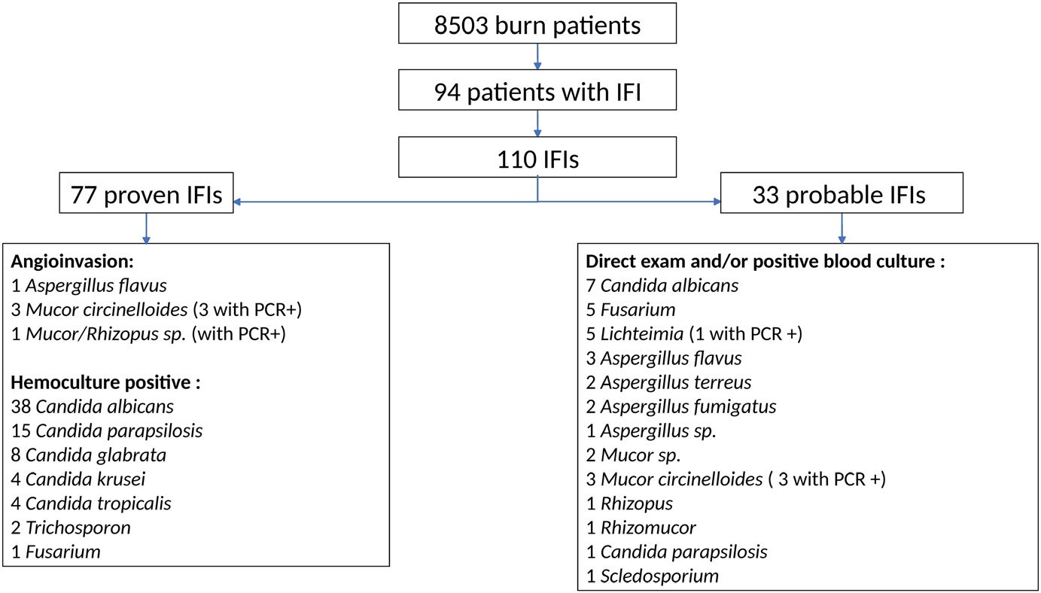 FIGURE 1 Flow chart of participants

Among the 79 yeast infections, 71 had candidaemia. Among the 16 Mucorales, 4 were diagnosed by biopsy and 12 by positive direct examination and/or culture positive. One blood culture was positive for Fusarium. PCR data for Mucorales detection were available in one centre only. Eight were positive (6 Mucor circinelloides, 1 Mucor/ Rhizopus and 1 Lichtheimia). Four were associated with angioinvasion and 4 others associated with a positive swab.
Origins of IFIs were burn wounds in 47%, catheters in 15%, lungs in 5%, urinary tract in 3%, maxillary sinus in 2%, digestive
TABLE 2 Type of IFI
IFI | All (n = 110)
tract in 1% and bone in 1%. Sixty-five (59%) IFIs cases were colonised with the same pathogen within the previous month. The pathogen was yeast in 72% of cases (57% of them were Candida albicans) and filamentous in 28% of cases (52% were Mucorales). Finally, 13 patients developed more than one IFI (Table 3). The median delay between the first and the second IFI was 4 [2-6] days, and between the second and the third IFI was 8 [4-12] days. Patients with multiple IFIs had a higher ABSI score (13 vs 9, P = .003) and higher TBSA (60% vs 40%, P = .001) than patients with one IFI only.
A bacterial co-infection was diagnosed in 91 (83%) cases at the time of IFI diagnosis, with a concomitant bacteremia in 57 (52%) of

 | Yeast infections | 79 (72)
 | Candida albicans | 45 (41)
 | Candida parapsilosis | 16 (13.6)
 | Candida glabrata | 8 (7.3)
 | Candida krusei | 4 (3.6)
 | Candida tropicalis | 4 (3.6)
 | Trichosporon | 2 (1.8)
Filamentous infections |  | 31 (28)
Aspergillus |  | 8 (7)
A fumigatus |  | 2 (1.8)
A flavus |  | 4 (3.6)
A terreus |  | 1 (0.9)
Not identified |  | 1 (0.9)
Mucorale |  | 16 (14.5)
Mucor sp. |  | 2 (1.8)
Muco circinelloides |  | 6 (5)
Rhizopus |  | 1 (0.9)
Rhizomucor |  | 1 (0.9)
Lichteimia (Absidia) |  | 5 (4.5)
Fusarium |  | 6 (5.5)
Scedosporium |  | 1 (0.9)
Note: One PCR was positive for ‘Rhizopus/Mucor’. This IFI, was directly classified as ‘Mucorale’.

TABLE 3 Detail of multiple fungal infections
Names of pathogens for patients who had 2 IFIs

First IFI Second IFI
Patient 1 | Trichosporon | Lichteimia corymbifera
Patient 2 | Fusarium sp. | Candida albicans
Patient 3 | Candida parapsilosis | Aspergillus flavus
Patient 4 | Candida albicans | Mucor sp.
Patient 5 | Candida parapsilosis | Fusarium sp.
Patient 6 | Candida parapsilosis | other Candida parapsilosis
Patient 7 | Candida albicans | Candida glabrata
Patient 8 | Candida tropicalis | Candida glabrata
Patient 9 Aspergillus flavus Fusarium fujikuroi
Patient 10 | Mucor circinelloides Aspergillus flavus
Names of pathogens for patients who had 3 IFIs

First IFI Second IFI Third IFI
Patient 11 Candida krusei Mucor Aspergillus sp.
circinelloides
Patient 12 | Mucor  circinelloides | Candida albicans | Scedosporidium
Patient 13 | Mucor  circinelloides | Fusarium sp. | Aspergillus fumigatus

IFIs. Gram negative bacteria were identified in 79 (72%) cases, including Pseudomonas aeruginosa in 33 (30%) of IFIs. Twenty-six (24%) IFIs cases had multiple co-bacterial infections.

| Treatment
At the time of IFI diagnosis, 89 (94%) patients were receiving a topical antimicrobial (47% were treated by sulfadiazine) and 10% patients were under topical antifungal treatment (ie amphotericin B emulsion −200 mg per litre of NaCl 0.9%, 3 times/day in irrigation or econazole). After IFI diagnosis, an antifungal local treatment was initiated in 18%.
Systemic treatment was initiated in 96% IFIs cases, with a median time of 1 [0-2] day after positive result.
Yeast infections were mostly treated by echinocandins and fluconazole (respectively, 39 (49%) and 31 (39%)). The initial treatment was modified in 45 cases, mainly due to lack of efficacy (n = 30), de-escalation (n = 10) and serious adverse event (n = 3). In 2 cases, the reason for initial treatment modification was not found. The median duration of treatment was 18 [11-21] days. Of the 76 yeast infections developed in patients with a central catheter, 70 catheters were removed at time of diagnosis.
First-line therapies for filamentous infections were mainly liposomal amphotericin B (58%) and voriconazole (32%). Initial treatment was re-adjusted in most patients: failure of this first-line treatment was reported in 48% of cases and dual therapy was initiated in 35% of cases. The duration of treatment was 20 [12-30] days. Twentysix of the 31 filamentous IFIs had a concomitant surgical procedure, including 6 amputations.
Patients with at least one filamentous infection had higher TBSA,
ABSI and UBS score than patients with only yeast IFI (56% vs 39%, 12 vs 9, 192 vs 120, with P = .001, P = .002 and P = .002, respectively). Patients with filamentous infection have more burn wound coverage by skin allografts than patients with only yeast infection (46% vs 21%, P = .021). No difference was found between these two groups according to the presence of autograft or xenograft (68% vs 40%, P = .239 and 32% vs 19%, P = .135).

| Mortality
ABSI, Baux score, SAPS II and TBSA were higher in non-survivors. They were more severely ill and more frequently mechanically ventilated (98% vs 80%, P = .006). The pre-identified potential risk factors of IFIs found in the literature ¹²⁻¹⁵ were as follows: inhalation injury, neutropenia, chemotherapy, corticosteroid, immunosuppressive therapy, deficit of acquired immunity, HIV, solid cancer, haematological cancer, allogenic stem cell transplant, chronic respiratory insufficiency, chronic renal replacement therapy, cirrhosis and hyperglycaemia. They were not significant associated with mortality (Table S1).
Median length of stay in BICU was 65 [39-F100] days. The 90day mortality was 37.2% (n = 35), with 52% 90-day mortality for patients with at least one filamentous infection vs 31.9% for patients with only yeast IFI (P = .082, Figure 2A). Patients with multiple IFIs and patients with bacterial co-infection at time of diagnosis had a higher mortality (61.5% vs 33.3%, P = .012, Figure 2B and 42.9% vs 12%, P = .028, Figure 3).
In multivariate analysis, the three factors, independently associated with mortality, were the presence of skin allografts at the time of IFI diagnosis, the presence of bacterial co-infections at the time of IFI diagnosis and a higher SAPS II score (Table 4).

| DISCUSSION
In this retrospective multicentre study, 110 IFIs were diagnosed among 94 burn patients over 5 years. Patients with IFIs had severe burn injury and high severity scores. Seventy-nine IFIs were yeasts infections mainly due to Candida albicans and 31 IFIs were filamentous infections of which 16 were mucormycosis. The incidence was low, but mortality was very high. Skin allografts at the time of IFI diagnosis, bacterial co-infections and a higher SAPS II score were associated with worse outcome, the two first being potentially modifiable factors.
The most represented pathogen involved were Candida and Mucor sp The four main groups of Mucoracae were Mucor, Rhizopus,

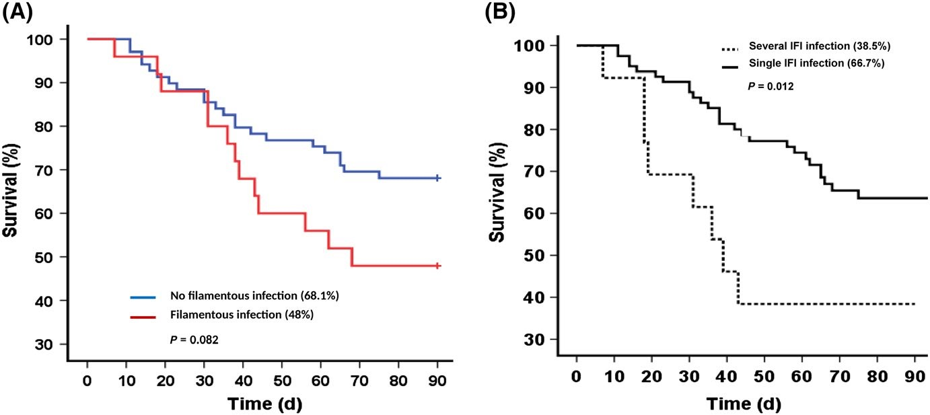
FIGURE 2 Probability of survival among patients with invasive fungal infections, according to a filamentous infection or not (Panel A) and according to the presence of single or multiple invasive fungal infections (Panel B)
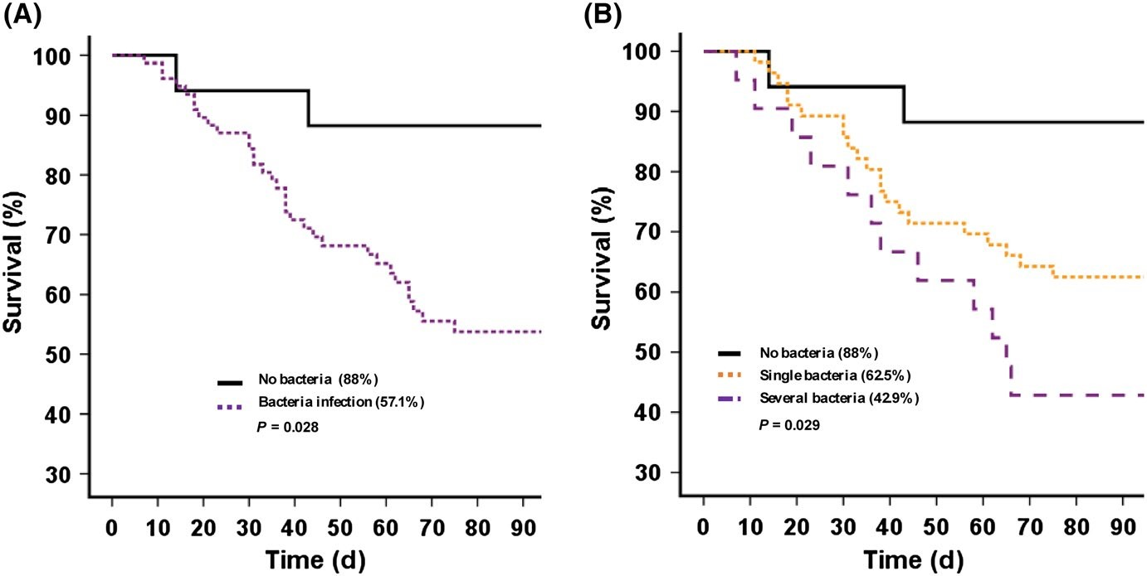
FIGURE 3 Probability of survival among patients with invasive fungal infections, according to the presence of a bacterial co-infection or not (Panel A) and according to the presence of a single, multiple or not bacterial co-infection
(Panel B)

TABLE 4 Final odds ratio estimates and 95% confidence intervals based on a multivariate analysis of factors associated with death at day 90 among patients with invasive fungal infections
Variable | Death at D90, OR (95%  CI) | P-value
SAPS II | 1.05 (1.02-1.09) | .003
Skin allografts | 3.87 (1.31-11.42) | .021
Bacterial co-infection | 3.85 (1.23-12.01) | .014
Note: Binary logistic regression models of mortality. A forward stepwise selection method was used for variables with nominal 2-tailed P less than 0.2.
Abbreviation: SAPS II, Simplified Acute Physiology Score II.
Rhizomucor and Lichteimia (or Absidia). Incidence of Mucoracae was close to the incidence of Schaal et al,¹⁶ but higher than in most previously reported series ¹⁷⁻²¹ in which Candida and Aspergillus were the most represented pathogens. Fusarium was rarely identified in our study (5.5% of the isolated fungi) which is in contrast to Branski et al (Fusarium was found in 30% of isolated fungi).⁵ Reasons for these differences might arise from evolution in patients’ characteristics and therapeutic procedures. Early surgical excision in the modern burn care era may limit the risk of Fusarium-related infections, which develop mostly in necrotic tissues. On the other hand, improved early survival can lead to prolonged critical illness with severe acquired immune deficiency increasing the risk of mucor-related infections. Of note, multiple and recurrent IFIs were not rare in our study.
In this line, mortality in the present study was slightly lower than in previous studies for the entire cohort ^{21,22} as well as for filamentous IFIs (Mitchell et al reported a 92% mortality in burn patients with mucormycosis²³). Studies related to yeast infections report mortality that can be either lower,^{24,25} similar²⁶ or higher²⁷ than mortality of patients with yeast IFIs in our study. Improvements in surgical procedures and critical care over the last decades, appropriate and prompt initiation of antifungal therapy as observed in our study, might also account for a better mortality outcome.^{28,29} Early initiation of a systemic antifungal therapy along with surgical treatment of filamentous infection was applied to most patients.³⁰⁻³² Finally, early detection of mucormycosis using circulating Mucorales DNA by PCR (polymerase chain reaction) with early treatment initiation in one centre might account for better survival in filamentous infections.^{11,33}
In univariate analysis, despite a trend towards higher mortality for filamentous IFI, the type of IFI was not significantly associated with outcome. This is probably due to a lack of power related to the low sample size. Number of IFIs and bacterial co-infection were associated with mortality in multivariate analysis.¹⁸ This suggests a major role of bacterial infections in outcome with strong interactions with fungal infection and also underline immunosuppression in these patients.
Early surgical excision might improve survival partially through prevention of recurrent infections but also more efficient treatment in fungal infection. On the other hand, patients with larger TBSA were more likely to receive allografts and were more severe. Allografts remained associated with the risk of death in patients with filamentous infections and represent a potential risk factor for uncontrolled infections due to the inert and non-vascularized nature of the graft limiting diffusion of antifungal therapies. Whether removal of allograft in patients with IFI would allow better control of the infections and ultimately improve of mortality should be explored.
Our study suffers from some limitations. First, this is a retrospective study introducing some potential bias in the data collection. Secondly, the sample size is rather low, which may limit the power to identify some risk factors of poor outcome (including the type of IFI). This is however, to the best of our knowledge, the study with the largest cases of IFI in burn patients. There is no consensus on diagnostic procedures. Thirdly, it is unclear to know how much bacterial infections have contributed to death. Fungal infection was very often associated with bacterial infection reflecting probably the associated immune suppression in these patients. The contribution of each infection to the outcome is highly difficult to determine. The cause of death in our patients was most of the time multiple organ failure without recovery. Our hypothesis is that initial burn injury was the cause of systemic inflammatory response with immune suppression and secondary infections strongly contributed to non-recovery of multiple organ failure. Finally, the study shows a great heterogeneity in practices between centres. Homogenisation of practices and implementation of modern techniques (such as PCR) to detect early fungal infections will represent a challenge for the future and an area of improvement.
In conclusion, this multicentre study shows that fungal infections are rare in burn patients but associated with high mortality. The mortality appears however lower compared to control historical cohorts, suggesting improved survival over time. Bacterial co-infection and presence of skin allografts at time of IFI were factors independent associated with mortality and potentially modifiable factors.

ACKNOWLEDGMENT
We would like to thank the Research group SPILF-CMIT for supporting this study.

CONFLICT OF INTEREST
Textoris Julien is a part-time employee of bioMérieux. All others authors: No potential conflicts of interest.

AUTHOR CONTRIBUTIONS
ML and BD conceived the study. MC, VM, MJ, AC, AA, BG, A-FR, RL, ML-X, JT and SW collected the data. CT analysed the data. VM wrote the first draft of the manuscript. ML supervised the study, and all approved the final version of the manuscript.

ORCID
Véronique Maurel https://orcid.org/0000-0001-7554-9821
Blandine Denis https://orcid.org/0000-0003-2101-2601

REFERENCES
- Ravat F, Payre J, Peslages P, Fontaine M, Sens N. Burn: An inflammatory process. Pathol Biol (Paris). 2011;59(3):e63-e72.
- Venet F, Tissot S, Debard A-L, et al. Decreased monocyte human leukocyte antigen-DR expression after severe burn injury: Correlation with severity and secondary septic shock. Crit Care Med. 2007;35(8):1910-1917.
- Fayazov AD, Shukurov SI, Shukurov BI, Sultanov BC, Namazov AN, Ruzimuratov DA. Disorders of the immune system in severely burned patients. Ann Burns Fire Disasters. 2009;22(3):121-130.
- Santucci SG, Gobara S, Santos CR, Fontana C, Levin AS. Infections in a burn intensive care unit: experience of seven years. J Hosp Infect. 2003;53(1):6-13.
- Branski LK, Al-Mousawi A, Rivero H, Jeschke MG, Sanford AP, Herndon DN. Emerging infections in burns. Surg Infect. 2009;10(5):389-397.
- Marichy J, Banssillon V, Fabry J, Sepetjian M, Margue Y. Vital prognosis of burns. Anesth Analg (Paris). 1977;34(6):1293-1302.
- De Pauw B, Walsh T, Donnelly J, et al. Revised definitions of invasive fungal disease from the European Organization for Research and Treatment of Cancer/Invasive Fungal Infections Cooperative Group and the National Institute of Allergy and Infectious Diseases Mycoses Study Group (EORTC/MSG) Consensus Group. Clin Infect Dis. 2008;46(12):1813-1821.
- Cornely OA, Bassetti M, Calandra T, et al. ESCMID* guideline for the diagnosis and management of Candida diseases 2012: non-neutropenic adult patients. Clin Microbiol Infect. 2012;18(Suppl 7):19-37.
- Société française d’étude et de traitement des brûlures (SFETB). [Guidelines for use of antibiotics in burn patient at the acute phase– long text. Société française d’étude et de traitement des brûlures]. Ann Fr Anesth Reanim. 2009;28(3):265-274.
- Millon L, Herbrecht R, Grenouillet F, et al. Early diagnosis and monitoring of mucormycosis by detection of circulating DNA in serum: retrospective analysis of 44 cases collected through the French Surveillance Network of Invasive Fungal Infections (RESSIF). Clin Microbiol Infect. 2016;22(9):810.e1-810.e8.
- Legrand M, Gits-Muselli M, Boutin L, et al. Detection of circulating mucorales DNA in critically Ill burn patients: preliminary report of a screening strategy for early diagnosis and treatment. Clin Infect Dis. 2016;63(10):1312-1317.
- Pedrosa AFB, Rodrigues AG. Candidemia in burn patients: figures and facts. J Trauma. 2011;70(2):498-506.
- Eggimann P, Bille J, Marchetti O. Diagnosis of invasive candidiasis in the ICU. Ann Intensive Care. 2011;1:37.
- Struck MF, Gille J. Fungal infections in burns: a comprehensive review. Ann Burns Fire Disasters. 2013;26(3):147-153.
- Arnould J, Le Floch R. Infections fongiques des brûlé: revue. Ann Burns Fire Disasters. 2015;28(1):21-28.
- Schaal JV, Leclerc T, Soler C, et al. Epidemiology of filamentous fungal infections in burned patients: A French retrospective study. Burns. 2015;41(4):853-863.
- Becker WK, Cioffi WG, McManus AT, et al. Fungal burn wound infection. A 10-year experience. Arch Surg. 1991;126(1):44-48.
- Sarabahi S, Tiwari VK, Arora S, Capoor MR, Pandey A. Changing pattern of fungal infection in burn patients. Burns. 2012;38(4):520-528.
- Capoor MR, Sarabahi S, Tiwari VK, Narayanan RP. Fungal infections in burns: Diagnosis and management. Indian J Plast Surg. 2010;43(Suppl):S37-S42.
- Mousa HA, Al-Bader SM, Hassan DA. Correlation between fungi isolated from burn wounds and burn care units. Burns. 1999;25(2):145-147.
- Schofield CM, Murray CK, Horvath EE, et al. Correlation of culture with histopathology in fungal burn wound colonization and infection. Burns. 2007;33(3):341-346.
- Horvath EE, Murray CK, Vaughan GM, et al. Fungal wound infection (not colonization) is independently associated with mortality in burn patients. Ann Surg. 2007;245(6):978-985.
- Mitchell TA, Hardin MO, Murray CK, et al. Mucormycosis attributed mortality: a seven-year review of surgical and medical management. Burns. 2014;40(8):1689-1695.
- Cochran A, Morris SE, Edelman LS, Saffle JR. Systemic Candida infection in burn patients: a case-control study of management patterns and outcomes. Surg Infect. 2002;3(4):367-374.
- Vinsonneau C, Benyamina M, Baixench MT, et al. Effects of candidaemia on outcome of burns. Burns. 2009;35(4):561-564.
- Gudlaugsson O, Gillespie S, Lee K, et al. Attributable mortality of nosocomial candidemia, revisited. Clin Infect Dis. 2003;37(9):1172-1177.
- Ekenna O, Sherertz RJ, Bingham H. Natural history of bloodstream infections in a burn patient population: the importance of candidemia. Am J Infect Control. 1993;21(4):189-195.
- Katz T, Wasiak J, Cleland H, Padiglione A. Incidence of non-candidal fungal infections in severe burn injury: an Australian perspective. Burns. 2014;40(5):881-886.
- Ibrahim EH, Ward S, Sherman G, Kollef MH. A comparative analysis of patients with early-onset vs late-onset nosocomial pneumonia in the ICU setting. Chest. 2000;117(5):1434-1442.
- Perlroth J, Choi B, Spellberg B. Nosocomial fungal infections: epidemiology, diagnosis, and treatment. Med Mycol. 2007;45(4):321-346.
- Walsh T, Anaissie E, Denning D, et al. Treatment of aspergillosis: clinical practice guidelines of the Infectious Diseases Society of America. Clin Infect Dis. 2008;46(3):327-360.
- Spellberg B, Walsh TJ, Kontoyiannis DP, Edwards J, Ibrahim AS. Recent advances in the management of mucormycosis: from bench to bedside. Clin Infect Dis. 2009;48(12):1743-1751.
- Millon L, Larosa F, Lepiller Q, et al. Quantitative polymerase chain reaction detection of circulating DNA in serum for early diagnosis of mucormycosis in immunocompromised patients. Clin Infect Dis. 2013;56(10):e95-e101.

SUPPORTING INFORMATION
Additional supporting information may be found online in the Supporting Information section.
How to cite this article: Maurel V, Denis B, Camby M, et al. Outcome and characteristics of invasive fungal infections in critically ill burn patients: A multicenter retrospective study. Mycoses. 2020;63:535–542. https://doi.org/10.1111/ myc.13068

