Supplementary information

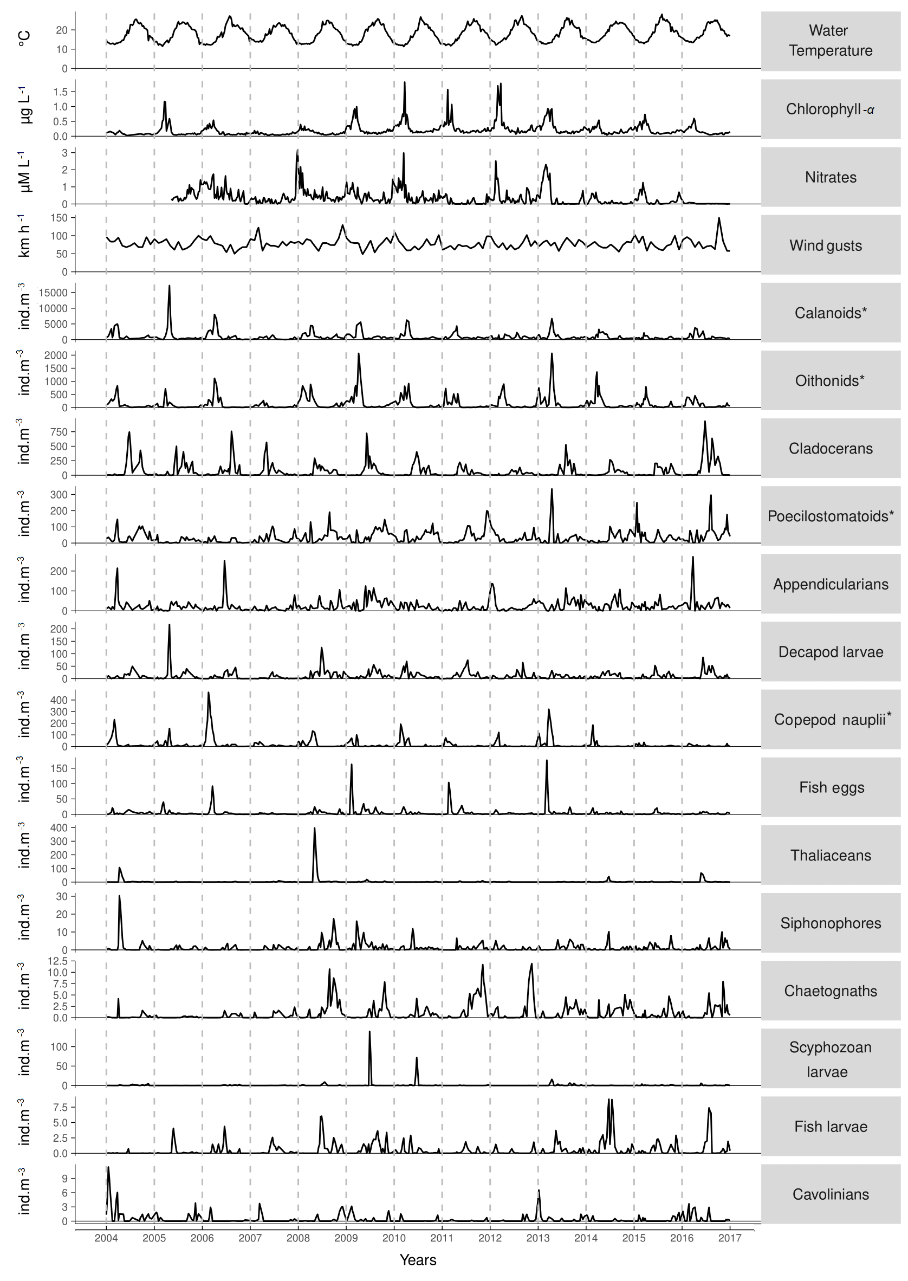Figure A1: The 13-year time series of environmental parameters (water temperature, chlorophyll-a, nitrates and wind gusts) and the 14 groups of zooplankton in decreasing order of average abundance. Copepod groups are highlighted by *.

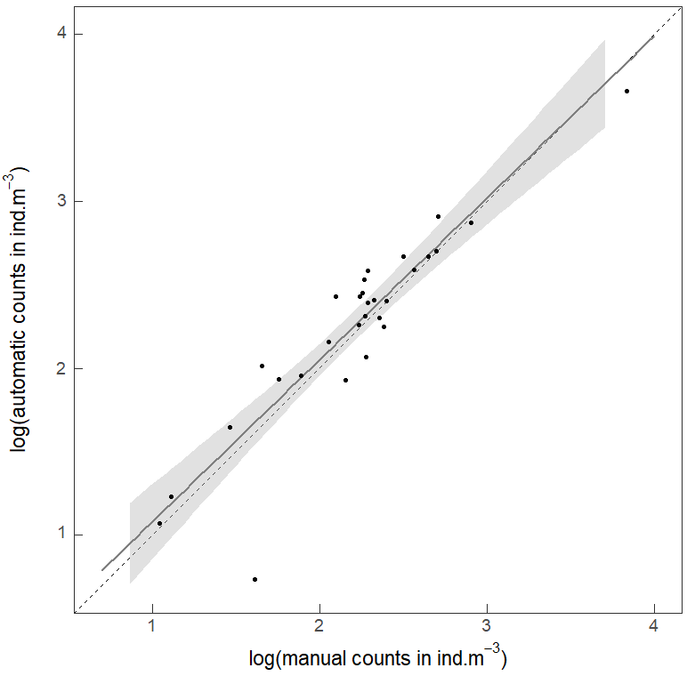
Figure A2: Relationship between the manual estimation of copepod abundance in the samples and its semi-automatic estimates. Altogether, 30 samples belonging to 6 nonconsecutive years (5 nonconsecutive months every year) were considered. A binocular (SMZ 1270 Ergo), Dollfus tray and Stempel pipettes were used. The grey area represents the 95% confidence envelope around the regression line (full line). The bisector (dotted line) representing a perfect match between the two counting methods is within the confidence envelope. This indicates that the regression line is not significantly different from the bisector at the alpha-level of 5 %.
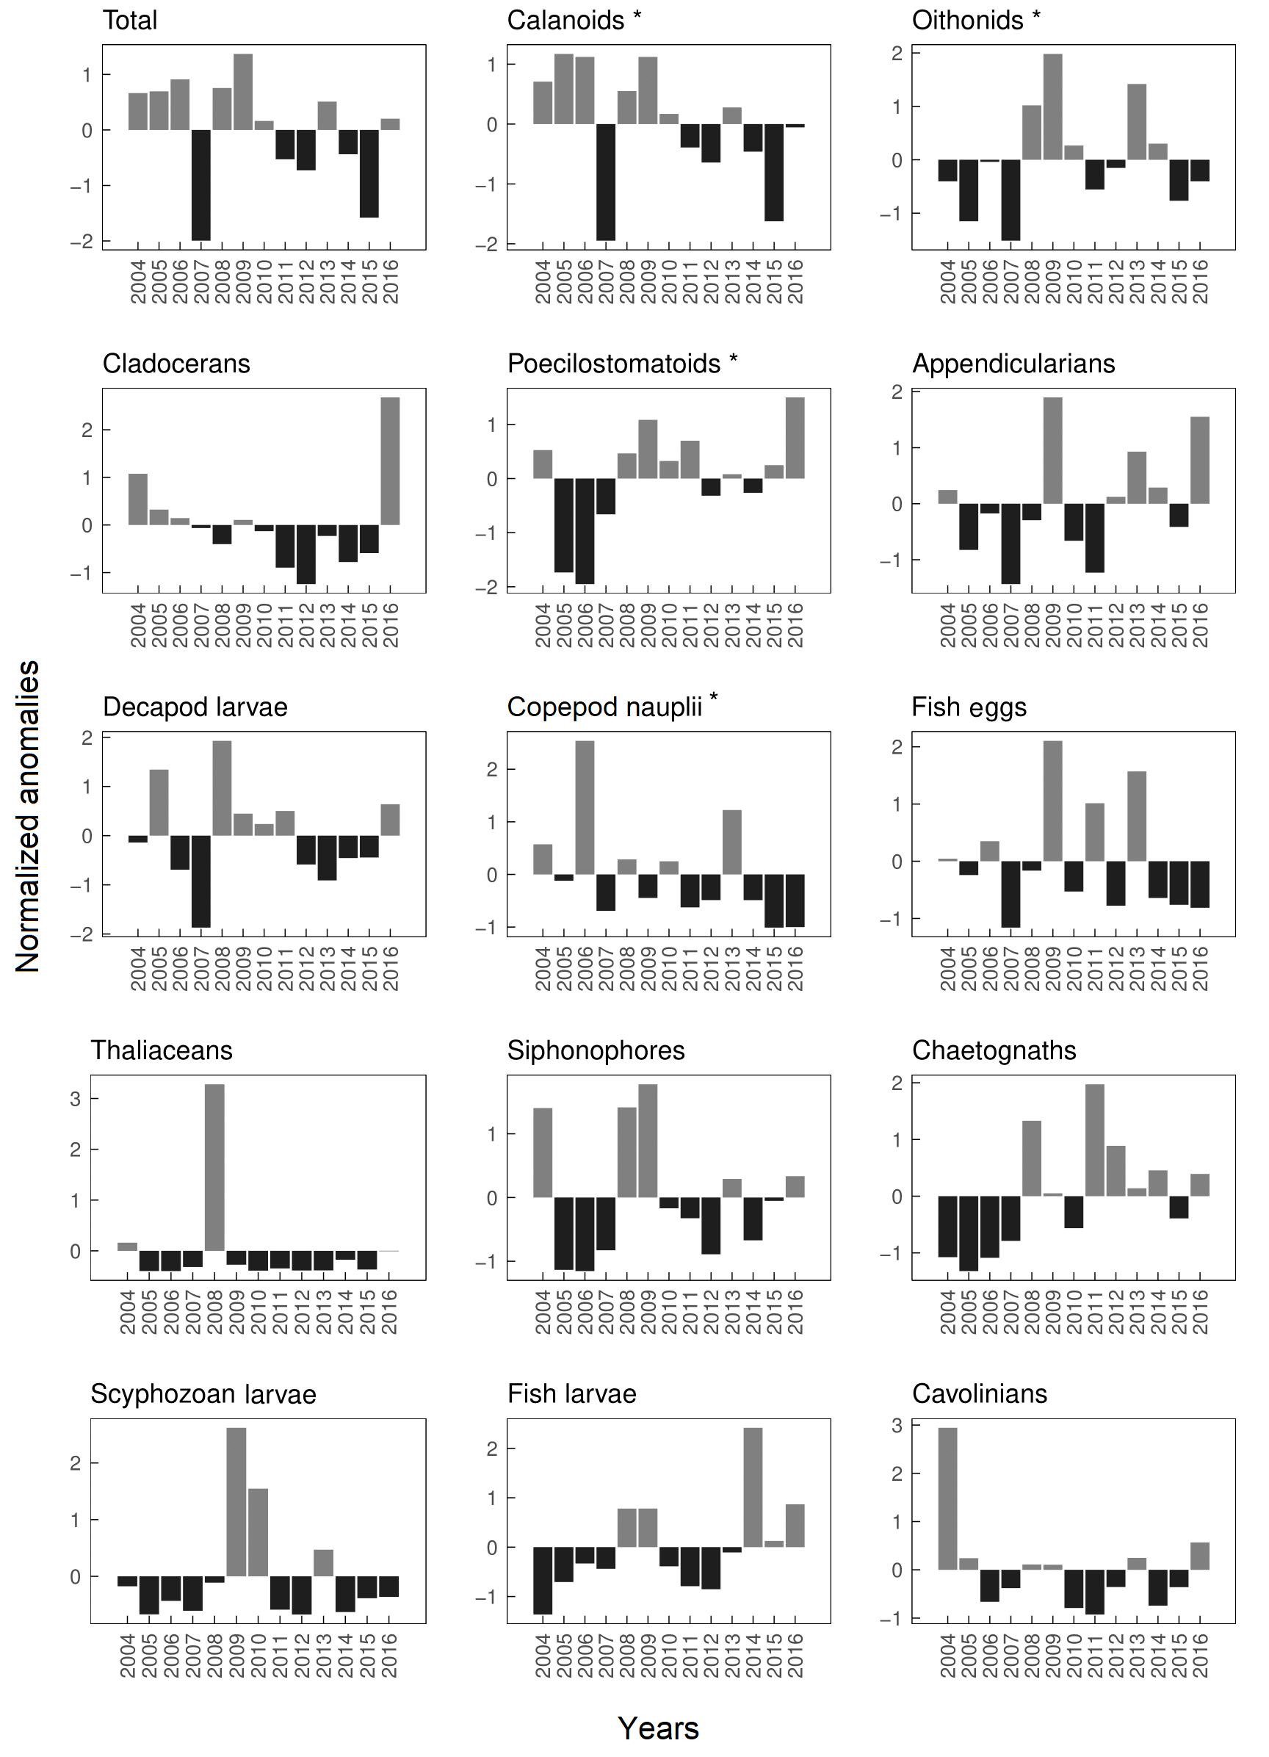
Figure A3: Annual normalized anomalies from 2004 to 2016 of total zooplankton and each zooplankton group, in decreasing order of average abundance. Copepod groups are highlighted by *.
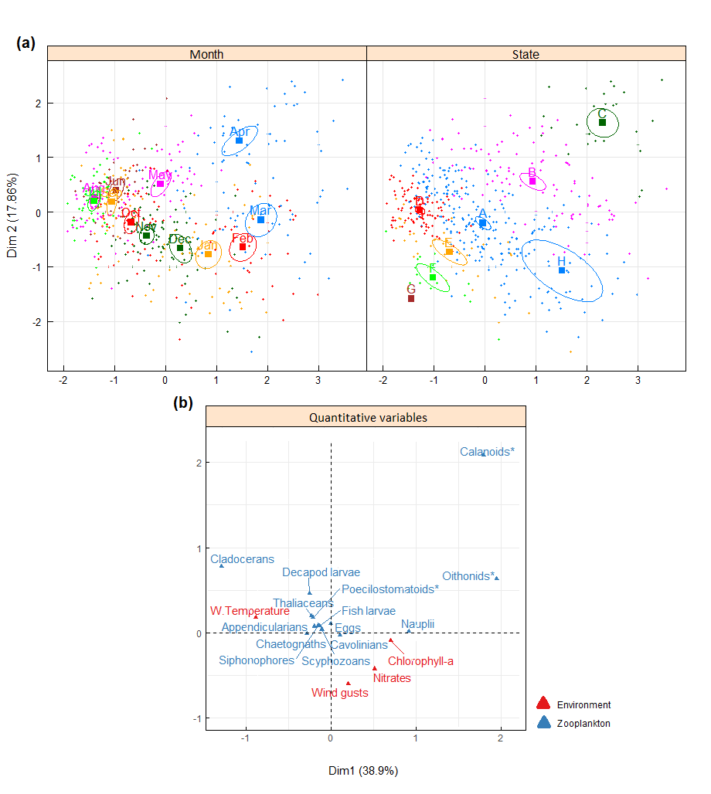
Figure A4. Two-dimensional plots of (a) observations and (b) quantitative variables generated through Multiple Factor Analysis (MFA) performed using the R package FactoMineR (http://factominer.free.fr). The MFA includes standardized environmental data (wind gusts, water temperature and nitrates), cubic rooted transformed zooplankton data, and two factors: “Month” and “State” corresponding to the eight community states from A to H of Figs. 7 to 9. Figure colors are independent of each other. Ellipses in (a) correspond to the 0.95 confidence level. Copepods groups are highlighted by * in (b). Note that group names were sometimes shortened to ensure better visibility.

