Figure 1. Sense of parental competence, efficacy and satisfaction based on childhood experiences.
Figure 2. Scores for sense of parental competence assessed by the model for each group and each sex, as a function of age.

Figure 3. Scores for sense of parental satisfaction assessed by the model for each group and each sex, as a function of age.

Figure 4. Scores for sense of parental efficacy assessed by the model for each group, as a function of age.

Figure 5. Distribution of subjects by age and sex
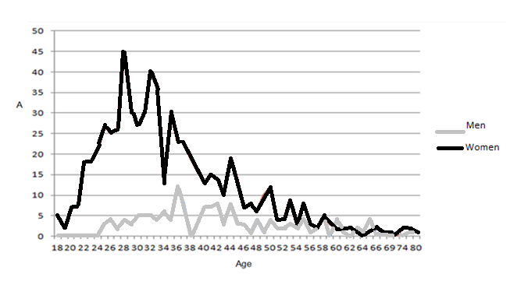

Figure 6. Distribution of subjects by nationality
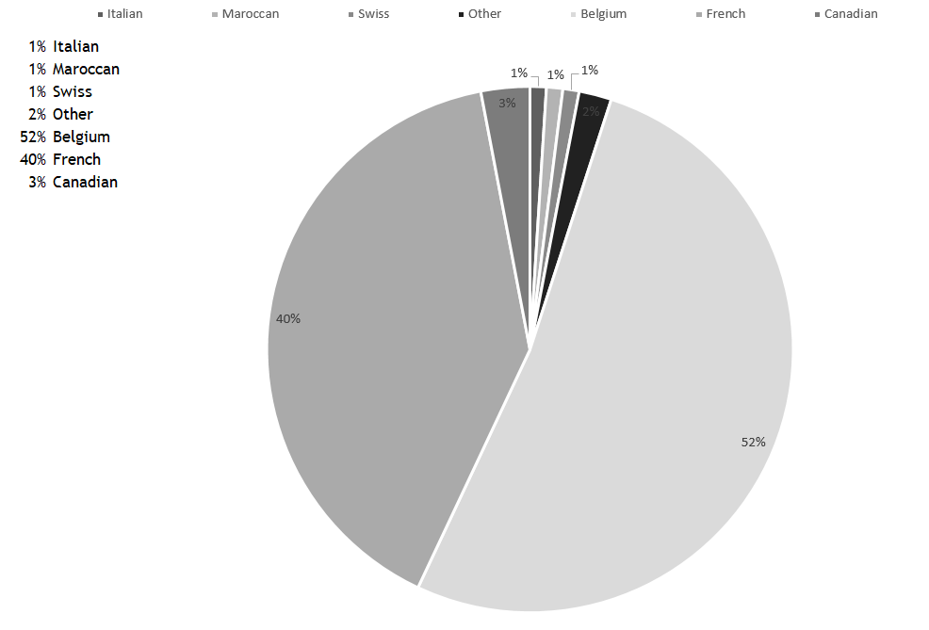

Figure 7. Distribution of subjects by highest degree obtained.
