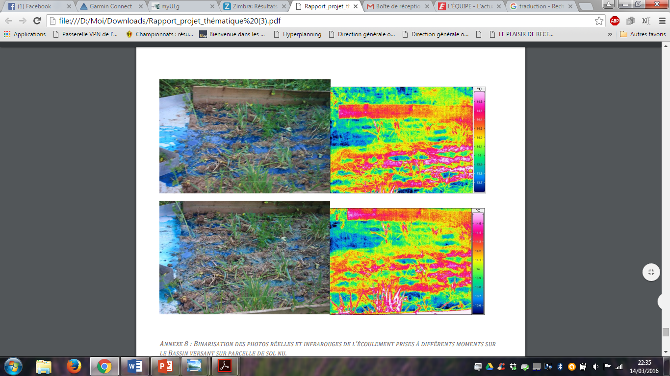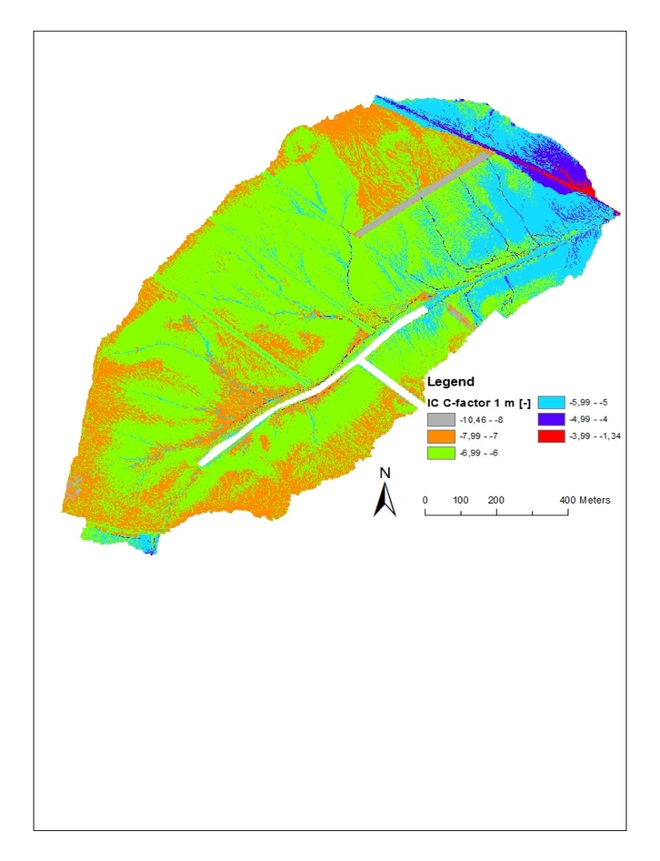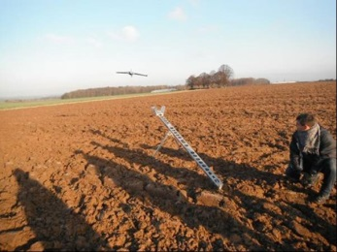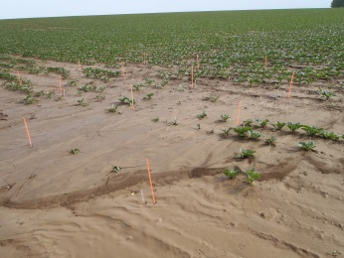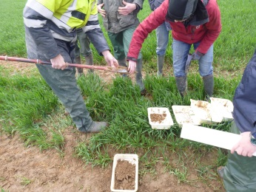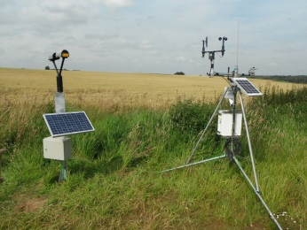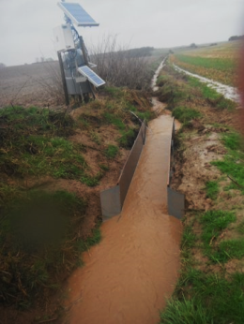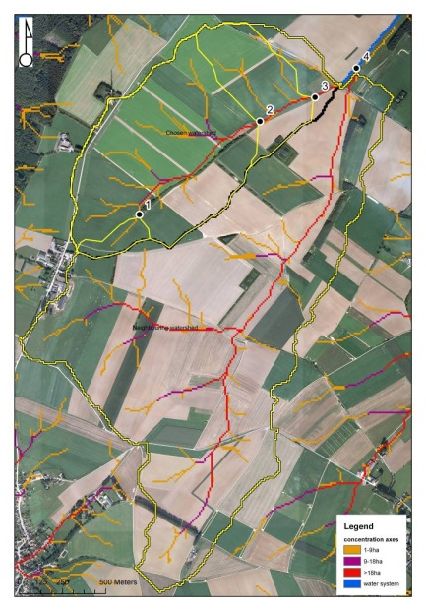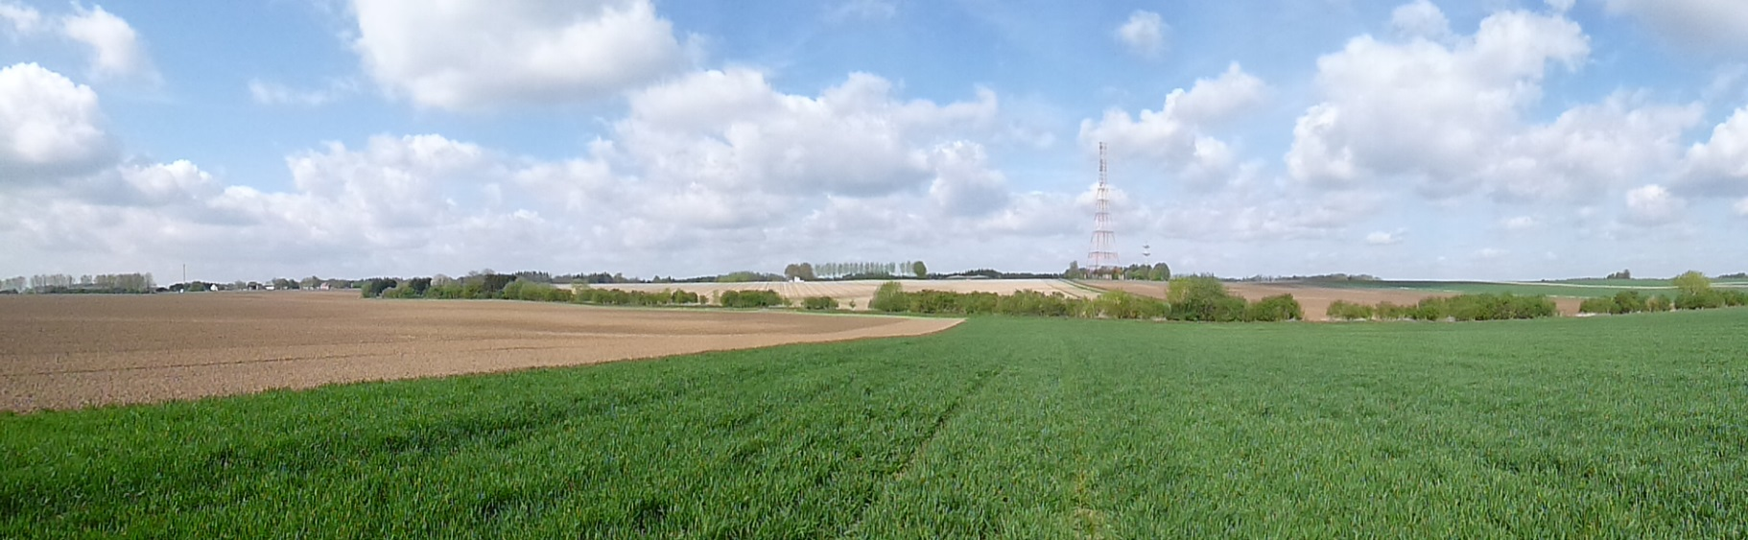

* Use of thermic camera to visualize runoff
* Index of connectivity of Borselli (more the value rises, more the area conducts fast water to the outlet)

**The combination of the use of indices and measurements helps to understand how water moves on the soil during and after rainy events.**

**We are also studying the hydrological connectivity of the catchment, that is the hydrological link between different parts of it (head, hillslopes, channel and outlet). It permits to identify areas which increase runoff and erosion or in the opposite hydrologic barriers in the catchment.**

**Within an agricultural area catchment representative of the loamy area, we observe continuously the rainy events and their consequences in terms of erosion by runoff water. Measurements are carried out since 2012, and will continue during several years.**

* Weather station   
  + flow measurements & sediments sampling
* Graduated rulers
* Annual DSM’s from drone
* Soil survey

**The combination of several measurement methods allows to test the performances of prediction models and to improve our knowledge of the spatial pattern of erosion/deposition.**

Nathalie Pineux and Vincent Cantreul

Univ. Liège, Gembloux Agro-Bio Tech, BIOSE, Soil Water Plant Exchanges

**Which measurement strategies to improve spatial erosion and deposition** **patterns modelling?**