Abstract Title *

Enter the presentation title with the first letter of each main content word capitalized. 200 character maximum (including spaces).

“Age-related differences in using memory to predict the course of new events”

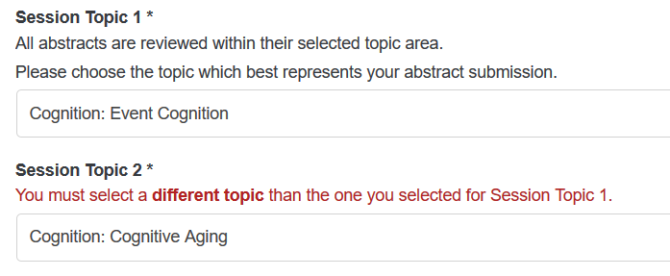

Your submission is not to exceed **1,250 characters, including spaces**.

All abstracts must be prepared in plain text, in English, with no embedded symbols or formatting characters, including "Smart Formatting" as used by some word processing programs. Electronic submission may not include charts, graphs, tables, or reference.

Activities such as parking a car or grocery shopping often repeat with variations. To guide action, people retrieve relevant previous events and register discrepancies with current ones. Wahlheim & Zacks (in press, JEP:G) proposed that perceivers’ brains register discrepancies and encode the retrieval and the discrepancy as part of the new event representation. If any of these steps are affected by aging, this could account for some age differences in event memory. To test this, we presented young and healthy older adults with pairs of movies showing similar daily activities but involving changed features—for example, hanging a purple vs white towel. Before each changed feature, we asked participants to predict what would happen based on their memory for the previous instance. For trials where young adults were able to make memory-based predictions their subsequent memory for the changed events was better. Older adults made fewer memory-based predictions—and, critically, failed to show a benefit of doing so on their subsequent memory for the changed features. This suggests that healthy aging may affect the ability to form memory representations that integrate the cognitive traces of processing unexpected discrepancies.

Keywords

Please just enter one keyword or keyword phrase per box. These will be used for the Topic Index.

Keyword 1 *



Keyword 2 *



Keyword 3



Contact Full Name *

David Stawarczyk