Prof. Yann Berthelet
University of Liège

Roman Gods' Networks: presentation of the research project and case study of Apollo
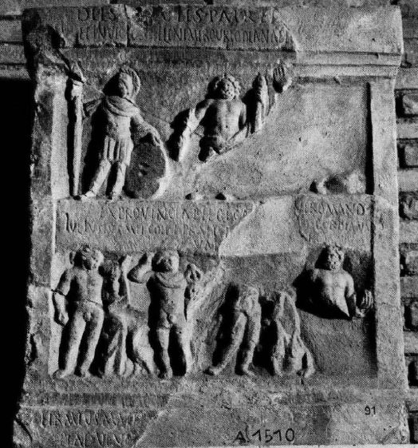
Thursday, November 21, 2019
5:00 PM
Murphey 104

Sponsored by the UNC Department of Classics
NB: If you are planning to offer extra credit to your students for their attendance at this lecture, please contact the Classics Department Office so we can ensure that ample space is available.
Contact: lealex@unc.edu or (919) 962-7191

