A Heartbeat Away From Consciousness:
Heart Rate Entropy can assess Consciousness

Stephen Karl Larroque^{1*}, Francesco Riganello^{1,2*}, Mohamed Ali Bahri³, Lizette Heine⁴, Charlotte Martial¹, Manon Carrière¹, Vanessa Charland-Verville¹, Charlène Aubinet¹, Audrey Vanhaudenhuyse⁵, Camille Chatelle¹, Steven Laureys¹, Carol Di Perri^{1,6}
¹ Coma Science Group, GIGA-Consciousness, University & Hospital of Liege, Belgium
² Research in Advanced NeuroRehabilitation, Istituto S. Anna, Crotone, Italy
³ GIGA-Cyclotron Research Center In Vivo Imaging, University of Liege, Belgium
⁴ Centre de Recherche en Neurosciences, Inserm U1028 - CNRS UMR5292, University of Lyon 1, France
⁵ Sensation & Perception research Group, GIGA-Consciousness, University & Hospital of Liege, Belgium
⁶ Centre for Clinical Brain Sciences, University of Edinburgh, Edinburgh, UK
* These authors contributed equally to this work.
stephen.larroque@uliege.be, f.riganello@istitutosantanna.it

Motivation:
Disorders of consciousness are challenging to diagnose, with inconsistent behavioral responses, motor and cognitive disabilities, leading to approximately 40% misdiagnoses[1]. Heart rate variability (HRV) reflects the heart-brain two-way dynamic interactions[2-5]. HRV entropy analysis quantifies the unpredictability and complexity of the heart rate beats intervals and over multiple time scales using multiscale entropy (MSE)[6-8]. The complexity index (CI) provides a score of a system’s complexity by aggregating the MSE measures over a range of time scales[8]. Most HRV entropy studies have focused on acute traumatic patients using task-based designs[9]. We here investigate the CI and its discriminative power in chronic patients with unresponsive wakefulness syndrome (UWS) and minimally conscious state (MCS) at rest, and its relation to brain functional connectivity.

Methods:
We investigated the CI in short (CI_{s}) and long (CI_{l}) time scales in 14 UWS and 16 MCS sedated. CI for MCS and UWS groups were compared using a Mann-Whitney exact test. Spearman’s correlation tests were conducted between the Coma Recovery Scale-revised (CRS-R) and both CI. Discriminative power of both CI was assessed with One-R machine learning model. Correlation between CI and brain connectivity (detected with functional magnetic resonance imagery using seed-based and hypothesis-free intrinsic connectivity) was investigated using a linear regression in a subgroup of 10 UWS and 11 MCS patients with sufficient image quality.

Results and Discussion:
Higher CI_{s} and CI_{l} measures were observed in MCS compared to UWS. Positive correlations were found between CRS-R and both CI. The One-R classifier selected CI_{l} as the best discriminator between UWS and MCS with 90% accuracy, 7% false positive and 13% false negative rates after a 10-fold cross-validation test. Positive correlations were observed between both CI and the recovery of functional connectivity of brain areas belonging to the central autonomic networks (CAN).
The CI has a high discriminative power for the level of consciousness between MCS and UWS, with low false negative rate at one third of the reported misdiagnosis rate of human assessors, providing an easy, inexpensive and non-invasive diagnosis tool. CI reflects functional connectivity changes in brain regions belonging to the CAN, suggesting that CI can provide an indirect way to screen and monitor connectivity changes in this neural system. Future studies should investigate further the extent of CI’s predictive power for other pathologies and prognostic power in acute patients.

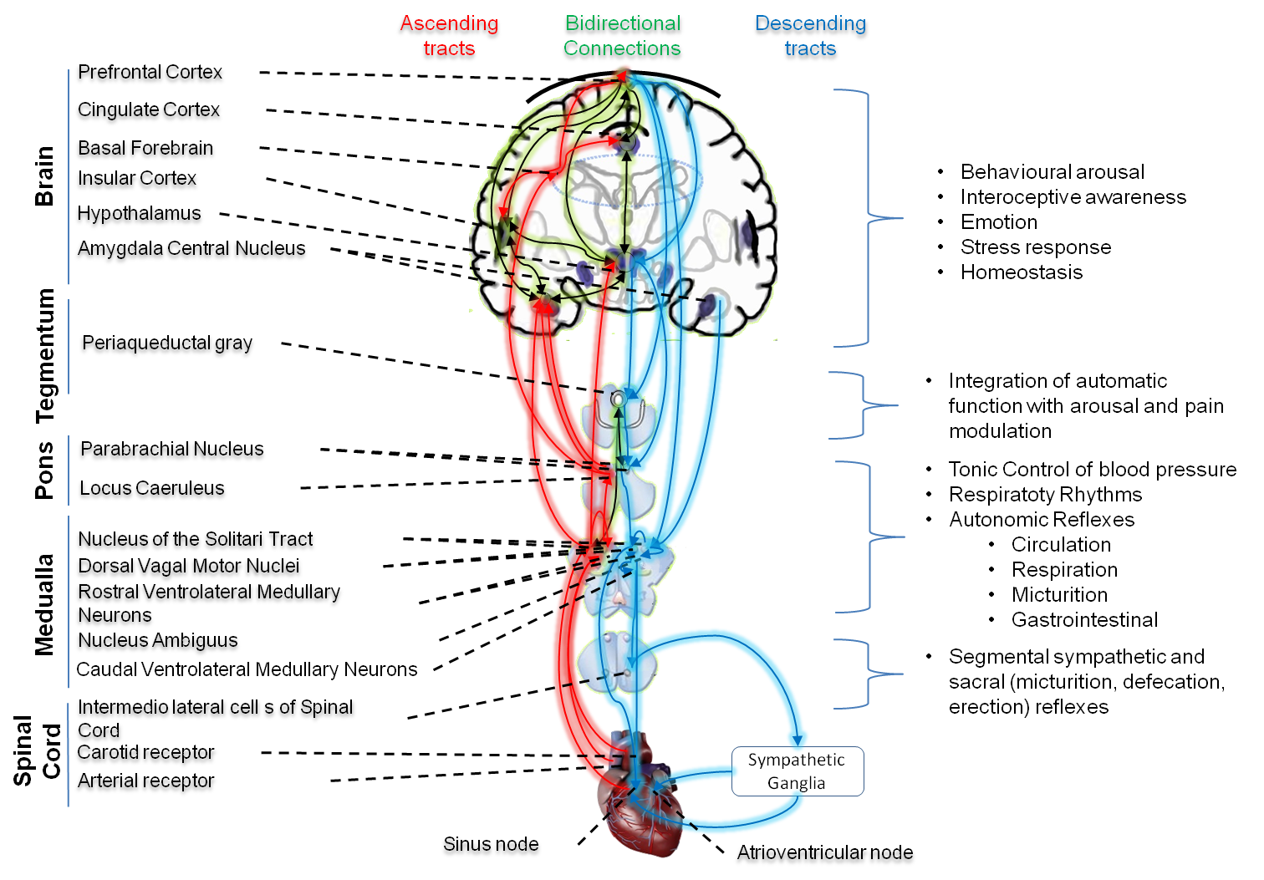
Figure 1: The heart-brain two-way pathways, connecting the heart through the Autonomic Nervous System (ANS) to the brain’s Central Autonomic Network (CAN) covering the structures of the brainstem (periaqueductal gray matter, nucleus ambiguous and ventromedial medulla), limbic structure (amygdala and hypothalamus), prefrontal cortex (anterior cingulate, insula, orbitofrontal, and ventromedial cortex) and cerebellum[10]. Some brain regions of the CAN (dorsolateral prefrontal cortex, mediodorsal thalamus, hippocampus, caudate, septal nucleus and middle temporal gyrus) seem to be unique to humans[11].

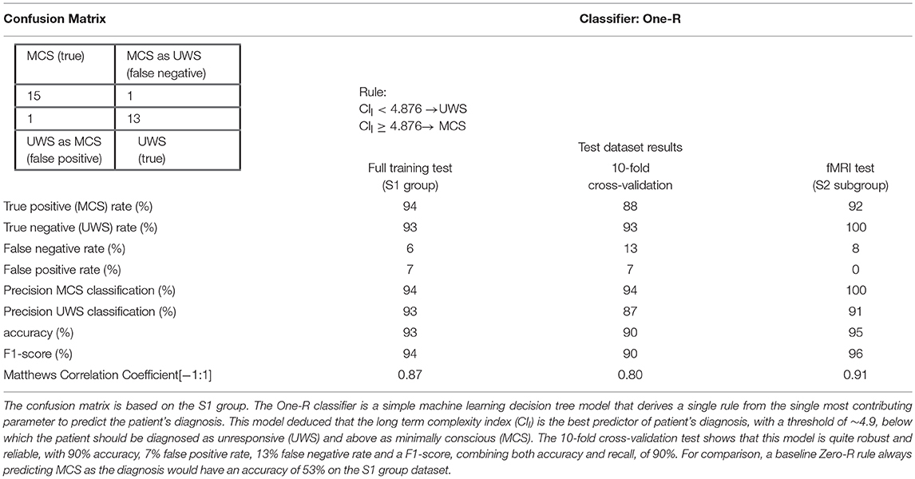

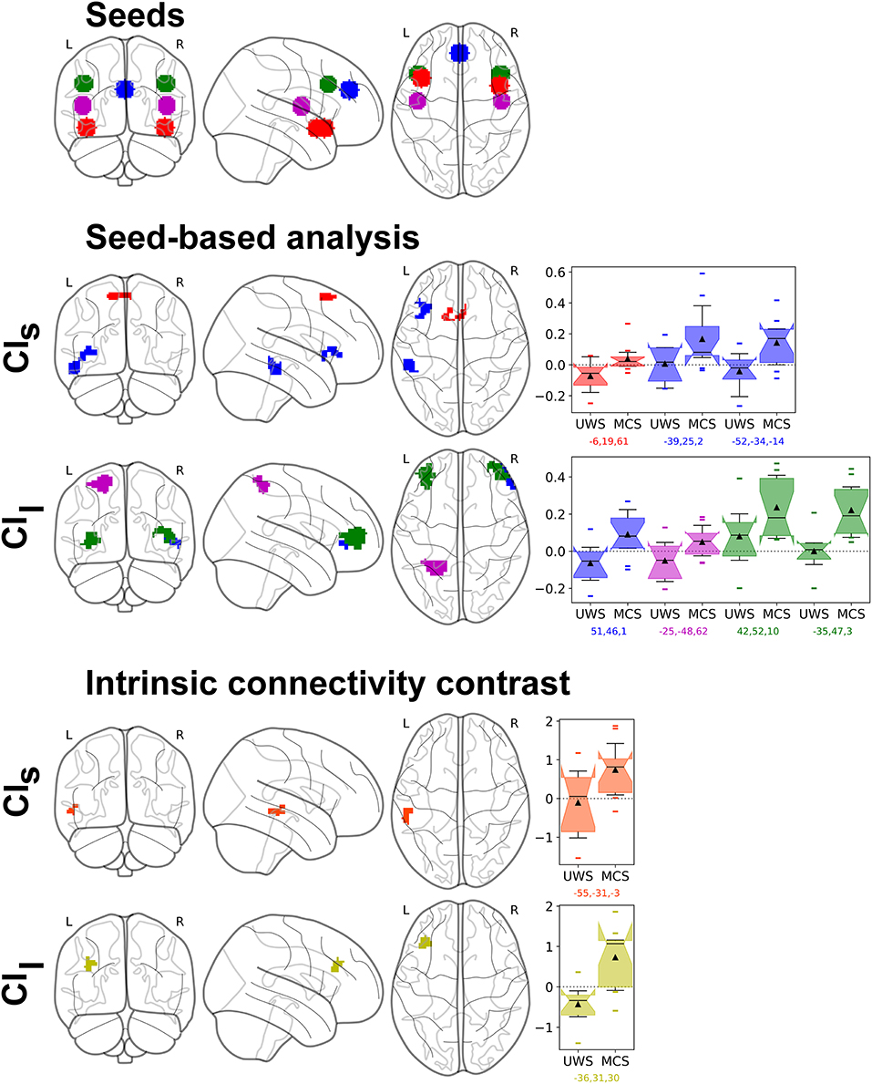
Figure 3: Resting-state fMRI analysis results of the parametric regression between CI and UWS/MCS patients' connectivity changes in the S2 group (n = 21). Top row shows the seeds: Fronto-Insular (FI, red), Paracingulate cortex (PC, blue), Superior Temporal Gyrus (STG, magenta), Dorso-lateral prefrontal cortex (DLPFC, green). Middle rows show the seed-based analysis results, with same colors as the seeds, and effect size as box plots, first with the CI in short time scale (CI_{s}) and then long time scale (CI_{l}). Bottom rows show the hypothesis-free intrinsic connectivity correlation (ICC) results, with a positive correlation between values of CI_{s} and an increase of intrinsic connectivity of the posterior Middle Temporal Gyrus and posterior STG (orange); and a correlation between CI_{l} and an increase of intrinsic connectivity in the Middle Frontal Gyrus (yellow). Statistical significance was considered at permutation of residuals test cluster-mass p-FWE < 0.1 and primary threshold p-uncorrected < 0.001.

References:
[1] Schnakers C, Vanhaudenhuyse A, Giacino J, Ventura M, Boly M, Majerus S, et al. Diagnostic accuracy of the vegetative and minimally conscious state: clinical consensus versus standardized neurobehavioral assessment. BMC Neurol. (2009) 9:35.
[2] Palma J-A, Benarroch EE. Neural control of the heart: Recent concepts and clinical correlations. Neurology (2014) 83:261–271.
[3] Porges SW. The polyvagal theory: New insights into adaptive reactions of the autonomic nervous system. Cleve Clin J Med (2009) 76:S86–S90.
[4] Thayer JF, Lane RD. A model of neurovisceral integration in emotion regulation and dysregulation. J Affect Disord (2000) 61:201–216.
[5] Harrison NA, Cooper E, Voon V, Miles K, Critchley HD. Central autonomic network mediates cardiovascular responses to acute inflammation: Relevance to increased cardiovascular risk in depression? Brain Behav Immun (2013) 31:189–196.
[6] Costa M, Goldberger AL, Peng CK, others. Multiscale Entropy Analysis (MSE). (2000).
[7] Voss A, Schulz S, Schroeder R, Baumert M, Caminal P. Methods derived from nonlinear dynamics for analysing heart rate variability. Philos Trans R Soc Math Phys Eng Sci (2009) 367:277–296.
[8] Costa M, Goldberger AL, Peng C-K. Multiscale entropy analysis of biological signals. Phys Rev E (2005) 71.
[9] Riganello F, Garbarino S, Sannita WG. Heart Rate Variability, Homeostasis, and Brain Function: A Tutorial and Review of Application. J Psychophysiol (2012) 26:178–203.
[10] Cechetto DF, Shoemaker JK. Functional neuroanatomy of autonomic regulation. NeuroImage (2009) 47:795–803.
[11] Napadow V, Dhond R, Conti G, Makris N, Brown EN, Barbieri R. Brain Correlates of Autonomic Modulation: Combining Heart Rate Variability with fMRI. NeuroImage (2008) 42:169–177.

