Proceedings of ECOS 2019 - the 32st International Conference on
Efficiency, Cost, Optimization, Simulation and Environmental Impact of Energy Systems
June 23-28, 2019, WROCLAW, PORTUGAL

Thermo-technical approach to characterize the performance of a reversible heat pump/organic Rankine cycle power system depending on its operational conditions
Olivier Dumont(CA)ª, Vincent Lemort^{b}
ª Thermodynamics laboratory, Liège, Belgium, olivier.dumont@ulg.ac.be
^{b}Thermodynamics laboratory, Liège, Belgium, vincent.lemort@ulg.ac.be
Abstract:
The concept of reversible Heat Pump/Organic Rankine Cycle (HP/ORC) power system has been studied more and more in the last decade. This innovative system allows a high flexibility through its ability to convert heat into electricity (ORC) or electricity into heat (HP) depending on the requirements of the application. To the author’s best knowledge, the concept was proposed for the first time in 2006 and the first prototype of reversible HP/ORC power system demonstrated its technical feasibility in 2013. A wide range of applications is possible thanks to the modularity of the system: heating, cooling and power production in passenger cars, boats, trucks and datacentres, Pumped Thermal Energy Storage (Carnot battery), Net Zero Energy Building, valorization of industrial waste heat and district heating networks. Based on the experimental investigation learned from the prototype developed in 2015, it is possible to identify physical constraints that limit the performance of the system. Indeed, due to the differences of operating conditions between the heat pump and Organic Rankine Cycle modes, some constraints are highlighted on the range of thermal power (compatibility of thermal power between ORC and HP modes), levels of temperatures and electrical power. Based on this, this paper aims at developing a simulation tool able to characterize the technical feasibility of a given application depending on the operating conditions. This mathematical tool computes the performance of the Heat Pump and Organic Rankine Cycle based on constant efficiency and pinch-point analysis while taking into account the physical constraints inherent to the reversible machine. All the aforementioned applications are compared thanks to the model in terms of performance, operational time and compatibility of thermal power between ORC and HP mode to identify which markets would be preferable for the reversible Heat Pump / Organic Rankine Cycle system. From a technical point of view, it is highlighted that the Net Zero Energy Building, the Truck and the Pumped Thermal Energy Storage (Carnot battery) are the most promising applications. However, this paper only consists in a preliminary analysis and advanced models should be used to characterize accurately the performance and the cost of such a system for a given application.

Keywords:
Reversible heat pump/organic Rankine cycle power system (HP/ORC), Pumped thermal energy storage, Waste heat recovery, Zero-dimensional modelling.

1. Introduction

Context
According to the EU 2050 Roadmap (European Climate Foundation, 2010), greenhouse gases emissions could be cut by 80% in 2050. This pathway involves several modifications of the current energy system. Novel technologies are required to achieve this goal. Among those, the reversible heat pump/organic Rankine cycle power system (HP/ORC) is a promising candidate. This innovative system allows a high flexibility thanks to its ability to convert heat into electricity (ORC mode) or electricity into heat (HP mode) depending on the requirements of the application. Literature is scarce about the topic mainly because of its novelty. To the author’s best knowledge, the concept was proposed for the first time in 2006 for automotive application (Girard, 2006). Innogie Aps (2013) proposed a patent to use this technology in the building sector. Finally, a first prototype of reversible HP/ORC power system demonstrated its technical feasibility in 2013 (Dumont et al., 2015).

Concept
It is interesting to note that low-capacity ORC power systems units are similar to HP systems in many aspects: volumetric machines are preferred to turbomachines because of their lower rotating speed, plate heat exchangers are the most cost-effective type of heat exchangers and common working fluids included HVAC-like refrigerants. Based on this observation, this work aims at investigating an innovative combined system able to operate either in heat pump or ORC mode. The proposed system takes advantage of the similarity between the heat pump and the ORC: by adding a pump and a four way valve (to allow switching between the inlet and outlet of the compressor) to a classical heat pump, the system can be inverted to operate in ORC mode (Figure 1). The scheme is an example of configuration but different layouts are possible in practice. The main advantage of this system is to provide the additional capability of producing electrical power to a heat pump with few additional costs.

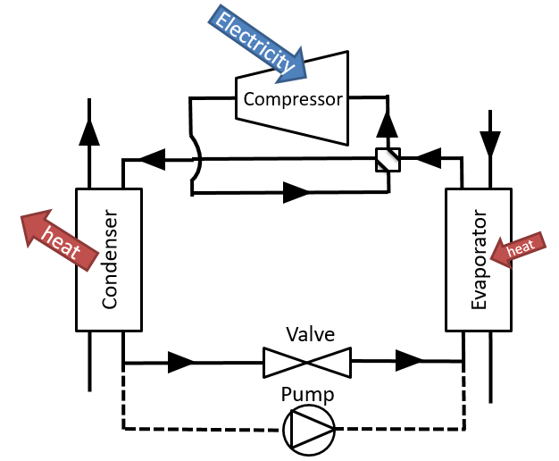  - Heat pump (HP) | 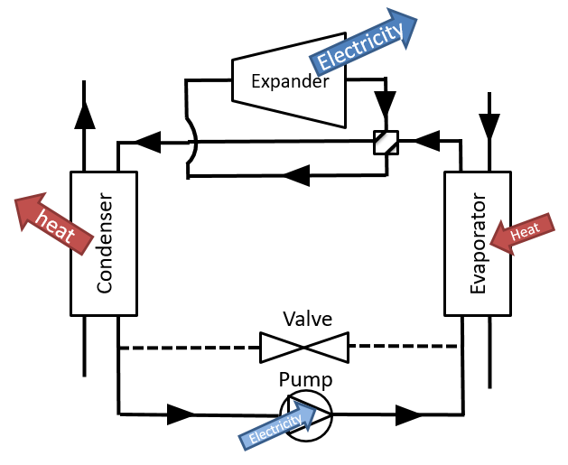  - Organic Rankine cycle (ORC)
Fig. 1. Concept of reversible HP/ORC power system (example)
After a brief context and description of the concept of the reversible HP/ORC power system (section 1 - Introduction), this paper describes several possible fields of application and a 0-D model is proposed to assess the technical feasibility for a given case (section 2 - Methodology). Following this, the results section provides a comparison of the aforementioned case studies based on the mathematical tool developed in section 2. Finally, the last section concludes and gives opportunities for further research.
- Methodology

Applications
The reversible HP/ORC power system can be used in many applications thanks to its operational flexibility. This section briefly describes several possible applications.

2.1.1 Internal combustion engine in industrial applications
In industrial applications, heat is required in a lot of processes (dryer, steamer, etc). In some context, it is interesting to a waste heat flux at low temperature to a higher temperature with a heat pump process. This allows the efficiency of the industrial plant to be increased. Internal combustion engines (ICE) are widely used in combined heat and power generation due to their heat recovery potential mainly contained in exhaust gases and cooling water. However, the low temperature of the cooling water circuit does not always allow its use, thermal energy often being rejected to the ambient. Yet, from about 90°C of cooling water waste heat, a heat pump can provide useful heat for processes up to 140°C. The ORC mode of the reversible system could use the cooling water of the engine as the heat source when the heat pump is not working (Peris et al., 2016). The condenser is water cooled and the cooling circuit is connected to a dry air cooler.

2.1.2 Residential heat pump with solar panels (or biomass boiler)
The integration of a heat pump and solar thermal panels in a residential building is a promising way to increase energy efficiency and to increase the share of renewable energy in the building sector. However, large amounts of thermal energy produced by the solar thermal panels are not used, particularly in summer when the building solar gains are high and the heat demand of the building is low. An elegant way to improve the global system efficiency is to produce electricity by means of a reversible HP/ORC system with the surplus heat provided by the solar roof. This system is therefore flexible with three operating modes. The heat pump is activated to supply the heat requirements of the building in the case of low solar radiations. The direct heating mode (solar thermal energy to thermal storage for domestic hot water and floor heating) is activated as soon as the solar roof temperature is higher than the storage temperature. Finally, when the storage reaches its high temperature set-point, the ORC mode is activated to produce electricity (Dumont et al., 2016). The condenser in ORC mode could be cooled either by a horizontal ground heat exchanger or by an air-cooled condenser. Instead of using solar panels, the system could integrate a combined heat and power biomass boiler.

2.1.3 Air-conditioning unit with solar panels (or biomass boiler)
In temperate climates, the cooling demand of new residential buildings is much higher than the heating requirements. The same concept as the residential heat pump combined with solar panels (described in section 2.1.2) could be applied with an air-conditioning unit.

2.1.4 Data center air conditioning
The purpose of data center cooling technology is to maintain environmental conditions suitable for information technology equipment (ITE) operation. Achieving this goal requires removing the heat produced by the ITE and transferring that heat to some heat sink. In 2020, data centers will represent more than 5% of the greenhouse gas emissions in the world. Those data centers should be installed in northern countries with cold climates in a way to decrease their large cooling demand. However, when the outdoor temperature is close or higher than the maximum acceptable temperature inside the data center ([21°C-27°C]), an air conditioning system is necessary. A reversible air conditioning/ORC system could use the thermal energy produced by the ITE to produce electricity when the outdoor temperature is low. When the outdoor temperature is too high to run the ORC power system, the air conditioning ensures the cooling of the ITE.

2.1.5 Car (or truck) air conditioning with heat recovery on exhaust gases or cooling engine
Valorisation of the waste heat in mobile internal combustion engines (car, truck, tractor…) is paramount to reach the norms in terms of CO₂ emissions (European Union, 2014). ORC and steam Rankine systems have been studied intensively during this last decade to recover the heat from the cooling engine or from the exhaust gas (Legros, 2014; Dumont et al., 2018, Guillaume, 2017, Pascal, 2017). This waste heat, converted in mechanical work through an ORC, can be directly injected to power the wheels or to charge the battery trough an alternator. Therefore, the air-conditioning of the vehicle could be used in ORC mode to recover the waste heat. The condenser could be an air-cooled condenser in the front of the vehicle (such as the one used for the cooling engine). The lower limit of exhaust gas temperature is 120°C to avoid acid condensation.

2.1.6 Refrigeration truck (or boat)
Air conditioning systems used for refrigeration trucks or boats are only used to reach a given cold environment temperature for the medium transported. In 2012, the number of refrigeration trucks is 1.2 million worldwide and the average CO₂ annual emissions are estimated at 50 tons (Liu et al., 2012). Those trucks could convert the cooling engine or exhaust gas thermal energy into mechanical energy trough the reversibility of the air conditioning system. The condenser of such an ORC system on a truck could be air-cooled. In the case of a boat, the seawater could be used in open loop to cool the ORC condenser. The boat application is not studied here because of the very large range of different boat typologies and sizes but the same methodology could be applied to a specific given case to determine the feasibility of the reversible application.

2.1.7 Waste heat energy district heating
A large amount of waste heat is produced in industrial applications and power generation. This thermal energy can be used in a district heating network. Because of the possible temperature fluctuations of the low temperature waste heat energy, a heat pump can be used to reach a given temperature set-point for the district heating network. This heat pump is not run continuously and could provide electricity by reverting its cycle using the heat flux from the waste heat.

2.1.8 Pumped thermal energy storage (Carnot battery)
Electrical energy storage becomes paramount with the increase of renewable energy share in the energy system. In the last years, a new technology has been investigated: the pumped thermal energy storage (PTES). During charge, PTES makes use of a heat pump to convert electrical energy into thermal energy which is stored as ‘sensible heat’ in two thermal reservoirs, one hot and one cold. When required, the thermal energy is then converted back into electricity by effectively operating the heat pump backwards as a heat engine (Mercangoz et al., 2012; Steinmann, 2014; White et al., 2013). This system could also be exploited with a waste heat flux (Thermally Integrated PTES –TIPTES). In this way, the heat pump is able to work with a higher cold source temperature (the temperature of the waste heat flux) and operates with a higher COP than a conventional pumped thermal energy storage (Frate et al., 2017).

2.1.9 Operational parameters for several case studies
Since the idea of this paper is to evaluate the performance of the reversible HP/ORC system in multiple applications, nominal classical points are assessed for each application (Table 1). For each application, the performance is characterized with different working fluids and the one leading to the highest ORC efficiency is selected (section 2.2).

Table 1. Operational parameters for several case studies. ${\dot{Q}}_{HP}$ corresponds to the condenser thermal power at the condenser.
Application | ${\dot{Q}}_{HP}$ [kW] | $t_{HP,cd}$[°C] | $t_{HP,ev}$[°C] | $t_{ORC,cd}$[°C] | $t_{ORC,ev}$[°C]
Car exhaust gas | 15 | 60 | 5 | 50 | 155.6
Car (Cooling Engine) | 15 | 60 | 5 | 50 | 110
Truck (Exhaust gas) | 15 | 60 | 5 | 50 | 155.6
Truck (Cooling Engine) | 15 | 60 | 5 | 50 | 110
Refrigeration truck (Exhaust gas) | 9 | 30 | -15 | 50 | 155.6
Refrigeration truck (Cooling Engine) | 9 | 30 | -15 | 50 | 110
Datacentre chiller 500m2 (cold climate) | 118 | 30 | 15 | -15 | 27
ICE in industrial application | 145 | 120 | 90 | 30 | 90
Residential building | 15 | 60 | 15 | 30 | 100
Residential chiller | 17 | 35 | 15 | 30 | 100
Biomass building + chiller | 17 | 35 | 15 | 30 | 155.6
Waste heat recovery + district heating | 100 | 65 | 15 | 30 | 65
PTES | 10000 | 150 | 1 | 1 | 150
TIPTES | 10000 | 80 | 70 | 15 | 80

Modelling

Assumptions
The goal of this paper is to evaluate if existing heat pumps could be replaced or transformed into reversible HP/ORC power systems. Therefore, a simple constant efficiency model is assumed (Table 2).

Table 2. Hypotheses of modelling
Parameter | Value
Compressor isentropic efficiency - $ε_{exp,nom}$ (HP) [%] | 75
Superheating (HP and ORC) and sub-cooling (ORC) [K] | 5
Pump isentropic efficiency (ORC) [%] | 50
Maximum isentropic efficiency of the expander (ORC) [%] | 75

The compressor, used as an expander, is supposed to present an efficiency varying in function of the ORC operating conditions. To this end, the expansion modelling is divided into two parts to account for over and under-expansion losses (Eq. 1). First, an isentropic expansion (${\dot{W}}_{exp,1})$ is described (Eq. 2) followed by a constant machine volume expansion (${\dot{W}}_{exp,2}$ – Eq. 3). The isentropic power is evaluated with the isentropic exhaust enthalpy calculated with the exhaust pressure and the supply entropy (Eq. 4).

 | $$ε_{exp,is}=ε_{exp,nom}.\frac{{\dot{W}}_{exp,1}+{\dot{W}}_{exp,2}}{{\dot{W}}_{exp,is}}$$ | 1

 | $${\dot{W}}_{exp,1}=\dot{m}(h_{exp,su}-h_{exp,in})$$ | 2

 | $${\dot{W}}_{exp,2}={\dot{V}}_{in}(P_{exp,in}-P_{exp,ex})$$ | 3

 | $${\dot{W}}_{exp,is}=\dot{m}(h_{exp,su}-h_{exp,ex,is})$$ | 4

ORC efficiency
In order to compare several case studies, the first criteria to take into account is the ORC efficiency (Eq. 5). The efficiency can be affected by low temperature difference between hot source and cold sink, non-adaptation of the volume ratio of the volumetric compressor (HP) to the expander application or inadequate working fluid for example.

 | $$η_{ORC}= \frac{{\dot{W}}_{exp}}{{\dot{Q}}_{ev, ORC}}$$ | 5

Minimum thermal power
From the only referenced experimentation on a reversible HP/ORC power system (Dumont et al; 2015), the second constraint has been highlighted: the electrical consumption of the compressor (HP) and the electrical production of the expander (ORC) needs to have the same order of magnitude. If the COP of the heat pump is introduced (Eq. 6), and combined with Eq. 5, it can be shown that there is a direct relation between the thermal power at the evaporator of the HP and of the ORC power system (Eq. 7). It should be noted that in the case of an air conditioning or chiller

 | ${COP}_{HP,cool}= \frac{{\dot{Q}}_{ev,HP} }{{\dot{W}}_{cmp}}$ or ${COP}_{HP,heat}= \frac{{\dot{Q}}_{cd,HP} }{{\dot{W}}_{cmp}}$ | 6

 | $$\frac{{\dot{Q}}_{ev,ORC}}{{\dot{Q}}_{ev,HP}}= \frac{1}{η_{ORC}.{COP}_{HP}}$$ | 7

The right term of Eq. 7 is almost always lower than one. For a fixed maximum ratio between expander power and compressor power, this equation gives a minimal evaporative power for the ORC power system for a given application.

Maximum thermal power
Finally, a third criterion is an upper limit on the ORC thermal power. Practically, it is not possible for a system to work efficiently whatever the thermal power. First, the flow should be limited to avoid too large pressure drop in the pipes and in the heat exchangers. Secondly, positive displacement machines can only absorb a limited flow rate. Finally, Reynolds numbers should be of the same order of magnitude to keep decent heat transfer coefficient in the exchangers. For these reasons, a lumped approach to take these effects into account is to limit the Reynolds number of the ORC system (at the expander outlet) in the order of magnitude of the heat pump system (at the compressor inlet). These two locations are chosen because they correspond to the higher pressure losses locations. This proposed constraint based on the Reynolds number is not validated but should play an important role to avoid a huge mismatch between ORC and HP working conditions. Of course, this approach is only used for the pre-selection of a given application but more accurate models are required to assess the performance of the system accurately.

Performance assessment process
After the introduction of the three constraints (ORC efficiency, volumetric machine power range (minimum thermal power) and Reynolds limitation (maximum thermal power), a methodology to evaluate the technical feasibility of a given heat pump to become reversible is proposed:
- Definition of the heat pump parameters for the application in terms of temperature levels, thermal power and compressor efficiency.
- Sizing of the heat pump based on the inputs to determine the compressor volume ratio, the mass flow and the compressor power.
- Definition of the ORC parameters in terms of Reynolds factor, power factor and temperature levels of the application.
- Determination of the outputs: ORC efficiency, minimal and maximal thermal power.
Other criteria could be raised but are more subject to specific applications (temperature or pressure limitations, weight or space constraints, fraction of the time where the heat pump is used, oil lubrication, etc.).

Results and discussion
Various applications where a heat pump could be inverted in an ORC have been presented in section 2.1. However some applications are technically more interesting than the others. A comparison is performed in terms of ORC efficiency, operating time and compatibility. The first criterion is chosen because the temperature levels of heat pump and ORC could be inappropriate and lead to very low ORC efficiency (temperature and/or volume ratio of the compressor non-adapted). The operating time criterion refers to the fraction of time when the heat pump is not used and when the ORC could be run. Finally, the compatibility refers to the thermal power of the heat pump and the required power of the ORC. In section 2.2, it has been shown that there is a minimum and maximum thermal power ratio between the ORC system and the heat pump. This analysis limits the Reynolds number of the ORC at three times the one in heat pump mode and limits the electrical power of the expander at half of that of the compressor (as an example and corresponding to the only experimental investigation available (Dumont, 2015). No cost or limit on the volume ratio of the machine is considered. The inputs for each application in terms of temperature levels and thermal power of the heat pump are listed in Table 1 In this table, ${\dot{Q}}_{HP}$ represents the thermal power at the condenser of the heat pump. The temperature levels (condensation and evaporation) are usually not know a priori (dependence of the temperature glide, the fluid…) but are roughly estimated in this study to obtain a first approximation of the performance.
Table 3 presents a summary of performance and limitations of each study case with the optimal working fluid (which is the fluid giving the highest efficiency). In this table, $η_{ORC}$ is the efficiency of the ORC system, ${\dot{Q}}_{min}$(resp. ${\dot{Q}}_{max}$) is the minimum (resp. maximum) thermal power required at the evaporator of the ORC system, VR is the machine volume ratio and $ε_{exp,is}$ is the isentropic efficiency of the expander in ORC mode.
Table 3 : Performance and limitation of each study case with the optimal working fluid. * see explanation here below.
Application | $η_{ORC}$[-] | ${\dot{Q}}_{min}$[kW] | ${\dot{Q}}_{max}$[kW] | ${VR}_{HP}$[-] | $ε_{exp,is}$[-] | Fluid
Car exhaust gas | 0.0939 | 19.16 | 58.42 | 5.86 | 0.6569 | R1233zd
Car (Cooling Engine) | 0.0644 | 27.93 | 54.71 | 5.86 | 0.7346 | R1233zd
Truck (Exhaust gas) | 0.0939 | 19.16 | 58.42 | 5.86 | 0.6569 | R1233zd
Truck (Cooling Engine) | 0.0644 | 27.93 | 54.71 | 5.86 | 0.7346 | R1233zd
Refrigeration truck (Exhaust gas) | 0.0924 | 9.995 | 31.27 | 5.627 | 0.649 | R1233zd
Refrigeration truck (Cooling Engine) | 0.0651 | 14.19 | 29.28 | 5.627 | 0.7396 | R1233zd
Datacentre chiller | 0.0375 | 101.2 | 447.4 | 1.665 | 0.5428 | R1233zd
ICE in industrial application | 0.0491 | 171.2 | 793.2 | 2.01 | 0.5871 | R1233zd
Residential building | 0.0761 | 18.92 | 60.21 | 4.036 | 0.703 | R1233zd
Residential chiller | 0.0495 | 14.67 | 63.3 | 1.952 | 0.5333 | R1233zd
Biomass building + chiller | 0.0435 | 16.69 | 68.65 | 1.952 | 0.3265 | R1233zd
Waste heat recovery + district heating | 0.0325 | 386.2 | 433.8 | 3.878 | 0.6653 | R1234yf
PTES | * | 26796 | 80290 | 11.56 | 0.7499 | R1233zd
TIPTES | * | 6278 | 45346 | 1.288 | 0.4083 | R1233zd
Following the results from Table 3, each application can be compared based on the ORC efficiency, operating time and compatibility. To facilitate the analysis, a ranking between zero and five is given for each criterion and application. The ORC system efficiency is normalized based on a maximum efficiency of 10% (=5) (Figure 10).
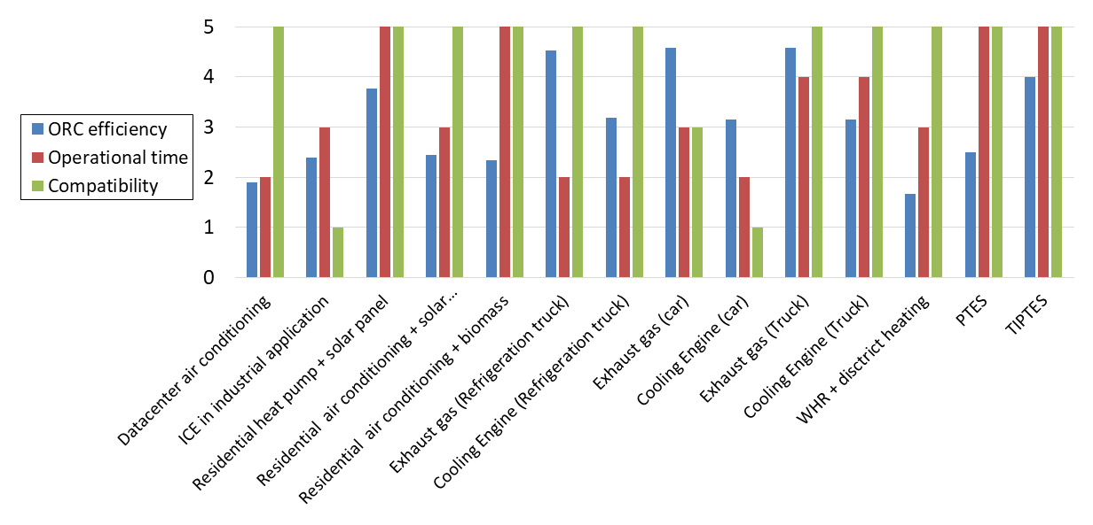
Figure 10: Performance criteria in terms of ORC efficiency, operating time and compatibility for each application.
First, the data centre is interesting in terms of thermal power compatibility because the available thermal energy at the evaporator is equal to 118 kW (Table 1) and fits in the minimum and maximum imposed criteria. But, this system can only produce a decent level of electrical production when the outdoor temperature is very cold (-15°C), leading to a relatively low operating time (depending on the climate). The low temperature difference between evaporation and condensation temperature leads to a low-pressure ratio around the expander. This creates over-expansion that leads to a lower expander efficiency (see Table 3).
The internal combustion engine in industrial application presents a decent ORC efficiency of 4.9 %. The operating time is very dependent on the case study, which is the reason to use an average value of 3. Unfortunately, the minimum required thermal power at the ORC evaporator is 1.2 times higher than the actual one. The expander production is indeed much lower than the compressor consumption. To overcome this issue, it is possible to couple two electric machines (one motor for the compressor and one generator for the expander) to the reversible volumetric machine in a way to get decent efficiency in expander mode.
The residential heat pump combined with solar thermal panels is very interesting with a high efficiency and a high operating time because the heat pump and the ORC system are not operated during the same periods. Also, the ORC evaporator thermal power should be comprised between 18.92 kW and 60.21 kW for compatibility reasons. This corresponds to a minimum solar thermal roof area of 35 m² in nominal conditions in mid-Europe. In hot climates, a residential air conditioning system also presents a nice opportunity to be used in ORC mode. However, the operating time of the ORC system is limited because the air conditioning system often operates when the ORC could produce electricity. The combination of an air conditioning system with a biomass CHP system would lead to a higher operating time.
The refrigeration truck application is promising with high ORC efficiencies (more than 9% when coupled with exhaust gas). Also, the available thermal power (around 150 kW at the exhaust gases on a high load nominal point) is compatible with the requirement of the reversible HP/ORC system. Nevertheless, depending on the refrigeration needs of the application, the operating time of the ORC could be relatively low.
The reversibility of a heat pump in ORC for a passenger car could present decent efficiencies with cooling engine and/or exhaust gas. Unfortunately, the necessity to have the same order of magnitude for the electrical power of the compressor and the expander leads to a high minimum thermal energy (19 kW) necessary at the evaporator of the ORC system. This value could be reached with the exhaust gases on a passenger car but only during high load and a relatively small fraction of time.
The integration of a reversible HP/ORC system on a truck for air-conditioning is one of the most attractive applications because it presents relatively high ORC efficiency (like the passenger car) and presents a high operating time (except in the case of severe climates). The advantage compared to the car application is that the minimum thermal power necessary at the exhaust gas (10 kW) or at the cooling engine (14 kW) fits with the actual heat rejection of a truck (respectively 150 kW and 75 kW on a nominal point).
The waste heat recovery district heating application presents a nice compatibility and an operating time depending on the waste heat fluctuations. However, the ORC efficiency is rather low in the studied configuration but is depending on the waste heat temperature.
The ORC efficiency of the PTES application is not presented in Table 3 since it is very dependant of the temperature levels of the storages. Also, the roundtrip efficiency, defined as the electrical power output divided by the electrical power input, is more relevant. Values of roundtrip efficiencies up to 75% are possible with the classical configuration. The operational time is high since the the idea is to use those types of electrical storages once per day. The heat pump and ORC power system are turned on at different time by definition (low grid electricity price for HP and high electricity price for HP). The TIPTES presents the same caracteristics as the PTES except that the roundtrip efficiency, as defined ere above, can reach higher values (>100%).

Conclusion
A methodology, based on practical limitations to modify a heat pump into a reversible HP/ORC unit is developed. It helps to identify which applications could be the most interesting for a heat pump to become a reversible HP/ORC unit. This preliminary study shows that a residential building with a solar roof, the truck application for air-conditioning and the Thermally Integrated Pumped Thermal Energy Storage are the most promising ones. More advanced modelling should be considered to determine accurately the energy performance and the economic interest in a specific given case.
Nomenclature
- COP Coefficient Of Performance [-]
- h Enthalpy [J/(kg.K]
- HP Heat Pump
- HVAC Heating, Ventilation and Air Conditioning
- ICE Internal Combustion Engine
- ITE Information Technology Equipment
- $\dot{m}$ Mass flow rate [kg/s]
- ORC Organic Rankine Cycle
- P Pressure [Pa]
- PTES Pumped Thermal Energy Storage
- $\dot{Q}$ Thermal power [W]
- TIPTES Thermally Integrated Pumped Thermal Energy Storage
- VR Volume ratio [-]
- $\dot{V}$ Volumetric flow [m³/s]
- WHR Waste Heat Recovery
- $\dot{W}$ Power [W]

Greek symbols
- η efficiency
- ε effectiveness

Subscripts and superscripts
- Ev Evaporator
- Ex Exhaust
- Exp Expander
- In Internal
- Is Isentropic
- max maximum
- min Minimum
- Su Supply

References
White, A., Parks G., Markides C., 2013. Thermodynamic analysis of pumped thermal electricity storage Applied Thermal Engineering 53, 291-298.
Dumont, O., Quoilin, S., Lemort, V., 2015. Experimental investigation of a reversible heat pump/organic Rankine cycle unit designed to be coupled with a passive house to get a Net Zero Energy Building, International Journal of Refrigeration, 54, 190-203, https://doi.org/10.1016/j.ijrefrig.2015.03.008.
Dumont, O., Carmo, C., Fontaine, V., Randaxhe, F., Quoilin, S., Lemort, V., Elmegaard, B., Nielsen, M.P., 2016. Performance of a reversible heat pump / organic Rankine cycle unit coupled with a passive house to get a Positive Energy Building, Journal of Building Performance Simulation, 11-2018.
Dumont, O., Diny, M., Lemort, V., 2018. Experimentation and driving cycle performance of three architectures for waste heat recovery through Rankine cycle and organic Rankine cycle of a passenger car engine, PROCEEDINGS OF ECOS 2018 - THE 31ST INTERNATIONAL CONFERENCE ON EFFICIENCY, COST, OPTIMIZATION, SIMULATION AND ENVIRONMENTAL IMPACT OF ENERGY SYSTEMS
European Climate Foundation, 2010. EU Roadmap 2050. Retrieved from http://www.roadmap2050.eu.
European Union, 2014. Reducing CO2 emissions from passenger cars. Available: http://ec.europa.eu/clima/policies/transport/vehicles/cars/index_en.htm#top-page
Girard O., 2006. Système et procédé de gestion d’énergie d’un véhicule. French patent FR29132117.
Guillaume, L., 2017. On the design of waste heat recovery organic Rankine cycle systems for engines of long-haul trucks, PhD dissertation, Liege (Belgium).
Innogie ApS, 2013. Thermal solar absorber system generating heat and electricity, United States Patent Application Publication, US 2013/025778 A1.
Legros, A., Guillaume, L., Diny, M., Hamid, Z., Lemort, V., 2014. Comparison and impact of waste heat recovery technologies on 7 passenger car fuel consumption on a normalized driving cycle, Energies 2014, 7, 1-x manuscripts; doi:10.3390/en70x000x.
Liu, M. Saman, W., Bruno, F., 2012. Development of a novel refrigeration system for refrigerated trucks incorporating phase change material, Applied Energy 92, 336–342.
Mercangöz, M., Hemrle, J., Kaufmann, L., Z’Graggen, A., Christian, 2012. Energy 45, 407-415.
Pascual, L., Study of Organic Rankine Cycles for Waste Heat Recovery in Transportation
Vehicles, PhD thesis, 2017, Valencia.
Peris B., Dumont O., Quoilin S., Navarro-Esbría, J., 2016. Internal combustion engines cooling water valorization through invertible HTHP/ORC systems, Symposium waste heat valorization in industrial processes, Kortrijk, Belgium.
Steinmann, W.D., 2014. The CHEST (Compressed Heat Energy STorage) concept for facility scale thermo mechanical energy storage, Energy 69, 543-552.

