A tree-bordered field as a surrogate for agroforestry in temperate regions: where does the water go?
Tom Coussementa , Sophie Maloteaub , Paul Pardonc,d , Sidonie Artrub , Simon Ridleyb , Mathieu Javauxe , Sarah Garr´eb,∗

aSoil Service of Belgium, Heverlee, Belgium
b Universit´e de Li`ege, Gembloux Agro-Bio Tech, BIOSE, Gembloux, Belgium
c Flanders Research Institute for Agriculture, Fisheries and Food (ILVO),Merelbeke, Belgium
d Ghent University, Bioscience Engineering, Ghent, Belgium e Universit´e catholique de Louvain, Earth and Life Institute/Environment, Louvain-la-neuve, Belgium
Abstract

There is a renewed interest in temperate agroforestry systems because of their potential to increase biodiversity, sequester carbon and diversify the landscape while maintaining productivity. Little quantitative information is available about the interaction between trees and the crop for water, especially in temperate climate and for tree ages towards the end of an agroforestry cycle. With this study, we quantified the effect of mature poplar trees on soil moisture dynamics in space and time in an agricultural field sown with maize during one growing season. We confirmed the ability of electrical resistivity tomography to study tree-crop interactions for water under field conditions and we delimited an area of influence of the 40-year old trees on the crop of about 15m. In order to do this, we installed four 30m electrode transects perpendicular to the field border. Three transects were located next to a tree-bordered part of the field and one reference transect was located along the same border, but without any tree present. We performed seven electrical resistivity tomography (ERT) measurements during the maize growing season and compared the soil moisture distribution and dynamics with and without tree border as a proxy for a mature agroforestry system. We showed that the ERT tomograms in a tree-bordered zone are significantly different from a reference zone without trees along the 30 m of the transect using a single and segmented linear regression analysis. This article shows the potential of ERT to quantify tree-crop-soil interactions for water in agroforestry systems.
Keywords: agroforestry, electrical resistivity tomography, soil moisture, tree-crop-soil interactions.

∗ Universit´e de Li`ege, Gembloux Agro-Bio Tech,TERRA Research Center, Gembloux, Bel- gium, sarah.garre@ulg.ac.be

Preprint submitted to Agriculture, Ecosystems and Environment July 14, 2017

Introduction
During the last decade, there was a renewed interest in agroforestry systems in temperate climate because of their potential to increase biodiversity, sequester carbon and diversify the landscape (Borremans et al., 2016; Nair, 2007; Pardon et al., 2016; Torralba et al., 2016; Sanchez, 1995). A central hypothesis in the design of a performant agroforestry system states that the trees should acquire resources that would otherwise not be used by the crop (Cannell et al., 1996). Even though the number of projects studying agroforestry systems in the field is increasing lately (e.g. AGFORWARD, SAFE, TransAgroForest, AgroforestryVlaanderen.be, (non-exhaustive)), little quantitative information is available about the interaction between trees and the crop for water, especially in temperate climate. In most of the publications, trees and crop are in competition for water (Miller & Pallardy, 2001; Jose & Gillespie, 1998; Rao et al., 1997), especially where water availability is a limiting factor.
The main effect of trees on the soil water content (SWC) distribution in agroforestry systems is an increased depletion of soil moisture caused by the tree root water uptake in addition to the crop root water uptake. However, trees can also act as facilitators of water availability for the crop: the mechanism of hydraulic lift can increase soil moisture for the crop nearby the trees by the transport of water from deep moist soil to drier surface soil, through the root system of the trees (Burgess et al., 1998; Ong et al., 1998; Lambers et al., 1998). As the tree also creates shadow and can affect the micro-climate (e.g. relative humidity), its presence can reduce the evapotranspiration and therefore positively affect soil moisture. Other aspects might also increase the available SWC for crops like tree stem flow and deeper root water uptake (Pierret et al., 2007).
Different methods can be used to monitor soil water dynamics in agroforestry systems. Classical methods to measure SWC such as gravimetric measurements, neutron probes, time domain reflectometry or capacitance probes, are well known to provide correct and robust results. However, these methods give only local measurements of the SWC. Geophysical methods, and more specifically Electrical Resistivity Tomography (ERT) has proven to be a method avoiding some of the disadvantages mentioned above. ERT is minimally-invasive and results in a 2- or 3-D image of the soil electrical resistivity up to a few meters depth, depending on the electrode lay-out. Since the soil electrical resistivity is strongly linked to SWC (Zhou et al., 2001), this geophysical method is more and more applied to hydrological and soil sciences in a field called “hydrogeophysics”. ERT has been used to study solute transport (Kemna et al., 2002; Cassiani et al., 2006; Koestel et al., 2008; Garr´e et al., 2010)), water dynamics in cropped soil (Michot et al., 2003; Srayeddin & Doussan, 2009; Garr´e et al.,2013; Beff et al., 2013; Whalley et al., 2017), or orchard/trees (Ain-Lhout et al., 2016; Cassiani et al., 2015; Mares et al., 2016), showing that the technique has a lot of potential to provide data to complement classical agronomic experiments. This being said, ERT also has some limitations in respect of soil moisture monitoring: the decrease of resolution and sensitivity of the data with depth and the difficulty to investigate very dry soil because of the poor soil-electrode contact, the dependency of electrical resistivity to soil solution concentration (Moreno, 2014), and the sensitivity of the final SWC maps to inversion scheme and applied constraints. In addition, the need for independent soil water content data to establish a field-scale relationship between SWC and bulk soil resistivity remains. And even though different relationships have been applied to represent different soil horizons, the inherent spatial heterogeneity of this relationship because of soil heterogeneity in all dimensions has not been taken into account so far (Vanderborght et al., 2012). Pedo-electrical functions are less sensitive to bulk density changes than SWC.
In this paper, we aimed at quantifying the effect in space and time of mature poplar trees on the dynamics of soil electrical resistivity in an agricultural field sown with maize as a proxy for soil moisture dynamics. More specifically, we

- confirm the ability of electrical resistivity tomography to study tree-crop interactions under field conditions,
- delimit an area of influence of the tree on the crop and study its characteristic during the growing season and
- use the soil resistivity data to study the relationship between soil moisture dynamics and crop performance in this specific tree-bordered field experiment.

This study does not aim to give general conclusions about soil moisture dynamics in temperate agroforestry systems, but rather to give a proof-of-concept of complementary ways to study the tree-crop interactions for water using a specific case-study in Belgium.

Material and methods

Experimental site
The experiment was conducted in an agricultural field of 9.7 ha in Ypres, West Flanders, Belgium (50◦ 520 48.100 N lat, 2◦ 480 00.800 E long), during the growing season of 2016. The climate is temperate maritime. The soil type is a Luvisol (FAO). Table 1 gives the soil profile description as observed in a 90 cm deep soil pit followed by soil augering up to a depth of 180 cm. On 29th of March, 25 ton ha−1 of pig manure was added to the field. The slurry was incorporated into the soil on April 30th . The field was ploughed (30cm depth) the 6th of May and fertilized with 100L of liquid N on May 8th . The maize (Zea Mays L.) was sown on May 9th , 2016 with a density of 110 000 plant ha-1 (row spacing of 75 cm and ca. 13 cm between plants in the row). The field was treated with herbicide the 20th of May and 1st of June (0.5 L ha-1 Laudis and 0.5L ha-1 Stomp). Crop shortener was applied the 31st of June (1L ha-1 Terpal). The plants were harvested on October 30th , 2016.

z(m) | Horizon | Description
0-0.38 | A | Silt loam; brown; little moist; abrupt transition.
0.38-0.64 | B | Silt loam; light brown with black spots of 0.5-2 mm (Mn concretions or small charcoal fragments), few dark orange spots of Fe concretions, and sporadic brick fragments originating from drainage pipes; (very) dry.
0.64-0.90 | C1 | Loamy sand; very light brown with black and orange concretions (slightly finer than previous horizon, 0.2-1 mm, and larger in number); at 62.5-67.5 cm: brick drainage pipe; dry.
0.90-1.25 | C2 | Loamy sand; light olive-grey with some orange spots increasing from 5 to 30 % with depth; little to moderately moist.
1.25-1.30 | D1 | Sand with clayey layer, light olive-grey with 10 % Fe orange spots;  moderately moist.
1.30-1.80 | D2 | Sand with clay content increasing with depth, at 160-180 cm very elastic/plastic material; light olive-gray with 10-15% brown-orange spots; at 130-150 cm: moderately moist, at 150-180 cm: very moist.

Table 1: Soil profile description. 0-0.90m depth: profile pit,>0.90m augering in bottom of profile pit.

The experimental field is composed of two zones as shown in Figure 1. The first one, the tree-bordered zone (TZ) (20 m x 30 m) is bordered by four 40-years old poplar trees (Populus sp) of about 19 m high and 5 m tree-to-tree spacing. The second one (5 m x 30 m) is a reference zone (RZ) without any tree, located at a distance of 50 m from the TZ. The TZ is used as a proxy for mature alley cropping systems, since those systems are practically unavailable in Belgium.
Using a single tree line of mature trees allows us to study the gradient in environmental and biotic variables from the tree line up to the open field. The orientation of the trees was N-E as is recommended for actual alley cropping fields, because it limits the duration of and crop area affected by shade for the crop to a minimum.
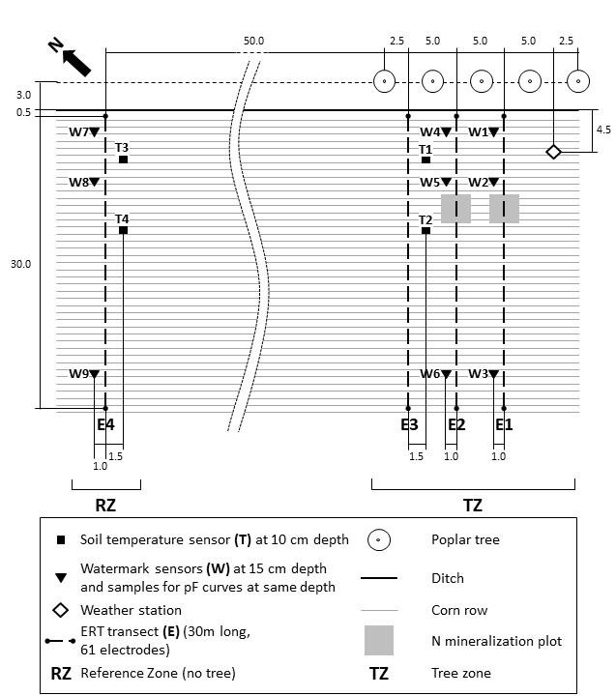
Figure 1: Scheme of the experimental field lay-out. Dimensions are indicated in meters.

Field equipment
We acquired standard meteorological data (air temperature, air humidity, solar radiation, wind speed and rainfall) from a weather station from the Royal Meteorological Institute (RMI) network located in Beitem, at 20 km from the experimental field. In addition, we measured the same variables using a weather station installed in the field at 7 m from the tree line (see Figure 1) to assess the impact of the dynamic shade created by the trees on the reference evapotranspiration. The in-field measurements were performed with a Mety2 weather station (Bodata, Dordrecht, the Netherlands). From these meteorological data, we calculated the reference evapotranspiration (ET0) using the FAO Penman-Montheith equation (Allen et al., 1998) for full light and shade conditions. Note that the RMI station is located in standard conditions (well-watered grass), while the weather data of the in-field station are affected by crop evapotranspiration and differences in surface resistance due to the presence of the maize crop. On the other hand, tree rows in agroforestry systems also significantly affect the relative humidity and wind speed, due to a sheltering effect and the creation of a microclimate (Cleug, 1998; Jose et al., 2004). Therefore, ET₀ for the shaded situation was calculated in two ways: (1) with all data from the in-field station, and (2) with radiation data from the in-field station and relative humidity, wind speed, and air temperature from the RMI station. The crop evapotranspiration (ET_{c}) was subsequently calculated using the single K_{c} function approach for field corn (grain) under standard conditions as proposed by the FAO guidelines for computing crop water requirements (Allen et al., 1998), tables 11 and 12. For the length of the crop development stages values from Idaho (USA) were used, and for Kc values for field corn were used.
Soil water matric potential at 15 cm depth was monitored hourly along three transects (TZ: two transects, RZ: one transect) at three distances from the tree line using Watermarks sensors (Irrometer Co., Riverside, USA) (see Figure 1). Watermark sensors measure the electrical resistance of a granular matrix in which two electrodes are embedded, which can be related to the soil water potential using predetermined calibration curves. They are commonly used in irrigation scheduling and function in the range of -10 to -100 kPa (Spaans & Baker, 1992; Whalley et al., 2001). Some limitations must be taken into account, such as a possible time lag between the real soil moisture change and the wetting of the matrix during rapid wetting or drying of the soil (McCann et al., 1992), the potential impact of soil solution concentration evolution, or the hysteretic relationship between water content and soil water potential (Whalley et al., 2001).
Soil temperature at 10 cm depth was registered with four 200TS temperature sensors (Irrometer Co., Riverside, USA) attached to the watermark datalogger (TZ: two sensors, RZ: two sensors). Four electrode transects of 30 meters perpendicular to the tree line and crop rows were placed permanently in the field (TZ: three transects, RZ: one transect) in order to conduct electrical resistivity measurements. Figure 1 gives an overview of the field site and location of the equipment.
On June 29th , 2016, four rows of maize (rows 12 to 15) were harvest along transects E1 and E2 in order to determine nitrogen mineralization from the top soil layer (within the framework of the overarching research project assessing the performance of agroforestry systems in Flanders).

Soil hydraulic properties

On August 12th, nine soil samples of 100 cm³ (Kopecky-rings) were taken at 15 cm depth, next to the Watermark sensors to determine the soil moisture retention curve using pressure plates at 0, -10, -50.1, -199.5 and -1585 kPa.

z (m) | θr (^{m3m-3} ) | θs (m³ m⁻³ ) | n (-) | α (-) | BD (g.cm⁻³ )
0-0.30 | 0 (-) | 0.39 (0.018) | 1.41 (0.08) | 0.00995 (0.005) | 1.56 (0.032)
Table 2: Average (and standard deviation) of fitted parameters of the van Genuchten equation and bulk density (BD).

For each sample, the water retention curve was determined by fitting the Mualem-Van Genuchten equation (Van Genuchten, 1980) using the RETC software package (Van Genuchten et al., 1991). Table 2 shows the set of parameters obtained by averaging the parameters fitted to the data of each soil sample. The retention curve was used to convert the soil water potential measurements of the watermark sensors to soil moisture using the Van Genuchten equation (Van Genuchten, 1980):
$θ(h)=θ_{r}+\frac{θ_{r}-θ_{s}}{{[1+{(αh)}^{n}]}^{1-\frac{1}{n}}}$ (1)
where θ (m³ m⁻³ ) is the volumetric soil water content as a function of the matric head, h (m); the subscript r refers to residual and s to saturated water content; α (m-1 ), n(-) are fitting parameters. The bulk density, which was used to relate the gravimetric soil water content to volumetric SWC, was determined using the same samples.
During the growing season the SWC was determined gravimetrically at four different moments. Samples were taken with a gauge auger of 30 cm at 0–30 cm and 30–60 cm. One sample consisted of minimum eight subsamples taken randomly within plots of 1.5 x 5 meter located at 3.5, 9 and 29 meter distance from the tree line. Gravimetric SWC was measured by drying the samples at 105 ◦ C during 24h. All soil analyses were performed by the Soil Service of Belgium.

Electrical resistivity tomography (ERT)
We conducted seven electrical resistivity campaigns between May 31st and September 20th , 2016 (i.e. ca. bi-weekly) with the 4point light resistivity meter (LGM Lippman, Schaufling, Germany) and a custom-made multiplexer. The field cable was replaced for each measurement and connected to the electrodes with crocodile clips. The four ERT transects of 30 m long were composed of 61 surface electrodes (inserted 0.10 m into the soil) with 0.5 m spacing. The electrodes were 0.20 m stainless steel rods (0.01 m diameter) connected to electric wire ending on a crocodile clip. The electrodes stayed in place permanently during the experiment. The first electrode of the transect was located at 3.50 m from the tree line and around 0.50 m from the field drainage ditch in between trees and maize (see Figure 1). We determined the soil microtopography caused by the plant rows and field operations at the electrode locations by manually measuring the height difference between the soil and a horizontal rope. We used a dipole-dipole surface array configuration composed of 1088 quadrupoles (normal and reciprocal measurements included) for each transect, taking a measurement time of about 45 minutes. The apparent resistivity data were converted into bulk resistivity values by performing a geophysical inversion process. pyBERT (Gunther et al 2006, Klaus et al. 2006) was used to perform the 2.5D inversion which applies an error-weighted, smoothness constrained Occam type algorithm. The inverted bulk electrical resistivity values were corrected for soil temperature, at the 25°C reference temperature, using the equation proposed by Campbell (1949). The soil temperatures were obtained from measurement at the soil surface and combination with modelling of heat transport in the soil. We provide further details on the applied data processing and inversion in appendix 1.
Since the pedo-physical relationship between electrical resistivity and soil moisture is non-linear, we converted the resistivity data into soil moisture using the parameters of the modified Waxman and Smits model of the Bt layer of a loamy soil as obtained in Garr´e et al., (2011) (a =0.8037, b=0.00999531 and c=1.0356):

$θ={\left[\frac{{EC}_{b}-b}{a}\right]}^{1/n}$ (2)
We do not pretend these soil moisture values to be perfectly correct for this particular field and situation, but they should at least be similar and most importantly, they allow us to identify the effect of the non-linear relationship on the area of influence of the tree. Figure 6 shows the estimated soil moisture transects of E3 (TZ) and E4 (RZ). The tree-bordered transect displays an increasing soil moisture trend from the tree into the field until about 15m, after this point the soil moisture content decreases again with the distance.

Yield measurements
To estimate the yield and quality of the maize in relation to distance to the tree row, 6 transects (three in TZ, three in RZ) were put in place perpendicularly to the field edge. One transect consists of five rectangular sampling plots, 1.5m wide (two maize rows) and 5 m long, of which the center was located at distances 4.25, 5.75, 8.75, 19.25 and 29.75 m away from the tree row. On October 10th the maize cobs grown in each of the plots were collected manually. The harvested cobs were then threshed and after oven-drying at 70°C, the average percentage moisture content and total grain yield (ton DM ha⁻¹) was determined for each of the sampling plots.

Statistical analysis
ERT data
In order to assess the area of influence of the trees in the field, we calculated the average SWC values in blocks of 0.5 m depth and 1m width along the ERT transects. We performed a normal and a segmented linear regression on these average soil moisture curves with the R statistical software (R Development Core Team, 2008). Using a Fisher test over the residuals of these two models, we determined whether the segmented regression was a significantly better fit to the data than the normal one. In order to reject the null hypothesis that both models are equally good in explaining the data, the p-value of the test has to be lower than 0.05. In other words, p-values lower than 0.05 indicate that the segmented model is the better choice.
Yield data
A mixed effects model was fitted to the yield-data of the maize. The interaction between presence of the tree row and the location of the sampling plot in relation to field edge was included as fixed effect. Transect was included as a random effect. The analysis was performed using the lmer function in the lme4 package in R.

Results and discussion

Climate and soil moisture dynamics
The occurrence of (a) rain events and (b) evolution of daily reference and crop evapotranspiration (ET0 and ETc ) and (c) soil water content (θ) are shown in Figure 2 from May 30th to October 10th . ET₀ and ET_{c} for the shaded situation are shown as the range between the two calculation methods described in section 2.2. Vertical lines show the dates when ERT measurements were conducted on May 31st (t0), June 17th (t1), July 1st (t2), July 19th (t3), Aug. 2nd (t4), Aug. 17th (t5) and Sept. 20th (t6). Blue curves of ET₀, ET_{c} and θ (average of sensors W1, W4, location see Figure 1) correspond to data close to trees and affected by dynamic shadow; red curves indicate data without tree impact (average of sensors W3, W6). On the first measurement day (t0) the soil was completely saturated and θ is characterized by an overall decreasing trend with time until t5 (some smaller rainfall events took place during this period). As can be noticed, the plateau in the soil moisture data during the first week corresponds to the saturated field conditions and very rainy weather. Just before t6, an important rainfall event was registered, replenishing the soil partially. In Figure 2a we also show the soil moisture deficit (SMD), defined as the difference between the cumulated crop evapotranspiration and precipitation daily rates. The soil moisture deficit increased strongly starting from July 9th, and this increase corresponded well with changes in the soil water content as observed by the soil moisture sensors (Figure 2c).
In general, the daily ETc is lower close to the tree than in the open field, due to the lower global radiation near the trees. On a few occasions, the ETc is slightly higher for the data near the trees, which is physically unexpected. Since the data for the open field are taken from a nearby weather station (20km), the local weather conditions might be slightly different sometimes, resulting in this behavior. Calculating the difference between the daily ETc (shadow) and the daily ETc (open), we can estimate the difference in soil moisture in the root zone due to a difference in evapotranspiration. This daily difference was maximum 1.6-2.4mm during the growing season (range depending on the calculation of ET₀ for the shaded situation). The cumulative difference between the two is 51-75mm. If we assume a root zone of 1 meter depth, this cumulative difference corresponds to a soil moisture content of 0.051-0.075 m³.m⁻³. It should be noted that ET_{c} represents the maximum possible evapotranspiration without considering any potential water stress for maize. Starting from the beginning of July, soil water tension fell below -70 kPa, around which point water stress generally starts to occur (Deproost et al., 2004), so that the actual maize evapotranspiration will likely be lower than the calculated ET_{c}.
During July and August, the soil became very dry, and the Watermark sensors located at 5 m from the tree line reached the sensor measurement limit of 200 kPa. The sensors therefore failed to register some of the subsequent rainfall events in case they did not result in a sufficiently large increase of soil water potential. At the end of the season, the sensors close to the tree line responded abruptly to the rainfall of September 16th , but those located further away in the field show a smoother response. The slow response can probably be attributed to a heterogeneous wetting front after the rainfall event with activation of preferential flow pathways in the soil and heterogeneous infiltration pattern at the soil surface due to rainfall interception by the maize plants and the subsequent stem flow. The Watermark sensors were located between the maize rows, which makes it possible that a large fraction of the rainfall only reaches the sensors by lateral flow. Similar observations were done by Beff et al (2013) in a maize field. The largest soil moisture losses are occurring between our measurement times t2 and t3 (see Figure 2c), but the SMD is the highest between t5 and t6 (Figure 2a).
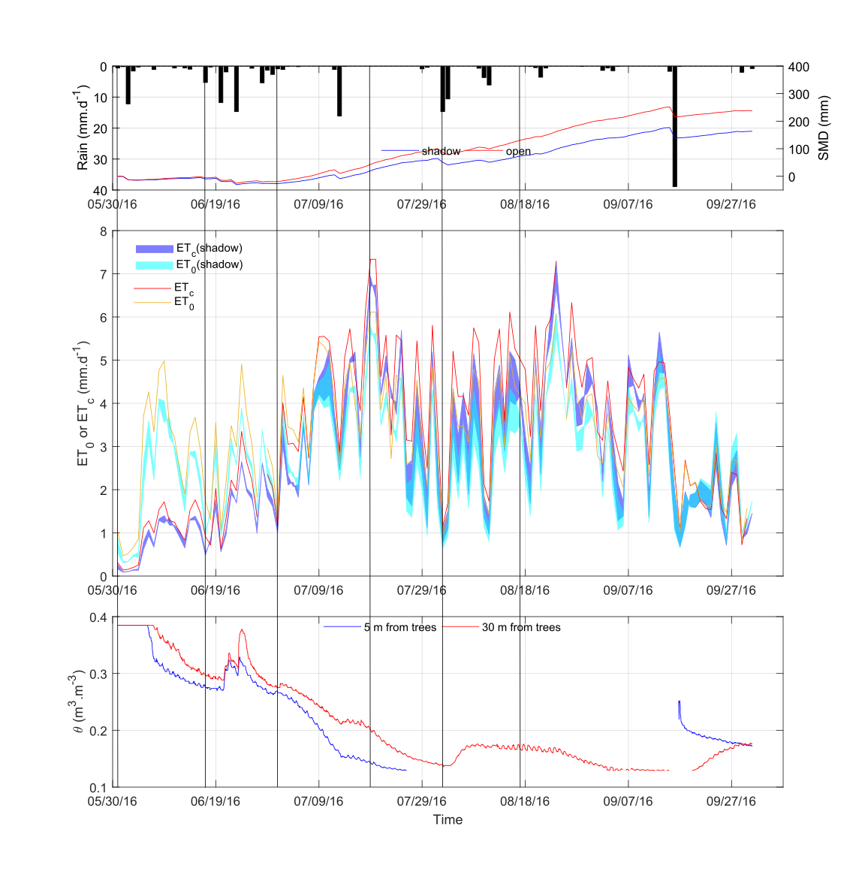
Figure 2: Evolution of (a) rainfall and soil moisture deficit in the tree zone (SMD(shadow)), (b) reference and crop evapotranspiration (ET0 ,(cyan and orange), ETc (blue and red)) and (c) soil moisture through time, from May 20th to October 10th. Vertical lines show ERT measurement dates, named t0 to t6. Blue curves of ETc and SWC correspond to data influenced by thetrees (TZ); red curves indicate data without impact of the tree line (RZ).

Soil bulk electrical resistivity gradients and field variability
Figure 3 shows the temperature-corrected bulk electrical resistivity distribution on August 2nd, 2016 (DOY 201) of the first 15 m of the reference transect E4 (RZ) and tree bordered transects E1, E2 and E3 (TZ). Only visualizing the first 15 m allows for better visualization of what happens with depth. Two distinct zones can be identified: the top soil layer (ca. 0-50 cm depth) with higher resistivity values and the zone below with low resistivity values. In the resistivity maps of E1 and E2, a fallow zone appears clearly at around 12-15m from the trees. These were N mineralization yield plots, in which the plants were sampled on June 29th by collaborators of the overarching research project. This zone is visibly less resistive than the rest of the surface soil layer which confirms that this upper, more resistive zone corresponds to the active water depletion zone of the maize plants. In addition, the upper 60 cm of soil has a different texture than below (silt loam vs loamy sand, respectively). In these tomograms one can already see an influence of field drainage ditch and tree root zone. The effect of the ditch occurs in all transects, whereas the tree-bordered transects are also affected by the trees, in addition to the ditch. We also see a rather regular pattern of high resistivity bulbs alternated with lower resistivity zones, which is most probably related to the maize rows and the associated root water uptake.

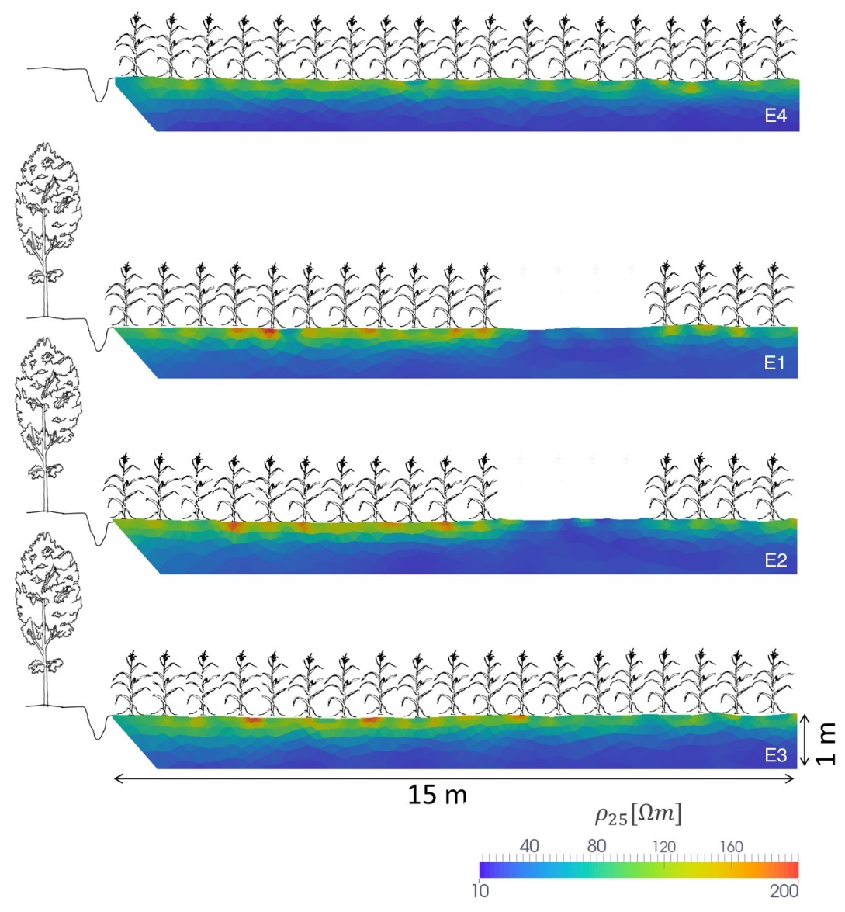

Figure 3: Detail of temperature corrected bulk electrical resistivity tomography, 25 (m) of Aug 2nd (t4), for the first 15 m of the four transects and up till 1m depth: E4 without tree; E1, E2 and E3 with trees.

  - Evolution of bulk resistivity over time
305
Evolution of bulk electrical resistivity over time is shown in Figure 4. From top to bottom, we first see the ‘base’ tomogram at t0 and then the differences of subsequent time steps with the start date (t0) for two transects: E3 in the TZ and E4 in the RZ. The white line on the difference tomograms represents the bottom border of the area in which the resistivity values changed more than 10% with respect to the reference time t0 for a give measurement time tx. It therefore marks the zone in which changes are certainly due to environmental processes and not due to noise or inversion uncertainties. At t0, soil bulk electrical resistivity ranges from 10 to 60 Ohm.m in the upper 0.05m. These resistivity values are rather low, corresponding to high soil water content (saturated conditions at t0). The resistivity differences are always positive, showing the transition from saturation to unsaturated (drier) conditions. Until t5, the resistivity difference with the reference date continues to increase and we can observe a drying front moving deeper over time. A rainfall event four days before t6 resulted in a lower difference in surface resistivity for the last timestep. If we compare the reference zone (E4) with the tree zone (E3) for each date, we can see that the resistivity maps show higher resistivity values in the tree zone than in the reference zone close to the field border. Depletion zones around of the maize rows are clearly visible in all transects as locations with higher resistivity compared to the resistivity between the maize rows. Nevertheless, these bulbs vary in size and intensity along and between transects.

Distance of influence of poplar tree line
To quantify the distance of influence of the tree on the soil moisture dynamics in the field, we plotted the weighted average of the bulk electrical resistivity of a block of 0.50 m depth and 1 m width as a function of the distance to the tree in Figure 5. For each of the four transects, the figure shows the seven measurement dates (t0-t6). It has to be noted that the beginning of the curves in both TZ and RZ is affected by a field ditch, especially in very moist conditions (first measurement dates).
The impact of trees on electrical resistivity is clearly visible for E1-3: the closer we come to the tree line, the higher the resistivity becomes. For E3, resistivity curves become stable again at around 15-20 m from the trees. Huth & Poulton (2007) came to similar conclusions using electromagnetic induction (EMI) in a cotton field with eucalyptus trees. Unfortunately, the fallow zone in E1 and E2 (Figure 7) is very close to this pivot zone, making it difficult to see whether this point is consistent over all transects we measured. The impact of the early maize sampling at rows 12-15 clearly visible as a drop of resistivity values (between 12 and 15 m from the trees). Upon drying, the difference between the reference and the tree-bordered zone increases in the first 15 m.

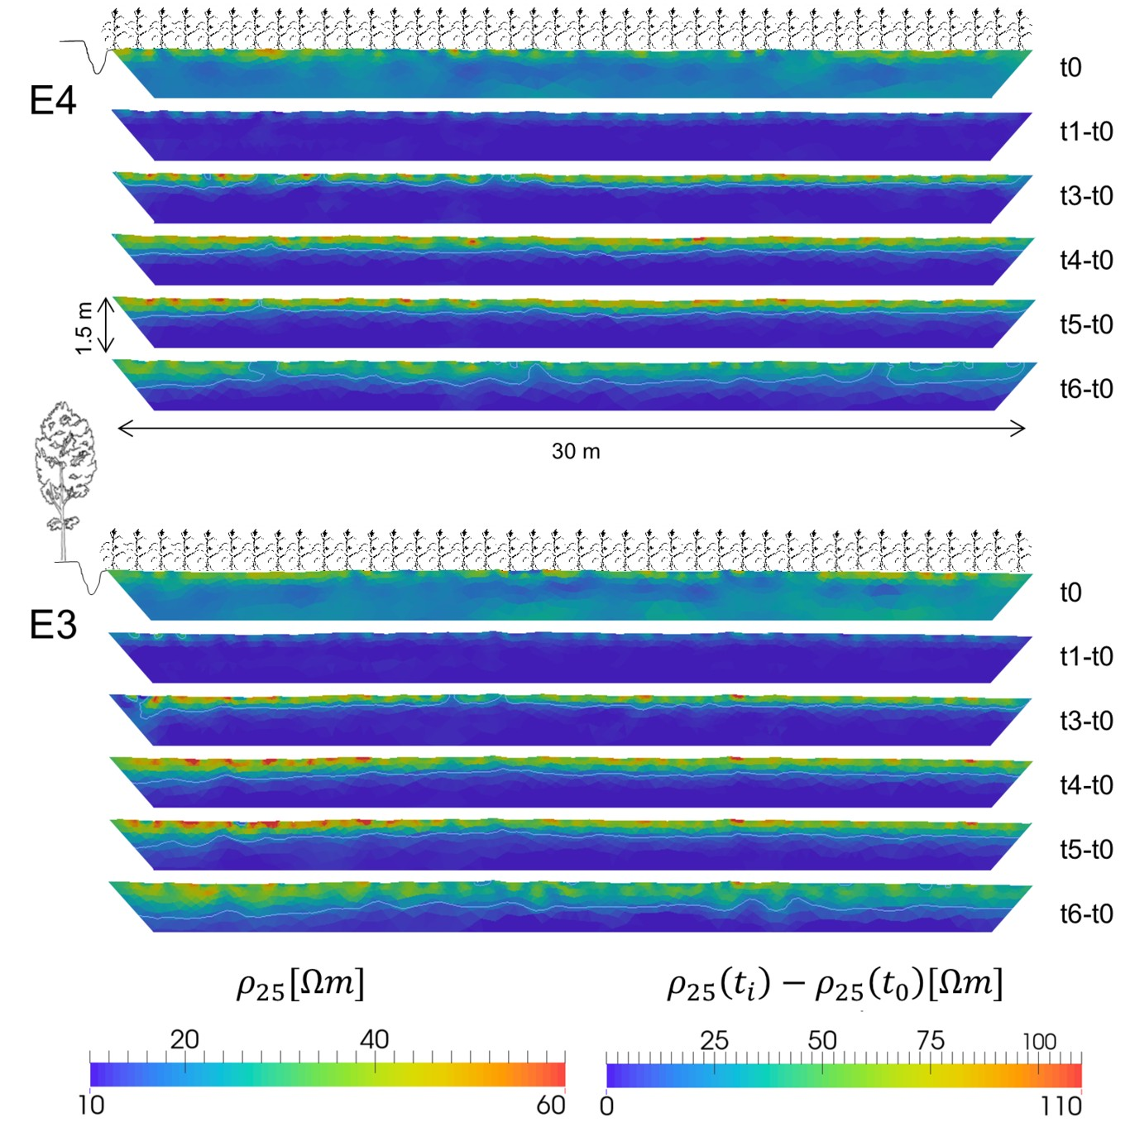

Figure 4: Bulk electrical resistivity distribution on May 31st, 2016 (t0) and distribution of the differences in resistivity between reference day t0 and June 17th (t1), July 19th (t3), Aug 2nd (t4), Aug 17th (t5) and Sep 20th (t6); for the reference zone (E4) and the tree-bordered zone (E3).
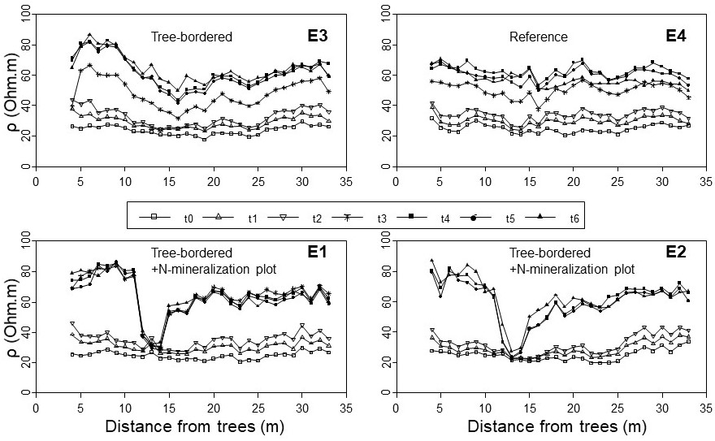
This is probably because the tree takes up water deeper down in the profile than the crop, reducing the average value of resistivity in this area.

Figure 5: Evolution of bulk electrical resistivity along the transect for each measurement date: May 31th (t0), June 17th (t1), July 1st (t2), July 19th (t3), Aug 2nd (t4), Aug 17th (t5) and Sep 20th (t6); and for transects E1-3 (tree-bordered zone) and E4 (reference zone). Transects E1 and E2 are affected by N mineralization plots at later dates (local depression of resistivity values) (exact location of these plots see Figure 1).

Resistivity values were subsequently converted to soil moisture (Figure 6), using the approach described in section 2.4.
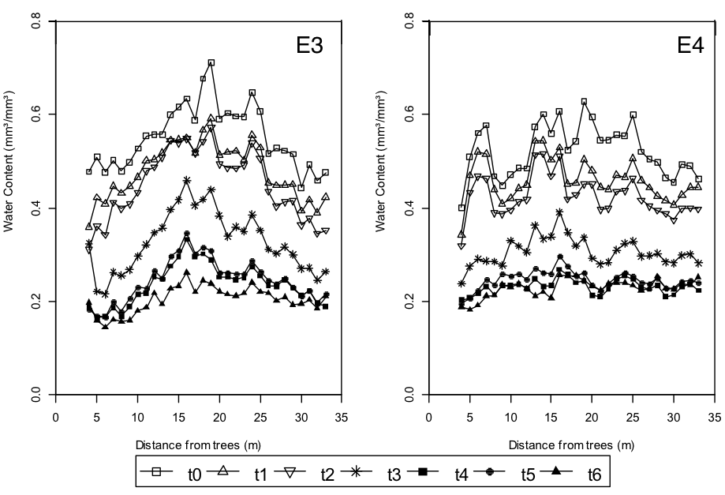

Figure 6: Estimation of soil moisture along the transect for each measurement date: May
31th (t0), June 17th (t1), July 1st (t2), July 19th (t3), Aug 2nd (t4), Aug 17th (t5) and Sep
20th (t6); and for transects E3 (tree-bordered zone) and E4 (reference zone).
In Figure 7, we can see the (segmented) linear regression and the obtained pivot point for the E3 and E4 transects for the last three measurement dates. This pivot point is located around 15m and moves slightly over time. A Fischer test confirmed that the segmented regression was only meaningful for the tree- bordered transect and not for the reference transect. It must be noted that this analysis was done on data starting 8 m from the tree to avoid any effect of the field drainage ditch. Moving closer to the border makes the regression analysis more ambiguous, resulting in a segmented linear regression for one of the dates of the reference transect. If we compare the difference in soil moisture values from 3.5 to 15 m, we see an increase of soil moisture of between 0.10-0.20 m3 .m-3 in the period when the soil started to dry out after the heavy rains of June (t4-t6). Based on the estimated effect of the decrease of radiation on the evapotranspiration of maize (cumulative 0.024-0.037 m3 .m-3 for t4, 0.032-0.058 for t5, and 0.049-0.075 for t6; range depending on the calculation of ET₀ for the shaded situation), this indicates that tree water uptake played a very important role in reducing the soil water content close the trees. Furthermore, the effect of decreased radiation on maize ET does not take into account drought stress, which may cause this value to be even higher.
After the pivot point at ca. 15m, the linear regression indicates a decrease of soil moisture with distance. This may be related to an increased water uptake by the maize, as indicated by the increasing crop yield with the distance (Figure 8), while the regression before the pivot point is mainly caused by the water uptake of the trees. Soil heterogeneity may also play a role here, since the trend of increased water content at 15 m was already present at the start of the season (t0).
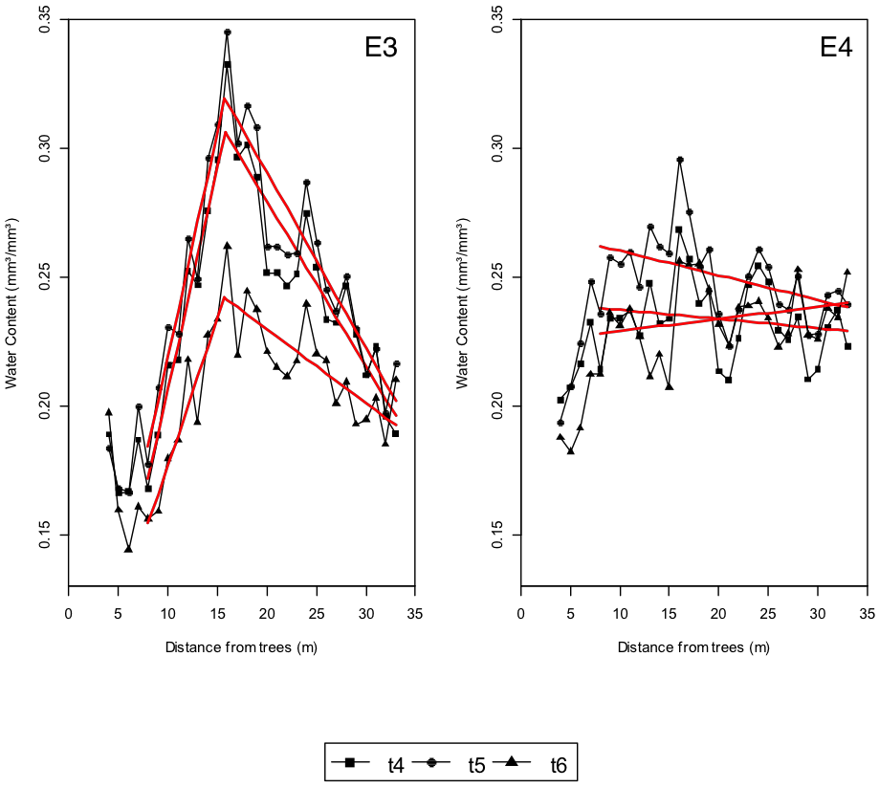

Figure 7: Single (E4) and segmented (E3) linear regression on estimated soil moisture transects for Aug 2nd (t4), Aug 17th (t5) and Sep 20th (t6).

Date | E3  Pval | x.pivot (m) | E4  Pval
t4 | 3.125e-11 | 15.766 | 0.108
t5 | 1.712e-10 | 15.742 | 0.078
t6 | 3.889e-08 | 15.683 | 0.373

Table 3: Fischer test comparing single and segmented linear regressions for transects E3 and
E4.

  - Yield transects
Figure 8 shows the maize yield response in the TZ and RZ zone. Based on the mixed modelling results, a significant interaction was found between tree row presence and location into the field (p <0.001). Large differences occur between the transects bordered by a tree line and the reference zone (p<0.001 for locations at 4.25 m, 5.75 m, 8.75 m, 19.25 and p=0.032 for locations at 29.75 m.) These differences show a decreasing trend as distance to the field edge increases. Even though it is tempting to link the differences in soil moisture dynamics to these yield differences, one should be very careful. Many factors are potentially affected by the presence of the tree line (e.g. micro-climate, nutrients, pests, . . . ) and the link to yield repercussions should be established taking into account all these factors and there interactions. In addition, one experimental year is not enough to conclude on the effect of the trees on the crop performance, since a range of climatic conditions should be evaluated. This integration is object of the overarching research project AgroforestryVlaanderen.be, and not of this particular paper.

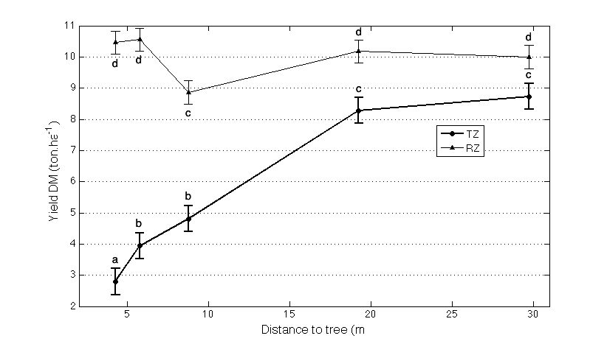

Figure 8: Average yield of transects in the tree-bordered (TZ) and reference (RZ) zone (dry matter in tons per hectare). The error bars indicate the standard deviation, different super- script letters (a-d ) indicate significantly differing DM yield.

Conclusion
In this research paper we tested the potential of 2D electrical resistivity transects perpendicular to a tree row to monitor the effect of tree-crop-soil interactions on soil moisture dynamics and spatial distribution of soil moisture. We showed that the ERT tomograms in a tree-bordered zone are significantly different from a reference zone without trees along the 30 m of the transect using a single and segmented linear regression analysis. The segmented regression also allows the determination of pivot points, which can be used to quantify the area of influence of the tree line on the crop (ca. 15m in this case). ERT tomograms give interesting information on spatio-temporal dynamics of soil moisture and show that the influence of the trees is mainly visible under drier soil moisture conditions. In order to fully profit from the information on SWC dynamics available in such ERT tomograms, one should acquire field-specific pedo-physical relationships. This could be done by taken soil samples of the different soil horizons in the field and performing a laboratory calibration of the pedo-physical properties of the soil or by installing electrodes together with soil moisture sensors in the different horizons in a soil pit directly in the field. Since the pedo-physical relationship is non-linear, it is not recommended to directly interpret raw resistivity images in order to determine the area of influence of trees on a crop. Taking into account these recommendations, the relatively straightforward ERT setup can be repeated for trees of different ages, different crops, under different meteorological conditions and combined with data on microclimate and soil nutrient fluxes in order to disentangle the processes governing the interactions between tree and crop in an agroforestry context.

Acknowledgements
We would like to thank Bert Reubens, coordinator of the project “Agro- forestry in Vlaanderen”, for this opportunity to collaborate on the field in Ypres. The project “Agroforestry in Vlaanderen” is funded by Flanders Innovation & Entrepreneurship (VLAIO), an agency of the Flemish government (grant number 135068). The measurements were done within the framework of the FNRS PDR project eRoot (grant number T.1088.15 - PDR (FRFC)). We also would like to thank the farmers for allowing us to perform measurements on their fields.
We profoundly thank Thomas Gu¨nther for his help on the ERT data inversions and Yves Brostaux for his ideas on the statistical analysis. We mention Gino Mancini, Nicolas Leclercq, Keyvan Amigh, Solomon Ehosioke, Baoqin Chen and Sathyanaryan Rao for their punctual help during the ERT measurement campaign.

References

Ain-Lhout, F., Boutaleb, S., Diaz-Barradas, M. C., Jauregui, J., & Zunzunegui, M. (2016). Monitoring the evolution of soil moisture in root zone system of Argania spinosa using electrical resistivity imaging. Agric. Water Manage.,164, Part 1 , 158–166.

Allen, R., Pereira, L., Raes, D., & Smith, M. (1998). Crop evapotranspiration - Guidelines for computing crop water requirements. Technical Report X0490/E FAO Rome.

Beff, L., Günther, T., Vandoorne, B., Couvreur, V., & Javaux, M. (2013). Three-dimensional monitoring of soil water content in a maize field using Electrical Resistivity Tomography. Hydrol. Earth Syst. Sci., 17, 595–609.

Borremans, L., Reubens, B., Van Gils, B., Baeyens, D., Vandevelde, C., Wauters, E., 2016. A sociopsychological analysis of agroforestry adoption in flanders: understanding the discrepancy between conceptual opportunities and actual implementation. Agroecol. Sustain. Food Syst. 40, 1008–1036.

Burgess, S. S. O., Adams, M. A., Turner, N. C., Ong, C. K. (1998). The redistribution of soil water by tree root systems. Oecologia , 115 , 306–311.

Campbell, R. B. (1949). Change of Electrical Conductivity with Temperature and the Relation of Osmotic Pressure to Electrical Conductivity and Ion Concentration for Soil Extracts. Soil Sci. Soc.Am. J., 13, 66.

Cannell, M. G. R., Noordwijk, M. V., & Ong, C. K. (1996). The central agro- forestry hypothesis: the trees must acquire resources that the crop would not otherwise acquire. Agrofor. Syst., 34, 27–31.

Cassiani, G., Boaga, J., Vanella, D., Perri, M. T., & Consoli, S. (2015). Monitoring and modelling of soil-plant interactions: the joint use of ERT, sap flow and eddy covariance data to characterize the volume of an orange tree root zone. Hydrol. Earth Syst. Sci., 19 , 2213–2225.

Cassiani, G., Bruno, V., Villa, A., Fusi, N., & Binley, A. M. (2006). A saline tracer test monitored via time-lapse surface electrical resistivity tomography. J. Appl. Geophys., 59 , 244–259

Chung, S.-O., & Horton, R. (1987). Soil heat and water flow with a partial surface mulch. Water Resour. Res., 23 , 2175–2186.

Cleug, H. A. (1998). Effects of windbreaks on airflow, microclimates and crop yields. Agrofor. Syst. 41: 55-84.

Deproost, P., Elsen, F., Geypens, M. (2004). High yields of mechanically harvested snap beans as induced by moderate water stress during flowering. Acta hortic. 664, 205-121.

FAO (2014). World reference base for soil resources 2014 . Number 106 in World Soil Resources Reports (update 2015 ed.). Rome.

Garr´e, S., Coteur, I., Wongleecharoen, C., Kongkaew, T., Diels, J., & Vanderborght, J. (2013). Noninvasive Monitoring of Soil Water Dynamics in Mixed Cropping Systems: A Case Study in Ratchaburi Province, Thailand. Vadose Zone J., 12 .

Garr´e, S., Javaux, M., Vanderborght, J., Pages, L., & Vereecken, H. (2011). Three-Dimensional Electrical Resistivity Tomography to Monitor Root Zone Water Dynamics. Vadose Zone J., 10 , 412–424.

Garr´e, S., Koestel, J., Guenther, T., Javaux, M., Vanderborght, J., & Vereecken, H. (2010). Comparison of Heterogeneous Transport Processes Ob- served with Electrical Resistivity Tomography in Two Soils. Vadose Zone J., 9 , 336–349.

Guenther, T., Ruecker, C., & Spitzer, K. (2006). Three-dimensional modelling and inversion of DC resistivity data incorporating topography - II. Inversion. Geophys. J. Int., 166 , 506–517.

Huth, N. I., & Poulton, P. L. (2007). An electromagnetic induction method for monitoring variation in soil moisture in agroforestry systems. Soil Res., 45 , 63–72

Jose, S., & Gillespie, A. R. (1998). Allelopathy in black walnut (Juglans nigra L.) alley cropping. I. Spatio-temporal variation in soil juglone in a black walnutcorn (Zea maysL.) alley cropping system in the midwestern USA. Plant Soil , 203, 191–197.
Jose, S., Gillespie, A. R., Pallardy, S. G. (2004). Interspecific interactions in temperate agroforestry. Agrofor. Syst. 61, 237-255.
Kemna, A., Vanderborght, J., Kulessa, B., & Vereecken, H. (2002). Imaging and characterisation of subsurface solute transport using electrical resistivity tomography (ERT) and equivalent transport models. J. Hydrol., 267, 125–146.

Koestel, J., Kemna, A., Javaux, M., Binley, A., & Vereecken, H. (2008). Quantitative imaging of solute transport in an unsaturated and undisturbed soil monolith with 3-D ERT and TDR. Water Resour. Res., 44 , W12411.

Lambers, H., Iii, F. S. C., & Pons, T. L. (1998). Photosynthesis, Respiration, and Long-Distance Transport. In Plant Physiological Ecology (pp. 10–153). Springer New York.

Mares, R., Barnard, H. R., Mao, D., Revil, A., & Singha, K. (2016). Examining diel patterns of soil and xylem moisture using electrical resistivity imaging. J. Hydrol., 536, 327–338.

McCann, I. R., Kincaid, D. C., & Wang, D. (1992). Operational characteristics of the watermark model 200 soil water potential sensor for irrigation manage- ment. Appl. Eng. Agric., 8 , 603–609.

Michot, D., Benderitter, Y., Dorigny, A., Nicoullaud, B., King, D., & Tabbagh, A. (2003). Spatial and temporal monitoring of soil water content with an irrigated corn crop cover using surface electrical resistivity tomography. Water Resour. Res., 39, 1138.

Miller, A. W., & Pallardy, S. G. (2001). Resource competition across the crop-tree interface in a maize-silver maple temperate alley cropping stand in Missouri. Agrofor. Syst., 53, 247–259.

Moreno, G. (2014). Cropping among trees to cope with climate change (Spain).

EURAF Newsletter, 7 , 3–5.
Nair, P.K.R., 2007. The coming of age of agroforestry. J. Sci. Food Agric. 1613–1619.

Ong, C. K., Deans, J. D., Wilson, J., Mutua, J., Khan, A. a. H., & Lawson, E. M. (1998). Exploring below ground complementarity in agroforestry using sap flow and root fractal techniques. Agrofor. Syst., 44 , 89–106.
Pardon, P., Reubens, B., Reheul, D., Mertens, J., De Frenne, P., Coussement, T., Janssens, P., Verheyen, K. (2016). Trees increase soil organic carbon and nutrient availability in temperate agroforestry systems. Agriculture, Ecosystems and Environment, 247, 98-111.

Pierret, A., Doussan, C., Capowiez, Y., Bastardie, F., & Pags, L. (2007). Root Functional Architecture: A Framework for Modeling the Interplay be- tween Roots and Soil. Vadose Zone J., 6 , 269–281.

R Development Core Team (2008). R: A Language and Environment for Statistical Computing. R Foundation for Statistical Computing Vienna, Austria. URL: http://www.R-project.org ISBN 3-900051-07-0.

Rao, M. R., Nair, P. K. R., & Ong, C. K. (1997). Biophysical interactions in tropical agroforestry systems. Agrofor. Syst., 38 , 3–50.

Sanchez, P. A. (1995). Science in agroforestry. In F. L. Sinclair (Ed.), Agro- forestry: Science, Policy and Practice number 47 in Forestry Sciences (pp.
5–55). Springer Netherlands.

Spaans, E. J. A., & Baker, J. M. (1992). Calibration of Watermark soil moisture sensors for soil matric potential and temperature. Plant Soil , 143 , 213–217.

Srayeddin, I., & Doussan, C. (2009). Estimation of the spatial variability of root water uptake of maize and sorghum at the field scale by electrical resistivity tomography. Plant Soil , 319 , 185–207. 1-2.

Torralba, M., Fagerholm, N., Burgess, P.J., Moreno, G., Plieninger, T., 2016. Do European agroforestry systems enhance biodiversity and ecosystem services? A meta-analysis. Agric. Ecosyst. Environ. 230, 150–161.

Udphuay, S., Guenther, T., Everett, M. E., Warden, R. R., & Briaud, J.-L. (2011). Three-dimensional resistivity tomography in extreme coastal terrain amidst dense cultural signals: application to cliff stability assessment at the historic D-Day site. Geo- phys. J. Int., 185, 201–220.

Van Genuchten, M. T. (1980). A Closed-form Equation for Predicting the Hydraulic Conductivity of Unsaturated Soils. Soil Sci. Soc. Am. J., 44 , 892–898

Van Genuchten, M. T., Leij, F., & Yates, S. (1991). The RETC Code for Quantifying the Hydraulic Functions of Unsaturated Soils . Technical Report EPA/600/2-91/065 R. S. Kerr Environmental Research Laboratory, U. S. Environmental Protection Agency Ada, Oklahoma 74820.

Vanderborght, J., Huisman, J. A., van der Kruk, J., & Vereecken, H. (2013). Geophysical methods for field-scale monitoring of flow and transport in the root zone. In: Anderson, S.H., Hopmans, J.W. (Eds.): Soil–Water–Root Processes: Advances in Tomography and Imaging. Soil Science Society of America, Madison, USA, 247 - 282.

Whalley, W. R., Binley, A., Watts, C. W., Shanahan, P., Dodd, I. C., Ober, E. S., Ashton, R. W., Webster, C. P., White, R. P., & Hawkesford, M. J. (2017). Methods to estimate changes in soil water for phenotyping root activity in the field. Plant Soil , 415 , 407–422.

Whalley, W. R., Watts, C. W., Hilhorst, M. A., Bird, N. R. A., Balendonck, J., & Longstaff, D. J. (2001). The design of porous material sensors to measure the matric potential of water in soil. Eur. J. Soil Sci., 52 , 511–519.

Zhou, Q. Y., Shimada, J., & Sato, A. (2001). Three-dimensional spatial and temporal monitoring of soil water content using electrical resistivity tomography. Water Resour. Res., 37 , 273–285.

Appendices

Appendix 1: ERT data processing and inversion
Raw data processing
First, we removed measurements with electrodes having a high contact resistance (> 10 000 Ohm). Second, data with a reciprocal error ($ϵ_{i}$) higher than 10 % of the mean resistance ($R_{i}$) were deleted ($ϵ_{i}=R_{n,i}-R_{r,i} < 0.1R_{i}$, with $R_{n,i}$ the i^{th} normal resistivity, $R_{r,i}$ the i^{th} reciprocal resistivity, and $R_{i}=\frac{R_{n,i}+R_{r,i}}{2}$).
Inversion
We used pyBERT (Gunther et al 2006, Klaus et al. 2006) to perform the 2.5D inversion and applied an error-weighted, smoothness constrained Occam type algorithm. The objective function (Φ) to be minimized is:
Φ = Φd + λΦm (3)
where Φd is the data functional, Φm is the model functional, and λ is a regularization parameter (Guenther et al., 2006). We estimated and applied an error model as described in (Udphuay et al., 2011). The quality of the inversions is determined using two indices: the χ2 ($χ^{2}=\frac{\left\|D(d - f\left(m\right))\right\|²}{n}$) and the relative root mean (RRMS) square error ($RRMS = \frac{\left\|(d - f\left(m\right))/d\right\|}{n})$, with d the data vector, f(m) the forward modelling vector, n the number of data points and D the data weight matrix. The values of these indices for all our inversion results are listed in Table A1.
 |  | χ2 (-)  E1 | E2 | E3 | E4 | RRMS (-)  E1 | E2 | E3 | E4
t0 | 31/05/16 | 0.690494 | 0.261234 | 0.819593 | 0.749761 | 2.41124 | 5.94245 | 2.54951 | 2.48583
t1 | 17/06/16 | 0.171366 | 0.204769 | 0.127329 | 0.123019 | 1.31323 | 1.29956 | 1.09777 | 1.03901
t2 | 01/07/16 | 0.810274 | 0.67217 | 0.454493 | 0.468444 | 2.59677 | 2.41501 | 1.96753 | 8.49533
t3 | 19/07/16 | 0.0395641 | 0.569401 | 0.542277 | 0.793198 | 0.783276 | 20.8828 | 5.64476 | 10.2854
t4 | 02/08/16 | 0.0427643 | 0.778321 | 0.0431514 | 0.0518466 | 0.814064 | 13.8804 | 0.835046 | 1.63776
t5 | 17/08/16 | 0.0599858 | 0.534731 | 0.0403457 | 0.032309 | 0.945535 | 15.4504 | 0.793021 | 0.725004
t6 | 20/09/16 | 0.166553 | 0.20776 | 0.803867 | 0.12639 | 8.42771 | 11.8128 | 7.88359 | 3.88827
Table A1: Inversion quality indices.

Temperature correction
The inverted bulk electrical resistivity values were corrected for soil temperature, at the 25C reference temperature, using the following equation (Campbell, 1949):
$σ_{b,25}= \frac{σ_{b}}{\left[1+0.02\left(T-25\right)\right]}$ (4)
where σ_{b,25} is the bulk electrical conductivity at 25◦ C, σ_{b} is the bulk electrical conductivity at soil temperature T (◦ C), and with ρ = 1/σ, being the electrical resistivity (Ohm.m).
The soil temperature profile T(z,t) during the measurements was predicted numerically solving the heat flow equation with Hydrus 1-D, neglecting water vapor diffusion:
$C_{p}\left(θ\right)\frac{δT}{δt}=\frac{δ}{δz_{i}}\left(λ_{ij}\left(θ\right)\frac{δT}{δz_{i}}\right)-C_{w}q_{i}\frac{δT}{δz_{i}}$ (5)
where λ_{ij} (θ) = apparent thermal conductivity of the soil C_{p} , C_{w} = volumetric heat capacities [Jm-3 C⁻¹ ] of the porous medium and the liquid phase, respectively; and q_{i} = fluid flux density [md⁻¹ ]. The thermal conductivity for our site was estimated using the model by (Chung & Horton, 1987) for a loamy soil (Hydrus 1D default parameters: b1 =1.133741012 Wm⁻¹ K⁻¹ , b2 =1.83358 1012 Wm⁻¹ K⁻¹ , b3 =7.15703 1012 Wm⁻¹ K⁻¹ , Cn =2.488321011 Jm⁻³ K⁻¹ , C0 = 3.25296 1011 Jm⁻³ K⁻¹ , Cw = 5.41728 1011 Jm⁻³ K⁻¹ ). We did not take into account soil water flow on the thermal properties and kept the soil moisture content constant over the profile at 0.24, which is a simplification of reality. The top boundary condition was the average of the four measured daily soil temperatures at 10 cm depth and we fixed the lower boundary condition at 8 m depth at 12◦ C, corresponding to annual average ground temperature below 3 m depth. This average annual temperature can be considered as constant over the year below 3 m and was estimated with the average annual temperature of the previous year. Parameters describing the soil water properties were the same as the one shown in Table 2.

