Evaluation of different adsorbent materials for the untargeted and targeted bacterial VOC analysis using GC×GC-MS
Flavio A. Franchina ¹, Giorgia Purcaro ², Alison Burklund, Marco Beccaria ^{3,} Jane E. Hill*

Thayer School of Engineering at Dartmouth College, 03755, Hanover, NH, United States

Highlights
- Different adsorbent materials were compared for the extraction of standards and bacterial volatile metabolites in vitro.
- Bacterial VOCs were desorbed and analyzed in a comprehensive GC × GC-ToF MS.
- Tenax resulted more efficient to extract the standard mix and bacterial VOCs with better repeatability and higher sensitivity.

Abstract
The analysis of bacterial volatile organic compounds has gained attraction as a non-invasive way to identify disease-causing organisms, given that bacteria have unique metabolisms and volatile metabolic byproducts. In the present research, different adsorbent materials (Carbopack Y, X, B, Carboxen 1000 and Tenax TA), packed singularly or in combination, were compared in terms of sampling performance (sensitivity, repeatability and selectivity) for the extraction of standards and bacterial volatile metabolites in vitro (from Staphylococcus aureus, Pseudomonas aeruginosa, and Escherichia coli). After extraction, bacterial volatile organic compounds were desorbed and analyzed in a comprehensive two-dimensional gas chromatography system coupled to a time-of-flight mass spectrometer (GC × GC-ToF MS).
The results show that Tenax has the greater ability to extract the standard mix as well as volatile organic compounds with better repeatability (4–26 RSD%), higher sensitivity (on average ∼24 fold) compared to Carbopack Y, X and Carboxen 1000 tube, which followed in terms of performance. In addition, Tenax confirmed the best sensitivity and discriminatory power with no misclassification in the untargeted and unsupervised analysis for the differentiation of the bacterial species.

Keywords
Bacterial metabolites, Comprehensive two-dimensional gas chromatography, Mass spectrometry, Targeted and untargeted analysis

* Corresponding author.
E-mail address: jane.hill@dartmouth.edu (J.E. Hill).
¹ Present Address: University of Liège, Molecular System Organic & Biological Analytical Chemistry, 4000, Liège, Belgium.
² Present Address: University of Liège, Gembloux Agro-Bio Tech, Gembloux, 5030, Belgium.
³ Present Address: University of Leuven, Department for Pharmaceutical and Pharmacological Sciences, Leuven, B-3000, Belgium.

Introduction
The analysis of bacterial volatile organic compounds (VOCs) is proposed as a non-invasive way to identify the organisms responsible for the occurrence of a particular infectious disease, given that pathogens have unique metabolism and volatile metabolic byproducts [1-3]. Generally, the discovery of volatile biomarkers and VOC profiling employs a pre-concentration step coupled to a separation technique and/or direct infusion into a mass spectrometer [4-6]. Although frequently overlooked, sampling optimization is critical for reliable and robust analyses.
Sample headspace is usually exposed to sorbent phases which can absorb and/or adsorb molecules depending on the chemical and physical properties of the material(s) used [4,7]. The general approaches employed are solid phase micro-extraction (SPME), thermal desorption with sorbent tubes (TDTs) or needle trap device (NTD) [4,8]. Solid phase micro-extraction has played the major role as an extraction technique for in vitro analysis of bacterial VOCs since its introduction [9-11], whereas TDTs have more commonly been used in in vivo applications, such as in breath for detecting bacterial infection [12,13]. SPME fibers and TDTs have different selectivity and loading factors, and sensitivity varies between the static and dynamic sampling methods. Considering that biomarker translation from in vitro to in vivo studies is often one of the primary research goals, the use of thermal desorption tubes, which is the most widely-used approach for VOC analysis in breath, should also be applied in in vitro research.
Thermal desorption is a well-established and regulated sample extraction technique for air monitoring [14-16], and although the number of applications is recently growing in in vitro and in vivo applications [17-19], the sampling for thermal desorption was not investigated in sufficient detail in the context of clinical research. Specifically, the present study aimed to evaluate the sampling performance in terms of sensitivity, repeatability, and selectivity of four TDTs (Tenax TA, Carbopack Y/X/Carboxen1000, Carbopack B/X, and Carbopack Y) on (micro-)biological matrices, specifically in the context of bacterial volatile metabolites. A preliminary investigation was carried out on an analytical standard mix of 17 compounds to select tubes with better recovery, coverage, and repeatability. The selected TDTs were then compared through measurement of bacterial VOC profiles from the headspace of three different bacterial cultures, namely Staphylococcus aureus, Pseudomonas aeruginosa, and Escherichia coli, which are the main bacterial species causing respiratory tract infection and sepsis [20,21]. After the extraction from bacterial culture headspace, the tubes were desorbed and analyzed in a comprehensive two-dimensional gas chromatography system coupled to a time-of-flight mass spectrometer (GC×GC-ToF MS) [22]. The entire volatile profile, as well as the known bacterium-specific VOCs, were compared both in an untargeted and targeted way to evaluate the performance of the selected TDTs.

Materials and methods

2.1. Chemicals and standards
The following standards were acquired from Millipore/Sigma (Bellefonte, PA) for preliminary evaluation of the TD tubes: 2pentanone, 3-methylbutyl acetate, decane, limonene, undecane, 1-octanol, acetophenone, nonanal, 2,6-dimethylphenol, 2,6dimethylaniline, methyl salicylate, ethyl salicylate, methyl decanoate, cinnamaldehyde, methyl undecanoate, methyl anthranilate, methyl dodecanoate. Additional information on these standards is listed in Supplementary Table S1. Stock solutions and dilutions were prepared in ethanol. Tryptic soy broth (TSB) media were spiked with the standards at a concentration of 100 ng mL¹ and used to evaluate the different TDT (n ¼ 5 for each tube).

2.2. Bacterial culture conditions and preparation
The VOC profile of three bacterial species was evaluated to assess the sampling efficacy of TDTs: 1) Escherichia coli (EC), 2) Staphylococcus aureus (SA), and 3) Pseudomonas aeruginosa (PA). All three bacterial species were clinical isolates obtained from the clinical microbiology laboratory at Dartmouth-Hitchcock Medical Center (Lebanon, NH, United States). The 16S rDNA sequencing was used to confirm genera. All three bacterial species were precultured aerobically overnight (37 C, 200 rpm) in 5 mL TSB(Becton Dickinson, Franklin Lakes, NJ, United States) and then inoculated (1:1000) into 100 mL of fresh TSB, which was incubated under identical conditions (37 C, 200 rpm shaking) in a 500 mL Erlenmeyer flask until early stationary phase of growth (12 h postinoculation). The number of bacterial cells were also obtained and are listed in Supplementary Table S2. Cultures were then transferred to 50 mL conical flasks, submerged on ice to quench cellular metabolism, and centrifuged (12100g, 4 C, 20 min). A 4 mL aliquot of culture supernatant was transferred to a 20 mL airtight glass headspace vial, sealed with a Silicone/PTFE screw cap (Millipore/Sigma), and stored at 20 C until analysis. VOCs were extracted within one week of sample storage. Ten technical replicates were prepared for each unique sample. Sterile TSB media were identically prepared and analyzed.

2.3. Sampling and thermal desorption tubes
The volatile molecules from the standards solution and bacterial cultures were extracted using the dynamic headspace system illustrated in Supplementary Figure 1. Specifically, the 4 mL sample contained in the 20 mL air-tight headspace glass vial was incubated at 37 °C for 5 min, under magnetic stirring. The PTFE/Silicone cap was penetrated with two 14 gauge syringe needles (VWR, Radnor, PA), while the sample was held at 37 °C under magnetic agitation. A vacuum pump was used to draw ~1 L room air through the vial headspace and onto the thermal desorption tube. The contribution of interfering VOCs from room air can be considered equal for all samples, since the extractions were performed under laminar hood and within 2 h, and thus not relevant for the further data analysis. The average sampling flow rate per tube was 180-200 mL min⁻¹. Such a sampling flow was adapted from the regulated method for active sampling using sorption tubes to minimize the extraction time [15]. The absence of sampling breakthrough was assessed by connecting two tubes in series during the sampling, and ensuring the absence of signals from the second tube (data not shown). Tubes were sealed with hermetic caps, stored at 4 °C in solvent-free environment, and analyzed within 10 days from the sampling.
Four types of TDTs containing 5 different adsorbents materials, packed singularly or in combination, were initially tested. They include carbon molecular sieves (Carboxen1000), graphitized carbon (Carbopack Y, Carbopack X, Carbopack B) and porous polymer (Tenax TA).
Specifically, the TDTs evaluated were Carbopack Y/X/Carboxen1000 (CarY/X/1000), Carbopack Y (CarY), Tenax TA (Tenax), and Carbopack B/X (CarB/X), and they were supplied (brand new), pre-conditioned, and pre-packed by Millipore/Sigma. Thermal desorption tubes were conditioned using a pure nitrogen gas according to the supplier's recommendations before each sampling process. All the standard solutions and samples were extracted 5 times (n = 5) on separate tubes for each sorbent type.

2.4. TD-GC GC-MS instrumental parameters
Thermal desorption tubes were desorbed into a Pegasus 4D (LECO Corporation, St. Joseph, MI) GC GC-TOF MS instrument with an Agilent 7890 GC equipped with a thermal desorption unit (TDU), cooled injection system (CIS), and a MultiPurposeSampler (MPS) autosampler (Gerstel, Linthicum Heights, MD).
The first-dimension column was a Rxi-624Sil (60 m×250 mm×1.4 mm (length×internal×diameter film thickness)) connected in series with a Stabilwax secondary column (1.3 m×250 mm×0.5 mm), both from Restek (Bellefonte, PA, USA). The carrier gas was helium, at a flow rate of 2 mL min⁻¹. The primary oven temperature program was 45 °C (hold 1 min) ramped to 235 C at a rate of 8.0 °C/ min. The secondary oven and the thermal modulator were offset from the primary oven by þ5 C and þ20 C, respectively. A modulation period of 2.5 s (alternating 0.85 s hot and 0.40 s cold pulses) was used. The transfer line temperature was set at 250 °C. A mass range of m/z 40 to 400 was collected at a rate of 150 spectra/s. The ion source was maintained at 200 °C. Data acquisition and analysis were performed using ChromaTOF software, version 4.50 (LECO Corp.).
The volatile molecules were thermally desorbed from the sorbent tubes using the Gerstel thermal desorption unit. The initial temperature of the thermal desorption was set at 20 °C (held for 2 min) then heated to 300 C (when Tenax was used) 330 C (when CarY/X/1000, CarY, and CarB/X were used) at 700 °C/min, with helium venting flow at 60 mL min¹ for 2 min. The interface temperature was kept at 275 °C. The VOCs desorbed from the thermal desorption tube were focused at 30 °C on a quartz wool glass liner of a cooled injection system (CIS 4, Gerstel). The CIS 4 was programmed from 30 °C to 330 °C at 12 °C/sec. The injection was performed in split mode (1:10).
Chromatographic data were processed and aligned using ChromaTOF. For peak identification, a signal-to-noise (S/N) cutoff was set at 100, and resulting peaks were identified by a forward search of the NIST 2011 library (70% minimum similarity was required). For the alignment of peaks across chromatograms, maximum first and second-dimension retention time deviations were set at 6s and 0.1s, respectively, and the inter-chromatogram spectral match threshold was set at 70%. Moreover, the search for peaks not found by the initial peak finding during the alignment was set to 50 S/N.
Peaks with retention time prior to 4 min were removed. Artifacts such as siloxane and phthalates were identified and deleted with the support of the script tool available in ChromaTOF. The scripts used to identify linear siloxanes and phthalates were adopted from Weggler et al. [23]. Additional scripts were also developed to define and identify cyclosiloxanes and silanols [24]. Peaks identified using the aforementioned scripts were then manually checked to avoid false positives, deleted from the peak table, and not considered for further data analysis.

2.5. Statistical analysis
Statistical analyses were performed using R (version 3.3.0). For the preliminary evaluation, repeatability (5 replicates) on the standards was calculated using the raw area from extracted ion currents (EIC). A two-tailed t-test was used to determine statistical significance (p < 0.05) of the measured peak area between the different TDTs, during the preliminary evaluation on standards.
Prior to statistical analyses and after assessing that the chromatographic signal for each chemical class was within the linear range, samples were normalized using probabilistic quotient normalization [25] and log transformed. Since zero values in the dataset may cause a problem for data normalization (i.e. log), the missing values were replaced with a low number equal to the half of the lowest detected area with the assumption that they were below the detection limit.
Random forest (RF) [26] algorithm was used for the selection of the discriminant features between the bacterial sample types (EC, SA, and PA), in multiple rounds of pair-wise classification. The TSB media was not considered in the pair-wise RF models because of the low clinical and biological relevance and because it was the same for the 3 bacteria providing a constant background (or baseline) contribution. The RF machine learning method constructs numerous decorrelated decision trees to classify samples in a 2class model and return the list of features ranked according to their mean decrease accuracy. Features were selected as discriminatory if they were ranked in the top 100 in 100/100 random forest iterations of 1000 trees, based on their mean decrease in impurity. Hierarchical clustering and principal component analysis were used to visualize the separation between samples.

Results and discussion

3.1. Thermal desorption tubes performance evaluation on standards
Generally, the selectivity and sensitivity of the sorbent materials, beyond the physical (surface area, porosity, pore volume, density) and chemical characteristic of the adsorption particles, depend on analyte properties like molecular size and polarity [27,28]. The ability of an adsorbent to retain the analytes of interests is also influenced by other conditions such as the relative humidity of the samples [29,30]. The investigation of this variable was outside the scope of the present research and was maintained constant during all the extractions.
In this research, the TDTs were initially selected based on their capability to efficiently trap known bacterial biomarkers, as well as other VOCs to permit both the targeted and the exploratory approaches for biomarker identification. Generally, graphitized carbon black (i.e. Carbopack) and carbon molecular sieve (i.e., Carboxen) materials are considered strong adsorbents because of the high capacity in retaining low-boiling point compounds. On the other side, the porous hydrophobic polymer (i.e., Tenax) shows a better capacity compared to the previous sorbents in retaining analytes with high boiling points. A detailed discussion about the sorbent material characteristics can be found in the literature [16,29,31-33].
The performance of four thermal desorption tubes containing different adsorbent types (carbon molecular sieve, graphitized carbon, porous polymer), namely Tenax, Carbopack Y/X/Carboxen1000 (CarY/X/1000), Carbopack B/X (CarB/X), and Carbopack Y (CarY) were compared by analyzing the headspace of TSB media spiked with standards at the 100 ng mL⁻¹ concentration.
Seventeen standards were selected to represent different chemical classes (hydrocarbons, alcohols, aldehydes, aromatics, ketones, and esters), boiling points (101-261 °C) and vapor pressures (1.1×10⁻² to 35 mmHg at 25 °C). Additionally, emphasis was placed on selecting compounds chemically similar to those that most commonly characterize the headspace of bacterial culture [1,2,9]. Supplementary Table S1 provides detailed information about the standards used.
Fig. 1 reports the average area (n = 5) of the 17 standards extracted with the different sorbents, with each extraction performed on separate thermal desorption tubes. Because of the diverse intensity and to better highlight the differences in the extraction yield, three sections with different y-scale axis were created in Fig. 1. Overall, a higher trapping yield for all compounds was obtained using Tenax tubes. This is particularly evident with high boiling point compounds (for example, methyl decanoate, ethyl salicylate, methyl undecanoate, and methyl dodecanoate) [34]. The tri-bed CarY/X/1000 follows Tenax in terms of trapping efficiency. The statistically different (p < 0.05) peaks, which were higher in Tenax and CarY/X/1000 are marked in Fig. 1 with * and #, respectively. The EIC signal of 9 out of 17 standards was statistically higher when tubes packed with Tenax were used compared to tubes packed with the other sorbents. Eight compounds had significantly lower signals when analyzed using CarY tubes and CarB/X tubes compared to CarY/X/1000 tubes. At the concentration of 100 ng mL⁻¹, three compounds (2,6-dimethylphenol, cinnamaldehyde, and methyl anthranilate) were detected exclusively with Tenax and one compound (2,6-dimethylaniline) was detected only with Tenax and CarY/X/1000.
In terms of repeatability, an overall lower variance was observed using Tenax tubes, which showed an average 16% RSD (4-25% RSD range, with the exception of acetophenone). In view of this preliminary study on standards, both Tenax and CarY/X/1000 tubes were selected for further evaluation of bacterial cultures headspace.

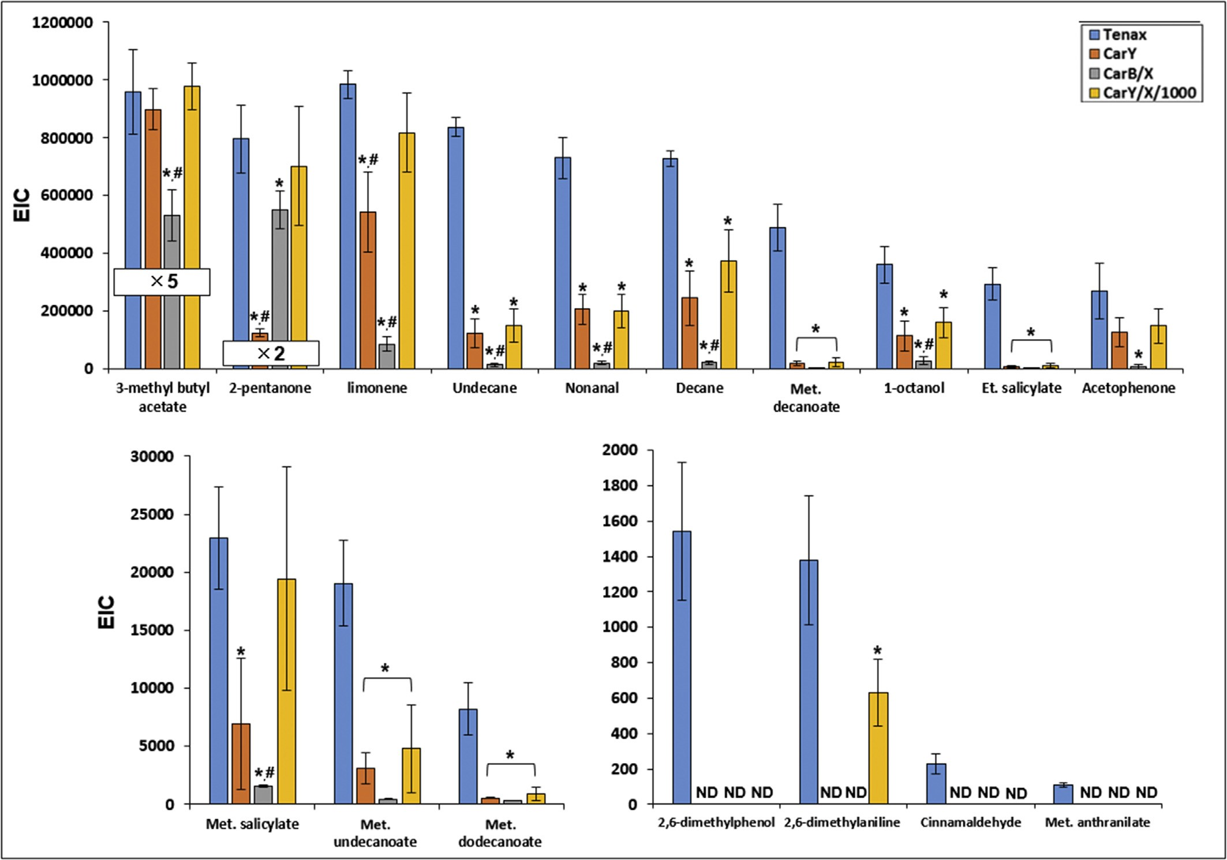
Fig. 1. Extraction yields obtained using the different type TDTs in TSB media spiked with 17 standards (100 ng mL⁻¹). Statistically lower (p < 0.05) areas are marked with * and # only for those significant compared to Tenax and CarY/X/1000, respectively. For 3-methyl butyl acetate and 2-pentanone, the real area value is 5 and 2 times more than the one shown, respectively. ND = not detected. EIC =extracted ion current. To better highlight the differences, three sections with different y-scale axis were generated.

3.2. Application to bacterial culture headspace: untargeted investigation
Tenax tubes and CarY/X/1000 tubes were then used to analyze the headspace of different bacterial cultures, namely Escherichia coli (EC), Pseudomonas aeruginosa (PA), and Staphylococcus aureus (SA) grown in TSB media. In addition, sterile TSB media was analyzed and considered for the untargeted evaluation. Bacterial cultures were sampled at a single time point corresponding to the early stationary phase of growth (see Section 2.2). Five samples for each culture were taken for each TDT type and analyzed by GC×GC-TOF MS.
After the chromatographic alignment based on retention time and mass spectrum match, and artifact removal (see 2.4 for details), a refined list of 257 peaks was obtained.
For further data analysis, an inclusion criterion was applied to consider only the features detected in at least 3 out of 5 replicates within each group type. These are defined as the most consistent features and they consisted of 220 and 177 total features (among the 4 sample type) for Tenax tubes and CarY/X/1000 tubes respectively. The majority of the features were detected in 5 out of 5 replicates for both tubes. A complete overview of the number of features exclusively detected in 3, 4, and 5 out of 5 replicates for each sample type is showed in Supplementary Figure 2. Fig. 2 illustrates the overall flow of data treatment applied in the present research.
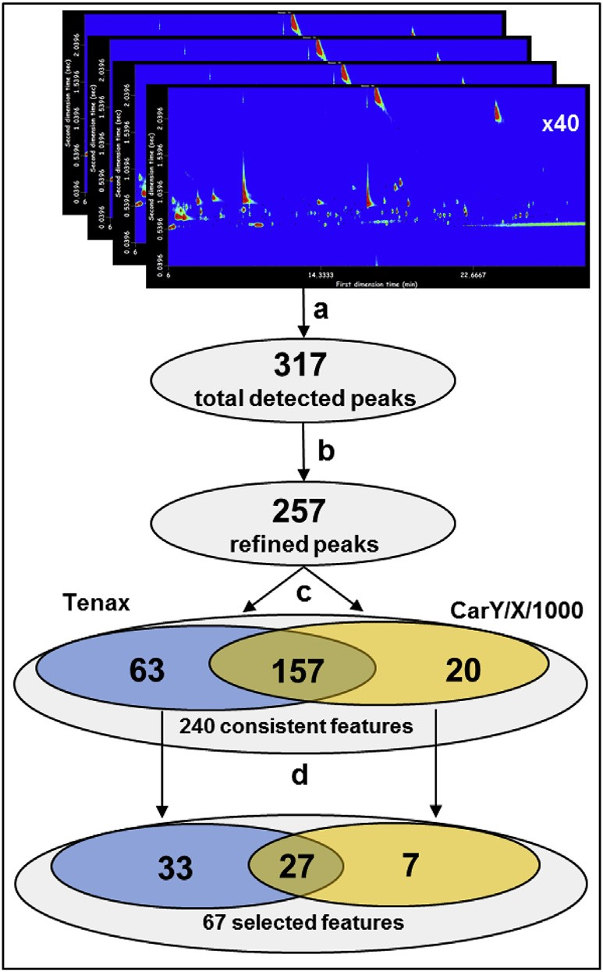
Fig. 2. Scheme illustrating the flow of data treatment for bacterial culture analysis. The numbers in the circles relate to the number of analyte detected. Step a) Chromatogram alignment; Step b) artifact removal using scripts; Step c) adoption of an inclusion criteria to retain the more consistent features (presence in at least 3/5 replicates within each group type) and normalization (PQN); Step d) Discriminatory feature selection using random forest. (For interpretation of the references to colour in this figure legend, the reader is referred to the Web version of this article.)
The most consistent features were used to evaluate the correlation of the volatile profile within each sample type as a measure of the sampling consistency. On Tenax, the average group correlation (Pearson r) was 0.97 ± 0.02, 0.69 ± 0.12, 0.85 ± 0.12, and 0.99 ± 0.01, for EC, SA, PA, and TSB respectively. On CarY/X/1000, the group correlation was 0.84 ± 0.11, 0.66 ± 0.27, 0.78 ± 0.13, and 0.59 ± 0.25, for EC, SA, PA, and TSB respectively. The observed high correlation between technical replicates was expected, but it is important to note that Pearson correlation gave both higher coefficient values and narrower standard deviations for Tenax compared to CarY/X/1000. This finding confirmed the higher consistency and lower variability of measurements obtained using Tenax tubes that were observed in the preliminary experiments on standards (section 3.1).
The chemical classes of the features selected in Fig. 2 (step c) are reported in Fig. 3. Notably, both tubes efficiently trapped a wide range of chemical classes, ranging from alcohols to hydrocarbons and Tenax trapped generally an equal or greater number (~25%) of compounds across the chemical classes (except for ethers) present in those bacterial cultures, compared to CarY/X/1000 (in total 220 instead of 177 peaks).
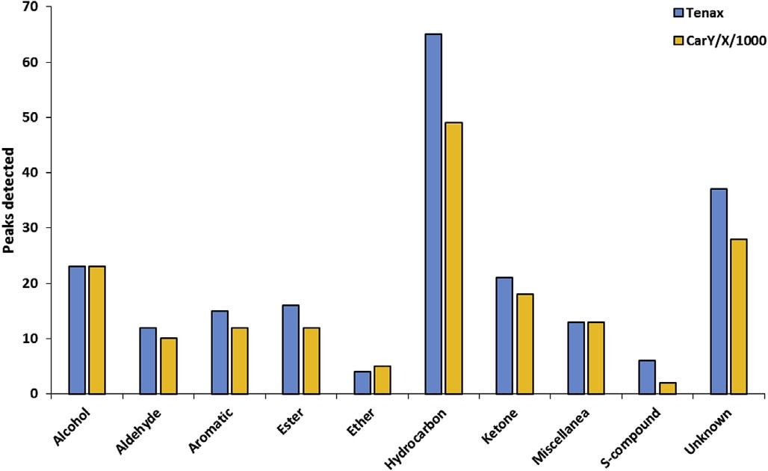
Fig. 3. Number of compounds per chemical class detected considering the aggregate peaks meeting the inclusion criteria in TSB, SA, PA, and EC using Tenax (blue) and CarY/ X/1000 (yellow). (For interpretation of the references to colour in this figure legend, the reader is referred to the Web version of this article.)

Upon closer inspection, the different yield between the two tubes in trapping VOCs was selective and related to analyte size. As a representative example, Fig. 4 shows the averaged chromatogram of the EC volatile profile extracted with Tenax and CarY/X/1000 tubes (the profile of PA and SA are reported in Supplementary Figures 3 and 4). Here, the analytes detected in 100% of the replicates (5 out of 5) in E. coli are represented, and thus the average is derived from 5 measurements.
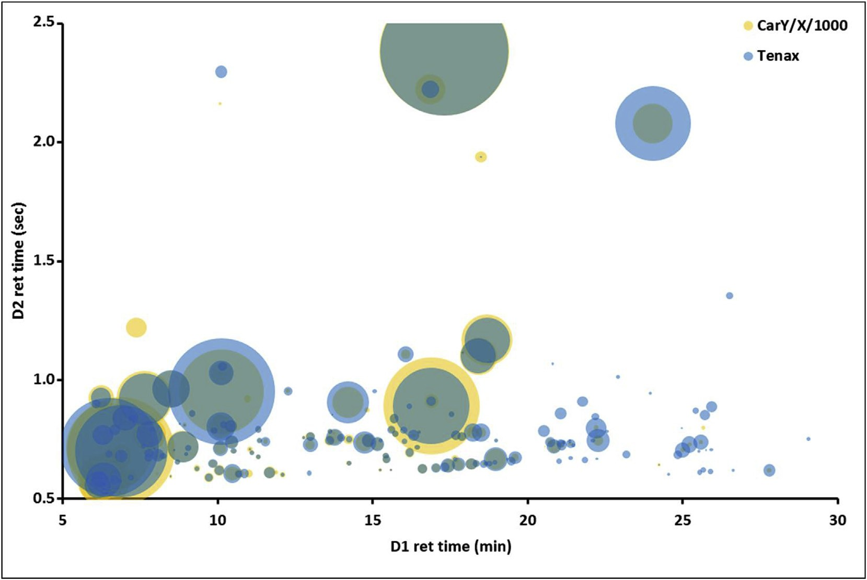
Fig. 4. Bubble plot showing the VOCs from P. aeruginosa, detected in 5 out of 5 replicates with Tenax (blue circles, 138 features) and CarY/X/1000 (yellow circles, 88 features). The size of the bubbles is relative to the average area (n = 5). (For interpretation of the references to colour in this figure legend, the reader is referred to the Web version of this article.)

Generally, in the first half of the chromatogram, the difference between the profiles is quantity-related; indeed, the same analytes are detected with Tenax and CarY/X/1000 but with different signals. In the last part instead (>20 min), the chromatogram with Tenax (blue circles) shows more peaks due to the better affinity for trapping the higher boiling-point analytes.
In the attempt to differentiate the samples based on the VOC profile, the samples were plotted using hierarchical clustering analysis and heatmap using the 220 and 177 consistent features (Fig. 5). With this straightforward and unsupervised data analysis flow, a very good clustering of the 4 groups is obtained with Tenax (Fig. 5A), whereas TSB and PA sample results were not well distinguished from one another when CarY/X/1000 was used for VOCs sampling (Fig. 5B). Euclidean distances (intra- and intergroups), a measure of the distance between samples/groups in the dendrogram for hierarchical analysis [24], were extrapolated to better evaluate and compare the sampling tubes. The intra-group distance (within the same sample-type) is a value of the dispersion of the samples within the same group, and the inter-group gives a measure of the separation between the two classes. The values obtained are reported in Fig. 5C. As can be noted from the diagonal, which reports the intra-group Euclidian distances, smaller values (thus, tighter intra-grouping) are obtained for Tenax (on average 15.8) compared to CarY/X/1000 (on average 19.8). On the other hand, all the inter-group distances (between different sample-types) result on average doubled with Tenax (26.2) compared to CarY/X/1000 (13.8), meaning that the discrimination between the bacteria headspace is more effective when Tenax is used for VOCs sampling. These results can be explained by a sum of two factors: I) the use of Tenax gave a better repeatability compared to CarX/Y/1000, thus determining a lower dispersion and variability of the replicates; II) using Tenax about 50 more features, highly informative, were extracted compared to CarX/Y/1000.
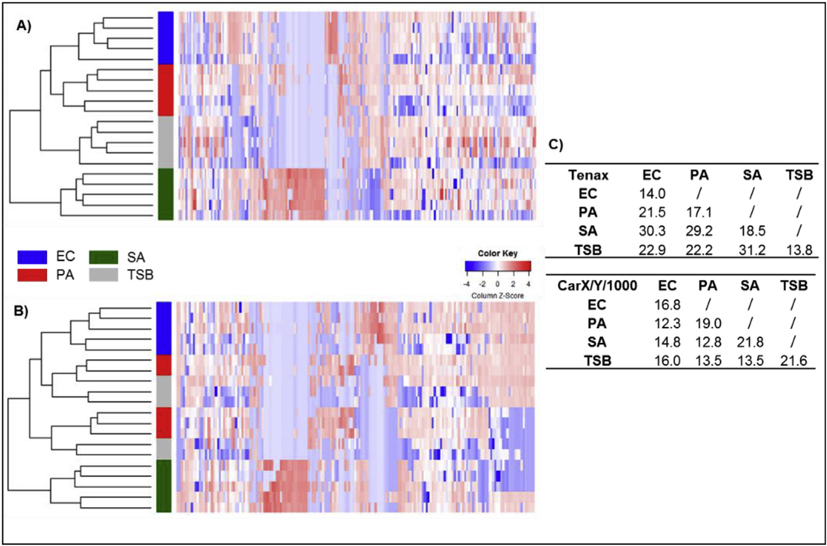
Fig. 5. Heatmap and hierarchical clustering for TSB, SA, PA and EC samples using Tenax (A) and CarY/X/1000 (B) considering the peaks meeting the inclusion criteria (220 and 177 features, respectively). C) Euclidean distances for each combination of sample groups, measured in Tenax and CarY/X/1000.

3.3. Characteristic VOCs from bacterial cultures: targeted evaluation
The common progression of untargeted analysis is the subsequent identification of features that best discriminate and characterize the samples under investigation, and which can be possibly considered as diagnostic biomarkers. For this purpose, random forest was used to select discriminatory volatile metabolites [12,19] between the three bacterial species evaluated (Fig. 2, step d). The media was not considered for feature selection because of its low clinical relevance.
The random forest model considered the aggregated discriminatory features from either EC, SA, and PA, and selected 60 molecules (from the initial 220) using Tenax and 34 molecules (from the initial 177) using CarY/X/1000 tubes. Of these, 26 volatile metabolites were in common between Tenax and CarY/X/1000, and are listed in Table 1. Moreover, the relative abundance (normalized to the highest signal between the two tubes within the same culture type), is reported as well. The box plot confirmed that Tenax performed better than CarY/X/1000 for VOC sampling, both in terms of trapping efficiency (higher signals in 17 out of 26 analytes in common) and standard deviation of the measured area (all below 30% RSD, except for 5 analytes).

Table 1
Discriminatory molecules selected by using random forest and shared between Tenax (blue) and CarY/X/1000 (yellow). Also reported for each peak the average library match, retention times and relative abundance. The box plots reflect the analyte extraction efficiency of Tenax (blue) and CarY/X/1000 (yellow) in the same sample type (^{a,b,c}).
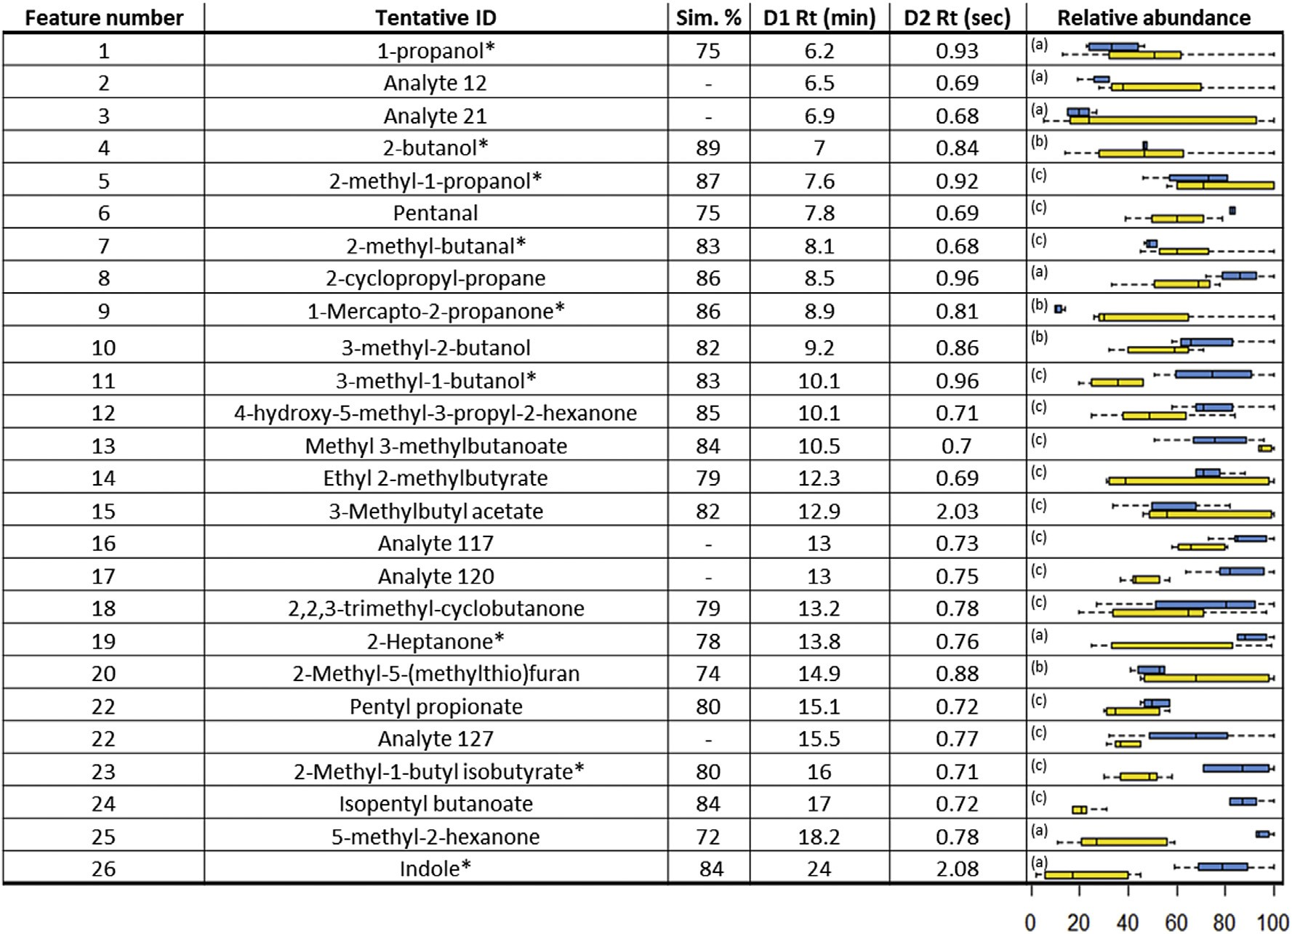

In terms of discrimination capability between the four groups is worthy saying that although both tubes showed a good discrimination between the 4 groups after feature selection, a ~30% better clustering and separation were obtained when sampling with Tenax (average inter-group Euclidean distance of 12.6 for Tenax versus 9.8 for CarY/X/1000), as shown in Supplementary Figure 5. The random forest algorithm highly benefitted from the higher repeatability and consistency of the measurements using Tenax, thus retaining a higher number of informative features (60 vs 34) and giving a better discrimination capability.
Although an exhaustive discussion of the discriminatory features is outside the aim of the paper, it is important to mention that of the discriminatory VOCs in common when sampling with Tenax and CarY/X/1000, nine are largely reported in the literature (those indicated as * in Table 1) [1, 35-41]. For example, indole was detected and confirmed as a discriminatory feature for EC [38,40,41]. For indole, both trapping efficiency and repeatability resulted greater using Tenax tubes (~3.5 fold higher area and 4 times lower RSD respect to CarY/X/1000).
The aldehyde 2-methyl butanal was selected as characteristic VOC for SA, in agreement with previous reports [1,37], and had a higher signal when CarY/X/1000 was used (~0.3 fold higher area), probably because of the low molecular size and higher affinity to the stronger adsorbent, but with higher variability (33% RSD) than Tenax (12% RSD).
The ketone 2-heptanone, which is a known P. aeruginosa biomarker [36,39], had a signal approximately 1.3 fold higher area with 3 times lower RSD values with Tenax in comparison to CarY/X/ 1000.

Conclusion
The goal of the current research was to evaluate the use of different TDTs for bacterial VOC analysis, both in a targeted and untargeted manner. Of the four different TDTs tested, tubes packed with Tenax showed the best sensitivity and repeatability on the standard analytes used in the preliminary evaluation, followed by CarY/X/1000 tubes.
Tenax tubes also showed a better performance in terms of correlation and discrimination efficiency in a multivariate data analysis between bacterial headspace samples (Escherichia coli, Staphylococcus aureus, Pseudomonas aeruginosa, and the growth media). In looking at this in a univariate way, Tenax confirmed an overall better repeatability, analyte coverage, and recovery of the most characteristic bacterial VOCs, considering the samples and condition herein used.
The future intent is to be more consistent in VOC sampling (i.e. using thermal desorption tubes) when in vitro studies want to be compared to in vivo studies for biomarkers discovery and translation, in order to exclusively focus on biological differences and minimize the variability of sample preparation. This study recommends the presence of the Tenax bed in TDTs.

Conflict of interest

All authors report no potential conflicts of interest.

Ethical approval
This article does not contain any studies with human participants or animals performed by any of the authors.

Acknowledgments
The authors gratefully acknowledge Millipore/Sigma for providing the thermal desorption tubes. The authors thank also Mavra Nasir (Dartmouth College) for the fruitful discussions about data analysis.

Appendix A. Supplementary data
Supplementary data to this article can be found online at https://doi.org/10.1016/j.aca.2019.03.027.

References
- L.D.J. Bos, P.J. Sterk, M.J. Schultz, Volatile metabolites of pathogens: a systematic review, PLoS Pathog. 9 (2013), https://doi.org/10.1371/ journal.ppat.1003311.
- S. Schulz, J.S. Dickschat, Bacterial volatiles: the smell of small organisms, Nat. Prod. Rep. 24 (2007) 814e842, https://doi.org/10.1039/b507392h.
- F. Buljubasic, G. Buchbauer, The scent of human diseases: a review on specific volatile organic compounds as diagnostic biomarkers, Flavour Fragrance J. 30 (2015) 5e25, https://doi.org/10.1002/ffj.3219.
- O. Lawal, W.M. Ahmed, T.M.E. Nijsen, R. Goodacre, S.J. Fowler, Exhaled breath analysis: a review of ‘breath-taking’ methods for off-line analysis, Metabolomics 13 (2017) 1e16, https://doi.org/10.1007/s11306-017-1241-8.
- F.J. Gilchrist, P. Span el, D. Smith, W. Lenney, The in vitro identi fication and quantification of volatile biomarkers released by cystic fibrosis pathogens, Anal. Methods. 7 (2015) 818e824, https://doi.org/10.1039/c4ay02981j.
- B. Buszewski, M. Kesy, T. Ligor, A. Amann, Human exhaled air analytics: biomarkers of diseases, Biomed. Chromatogr. (2007), https://doi.org/10.1002/ bmc.835.
- Sampling and analysis of gases and vapours [air monitoring methods, 2009], in: MAK-Collection Occup. Heal. Saf., American Cancer Society, 2012, pp. 14e47, https://doi.org/10.1002/3527600418.amsampgase0011.
- P. Mochalski, J. King, M. Klieber, K. Unterkofler, H. Hinterhuber, M. Baumann, A. Amann, Blood and breath levels of selected volatile organic compounds in healthy volunteers, Analyst (2013), https://doi.org/10.1039/c3an36756h.
- K.D. N, K.A. P, A.N. T, M. U, S. S, J.R. I, P.G. M, S.L. Forbes, In vitro volatile organic compound profiling using GCGC-TOFMS to differentiate bacteria associated with lung infections: a proof-of-concept study, J. Breath Res. 10 (2016) 26008. http://stacks.iop.org/1752-7163/10/i¼2/a¼026008.
- M. Nasir, H.D. Bean, A. Smolinska, C.A. Rees, E.T. Zemanick, J.E. Hill, Volatile molecules from bronchoalveolar lavage fluid can “rule-in” Pseudomonas aeruginosa and “rule-out” Staphylococcus aureus infections in cystic fibrosis patients, Sci. Rep. 8 (2018), https://doi.org/10.1038/s41598-017-18491-8.
- C.A. Rees, F.A. Franchina, K.V. Nordick, P.J. Kim, J.E. Hill, Expanding the Klebsiella pneumoniae volatile metabolome using advanced analytical instrumentation for the detection of novel metabolites, J. Appl. Microbiol. 122 (2017), https://doi.org/10.1111/jam.13372.
- F.A. Franchina, T.R. Mellors, M. Aliyeva, J. Wagner, N. Daphtary,
L.K.A. Lundblad, S.M. Fortune, E.J. Rubin, J.E. Hill, Towards the use of breath for detecting mycobacterial infection: a case study in a murine model, J. Breath Res. 12 (2018), https://doi.org/10.1088/1752-7163/aaa016.
- M.A.G. Wallace, J.D. Pleil, Evolution of clinical and environmental health applications of exhaled breath research: review of methods and instrumentation for gas-phase, condensate, and aerosols, Anal. Chim. Acta (2018), https:// doi.org/10.1016/j.aca.2018.01.069.
- U.S. Environmental Protection Agency (EPA), Compendium method TO-14A determination of volatile organic compounds ( VOCs ). Ambient Air Using Specially Prepared Canisters with Subsequent Analysis B, 1999.
- U.S. Environmental Protection Agency (EPA), Compendium method TO-17: determination of volatile organic compounds in Ambient air using active sampling onto sorbent tubes, Compend. Methods Determ. Toxic Org. Compd. Ambient Air. (1999).
- E. Woolfenden, Sorbent-based sampling methods for volatile and semivolatile organic compounds in air. Part 1: sorbent-based air monitoring options, J. Chromatogr. A 1217 (2010) 2674e2684, https://doi.org/10.1016/ j.chroma.2009.12.042.
- O. Lawal, H. Knobel, H. Weda, T.M.E. Nijsen, R. Goodacre, S.J. Fowler,
W.M. Ahmed, A. Artigas, J. Bannard-Smith, L.D.J. Bos, M. Camprubi, L. Coelho, P. Dark, A. Davie, E. Diaz, G. Goma, T. Felton, S.J. Fowler, J.H. Leopold, P.M.P. van Oort, P. Povoa, C. Portsmouth, N.J.W. Rattray, G. Rijnders, M.J. Schultz, R. Steenwelle, P.J. Sterk, J. Valles, F. Verhoeckx, A. Vink, I.R. White, T. Winters, T. Zakharkina, TD/GCeMS analysis of volatile markers emitted from mono- and co-cultures of Enterobacter cloacae and Pseudomonas aeruginosa in artificial sputum, Metabolomics 14 (2018), https://doi.org/10.1007/ s11306-018-1357-5.
- O. Lawal, H. Knobel, H. Weda, L.D. Bos, T.M.E. Nijsen, R. Goodacre, S.J. Fowler, Volatile organic compound signature from co- culture of lung epithelial cell line with Pseudomonas aeruginosa, Analyst (2018), https://doi.org/10.1039/ c8an00759d.
- T.R. Mellors, M. Nasir, F.A. Franchina, A. Smolinska, L. Blanchet, J.L. Flynn, Tomko Jaime, M. O'Malley, C.A. Scanga, P.L. Lin, J. Wagner, J.E. Hill, Identification of Mycobacterium tuberculosis using volatile biomarkers in culture and exhaled breath, J. Breath Res. 13 (2019), 016004, https://doi.org/10.1088/ 1752-7163/aacd18.
- P.V. Dasaraju, C. Liu, Infections of the respiratory system; Chapter 93:infections of the respiratory system. http://www.ncbi.nlm.nih.gov/pubmed/ 21413304, 1996.
- F.B. Mayr, S. Yende, D.C. Angus, Epidemiology of severe sepsis, Virulence 5 (2014) 1e11, https://doi.org/10.4161/viru.27372.
- J.V. Seeley, S.K. Seeley, Multidimensional gas chromatography: fundamental advances and new applications, Anal. Chem. 85 (2013) 557e578, https:// doi.org/10.1021/ac303195u.
- B.A. Weggler, T. Groger, R. Zimmermann, Advanced scripting for the auto-€ mated profiling of two-dimensional gas chromatography-time-of-flight mass spectrometry data from combustion aerosol, J. Chromatogr. A 1364 (2014) 241e248, https://doi.org/10.1016/j.chroma.2014.08.091.
- G. Purcaro, P.H.P.-H. Stefanuto, F.A. Franchina, M. Beccaria, W.F.W.F. WielandAlter, P.F.P.F. Wright, J.E.J.E. Hill, SPME-GCGC-TOF MS fingerprint of virallyinfected cell culture: sample preparation optimization and data processing evaluation, Anal. Chim. Acta (2018), https://doi.org/10.1016/j.aca.2018.03.037.
- F. Dieterle, A. Ross, G. Schlotterbeck, H. Senn, Probabilistic quotient normalization as robust method to account for dilution of complex biological mixtures. Application in1H NMR metabonomics, Anal. Chem. (2006), https:// doi.org/10.1021/ac051632c.
- T. Hastie, R. Tibshirani, J. Friedman, The Elements of Statistical Learning, 2013.
http://link.springer.com/10.1007/978-0-387-21606-5%0Apapers3:// publication/doi/10.1007/978-0-387-21606-5.
- J. Brown, B. Shirey, A tool for selecting an adsorbent for thermal desorption applications, Supelco Tech. Rep. (2001) 36.
- S. Supelco, Supelco ® Specialty Carbon Adsorbents (n.d.), https://webqws.sial. com/content/dam/sigma-aldrich/docs/Supelco/General_Information/1/ specialty-carbon-adsorbents-t410081.pdf.
- C.Y. Peng, S. Batterman, Performance evaluation of a sorbent tube sampling method using short path thermal desorption for volatile organic compounds, J. Environ. Monit. 2 (2000) 313e324, https://doi.org/10.1039/b003385p.
- A. Maceira, L. Vallecillos, F. Borrull, R.M. Marce, New approach to resolve the humidity problem in VOC determination in outdoor air samples using solid adsorbent tubes followed by TD-GCeMS, Sci. Total Environ. 599e600 (2017) 1718e1727, https://doi.org/10.1016/j.scitotenv.2017.05.141.
- K. Dettmer, W. Engewald, Adsorbent materials commonly used in air analysis for adsorptive enrichment and thermal desorption of volatile organic compounds, Anal. Bioanal. Chem. 373 (2002) 490e500, https://doi.org/10.1007/ s00216-002-1352-5.
- E. Woolfenden, Sorbent-based sampling methods for volatile and semivolatile organic compounds in air. Part 2. Sorbent selection and other aspects of optimizing air monitoring methods, J. Chromatogr. A 1217 (2010) 2685e2694, https://doi.org/10.1016/j.chroma.2010.01.015.
- A.R. Mastrogiacomo, E. Pierini, L. Sampaolo, A comparison of the critical parameters of some adsorbents employed in trapping and thermal desorption of organic pollutants, Chromatographia 41 (1995) 599e604, https://doi.org/ 10.1007/BF02688092.
- N.E. Rabaud, S.E. Ebeler, L.L. Ashbaugh, R.G. Flocchini, The application of thermal desorption GC/MS with simultaneous olfactory evaluation for the characterization and quantification of odor compounds from a dairy, J. Agric. Food Chem. 50 (2002) 5139e5145, https://doi.org/10.1021/jf020204u.
- W. Filipiak, R. Beer, A. Sponring, A. Filipiak, C. Ager, A. Schiefecker, S. Lanthaler, R. Helbok, M. Nagl, J. Troppmair, A. Amann, Breath analysis for in vivo detection of pathogens related to ventilator-associated pneumonia in intensive care patients: a prospective pilot study, J. Breath Res. 9 (2015), 016004, https://doi.org/10.1088/1752-7155/9/1/016004.
- H.D. Bean, C.A. Rees, J.E. Hill, Comparative analysis of the volatile metabolomes of Pseudomonas aeruginosa clinical isolates, J. Breath Res. 10 (2016), https://doi.org/10.1088/1752-7155/10/4/047102.
- W. Filipiak, A. Sponring, M.M. Baur, A. Filipiak, C. Ager, H. Wiesenhofer, M. Nagl, J. Troppmair, A. Amann, Molecular analysis of volatile metabolites released specifically by staphylococcus aureus and pseudomonas aeruginosa, BMC Microbiol. 12 (2012), https://doi.org/10.1186/1471-2180-12-113.
- G. Alvarez-Rivera, T. De Miguel, M. Llompart, C. Garcia-Jares, T.G. Villa, M. Lores, A novel outlook on detecting microbial contamination in cosmetic products: analysis of biomarker volatile compounds by solid-phase microextraction gas chromatography-mass spectrometry, Anal. Methods. 5 (2013) 384e393, https://doi.org/10.1039/c2ay25833a.
- V. Shestivska, P. Span el, K. Dryahina, K. Sovov a, D. Smith, M. Musílek, A. Nemec, Variability in the concentrations of volatile metabolites emitted by genotypically different strains of Pseudomonas aeruginosa, J. Appl. Microbiol. 113 (2012) 701e713, https://doi.org/10.1111/j.1365-2672.2012.05370.x.
- J.H. Lee, J. Lee, Indole as an intercellular signal in microbial communities, FEMS Microbiol. Rev. 34 (2010) 426e444, https://doi.org/10.1111/j.15746976.2009.00204.x.
- A. Burklund, H.K. Saturley-Hall, F.A. Franchina, J.E. Hill, J.X.J. Zhang, Printable QR code paper microfluidic colorimetric assay for screening volatile biomarkers, Biosens. Bioelectron. (2019), https://doi.org/10.1016/j.bios.2018.12.026.

