Early Mucosal Healing Predicts Favorable Outcomes in Patients With Moderate to Severe Ulcerative Colitis Treated With Golimumab: Data From the Real-life BE-SMART Cohort

Peter Bossuyt, MD,¹ Filip Baert, MD PhD,² Francois D'Heygere, MD,³Antoine Nakad, MD,⁴ Catherine Reenaers, MD PhD,⁵ Fernand Fontaine, MD,⁶ Denis Franchimont, MD PhD,⁷ Olivier Dewit, MD PhD,⁸ Philippe Van Hootegem, MD,⁹ Stijn Vanden Branden, MD,¹⁰ Guy Lambrecht, MD,¹¹ and Marc Ferrante, MD PhD¹²; on behalf of the Belgian IBD Research and Development Group
From the
¹Department of Gastroenterology, AZ Imelda, Bonheiden, Belgium;
²Department of Gastroenterology, AZ Delta, Roeselare-Menen, Belgium;
³Department of Gastroenterology, AZ Groeninge, Kortrijk, Belgium;
⁴Department of Gastroenterology, CHWAPI, Mons, Belgium;
⁵Department of Gastroenterology, CHU Sart Tilman, Liège, Belgium;
⁶Department of Gastroenterology, CHC Saint-Joseph, Liège, Belgium;
⁷Department of Gastroenterology, Erasme, Brussels, Belgium;
⁸Department of Gastroenterology, CHU Saint-Luc, Brussels, Belgium;
⁹Department of Gastroenterology, AZ Sint-Lucas, Brugge, Belgium;
¹⁰Department of Gastroenterology, Onze-Lieve-Vrouwziekenhuis, Aalst, Belgium;
¹¹Department of Gastroenterology, AZ Damiaan, Oostende, Belgium;
¹²Department of Gastroenterology, University Hospitals Leuven, KU Leuven, Leuven, Belgium

Author contributions: conception or design of the work: P.B., M.F.; data collection: all; data analysis and interpretation: P.B., M.F.; drafting the article: P.B.; critical revision of the article: all; final approval of the version to be published: all.

ABSTRACT
Background: Golimumab (GOL) is registered for moderate to severely active ulcerative colitis (UC). Data on the use of GOL in daily clinical practice are limited. Currently, it is unclear which factors are predictive of a favorable outcome. The goals of this study were to evaluate the midterm outcome of GOL (week 26) in patients with moderate to severe UC and to determine predictors of favorable outcome.
Methods: Patients included in the SMART study (NCT02155335) were evaluated for their mid-term outcome. Demographic data, disease characteristics, and medical history were recorded retrospectively. Data on disease activity based on total Mayo score, previous and concomitant medication, GOL dosing, mucosal healing (Mayo 0 or 1), adverse events (colectomy, hospitalization), and biomarkers (C-reactive protein, fecal calprotectin, hemoglobin, and albumin) were collected at baseline and weeks 2, 6, 14, 26, and 52. GOL was dosed at 200 and 100 mg at weeks 0 and 2, respectively, and 50 mg (<80 kg body weight) or 100 mg (≥80 kg body weight) every 4 weeks thereafter. The primary end point was steroid-free GOL continuation at week 26.
Results: From the 91 evaluable patients (42% female; median age, 42 years; median disease duration, 5 years), 4% were active smokers, 25% had extensive colitis, and 38% had an endoscopic Mayo score of 3 at baseline. The median (interquartile range [IQR]) baseline Mayo score was 9 (8-10). Although 75% of patients had previously failed immunomodulators (IMMs), the majority (87%) were anti-tumor necrosis factor (TNF) nai've. GOL was started in combination with IMM in 40% and steroids in 64%. The median (IQR) duration of GOL therapy during follow-up was 35.7 (11.4-105.7) weeks. Twenty-six weeks after GOL induction, 37 patients (41%) were steroid-free and still on GOL, of whom 8 (21.6%) required GOL dose optimization. Short-term mucosal healing (STMH) at week 14 was evaluated in 60% of the patients. Considering the whole cohort, only 40% achieved STMH. No predictors could be retained of short-term treatment outcome. In multivariate analysis, STMH was predictive of steroid-free GOL continuation at week 26 (odds ratio [OR], 5.56; 95% confidence interval [CI], 1.90-16.29; P = 0.002) and week 52 (OR, 9.38; 95% CI, 2.68-32.84; P < 0.001). In patients continuing GOL after week 14, STMH was predictive of intervention-free survival (OR, 2.05; 95% CI, 1.09-3.86; P = 0.026) and discontinuation-free survival (OR, 3.47; 95% CI, 1.58-7.58; P = 0.002). During follow-up, 78% needed an intervention, 68% discontinued GOL, and 3 patients needed a colectomy.

Conclusions: Real-life data confirm the moderate effectiveness of GOL on the mid-term in active UC, but therapeutic interventions are frequently needed. Short-term mucosal healing predicts a favorable outcome.
Key Words: mucosal healing, ulcerative colitis, golimumab, mid term outcome, golimumab

INTRODUCTION
Ulcerative colitis (UC) is a chronic inflammatory condition causing continuous mucosal inflammation of the colon, affecting the rectum and a variable extent of the colon.¹ Compared with the general population, the quality of life patients with UC experience is low across all dimensions of health.^{2,3} Over the last years, the therapeutic armamentarium for UC has expanded intensively. When deciding the appropriate treatment strategy for active UC, one should consider the activity, distribution, and pattern of disease.^{4,5} Current treatment targets of UC are clinical (based on stool frequency and rectal blood loss) and endoscopic remission.^{6,7} Golimumab (GOL) is the latest anti-tumor necrosis factor (anti-TNF) antibody approved for moderately to severely active UC. This subcutaneous (SC) human anti-TNF is indicated for the treatment of moderately to severely active UC in adult patients who have had an inadequate response to conventional therapy, including corticosteroids and immunomodulators, or who are intolerant to or have medical contraindications for such therapies.^{8,9} In the registration PURSUIT SC induction trial, anti-TNF-naïve patients with an established diagnosis of UC and moderate to severe disease activity randomly received GOL 200 mg followed by 100 mg, 400 mg followed by 200 mg, or placebo at weeks 0 and 2, respectively.⁹ At week 6, significantly greater proportions of patients in the GOL 200/100 mg and GOL 400/200 mg groups (51.0% and 54.9%, respectively) were in clinical response (defined as a decrease from baseline in the Mayo score >30% and ≥3 points, accompanied by either a rectal bleeding subscore of 0 or 1 or a decrease from baseline in the rectal bleeding subscore ≥1) than patients assigned to placebo (30.3%).⁹ In the maintenance phase, the responders to GOL induction were randomly assigned to SC injections of placebo or 50 or 100 mg GOL every 4 weeks through week 52.⁸ The primary end point of the maintenance phase, clinical response maintained through week 54, was observed in 31.2% of patients receiving placebo, 47.0% of patients receiving 50 mg GOL, and 49.7% of patients receiving 100 mg GOL. At weeks 30 and 54, a higher percentage of patients who received 100 mg GOL were in clinical remission or had mucosal healing compared with the maintenance placebo or 50 mg GOL group. Data on the use of GOL in daily clinical practice are scarce.¹⁰⁻¹³ Overall, the response rates are in line with or slightly higher than the results of the PURSUIT registration trials. A correlation between adequate GOL exposure and treatment success has been suggested.¹³ In PURSUIT-M, early dose optimization with 100 mg golimumab given at weeks 6 and 10 to week 6 nonrepsonders resulted in delayed response achieved by 28% of patients by week 14.^{8,14} Higher drug exposure during induction or early optimization of the dose may lead to a more favorable outcome.^{15, 16}
To date, no early predictors of mid-term (week 26) and longterm (≥week 52) response to GOL have been established, but these—if found—may offer a useful clinical tool to implement a treat-to-target approach.
The aims of this study were to evaluate retrospectively the mid- and long-term outcomes of GOL in patients with moderate to severe UC and to identify predictors of a favorable long-term outcome.

METHODS Patient Population
This was a retrospective study based on the prospectively collected data from patients with UC who were previously included in the SMART study (NCT02155335;¹⁷). The SMART study was an open-label observational study looking at patient preferences for an injection device (pen vs syringe) used during subcutaneous induction with GOL. In total, 100 patients were included in the SMART study.
For the current BE-SMART study, all these patients were retrospectively assessed. All patients previously gave their informed consent for participation in the prospective SMART study, and the protocol of SMART and BE-SMART was approved by the ethical committee of UZ Leuven, Belgium (SMART: S56549 and NCT02155335; BE-SMART: S59335 and NCT02914717).

Data Collection
Part of the baseline characteristics were collected prospectively in the SMART study and included sex, race, marital status, year of birth, date of diagnosis of UC, age at diagnosis, extra-intestinal manifestations (arthritis, psoriasis, psoriatic arthropathy, spondylarthropathy, arthralgia, erythema nodosum, primary sclerosing cholangitis, celiac disease, diabetes mellitus type 1, Behçet disease, iritis, uveitis, pyoderma gangrenosum, other autoimmune disorders, and other comorbidities), date of GOL initiation, age at GOL initiation, disease duration at GOL initiation, mode of administration during induction, total Mayo score, and Mayo subscores. All other baseline characteristics were retrospectively retained by search in the electronic medical file of the patient: date of birth, extension of ulcerative colitis (proctitis, left-sided colitis, extensive colitis),¹⁸ family history of IBD, other familial diseases, smoking habits (never, stopped, current smoker), prior and current UC treatment type (5-aminosalicylate [5-ASA], steroids, immuno- modulators, anti-TNFs, vedolizumab), reason for discontinuation of prior UC treatment (primary nonresponse [absence of any clinical response during prior treatment, as assessed by the treating physician], loss of response [loss of initial clinical response during prior treatment, as assessed by the treating physician], allergic reaction, pregnancy, adverse event [type], remission, other), length, and body weight. Only patients with a baseline total Mayo score ≥6 and an endoscopic subscore ≥2 were retained for further analysis. For the follow-up after GOL, we collected data at weeks 2, 6, 14, 26, and 52, and a maximal deviation of 3 weeks around the assessment time point was accepted. These time points reflect the standard assessment points in daily clinical practice. At these time points, we retrospectively collected the following data: C-reactive protein, fecal calprotectin, hemoglobin, albumin, Mayo score and subscores, type and dose of concomitant medication (5-ASA, steroids, immunomodulator), changes in GOL treatment regimen (stopped, dose increase, interval shortening), date of change of GOL dosing regimen, stop of GOL (date, reason), new UC treatment initiation instead of GOL, UC-related hospitalization, colectomy. The regimen used was the one reimbursed in most European countries: GOL 200 mg at week 0 and 100 mg at week 2.
The maintenance GOL dose was 50 mg every 4 weeks for patients with a body weight below 80 kg and 100 mg every 4 weeks for the other patients.
The primary end point of the study was the percentage of patients on GOL at week 26 without steroids. Major secondary end points were GOL continuation at weeks 14 and 52 without steroids. Furthermore, we evaluated the percentage of patients with mucosal healing (Mayo endoscopic subscore of 0 or 1) at week 14, the need for GOL dose optimization, GOL discontinuation, UC-related hospitalization rate, and colectomy rate. We also evaluated the need for an intervention, which was defined as dose optimization or discontinuation of GOL (for any reason including colectomy) or addition of any other UC medication. Shortterm mucosal healing was defined as a Mayo endoscopic subscore of 0 or 1 at 12 to 14 weeks postinduction with GOL. A favorable outcome was defined as steroid-free GOL continuation.

Statistical Analysis
Statistical analysis was done using SPSS 24.0 (IBM Corp, Armonk, NY, USA). Continuous variables with non-normal distribution were described as medians with interquartile ranges (IQRs). Categorical variables were described as percentages. For time-independent evaluation of continuous variables, we used the Mann-Whitney test, and for categorical variables we used the chi-square tests (or Fisher exact test where applicable). Results of the multivariate analysis were presented as odds ratios (ORs) with 95% confidence intervals (CIs). Kaplan- Meier curves were constructed to evaluate the outcome of GOL therapy. Kaplan-Meier survival analyses were performed in patients continuing GOL beyond week 14 (moment of endoscopic evaluation). Log-rank statistics and Cox regression analyses were performed to evaluate the predictive value of baseline characteristics, concomitant therapy, and short-term changes in C-reactive protein level, serum albumin, and short-term mucosal healing. Nonresponder imputation was used in the evaluation of the predictors of mid- and long-term outcome (patients who stopped GOL before a certain time point were evaluated as failure). A 2-tailed P value <0.05 was considered statistically significant.

RESULTS

Patient Population
From the 100 patients included in the SMART study, 9 patients were excluded for evaluation in the BE-SMART. Five patients were excluded because they had no active disease at baseline (total Mayo <6 or endoscopic subscore <2), 3 were lost to follow-up, and 1 patient was diagnosed as having Crohn's disease during follow-up. This resulted in 91 evaluable patients from 19 different sites, including 6 academic hospitals. Baseline characteristics are summarized in Table 1. All patients had previously been treated with 5-ASA, 98% had recieved steroids, 75% had been treated with immunomodulators, and 87% were anti-TNF naïve. Two-thirds received steroids at the start of GOL. All patients had induction therapy with GOL consisting of GOL 200 mg SC at week 0 followed by GOL 100 mg SC at week 2. After induction, maintenance therapy with GOL 50 mg SC (<80 kg) or 100 mg (≥80 kg) every month was started. The decision for dose optimization during maintenance was at the discretion of the treating physician (GOL 50 mg SC q2 weeks, GOL 100 mg SC q4 weeks or GOL 100 mg SC q2 weeks).

Outcome
Patients had a median (IQR) follow-up on GOL of 35.7 (11.4-105.7) weeks and were followed for a median (IQR) of 112.6 (99.6-173.2) weeks after the start of GOL to last follow-up (04/2017). The primary end point of GOL continuation without steroids at week 26 was met in 41% of the patients (n = 37/91), of whom 8 needed GOL optimization before week 26 (GOL 100 mg q4 weeks and GOL 50 mg q2 weeks). At weeks 14 and 52, steroid-free GOL continuation was achieved in, respectively, 43% (n = 39/91) and 30% (n = 27/91) of the patients (Fig. 1). Only 21% (n = 19/91) of the patients reached week 52 without need for steroids or GOL dose optimization. Moreover, 34% (n = 31/91) of the patients had a primary nonresponse on GOL, and 23% (n = 31/91) had secondary loss of response during the first year. Twelve patients (13%) were hospitalized for UC during follow-up, from whom 3 underwent a colectomy. From the patients who had a colectomy during follow-up (n = 3), 2 were primary nonresponders to GOL. Mucosal healing data at week 14 were missing in 4 patients. The mucosal healing rate at week 14 was 40% (n = 35/87), including the patients (n = 23) who discontinued before week 14 (intention-to-treat analysis).

Table 1 : Baseline Characteristics

Variable | Subtype of Variable
Female sex, No. (%) |  |  | 38/91 (42)
Caucasian, No. (%) |  |  | 88/91 (97)
Marital status, No. (%) | Single |  | 23/91 (25)
 | Married/living together |  | 67/91 (74)
 | Widow |  | 1/91 (1)
Education level, No. (%) | At least secondary school |  | 84/91 (92)
 | At least high school |  | 46/91 (51)
Employment, No. (%) | Student |  | 9/91 (10)
 | Active |  | 59/91 (65)
 | Nonactive |  | 23/91 (25)
Disease extension, No. (%) | E1 |  | 11/86 (13)
 | E2 |  | 53/86 (62)
 | E3 |  | 22/86 (25)
Concomitant disease of interest, No. (%) | Psoriasis |  | 3/91 (3)
 | Spondylarthropathy |  | 1/91 (1)
 | PSC |  | 3/91 (3)
Familial history IBD, No. (%) |  |  | 12/83 (13)
 | First degree |  | 7/83 (8)
 | Second degree |  | 3/83 (3)
 | Third degree |  | 2/83 (2)
Smoking behavior, No. (%) | Never |  | 46/75 (61)
 | Former |  | 26/75 (35)
 | Active |  | 3/75 (4)
Previous medical therapy, No. (%) | 5-ASA |  | 91/91 (100)
 | Steroids |  | 89/91 (98)
 | IMM |  | 68/91 (75)
 | IFX |  | 12/91 (13)
 | ADM |  | 0/91 (0)
Reason to stop previous IFX therapy, No. (%) | Primary nonresponse |  | 1/12 (8)
 | Loss of response |  | 5/12 (42)
 | Adverse events |  | 4/12 (33)
 | Remission |  | 1/12 (8)
 | Patients' choice |  | 1/12 (8)
Concomitant medical therapy, No. (%) | Any 5-ASA |  | 62/91 (68)
 | Oral 5-ASA |  | 57/91 (63)
 | Any steroids |  | 58/91 (64)
 | Any oral/IV steroids |  | 56/91 (62)
 | Any systemic steroids |  | 34/91 (37)
 | Thiopurines |  | 36/91 (40)
 | Antibiotics |  | 3/91 (3)
Age at diagnosis, median (IQR), y |  | 29.34 (23.58-44.61)
Age at GOL initiation, median (IQR), y |  | 41.53 (31.62-52.12)
Disease duration at GOL initiation, median (IQR), y |  | 5.14 (1.40-12.93)
Length, median (IQR), m |  | 1.72 (1.66-1.79)
Body weight, median (IQR), kg |  | 73 (63.4-84.3)
BMI, median (IQR), kg/m² |  | 24.34 (21.48-26.87)
Clinical Mayo score, median (IQR) |  | 6 (5-7)
Endoscopic Mayo score, median (IQR) |  | 2 (2-3)
Total Mayo score, median (IQR) |  | 9 (8-10)

Table 1 : Continued
Variable | Subtype of Variable
CRP, median (IQR), mg/L |  | 8 (1.7-29.3)
Hemoglobin, median (IQR), g/dL |  | 13.2 (12.2-14.2)
Serum albumin, median (IQR), g/L |  | 42.1 (38.7-44.7)

Abbreviations: ADM, adalimumab; BMI, body mass index; CRP, C-reactive protein; E, extension according to Montreal classification¹⁸; GOL, golimumab; IFX, infliximab; IMM, immunomodulator; IV, intravenous; IQR, inter quartile range; PSC, primary sclerosing cholangitis; 5-ASA, 5-aminosalicylic acid.

FIGURE 1. GOL continuation without steroids and GOL continuation without need for steroids or dose optimization. The primary end point of BE-SMART was GOL continuation without need for steroids regardless of GOL dose optimization.
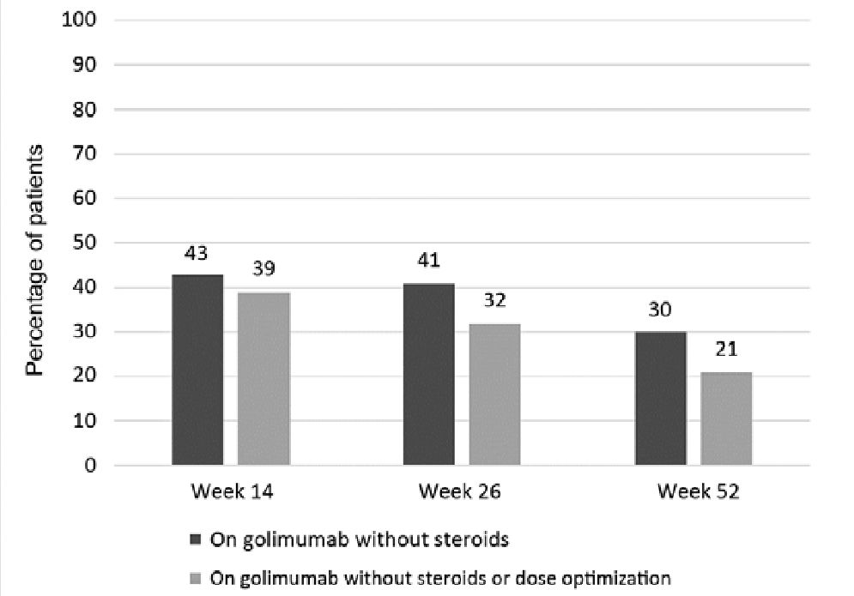

FIGURE 2. Kaplan-Meier curve showing intervention-free survival over time in patients who achieved week 14 on GOL with mucosal healing vs those with no mucosal healing.

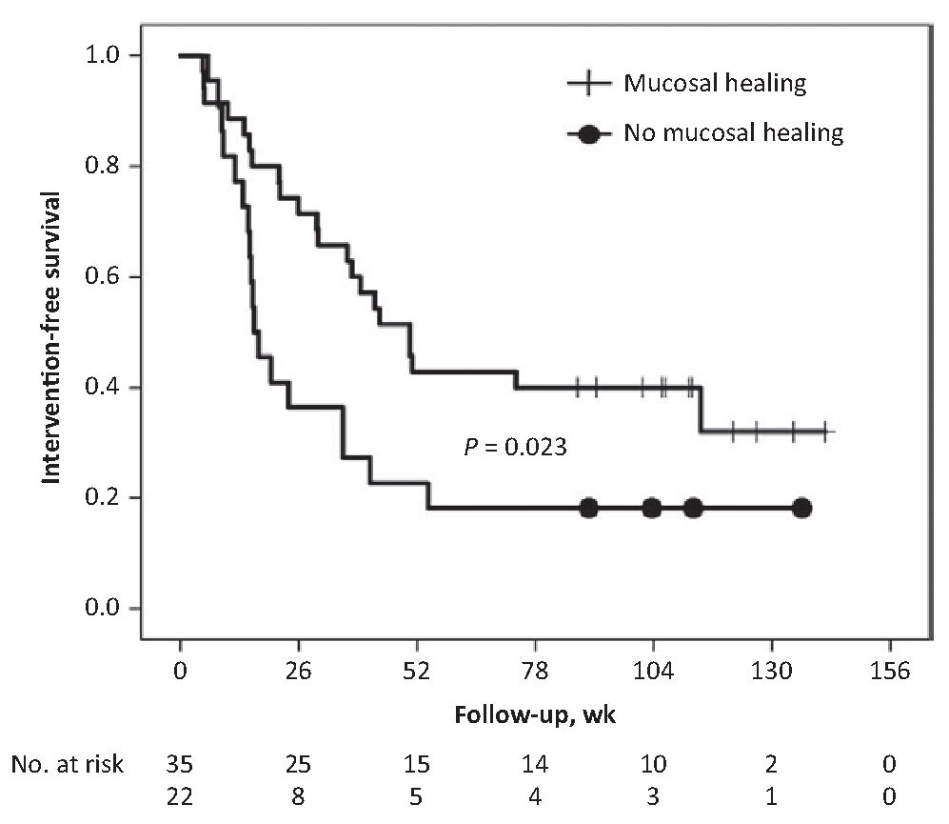

Outcome Predictors
In multivariate analysis, no independent factors were identified that predicted mucosal healing at week 14. Neither could any predictor be retained for primary response to GOL (GOL continuation till week 14 without steroids). However, in multivariate analysis, mucosal healing at week 14 (OR, 3.68; 95% CI, 1.14-11.85; P = 0.029) and steroid-free GOL treatment at week 14 (OR, 5.49; 95% CI, 1.71-17.70; P = 0.004) were predictive of steroid-free GOL continuation at week 26 (primary end point). Mucosal healing at week 14 was significantly associated with the long-term favorable outcome of steroid-free GOL continuation at week 52 (OR, 9.38; 95% CI, 2.68-32.84; P < 0.001). Additional analyses were performed focusing specifically on patients continuing GOL beyond week 14 (n = 57), independent of combined steroid treatment at week 14. In this group of patients, it was seen that mucosal healing at week 14 was a significant predictor of intervention-free survival (OR, 2.05; 95% CI, 1.09-3.86; P = 0.026) (Fig. 2) and of discontinuation-free survival over time (OR, 3.47; 95% CI, 1.58-7.58; P = 0.002) (Fig. 3).

FIGURE 3. Kaplan-Meier curve showing discontinuation-free survival over time in patients who achieved week 14 on GOL with mucosal healing vs those with no mucosal healing.
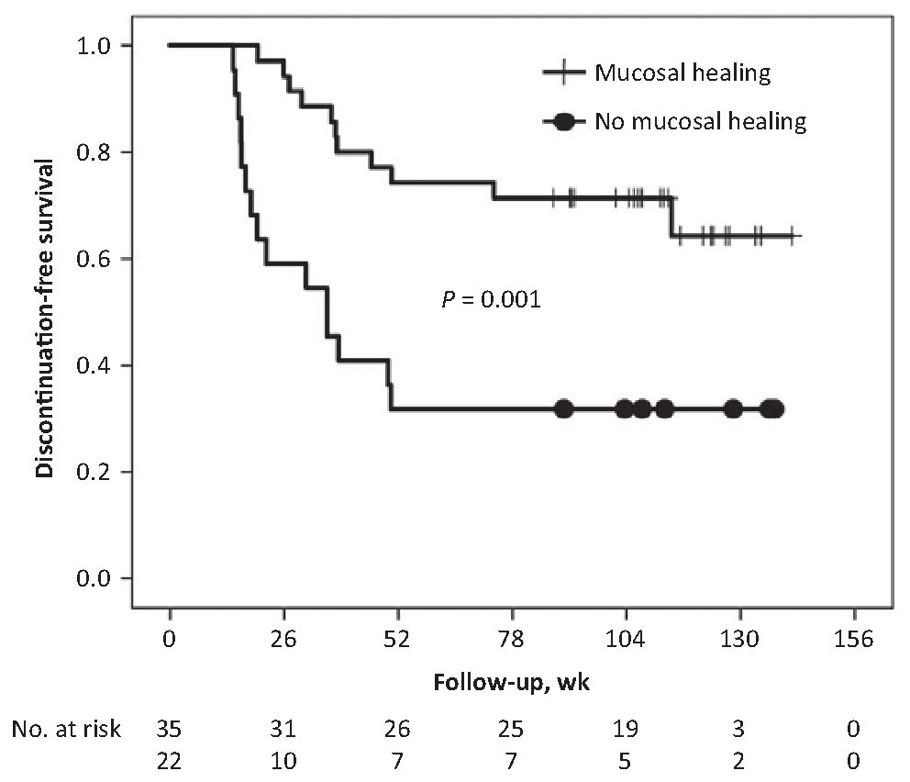

DISCUSSION
We describe the effect of GOL in a real-life setting in a cohort of consecutive patients from academic and nonacademic centers in Belgium. Overall, a high rate of primary nonresponse to GOL and secondary loss of response to GOL was observed in this cohort, with subsequent low rates of patients continuing GOL without intervention (dose optimization, additional UC treatment) within the first year. The most important predictor for treatment success was mucosal healing after induction at week 14. Our results demonstrate rather low effectiveness of GOL in the long term. This cannot be linked to the disease severity or previous anti-TNF exposure in our cohort. Most of the patients in our cohort were anti-TNF naïve (87%), and GOL was not initiated as third-line anti-TNF in our cohort. Taxonera et al. recently showed that the efficacy of GOL was lower when used as third-line anti-TNF compared with its use as first- or second-line anti-TNF. He also demonstrated a loss of response in 44%. In the patients losing response, 62% needed dose optimization. This resulted in recovery of response in 71% of the patients.¹¹ In another cohort, anti-TNF-naïve patients with UC had significantly better outcomes.¹⁰ Furthermore, the severity of the disease was rather low in our cohort. The median total Mayo score (IQR) was 9 (8-10) points, which indicates predominantly moderately active UC. Detrez et al. found a significant association between disease severity, based on Mayo endoscopic subscore and treatment success. Other real- life series demonstrated comparable poor results. In an Italian prospective cohort, only 19% of the patients had steroid-free remission at week 26.¹² Probably the main reason for these low response rates is the relative underdosing of GOL in patients with UC. As no real-life data from non-European countries are available, it is unclear whether different dosing regimens like the one used in the United States lead to better outcomes (200/100 mg induction followed by 100 mg q4w independent of body weight). Clinical response is indeed highly correlated to the level of GOL exposure.¹³ A similar effect was also seen with infliximab, where low anti-TNF exposure had significantly lower response rates after induction.¹⁹ Therefore, it is quite surprising that in the PURSUIT trial the higher induction dose of 400/200 mg was not associated with a better outcome.^{9, 20} After induction and during maintenance, serum GOL concentrations of 2.5 µg/mL and 1.4 µg/mL, respectively, are suggested as the therapeutic threshold based on data from PURSUIT.¹⁵ A high rate of primary nonresponse to GOL (34%) was seen, but no data on GOL serum concentration at induction were available in our cohort. It could be argued that the high primary nonresponse rate to GOL might be linked to an inadequate induction dosing regimen. We could not find any other predictor of success of induction therapy with GOL in our cohort.
For mid- and long-term treatment success with GOL, mucosal healing after induction (week 14) was the best predictor. Patients who continued GOL after week 14 had a 3.5 times higher chance of continuing GOL over time when they had mucosal healing at week 14 compared with those who had no mucosal healing. Moreover, patients with mucosal healing at week 14 had a 2 times higher chance of not requiring any intervention (dose optimization of GOL, new UC treatment) during follow-up compared with those without mucosal healing. Indeed, short-term mucosal healing has previously been identified as predictor of long-term favorable outcome in UC.²⁰⁻²² Early assessment of mucosal healing and consequent treatment adjustments in case of absence of mucosal healing lead to better outcomes.²³ In our cohort, early mucosal healing was associated with a lower need for intervention. We could not document, due to the small number of patients, that a therapeutic intervention in the case of absence of mucosal healing was associated with better outcomes.
There are some limitations to our study. First, this is a retrospective study, which may lead to incomplete data collection, which results in lack of sufficient objective biomarkers of disease activity (eg, C-reactive protein and fecal calprotectin). Furthermore, 9 patients were excluded from the analysis, which can subsequently bias the results. Second, data on response and remission based on an activity index like the Mayo score are missing. We tried to overcome this by using GOL continuation as the end point. This is acceptable as, for most patients in this cohort, GOL was the firstline biological. We presume that GOL was continued only in cases of response or remission, as evaluated by the treating physician. In the case of nonresponse, many other UC therapies were available, which lowers the threshold for switching to another anti-TNF or biological. Furthermore, we used mucosal healing data as the end point. Third, trough serum concentrations of GOL were not available in this study.
In conclusion, in this UC cohort with predominantly moderate disease activity and bio-naïve patients, GOL was only moderately effective. Short-term mucosal healing was the best predictor for treatment success over time. For this, proactive optimization of GOL therapy in the case of absence of mucosal healing at week 14 may be suggested. The high rate of primary nonresponse compared with other anti-TNF agents suggests that the current induction dosing regimen of GOL may need to be optimized.

ACKNOWLEDGMENTS
The authors would like to thank Saskia Appelmans for her organizational support.
Conflicts of interest: P.B.: educational grants from AbbVie, Janssen; speaker fees and/or advisory board fees from AbbVie, Dr Falk Benelux, Hospira, Janssen, MSD, Mundipharma, Pfizer, Roche, Takeda, Vifor Pharma. F.B.: research grants from Abbvie, Chiesi, Ipsen, MSD, Roche; speaker and consultancy fees from Abbvie, Falk, Ferring, Janssen, Mundipharma, MSD, Pfizer, Takeda, Vifor. F.D.: none declared. A.N.: none declared. C.R.: consulting fees, lecture fees, and travel accommodations from AbbVie, Takeda, MSD, Mundipharma, Hospira, Ferring. F.F.: none declared. D.F.: none declared. O.D.: grant or speaker fee or consultancy from MSD, Abbvie, Ferring, Takeda, Mundipharma, Chiesi. P.VH.: none declared. S.VB.: none declared. G.L.: none declared. M.F.: research grant from Janssen, Takeda; speaker fees from Abbvie, Boehringer-Ingelheim, Chiesi, Falk, Ferring, Janssen, Mitsubishi Tanabe, MSD, Takeda, Tillotts, Zeria; consultancy fees from Abbvie, Boehringer-Ingelheim, Ferring, Janssen, MSD.
Supported by: unrestricted grant from Merck Sharp and Dhome for the SMART and BE-SMART studies.
The other members of the Belgian IBD Research and Development Group participating in this trial: Pieter Hindryckx, PhD (UZ Gent, Department of Gastroenterology, Gent, Belgium), Elisabeth Macken, PhD (UZ Antwerpen, Department of Gastroenterology, Antwerp, Belgium), Philip Caenepeel, PhD (ZOL, Department of Gastroenterology, Genk, Belgium), Anne Vijverman, MD (CHR de la citadelle, Department of Gastroenterology, Liège, Belgium), Nicolas de Suray, MD (GHDC, Department of Gastroenterology, Charleroi, Belgium), Joris Dutré, MD (ZNA, Department of Gastroenterology, Antwerp, Belgium), Edouard Louis, PhD (CHU Sart Tilman, Department of Gastroenterology, Liège, Belgium), and Jean-Louis Coenegracths, MD (Jessa, Department of Gastroenterology, Hasselt, Belgium).

REFERENCES
- Ungaro R, Mehandru S, Allen PB, et al. Ulcerative colitis. Lancet. 2017;389:1756-1770.
- Burisch J, Jess T, Martinato M, et al. The burden of inflammatory bowel disease in Europe. J Crohns Colitis. 2013;7:322-337.
- Kaplan GG. The global burden of IBD: from 2015 to 2025. Nat Rev Gastroenterol Hepatol. 2015;12:720-727.
- Dignass A, Lindsay JO, Sturm A, et al. Second European evidence-based consensus on the diagnosis and management of ulcerative colitis part 2: current management. J Crohns Colitis. 2012;6:991-1030.
- Pouillon L, Bossuyt P, Peyrin-Biroulet L. Considerations, challenges and future of anti-TNF therapy in treating inflammatory bowel disease. Expert Opin Biol Ther. 2016;16:1277-1290.
- Peyrin-Biroulet L, Sandborn W, Sands BE, et al. Selecting Therapeutic Targets in Inflammatory Bowel Disease (STRIDE): determining therapeutic goals for treat- to-target. Am J Gastroenterol. 2015;110:1324-1338.
- Bossuyt P, Vermeire S. Treat to target in inflammatory bowel disease. Curr Treat Options Gastroenterol. 2016;14:61-72.
- Sandborn WJ, Feagan BG, Marano C, et al; PURSUIT-Maintenance Study Group. Subcutaneous golimumab maintains clinical response in patients with moderate-to-severe ulcerative colitis. Gastroenterology. 2014;146:96- 109.e1.
- Sandborn WJ, Feagan BG, Marano C, et al; PURSUIT-Maintenance Study Group. Subcutaneous golimumab maintains clinical response in patients with moderate-to-severe ulcerative colitis. Gastroenterology. 2014;146:96-109.e1.
- Bosca-Watts MM, Cortes X, Iborra M, et al. Short-term effectiveness of golimumab for ulcerative colitis: observational multicenter study. World J Gastroenterol. 2016;22:10432-10439.
- Taxonera C, Rodríguez C, Bertoletti F, et al; Collaborators. Clinical outcomes of golimumab as first, second or third anti-TNF agent in patients with moder- ate-to-severe ulcerative colitis. Inflamm Bowel Dis. 2017;23:1394-1402.
- Tursi A, Allegretta L, Buccianti N, et al. Effectiveness and safety of golimumab in treating outpatient ulcerative colitis: a real-life prospective, multicentre, observational study in primary inflammatory bowel diseases centers. J Gastrointestin Liver Dis. 2017;26:239-244.
- Detrez I, Dreesen E, Van Stappen T, et al. Variability in golimumab exposure: a 'real-life' observational study in active ulcerative colitis. J Crohns Colitis. 2016;10:575-581.
- Rutgeerts P, Reinisch W, Feagan B, et al. How long should golimumab treatment be continued in patients with ulcerative colitis who do not respond to initial induction therapy? Unit Eur Gastroenterol J. 2014;2:A1-A131.
- Adedokun OJ, Xu Z, Marano CW, et al. Pharmacokinetics and exposure-response relationship of golimumab in patients with moderately-to-severely active ulcerative colitis: results from phase 2/3 PURSUIT induction and maintenance studies. J Crohns Colitis. 2017;11:35-46.
- Philip G, Marano C, Adedokun J, et al. Early dose optimization in nonresponders to golimumab induction treatment for ulcerative colitis is supported by pharmacokinetic data. Paper presented at: ECCO February 16, 2018; Vienna, Austria.
- Vermeire S, et al. Preference for a prefilled syringe or an auto-injection device for delivering golimumab in patients with moderate-to-severe ulcerative colitis: a randomized crossover study. Patient Prefer Adher. 2018; Accepted (in press).
- Silverberg MS, Satsangi J, Ahmad T, et al. Toward an integrated clinical, molecular and serological classification of inflammatory bowel disease: report of a working party of the 2005 Montreal World Congress of Gastroenterology. Can J Gastroenterol. 2005;19:5A-36A.
- Papamichael K, Van Stappen T, Vande Casteele N, et al. Infliximab concentration thresholds during induction therapy are associated with short-term mucosal healing in patients with ulcerative colitis. Clin Gastroenterol Hepatol. 2016;14:543-549.
- Colombel JF, Rutgeerts P, Reinisch W, et al. Early mucosal healing with infliximab is associated with improved long-term clinical outcomes in ulcerative colitis. Gastroenterology. 2011;141:1194-1201.
- Frøslie KF, Jahnsen J, Moum BA, et al. Mucosal healing in inflammatory bowel disease: results from a Norwegian population-based cohort. Gastroenterology. 2007;133:412-422.
- Ferrante M, Vermeire S, Fidder H, et al. Long-term outcome after infliximab for refractory ulcerative colitis. J Crohns Colitis. 2008;2:219-225.
- Bouguen G, Levesque BG, Pola S, et al. Feasibility of endoscopic assessment and treating to target to achieve mucosal healing in ulcerative colitis. Inflamm Bowel Dis. 2014;20:231-239.

