Online appendice

Analytical solution
The heat pump coefficient of performance (COP) in heating mode is defined by Eq. 2 while the one in cooling mode is defined by Eq. 3 [7]. They correspond to the COP of a Carnot system multiplied by a factor (g) taking into account all the irreversibilities and physical constraints.
 | $${COP}_{heating}=\frac{Q_{cd}}{E_{el}}=g_{heating}\frac{T_{hot}}{T_{hot}-T_{cold}}$$ | 2

 | $${COP}_{cooling}=\frac{Q_{ev}}{E_{el}}=g_{cooling}\frac{T_{cold}}{T_{hot}-T_{cold}}$$ | 3

The Rankine cycle (RC) efficiency is defined by the Carnot efficiency multiplied by a factor (g) taking into account all the irreversibilities and physical constraints (Eq. 4 [7]).
 | $$η_{RC}=\frac{E_{el}}{Q_{ev}}=g_{RC}(1-\frac{T_{cold}}{T_{hot}})$$ | 4

It is conventionally accepted that g is comprised between 0.5 and 0.7 to obtain performance that match real applications [7]. In the case of the hot storage architecture, the roundtrip efficiency is simply evaluated by the product of the COP and the efficiency of the power cycle (Eq. 5) in which Q_{ev} is the thermal energy at the evaporator.

 | $${EFF}_{roundtrip,hot}=\left(\frac{{COP}_{HP,hot}}{Q_{cd,HP}}\right).\left(η_{RC,hot}Q_{ev,RC}\right) ={COP}_{HP,hot}. η_{RC,hot}$$ | 5

In the case of the cold storage, the roundtrip efficiency is defined by Eq 6 where Q_{cd} is the thermal energy at the condenser.

 | $${EFF}_{roundtrip,cold}=\frac{E_{el,out}}{E_{el,in}}=\left(\frac{{COP}_{HP,cold}}{Q_{ev,HP}}\right). \left(η_{RC,cold}Q_{ev,RC}\right)=\frac{η_{RC,cold}}{1-η_{RC,cold}}{COP}_{HP,cold}$$ | 5

A simple analytical model based on Eqs. 2-5 provides the ratio of the roundtrip efficiencies between the cold and hot storage layouts (Eq. 10). The demonstration is provided through (Eqs. 6-9). For the simplicity of the formulation, g is assumed to be equal in Eqs. 2-4.

 | $$R=\frac{{EFF}_{roundtrip,cold}}{{EFF}_{roundtrip,hot}}=\frac{η_{RC,cold}}{1-η_{RC,cold}}{COP}_{cold}.\frac{1}{{COP}_{hot}. η_{RC,hot}}$$ | 6

 | $$R=\left(\frac{(1-\frac{T_{air}-ΔT}{T_{waste}})}{1-g(1-\frac{T_{air}-ΔT}{T_{waste}})}\right)\left( \frac{T_{air}-ΔT}{ΔT}\right).\frac{1}{\left(\frac{T_{waste}+ΔT}{ΔT}\right)\left((1-\frac{T_{air}}{T_{waste}+ΔT}\right)}$$ | 7

 | $$R=\left(\frac{(\frac{T_{waste}-T_{air}+ΔT}{T_{waste}})}{\frac{T_{waste}-g(T_{waste}-T_{air}+ΔT)}{T_{waste}}}\right)\left( \frac{T_{air}-ΔT}{ΔT}\right).\frac{1}{\left(\frac{T_{waste}+ΔT}{ΔT}\right)\left((\frac{T_{waste}+ΔT-T_{air}}{T_{waste}+ΔT}\right)}$$ | 8

$$R=\left(\frac{T_{waste}-T_{air}+ΔT}{T_{waste}-g(T_{waste}-T_{air}+ΔT)}\right)\left( \frac{T_{air}-ΔT}{T_{waste}+ΔT-T_{air}}\right).$$ | 9

 | $$R=\frac{{EFF}_{roundtrip,cold}}{{EFF}_{roundtrip,hot}}=\left(\frac{\left( T_{air}-ΔT\right)}{T_{waste}-g(T_{waste}-T_{air}+ΔT)}\right)$$ | 10

This ratio (R) is always below one since the lift, ΔT (assumed equal for hot and cold storage) is larger than 0 and g is by definition comprised between 0 and 1.

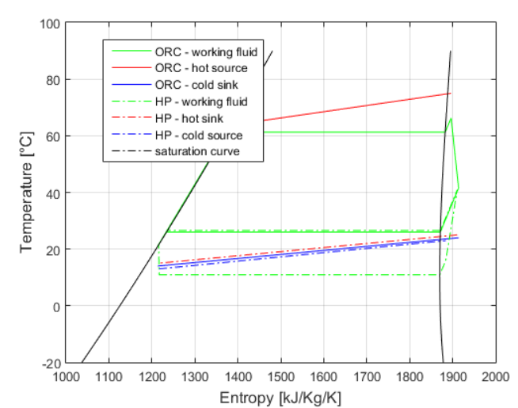
Figure 1: Example of T-s diagram for a cold storage configuration.

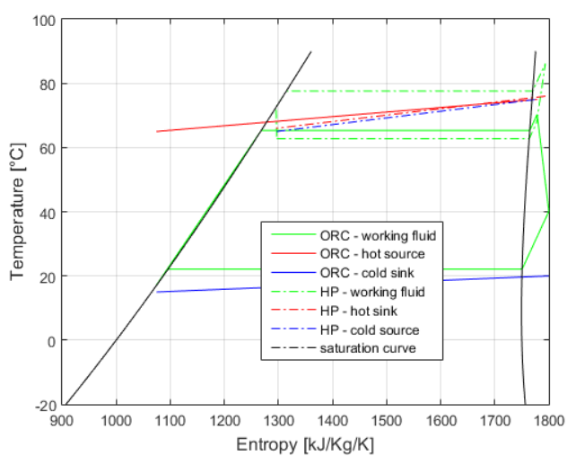
Figure 2: Example of T-s diagram for a hot storage configuration.

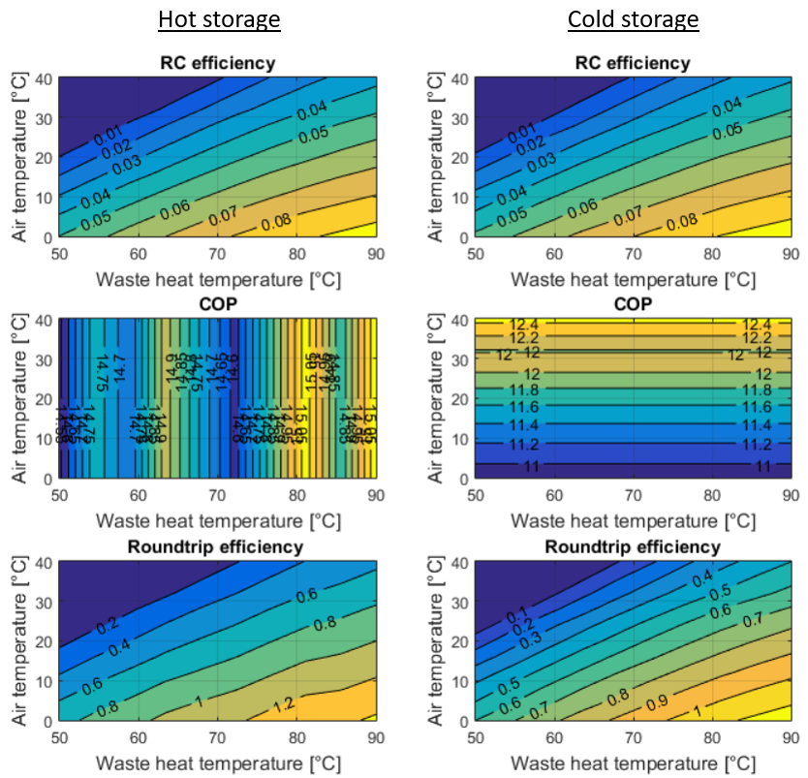
Figure 6: ORC efficiency, COP of HP and roundtrip efficiency as a function of the air temperature and the waste heat temperature (glide = 10 K, fluid = R1234yf).

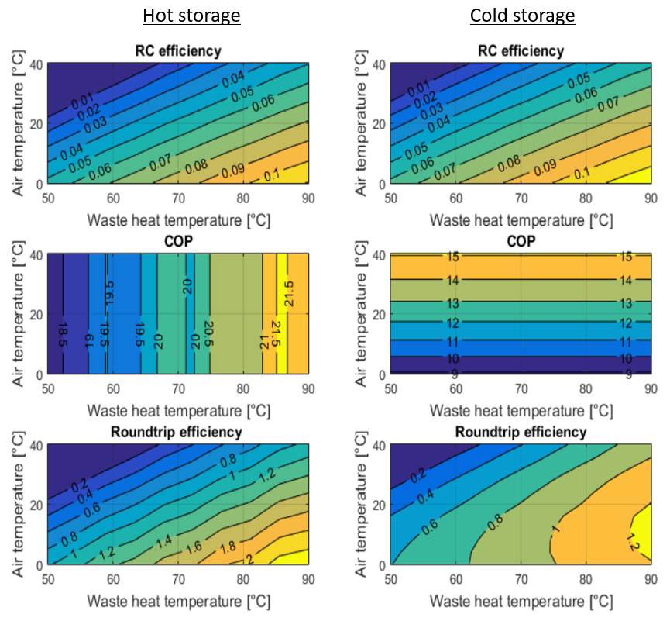
Figure 7: ORC efficiency, COP of HP and roundtrip efficiency as a function of the air temperature and the waste heat temperature (glide = 5 K, fluid = R1233ZD(E)).

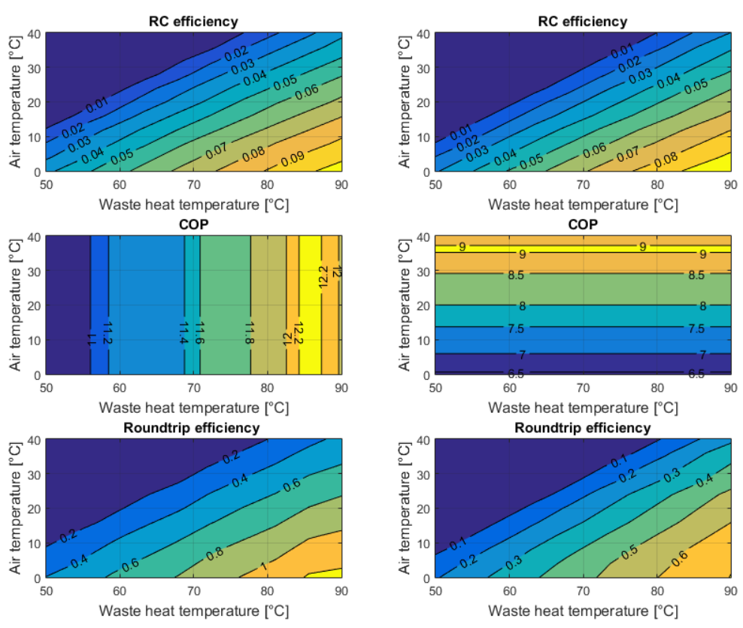
Figure 8: ORC efficiency, COP of HP and roundtrip efficiency as a function of the air temperature and the waste heat temperature (glide = 15 K, fluid = R1233ZD(E)).

