Conduit processes during the February 11, 2010 Vulcanian eruption of Soufrière Hills, Montserrat

Alain BURGISSER^{1*}, Tonin BECHON², Laure CHEVALIER^{1,3}, Marielle COLLOMBET¹, Laurent ARBARET⁴, Mélanie FORIEN⁵

¹ Univ. Grenoble Alpes, Univ. Savoie Mont Blanc, CNRS, IRD, IFSTTAR, ISTerre, 38000 Grenoble, France.
² Département de Géologie, Université de Liège, Allée du Six Août 12, 4000 Sart Tilman, Belgium.
³ Now at: Institut für Geowissenschaften, Goethe Universität, Altenhöferallee 1, 60348 Frankfurt am Main, Germany.
⁴ Institut des Sciences de la Terre d'Orléans (ISTO), Université d'Orléans-CNRS-BRGM, Orléans, France.
⁵ Department of Geosciences, UiT The Arctic University of Norway in Tromsø, 9037 Tromsø, Norway.

* Corresponding author: Phone: (+33) 479 758 780. Fax: (+33) 479 758 742. Email: alain.burgisser@univ-savoie.fr

Supplementary Information

This Supplementary Information includes text providing additional details on the textural analysis and the conduit flow modeling (Text S1–S5), one table with GPS coordinates of the sampling locations (Table S1), and 6 figures (Figs. S1–S6).

Supplementary Text S1.
Weight fractions of water in the glass, X_{gl}, were calculated by neglecting the weight of the vesicles:
$X_{gl}=\frac{X_{bulk}\sum_{i}{V_{i}ρ_{i}}-X_{a}C V_{a+cpx}ρ_{a}}{V_{gl}ρ_{gl}}$ (S1)
where X_{bulk} is the bulk H₂O weight fraction, X_{a} = 0.02 is the H₂O weight fraction in amphibole, C = 0.95 is the assumed constant ratio between the volume fraction of amphibole and that of amphibole plus clinopyroxene (Murphy et al., 2000), V_{i} are volume fractions, and ρ_{i} are densities. The sum is $\sum_{i}{V_{i}ρ_{i}}=V_{opx}ρ_{opx}+V_{a+cpx}ρ_{a+cpx}+V_{gl}ρ_{gl}+V_{ox}ρ_{ox}+V_{qz}ρ_{qz}+V_{plg}ρ_{plg}+V_{oth}ρ_{oth}$ and the subscripts opx, a+cpx, gl, ox, qz, plg, oth, and a mean orthopyroxene, amphibole plus clinopyroxene, glass, oxide, quartz, plagioclase, other, and amphibole, respectively and where densities are ρ_{opx} = ρ_{a+cpx} = ρ_{a} = ρ_{oth} =3300 kg/m³, ρ_{gl} = 2380 kg/m³, ρ_{ox} = 4720 kg/m³, ρ_{qz} = 2650 kg/m³, and ρ_{plag} = 2570 kg/m³. Uncertainties on X_{gl} were calculated by error propagation (Drignon et al., 2016). The mineral separation procedure from Drignon et al. (2016) was adjusted to the phases present in our samples (Fig. 1B). Let F_{j} be the final binary images with the additional subscripts ves and m+gl being vesicles and matrix plus glass, respectively. Let I_{k} be the segmented elemental images per zoom level with k = Al, Si-m, Si-h, Fe-h, Fe-m, Mg, and Ca (X-m and X-h are medium and high threshold levels). The series of Boolean manipulations to obtain the final images reads:
F_{ves} = I_{ves} OR NOT(I_{Al} OR I_{Ca} OR I_{Fe} OR I_{Mg} OR I_{Si-h} OR I_{Si-m} OR I_{Fe-h} OR I_{Fe-m})
F_{ox} = I_{Fe-h}
J_{i} = I_{i} - F_{ves} - F_{ox}
F_{a+cpx} = J_{Ca} AND J_{Mg}
K_{i} = J_{i} - F_{a+cpx}
F_{opx} = K_{Fe-m} AND K_{Mg}
L_{i} = K_{i} - F_{opx}
F_{plg} = L_{Ca} AND L_{Al}
M_{i} = L_{i} - F_{plg}
F_{qz} = M_{Si-h}
N_{i} = M_{i} – F_{qz}
F_{m+gl} = N_{Ca} OR N_{Fe-m} OR N_{Mg} OR N_{Si-m} OR N_{Si-h} OR N_{Al}
F_{oth} = 100% - F_{ves} - F_{ox} - F_{a+cpx} - F_{opx} - F_{plg} - F_{qz} - F_{m+gl} (S2)
The sign minus implies image subtraction so that A-B corresponds to A AND NOT B in Boolean notation, and 100% corresponds to a full image area. Figure S2 illustrates the steps summarized by Eq. (S2)

Supplementary Text S2.
Figure S4 shows how bubble and oxide number densities were calculated by combining two image magnifications for sample AMO210A. This sample features a strong mismatch of size distribution between the two magnifications around 30 μm. The reconstruction procedure smooths this mismatch and creates a break in slope that translates into an apparent bimodality of the distribution across that length scale. The bubble-free number density reported in Table 2, however, is a cumulative sum of the distribution shown in Fig. S4. The cumulative sum is not sensitive to this artifact because it affects a number of bubbles much smaller (typically by 2–3 orders of magnitude) than that of the sum.

Supplementary Text S3.
Figure S5 shows bubble-free crystal content as a function of pre-explosive pressure. The natural variability far exceeds the trend calculated by a fit based on experimental data of crystal growth kinetics in the Soufriere Hills Volcano magma (Kozono and Koyaguchi, 2010), so we opted for a constant, average value of crystal content.

Table S1: Sample locations in standard UTM zone 20N coordinates.
Location | Easting | Northing | Elevation (m) | Location
AMO210 | 589338 | 1852498 | 24 | Farm River valley
WP1.095 | 588597 | 1851421 | 259 | Harris Lookout
WP1.108 | 590487 | 1851591 | 33 | Spanish Point
WP2.200 | 589696 | 1850761 | 116 | White's Bottom Ghaut
WP2.201 | 590067 | 1850532 | 94 | White's Bottom Ghaut
WP2.329b | 588373 | 1851291 | 279 | Harris Lookout

A) B) C)

Figure S1: Representative tomographic slice of sample AMO210Q. Each image spans 1.34 cm horizontally. A) Grayscale image of X-ray attenuation levels. B) Same image as A) but with a color scheme highlighting the different mineral phases to aid automatic and manual segmentations. C) Segmented image. Analyzed objects are oxides (pale yellow), plagioclases (green), other minerals (red to dark yellow shades), matrix (dark shades of blue), vesicles with circularity <0.2 and equivalent size >300 μm (orange), and other vesicles (light blue).

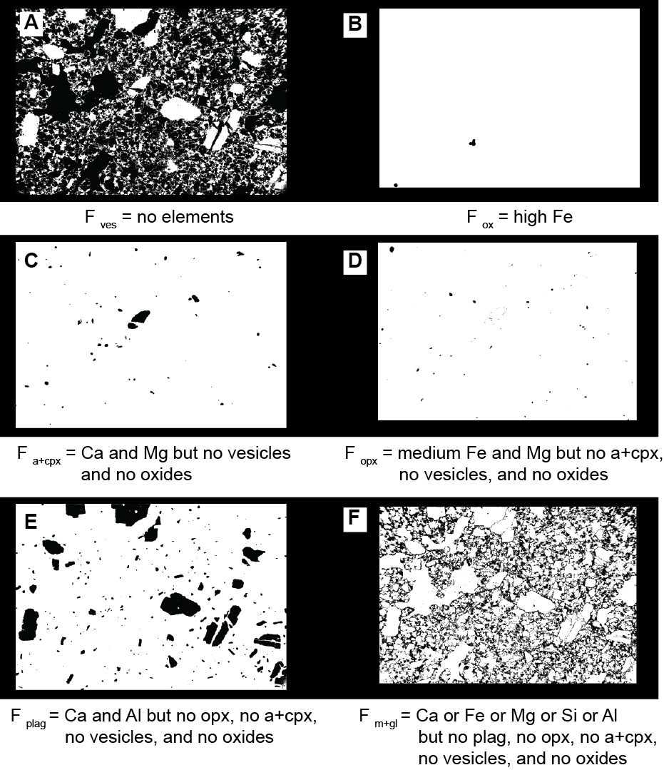
Figure S2: Mineral phase quantification by EDS for sample AMO210C (same image as that of Fig. 1). Images A)–F) correspond to the successive steps summarized in Eq. (S2) that result in the composite image on Fig. 1B.

A)
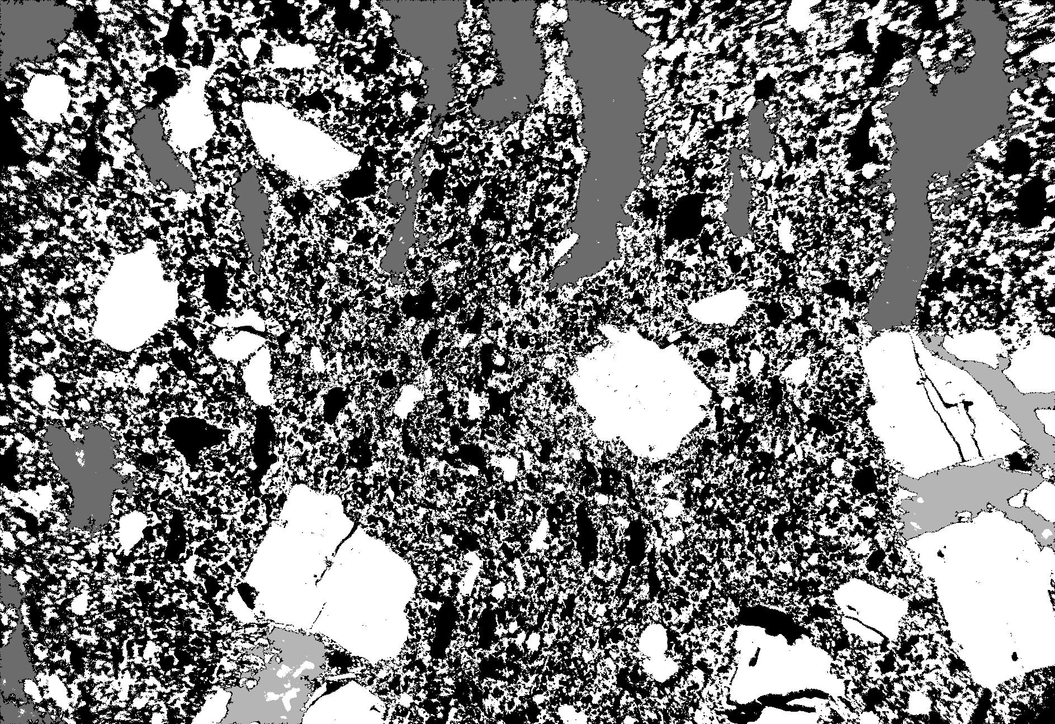

B)
Figure S3: Representative pumice WP1.059B from the 2010 event. Minerals and glass are white. A) Composite grayscale ×50 image spanning 7 mm horizontally that contains parts of three of the four vesicle populations. Large vesicles >300 μm across and circularity <0.2 are divided into two populations. Population 1 (light grey) is composed of large, syn-explosive angular voids existing between crystal fragments that were segmented by hand. Population 2 (dark grey) is composed of the remaining large vesicles, which are classified as pre-explosive. The coarse part of population 3 (black) is composed of all the vesicles that do not belong to the first two populations. B) Composite grayscale ×1000 image spanning 436 μm horizontally that contains parts of populations 3 and 4. Black vesicles compose the fine part of population 3. Population 4 (grey) is composed of rounded, syn-eruptive vesicles <50 μm across and circularity >0.4.

A)
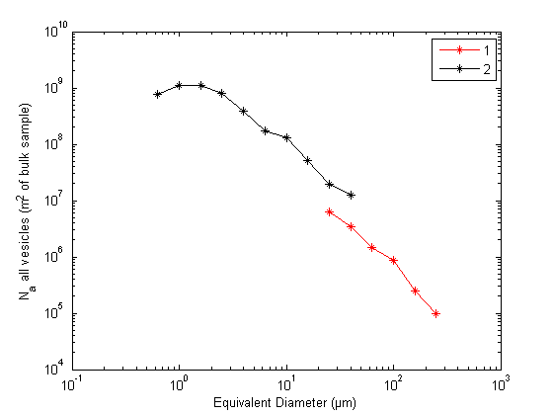
B)
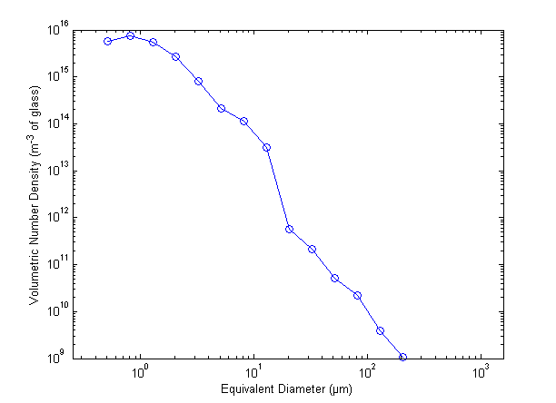

Figure S4: Bubble size distribution reconstruction of sample AMO210A following the method by Giachetti et al. (2010). A) Number of all vesicles per m² of glass for each magnification used (1: ×2000 and 2: ×50). B) Combination of the 2 magnifications with a cut-off of 30 μm followed by 3D conversion obtained using 2D data and stereological transformations from Cheng and Lemlich (1983). The number density reported in Table 2 for AMO210A is the cumulative sum of the distribution in B).

Figure S5: Sample crystal contents (squares) as a function of pre-explosive pressure (P). The vertical line indicates the average value of 55 vol.% that we chose in our simulations. The dotted line corresponds to the fit based on experimental data of crystal growth kinetics for the Soufriere Hills Volcano magma used by Kozono and Koyaguchi (2010).

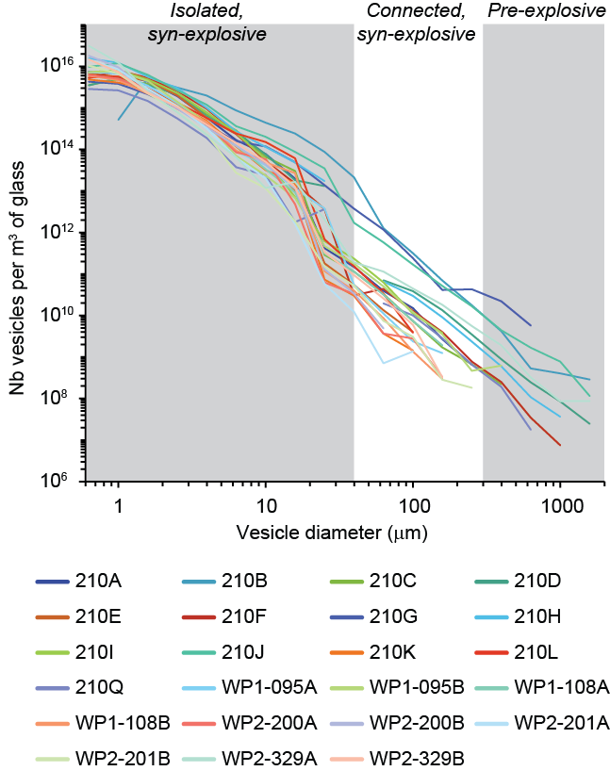
Figure S6: Bubble size distributions of samples listed in Table 2. Vertical boundaries roughly correspond to vesicle origin (pre- or syn-explosive). These boundaries are only indicative because the origin discrimination is made on the joint basis of size and circularity.

