(Acta Anaesth. Belg., 2018, 69, 159-164)
Highly standardized quadriceps dynamometry of critically ill adults at bedside: a step towards individualized rehabilitation
A.-F. RousseAu (*), I. Kellens (*), G. FReycenon (**), n. DARDenne (***), o. BRuyèRe (****,*****),

P. DAmAs (*),, J.-L. Croisier (*****)
Abstract : To overcome lack of consistency in published studies, we designed a standardized protocol for the measurement of quadriceps strength (QS) to be performed in supine position in collaborative critical care patients. Isometric QS was assessed using a handheld dynamo- meter (MicroFet2). An adjustable system of traction plain bars and clamp bars ensured a standardized patient positioning (45° hip and 40° knee flexion). The same trained operator performed measurements at T0, after 1h and the following day, and provided standardized instructions. Thirty adults were enrolled (68 [54-76] years of age, 77% men). Peak forces measured at the 3 time points were not statistically different from each other. Median QS was 194 [115-269]N, showing a huge strength heterogeneity among patients. Interclass correlation coefficients of the tests were all >0.90. Minimal detectable changes ranged from 17.13 to 27.33%. The measurement procedure was highly feasible and well tolerated. Our highly standardized protocol had a very high intra-observer reliability. Reproduced with strict observance, it should help to target individualized rehabilitation based upon the extent of muscular weakness.
Key words : Critical Care ; Critical Illness ; Handheld Dynamometry ; Quadriceps.

Introduction
Muscle weakness represents a cumbersome legacy of critical care and critical illness. What is referred to as “intensive care unit – acquired weakness” (ICU-AW) may concern a substantial number of critically ill patients of all ages, regardless of the admission diagnosis (1). ICU-AW has serious implications in terms of outcomes during the acute stage of critical illness (2) and in survivors (3), leading to higher mortality rates, higher healthcare resources utilization and higher health care costs (2-4). According to some authors (5), ICU-AW has thus become a real public health problem, transcending the boundaries of critical care. This emphasizes the importance of early identification and characterization of ICU-AW, in order to target early rehabilitation and secondary prevention (6).
From that point of view, lack of accurate diagnosis may hinder management of ICU-AW (7). In ICU-AW, clinical signs of limb weakness are generally more pronounced in the proximal muscles (1). Furthermore, quadriceps is essential for standing, walking and autonomy. Relationship between quadriceps strength and limb function (8, 9) or quality of life (10) have already been demonstrated. Considering quadriceps strength quantification as a relevant parameter for mobility outcome assessment does thus make sense (11). Manual muscle testing, using the Medical Research Council (MRC) scale (12) is, in the literature, the most commonly reported way to assess muscle strength in ICU patients (13). However, this subjective method is poorly discriminating and reliable when patients reach the highest scores (14-16). Quantitative techniques measure muscle strength in collaborative patients with minimum movement capacity. These techniques includes dynamic testing such as isokinetic dynamometry, considered as the gold standard for muscle strength measurement. Unfortunately, portability and costs are barriers for its use at ICU bedside. In the critical care setting, isometric testing using a handheld dynamometer is a portable, light and inexpensive option, with good sensitivity to quantify strength changes over time (13).
Anne-Françoise rousseau, MD, PhD ; Isabelle Kellens, PT, PhD ; Gaelle Freycenon ; Nadia dardenne, MSc ; Olivier Bruyère, PT, PhD ; Pierre damas, MD, PhD ; Jean-Louis croisier, PT, PhD
(*) General Intensive Care Department, University Hospital, University of Liège, Sart-Tilman, Liège, Belgium.
(**) Student.
(***) Support Unit in Epidemiology and Biostatistics. (****) Department of Public Health, Epidemiology and Health Economics.
(*****) Department of Sport Sciences and Rehabilitation, University of Liège, Sart-Tilman, Liège, Belgium.
Corresponding author : Anne-Françoise Rousseau, MD, PhD, Burn Centre and General Intensive Care Department, University Hospital, Sart-Tilman B35, B-4000 Liège, Belgium, Tel. : +32 4 3667495.
E-mail : afrousseau@chuliege.be
All authors declare that they have no conflict of interest. The present study has not been supported by any funding.
160
Portable force gauges have already been studied in different publications related to critical care (15, 17, 18). Nevertheless, studies are very heterogeneous in terms of devices, patient positioning and measurement. Furthermore, standardization of protocols was not constantly insured. Yet, both patient or limb position and test design (including warm-up or number of contraction repetitions for example) are critical elements that may dramatically influence measurement quality (19). Unfortunately, insufficient precision in the reported methods prevents any replication of the cited procedures and lack of consistency among all studies prevents any comparison. In this way, building of well established knowledge about muscle strength in ICU survivors seems difficult. To make progress, the use of welldefined standardized dynamometry is therefore crucial (15).
To help identify and quantify acquired quadriceps weakness as early as possible during the ICU course, we designed a highly standardized protocol of quadriceps strength measurement, performed in supine position. The main objectives of the present study were to evaluate its applicability and to test intra-observer reliability of measurements obtained in such well-defined conditions. By doing so, this study in part meets expectations of the research agenda on ICU-AW as defined by ICU experts (16). At the same time, we took advantage of this study to describe the profile of quadriceps strength measured early in a critically ill population.
Age, gender, weight, height, body mass index (BMI) and dominant side were recorded. Physical activity before ICU admission was also characterized. Patients who reported no sports activity or sports activity exceeding 5 hours a week were considered as sedentary or sportsmen, respectively. Sports activity not exceeding 4 hours a week was considered as a moderate physical activity.
Maximal isometric voluntary quadriceps con- traction was measured using a hand-held dynamometer (MicroFet2®, Hoggan Health Industries, West Jordan, UT, USA) with a curved transducer pad. It is a battery-operated, load cell system with a digital reading of peak force expressed in Newton (N). The high threshold, with a recording of test data beginning at 13N, was applied in the protocol. The device was calibrated by the manufacturer prior to the start of the study.
Measurements were performed at bedside, with the patient lying in the supine position. The tested limb was chosen according to dominance (kicking leg). Limb position during measurements was standardized using an adjustable system of vertical and horizontal traction plain bars and clamp bars (Zimmer, Warsaw, IN, USA), fixed on the bed’s lateral rails, and aiming to get a 45° hip flexion and 40° knee flexion (Fig. 1). Correct limb position was confirmed using a long arms goniometer, making sure the leg was not in external rotation. A nondepressible foam was interposed between the cross bar and the popliteal region to optimize patient

methods
This observational study was conducted in October and November 2016 in a 28-bed general intensive care unit after approval by the local Ethics Committee of our University Hospital (National Ref B707201525790, Local Ref 2015/231, 2nd November 2015 and 28th July 2016 for the amended version). Informed consent was obtained from the patients or their relatives prior to enrolment. Consecutive adult patients hospitalized in ICU were enrolled as early as they were able to collaborate and understand the instructions. Patients were excluded in case of RASS (Richmond Agitation and Sedation Scale) score >1 or <-1, coma, total hip or knee arthroplasty in the dominant limb, unauthorized support on the dominant leg, open wound located at the ankle’s anterior face of the dominant leg, pre-existing myopathy or polyneuropathy, para- or tetraparesis, para- or tetraplegia, or refusal. The same patient could not be included twice in the study.
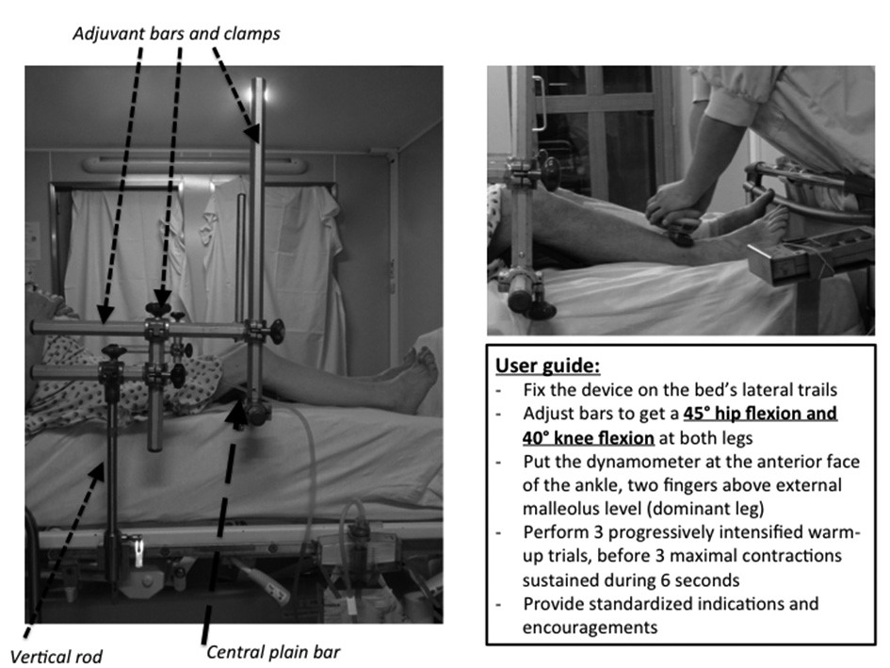
Figure 1. — Illustration of the testing structure, patient positioning and operator positioning. Protocol summary. The testing structure is fixed on the bed’s lateral rails using a vertical rod. The structure is based on a horizontal central rigid bar that supports legs and maintains their position all along the measurements. Using adjuvant lateral bars (horizontal and vertical) and clamps, the central bar can slide vertically and horizontally to get a 45° hip flexion and 40° knee flexion at both legs.
quadriceps dynamometry in critically care 161
comfort. The operator was positioned in front of the patient, at the foot of the bed, withstanding the subject’s movement (raising the leg). The MicroFet2 was localized at the anterior face of the ankle, two fingers above external malleolus level (Fig. 1). The position of the non-dominant leg was exactly the same as for the tested one. Patients kept the arms in a resting position along the trunk. Foam and dynamometer transducer pad were covered by a thin transparent film to allow their disinfection between each patient, using detergent SurfaSafe Premium (Anios, Lille-Hellemmes, France). The protocol consisted of three consecutive maximal contractions, preceded by three progressively intensified warm-up trials. Subjects were first shown the movement to be tested and then asked to perform it to confirm their understanding and finally did the warm-ups. The three measurements were then performed with 30 sec intervals between contractions. Subjects were asked to gradually increase their muscle force to a maximum effort that had to be sustained for 6 sec. Operator provided standardized indications and encouragements. The highest performance of the 3 measurements was finally considered for analysis.
This session was performed at 3 time points: H0, after 1 hour (H1) and after 24 hours (H24). The same operator performed all the tests in all the patients, thus allowing the assessment of the intraobserver reliability.
During the baseline test, vital parameters (invasive or non invasive blood pressure, heart rate and peripheral oxygen saturation) were also recorded, particularly before the test and at the third maximum effort.
Pain and fatigue were evaluated separately before and after each session using a numeric rating scale. Patient was asked to rate pain or fatigue from 0 to 10, understanding that 0 is equal to no pain or fatigue and 10 is equal to the worst possible pain or fatigue.
A sample size calculation was performed using R statistical packages (version 3.3.1, Revolution Analytics, Redmond, WA, USA). The number of patients needed for the study was calculated to be 18 when repeating 3 observations in each patient to demonstrate an interclass correlation coefficient (ICC) >0.85 with a power of 80%.
Statistical analysis was performed using Graphpad Prism (version 6.0 for Mac OSX, Graphpad Inc., San Diego, CA, USA), SAS (version 9.4 for Windows, SAS Institute, Cary, NC, USA) and R statistical packages (version 3.3.1 for Windows, Revolution Analytics, Mountain View, CA, USA).
Normality was assessed using the Shapiro-Wilk test. Results are expressed as medians and interquartile ranges (P25-P75) for quantitative parameters or as percentages for qualitative parameters. Paired data were analyzed using the Wilcoxon signedrank test or the Friedman test. Unpaired data were analyzed using the Mann-Whitney test. The relative reliability of the test-retest performed by the same operator was assessed using the ICC. The closer the coefficient is to 1, the higher is the reliability. ICC over 0.9, between 0.7 and 0.89 and between 0.5 and 0.69 mean a very high, a high and a moderate reliability, respectively (20,21). The absolute reliability was examined using the standard error measurement [SEM = √ (mean squared error)] and minimal detectable change (MDC= SEM*1 96*√2) (22). SEM% and MDC% were calculated by dividing their respective values by the related average of the test and retest values. A p value < 0.05 was considered to be statistically signifi- cant.
results
A total of 30 consecutive patients were included in the study (7 women and 23 men). Median age was 68 [54-76] years and median body mass index was 27 [23-31] kg/m². Two third of the patients were considered sedentary before hospital admission and the others did only moderate physical activities. Median SAPS (Simplified Acute Physiology Score). II was 27 [19-35]. Patients had a median ICU length of stay (LOS) of 2 [2-6] days and a median hospital LOS of 11 [9-17] days. None of the patients received neuromuscular blocking agents or corticosteroids during ICU stay before testing quadriceps strength.
Patient RASS score before starting tests was most often 0, and never exceeded -1 or 1, as required for inclusion. Median strength was 192.5 [113.4-266.1] N at H0, 206.5 [111.8-273.5] N at H1 and 181.5 [122.7-281] N at H24 (Fig. 2). Peak forces measured at the three time points were not statistically different (p=0.69). At each time point, quadriceps strength was significantly higher in patients younger than 68 years or in men (Fig. 2). Maximal strength tended to be higher at H0 and H1, and was significantly higher at H24 in patients who reported basal moderate physical activity (Figure 2). Quadriceps strength was highly variable among patients, either in the global population or in age, sex or physical activity subgroups. Reliability assessment is detailed in Table 1. The relative intraobserver reliability was very high with an ICC > 0.9.
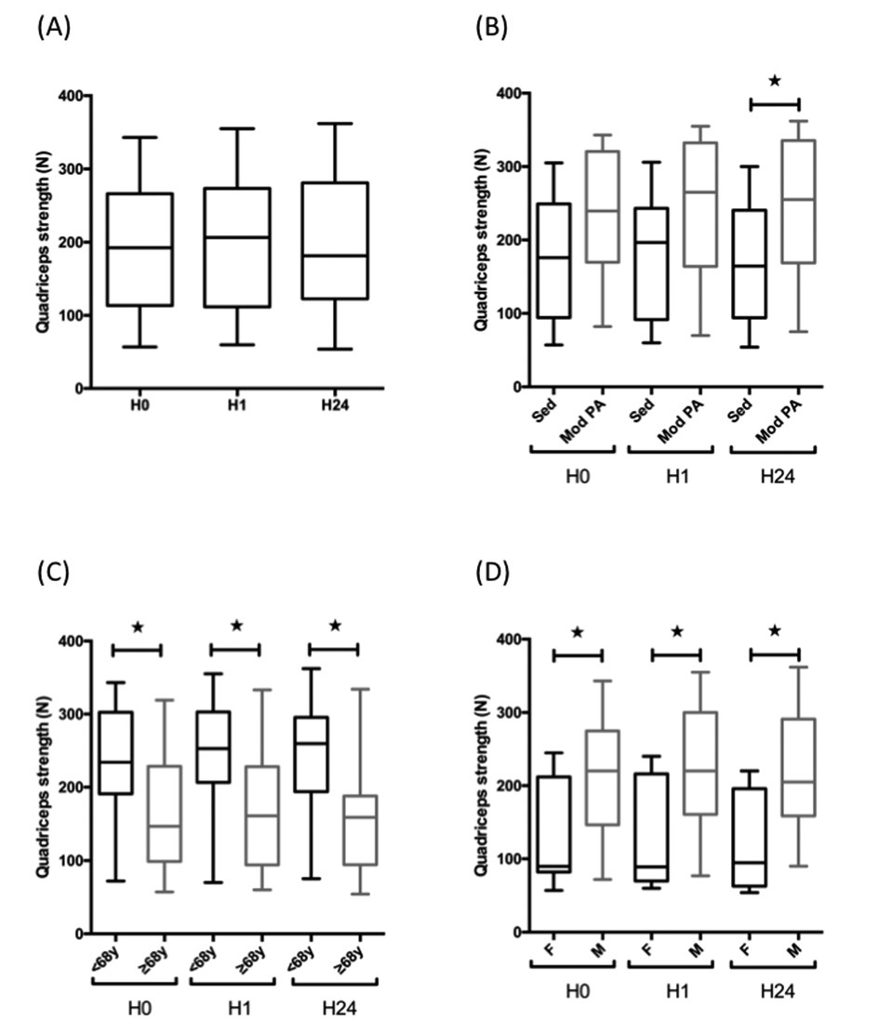
162
discussion
Figure 2. — Quadriceps strength measured at the three time points: in the global population (A), in physical activity subgroups (B), in age subgroups (C) and in sex subgroups (D). Global population: n = 30, sedentary (sed) subgroup: n = 20, moderate physical activity (mod PA) subgroup: n = 10, age subgroup <68y: n = 13, age subgroup ≥68y: n = 17, female subgroup: n = 7, male subgroup: n = 23. N = newton, F = female, M = male, * = p<0.05
Regarding the absolute reliability, SEM was quite low, indicating a high level of accuracy. MDC% ranged from 17.1 to 27.3.
Median pain score before sessions was 5
[2.7-7] and median fatigue score was 3 [0-5]. Pain score was not modified after the tests (p=0.3). Fatigue score was statistically higher after the tests (p=0.0459) but this difference was not clinically relevant: median post-test fatigue score was 5 [3-7]. Vital parameters before the test and at the third maximum effort of H0 measurements were recorded. Variation between the two values was 3.5 [0-7.6]% for heart rate, 1.5 [-2.6-8.3]% for systolic blood pressure and 0 [0-1]% for peripheral oxygen saturation. Changes did not reached 10% for all the parameters, being thus considered as clinically insignificant.
The present study is, to the best of our knowledge, the first to describe a highly standardized procedure (both in term of positioning and measure), aiming to early assess quadriceps strength in a suitable position for critically ill patients. This procedure allowed bedside implementation, as soon as patients were collaborative (RASS -1 to +1). In these specific conditions, measurements performed using the MicroFet2 handheld dynamometer showed a very high intra-observer reliability and were stable between two days in the absence of acute intercurrent events.
Measurements in supine position can be performed in virtually all collaborative critically ill patients, contrary to the sitting position that requires hemodynamic stability and a substantial muscle tone. In the available literature, quadriceps dynamometry is however mostly performed in sitting conditions (18, 23), thus postponing assessment to a later stage of ICU stay and recovery. In the present protocol, the testing position has been chosen as a compromise between rigorous positioning, optimal quadriceps force production and clinical feasibility (patients’ comfort, protection of any femoral catheter, and clinical stability regarding circulatory, respiratory or neurologic functions). The 40° knee flexion places the quadriceps muscle in a suitable length range for optimal efficiency in torque development. The rigid structure helped maintaining both the knee and the hip in the mandatory position during all the procedures. In previously published papers (17, 24), Baldwin et al also reported quadriceps handheld dynamometry in critically ill patients in supine position. However, a simple bolster was put under the tested knee, leading to variable knee flexion angles due to pressure on the support and patient’s height heterogeneity. The importance of a standardized testing position, including limb position and joint angle for the tested muscle, has to be emphasized when interpreting repeated measures or comparing results from different studies.
The positioning structure used in this study was easy to achieve. Patients did not complain

Table 1
Intra-observer reliability of the MicroFet 2 in ICU setting (n=30)
Reliability | ICC (IC95%) | SEM | SEM% | MDC | MDC%
H0 vs H1 | 0.98 [0.95-0.96] | 12.13 | 6.18 | 33.62 | 17.13
H0 vs H24 | 0.95 [0.90-0.97] | 19.18 | 9.86 | 53.16 | 27.33
H1 vs H24 | 0.96 [0.93-0.98] | 17.15 | 8.70 | 47.55 | 24.11
H0, H1, H24 : time points of muscle strength measurement, ICC : interclass correlation coefficient, SEM : standard error measurement, MDC : minimal detectable change.
quadriceps dynamometry in critically care 163

of any discomfort. No adverse events were noted during efforts related to strength measurements. Particularly, vital parameters of the included patients, such as blood pressure or heart rate, did not significantly change, even during maximal contractions. Quadriceps dynamometry may thus be considered safe and well tolerated in the specific context of critical care.
The proposed protocol was designed to limit bias. Contrary to other previously published protocols (17, 18), warm-up contractions preceded the maximal contractions. To ensure the validity of the test, patients need to get familiar with the device, the movement they are asked to perform and, overall, with what may be considered as a maximal contraction. Moreover, three repetitions of sub-maximal and progressive contractions are a safe practice in the context of muscle contractility impairment going along with muscle wasting in ICU-AW (25). The number of needed attempts for maximal contraction assessment has been set as three, thus avoiding fatigue. This is in line with the three attempts found to be the ideal protocol for testing handgrip maximal strength in a large cohort of patients with various age and health status (26). In the present study, peak forces did not decrease or increase over the three time points, thus excluding any fatigue or lack of familiarization issues. Finally, from the operator’s point of view, his position (vertically above the tested leg) aimed to provide him with sufficient resistive force and he did not report any difficulties to stabilize the dynamometer. Interestingly, in the presented rigorous measurement conditions, a huge heterogeneity in quadriceps strength was observed among the included patients. Age and sex are not the only explanatory factors : heterogeneity persists within age and sex subgroups, as shown in Figure 2. It is probably mainly due to the high variability in the patients’ condition, involving their muscular status. Two important clinical implications arise from that variability. First, comparison of muscle strength between patients is not relevant. Muscle strength measurement should rather be viewed as detection and follow-up tool. The MDC defined in the present protocol, ranging from 17.1 to 27.3%, fulfill requirements of such a tool, especially for critically ill patients having hopefully a great potential of muscle strength improvement. Second, such early observation of high strength heterogeneity indicates that patients’ needs in term of muscle strengthening and rehabilitation will be largely different and variable. It emphasizes the necessity of objective muscle strength quantification, aiming for individualized rehabilitation (27). To move in that direction, accurate muscle (and quadriceps) strength dynamometry is a key step.
Potential limitations of this study must be acknowledged. First, inter-observer reliability was not assessed in the specific context of critical care. However, high inter-observer reliability has already been demonstrated for other devices in critically ill patients (18) and for the same MicroFet2 in a healthy elderly population (28). Of note, such high inter-observer reliability can only be reached after operator training and perfect standardization of all procedures. Second, this study was a first but necessary methodological step. A reliability study does not imply the use of a control group. Thus, our data could not be compared to healthy or less sick patients. Furthermore, in such a study, time points have to be clustered to minimize intercurrent events that could interfere with reproducibility. They were defined according to a previously published similar protocol (28). Thereby, patients were tested during 24 hours only and not at later moments. However, replication of the described protocol during a longitudinal study will certainly help to increase knowledge about ICU-AW. Comparison of such data with similar measures in a control group is another exciting perspective.
conclusion
Quadriceps strength dynamometry is a key tool to quantify ICU-AW. To avoid measurement errors and to allow reliable follow-up or comparison between different studies, the testing procedure must be extremely standardized from patient positioning to isometric testing protocol, not forgetting instructions and encouragements. The protocol we described and tested here, using the MicroFET2 device at bedside in a well-defined supine position, was shown to have a very high intra-observer reliability, was feasible in daily practice and well tolerated. Reproduced with strict observance in clinical settings or studies, the present protocol should help in the next future to target both early and long-term rehabilitation according to weakness extent. Thus, qualities of this protocol make it a reference on the way to individualize care of ICUAW.

Acknowledgment
We want to thank Christophe Remy, one of our physical therapist and Geoffroy Balthasart, our medical technician, for their valuable contribution to the positioning structure creation.
164
References
- Hermans G and Van den Berghe G. 2015. Clinical review:
intensive care unit acquired weakness. Crit Care.19:274.
- Hermans G, Van Mechelen H, Clerckx B, Vanhullebusch T, Mesotten D, Wilmer A and Casear MP et al. 2014. Acute outcomes and 1-year mortality of intensive care unitacquired weakness. A cohort study and propensity-matched analysis. Am J Respir Crit Care Med. 190 : 410-420.
- Herridge MS, Tansey CM, Matte A, Tomlinson G, DiazGranados N, Cooper A, Guest CB and Mazer CD et al. 2011. Functional disability 5 years after acute respiratory distress syndrome. N Engl J Med. 364:1293-1304.
- Hill AD, Fowler RA, Pinto R, Herridge MS, Cuthbertson BH and Scales DC. 2016. Long-term outcomes and healthcare utilization following critical illness -a population-based study. Crit Care. 20 : 76.
- Lipshutz AK and Gropper MA. 2016. Intensive Care Unitacquired Muscle Weakness: An Ounce of Prevention Is Worth a Pound of Cure. Anesthesiology. 124 : 7-9.
- Cuthbertson BH and Goddard S. 2017. Benefits and harms of early rehabilitation. Intensive Care Med. 43:1878-1880.
- Reijnierse EM, de van der Schueren MAE, Trappenburg MC, Doves M, Meskers CGM and Maier AB. 2017. Lack of knowledge and availability of diagnostic equipment could hinder the diagnosis of sarcopenia and its management. PloS one. 2012:e0185837.
- Moxley Scarborough D, Krebs DE and Harris BA. 1999. Quadriceps muscle strength and dynamic stability in elderly persons. Gait Posture. 10 : 10-20.
- Schilling BK, Karlage RE, LeDoux MS, Pfeiffer RF, Weiss LW and Falvo MJ. 2009. Impaired leg extensor strength in individuals with Parkinson disease and relatedness to functional mobility. Parkinsonism & related disorders. 15 : 776-780.
- Hansen EM, McCartney CN, Sweeney RS, Palimenio MR and Grindstaff TL. 2015. Hand-held Dynamometer Positioning Impacts Discomfort During Quadriceps Strength Testing: A Validity and Reliability Study. International journal of sports physical therapy. 10 : 62-68.
- Chan OY, van Houwelingen AH, Gussekloo J, Blom JW and den Elzen WP. 2014. Comparison of quadriceps strength and handgrip strength in their association with health outcomes in older adults in primary care. Age. 36 : 9714.
- Bittner EA, Martyn JA, George E, Frontera WR and Eikermann M. 2009. Measurement of muscle strength in the intensive care unit. Crit Care Med. 37 : S321-S330.
- Parry SM, Granger CL, Berney S, Jones J, Beach L, ElAnsary D and Koopman R et al. 2015. Assessment of impairment and activity limitations in the critically ill: a systematic review of measurement instruments and their clinimetric properties. Intensive Care Med. 41 : 744-762.
- Bohannon RW. 2005. Manual muscle testing: does it meet the standards of an adequate screening test? Clin. Rehabil.
19:662-667.
- Vanpee G, Hermans G, Segers J and Gosselink R. 2014. Assessment of limb muscle strength in critically ill patients: a systematic review. Crit Care Med. 42 :701-111.
- Latronico N, Herridge M, Hopkins RO, Angus D, Hart N, Hermans G and Iwashyna T et al. 2017. The ICM research agenda on intensive care unit-acquired weakness. Intensive Care Med. 43 : 1270-1281
- Baldwin CE, Paratz JD and Bersten AD. 2013. Muscle strength assessment in critically ill patients with handheld dynamometry: an investigation of reliability, minimal detectable change, and time to peak force generation. J Crit Care. 28 : 77-86.
- Vanpee G, Segers J, Van Mechelen H, Wouters P, Van den Berghe G, Hermans G and Gosselink R. 2011. The interobserver agreement of handheld dynamometry for muscle strength assessment in critically ill patients. Crit Care Med. 39:1929-1934.
- Keating JL and Matyas TA. 1996.The influence of subject and test design on dynamometric measurements of extremity muscles. Phys. Ther. 76:866-889.
- Bartko JJ. 1991. Measurement and reliability: statistical thinking considerations. Schizophr Bull. 17 : 483-489.
- Kolber MJ, Beekhuizen K, Cheng MS and Fiebert IM. 2007. The reliability of hand-held dynamometry in measuring isometric strength of the shoulder internal and external rotator musculature using a stabilization device. Physiother Theory Pract. 23 : 119-124.
- Weir JP. 2005. Quantifying test-retest reliability using the intraclass correlation coefficient and the SEM. J Strength Conditioning Res.19 : 231-240.
- Borges RC, Carvalho CR, Colombo AS, da Silva Borges MP and Soriano FG. 2015. Physical activity, muscle strength, and exercise capacity 3 months after severe sepsis and septic shock. Intensive Care Med. 41 : 1433-1444.
- Baldwin CE and Bersten AD. 2014. Alterations in respiratory and limb muscle strength and size in patients with sepsis who are mechanically ventilated. Phys Ther. 94 : 68-82.
- Batt J, Mathur S and Katzberg HD. 2017. Mechanism of ICU-acquired weakness: muscle contractility in critical illness. Intensive Care Med. 43 : 584-586.
- Reijnierse EM, de Jong N, Trappenburg MC, Blauw GJ, Butler-Browne G, Gapeyeva H and Hogrel JY et al. 2017. Assessment of maximal handgrip strength: how many attempts are needed? J Cachexia Sarcopenia Muscle. 8 : 466-474.
- Jolley SE, Bunnell AE and Hough CL. 2016. ICU-Acquired Weakness. Chest. 150 : 1129-1140.
- Buckinx F, Croisier JL, Reginster JY, Dardenne N, Beaudart C, Slomian J and Leonard S. et al. 2017. Reliability of muscle strength measures obtained with a hand-held dynamometer in an elderly population. Clin Physiol Funct Imaging. 37(3) : 332-340.

