In-pipette solid-phase extraction prior to flow-modulation comprehensive two-dimensional gas chromatography with dual detection for the determination of minor components in vegetable oils
Laura Barp^{a,1}, Flavio A. Franchina^{b,1}, Giorgia Purcaro^{b,⁎}, Peter Q. Tranchidaª, Luigi Mondello^{a,b}

- “Dipartimento di Scienze Chimiche, Biologiche, Farmaceutiche ed Ambientali”, University of Messina, Polo Annunziata - viale Annunziata, 98168 Messina, Italy
- Chromaleont s.r.l., c/o University of Messina, Polo Annunziata - viale Annunziata, 98168 Messina, Italy

Keywords: Vegetable oil, Food quality, Food authenticity, In-pipette solid phase extraction, Comprehensive two-dimensional gas chromatography Flow modulation

Abstract
The present research is based on the development of an effective, environmentally-friendly and low-cost method for investigation of minor components in vegetable oils, exploiting the advantages of a miniaturized solid-phase extraction (SPE) and the potential of flow modulation (FM) comprehensive two-dimensional gas chromatography (GC×GC), coupled to a mass spectrometer (MS) and a flame ionization detector (FID).
The initial sample preparation step was carried out using a miniaturized approach characterized by a SPE process in a Pasteur pipette. Then, the isolated fraction was injected into an FM GC×GC system. Tentative identification was carried out by means of MS spectral information, while quantification was carried out by using the FID data.
Four different vegetable oil samples were analyzed using the proposed method, namely an extra virgin olive oil (EVO), a hazelnut oil (HO), a borage oil, and an EVO/HO mixture.

⁎ Corresponding author.
E-mail addresses: giorgia.purcaro@chromaleont.it, giopurcaro@gmail.com (G. Purcaro). ¹These authors contributed equally to this work.

Introduction
The so-called “minor components” in vegetable oils represent less than 5% of the entire oil [triacylglycerols (TAGs) are the main compounds], and their detailed profiling can provide highly specific information on quality and authenticity [1]. Among the main classes, fatty acid alkyl esters (FAAEs), waxes, and sterols are currently used as (official) markers to verify the quality and authenticity of olive oil products [2,3].
Limits for the presence of fatty acid methyl esters (FAMEs) and FAEEs were first introduced with the European Regulation n. 61/2011, as markers to determine the quality of olives, and related oils, as they were considered direct indicators of illegal addition of mildly deodorized low quality olive oil [1,4,5]. These requirements were modified in 2013, with the EU Regulation n. 1348/2013, considering only FAEEs (since FAMEs were observed to change during oil storage) and with a fixed limit of 30 mg/kg in EVO [6].
Waxes (fatty acids esterified with long-chain alcohols) are located in the external surface layer of the olives and are usually present in high amounts in solvent-extracted oils (such as pomace oil), or when degraded olives are processed. Waxes are useful markers to evaluate authenticity (e.g., mixtures containing EVO and a solvent-extracted oil). A first limit on the sum of waxes from C₄₀ up to C₄₆ was established in 2007, fixing different values according to the olive oil category. In 2013, C₄₀ waxes were excluded from the sum because their presence can also depend on geographical origin [6,7].
The determination of sterols is used as authenticity parameter, as these constituents are considered as the fingerprint of a vegetable oil. Sterols can be present either in the free form, or esterified with a fatty acid. These compounds are officially determined together as free sterols, after saponification and purification on a silica gel plate (thin layer chromatography). Then, they are derivatized into trimethylsilyl (TMS) ethers, prior to GC analysis [6].
According to the official methods for olive oil control, two separate analyses are required for sterols, on one side, and for FAAEs and waxes on the other [6].
For the latter determination, the International Olive Council (IOC) proposed to scale down the preparation step to reduce the amounts of solvent and sorbent involved of about 5 times [2].

Only a few applications have been proposed to perform the analysis of sterols, FAAEs and waxes in a single analysis [8–10], by performing derivatization prior to the purification step. Recently, Purcaro and coworkers combined a more exhaustive sample preparation method with
a powerful analytical separation method, namely comprehensive twodimensional gas chromatography (GC×GC), for the determination of FAAEs, waxes, along with free alcohols and sterols as TMS derivatives [10,11]. In general, GC×GC has been used for the analysis of single classes of vegetable-oil minor constituents, such as waxes [12] and the unsaponifiable fraction [13]. Such GC×GC works were performed with cryogenic modulators, which are effective even though expensive transfer devices [10–13]. Flow modulation (FM) is a low-cost alternative, which has gained interest in recent years [14]. The most interesting FM model, in the present authors’ opinion, was that proposed by Seeley and co-workers [15]. The main disadvantage of such an FM approach was the generation of excessively-high gas flows (20–25 mL/min) for the use of an MS system. A way to circumvent such a problem is to split the high flow exiting the modulator, between two capillaries, one to an MS device, and the other to an FID [16], or to a waste branch [17]. Reduced FM gas flows can also be obtained by fine tuning of the FM conditions, in particular, the duration of the reinjection step [18].
However, the use of a “greener” final analytical method would be pointless if the sample preparation step involves the use of a large amount of solvents and disposables. Therefore, the aim of this work is to propose an overall more “environmental-friendly” method by miniaturizing the sample preparation step and avoiding the use of cryogenic fluids. Specifically, sample preparation was carried out, after derivatization of the oil, by using a Pasteur pipette (PP) to perform solid-phase extraction (SPE). The isolated minor components were then subjected to qualitative and quantitative analysis by using FM GC×GC (thus avoiding the use of cryogenic fluids) with simultaneous quadrupole mass spectrometry (qMS)/FID detection.

Materials and methods

CHEMICALS

n-Hexane (n-hex) was provided by AppliChem (Darmstadt, Germany), while diethyl ether (Et₂O), pyridine, N,O-bis(trimethylsilyl)trifluoroacetamide (BSTFA) containing 1% of trimethylchlorosilane (TMCS), the alkane mixture (n-C_{7–40}), and silica gel (60–200 µm mesh) were from Sigma-Aldrich/Supelco (Bellefonte, USA). A working internal standard solution was obtained by mixing heptadecanoic acid methyl ester (99%), dodecyl arachidate (C_{12:0}-C_{20:0}, 99%), α-cholestanol (≥95%), 1-eicosanol (≥98.5%) (all from Sigma-Aldrich/Supelco) at a concentration of about 0.05 mg/mL each. Quantification was carried out by using the internal standard approach, as reported in the IOC method [2].

SAMPLES AND SAMPLE PREPARATION

The EVO and borage oil were purchased in stores located in Messina (Italy), the refined hazelnut oil (HO) was from Turkey, while the mixture containing EVO and about 19% (w/w) of Turkish refined HO was prepared in the laboratory. A hazelnut oil fortified (HO_{ref}) with FAAEs and (synthesized) waxes, used for method optimization, was kindly provided by Dr. C. Mariani (Stazione Sperimentale Oli e Grassi, Milan, Italy). Samples pre-treatment was performed according to the method described in ref. 10. Briefly, 100 mg of oil were derivatized by adding 150 μL of BSTFA (1% TMCS) and 150 μL of pyridine, and left to react 30 min at room temperature, before performing a miniaturized silica purification step, herein optimized. In particular, 0.5 g of silica gel (treated at 500 °C for at least 4 h and then added with 2% of water) was packed in a Pasteur pipette [100 mm (main body) × 7 mm ID]; a plug of glass wool prevented the loss of silica from the tip. The silica was washed with 3 mL of n-hexane before 30 mg of derivatized oil were loaded in a total volume of 150 μL of n-hexane. A further 2 mL of nhexane were percolated to remove any alkanes naturally present; then, the fraction of interest, containing FAAEs and waxes, along with free alcohols and sterols (as TMS derivatives), was eluted with a 4.5-mL mixture of n-hexane/diethyl ether (99:1, v: v).

FM GC×GC-qMS/FID INSTRUMENTATION

The FM GC×GC-qMS/FID applications were carried out on a system consisting of two independent GC2010 gas chromatographs (GC1 and GC2) and a QP2010 Ultra quadrupole mass spectrometer (Shimadzu, Kyoto, Japan). GC1 was equipped with an AOC-20i autoinjector, and a split-splitless injector (300 °C).
The first column was an SLB-5ms 12.5 m × 0.25 mm ID × 0.25 µm d_{f} [silphenylene polymer, virtually equivalent in polarity to poly(5% diphenyl/95% methylsiloxane)], while the second was an SLB-35ms 5 m × 0.25 mm ID × 0.10 µm d_{f} capillary [poly(35% diphenyl/65% methyl siloxane)] (Sigma-Aldrich/Supelco).
The FM device was linked to a 2-way solenoid valve (located outside the GC), the latter was then connected to an auxiliary pressure source (APC). The output ports of the solenoid valve were connected to FM through two ports. One port of the FM was linked to the primarycolumn outlet, while another directed the flow to the second dimension. A stainless steel accumulation loop measuring 15 cm × 0.51 mm ID (SGE, Ringwood, Victoria, Australia) bridged two ports. Modulation period was 4,500 ms, with a 500-ms flushing period.
The outlet of the second analytical column was connected to a fixed outlet capillary column splitter (SGE); the latter was then linked to a 1.5 m × 0.18 mm ID and a 0.7 m × 0.18 mm ID uncoated column, for qMS and FID analysis, respectively. A scheme of the complete system is reported in Supplementary Material - Fig. S1.
Two different temperature programs were used to create a positive temperature offset: in GC1 from 50 °C (2 min) to 140 °C at 40 °C/min, then to 350 °C (20 min) at 4 °C/min; in GC2 from 50 °C (2 min) to 150 °C at 40 °C/min, then to 350 °C (22.25 min) at 4 °C/min. The carrier gas (helium) was delivered at an initial inlet pressure of 236.7 kPa; the auxiliary carrier gas was delivered at an initial APC (advanced pressure control) pressure of 221.7 kPa. The two pressure gradients were regulated to operate under constant gas flow conditions in both dimensions. Injection (2 μL) was performed in the direct injection mode.
Quadrupole MS parameters: the sample was analyzed in the full scan mode with a scan speed of 20,000 amu/s, a mass range of 50– 700 m/z and a sampling frequency of 25 spectra/s; interface and ion source temperatures were 250 °C and 200 °C, respectively. MS ionization mode: electron ionization (70 eV). Data were acquired by using the GCMSsolution software ver. 4.2 (Shimadzu). Bidimensional chromatograms were generated by using the ChromSquare software ver. 2.2 (Shimadzu Europe, Duisburg, Germany). MS databases were NIST11, and the Lipid Library (Shimadzu Europe).
FID parameters: temperature was 360 °C; acquisition frequency was 50 Hz; gases: make-up (He), 40 mL/min; H₂, 40 mL/min; air, 400 mL/min.
Fast GC-qMS applications, for sample preparation optimization, were performed using an SLB-5 ms 15 m × 0.10 mm ID × 0.10 µm d_{f} column (Sigma-Aldrich/Supelco). The FM device was obviously not involved in such applications. GC1 and GC2 temperature program: from 50 °C (1 min) to 350 °C (5 min) at 20 °C/min; the carrier gas (helium) was maintained at a constant average linear velocity of 50 cm/ s. Injection (0.2 μL) was performed in the splitless mode (1 min sampling time), then a split ratio of 10:1 was applied.
Quadrupole MS parameters were the same as above.

Results and discussion

PP SPE OPTIMIZATION

Initial work was devoted to the optimization of the sample preparation step. A fast GC-MS approach was used to evaluate the elution order of the fraction of interest. Different approaches to miniaturize the SPE step were evaluated. Both a small plastic syringe (50×10 mm ID), without the plunger and an automatic pipette tip (70×7 mm ID), were filled with 0.5 g of silica. However, in the former case, the TAGs coeluted with the fraction of interest, irrespectively from the amount of oil loaded, probably due to the short chromatography bed. In the latter case, although a better separation was obtained a poor repeatability was observed, especially when different tips were used. Moreover, the presence of polyolefins, deriving from the plastic material, was visible in the GC chromatogram (data not shown).
Finally, a Pasteur pipette [100 mm (main body) × 7 mm ID] was filled with 0.5 g of deactivated silica, kept in place by a glass-wool plug. The PP tip was passed through a GC injector septum, properly shaped to fit into the plastic tap of a 12-position manifold. Hence, several samples could be treated simultaneously. The regular-shaped longer chromatography bed guaranteed the isolation of the TAGs from the fraction of interest, along with satisfactory repeatability.
Optimization of the elution conditions was performed by using 30 mg of HO_{ref}, added with the internal standard solution, previously subjected to derivatization. Small-volume consecutive fractions were collected, evaporated, dissolved in 50 μL of n-hexane, and then subjected to fast GC-qMS analysis. No target analytes were detected in the first 2 mL of n-hexane (Fig. 1). The compounds of interest were then eluted in the following fractions, up to 4.5 mL of n-hexane/diethyl ether (99:1, v:v) (Fig. 1), obtaining recoveries of over 96% (see Section 3.3 for further discussion on the figure-of-merits of the method, evaluated in the GC×GC experiments).
Although traces of monoacylglycerols (MAGs) were present in the fraction of interest, they did not represent an issue, since they were under the form of TMS derivatives (no GC elution problems were observed) and did not co-elute with other compounds in the GC×GC separations.

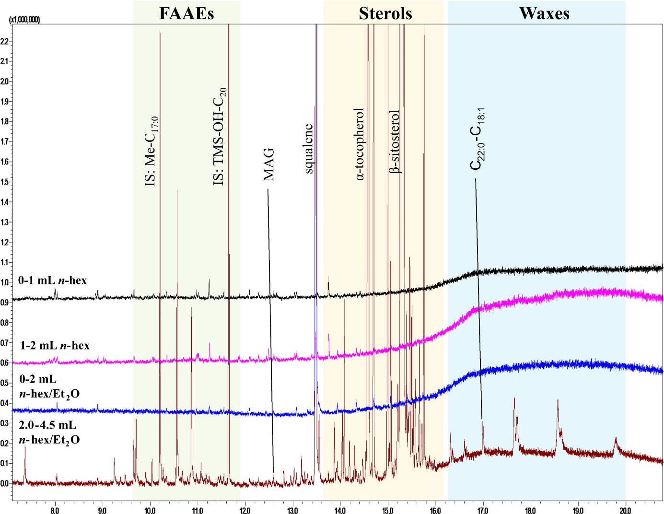
Fig. 1. Fast GC-qMS chromatogram relative to four different SPE fractions, eluted loading 30 mg of spiked derivatized hazelnut oil. The FAAE, sterol and wax elution windows are highlighted. Abbreviation: Me=methyl ester.

FM GC×GC-qMS/FID OPTIMIZATION

After optimization of the PP SPE step, attention was focused on FM GC×GC-qMS/FID method development. A rather short apolar primary column (12.5 m × 0.25 mm ID × 0.25 µm d_{f}) was selected to enable the elution of high boiling-point components. An ID of 0.25 mm was preferred to one of 0.1 mm because of the higher sample loadability. A mid-polarity 5 m × 0.25 mm ID × 0.25 µm d_{f} capillary, with high thermal stability (max. temperature: 350 °C), was used as second dimension. It is advisable to use longer secondary columns in FM experiments, compared to cryogenic-based ones, due to the lack of analyte re-concentration and, hence, to the non-ideal second-dimension re-injection conditions. The 5 m length and 0.25 mm ID of the second column were a good compromise enabling both satisfactory efficiency and non-excessive retention for the high boiling-point constituents. A positive offset of 9 °C was used in GC2, in the central part of the temperature program: after 4.5 min, GC1 and GC2 reached temperatures of 141 °C and 150 °C, respectively. From then onwards, the ovens were heated to 350 °C at 4 °C/min, and then maintained at the final analysis temperature, as specified in Section 2.3.
The second analytical column was connected to two uncoated ones: 1.5 m × 0.18 mm ID and 0.7 m × 0.18 mm ID, them being linked to the qMS and FID systems, respectively. Constant gas flows were approx. 1.1 and 17.7 mL/min, in the first and second dimension, respectively. Even though reduced FM gas flows have been used in recent work [18], such an approach was not herein applied because the second-dimension gas flow was split between two detectors: approx. 41–59% at the beginning (50 °C) and 35–65% (qMS-FID) at the end (350 °C) of the analysis. The primary-column average linear velocity was about 12.1 and 12.8 cm/s at the beginning and at the end of the analysis, respectively. The secondary-column average linear velocity was about 260 and 308 cm/s at the beginning and at the end of the analysis, respectively. Modulation was performed every 4500 ms (flushing period: 500 ms).
An FM GC×GC-FID chromatogram of the fortified HO is shown in Fig. 2; as can be readily seen, and in the following elution order, FAAEs, free sterols (as TMS derivatives), and waxes, are all located in specific zones of the 2D plane.
Although the waxes are rather broadened (and wrapped-around), since their elution was in the isothermal zone of the chromatogram, reliable identification and quantification was possible up to C₄₆ (C_{28:0}C_{18:1}).

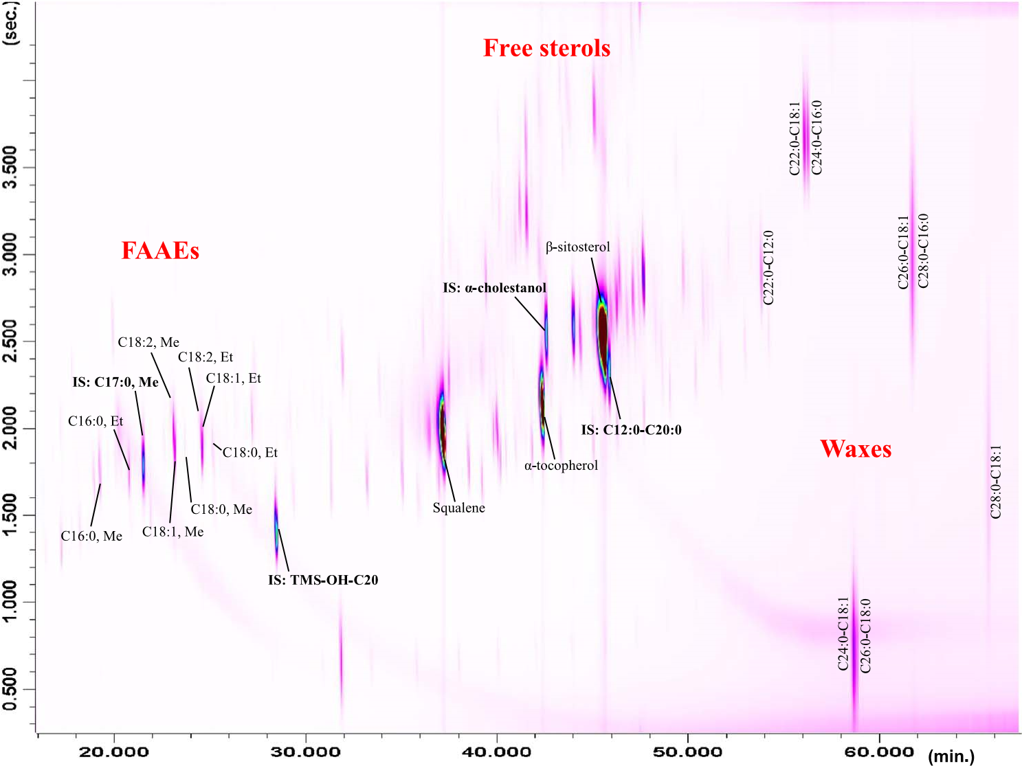
Fig. 2. FM GC×GC-FID chromatogram of the spiked hazelnut oil. Abbreviation: Et=ethyl ester.

FIGURES-OF-MERIT
Performance evaluation of the proposed PP SPE FM GC×GC method was evaluated in terms of discrimination, repeatability, and recovery. Such tests were carried out on the GC×GC system, using the FID signals.
A mixture of equal molarity n-alkanes (C_{7–40}), was analyzed and the area variability within the entire range of alkanes was evaluated as an indicator of the molecular weight discrimination occurrence; an acceptable coefficient of variation (CV%) value of 10.8% was obtained. This trial was performed in triplicate.
Intra- and inter-day repeatabilities were calculated by analyzing the spiked HO sample, performing six independent measurements on two different days (three replicates per day) and using different Pasteur pipettes. Intra-day CV% values in the 2.0–13.2% and in the 2.3–7.6% ranges were found for FAAEs and waxes, respectively. Inter-day CV% results were in the 2.6–11.3% and in the 2.4–6.2% ranges, for FAAEs and waxes, respectively. Considering the sum of each class, CV% values of maximum 4.5% were calculated, both for intra- and inter-day analysis. In the previous work described by Purcaro and co-workers [10] a repeatability of less than 7% was obtained for both FAAEs and waxes.
Recoveries were assessed by considering the difference between the spiking concentrations of FAAEs (78.8 mg/kg) and waxes (325 mg/kg), and those determined experimentally. Specifically, the experimental values determined for FAAEs and waxes were 78.6 mg/kg and
313.9 mg/kg, respectively, corresponding to recovery values of 99.8% and 96.6% (Table 1). These values correspond to a trueness (deviation determined from the difference between the observed and the expected value and expressed as relative error) of less than 3.4% for both FAAEs and waxes, which are comparable with the results reported previously
[10].
Considering a signal-to-noise ratio (S/N) of 10, limits of quantification (LOQ) were estimated from the FID trace and calculated for the 4 ISs. The extrapolated LOQs values for heptadecanoic acid methyl ester, dodecyl arachidate, α-cholestanol and 1-eicosanol were 0.13, 0.6, 0.1 and 0.1 mg/kg, respectively.
Table. 1. Figure-of-merits of the proposed PP SPE FM GC×GC-qMS/FID method calculated by
analyzing the spiked hazelnut oil. Abbreviation: SD=standard deviation
Analyte | mg/kg  (n=3) | SD | Recovery (%) | Intra-day  CV% (n=3) | Inter-day  CV% (n=6)
C_{16:0}, Me | 11.3 | 0.2 |  | 2.0 | 2.6
C_{16:0}, Et | 3.6 | 0.1 |  | 2.1 | 4.2
C_{18:2}, Me | 1.8 | 0.2 |  | 13.2 | 11.3
C_{18:1}, Me | 37.3 | 3.1 |  | 8.4 | 4.6
C_{18:0}, Me | 0.8 | 0.0 |  | 1.6 | 4.9
C_{18:2}, Et | 2.5 | 0.3 |  | 11.5 | 10.2
C_{18:1}, Et | 21.0 | 0.4 |  | 1.9 | 3.2
C_{18:0}, Et | 0.4 | 0.0 |  | 9.9 | 8.1
Total  FAAEs | 78.6 | 3.5 | 99.8 | 4.5 | 2.5
C_{22:0}-C_{18:1} | 41.8 | 7.6 |  | 7.6 | 6.2
C_{24:0}-C_{16:0} | 29.8 | 4.0 |  | 4.0 | 3.9
C_{24:0}-C_{18:1} | 92.0 | 2.9 |  | 2.9 | 5.4
C_{26:0}-C_{16:0} | 25.9 | 4.3 |  | 4.3 | 5.7
C_{26:0}-C_{18:1} | 82.6 | 3.0 |  | 3.0 | 2.4
C_{28:0}-C_{16:0} | 11.4 | 4.5 |  | 4.5 | 6.2
C_{28:0}-C_{18:1} | 32.9 | 2.3 |  | 2.3 | 3.3
Total waxes | 313.9 | 2.6 | 96.6 | 2.6 | 2.5

REAL-WORLD SAMPLE APPLICATION

The optimized PP SPE FM GC×GC-qMS/FID method was then applied to the analysis of 4 different vegetable oil samples (EVO, HO, EVO/HO, borage oil). Tentative identification was performed through the use of MS databases, linear retention index information (when available), and specific 2D locations. Qualitative (peak identification) and quantitative (mg/kg calculated from the FID) data relative to the vegetable oils are listed in Supplementary Material - Table S1. Apart from the aforementioned FAAE, sterol and wax chemical classes, which were located into specific zones of the 2D plot (Fig. 2), other compound groups were present. Namely, homologous series of free alcohols and traces of monoacylglycerols (both as TMS derivatives) were positioned just below FAAEs and sterols. Squalene isomers and sterols, both oxidized, along with steryl acetates, were located in the
middle part of the chromatogram, above the sterols. It must be mentioned that many of such peaks were not given a specific name, due to the lack of available standards and MS database information.
However, they were tentatively assigned to the family of oxidized and sterlyl acetates for the specific elution location on the 2D plane and the similar fragmentation patterns.
Benzyl and phythyl esters eluted between sterols and waxes. Finally, a series of siloxanes were present in the lower part of the chromatogram and were not sample-related.
The EVO sample was characterized by the highest amount of squalene (≈4000 mg/kg, peak 32), α-tocopherol (≈99.5 mg/kg, peak 62), β-sitosterol (≈779 mg/kg, peak 78), cycloartenol (≈71 mg/kg, peak 91), 24-methylene-cycloartanol (≈184 mg/kg, peak 95), citrosta- dienol (39 mg/kg, peak 98), free alcohols (≈85 mg/kg), and waxes (≈44 mg/kg). The total amounts of free and oxidized sterols, as well as steryl acetates, were about 1110, 13, and 2 mg/kg, respectively.
The refined HO sample presented lower amounts of squalene (≈57 mg/kg), tocopherols (0.7 mg/kg), free sterols (≈202 mg/kg), and waxes (≈26 mg/kg) with respect to the EVO sample, but higher amounts of octadecenoic acid methyl ester (≈160 mg/kg), along with steryl acetates (55 mg/kg). Free alcohols were found to be about 5 mg/kg.
The 2D chromatogram of the mixed sample (EVO, plus 19% of refined HO) is reported in Fig. 3, with the related qualitative and quantitative data listed in Supplementary Material - Table S1.
Obviously, the qualitative/quantitative profile of the mixed sample was directly related to the composition of the single oils, even though the high degree of similarity between these two lipidic foods complicates the detection of low percentages of HO in EVO. From a quantitative point of view, it was found that the concentrations of the components in the EVO/HO sample reflected the spiking level (19% w/w HO), with a maximum 20% deviation from the estimated quantity (weighted average amounts were calculated).
Borage oil is often used as a dietary supplement and in pharmaceutical products, since it is an important source of gamma-linolenic acid [19]. In fact, the presence of both gamma-linolenic methyl and ethyl esters was observed only in borage oil (qualitative/quantitative data reported in Supplementary Material - Table S1); furthermore, high amounts of sterols were present as can be seen in the expansion shown in Fig. 4.
The borage oil was characterized by the highest amounts of campesterol (316.2 mg/kg), δ-tocopherol (23.7 mg/kg) and brassicasterol (4.9 mg/kg), with the last two compounds not found in the other samples. In general, borage oil was characterized by the highest number of sterols (15), with respect to EVO (8) and HO (10), even though only half of these were tentatively-assigned. Again, the fragmentation behavior and the location on the 2D plane of such compounds provided an indication of the chemical class. In particular, borage oil contained the highest concentration of steryl acetates (≈45 mg/kg), positioned on the upper left side of the IS α-cholestanol (peak 64), on the 2D plane (Fig. 4).
As aforementioned, a relatively short primary column was selected to enable the elution of the high boiling-point components, with the obvious main disadvantage of such a choice being the reduced first-dimension separation power, which caused a series of co-elutions, in particular in the sterol zone (Fig. 4). Even though peak overlapping did hinder the quantification of specific sterols (compounds marked with *in Table S1), it did not obstruct tentative identification.

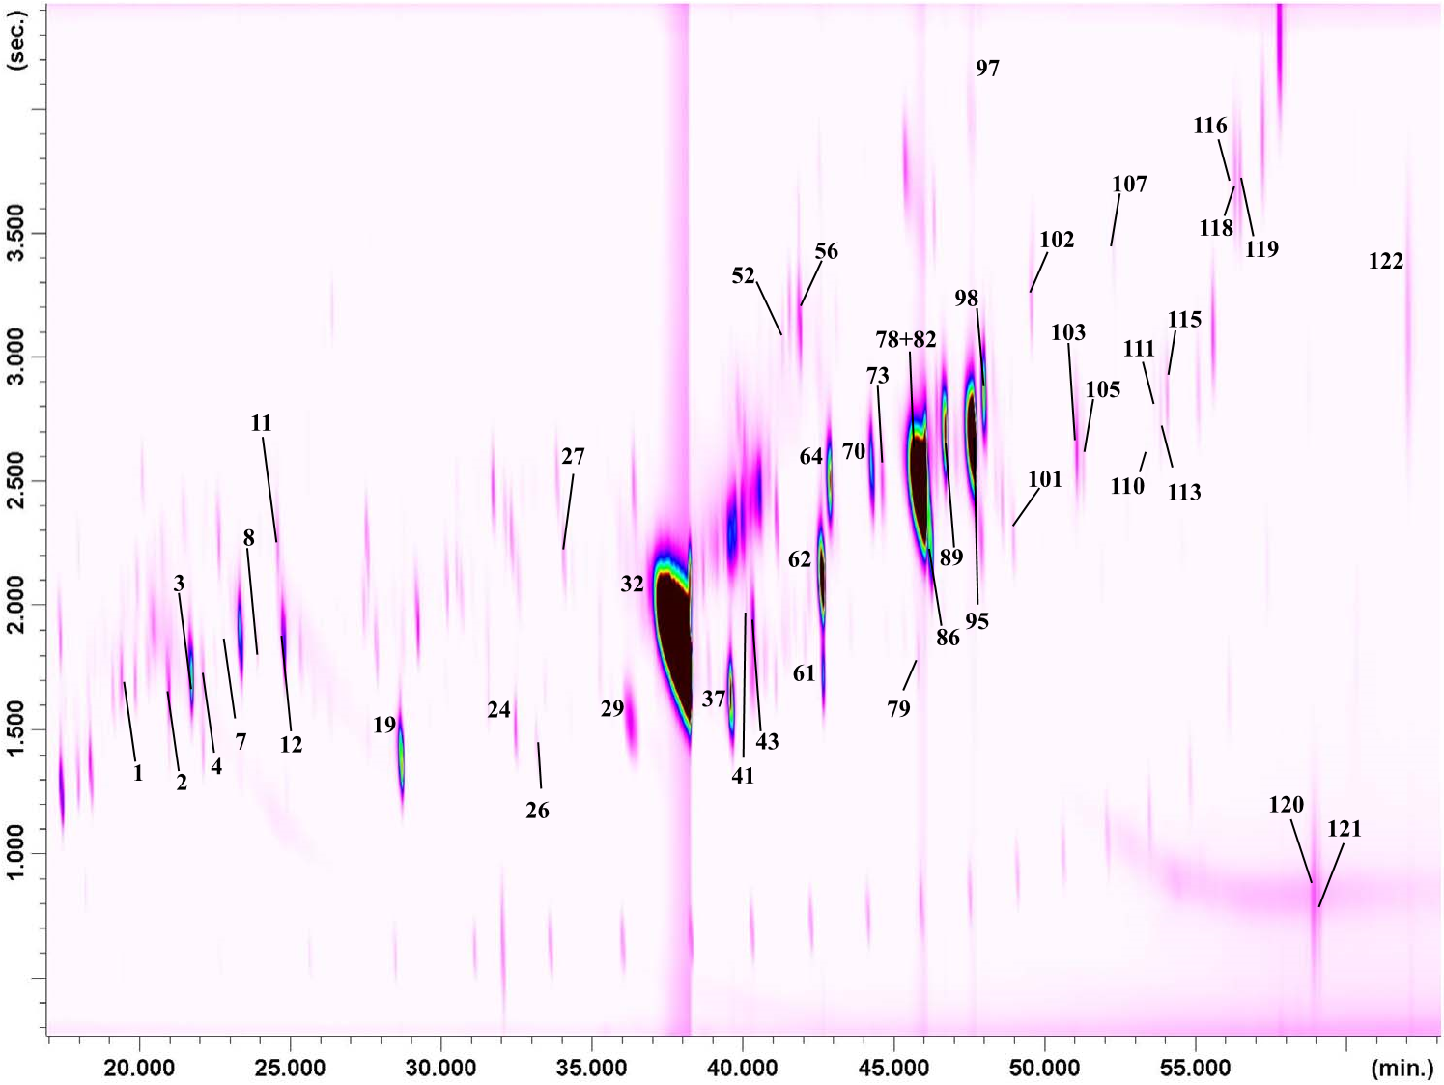

Fig. 3. FM GC×GC-FID chromatogram of the EVO/19% HO mixture. For peak identification refer to Supplementary Material - Table S1.

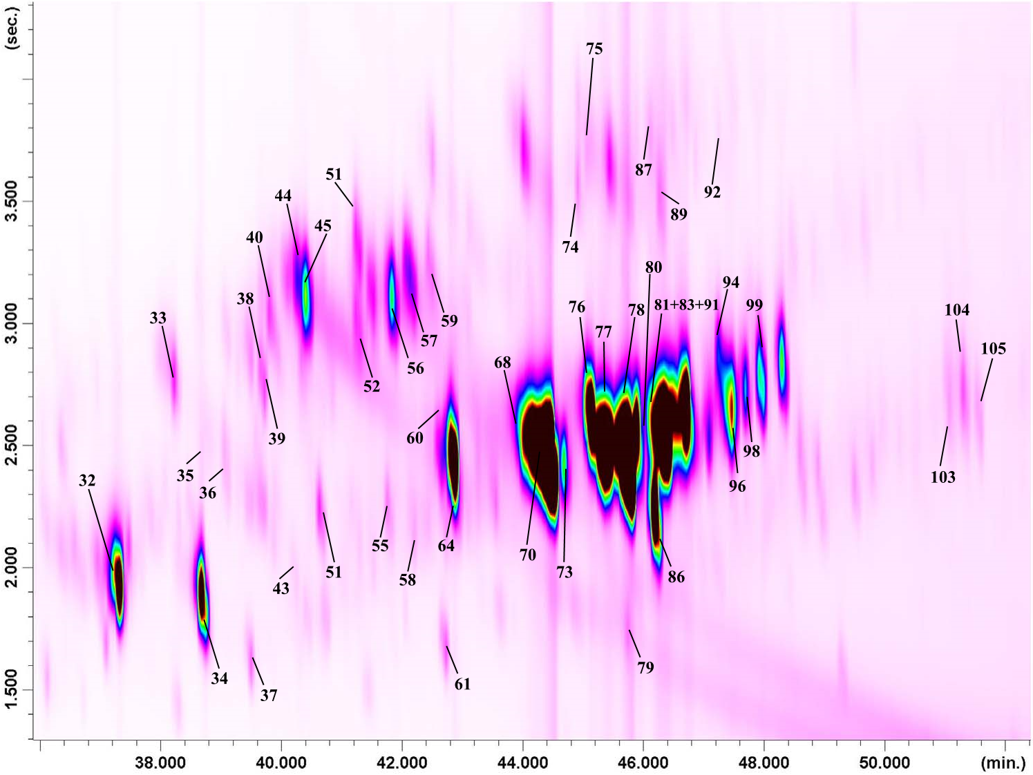

Fig. 4. FM GC×GC-FID chromatogram expansion highlighting the borage oil “sterol zone”. For peak identification refer to Supplementary Material - Table S1.

Conclusion

The present research can be considered as a “green” evolution of existing approaches [2,4,10,11], used for the analysis of minor components in vegetable oils. Specifically, sample preparation was performed by using circa 10 times less organic solvents, while GC×GCqMS/FID analysis was carried out without the need of cryogenic fluids. Not only, the hardware cost of the FM device herein used is much lower than commercially-available cryogenic-based systems. Future research will be devoted to the use of the PP SPE FM GC×GC-qMS/FID method herein proposed, to a high number of vegetable oils, for detailed studies on quality and authenticity.

Conflict of interest

The authors declare no conflict of interest.

Appendix A. Supplementary material

Supplementary data associated with this article can be found in the online version at http://dx.doi.org/10.1016/j.talanta.2017.01.009.

References
- C. Mariani, G. Bellan, Detection of interesterified oils and fats with different methodologies, Riv. Ital. Sostanze Gr. 88 (2011) 3–10.
- International Olive Council, Determination of the content of waxes, fatty acid methyl esters and fatty acid ethyl esters by capillary gas chromatography using three grams of silica. COI/T.20/Doc. N. 31, 2012, pp. 1–14.
- C. Mariani, E. Fedeli, Minor components of vegetable oils: non-glyceridic esters, Riv. Ital. Sostanze Gr. 66 (1989) 397–401.
- Reg. (EU) n. 61/2011 Off. J. Eur. Comm. 2011, L23, 1-14.
- M.D.C. Pérez-Camino, A. Cert, A. Romero-Segura, R. Cert-Trujillo, W. Moreda, Alkyl esters of fatty acids a useful tool to detect soft deodorized olive oils, J. Agric. Food Chem. 56 (2008) 6740–6744.
- Reg. (EU) n. 1348/2013 Off. J. Eur. Comm. 2013, L338, 31-67.
- Reg. (EC) n. 702/2007 Off. J. Eur. Comm. 2007, L161, 11-27.
- C. Mariani, E. Fedeli, K. Grob, Evaluation of free and esterified minor components in fatty materials, Riv. Ital. Sostanze Gr. 68 (1991) 233–242.
- K. Grob, M. Lanfranchi, C. Mariani, J. Chromatogr. 471 (1989) 397–405.
- G. Purcaro, L. Barp, M. Beccaria, L.S. Conte, Fingerprinting of vegetable oil minor components by multidimensional comprehensive gas chromatography with dual detection, Anal. Bioanal. Chem. 407 (2015) 309–319.
- G. Purcaro, L. Barp, M. Beccaria, L. Conte, Characterization of minor components in vegetable oil by multidimensional comprehensive gas chromatography, Food Chem. 212 (2016) 730–738.
- M. Biedermann, P. Haase-Aschoff, K. Grob, Wax ester fraction of edible oils: analysis by on-line LC-GC-MS and GC×GC-FID, Eur. Lip. Res. Technol. 110 (2008) 1084–1094.
- P.Q. Tranchida, S. Salivo, F.A. Franchina, I. Bonaccorsi, P. Dugo, L. Mondello, Qualitative and quantitative analysis of the unsaponifiable fraction of vegetable oils by using comprehensive 2D GC with dual MS/FID detection, Anal. Bioanal. Chem. 405 (13) (2013) 4655–4663.
- J.V. Seeley, S.K. Seeley, Multidimensional gas chromatography: fundamental advances and new applications, Anal. Chem. 85 (2013) 557–578.
- J.V. Seeley, N.J. Micyus, J.D. McCurry, S.K. Seeley, Comprehensive two-dimensional gas chromatography with a simple fluidic modulator, Am. Lab. 38 (2006) 24–26.
- Q. Gu, F. David, F. Lynen, K. Rumpel, G. Xu, P. De Vos, P. Sandra, Analysis of bacterial fatty acids by flow modulated comprehensive two-dimensional gas chromatography with parallel flame ionization detector/mass spectrometry, J. Chromatogr. A 1217 (2010) 4448–4453.
- P.Q. Tranchida, F.A. Franchina, P. Dugo, L. Mondello, A flow-modulated comprehensive gas chromatography-mass spectrometry method for the analysis of fatty acid profiles in marine and biological samples, J. Chromatogr. A 1255 (2012) 171–176.
- P.Q. Tranchida, F.A. Franchina, P. Dugo, L. Mondello, Use of greatly-reduced gas flows in flow-modulated comprehensive two-dimensional gas chromatographymass spectrometry, J. Chromatogr. A 1359 (2014) 271–276.
- I. Wretensjö, B. Karlberg, Characterization of sterols in refined borage oil by GCMS, JAOCS 79 (2002) 1069–1074.

