A Heartbeat Away From Consciousness: Heart Rate Variability Entropy can discriminate disorders of consciousness and is correlated with resting-state fMRI brain connectivity of the Central Autonomic Network

Francesco Riganello^{1,2*}, Stephen Karl Larroque^{2*}, Mohamed Ali Bahri³, Lizette Heine⁴, Charlotte Martial², Manon Carrière², Vanessa Charland-Verville², Charlène Aubinet², Audrey Vanhaudenhuyse⁵, Camille Chatelle², Steven Laureys², Carol Di Perri^{2,6}
¹ Research in Advanced NeuroRehabilitation, Istituto S. Anna, Crotone, Italy
² Coma Science Group, GIGA-Consciousness, University & Hospital of Liege, Belgium
³ GIGA-Cyclotron Research Center In Vivo Imaging, University of Liege, Belgium
⁴ Centre de Recherche en Neurosciences, Inserm U1028 - CNRS UMR5292, University of Lyon 1, France
⁵ Sensation & Perception research Group, GIGA-Consciousness, University & Hospital of Liege, Belgium
⁶ Centre for Clinical Brain Sciences, University of Edinburgh, Edinburgh, UK
* These authors contributed equally to this work.
stephen.larroque@uliege.be, f.riganello@istitutosantanna.it

Motivation:
Heart rate variability (HRV) reflects the heart-brain two-way dynamic interactions[1-5]. HRV entropy analysis quantifies the unpredictability and complexity of the heart rate beats intervals and over multiple time scales using multiscale entropy (MSE)[6-8]. The complexity index (CI) provides a score of a system’s complexity by aggregating the MSE measures over a range of time scales[8]. Most HRV entropy studies have focused on acute traumatic patients using task-based designs[9]. We here investigate the CI and its discriminative power in chronic patients with unresponsive wakefulness syndrome (UWS) and minimally conscious state (MCS) at rest, and its relation to brain functional connectivity.

Methods:
We investigated the CI in short (CI_{s}) and long (CI_{l}) time scales in 16 UWS and 17 MCS sedated. CI for MCS and UWS groups were compared using a Mann-Whitney exact test. Spearman’s correlation tests were conducted between the Coma Recovery Scale-revised (CRS-R) and both CI. Discriminative power of both CI was assessed with One-R machine learning model. Correlation between CI and brain connectivity (detected with functional magnetic resonance imagery using seed-based and hypothesis-free intrinsic connectivity) was investigated using a linear regression in a subgroup of 12 UWS and 12 MCS patients with sufficient image quality.

Results and Discussion:
Significant differences were found between MCS and UWS for CI_{s} and CI_{l} (0.0001≤p≤0.006). Significant correlations were found between CRS-R and CI_{s} and CI_{l} (0.0001≤p≤0.026). The One-R classifier selected CI_{l} as the best discriminator between UWS and MCS with 85% accuracy, 19% false positive rate and 12% false negative rate after a 10-fold cross-validation test. Positive correlations were observed between CI and brain areas belonging to the autonomic system.
CI was found to be significantly higher in MCS compared to UWS patients, with high discriminative power and lower false negative rate than the reported misdiagnosis rate of human assessors, providing an easy, inexpensive and non-invasive diagnosis tool. CI is correlated to functional connectivity changes in brain regions belonging to the autonomic nervous system, suggesting that CI can provide an indirect way to screen and monitor connectivity changes in this neural system. Future studies should investigate further the extent of CI’s predictive power for other pathologies in the disorders of consciousness spectrum.

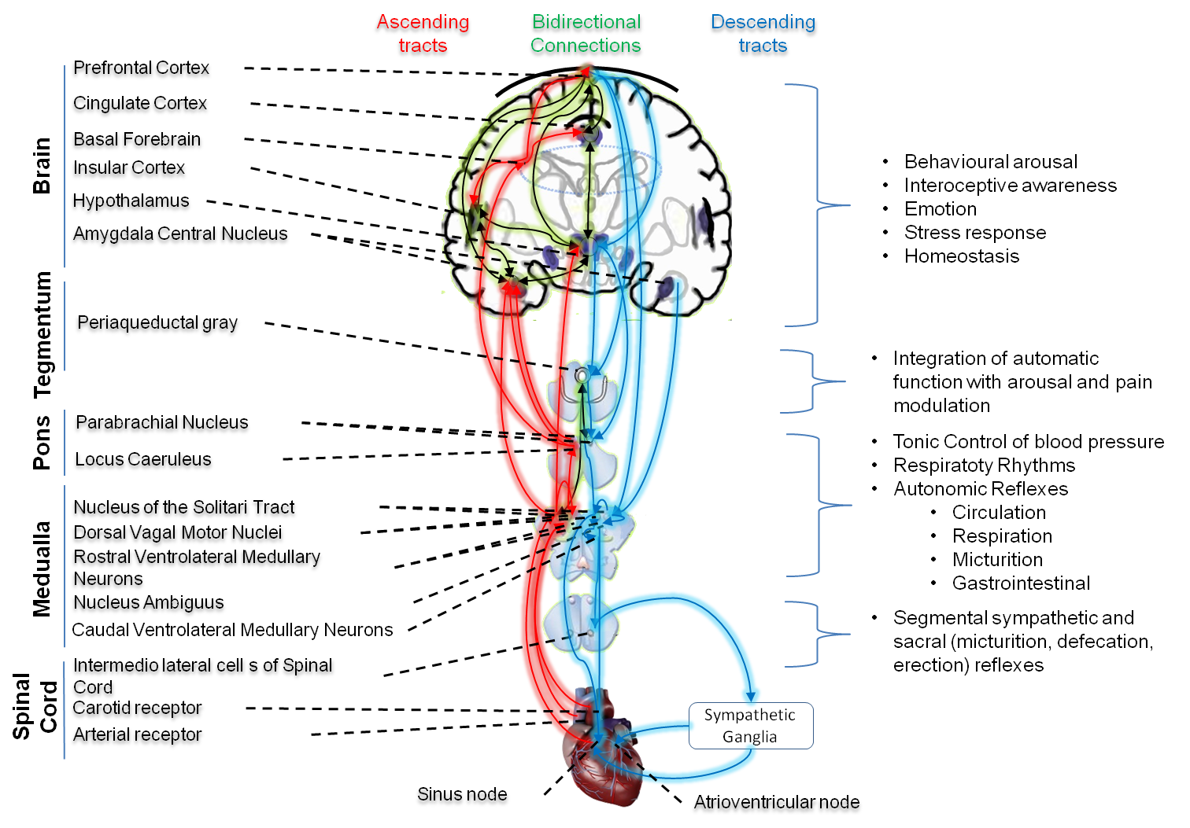
Figure 1: The heart-brain two-way pathways, connecting the heart through the Autonomic Nervous System (ANS) to the brain’s Central Autonomic Network (CAN) covering the structures of the brainstem (periaqueductal gray matter, nucleus ambiguous and ventromedial medulla), limbic structure (amygdala and hypothalamus), prefrontal cortex (anterior cingulate, insula, orbitofrontal, and ventromedial cortex) and cerebellum[10]. Some brain regions of the CAN (dorsolateral prefrontal cortex, mediodorsal thalamus, hippocampus, caudate, septal nucleus and middle temporal gyrus) seem to be unique to humans[11].

Figure 2: Complexity Index statistical analysis comparing UWS and MCS patients summarized as a box plot. Higher values of CI_{s} (z=-2.846, p=0.002) and of CI_{l} (z=-3.386, p<0.0001) were observed for MCS group compared to UWS using Mann-Whitney’s test. The 1st row compares the entire group of patients S1 (n=33), while the 2nd row compares the subgroup of patients S2 (n=24) who underwent fMRI analysis. The 1st column represents the complexity index (CI) in short time scale, while the 2nd column is for the long time scale. White boxes represent MCS patients; gray boxes the UWS patients. The boxes range from Q1 to Q3, while the whiskers are defined at the 1.5 interquartile range, and the black lines are the medians, points are outliers.

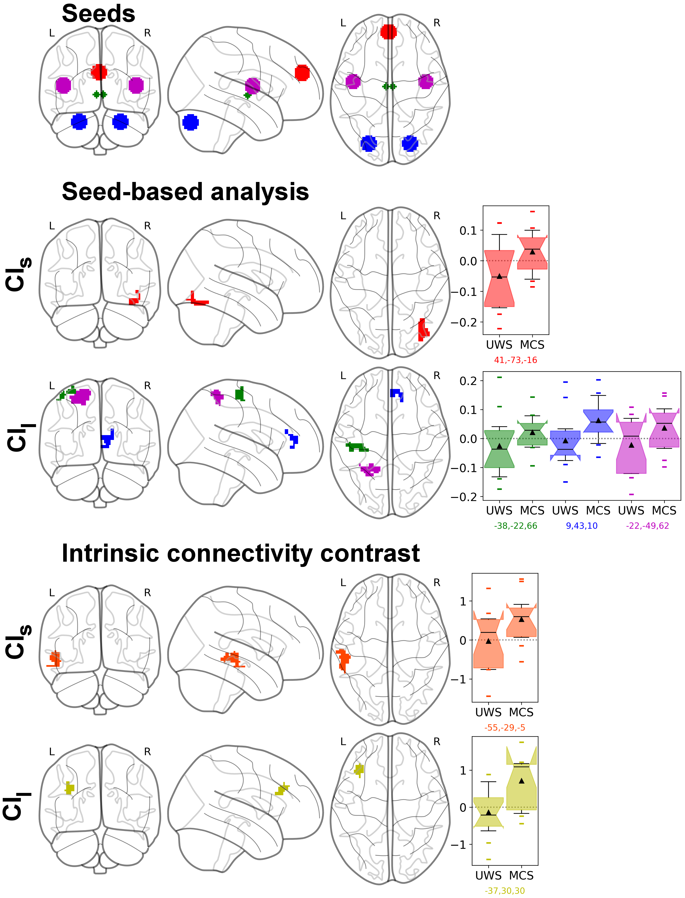
Figure 3: Resting-state fMRI analysis results of the parametric regression between CI and UWS/MCS patients connectivity changes. Top row shows the seeds used: Medial Prefrontal Cortex (MPFC, red), Cerebellum (blue), Thalamus (green), Superior Temporal Gyrus (STG, magenta). Middle rows show the seed-based analysis results, with same colors as the seeds, and effect size as box plots (range Q1-Q3, whiskers interquartile 1.5, black line as median, black triangle as mean, points as outliers), first with the CI in short time scale (CI_{s}) and then long time scale (CI_{l}). We can see a significant positive correlation between CI_{s} and connectivity between MPFC with Lateral Occipital Cortex/Occipital Fusiform Gyrus (red), and between CI_{l} and connectivity between Thalamus and the Sensorimotor areas (green) and between cerebellum and the anterior cingulate gyrus/paracingulate gyrus (blue) and between the auditory STG with the Superior Parietal Lobule (magenta). Bottom rows show the hypothesis-free intrinsic connectivity correlation (ICC) results, with a significant positive correlation between values of CI_{s} and intrinsic connectivity of the posterior middle Temporal Gyrus (pMTG) and posterior STG associated (orange) ; and a correlation between CI_{l} and connectivity in the middle frontal gyrus (MFG) (yellow). Statistical significance was considered at permutation of residuals test cluster-mass p-FWE<0.05 and primary threshold p-uncorrected < 0.001.

References:
[1] Palma J-A, Benarroch EE. Neural control of the heart: Recent concepts and clinical correlations. Neurology (2014) 83:261–271. doi:10.1212/WNL.0000000000000605
[2] Porges SW. The polyvagal theory: New insights into adaptive reactions of the autonomic nervous system. Cleve Clin J Med (2009) 76:S86–S90. doi:10.3949/ccjm.76.s2.17
[3] Thayer JF, Lane RD. A model of neurovisceral integration in emotion regulation and dysregulation. J Affect Disord (2000) 61:201–216.
[4] Kleiger RE, Miller JP, Bigger Jr. JT, Moss AJ. Decreased heart rate variability and its association with increased mortality after acute myocardial infarction. Am J Cardiol (1987) 59:256–262. doi:10.1016/0002-9149(87)90795-8
[5] Harrison NA, Cooper E, Voon V, Miles K, Critchley HD. Central autonomic network mediates cardiovascular responses to acute inflammation: Relevance to increased cardiovascular risk in depression? Brain Behav Immun (2013) 31:189–196. doi:10.1016/j.bbi.2013.02.001
[6] Costa M, Goldberger AL, Peng CK, others. Multiscale Entropy Analysis (MSE). (2000).
[7] Voss A, Schulz S, Schroeder R, Baumert M, Caminal P. Methods derived from nonlinear dynamics for analysing heart rate variability. Philos Trans R Soc Math Phys Eng Sci (2009) 367:277–296. doi:10.1098/rsta.2008.0232
[8] Costa M, Goldberger AL, Peng C-K. Multiscale entropy analysis of biological signals. Phys Rev E (2005) 71: doi:10.1103/PhysRevE.71.021906 [3] lula
[9] Riganello F, Garbarino S, Sannita WG. Heart Rate Variability, Homeostasis, and Brain Function: A Tutorial and Review of Application. J Psychophysiol (2012) 26:178–203. doi:10.1027/0269-8803/a000080
[10] Cechetto DF, Shoemaker JK. Functional neuroanatomy of autonomic regulation. NeuroImage (2009) 47:795–803. doi:10.1016/j.neuroimage.2009.05.024
[11] Napadow V, Dhond R, Conti G, Makris N, Brown EN, Barbieri R. Brain Correlates of Autonomic Modulation: Combining Heart Rate Variability with fMRI. NeuroImage (2008) 42:169–177. doi:10.1016/j.neuroimage.2008.04.238

