Supplementary data 1
The identification of the scoria layer in the 17.65 m borehole was done based on several lines of evidences. We first combine data from inland boreholes located close to the lake (see Table A2 and borehole 4-8, 11, 13, 14 in Fig. A1) and the published isopach maps of scoria fall-out (Machida, 1964; Miyaji, 1988, 2007). The number and the stratigraphic order of scoria layers above, below and between Kg and K-Ah tephra layers and the thickness of the scoria deposits were also taken into account. Additionally, the morphology (shape and color) of the scoria in the borehole was also used to identify the volcanic eruption of Mt. Fuji. In total, four volcanic eruptions from Mt. Fuji were identified: Yufune-II, RII, RI as well as reworked scoria from Omuro eruption.
In the 17.65 m borehole, RI and RII scoria fall-out were recorded at 9.6 m and 10.2 m respectively. These two eruptions are characterized by reddish scoria (Uesugi, 1990). They are dated around 5485–5311 cal yr BP and 5196–5049 cal yr BP, respectively. Reworked scoria from the Omuro eruption were identified at 6.10 m depth in the 17.65 m borehole (Yamamoto, pers. comm.). Yufune-II is inferred to be deposited at 4.2 m depth based on its large thickness (~60 cm) and its stratigraphic position with respect to the radiocarbon dating (Table A1). The age of Yufune-II was calculated by combining published ¹⁴C dating.
Table A1 - Radiocarbon age of scoria layers from Yamamoto et al. (2005) and R-combine oxcal age. Date in bold was not include in our R-combine model due to the important offset with their other radiocarbon dating performed to date Yufune II.
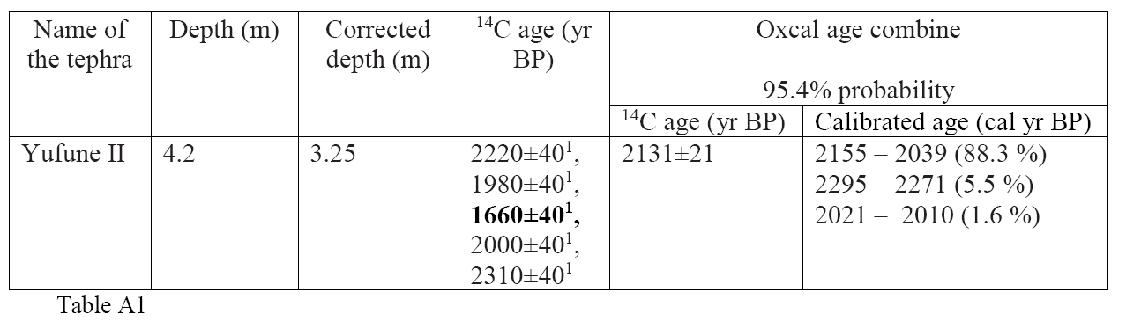
Table A2 - Correlation between scoria identified in the inland borehole and scoria layer identified in the 17.65 m borehole taken in Lake Yamanaka.
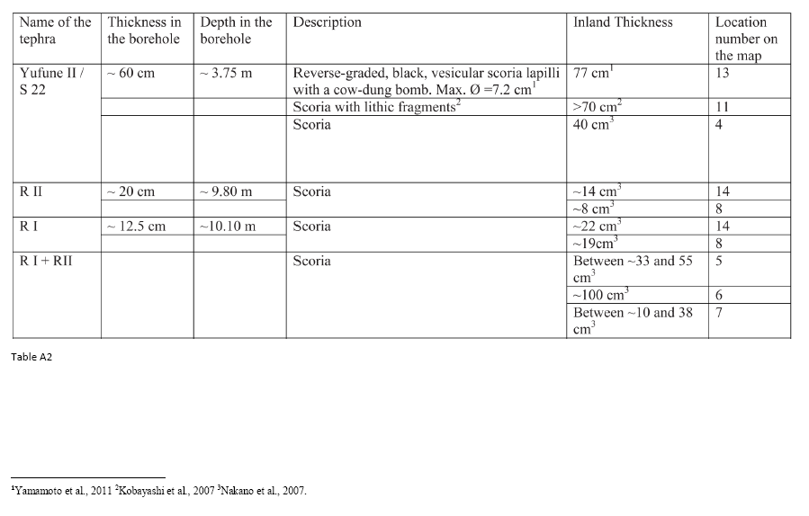
Figure A1 - Location of onland boreholes (Yamamoto et al., 2011; Kobayashi et al, 2007; Nakano et al., 2007) used to identify scoria layers in Lake Yamanaka based on their thickness.
