**Supplementary Material**

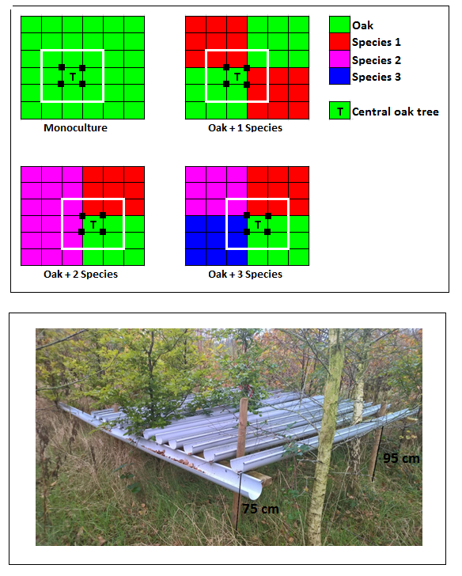

**Supplementary Fig. S1** Plot configuration in the field, where each cell represents one tree (distance between each tree is 1.5 m) and different species of tree in admixture are denoted by different colours (1-4 levels of tree species in admixture). The white square depicts each plot (whereby the white square represents the limits of the rain exclusion shelter in a drought plot, and the equivalent theoretical plot limit in control plots). Black dots around the central target oak tree (T) indicate the position of soil sampling. Plot configuration was the same for control and drought plots at equivalent levels of species admixing.

**Supplementary Fig. S2** The relationship between (**a**) bacterial growth, (**b**) fungal growth, (**c**) respiration, (**d**) fungal-to-bacterial growth ratio, and soil moisture (% WHC) in control soils (C; closed symbols) and soils with a history of drought (D; open symbols). Symbols represent mean ± SE (*n* = 3), where different symbols indicate different tree species admixtures (levels 1-4). All relationships non-significant (p > 0.19, *n* = 12).



**Supplementary Fig. S3** The relationship between (**a**) microbial biomass C, (**b**) total PLFA, (**c**) fungal PLFA, (**d**) bacterial PLFA, (**e**) ergosterol, and soil moisture (% WHC) in control soils (C; closed symbols) and soils with a history of drought (D; open symbols). Symbols represent mean ± SE (*n* = 3), where different symbols indicate different tree species admixtures (levels 1-4; see Supplementary Fig. S2 for legend). All relationships non-significant (p > 0.18, *n* = 12).