Application of Mr. Thuong Van DANG
ULiege scholarship, Engineering Faculty – FSA

History & Status of the PhD Thesis
Mr. Dang started his PhD at ULiege in June 2016, based on a 3-year scholarship from WBI (more exactly 3 x 9 months at ULiege, and 3x3 months at Hanoi – Vietnam). In January 2019, his WBI scholarship will be finished and WBI does not accept to extend their support (we received that news on 4th June 2018 from Ms Kinnen, WBI).

Currently Mr. Dang (June to August 2018) is in Hanoi for the 3 months in Vietnam corresponding to his 3rd year.

By June 2018 (after 2.5 years of research) the main achievements can be summarized as follows:
- Full literature review for reliability updating has been done. Reliability analysis theory is now mature; for instance, it has been applied in various fields, especially for safety assessment of offshore structures. However, in hydraulic steel structures, especially lock gates, it has received modest attention. That does not mean their failures are not important. The evidence is that the U.S Army Corps of Engineers (USACE) has invested lots of money to monitoring of their existing lock gates to detect and forecast failures. The reliability approach, in combination with new information from monitoring or crack inspection, can be used to predict the remaining life and optimize the inspection and maintenance schedule.
- In reliability analysis, the first order reliability method (FORM) and the second order reliability method (SORM) are the two fast and efficient methods to calculate failure probabilities. Invented in the years 1990s, the FORM/SORM methods are the asymptotic solutions to find the design point by using a linear or quadratic expansions of the failure surface. MATLAB codes have been developed by the candidate to calculate reliability indices using these two methods and be familiar with these methods.
- Failure probabilities of welded joints can be updated when new information is available. In this research, new information can be “monitoring data” or “crack inspection results and repair policies”. Reliability updating can be done by solving a condition probability problem. Here the FORM/SORM methods can also be used to solve the parallel system of two limit state functions: “Failure crack size” and “feasibility of a crack detection”. This updating problem can also be solved using a simulation-based method. MATLAB codes have been developed to update failure probability considering crack inspection and repair policies, including the uncertainty of the non destructive inspection methods. The results of updating using simulation-based method has been shown in a conference paper presented by the Mr Thuong DANG.
- To quantify the uncertainty in stress-ranges for reliability analysis, the candidate and his supervisor developed contacts with the USACE (Corps of Engineering) and got a large series of the strain data of a specific lock gate (in US). This information is crucial since it is hard to find information about the probability distribution of such uncertainty in the literature for lock gates.

The remaining work to finish (for last 12 months):
- Risk-based inspection plan of welded joints considering periodic maintenance of movable parts;
- Run applications and critical analysis of the results;
- Finalize the thesis and prepare defense.

The main contribution of the thesis is a methodology to assess the reliability of hydraulic structures as lock gate and floating flood protection barriers with regards to fatigue failure and then optimize the inspection plan to find a cost effective schedule for the whole lifetime. This contribution is valuable, especially for operation and maintenance of existing lock gates where the labor cost and the economic loss of lockage stopping are high/critical.

2) Planning to finalize the thesis
- Sep - Nov 2018: Identify relevant method(s) for risk-based inspection (RBI) plan in collaboration with Mr. Mai Anh Quang, who will present his thesis in Oct-Nov 2018 at ULiege.
- Dec - Jan 2019: Collecting the information about relevant costs: dewatering, periodic inspection of movable parts, crack inspection, crack repair, failure, etc.
- Feb - Jun 2019: RBI code development and results to be published in a journal paper
- Jul - Nov 2019: Thesis writing
- Dec - Jan 2020: Thesis defense

3) Funding history (from WBI, Brussels)
- Period 6/2016 - 2/2017 (9 months): 944 euros per month
- Period 5/2017 - 1/2018 (9 months): 944 euros per month
- Period 2/2018 - 05/2018 (4 months): 963.29 euros per month
- Period 9/2018 - 01/2019 (5 months): 963.29 euros per month (already accepted)
- From 1 Feb 2019, no more scholarship. WBI informed us on 4th June 2018 that there is no fund available for 2019.

4) The reasons for more funding
In the framework of the WBI program, the candidate has received a 9-month each year scholarship to work in ULiege. The WBI scholarship will end in January 2019. By that time, the remaining work required about one more year to finish the working plan.

5) Expected financial support to finish the thesis
We would like to have 12 months with an equivalent scholarship of WBI (963.29€ x 12 months) or during 6 months the standard PhD ULiege scholarship (about 2000€/month), which will be sufficient for living during 12 months

6) Remark
On 29th June 2019, Mr Thuong Dang will be in Hanoi, Vietnam. He may join the interview by skype, if acceptable, or/and he can be replaced by Mr MAI Anh Quang with who he shares his research (Mr Mai will defend his this in Oct/Nov 2018 on a similar topics). Prof Rigo may also be available, if relevant.

Curriculum Vitae
- Person Information
- Full name: Thuong Van DANG
- Date of birth: 18/01/1987
- Phone: +32 0488 613 309
- Email: thuongdv@tlu.edu.vn

- Education and Qualification

Institution | Degree(s) or Diploma(s) obtained:
Water Resources University, Vietnam  09/2005 - 06/2010 | Diploma Engineer in Hydraulic  Construction
Water Resources University, Vietnam  10/2010 – 11/2012 | Master of Science (MSc) in Hydraulic  Construction
Short course in India  11/2005 – 01/2016 | Certificate Course in English Fluency  and IT skills

- Working experience
- 06/2016 - until now: PhD student at Liege University
- 12/2012 – 05/2016: Lecturer at ThuyLoi University - Southern Campus. Partially working at Division of Education and Student Management.
- 06/2010 – 11/2012: Staff at Division of Education and Student Management, Water Resources University -Southern Campus.
- Working at projects: Material and construction control of in Bao Dinh barrier, Tan An barrier, Ky Son barrier, Ca Nhip bridge, Phuoc Hoa channel sponsor by Ministry of Agricultures and Rural Development (MARD).

- Publications
Thuong Van DANG, Quang Anh MAI, Pablo G. MORATO, Philippe RIGO (2018), “Updating the failure probability of miter gates based on observation of water levels”, XIX International Colloquium on Mechanical Fatigue of Metals, Porto, Portugal.
“A Novel Approach in Failure Probability Updating for Offshore Wind Turbine Support Structures”. Poster presentation at a BERA seminar, held on at campus of the Université catholique de Louvain on December 5, 2016.

Hanoi, 8th June 2018 Liege, 8th June 2018
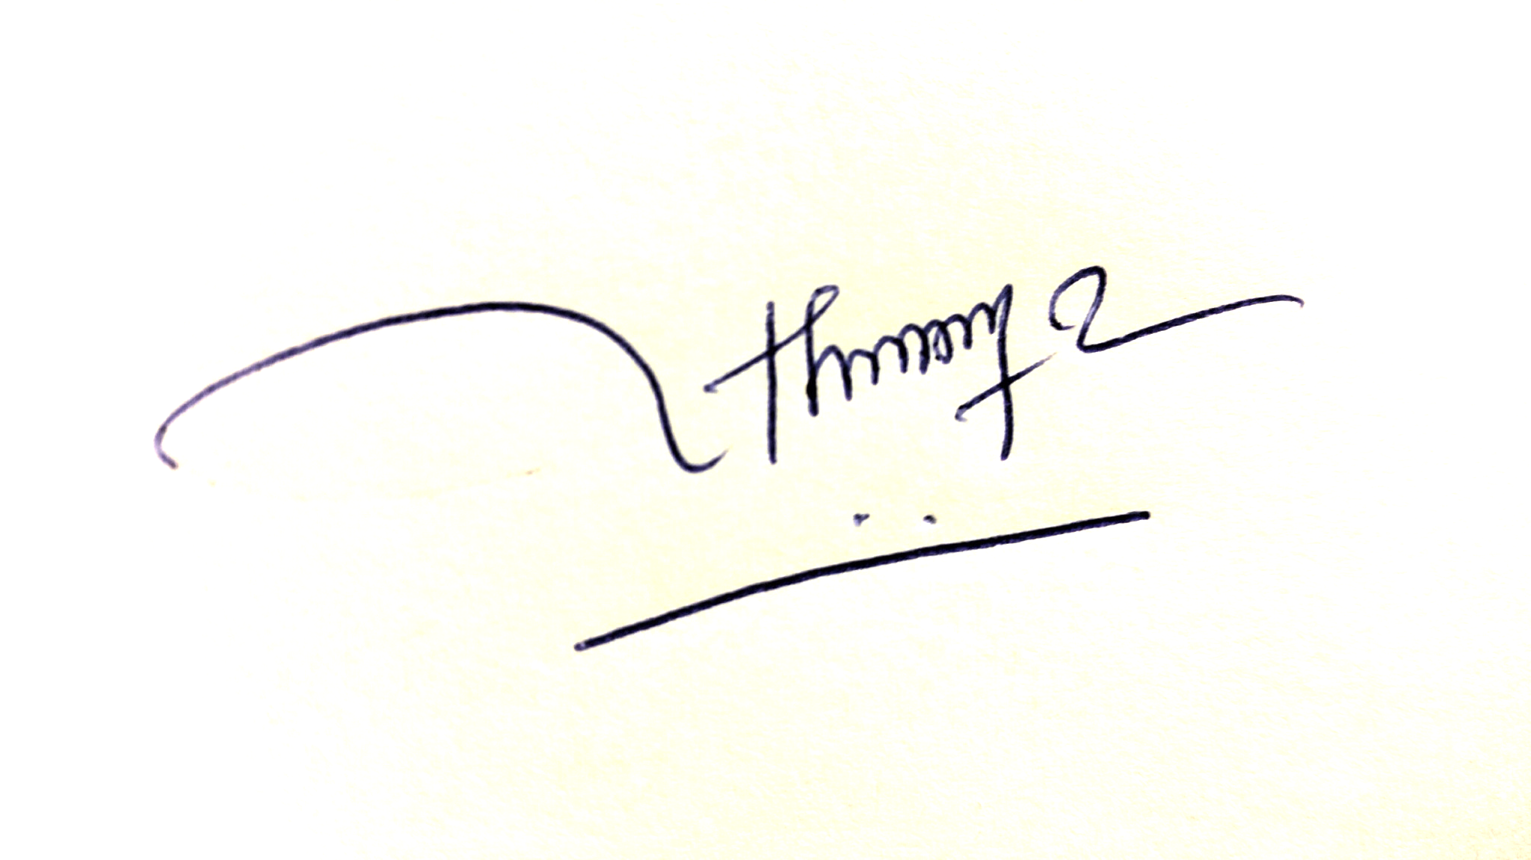
Thuong Van DANG Philippe RIGO

