Synthesis, characterization, and durability study of PtCo hollow nanoparticles deposited on carbon xerogel as electrocatalysts for Proton Exchange Membrane Fuel Cells
Anthony Zubiaur,ª Tristan Asset,^{a,b,c} Fabien Deschamps,ª Laetitia Dubau,^{b,c} Frederic Maillard ^{b,c} and Nathalie Job ^{a*}

ª University of Liège, Department of Chemical Engineering – Nanomaterials, Catalysis, Electrochemistry, Building B6a, 4000 Liège, Belgium
^{b} CNRS, LEPMI, F-38000 Grenoble, France
^{c} Univ. Grenoble Alpes, CNRS, Grenoble INP, LEPMI, 38000 Grenoble, France
* Corresponding author email address: nathalie.job@ulg.ac.be

Proton exchange membrane fuel cell (PEMFC) catalysts are generally made of carbon black (CB)-supported platinum-based nanoparticles, and the PEMFC electrodes display high Pt loading (up to 0.5 mg_{Pt}/cm²) to reach high current without severe mass transport issues. To decrease the system cost, the decrease of the Pt mass contained in the PEMFC electrodes, in particular at the cathode where the oxygen reduction reaction (ORR) proceeds, remains a major challenge. Improving the mass activity of the catalyst towards ORR is currently best achieved by alloying Pt with 3d-transition metal atoms such as cobalt or nickel. These alloys perform better for the ORR because the substitution of some Pt atoms by 3d-metal atoms with smaller radius leads to a modified Pt electronic structure [1]. Therefore, the Pt loading of the electrode can be decreased by increasing the catalyst mass activity through alloying.

Moreover, the properties of CBs, as described by Rodríguez-Reinoso [2], are not optimal for electrocatalysis; in particular, the electrode pore texture after processing (which includes hot-pressing) cannot be controlled. A possible solution to the drawbacks of CBs is the use of synthetic nanostructured materials with a controllable and reproducible pore texture and with a pure, known and constant chemical composition; carbon xerogels (CX) exhibit such properties [3]. Recently, various highly dispersed CX-supported Pt catalysts (Pt/CX), made of 3-4 nm metal nanoparticles, have been synthesized via several methods, such as the strong electrostatic adsorption (SEA), the charge enhanced dry impregnation (CEDI), or the liquid phase reduction of Pt ions with formic acid [4]. Their performances were found quite comparable to those of up-to-date commercial Pt/carbon black electrocatalysts.

Another major challenge for the extensive worldwide commercialization of PEMFCs is the stability of the catalysts. Indeed, the stability of the Pt-based nanoparticles, as shown in Fig. 1a and 1b, has to be improved in order to increase the lifetime of PEMFCs [5]. A way to improve the durability of the catalyst is to use new and stable particle structures, such as hollow nanoparticles.

The synthesis and performance of hollow PtCo nanoparticles/CX (Fig. 1c) are currently studied by our group. The synthesis consists in the formation of a Co nanoparticle colloid using citrate molecules as complexing agents, followed by the galvanic replacement of Co atoms by Pt ions and, then, by the diffusion of the remaining core Co atoms through/in the Pt shell. The results indicate that the ORR specific activity (expressed in A/m_{Pt}²) and the ORR mass activity (expressed in A/g_{Pt}) of the bimetallic hollow particles dispersed on CX are ca. 15 or 7 times higher than that of commercial pure Pt/CB, respectively.

The durability of the hollow PtCo/CX catalyst was studied in a three-electrode cell and in a PEMFC electrode. In particular, accelerated stress tests (ASTs, i.e. 30,000 potential cycles between 0.6 and 1.0 V), performed in PEMFC assemblies, show that the hollow structure is stable: hollow particles present in the pristine catalyst (Fig. 1c) are still observed after cycling (Fig. 1d). Moreover, the performance of the cell constituted of the hollow PtCo/CX catalyst stabilizes: while Pt/C catalyst show a continuous performance drop, no further performance decrease is observed after the 10,000 first AST cycles, proving the good stability of this catalyst (Fig. 2).

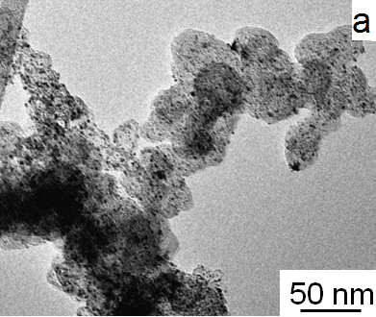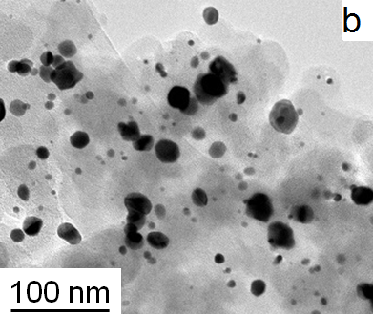
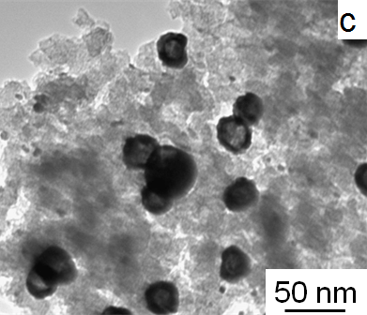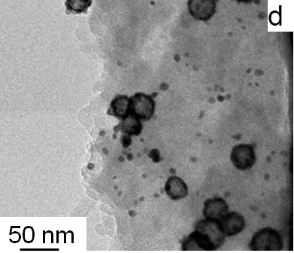
Figure 1: Initial TEM micrographs and TEM micrographs after 30,000 AST cycles between 0.6 and 1.0 V in PEMFC of a commercial Pt/C (a and b, respectively) and of a hollow PtCo particles/CX (c and d, respectively).

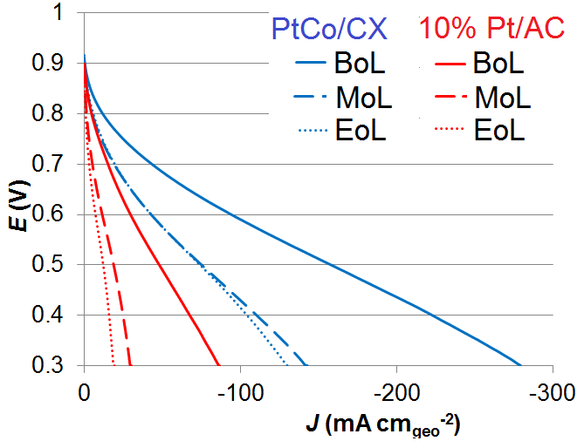
Figure 2: Voltage vs. current density curves of PEMFCs constituted of hollow PtCo/CX catalyst (blue) and commercial 10 wt.% Pt/AC catalyst (red) measured initially (BoL), after 10,000 (MoL), and after 30,000 AST cycles (EoL).

References
[1] J. R. Kitchin, J. K. Nørskov, M. A. Barteau, et al., Journal of Chemical Physics, 2004, Vol. 120, No. 21, 10240-10246.
[2] F. Rodríguez-Reinoso, Carbon as a catalyst support in Porosity in carbons, J.W. Patrick, Ed.(Wiley, UK, 1995), p. 253.
[3] N. Job, A. Théry, R. Pirard, et al., Carbon, 2005, 43, 2481-2494.
[4] A. Zubiaur et N. Job, Applied catalysis B: Environmental, 2017, under review.
[5] Y. Shao-Horn, W. C. Sheng, S. Chen, et al., Topics in Catalysis, 2007, 46, 285-305.

