**Integrated continuous flow photoreactors: Photooxidation of (L)-methionine with singlet oxygen**

Noémie Emmanuel1, Carlos Mendoza2, Marjorie Lismont3, Laurent Dreesen3, Benoit Heinrichs2, Jean-Christophe Monbaliu1*

1. *Center for Integrated Technology and Organic Synthesis, Department of Chemistry, University of Liège, B-4000 Liège (Sart Tilman), Belgium*
2. *Department of Chemical Engineering, University of Liège, B-4000 Liège (Sart Tilman), Belgium*
3. *Biophotonics, Department of Physics, University of Liège, B-4000 Liège (Sart Tilman), Belgium*

[*n.emmanuel@ulg.ac.be*](mailto:n.emmanuel@ulg.ac.be)

**INTRODUCTION**

Development of photochemistry in macroscopic batch reaction vessels is hampered due to inherent limitations: light penetration remains superficial, resulting in inhomogeneous irradiation and hence to side-reactions or product degradation due to overexposure. The recent implementation of photochemical processes in microreactors under continuous-flow conditions appeared to be much more powerful than its batch analogue in terms of irradiation efficiency and light penetration. Furthermore, the fine control of residence time ensures an accurate control of the irradiation time, avoiding side-reactions and degradation.

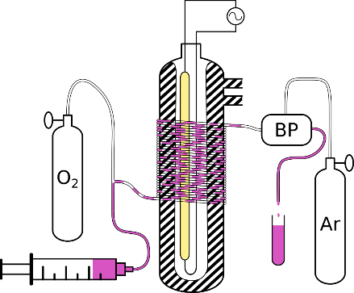

2 mL

30 °C

Oxidized

Compound

Substrate +

Rose Bengal in water/MeOH

The scalable photooxidation of (L)-methionine with singlet oxygen using Rose Bengal as a sensitizer was successfully implemented in a microreactor setup and led to total and selective conversion into methionine sulfoxide, an important building block for the organic synthesis of peptides or functionalized amino acid. The reaction was performed in less than 1 min while the same reaction in batch took 2 h. Other substrates as α-terpinene or citronellol were also photooxidized into high added value compounds using the same conditions.

**Keywords:** (L)-methionine, microfluidics, continuous-flow, photooxidation, singlet oxygen.

**REFERENCES**

[1] N. Emmanuel, C. Mendoza, M. Winter, C. R. Horn, A. Vizza, L. Dreesen, B. Heinrichs, J-C. M. Monbaliu, Org. Process Res. Dev., 21 (**2017)** 1435–1438.