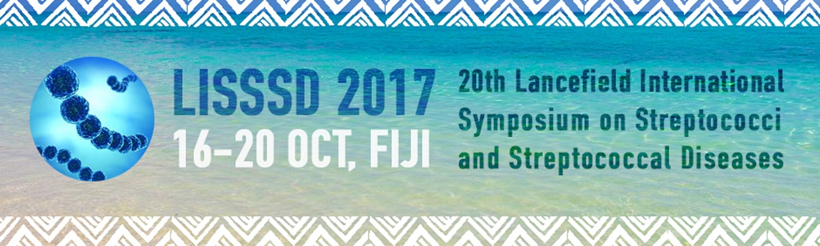

Prevalence and characteristics of group B streptococcus colonization in HIV-infected pregnant women in Belgium
Nicolas Dauby 1 , Catherine Adler 2 , Véronique Y Miendje Deyi 3 , Laurent Busson 3 , Mustapha Chamekh 4 , Marc Delforge 3 , Arnaud Marchant 4 , Patricia Barlow 5 , Stéphane De Wit 1 , Jack Levy 2 , Pierrette Melin 6 , Tessa Goetghebuer 2
1. Department of Infectious Diseases, CHU Saint-Pierre Université Libre de Bruxelles (ULB), Brussels, Belgium 2. Department of Pediatrics, CHU Saint-Pierre-Université Libre de Bruxelles (ULB), Brussels, Belgium 3. LHUB-ULB Microbiology Department, Pôle Hospitalier Universitaire de Bruxelles (PHUB), Brussels, Belgium . 4. Institute for Medical Immunology (IMI), Université Libre de Bruxelles, Gosselies, Belgium 5. Obstetric Department, CHU Saint-Pierre – Université Libre de Bruxelles (ULB), Brussels, Belgium 6. National Reference Centre for Streptococcus agalactiae – University Hospital - CIRM, LIEGE, Belgium
Objectives: High incidence of GBS sepsis has been reported in HIV-exposed but uninfected (HEU) infants in both developed and developing countries, particularly late-onset diseases. We aimed determining the prevalence, the characteristics and the risk factors of GBS carriage in HIV-infected and HIV uninfected pregnant women (PW).
Methods : Between 1/01/2011 and 31/12/2013, HIV-infected (n=132) and uninfected (n=123) PW had recto-vaginal swabs for GBS detection performed at 35-37 weeks of gestation and at deliver Demographic, obstetrical and medical data related to HIV-infection were prospectively collected. Serotyping of GBS strains was performed on a limited number of randomly selected samples (26 from HIV-infected and 13 from uninfected PW).
Results : The overall prevalence of GBS carriage was not statistically different between HIV-infected and uninfected PW (31% vs 24,4% respectively). Age, nadir CD4 cell count, CD4 cell count at delivery and detectable viral load at delivery were not associated with GBS carriage rate in HIV-infected PW. A distinct pattern of GBS serotype was found in HIV-infected PW who were predomina colonized by serotype III (12/26) while HIV-uninfected PW were mostly colonized by serotype Ia (8/13) (p<0,05).
Conclusions: As previously reported in other countries, HIV-infected PW do not have significantly higher rate of GBS colonization. However, our results suggest that HIV-infected PW are more lik be colonized with serotype III strains, that is the main serotype associated with late-onset neonatal sepsis. Ongoing research aims at characterizing the clonal features of the isolated strains.

