IAC-16.C2.8.9x33920
Low Cost Concentrator Solar Array
Collette J.P.
Walopt, Belgium, jpcollette@walopt.com
Rochus P.¹, Hodgetts P.², Nutal N.³, Larnicol M.⁴, Crahay J.⁵
Since the 70's, various researches have been undertaken to concentrate the solar flux on solar panels. In the 90's, concentrators with low concentration ratio appeared (C < 2.5), easily adapted to classical panels. From early 2000, the first commercial spacecrafts with such a technology were launched. Nevertheless, a gradual loss of power appeared and deep investigations concluded that this was due to various causes. From this incident, attention was paid to the contamination of the reflectors and more particularly to their operational temperature. Recently, in 2005, JAXA launched its small REIMEI scientific spacecraft, with two solar arrays equipped with a single lateral reflector. The good results achieved have triggered a new initiative in Europe to study a new concept of lightweight concentrator. The first results of this study including contamination and thermo-mechanical issues are presented.

- INTRODUCTION

Since the 70’s, various researches have been undertaken to concentrate the solar flux on solar panels. The primary target is linked to the surface gain for the solar cells. The profitability needs a low cost concentrator, lightweight and with low constraints to the spacecraft systems. On this empirical basis, a quick analysis concludes to the interest of a high concentration ratio (higher gain in cell surface). This is the target followed by the first researches in the 70’s and 80’s. But some difficulties appeared: high concentration led to difficulties in pointing and thermal design and finally made disappear most of the concepts of this period.

Only some Fresnel concentrator still survive but with a moderate concentration ratio of C < 10.

In the 90’s, new concentrators with low concentration ratio appeared (C < 2.5), easily adapted to classical panels. Commercial spacecrafts with such a technology (C_{power} ~1.5) have been launched in early 2000: their pair of 4-panel wings comprised thin film reflectors mounted either side of a conventional array. Nevertheless, a gradual loss of power appeared and deep investigations concluded that this was due to various causes already reported in various papers.

The increasing electrical power demand onboard telecommunication spacecraft’s leads the solar generator industry to develop new types of solar arrays. Progress in the field of high efficient photovoltaic cells give new insights for the solar power generation, but those new elements also bring new constraints from both technical and economical points of view.
The cost of a solar generator is dominated by that of high efficiency GaAs cells. Using concentrators means using fewer cells to deliver the same power. Concentrator systems incorporate either mirrors, either Fresnel lenses. The idea of concentration on solar cells is not new. Numerous designs have been proposed and some of them have flown. Not to mention the huge R&D effort performed for ground applications.

Attention was paid to the contamination of the reflectors and more particularly to their operational temperature. A Multi-V design has been mainly developed by the Belgian CSL associated with the formerly ALCATEL. The Multi-V design is made of a plurality of small tent-like reflectors disposed between rows of solar cells. These reflectors are automatically deployed when opening the solar panels. This concept presents a series of advantages and drawbacks.

Another design has been developed by Deployable Space Systems. Flight hardware has been built and flown on experimental payloads. The main drawback is that these systems occupy panel substrate area, which is far more expensive than an autonomous lightweight reflective surface.

Recently, in 2005, JAXA launched its small REIMEI scientific spacecraft, with two solar arrays equipped with a single lateral reflector.

- CONCENTRATION CONCEPTS

Solar concentration is a very wide subject that has been intensively developed for terrestrial applications. However using concentration in space is not straightforward; it needs detailed analyses and assessments. A lot of parameters need to be addressed: pointing sensitivity, deployment systems, thermal design, ageing in space, compact stowed configuration, compatibility with deployment schemes...
Among all the concepts that have been studied, we focused our study on one main type of configurations: the V-trough reflectors.
V-trough concentrators are based on reflective surfaces that collect and redirect the solar radiation on the solar cells (Figure 1). In practical applications, those systems can provide an additional effective collecting area similar to the cell surface. In that case, with ideal reflective coatings, the concentration reaches a geometric factor 2 along one direction. This concept has been studied and tested by several groups ⁸ ⁹ ¹⁰. Several parameters can be modified, such as reflector width, reflector coatings, reflector orientation...
The trough-concentrator concept requires that a light ray hitting the top of the concentrator reflects to the far edge of the solar panel. Using this constraint, equations (1) and (2) are derived to fully characterize the geometry of the concentrator (Rex 1978).

(1)
and
(2)

In these equations, L is the reflector height, S is the photovoltaic array width, A is the overall width of the array/reflector envelope, and θ is the reflector angle, as shown in the following figure. The relationships of importance here are between A/S, known as the geometric concentration ratio, which indicates the factor by which sunlight on the photovoltaic array is increased, and L/S, which is known as the length ratio, and between A/S and θ.

Figure 1: Geometric Relationships in Trough Configuration Concentrator.

Figure 1 shows these relationships graphically. These graphs illustrate the theory behind the trough-concentrator design, and they also illustrate its limitations. As the concentration ratio A/S increases beyond about 2.5, the length ratio L/S increases rapidly. As a result, the practical concentration ratio for this type of system is about 2.5.

- REIMI EXPERIENCE

Recently, JAXA has launched a small satellite equipped with a solar concentration array.

For the solar-concentrator paddles on REIMEI, the two paddles without reflectors weigh 2.6 kg and generate about 120 W of power. The specific power of the solar paddles without the reflectors is 46 W/kg. The structure of the solar-concentrator paddles is shown in Figure 2. There are two wings that have thin film reflectors. The reflective wings have a total mass of 0.32 kg and enhance solar intensity by a factor of 1.25. The power increase due to the reflectors is about 30 W. The specific power of the solar-concentrator paddles is 51 W/kg. The specific power of the reflectors, which is defined as the ratio of the power increment and the reflector mass, is 94 W/kg. In REIMEI, a single reflector is attached to the end of a solar paddle in order to use a single-stage deployment mechanism. If a double-stage deployment was applied to the system, two reflectors could be attached at both side facets of the paddle, doubling the effect of solar concentration.

Figure 2: Structure of solar paddles and reflectors.

For REIMEI, the maximum temperature of the cell panel was estimated to be 90 °C under 1.3 solar illumination with the reflector. The solar cells are triple junction InGaP/GaAs/Ge cells with 27% efficiency, which is very effective in reducing the cell temperature even for a solar concentration ratio of 1.3. To avoid possible contamination of the reflector, the temperature of the reflector should be higher than the cell temperature of 90 °C. Thin film polyimide (25 microns) aluminized on the both sides was selected as a reflector. The aluminized back side has low IR emittance, which is effective in keeping the film temperature high. The solar absorptance and IR emittance were measured to be 0.08–0.09 and 0.01–0.02, respectively. Consequently, the temperature of the reflector was estimated to be 130 °C in the sunshine given an incident angle of 60°, which corresponds to a sun angle of 0° with respect to the Z-axis of the satellite body. During eclipse, the temperature was estimated to be - 70 °C. Flight data show a cell temperature of 90 °C in the sunshine with 1.3 solar concentration and - 60 °C during eclipse. The contamination study indicates that, due to the higher temperature of the reflector and the relatively low temperature of the cell, the predicted degradation due to contamination is very small for REIMEI; less than 1% per year.

- THERMAL DESIGN

In the developed design, the spectral absorption and emissivity of the reflectors have a major influence in their final temperature. A high absorption will cause a higher temperature but will be detrimental to their reflective properties. A balance has been made to best choose the coating.
The following assumptions have been made for the thermal simulations:
- We consider a solar generator composed of a solar panel equipped with two solar concentrators. These are made of a thin film membrane coated with a high reflectivity coating.
- The different materials have been modelised: coverglass, glue, solar cell, glue, Kapton film, CFRP, honeycomb, CFRP.
- The satellite is in GEO
- The solar cells are triple junction InGaP/GaAs/Ge (efficiency of 29% - BOL).

In a first step, the operating temperature has been analyzed with Solidworks, for a steady state with a constant solar flux of 1357.5 W/m². The cold space is a source at 5K.

The temperature profile is presented in Figure 3.

Figure 3: Temperature field of a solar panel with reflectors

This figure allows making the following comments:

- The mean temperature of the reflectors is higher than the mean temperature of the PV panel. This is due to the low emissivity of the reflectors to the cold space.
- The PV panel is at a temperature of 96°C at the front face.
- The coldest points on the reflectors are at the upper corners at 102°C. The reflectors are therefore overall at a higher temperature than the PV panel (6 °C higher).
- There is a temperature gradient across the reflectors.

This result shows that it is possible to maintain the reflectors at a higher temperature than the PV panel in constant solar illumination, by an adequate choice of coatings.
At the preceding point, we have determined the temperatures in normal operating conditions. Nevertheless, the solar generator operation depends on the satellite orbit along the year. Sometimes, the satellite enters in eclipse. The eclipses in GEO only appear at specific periods of the year due to the 23, 5° inclination of the Earth rotation axis. A satellite in GEO only crosses the shade cone of the Earth only near the equinoxes. There is about 44 days per year (autumn and spring equinoxes) when the satellite enters in one eclipse per day. The duration of the eclipse is variable according to the orientation of the normal to the equatorial plane (GEO plane) versus the Sun. At equinoxes, the Earth axis is in the plane perpendicular to the Sun direction and the longest eclipse happens. It lasts 72 minutes, during which the solar panel and reflectors are no more illuminated and become cold.

A simulation has been made with specialized software dedicated to the study of bodies travelling in space: the geometry of the bodies is defined with their thermal properties, together with the mission orbit, the kinematic (AOCS). The full environment is modelized: solar flux, Earth IR, Albedo, cold space.

At each position of the body along its orbit, the fluxes and temperatures are evaluated. A particular attention has been given to the autumn equinox.

Figure 4: GEO Mission illustration

Figure 5: Autumn eclipse temperature of PV solar panel and reflector

Figure 5 shows the temperature evolution of the coldest point of the reflector (in red) and of the hottest point of the PV panel (in blue) during the autumn eclipse (between time 80 and 150 minutes). We can see that the reflectors are always warmer than the PV cells. The minimum difference between the two curves is never lower than 20 °

These calculations have been made with the materials properties at BOL. An evaluation at EOL has been made and shows that there is still a positive temperature gradient between the solar PV panel and the reflectors.

- SHAPING OF THE REFLECTOR

The literature is abundant on the tension of a thin film and avoidance of wrinkles. The numerous analyses are mostly based on the theory from Wagner (Tension Field Theory 1926).
The structural wrinkles are not permanent and disappear if the load creating them is removed, being supposed that we stay in the elastic domain. The plies appear when the film is submitted to compression or shear stress. These wrinkles are characterized by amplitude, wavelength and direction. They depend on the applied loads and on the boundary conditions. A study [20] shows that the structural wrinkles appear automatically in a thin membrane (thickness < 100μm) submitted to a unidirectional traction load. Their amplitude varies with the applied load and their direction is the same as the principal stress. The wrinkles disappear when applying a load with the same intensity in a perpendicular direction. The biaxial stress state is thus stable.

Another study shows the sensitivity of thin films under shear load. The following pictures show the behavior of a Kapton film 25μm thick.

Figure 6: Wrinkles in a thin membrane under shear stress

Figure 7: Profile of the membrane under shear stress

A test bench has been designed to study various configurations and eliminate the wrinkles, taking care of thickness, transverse loads, shape of the membrane versus the supporting frame geometry, …

Figure 8: Experimental thin film in tension

After this preliminary and experimental study, the target was to quantify the wrinkles shape according to the explored boundary conditions and to implement the deformed shapes into a ray tracing software. The simulation will then allow us to compute the exact energy falling on the solar cells after reflection.

Finally, an experimental set-up was built and used to measure the direct energetic effect of the wrinkles on the solar cells and validate the software.

The measurement of a thin film deformation should be made without interfering with the thin film, very sensible to any load applied by a sensor. A non contact measurement is thus necessary. Among the possible optical methods, photogrametry by frange or points projection [6] [7] has been used.

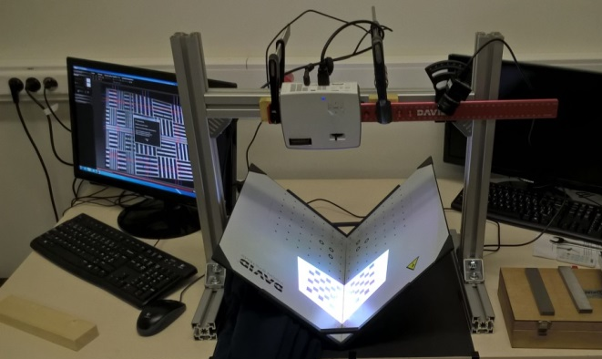

Figure 9: 3D scanner in its optical bench with the calibration corner

A white paint is necessary to use the 3D scanner.

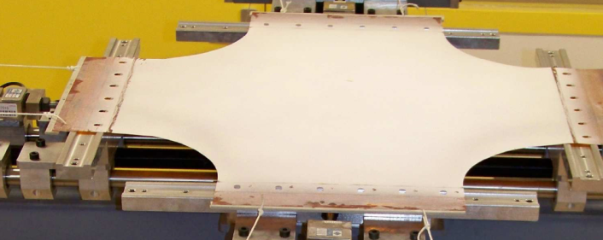

Figure 10: White coating on a Kapton film by Y. Lecieux

The following figure shows a thin film under uniaxial tensile stress. The plies are clearly visible

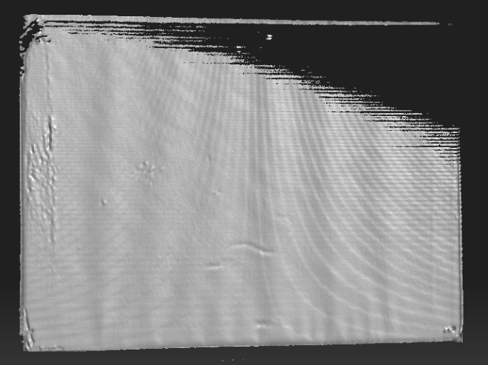

Figure 11: 3D scanner view of wrinkles

The Figure 12 shows the result of the scan with colored levels (colormap).

Figure 12: Colour scan

Figure 13: Plies showed by the 3D scan

After several trials, a bi-axial state has been realized and shows a rather good planarity of the thin film.

Figure 14: Colour scan for bi-axial state

Figure 15: Plies for bi-axial state

The accuracy of the measurements (0.1-0.2 mm) is not very high but, in the operational life, numerous wrinkles patterns can appear according to the boundary conditions and possible local plasticization. Nevertheless, the order of magnitude of the wrinkles depth and wavelengths has been measured and will be inserted in the ray-tracing software.

An optical bench has been manufactured to measure the impact of the reflector non-planarity on the efficiency of the solar concentrator. The optical bench is made of a light source, a simplified collimator, a reflector and a sensor.

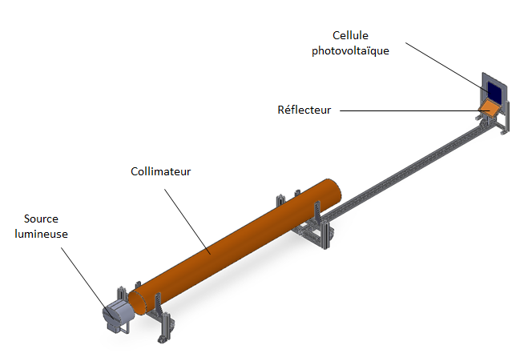

Figure 16: Optical bench

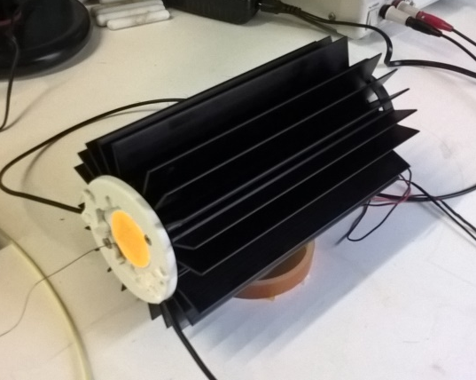

Figure 17: LED source with thermal dissipater

First, the efficiency of the set-up has been measured with a solar cell (integrated flux) for different configurations:
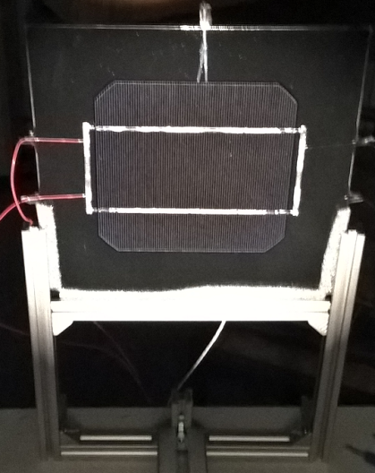

Figure 18: Solar cell alone

Tc [°C] | 20.3
Icc [mA] | 24.69
Ee [W/m²] | 2.81
C [/] | 1

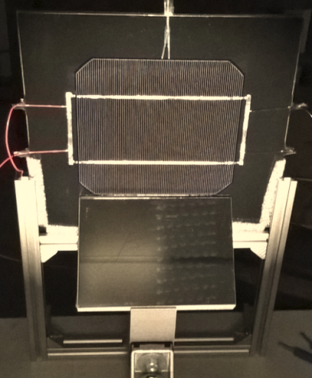

Figure 19: With a flat Ag mirror

Tc [°C] | 20.3
Icc [mA] | 33.07
Ee [W/m²] | 3.76
C [/] | 1.34 ± 0.03

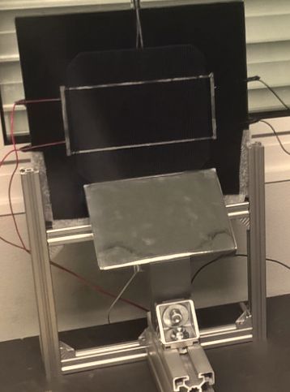

Figure 20: With a reflector without wrinkles

Tc [°C] | 20.3
Icc [mA] | 32.49
Ee [W/m²] | 3.70
C [/] | 1.32 ± 0.03

Figure 21: With a reflector with wrinkles

Tc [°C] | 20.3
Icc [mA] | 32.43
Ee [W/m²] | 3.69
C [/] | 1.31 ± 0.03

These measurements, made with a solar cell, show the relatively small influence of the wrinkles on the efficiency. Neglecting the error range, the difference of the optical concentration factor is 2 % with or without plies. This means a difference of 9 % in the illumination of the solar cell by the reflector, which is in accordance with the ray-tracing simulations that have shown a loss of efficiency of about 10 %.

The next testing campaign has been dedicated to the measurement of the incoming light flux with a photodiode mounted on a scanner.

The Figure 22 shows the projection on a screen of the reflected light by a thin film with wrinkles.

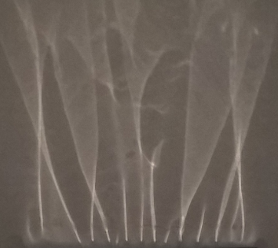

Figure 22: reflected light on a screen

This figure has to be compared with the data coming from the photodiode scan.

Figure 23: measurement of the reflected light with a photodiode

A reflector with wrinkles has been modelized in Solidworks from the data coming from the scan of a deformed thin film (Figure 9). This adjustment is made with the help of Matlab by the equation
$$\sum_{i=1}^{n}{a_{i}. (\sin\left(b_{i}\right)+c_{i})}$$
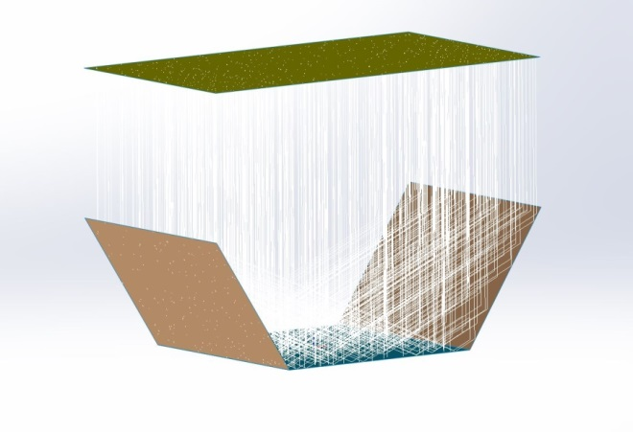
Figure 24: Ray-tracing of the full solar concentrator

The Figure 25shows the adjusted curve (blue) and experimental points (black). The results are shown at the figure 108b.
(a) |   (b)

Figure 25: numerical model of wrinkles in a thin film

Having traced the light rays, the software allows making a radiometric analysis of all the surfaces. The main information which is looked for is the irradiance (W/m²) falling on the solar panel and more particularly on each solar cell. The solar panel is thus divided according to the size of 3J solar cells to determine the energy falling on each of them.

A first simulation has been made with two deformed reflectors. The Figure 26 shows the detailed distribution of the irradiance on the solar panel.

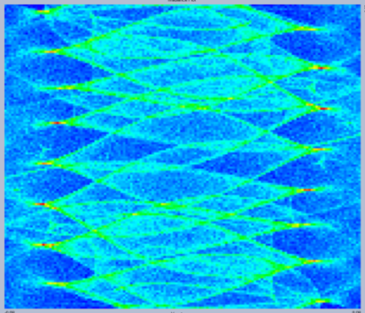

Figure 26: solar irradiance on the solar panel

The mean irradiance is 1656 W/m². The irradiance from the reflectors has a deficit of 9.3% versus a flat reflector.

In addition the detailed mapping of the illumination would allow taking care of the connection of the strings.

- COATING OF THE REFLECTOR

The choice of the reflector coating has been realized with a home-made Matlab program. This program computes the solar flux absorbed by the solar cells versus the wavelength. The program takes care of the direct incident flux and the reflected flux. This allows a direct evaluation of the optical concentration for various coatings. The range of interest is between 300 nm and 1800 nm, with an integration step fixed to 1 nm.

The material reflectivity is a function of the wavelength but also of the angle of incidence. Using the Fresnel formulas, we reached the following results.

Figure 27: Spectral reflectivity for Al and Ag

The integral of these two curves between 300 nm and 1800 nm shows that the reflectivity is a bit higher for Silver (94.7%) than for Aluminum (93%). Nevertheless, it is necessary to take care of the spectral intensity of the incident rays and of the spectral absorption of the solar cells. A spectral multiplication of the three curves gives the following result:

1) solar irradiation AM0
2) spectral reflectivity of the coating
3) spectral absorption of the solar cells

We can see that Silver is still the preferred coating.

Figure 28: solar cells respone after reflection on Ag/Al

- CONCLUSION

The developments of a low cost concentrator are still going on at the time being. Various glues have been tested for their outgassing properties and the best candidates will be incorporated in a laboratory model. This model will be manufactured at a reduced scale (about A4). The main challenge will be the holding mechanism of the reflectors. It will be exposed to the solar illumination available on ground (solar simulator or natural sun).

- ACKNOWLEDGMENT

This work has been founded by the European Space Agency ESA-ESTEC under contract number XXX. The authors wish to thank their colleagues who have made this work possible.

- LIST OF ABBREVIATIONS

AOCS  BOL  CFRP  EOL  ESA ESTEC  FEM  GEO | Attitude and Orbit Control System  Beginning Of Life  Carbon Fiber Reinforced Polymer  End Of Life  European Space Agency  European Space Research and Technology Centre  Finite Element Method  Geostationary Earth Orbit

- REFERENCES

- BOUZIDI (R.) LECIEUX (Y.), "Experimental analysis on membrane wrinkling under biaxial load - Comparaison with bifurcation analysis”, in International Journal of Solids and Structures, vol. 47, pp. 2459 - 2475, 2010.
- WANG (C.G.) et al., "A new computational methode for wrinkling analysis of Gossamer space structures", in International Journal of Solids and Structures, vol. 46 (6), pp. 1516 - 1526, 2009.
- HIROBUMI (S.) et al., "Small satellite REIMEI for auroral observations", in Elsevier, vol. 69, no. 7-8, pp. 499-513, Octobre 2011.

