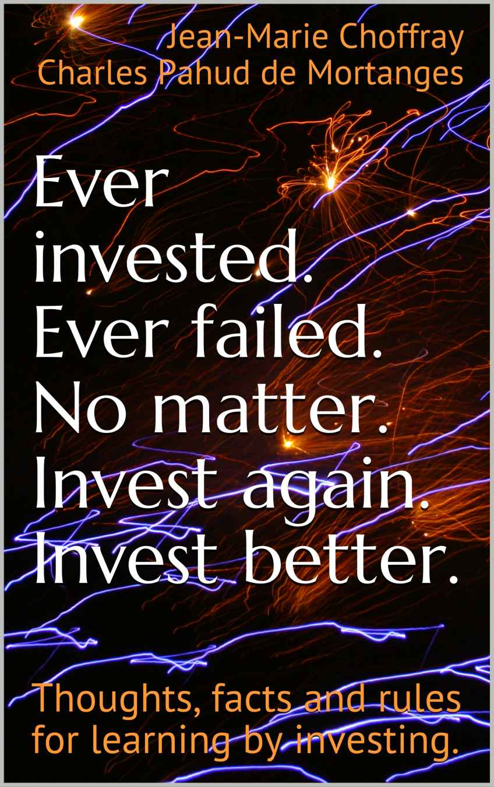

Ever invested
Ever Failed
No matter
Invest again
Invest better

Thoughts, facts and rules for
learning by investing

Jean-Marie Choffray
Charles Pahud de Mortanges

Kindle eBook
July 2017

Copyright © 2017 by Jean-Marie Choffray & Charles Pahud de Mortanges

All rights reserved. Reproductions must be strictly reserved for private use. Short analyzes and citations should be limited for example and illustration purposes. Any representation or reproduction, in whole or in part, made without the consent of the authors or their successors is illegal. Such representation or reproduction, whatever the method, would constitute an offense sanctioned by law.
Also by Jean-Marie Choffray

Ombres de réalité (Amazon: Kindle Edition, 2017)

De la crise à l’entreprise en passant par vous, (Amazon: Kindle Edition, 2016)

Investir ou mourir, il faut choisir, (Amazon: Kindle Edition, 2016)

Market: études et recherches en marketing, (Paris: Nathan, 1997), with Y. Evrard, B. Pras, E. Roux, A.M. Dussaix and M. Claessens

Systèmes intelligents de management, (Paris: Nathan, 1992)

Marketing expert: logiciels d’aide à la décision, (Paris: McGraw-Hill, 1985)

Développement et gestion des produits nouveaux, (Paris: McGraw-Hill, 1983), with F. Dorey

Market planning for new industrial products, (New-York: John Wiley, 1980), with G. L. Lilien

Acknowledgments

To all those – students, colleagues, fellow investors – who, most of the time involuntarily, but significantly, contributed to this work.

Jean-Marie Choffray & Charles Pahud de Mortanges

Contents

Preface
Ever invested? Ever failed?
The Great Recession of 2008
Businesses, assets and liabilities
Assessing market response
Financial engineering tricks and traps
Investors, swindlers and thieves
Rules for asset protection
Investing under non-parametric uncertainty
A few common myths about investing
Final thoughts on the art and science of investing
Authors

Preface

“Investing is not a science. It’s not an art either. It’s a lesson of humility!”

Three little mice fell in a bucket of cream. The first mouse quickly gave up and drowned. The second and third mouse, wouldn't quit. They struggled so hard that eventually they churned that cream into butter and crawled out. Dear reader, as of this moment, we are the second and third mice. (Adapted from “Catch Me If You Can”, a 2002 movie)

You might wonder what is the credibility, in the “jungle” of investing, of two university professors who spent their entire career reading, doing research, writing and teaching. That is your right! But, it turns out that these two professors also spent more than twenty years observing financial markets, conceptualizing their response, and building practical strategies to protect their hard-earned assets. Having gone through many crises, including the implosion of the 2000 Internet Bubble and the 2008 Great Recession – not to mention the recent Cryptocurrency Craze – without having lost their shirt – at least not all of it! – they feel obliged today to share some of their thoughts, facts and rules on how to transform the wealth of available financial information into “butter”, and, why not, into gold!

Both of us came to the world of investing after having lost a significant amount of money during these troubled periods of time that give you the feeling that the world is falling apart. A hard and humbling lesson for people who were teaching Management Science at various universities. Individuals who had already founded, developed and sold several businesses. And, professionals whose doctoral education meant that they were supposed to “know what they… didn’t know”, and had access to the “best” conceptual and analytical tools to monitor risk efficiently. Gosh! was that wake-up call hard…

“Ever Tried. Ever Failed. No matter. Try again. Fail again. Fail better.” (Samuel Beckett). Age helping, one has no other choice than to recognize that the surest way to learn is by doing. That is, through direct experience. The best predictor of success happens to be past failures. Always! So, we did try to invest intelligently and failed lamentably. We tried again – more prudently! – but failed anew. Finally, we learned the hard way that, as investors, we should always give the highest priority to protecting assets under any set of market circumstances, while learning to fail intelligently and, if possible, fail profitably! That is, learn to make money recurrently while balancing our portfolios over time through a succession of partial successes and marginally winning short-term (quarterly) investments. (Choffray & Pahud de Mortanges, 2017)

Scientists learn to be patient. They learn early to “sit down, shut up, and think”! They know that if the real world is largely unpredictable, and if the consequences of their decisions are mostly the result of improbable, impossible, and even unthinkable events, over time, history tends to repeat itself, alternating between comedies (bubbles…) and tragedies (crashes…). So, it makes sense to try to conceptualize and formalize our understanding of what appears to be happening, even if nobody can be sure of what really happened in the past, and of what will eventually happen in the future. Such an intelligence of the world – either model-based, and/or heuristics-based – is essential to our building a sensible theory of the behavior of the environment (here, the financial markets) to which we have no other choice than to adapt, if we want to survive!

Welcome to the “desert of the markets”, where businesses are playthings for bigger forces! The goal of this book is to share with you what we observed on the markets over the last twenty years, and what we believe to have learned as to their behavior. As any scientist would do, we started by reading some of the most respected books in the world of investing; always keeping in mind that many of them generated more money to their authors than the real-life application of the theories, the models and/or the principles for investment that they presented and, sometimes, aggressively promoted. We carefully noted the elements of knowledge on which they were organized that matched our own observations and reflections. The end-product is a set of several hundred “experience-filtered” thoughts, facts and rules whose any subset could provide a reasonable basis on which to build your own theory of investing. Painful and solitary work. But, your survival on the markets is at that price.

It’s true that most so-called professional investors make more money selling their services and/or their books, than having skin in the game; that is, investing their hard-earned money based on their expertise. That is hardly our case... We seriously doubt that this book will generate as much economic value as the decisions we take daily based on its content. But, who knows, we might be wrong once again... If this were the case, however, we would be happy and the first to recognize it publicly in a future revision.

As any paddling little mouse, we tend to work hard – very hard! – to produce the “butter” we need to feed our family. It is simply impossible to invest efficiently and productively without getting totally involved. “For most people, investing looks extremely easy. That's why it's so unbelievably difficult.” Investing is probably not for you if you do not have a high level of tolerance for uncertainty, lonesomeness, and unintelligible adversity. You will have no other choice than to build your own information system, your own decision system, and your own reward system. The latter being usually the most pleasant part of the journey!

Tools like Twitter, StockTwits, and other InvestorVillage Message Boards are undoubtedly helpful to understand markets behavior and investors psychology. They reflect real-time hopes (illusions), fears (illusions, too) and doubts (illusions, most often). Many such tools are available today and will have to be merged into your information system. Of course, you will undoubtedly discover other useful information sources, whose content will have to be validated. For a first list of such sources you may want to check Internet-based investing at the edge of chaos, or the appendix of its French counterpart: L’art d’investir avec internet. As any information system is unfortunately only worth the value of its weakest components, you will have no other choice than to constantly update and upgrade them based on your evaluation of their reliability and validity. On the financial markets, precise and timely information is your life jacket!

In its current 2017 edition, “Ever invested. Ever Failed. No matter. Invest again. Invest better.” is organized into seven chapters: The Great Recession of 2008; Businesses, assets and liabilities; Assessing market response; Financial engineering tricks and traps; Investors, swindlers and thieves; Rules for asset protection; Investing under non-parametric uncertainty. It concludes with a discussion of A few common myths and some Final thoughts on the art and science of investing. Each chapter comprises a short introduction, followed by an extensive, and unordered, list of thoughts, facts and rules that should help you articulate your information, decision and reward systems, some of which follow:

- Watch out! Events that did not happen in the past, and facts that did not materialize, are usually the best predictors of the future.

- If you believe you understand financial statements, keep in mind that those who produce them usually don’t.

- Investment candidates (businesses) should generate a recurrent level of return on equity (greater than the cost capital), as well as a high level of earnings per share growth (greater than operational growth and return on equity).

- Most politicians are “naked” short-sellers. They sell what they don’t own and usually can’t deliver.

- In today’s low growth environment, the most strategic “products” of any business might be its shares and its bonds.

- Respect quarterly cycles. Invest on solid businesses (roe, Δeps, Δeps > roe, low peg), that beat analysts’ estimates, at the end of their consolidation (bottoming) process. Avoid being invested when quarterly reports are released.

- Sad Belgian joke… Banks whose assets were greater than GDP collapsed. Hundreds of years of growth in smoke. Nobody responsible!

- As an investor, if you’re willing to pay managers/directors to do nothing, you will be amazed at how well they do it!

- There are two opposing crowds on the market: those who sell what they don’t own (short-sellers), and those who buy what they can’t afford (margin-buyers). Good investors follow them. Great investors lead them.

- Over time, financial markets don’t lie. Never. That’s why people – managers, directors, and leaders of all sorts – hate them!

The world of investing being what it is, constantly evolving and morphing, you should expect a major revision of this book every year. At least, while the market provides us with unexpected conditions and opportunities.

To those who have decided, whatever their past failures and frustrations on the markets, to “Invest again, invest better”, we simply wish good luck, and… “Bon appétit”!

Jean-Marie Choffray & Charles Pahud de Mortanges
Liège & Oud-Rekem, Belgium, July 2017

Ever invested? Ever failed?

“The lesson of history is that people – investors? – don’t learn the lesson of history!” (Jim Rogers)

Investors are like fishermen. They share rarely the composition of their bait. Rather, they tend to boast of their skills, and focus on their exploits in terms of volume and quality of catches – real or virtual!

There is an infinite number of strategies that can be deployed to try to make money on the financial markets. To “beat the market” – relative to some reference index (DJIA, S&P 500, Nasdaq…) – as most specialists would say. Over time, however, only two strategies seem to generate consistent and coherent “above average” results. The first one, used mainly by passive investors (institutional investors…) consists of investing over the long run on a diversified portfolio of assets (today, a mix of countries, markets, sectors, currencies, and/or bonds-based Exchange Traded Funds) whose performance is usually enhanced through leverage (i.e. debt), and… rests upon the assumption that in case of trouble (market crash…) the central bank will bail them out through some forms of accomodative monetary policy. “Heads I win, tails you lose.” In this regard, what happened in 2008 is no exception!

The second strategy, used mainly by active investors (Hedge Funds, and yours truly) aims at staying liquid as much as possible (“Cash is king!”); investing for short periods of time (a few quarters, if not less!); realizing profits quickly, while limiting losses aggressively. So, failing is part of investing! It’s simply impossible to avoid regular losses. The key is to control them as effectively as you can. Under this strategy, the rule of the game is to take advantage of short term market inefficiencies, asymmetries and discrepancies. “Times of panic recur oftener than once a year… with the regularity of the seasons… Making money becomes a matter of calculation, depending on the number of squalls that may occur during any particular year.” (Henry Clews)

Although we don’t totally reject the possibility, over the last twenty years, we haven’t been able to identify a single professional investor – including most “Oracles”! – whose performance had been statistically higher than that of the market (S&P 500 Index), when taking into consideration leverage and monetary policy. Could it be that most experts are merely illusionists? whose talent is to make people believe that they know how to recurrently beat the market, when the truth is that they simply transfer the bulk of their portfolio risk on credulous investors and/or on their community. In the latter case, through direct or indirect forms of bail-outs (Quantitative Easing, Zero or Negative Interest Rate Policy…). Independently of how painful it is to recognize it: financing has always been, and will probably always be… marketing!

We live in a world of illusions where private businesses, public organizations and leaders compete for monitoring the perceptions that people have of what is happening in their environment. Hard facts, assuming that they can be isolated, observed and measured, do not seem to matter as much as the way they are interpreted by the masses. In the field of sociology, Peter Berger was right when he wrote half a century ago: “The critics of socialism are right when they reject policies that accept terror today on the promise of a humane order tomorrow (and, again, when they question whether such a tomorrow is believable). The critics of capitalism are right when they reject policies that accept hunger today while promising affluence tomorrow (and they are right when they question the promise).” An observation that John Kenneth Galbraith, and others, would later rephrase as: “Under capitalism, man exploits man. Under communism, it's just the opposite.”

For us, however, the final word probably belongs to Milton Friedman, whose pragmatism lead to write: “The great virtue of a free market system is that it does not care what color people are; it does not care what their religion is; it only cares whether they can produce something you want to buy. It is the most effective system we have discovered to enable people who hate one another to deal with one another and help one another.” So, until men decide to renounce violence and reject all forms of escalation to the extreme, we will have to satisfy ourselves with the proposition that “The best economic system is simply the least… bad!” Under capitalism, businesses and investors are offered an opportunity to join in, to play the game, to compete responsibly, and to contribute openly to the wellbeing of society. Undeniably, not the worst of all possible worlds!

As most scientists, we spend a significant portion of our time reading books, although often superficially. In the field of investing, at least seven of them appear to be worth more than their price. They offer a comprehensive coverage of the key challenges that we face, and/or a historical perspective on what happened in the past. We invite you to discover them. By alphabetical order:

- Clews Henry, Fifty Years in Wall Street.
- Longin François, Extreme Events in Finance.
- Lynch Peter, Beating the Street.
- Malkiel Barton, A Random Walk Down Wall Street.
- Rubython Tom, The Man Who Sold America Short.
- Soros George, The Alchemy of Finance.
- Zola Emile, Money.

Henry Clews, a 19th century financier and banker, provides a captivating look at the financial markets during a period of exceptional economic growth. He reveals shocking stories of political and economic manipulation, and describes how the era's greatest speculators – Cornelius Vanderbilt, Daniel Drew, Jay Gould, Nathan Rothschild, Charles Woerishoffer, Henry Villard… – amassed and, episodically, lost their fortunes. It’s a unique analysis of Wall Street during an era of little regulation, political corruption, and financial change. For us…, it is a useful and timely reminder that “Those who do not learn history are doomed to repeat it.”

Jesse Livermore is the financier who massively sold the market short in October 1929. When the dust had settled, after Black Friday 24th and Black Tuesday 29th, Wall Street had lost more than $30 billion. Only later did it become known that Livermore had made more than $100 million and had become the richest man in the world. By 1932, however, he had lost most of it, and never recovered. His suicide note makes it clear that he considered his uncommon life as having been a failure. “In the end, he lost sight of his own identity and didn’t know whether he was a highly talented stock speculator or just a lucky gambler who happened to be in the right place at the right time.”

A well-known quote attributed to John Maynard Keynes is: “If the facts change, I change my mind.” Apparently, this has happened to Burton Malkiel, according to a recent article in the New York Times. In A Random Walk Down Wall Street Malkiel famously asserted that “a blindfolded monkey throwing darts at the stock listings could select a portfolio that would do just as well as one selected by the experts”. Three years later John Bogle started the first passive index (Vanguard) fund, no doubt inspired by Malkiel’s ideas. The NYT article calls Malkiel “the high priest of passive investing”. But Malkiel changed his mind, as passive funds have typically underperformed the S&P 500… And more importantly, “A large and growing body of academic research suggests there are market anomalies that can be exploited to beat a strict index approach”. Similarly, expect us to change our minds…as the facts change.

Finally, in his prescient novel which unfolds during the Second French Empire, Emile Zola describes the terrible effects of fraudulent management, the promotion of “concept” companies, the negligence of board members, the greed and corruption of investors, and the chronic weakness of the law. Going through the ventures of entrepreneur Saccard and banker Gundermann, one has often the chilling impression that his book could have been written today!

Hence, our world usually evolves at the edge of Chaos. It’s a world in which passenger planes disappear, buildings collapse, rockets explode, countries implode, democratic revolutions happen, and earthquakes, tsunamis and floods occur. But, it’s also a world in which financial markets react in less than a few tens of a second based on investors’ perceptions of the incidence of these events on the behavior of others. High frequency trading systems, over leveraged shadow entities, flash crashes, and stealth central bank actions, create an environment in which investors must cope with a whole spectrum of unknowns, including unknown unknowns – things they don’t know that they don’t know! Such a level of complexity and polymorphic uncertainty can hardly be conceptualized. Most of the time, it’s not amenable to mathematical analysis and modeling. A sizable portion of it – unknown too! – is, simply and irremediably, irreducible.

That’s why after having considered most options, in the next chapters of “Ever invested. Ever Failed. No matter. Invest again. Invest better.”, we have chosen to let our Thoughts, facts, and rules for learning by investing appear in some kind of “semi-order”. Creativity being a function of information entropy, we believe that by grouping these bits of knowledge under seven headings – allowing for some redundancy and randomness – we place our readers in an ideal position to discover, select and validate them, based on their experience and needs. Such fortuitous encounters, if deemed fit, are as many invitations to adapt the various components of their information, decision and reward systems.

The numeric format of this book permitting, you should expect it to evolve over time. Its current content covers what we believe are some of the most common sources of failure while investing. Mainly, a lack of understanding of: the macro-forces; the fundamentals of a business; the subtleties of market response; the art of financial engineering; the erratic behavior of participants; the ways to protect assets; and, decision making under the stress of Chaos. It concludes with a discussion of A few common myths and some Final thoughts on the art and science of investing. Each chapter may be discovered independently. As to the enclosed thoughts, facts and rules, they should probably be explored, analyzed and appraised patiently, at your own rhythm and convenience. More than ever, it is time to “sit down, shut up and think!”

End of this sample Kindle Book
Enjoyed the preview?
Get with 1-Click

