Molecular Dynamics Study of Micelles Properties According to their Size.
S Lebecque^{1§}, JM Crowet^{2§}, MN Nasir², M Deleu², L Lins^{2*}
¹AgricultureisLife Platform, University of Liège, Gembloux Agro-Bio Tech, Passage des Déportés 2, B-5030 Gembloux, Belgium
²Laboratory of Molecular Biophysics at Interfaces, University of Liège, Gembloux Agro-Bio Tech, Passage des Déportés 2, B-5030 Gembloux, Belgium
§ Those authors contribute equally to the work
*Corresponding author:
email- l.lins@ulg.ac.be
postal address- Passage des déportés, 2 B-5030 Gembloux, Belgium

Molecular Dynamics Study of Micelles Properties According to their Size.
Abstract
Surfactants are molecules able to spontaneously self-assemble to form aggregates with well-defined properties, such as spherical micelles, planar bilayers, cylindrical micelles or vesicles. Micelles have notably several applications in many domains, such as drug delivery or membrane protein solubilization. In this context, the study of micelle formation in relation with the structural and physico-chemical properties of surfactants is of great interest to better control their use in the different application fields.
In this work, we use the MD approach developed by Yoshii et al. and extend it to surfactants with different structures. We aim to systematically investigate different micellar properties as a function of the aggregates size by a molecular dynamics approach, to get an insight into the micellar organization and to collect some relevant descriptors about micelle formation. For this, we perform short MD simulations of preformed micelles of various sizes and analyze three parameters for each micelle size, namely the eccentricity of the micelles, the hydrophobic/hydrophilic surface ratio and the hydrophobic tails hydration. If these parameters are known descriptors of micelles, they were not yet studied in this way by MD.
We show that eccentricity, used as “validator” parameter, exhibits minimal values when the aggregate size is close to the experimental aggregation number for surfactants that are known to form spherical micelles. This hence indicates that our methodology gives consistent results. The evolution of the two descriptors follows another scheme, with a sharp increase and decrease, respectively, followed by a leveling-off. The aggregate sizes at which this stabilization starts to occur are close to the respective aggregation number of each surfactant. In our approach, we validate the use of these descriptors to follow micelle formation by MD, from “simple” surfactants to more complex structures, like lipopeptides. Our calculations also suggest that some peculiar behavior, like that of TPC, can be highlighted by our approach.
In the context of peptidic surfactants, our methodology could further help to improve computer simulations combined to molecular thermodynamic models to predict micellar properties of those more complex amphiphilic molecules.
Keywords
Surfactants; aggregation number; micelle stability; micellization; SDS; surfactin; SOS; TPC.
Introduction
Surfactants are able to lower surface or interfacial tension by adsorbing at the air-liquid or liquid-liquid interface due to their dual hydrophobic/hydrophilic structure. Their amphipathic nature is also responsible for their aggregation behavior in bulk aqueous phase. Above a critical concentration, surfactants spontaneously self-assemble to form aggregates with well-defined properties, such as spherical micelles, planar bilayers, cylindrical micelles, vesicles… In spherical micelles, polar heads are hydrated at the micellar surface while hydrophobic tails form an oily core to avoid contacts with water. These micelles have several applications in many domains, among which detergency is the best known. Their oily core is hence able to solubilize hydrophobic compounds within the micelle, making them readily washed by water. Similar processes are also used in fields like drug delivery [1] or solubilization of membrane proteins [2].
Characterization of micelles structure and formation is of great interest to better control their use in the different fields of applications. Properties such as Critical Micelle Concentration (CMC) [3], aggregation number [4], diameter [5] and shape [6] of surfactant micelles have been widely investigated. Conventional experimental methods for micelle study include dynamic light scattering [7], small-angle (X-ray or neutron) scattering [5], fluorescence quenching methods [4] and cryo-TEM [8].
Other works focused on energetic issues of micelle formation, giving a more theoretical insight into the topic [9]. Starting from these theoretical considerations based on thermodynamics, some authors have built models for the prediction of micelles properties [10–12]. The common approach relies on the estimation of the free-energy change associated with the micellization. This free-energy change is calculated as the sum of free-energy contributions originating from different phenomena. Once the free-energy change associated with micellization is estimated [13], it becomes possible to predict various properties of the aggregate, such as the CMC, the micellar shape and the aggregation number.
Initially, the input data were limited to parameters derived from molecular structures and experimental results [12]. More recently, molecular dynamics (MD) was used to improve molecular-thermodynamic (MT) models for surfactants for which hydrophilic and hydrophobic regions are not easy to distinguish [14,15]. Because of its ability to simulate phenomena at the atomic scale on very short time periods, MD has become a popular way to study micelles.
Apart from its combination with MT models to predict micellar properties, most of MD studies on micelles are descriptive. Part of those studies focuses on the structure of preformed micelles to compute a series of physical properties (diameter, eccentricity, solvent accessible surface area…) of a surfactant for which the aggregation number is already known [16–27]. The micelles are simulated with a starting structure as close as possible from their natural form. By using MD, their atomic structure becomes accessible, and their organization under different conditions can be studied. Bruce et al. [16], for example, built a micelle made of 60 SDS molecules (i.e. the aggregation number for SDS) and used it as a starting structure for their MD simulation. From the 5ns trajectory, they computed properties such as eccentricity and micelle radius and they discussed about the micelle structure and counterions distribution. MD was thus used as a new tool to study a precise system without taking into account its formation. Another kind of works aims to study the phenomenon of micelle formation. Usually, the simulation starts from a disperse solution of tensioactive molecules to analyze their aggregation behavior [28–33]. It is then complicated and computationally expensive to set proper initial conditions with respect to the box dimensions and the simulation time that have to be large and long enough, respectively. In addition, it might be tricky to determine when the system reached an “equilibrium”. As an example, Sammalkorpi et al. [30] performed 200 ns simulations starting from boxes containing 200 SDS molecules randomly dispersed and filled with water molecules and 200 Na+ ions. They studied the auto-assembly of SDS monomers and its kinetics, as well as the structure of the aggregates that were formed. It gave them interesting insight into the micellization process, but they were restricted by the computational cost that auto-assembly simulations require: the time window was too small to predict definite micelle size and they could not perform relevant simulations of dilute systems.
By performing short MD simulations of preformed SDS micelles of various sizes, Yoshii et al. [34] were able to study structural stability of SDS micelles as a function of their size at relatively low computational cost. Each simulation box contained a different number of SDS molecules forming a spherical micelle surrounded by water as a starting structure. They studied 15 micelle sizes, ranging from 1 to 121 molecules, and analyzed parameters such as radial density profile for each one. By combining the data obtained for every simulation box, it becomes possible to study the impact of micelle size on structural stability. It also allows to extrapolate about the phenomenon of micelle formation since each simulation box can be seen as a transient state of surfactants aggregation. For example, the low-density region described by Yoshii et al. in the center of micelles containing more than 61 SDS molecules brought them to conclude that this instability factor makes the existence of large aggregates unfavorable.
In the present work, we studied the micelle formation for several surfactants with different structures and properties, namely Sodium DodecylSulfate (SDS), Sodium OctylSulfate (SOS), TetraDecyl Phosphocholine (TPC) and surfactin (a lipopeptide molecule) in a systematic manner, similar to Yoshii et al.’s methodology. By doing so, we wanted to explore the behavior of various surfactants micelles as a function of their size, and determine if extrapolations about micellization process are accessible for different surfactants, including more complex ones such as surfactin, with this type of approach. We used parameters commonly found in MD studies on micelles, but not yet used for such a purpose.
The evolution of the calculated parameters is analyzed as a function of the micellar size. Eccentricity is used to validate our approach while the hydrophobic/hydrophilic surface ratio and the hydrophobic tails hydration are considered as descriptors for micelle formation process. The description of the results focuses on their significance for the micelle formation, with specific attention given to the aggregation number of each surfactant. This structural information is complementary to MT models that are used to predict micellar properties since our approach brings descriptive details that are not given by MT approaches. In the case of surfactin, for which the current MT models could be less accurate due to its peptidic moiety, this study could open the way to the use of some MD parameters to improve the prediction of micellar properties.
Material and methods
Tensioactive molecules studied in this work are presented in Table 1. Two ionic homologues (i.e. two surfactants with the same hydrophilic head but with different hydrophobic chain length), Sodium DodecylSulfate (SDS) and Sodium OctylSulfate (SOS) have been considered; their aggregation numbers are known to be around 60 [16,17] and 25 [35–37] molecules per micelle, respectively, and SDS micelles have been widely studied [18,34,38,39]. TetraDecyl Phosphocholine (TPC) is a zwitterionic surfactant that is not as well characterized as SDS; its aggregation number has been reported as 90 [40] or 108 [41]. We have also considered iso-C15 surfactin, a lipopeptide from Bacillus subtilis, for which an aggregation number of 20 ± 5 molecules per micelle is described [42].
Table 1: Presentation of the surfactants considered in this work.
Molecule | Structure | Aggregation number
SDS (Sodium  dodecyl sulfate) | 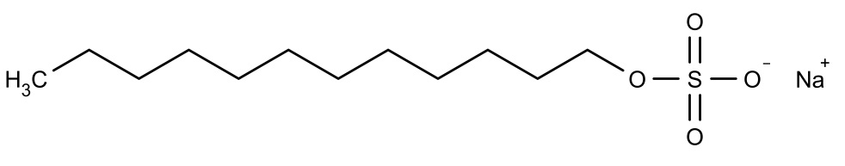 | 55 – 75 [43],  60 generally admitted [16,17]
SOS (Sodium octyl sulfate) | 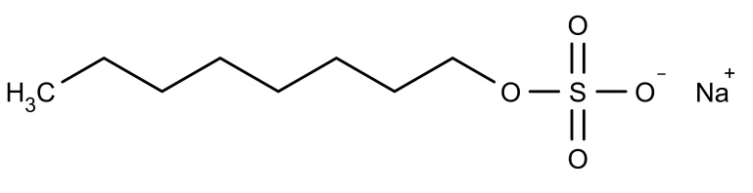 | 24 [35,36] – 27 [37]
TPC (Tetradecyl phosphocholine) | 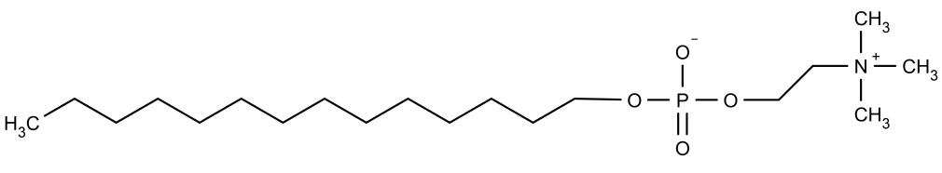 | 90 [40] – 108 [41]
Surfactin | 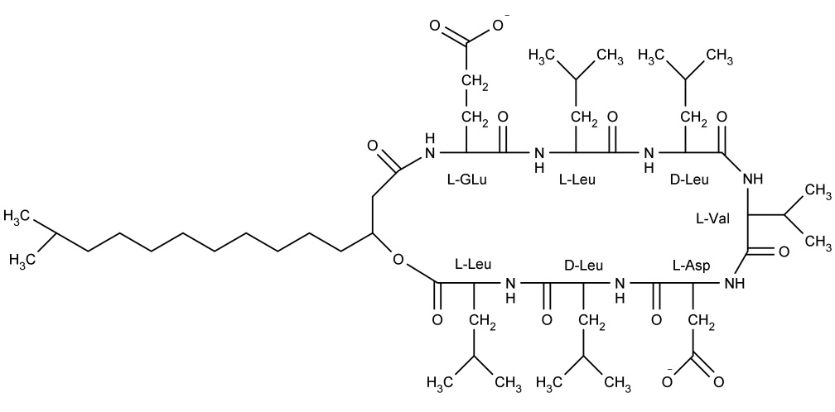 | 20 ± 5 [42]

Simulations have been performed with the united atom GROMOS 53a6 force field [44] on Intel Core i7-3930K 3.20GHz. The structure of each molecule has been built with Pymol software [45], and the surfactin peptidic cycle has been formed by using HYPERCHEM [46]. Topologies of SDS and SOS have been manually refined from Automatic Topology Builder’s (ATB) results [47]. Topology of surfactin has been obtained by using Gromacs’ program pdb2gmx with manual entries of D-amino acids. Topology of TPC has been derived from the topology of DPC created in Chen et al. (2011) [48] (charges from ref [49]) and available on ATB website. Preformed spherical micelles of various sizes have been created by using packmol software [50]. Polar head atoms were randomly placed outside a sphere with a radius similar to the length of the hydrocarbon tail of the surfactant whereas the ends of the apolar moieties were placed inside a smaller sphere with the same center. The distance tolerance between 2 atoms of different molecules was set to 2 Å, as advised on packmol website [51]. Each simulation box was built around the resulting structure, with distances ranging from 1 to 2 nm between each side of the preassembled micelle and the box boundaries.
All the systems studied were first run for a 500 ps simulation with the surfactants under position restraints in periodic boundary conditions (PBC) using a 2 fs time step. Production runs were performed for 10 ns. All the systems were solvated with SPC water [52] and the dynamics were carried out in the NPT conditions (300 K and 1 bar). Na⁺ ions were added to the simulations of SDS, SOS and surfactin molecules (respectively 1:1, 1:1 and 2:1 Na⁺:surfactant ratio) to reach a net charge of 0 for the box. Temperature was maintained by using the v-rescale thermostat with τ_{T} = 0.1 ps and an isotropic pressure was maintained by using the Parrinello-Rahman [53] barostat with a compressibility of 4.5 × 10⁵ (1/bar) and τ_{P} = 1 ps. Electrostatic interactions were treated by using the particle mesh Ewald (PME) method. Van der Waals and electrostatics were treated with a 1.2 nm cut-off. Bond lengths were maintained with the LINCS algorithm. [54] Positions and velocities of atoms in the system have been saved every 20 ps. The trajectories were performed and analyzed with the GROMACS 4.6.1 tools as well as with homemade scripts, and 3D structures were analyzed with both PYMOL [45] and VMD [55] softwares. A set of properties have been computed for each preformed micelle in order to further estimate the aggregation number of the surfactants. Since the micelles have been preformed as spherical aggregates, the first nanosecond of the simulations was not taken into account to compute properties, allowing molecules to move according to a more natural scheme. Discarding the first nanosecond was already applied by Bruce et al. [16] and it was proven to be sufficient to get equilibrated systems in our simulations as well (data not shown).
Eccentricity
Eccentricity has been computed as expressed by: [56]
$$e=1-\frac{I_{min}}{I_{avg}}$$
where I_{min} is the smallest of the moments of inertia along the principal axes of the micelle (computed with the gromacs tool g_principal) and I_{avg} is the average of these moments of inertia.
Hydrophilic / Hydrophobic surface ratio
For each micelle type and size, the solvent accessible surface area (SASA) has been computed with a solvent probe size of 0.14 nm to mimic water [57], with the gromacs tool g_sas. By defining a hydrophobic atom as an atom with a net charge between - 0.2 and + 0.2, it is possible to divide SASA into hydrophobic (pho) and hydrophilic (phi) components.
Hydrophobic tails hydration
The hydrophobic tails hydration has been computed as the average number of water molecules at a distance ≤ 0.35 nm from any atom belonging to the apolar moiety of each molecule by using the gromacs tool g_dist. The distance of 0.35 nm is a common cut-off of interatomic contact [21,29].
Micelle radius
The micelle radius has been computed according to: [16]
$$r_{mic}= \sqrt{5/3}× r_{gyr}$$
where r_{gyr} is the average radius of gyration of the micelle, computed with gromacs tool g_gyrate.
Results
A preliminary simulation starting from a disperse solution of 125 SDS molecules has been carried out to assess that a “natural” micellar behavior occurs under the conditions we have set (data not shown). Aggregation is immediately observed; after 100 ns, four micelles containing around 30 molecules were spontaneously formed. From those data, we cannot anticipate if these micelles could merge to form 2 micelles of about 60 tensioactive molecules (i.e. the experimental aggregation number for SDS) or even a single micelle including all the 125 molecules with an expanded simulation time; one could also argue that a micelle could split into two smaller aggregates within a long enough time span. An adequate simulation time is therefore difficult to set. Furthermore, despite the generous dimensions of the simulation box (around 7.5 x 7.5 x 7.5 nm), the SDS concentration is about 0.5 M, more than 60-fold the CMC (0.008 M) [58]. These conditions could promote micelles collisions and merging, leading to the formation of larger micelles that are unlikely to occur in a dilute solution, which is the most relevant system. Increasing both simulation time and box size in order to investigate the micellization process of a surfactant would imply huge computational resources that are not easily accessible.
To circumvent these problems, we followed an approach in which simulations of preformed micelles of various sizes are carried out. Properties of each micelle type are computed and each parameter is expressed as a function of the molecule number forming the micelle.
Table 2 compares properties of preformed micelles of 60 SDS from the current study and from literature (ref [16], [21], [23], [17]). Given the similarities between our results and the previous works on size and shape of the 60 SDS micelles, the methodology used here appears adequate.
Table 2: Comparison of different properties of 60 SDS micelles from several molecular dynamics simulations and this study.
References | Radius (Å) | SASA (Å²) | Phi/pho | Imax/Imin | Eccentricity | Simulation parameters
[16] | 20.9 | 10548 |  | 1.05 |  | AMBER parm98, 5 ns
[21] | 20.4 | 10470 | 1.09 | 1.21 |  | GROMOS45a3, 10 ns
[23] | 20.3 |  |  | 1.39 | 0.173 | MARTINI (coarse grain), 2 µs
[17] | 21.2 |  |  | 1.09 |  | AMBER parm94, 2 ns
Current study | 20.83 | 10530 | 1.06 | 1.29 | 0.134 | GROMOS53a6, 10 ns
Abbreviations: SASA: Solvent Accessible Surface Area, Phi/pho: hydrophilic SASA/hydrophobic SASA ratio, Imax: highest of the principal moments of inertia, Imin: smallest of the principal moments of inertia.
Knowing the aggregation number of each surfactant allows to simulate the corresponding micelles and then to compute properties of these ‘representative micelles’. Table 3 gives the average properties calculated in the current study, from ‘representative micelles’ of each surfactant; Figure 1 shows all the micelles after 10 ns simulation.
Table 3: Average properties of ‘representative micelles’ for each studied surfactant, +/- standard deviation.
Micelle type | Radius (Å) | SASA (nm²) | Phi/pho | Eccentricity
60 SDS | 20.8 +/- 0.1 | 105.3 +/- 0.2 | 1.06 +/- 0.005 | 0.134 +/- 0.008
25 SOS | 15.8 +/- 0.5 | 45.7 +/- 0.8 | 1.08 +/- 0.028 | 0.248 +/- 0.014
100 TPC | 26.3 +/- 0.03 | 175.9 +/- 1.5 | 2.03 +/- 0.03 | 0.084 +/- 0.009
20 surfactins | 21.4 +/- 0.15 | 116.7 +/- 0.7 | 0.6 +/- 0.016 | 0.159 +/- 0.051

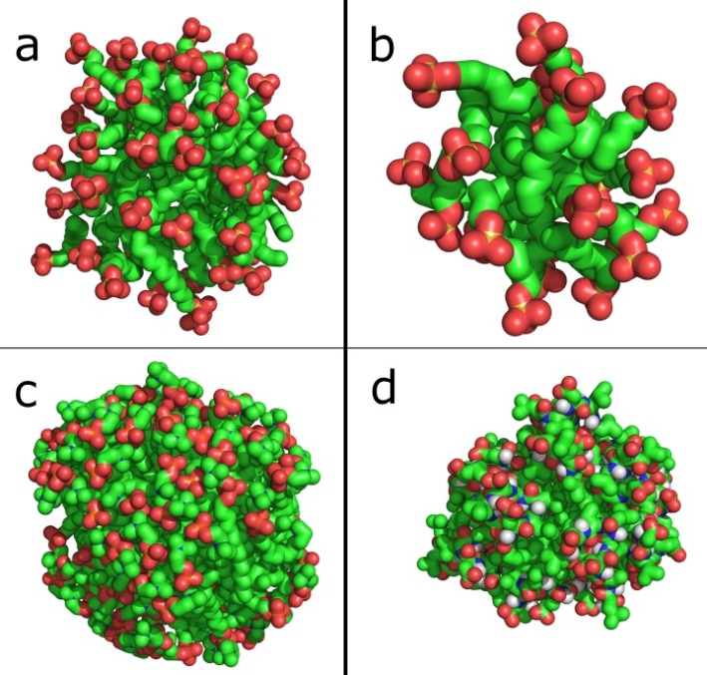
Figure 1. Illustration of the ‘representative micelles’ of each studied surfactant after 10 ns simulation. For clarity, ions and water molecules have been omitted. a: 60 SDS, b: 25 SOS, c: 100 TPC and d: 20 surfactins. Green: carbon, red: oxygen, orange: sulfur (SDS and SOS) or phosphor (TPC), blue: nitrogen, white: hydrogen.
In the following sections, we describe the different parameters that have been analyzed on the modeled micelles, as well as their evolution as a function of the aggregate size.
Eccentricity
Eccentricity is representative of micelle sphericity: the lower it is, the more spherical is the aggregate.
Looking at the eccentricity values of SDS micelles, three different parts can be defined in the graph presented on Figure 2. The first section, [1–10] molecules per micelle, exhibits high eccentricity values, decreasing dramatically with the increase of molecule number per micelle. The surfactant shape and the low number of molecules within the micelle should not allow them to form a steady spherical structure. The second part, [20-80] molecules per micelle, shows the smallest eccentricity values, i.e. the most spherical aggregates. It has to be noted that this part includes the aggregation number of SDS (60 molecules per micelle), a size for which micellar shape is known to be spherical [59]. Then the third section, [90-200] molecules per micelle, exhibits a rapid increase of the eccentricity values. These micelle sizes are probably excessive to support a spherical shape, given the SDS molecular morphology. Hence, these micelles take irregular and constantly varying forms (data not shown), which could eventually lead to micelle splitting or other forms of aggregate in longer simulations. Yoshii et al. computed a similar parameter, asphericity, for different sizes of SDS aggregates [34]. They also observed a sharp drop of this property for sizes ranging from a single molecule to a 20 SDS aggregate. Afterwards the parameter exhibits low values and, contrary to our results, still decreases when increasing the number of molecules constituting the micelle. However, they reported the formation of a cavity at the center of the largest aggregates simulated in their work. This cavity is actually an artifact, due to the finite length of SDS molecules that does not allow to keep a spherical shape with too large aggregates [34]. In our work, we did not observe such cavities for larger aggregates. It explains why the eccentricity value increases from sizes of 90 molecules, as one would expect. Therefore, we assume that the observed values for eccentricity of SDS micelles, as well as their evolution as a function of their size indicate that our simulations give consistent and reliable results.
The experimental aggregation number of SOS (around 25, see Table 1) is also included within the smallest eccentricity values, as well as for surfactin (Figure 2). The micelles formed by those two surfactants are known to be spherical when composed of a number of molecules close to their aggregation number [59,60]. In the case of TPC, micelles do not exhibit such minimal eccentricity values (Figure 2), which may indicate a peculiar micelle organization

Figure 2. Eccentricity of the micelles as a function of the number of molecules they contain. Standard deviations are between 1 and 14% for SDS, between 1 and 18% for SOS, between 4 and 32% for surfactin, between 1 and 29% for TPC. SDS: solid line (□), SOS: square dotted line (◆), Surfactin: round dotted line (●), TPC: dashed line (×).
Phi/pho surface ratio
Individual tensioactive molecules exhibit phi/pho surface ratio lower than 1, indicating that their hydrophobic part is larger than the polar moiety (Figure 3). Their assembly allows them to shield hydrophobic parts from contact with water, inducing an increase of phi/pho surface ratio. For the very small aggregates (i.e. the micelles containing much less molecules than the aggregation number), the ratio sharply increases with the number of molecules. Approaching the aggregation number, ratio value reaches a plateau. This observation is verified for SDS, SOS and surfactin. For TPC, the plateau is not as evident as for the other molecules tested, while the slope of the curve is slowing down around 100 molecules, which again corresponds to the experimental aggregation number.
The insert in Figure 3 shows the data expressed as a percentage of the highest value of each set (i.e. each surfactant). A threshold has been empirically set at 90%, corresponding to the aggregation number of SDS (60). SDS has been chosen as reference because it is a well described surfactant, and SDS data are more accurate since more points are available (Figure 3). At this threshold (blue line), micelles contain 24, 13 and 99 molecules for SOS, surfactin and TPC respectively. When comparing with Table 1, those values are in very good agreement with experimental aggregation numbers.
One can notice that while the ratio reaches a plateau at a value of 1 for SDS and SOS beyond the aggregation number, this is not the case for TPC (value around 2) and for surfactin (value lower than 1).
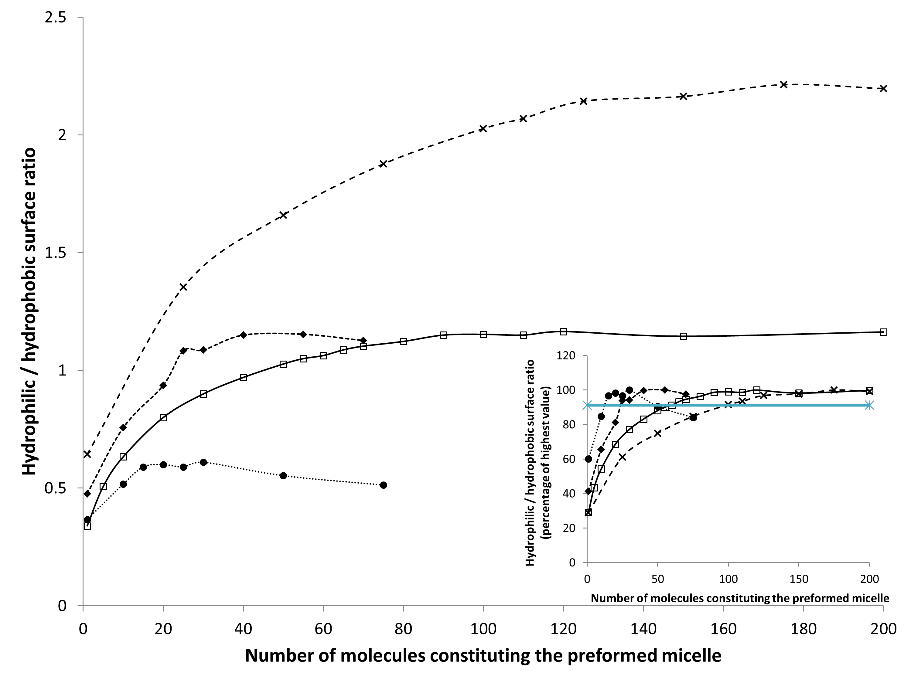
Figure 3. Hydrophilic SASA / hydrophobic SASA ratio of the micelles as a function of the number of molecules they contain. Standard deviations are less than 5% for all the surfactants. SDS: solid line (□), SOS: square dotted line (◆), Surfactin: round dotted line (●), TPC: dashed line (×). Insert: same data expressed as a percentage of the highest value reached for each surfactant. The blue line is a threshold empirically set at 90%, corresponding to the aggregation number of SDS (60).
Hydrophobic tails hydration
The hydrophobic tails hydration (Figure 4) is a parameter that offers insight into the micelle hydrophobic core. At first, a drastic decrease of the apolar tails hydration is observed when increasing the number of molecules in preformed micelles. Again, this is due to the increasing number of polar heads available to protect the hydrophobic tails from contacts with water and to the decreasing SASA per molecule induced by the close packing of the tails. Then the decrease slows down and eventually stops for surfactin, SDS and SOS with further increasing micelles sizes.
It can be seen that stabilization of hydrophobic tails hydration for surfactin occurs for micelle size of about 20 molecules. This is in good agreement with the experimental aggregation number. The same is observed for both SOS (25-30 molecules/micelle) and SDS (55-70 molecules/micelle). TPC micelles exhibit a slightly different behavior, since hydrophobic tails hydration actually never stops to decrease when increasing aggregate size. However, the decrease appears less marked for sizes higher than 100 molecules, i.e. around the aggregation number of TPC.
The insert of Figure 4 shows the data expressed as a percentage of the lowest value of each set. As for the phi/pho surface ratio, the threshold (namely 110) is fixed regarding SDS. At this threshold, SOS, TPC and surfactin micelles sizes correspond to 24, 169 and 29 molecules, respectively. The agreement with experimental values of aggregation numbers is, here again, remarkably good for SOS and pretty close for surfactin. However, the value for TPC (169) is quite far from the aggregation numbers found in literature.
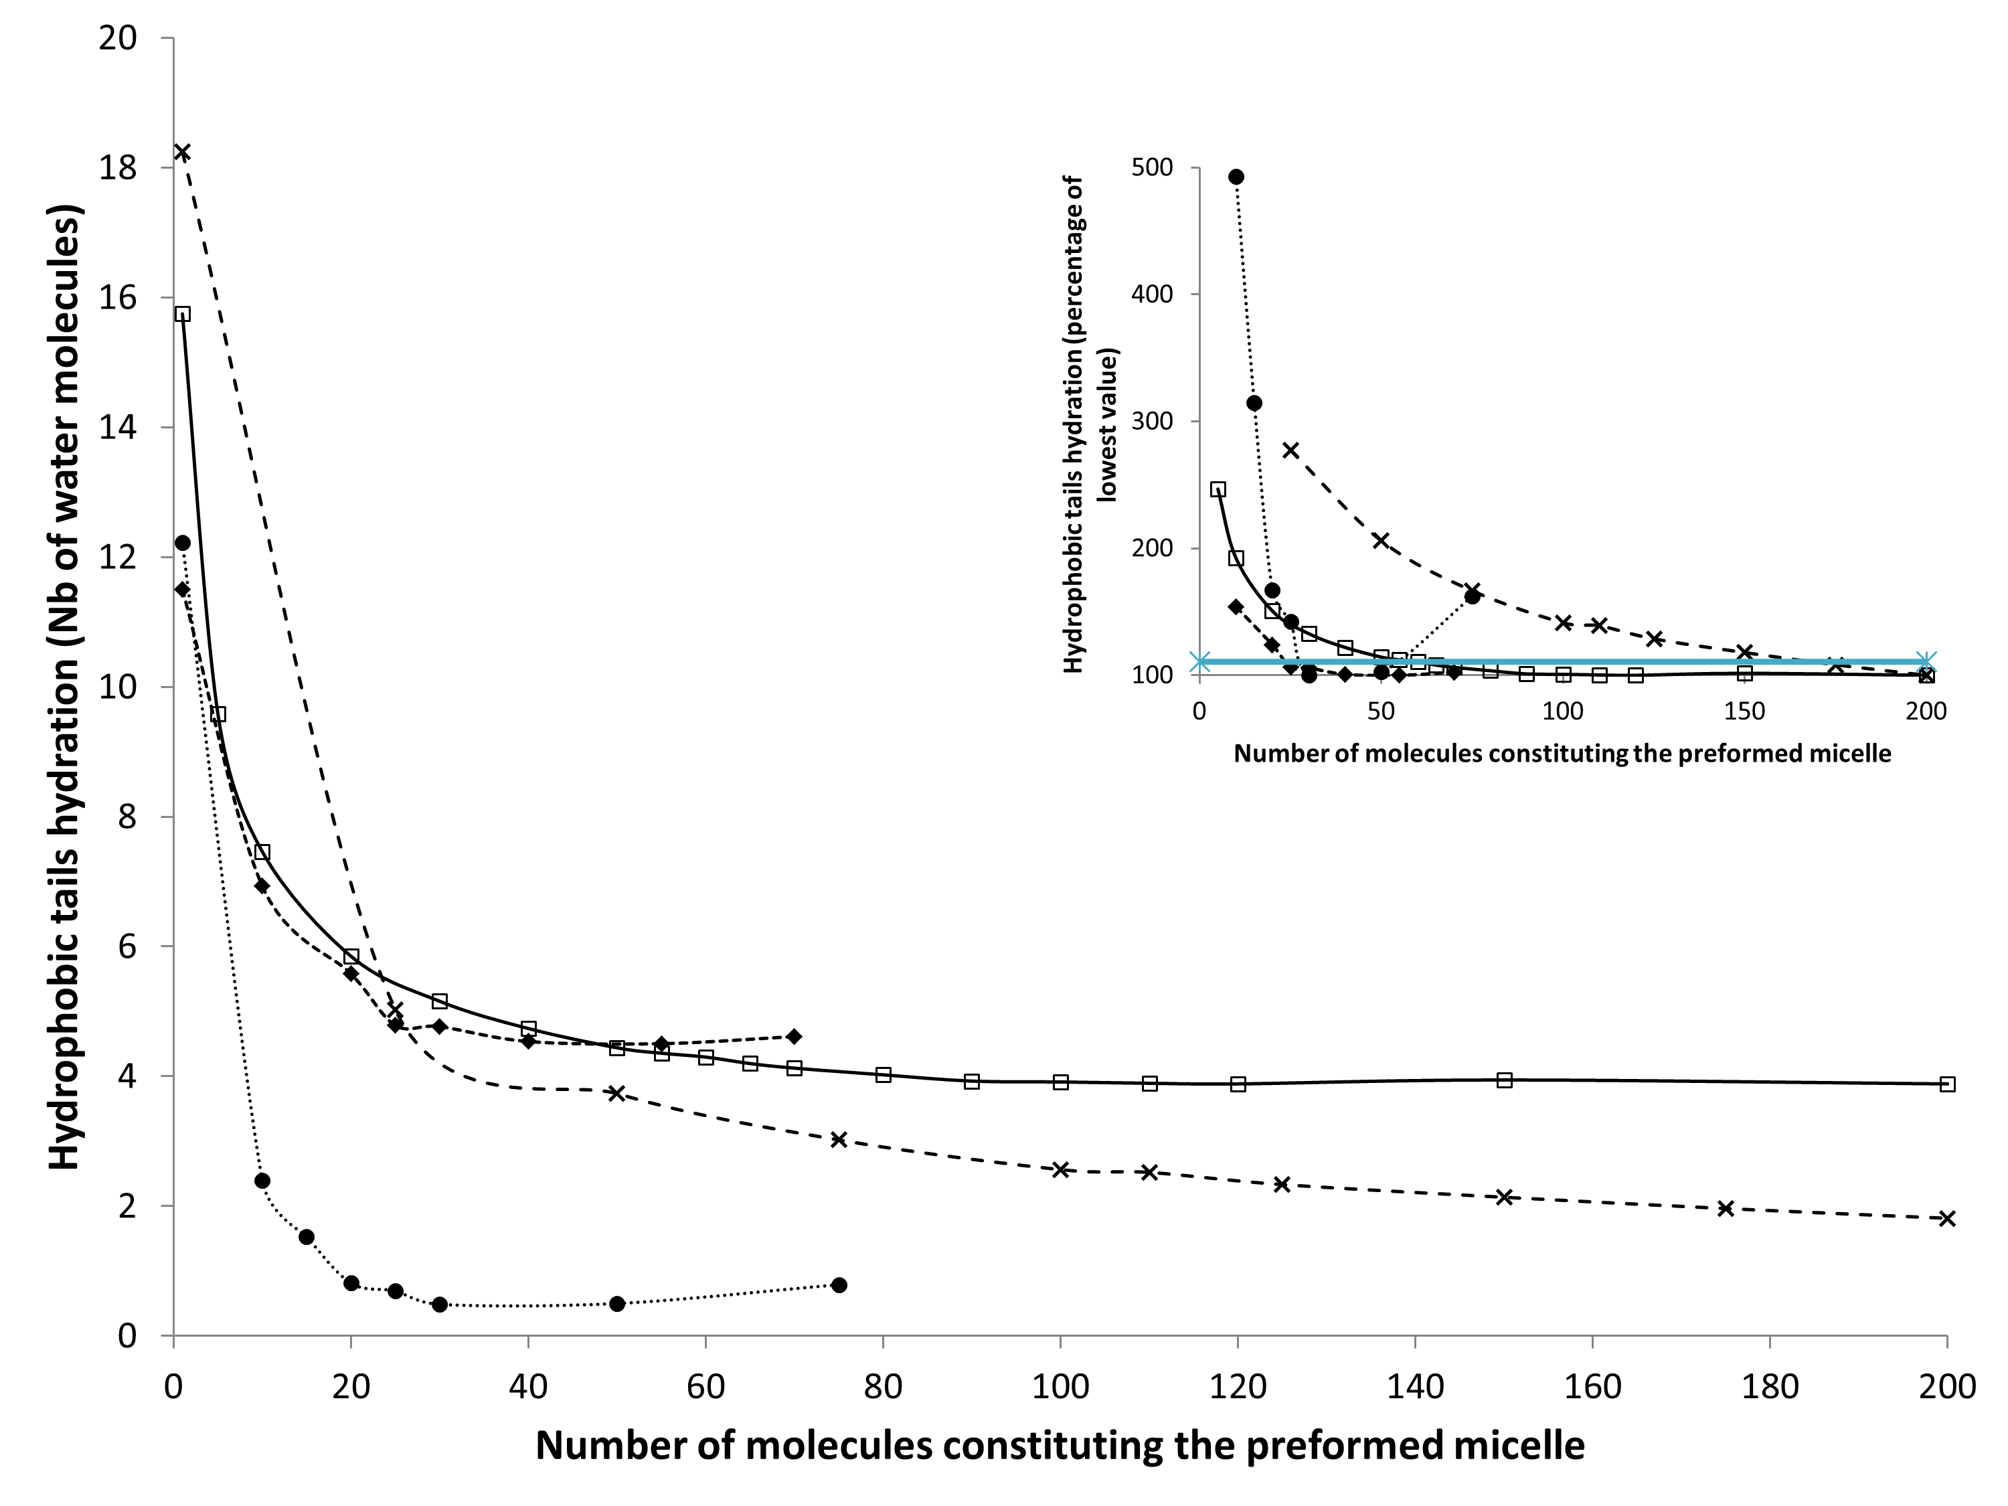
Figure 4. Hydrophobic tails hydration as a function of the number of molecules that micelle contains, expressed as the average number of water molecules present within a cut-off of 0.35 nm from each tail. Standard deviations are less than 5% for SDS, SOS and TPC, and between 3 and 14% for surfactin. SDS: solid line (□), SOS: square dotted line (◆), Surfactin: round dotted line (●), TPC: dashed line (×). Insert: same data expressed as a percentage of the lowest value reached for each surfactant. The blue line is a threshold empirically set at 110%, corresponding to the aggregation number of SDS (60).
Discussion
The calculation of eccentricity allows a validation of our approach when compared to experimental results while the two other parameters – namely phi/pho surface ratio and hydrophobic tail hydration – are interesting descriptors to follow the evolution of the micellar stability as a function of the aggregate size.
Validation of the methodology
Sodium alkyl sulfate surfactants are reported to form spherical micelles when no added salt is present [59]. Our simulations show that surfactin forms spherical micelles when the two acidic residues are negatively charged, in agreement with previous work [60]. It suggests that our simulations well reflect their aggregation behavior and that this “multiple micelle sizes” methodology gives consistent results. TPC aggregates composed of roughly 100 molecules exhibit very low eccentricity values, indicative of a spherical shape. This is in good agreement with Göbl et al. [41] but not with Oliver et al. [40] who assumed that TPC micelles are prolate ellipsoids. They suggest that significant steric and electrostatic repulsions between head groups as well as high surface area per head group are responsible for this peculiar shape. They assumed that this effect might be increased due to the counterion interactions at the surface, since they worked in presence of added salt ions (NaCl). They also predict that ellipticity of the phosphocholine prolate micelle would be dependent on ionic strength. In our TPC simulations, no ion was present and our data further suggest that electrostatic attraction may occur between anionic phosphate groups and cationic choline groups (see below), in contrast to the results of Oliver et al [40]. This interaction could explain the peculiar behavior observed for TPC aggregates’ eccentricity curve that does not exhibit a depression as for the other surfactants.
Phi/pho surface ratio
Since a higher phi/pho surface ratio means a more thermodynamically favorable organization of the hydrophilic and hydrophobic domains, one could expect the phi/pho ratio to rise endlessly by increasing the number of surfactants within a micelle. However, steric and/or electrical repulsions between polar heads have to be considered as a limiting factor. The fact that SDS and SOS (they both have the same polar head) micelles reach a same value for the plateau phase illustrates this pretty well. From these considerations, it can be postulated that the plateau corresponds to a balance reached at the micelle surface. Moreover, the insertion of additional molecule in a micelle whose surface is fully covered by charged heads should be less spontaneous.
Surprisingly, the phi/pho surface ratio eventually undergoes a decrease for the largest micelles of surfactin. To get insight on this decrease, the simulation time of a box containing a 75 surfactin-micelle has been extended to 400 ns. An increase of the ratio can be observed during roughly 200 ns, followed by a stabilization around values very close to the values computed for smaller micelles (about 0.6, data not shown). When the simulation time of a 20 surfactins’ micelle is increased to 200 ns, the phi/pho surface ratio only fluctuates around the value computed after the first 10 ns (data not shown).
These data suggest that aggregates containing a very high number of surfactin molecules (i.e. 50 and 75, at least twice and thrice the aggregation number of surfactin, respectively) have to rearrange themselves to reach a more favorable organization. This process is quite slow because, as a peptidic surfactant, surfactin is larger and probably needs more time to reach an equilibrium when such a high number of molecules is present in the system. However, even after 400 ns, the phi/pho surface ratio of the 75 surfactins-micelle does not become higher than the phi/pho surface ratio of the aggregate containing 20 molecules. This suggests that this phi/pho surface ratio value is like an optimal one for surfactin aggregates. This assumption is reinforced by the fact that even when extending the simulation of 20 surfactins by 190 ns, the phi/pho surface ratio mainly undergoes fluctuations.
While SDS and SOS phi/pho surface ratios reach a same value around their respective aggregation number, TPC ratio becomes much higher as it reaches its own aggregation number. This is due to its hydrophilic moiety (phosphocholine group), which is larger than SDS and SOS head (sulfate group). For surfactin, one could be surprised to see such low values, since it has by far the biggest “polar” head among the surfactants studied here. However, it should be reminded that a hydrophilic atom is defined here as an atom with a charge lower than -0.2 or higher than +0.2. Unlike the three other surfactants, not all the atoms forming the head of surfactin are hydrophilic ones. Thus, it is probably a more complex equilibrium that is reached, still promoting the exposure of hydrophilic atoms to water, but also involving exposure of neighboring hydrophobic atoms. The low values observed of surfactin phi/pho surface ratio could then be explained.
Hydrophobic tails hydration
Since micellization is driven by hydrophobic interactions, it is interesting to study the contacts that occur between water molecules and apolar tails. The less hydrated they are, the more stable micelles should be.
This assumption is in good agreement with the fact that sizes corresponding to the aggregation number for each surfactant are included in the lowest values of hydrophobic tails hydration. Actually, for SDS, SOS and surfactin, the values for sizes around the aggregation number indicate the transition between the sharp decrease and the plateau that can be observed on the curves. One could say that those sizes are “key sizes” because when less molecules are present in the micelle, the protection of the tails from contacts with water is not optimal, while increasing the number of molecules does not significantly further reduce the hydrophobic tails hydration. It seems pretty compatible with the definition of the aggregation number.
The stabilization occurs at a value that is function of the polar head size/electric charge and of the hydrocarbon chain length. For example, the low value of apolar moieties hydration observed for surfactin micelles is probably due to the very large peptidic heads that efficiently preserve hydrophobic tails from contact with water.
Global comment
The results seem in very good agreement with literature for SDS and SOS. Yoshii et al. [34] had already successfully used this “multiple micelle sizes” methodology for SDS. We here confirm that it also gives good results with the parameters used in our work. Those parameters seem evident for the study of surfactant properties, but were never used in such a way. In addition, we show that it can also be applied with another simple surfactant, SOS, which was expected but had to be proven. The use of a threshold based on SDS curves for phi/pho surface ratio and hydrophobic tails hydration (inserts in Figure 3 and Figure 4, respectively) is very accurate for estimating the aggregation number of SOS. This may indicate that for such a simple surfactant, it could even be possible to precisely estimate the aggregation number of all its homologues by following the same methodology.
The results for surfactin also support an interesting analysis concerning the evolution of micelle size and the aggregation number. It proves that for a surfactant with such a peculiar structure, the methodology allows to collect interesting and useful data, even though the results are slightly less accurate. As mentioned, the distribution of the hydrophobic and hydrophilic atoms is more subtle for surfactin, since not all the atoms of the “polar head” are actually hydrophilic. This feature probably makes surfactin a molecule for which the prediction of properties such as aggregation number is complicated with classical predictive tools. This work could help to improve existing MD-MT models for peculiar surfactants such as peptides.
For TPC, the methodology used with phi/pho surface ratio parameter still offers interesting data with regard to the aggregation number, but the results are globally less clear than for the other surfactants. A probable explanation for this relies on the organization of the polar heads at the micellar surface. When looking at pictures of TPC aggregates, some hydrophobic patches can be observed at the surface (Figure 5.a). While at the surface of SDS micelle there is an almost uniform distribution of the sulfate groups finely tuned as a function of the electrical repulsions between them (Figure 1), TPC heads seem closer to each other (Figure 5.b) and thus unable to recover the whole micellar surface. This behavior may be due to the zwitterionic nature of TPC: interactions between negatively charged phosphate groups and positively charged choline groups could occur and could contribute to pack together the heads. This heterogeneous organization could be at the origin of the different pattern observed for the evolution of the properties considered here, when compared with other surfactants. However, since all the simulations were performed with gromos53a6, we cannot rule out the possibility that these observations may depend on the forcefield. Tang et al. analyzed the effect of the force field on the structure of SDS micelles [61]. They concluded that some force fields, among which gromos53a6, were more adequate to simulate large SDS aggregates than others. On the other hand, Poger et al. found that default non-bonded parameters between choline methyls and non-ester phosphate oxygens in gromos53a6 did not allow to reproduce the behavior of DPPC bilayers experimentally observed [62]. Indeed, when using these default values, some properties of the simulated bilayers were not in good agreement with experimental data, including area per lipid that was too low. Authors thus tested new Lennard-Jones parameters with a higher repulsive term which gave better results [62]. In our work, we only used default parameters from gromos53a6 and showed that it allows to study micelles as a function of their size and to give globally consistent results. Since the discrepancies observed for our TPC simulations could arise from the tight packing of the heads, one could suggest that modifying Lennard-Jones parameters as done by Poger et al. would give more accurate results. According to a set of explorative simulations that we have performed (data not shown), the hydrophobic patches seem to be no more present at the micelle surface with Poger’s parameters. However, even though the values of some properties are slightly different, their evolution as a function of the micelle size seems to follow the same trends as we observed with gromos53a6 default parameters. A similar trial was done with a completely different force field, namely charmm36, for which we started from all-atom simulation files used by Abel et al. [63]. In this case, only eccentricity and phi/pho surface ratio were computed (data not shown). The trends followed by these curves are also very similar to those reported in this study, even though the values reached for the phi/pho surface ratio are much higher. As for Poger’s parameters, no large hydrophobic patches are observed with charmm36.
These preliminary results seem to indicate that, for a given surfactant, changing the force field may influence the absolute values of the calculated properties but not the trends described here. The evolution of the parameters as a function of the aggregate size seems to follow the same pattern, whatever the force field.
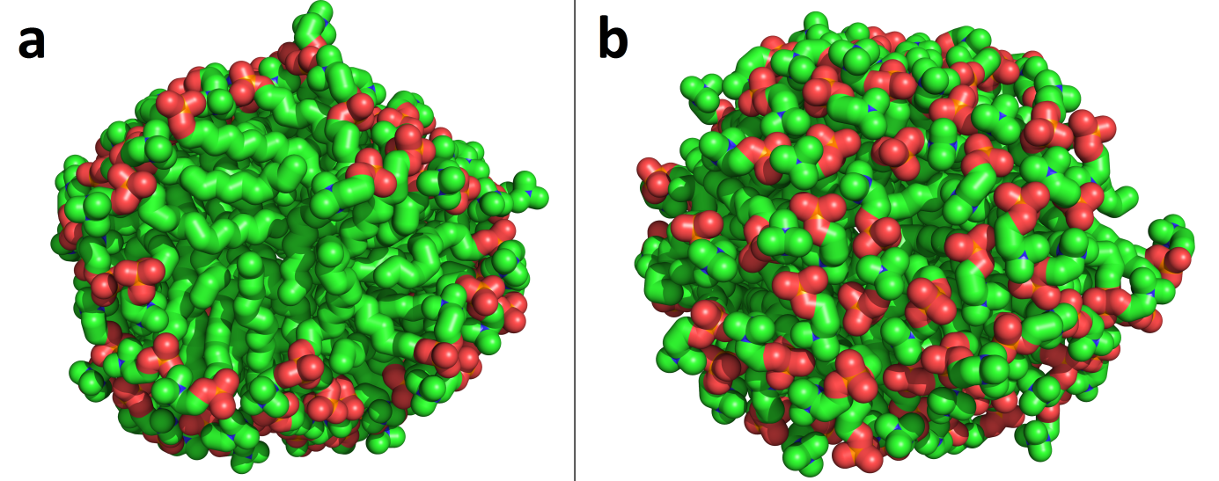
Figure 5. Pictures of 110 TPC micelles showing the heterogeneous distribution of the polar heads at the micellar surface. (a) Side of the micelle on which the distribution of the polar heads is not even, exposing a large hydrophobic area. (b) Polar heads are uniformly distributed on this side of the micelle. Green: carbon, red: oxygen, orange: phosphor, blue: nitrogen.
Conclusions
MD used in the systematic way that we developed in this paper is an interesting tool for the analysis of the micellar structure and stability. It also allows to study micelle formation phenomenon because each micelle size can be seen as a snapshot of a micellization process. Moreover, unlike auto-assembly MD simulations, it only requires low computational resources since systems dimensions and time windows are much smaller. We showed that it is applicable to different surfactants, even a very complex one such as surfactin and that the parameters used here are suitable for such a method. It gives the opportunity to monitor the behavior of surfactant aggregates as a function of their size, and to compare the data between several surfactants. Eccentricity parameter exhibits minimal values when the aggregate size is close to the aggregation number for the surfactants that are known to form spherical micelles. This is hence in good agreement with literature and indicates that the simulations give reliable results, validating our “multiple micelle sizes” approach. The evolution of the other parameters, phi/pho surface ratio and hydrophobic tails hydration, follows another scheme, with a sharp increase and decrease, respectively, followed by a leveling-off. Interestingly, the aggregate sizes at which this stabilization starts to occur are close to the respective aggregation number of each surfactant. It can be assumed that those two parameters are good descriptors of micelle stability and formation.
These observations might be general trends for micelle-forming surfactants, since different molecules tested here gave coherent patterns. Among the compounds that we considered, only zwitterionic TPC exhibited a slightly different behavior from the “common pattern” described above. This singularity may come from a peculiar organization at the micelle surface, some hydrophobic patches being more exposed to water. This specific pattern might be due to putative attractive interactions between negatively-charged phosphate groups and positively-charged choline groups. These interactions would pack TPC heads too tightly, making them unable to cover the whole micelle surface. Explorative simulations performed with different parameters of the force field or with a different force field seem to indicate that this tight packing would come from the gromos53a6 default parameters. However, changing the force field does not seem to have an impact on the trends that the evolution of the properties as a function of the aggregate size follows.
To confirm these preliminary observations and to further explore this topic, future investigation could extend our approach with other force fields as well as with other surfactants. New parameters to analyze could also be investigated to get a more precise picture of micelle organization. Eventually, our methodology could help to improve current computer simulations combined to molecular thermodynamics models to predict properties of peptidic surfactants, since simulations with surfactin appear to give promising results.
Acknowledgments
We gratefully thank Stéphane Abel for sending charmm36 simulations files from his work and for his kind support.
We thank the FNRS (PDR grant T.1003.14), the Belgian Program on Interuniversity Attraction Poles initiated by the Federal Office for Scientific, Technical and Cultural Affairs (IAP P7/44 iPros), The University of Liège (Fonds Spéciaux de la Recherche, Action de Recherche Concertée-Project FIELD) for financial support.
MD and LL are Senior Research Associates for the Fonds National de la Recherche Scientifique (FRS-FNRS), SL is supported by the AgricultureIsLife platform (GX ABT, Ulg), JMC is supported by the IAP iPros project and MNN by the ARC FIELD project.
Partial computational resources of the lab are provided by the “Consortium des Équipements de Calcul Intensif” (CECI), funded by the F.R.S.-FNRS under Grant No. 2.5020.11.

References
[1] A.N. Lukyanov, V.P. Torchilin, Micelles from lipid derivatives of water-soluble polymers as delivery systems for poorly soluble drugs., Adv. Drug Deliv. Rev. 56 (2004) 1273–89. doi:10.1016/j.addr.2003.12.004.
[2] W. Parker, P.S. Song, Protein structures in SDS micelle-protein complexes., Biophys. J. 61 (1992) 1435–9. doi:10.1016/S0006-3495(92)81949-5.
[3] A. Zdziennicka, K. Szymczyk, J. Krawczyk, B. Jańczuk, Critical micelle concentration of some surfactants and thermodynamic parameters of their micellization, Fluid Phase Equilib. 322-323 (2012) 126–134. doi:10.1016/j.fluid.2012.03.018.
[4] P.J. Tummino, a Gafni, Determination of the aggregation number of detergent micelles using steady-state fluorescence quenching., Biophys. J. 64 (1993) 1580–7. doi:10.1016/S0006-3495(93)81528-5.
[5] J.B. Hayter, J. Penfold, Determination of micelle structure and charge by neutron small-angle scattering, Colloid Polym. Sci. 261 (1983) 1022–1030. doi:10.1007/BF01421709.
[6] J. Lipfert, L. Columbus, V.B. Chu, S. a Lesley, S. Doniach, Size and shape of detergent micelles determined by small-angle X-ray scattering., J. Phys. Chem. B. 111 (2007) 12427–38. doi:10.1021/jp073016l.
[7] K. Schillh, W. Brown, R.M. Johnsen, Micellar Sphere-to-Rod Transition in an Aqueous Triblock Copolymer System., Macromolecules. 27 (1994) 4825–4832.
[8] Y. Zheng, H.T. Davis, Mixed Micelles of Nonionic Surfactants and Uncharged Block Copolymers in Aqueous Solutions: Microstructure Seen by Cryo-TEM, Langmuir. 16 (2000) 6453–6459. doi:10.1021/la000230r.
[9] C. Tanford, The Hydrophobic Effect: Formation of Micelles and Biological Membranes, Wiley, 1980.
[10] R. Nagarajan, E. Ruckenstein, Critical micelle concentration: A transition point for micellar size distribution, J. Colloid Interface Sci. 60 (1977) 221–231. doi:10.1016/0021-9797(77)90282-X.
[11] S. Puvvada, D. Blankschtein, Molecular‐thermodynamic approach to predict micellization, phase behavior and phase separation of micellar solutions. I. Application to nonionic surfactants, J. Chem. Phys. 92 (1990) 3710–3724. doi:10.1063/1.457829.
[12] R. Nagarajan, Theory of Surfactant Self -Assembly : A Predictive Molecular Thermodynamic Approach, Langmuir. 7 (1991) 2934–2969. doi:10.1021/la00060a012.
[13] A. Goldsipe, D. Blankschtein, Modeling Counterion Binding in Ionic-Nonionic and Ionic-Zwitterionic Binary Surfactant Mixtures, Langmuir. 21 (2005) 9850–9865. doi:10.1021/la050699s.
[14] B.C. Stephenson, K. Beers, D. Blankschtein, Complementary use of simulations and molecular-thermodynamic theory to model micellization, Langmuir. 22 (2006) 1500–1513. doi:10.1021/la052042c.
[15] B.C. Stephenson, A. Goldsipe, K.J. Beers, D. Blankschtein, Quantifying the hydrophobic effect. 2. A computer simulation-molecular-thermodynamic model for the micellization of nonionic surfactants in aqueous solution., J. Phys. Chem. B. 111 (2007) 1045–1062. doi:10.1021/jp065697a.
[16] C.D. Bruce, M.L. Berkowitz, L. Perera, M.D.E. Forbes, Molecular Dynamics Simulation of Sodium Dodecyl Sulfate Micelle in Water: Micellar Structural Characteristics and Counterion Distribution, J. Phys. Chem. B. 106 (2002) 3788–3793. doi:10.1021/jp013616z.
[17] A.R. Rakitin, G.R. Pack, Molecular Dynamics Simulations of Ionic Interactions with Dodecyl Sulfate Micelles, J. Phys. Chem. B. 108 (2004) 2712–2716. doi:10.1021/jp030914i.
[18] C.D. Bruce, S. Senapati, M.L. Berkowitz, L. Perera, M.D.E. Forbes, Molecular Dynamics Simulations of Sodium Dodecyl Sulfate Micelle in Water: The Behavior of Water, J. Phys. Chem. B. 106 (2002) 10902–10907. doi:10.1021/jp025872x.
[19] T.T. Chong, R. Hashim, R. a Bryce, Molecular dynamics simulation of monoalkyl glycoside micelles in aqueous solution: influence of carbohydrate headgroup stereochemistry., J. Phys. Chem. B. 110 (2006) 4978–84. doi:10.1021/jp056851g.
[20] P. Konidala, L. He, B. Niemeyer, Molecular dynamics characterization of n-octyl-beta-D-glucopyranoside micelle structure in aqueous solution., J. Mol. Graph. Model. 25 (2006) 77–86. doi:10.1016/j.jmgm.2005.11.008.
[21] B.Z. Shang, Z. Wang, R.G. Larson, Molecular dynamics simulation of interactions between a sodium dodecyl sulfate micelle and a poly(ethylene oxide) polymer., J. Phys. Chem. B. 112 (2008) 2888–900. doi:10.1021/jp0773841.
[22] B.Z. Shang, Z. Wang, R.G. Larson, Effect of headgroup size, charge, and solvent structure on polymer-micelle interactions, studied by molecular dynamics simulations., J. Phys. Chem. B. 113 (2009) 15170–80. doi:10.1021/jp9057737.
[23] S. Jalili, M. Akhavan, A coarse-grained molecular dynamics simulation of a sodium dodecyl sulfate micelle in aqueous solution, Colloids Surfaces A Physicochem. Eng. Asp. 352 (2009) 99–102. doi:10.1016/j.colsurfa.2009.10.007.
[24] Q. Wang, G. Hong, G.R. Johnson, R. Pachter, M.S. Cheung, Biophysical properties of membrane-active peptides based on micelle modeling: a case study of cell-penetrating and antimicrobial peptides., J. Phys. Chem. B. 114 (2010) 13726–35. doi:10.1021/jp1069362.
[25] C.D. Lorenz, C.-M. Hsieh, C. a Dreiss, M.J. Lawrence, Molecular dynamics simulations of the interfacial and structural properties of dimethyldodecylamine-N-oxide micelles., Langmuir. 27 (2011) 546–53. doi:10.1021/la1031416.
[26] A.-Q. She, H.-Z. Gang, B.-Z. Mu, Temperature influence on the structure and interfacial properties of surfactin micelle: a molecular dynamics simulation study., J. Phys. Chem. B. 116 (2012) 12735–43. doi:10.1021/jp302413c.
[27] S. Abel, F.-Y. Dupradeau, E.P. Raman, A.D.J. MacKerell, M. Marchi, Molecular Simulations of Dodecyl-B-maltoside micelles in water: Influence of the headgroup conformation and force field parameters, J. Phys. Chem. B. 115 (2012) 487–499. doi:10.1021/jp109545v.Molecular.
[28] S.J. Marrink, D.P. Tieleman, a. E. Mark, Molecular Dynamics Simulation of the Kinetics of Spontaneous Micelle Formation, J. Phys. Chem. B. 104 (2000) 12165–12173. doi:10.1021/jp001898h.
[29] J. Gao, W. Ge, G. Hu, J. Li, From homogeneous dispersion to micelles-a molecular dynamics simulation on the compromise of the hydrophilic and hydrophobic effects of sodium dodecyl sulfate in aqueous solution., Langmuir. 21 (2005) 5223–9. doi:10.1021/la047121n.
[30] M. Sammalkorpi, M. Karttunen, M. Haataja, Structural properties of ionic detergent aggregates: a large-scale molecular dynamics study of sodium dodecyl sulfate., J. Phys. Chem. B. 111 (2007) 11722–33. doi:10.1021/jp072587a.
[31] M. Sammalkorpi, S. Sanders, a Z. Panagiotopoulos, M. Karttunen, M. Haataja, Simulations of micellization of sodium hexyl sulfate., J. Phys. Chem. B. 115 (2011) 1403–10. doi:10.1021/jp109882r.
[32] B.G. Levine, D.N. LeBard, R. DeVane, W. Shinoda, A. Kohlmeyer, M.L. Klein, Micellization Studied by GPU-Accelerated Coarse-Grained Molecular Dynamics, J. Chem. Theory Comput. 7 (2011) 4135–4145. doi:10.1021/ct2005193.
[33] S. a Sanders, M. Sammalkorpi, A.Z. Panagiotopoulos, Atomistic simulations of micellization of sodium hexyl, heptyl, octyl, and nonyl sulfates., J. Phys. Chem. B. 116 (2012) 2430–7. doi:10.1021/jp209207p.
[34] N. Yoshii, S. Okazaki, A molecular dynamics study of structural stability of spherical SDS micelle as a function of its size, Chem. Phys. Lett. 425 (2006) 58–61. doi:10.1016/j.cplett.2006.05.004.
[35] R. Ranganathan, L. Tran, B.L. Bales, Surfactant- and Salt-Induced Growth of Normal Sodium Alkyl Sulfate Micelles Well above Their Critical Micelle Concentrations, J. Phys. Chem. B. 104 (2000) 2260–2264. doi:10.1021/jp993917x.
[36] H.F. Huisman, Light Scattering of solutions of ionic detergents, Proc. K. Ned. Akad. Wet., Ser. B Phys. Sci. 67 (1964).
[37] E.A.G. Aniansson, S.N. Wall, M. Almgren, H. Hoffmann, Theory of the kinetics of micellar equilibria and quantitative interpretation of chemical relaxation studies of micellar solutions of ionic surfactants, J. Phys. Chem. 80 (1976) 905–922.
[38] M. Almgren, J.C. Gimel, K. Wang, G. Karlsson, K. Edwards, W. Brown, K. Mortensen, SDS Micelles at High Ionic Strength. A Light Scattering, Neutron Scattering, Fluorescence Quenching, and CryoTEM Investigation, J. Colloid Interface Sci. 202 (1998) 222–231. doi:10.1006/jcis.1998.5503.
[39] B.L. Bales, L. Messina, A. Vidal, M. Peric, O.R. Nascimento, Precision Relative Aggregation Number Determinations of SDS Micelles Using a Spin Probe. A Model of Micelle Surface Hydration, J. Phys. Chem. B. 102 (1998) 10347–10358. doi:10.1021/jp983364a.
[40] R.C. Oliver, J. Lipfert, D. a Fox, R.H. Lo, S. Doniach, L. Columbus, Dependence of micelle size and shape on detergent alkyl chain length and head group., PLoS One. 8 (2013) e62488. doi:10.1371/journal.pone.0062488.
[41] C. Göbl, M. Dulle, W. Hohlweg, J. Grossauer, S.F. Falsone, O. Glatter, K. Zangger, Influence of phosphocholine alkyl chain length on peptide-micelle interactions and micellar size and shape., J. Phys. Chem. B. 114 (2010) 4717–24. doi:10.1021/jp9114089.
[42] H.-H. Shen, R.K. Thomas, C.-Y. Chen, R.C. Darton, S.C. Baker, J. Penfold, Aggregation of the naturally occurring lipopeptide, surfactin, at interfaces and in solution: an unusual type of surfactant?, Langmuir. 25 (2009) 4211–8. http://www.ncbi.nlm.nih.gov/pubmed/19714837.
[43] N. Yoshii, K. Iwahashi, S. Okazaki, A molecular dynamics study of free energy of micelle formation for sodium dodecyl sulfate in water and its size distribution., J. Chem. Phys. 124 (2006) 184901. doi:10.1063/1.2179074.
[44] C. Oostenbrink, A. Villa, A.E. Mark, W.F. van Gunsteren, A biomolecular force field based on the free enthalpy of hydration and solvation: the GROMOS force-field parameter sets 53A5 and 53A6., J. Comput. Chem. 25 (2004) 1656–76. doi:10.1002/jcc.20090.
[45] The PyMOL Molecular Graphics System, (n.d.).
[46] Hypercube, Hyperchem (TM), (2003).
[47] A.K. Malde, L. Zuo, M. Breeze, M. Stroet, D. Poger, P.C. Nair, C. Oostenbrink, A.E. Mark, An Automated Force Field Topology Builder (ATB) and Repository: Version 1.0, J. Chem. Theory Comput. 7 (2011) 4026–4037. doi:10.1021/ct200196m.
[48] R. Chen, A.E. Mark, The effect of membrane curvature on the conformation of antimicrobial peptides: implications for binding and the mechanism of action., Eur. Biophys. J. 40 (2011) 545–53. doi:10.1007/s00249-011-0677-4.
[49] D.P. Tieleman, D. Van Der Spoel, H.J.C. Berendsen, Molecular Dynamics Simulations of Dodecylphosphocholine Micelles at Three Different Aggregate Sizes: Micellar Structure and Chain Relaxation, J. Phys. Chem. 23 (2000) 6380–6388.
[50] L. Martinez, R. Andrade, E.G. Birgin, J.M. Martinez, Packmol: A Package for Building Initial Configurations for Molecular Dynamics Simulations, Wiley Intersci. (2009). doi:10.1002/jcc.
[51] J.M. Martinez, Packmol, (n.d.). http://www.ime.unicamp.br/~martinez/packmol/.
[52] J.A.N. Hermans, W.F. Van, A Consistent Empirical Potential lor Water-Protein Interactions, Biopolymers. 23 (1984) 1513–1518. http://onlinelibrary.wiley.com/doi/10.1002/bip.360230807/abstract (accessed July 17, 2014).
[53] M. Parrinello, A. Rahman, Polymorphic transitions in single crystals: A new molecular dynamics method, J. Appl. Phys. 52 (1981) 7182. doi:10.1063/1.328693.
[54] B. Hess, H. Bekker, H.J.C. Berendsen, J.G.E.M. Fraaije, LINCS: A linear constraint solver for molecular simulations, J. Comput. Chem. 18 (1997) 1463–1472. doi:10.1002/(SICI)1096-987X(199709)18:12<1463::AID-JCC4>3.0.CO;2-H.
[55] W. Humphrey, A. Dalke, K. Schulten, VMD : Visual Molecular Dynamics, J. Mol. Graph. 7855 (1996) 33–38.
[56] M. Marchi, S. Abel, Modeling the self-aggregation of small AOT reverse micelles from first-principles, J. Phys. Chem. Lett. 6 (2015) 170–174. doi:10.1021/jz5023619.
[57] F. Eisenhaber, P. Lijnzaad, P. Argos, C. Sander, M. Scharf, The double cubic lattice method: Efficient approaches to numerical integration of surface area and volume and to dot surface contouring of molecular assemblies, J. Comput. Chem. 16 (1995) 273–284.
[58] C.C. Ruiz, E.U. Politecnica, A photophysical study of the urea effect on micellar properties of sodium dodecylsulfate aqueous solutions, Colloid Polym. Sci. 1040 (1995) 1033–1040.
[59] P.J. Missel, N.A. Mazer, G.B. Benedek, M.C. Carey, Influence of Chain Length on the Sphere-to-Rod Transition in Alkyl Sulfate Micelles, J. Phys. Chem. 87 (1983) 1264–1277.
[60] H.-H. Shen, T.-W. Lin, R.K. Thomas, D.J.F. Taylor, J. Penfold, Surfactin structures at interfaces and in solution: the effect of pH and cations., J. Phys. Chem. B. 115 (2011) 4427–35. doi:10.1021/jp109360h.
[61] X. Tang, P.H. Koenig, R.G. Larson, Molecular Dynamics Simulations of Sodium Dodecyl Sulfate Micelles in Water—The Effect of the Force Field, J. Phys. Chem. B. 118 (2014) 3864–3880.
[62] D. Poger, W.F. Van Gunsteren, A.E. Mark, A New Force Field for Simulating Phosphatidylcholine Bilayers, J. Comput. Chem. 31 (2010) 1117–1125. doi:10.1002/jcc.21396.
[63] S. Abel, F.Y. Dupradeau, M. Marchi, Molecular dynamics simulations of a characteristic DPC micelle in water, J. Chem. Theory Comput. 8 (2012) 4610–4623. doi:10.1021/ct3003207.

