OceanBrowser: on-line visualization of gridded ocean data and in situ observations

Alexander Barth, University of Liege (Belgium), a.barth@ulg.ac.be
Sylvain Watelet, University of Liege (Belgium), swatelet@ulg.ac.be
Charles Troupin, SOCIB (Spain), ctroupin@socib.es
Alvera Aida, University of Liege (Belgium), A.Alvera@ulg.ac.be
Giorgio Santinelli, Deltares (The Netherlands), Giorgio.Santinelli@deltares.nl
Gerrit Hendriksen, Deltares (The Netherlands), Gerrit.Hendriksen@deltares.nl
Alessandra Giorgetti, OGS (Italy), agiorgetti@ogs.trieste.it
Jean-Marie Beckers, University of Liege (Belgium), JM.Beckers@ulg.ac.be

The ocean is generally a highly stratified fluid, where the seawater properties vary strongly with depth. While the ocean can be seen as a system made up of individual layers, the vertical movements (coastal upwelling due to wind for instance) and mixing couple the different layers. The ocean is also non-stationary as it varies on a broad range of temporal scales. Observational networks usually capture a limited range of these temporal scales. It is necessary to integrate the depth and time dimensions to provide a full 4D view of the ocean.

A web-based visualization allows the integration with other datasets, which facilitates the interpretation of the dataset in conjunction with results from different domains. For instance, physical and biogeochemical variables are strongly related due to the impact of ocean currents. The web interface should allow users to easily find a useful dataset and provide a mechanism to download it (entirely or a subset) and to be interoperable with other visualization platforms.

The web-interface OceanBrowser aims to respond to those challenges and requirements by implementing the following features:

- Horizontal sections of the 4-dimensional fields (longitude, latitude, depth and time) can be visualized at a selected depth layer and time. The climatological fields can also be interpolated and visualized on arbitrary vertical sections.
- The maps displayed in the browser are created dynamically and therefore several options are made available to the user to customize the graphical rendering of those layers. Layers can be displayed either using interpolated shading, filled contours or simple contours and several options controlling the color-map are also available.
- The horizontal and vertical sections can be animated in order to examine the temporal evolution.
- Images can be saved in raster (PNG) and vector image formats (SVG, EPS, PDF). They can also be saved as a KML file so that the current layer can be visualized in programs like Google Earth and combined with other information imported in such programs.
- The underlying 4-dimensional NetCDF file can be either downloaded as a whole from the interface or only as a subset using the OPeNDAP protocol.
- The web-interface can also import third-party layers by using standard Web Map Service (WMS) requests. The user needs only to specify the URL of the WMS server and its supported version.

Interoperability depends critically on the use of open standards. Beside the web-standards, OceanBrowser uses OGC WMS and NetCDF. Limitations in the WMS standards to implement the defined requirements are also highlighted and the adopted extensions are discussed.

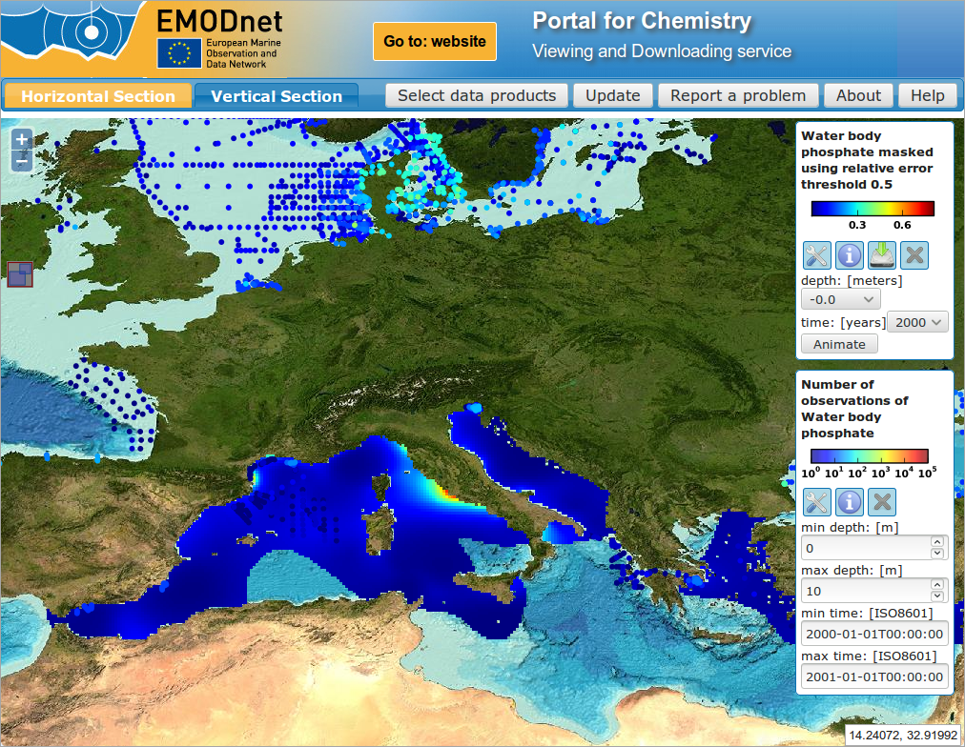

Figure 1: OceanBrowser installation for EMODNET Chemsitry http://ec.oceanbrowser.net/emodnet/

