Supplementary information
Figure S1. Images of the 10 forest plots studied
Plot 1: Coppice of hornbeam and birch | Plot 2: Even-aged coppice of Beech
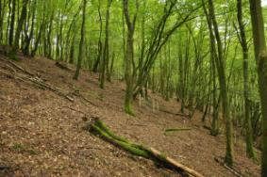 | 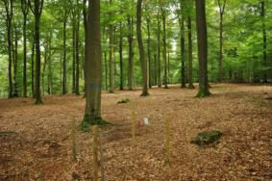
Plot 3: Uneven-aged coppice of beech | Plot 4: Even-aged coppice of douglas fir
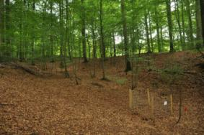 | 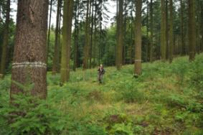
Plot 5: Even-aged coppice of spruce | Plot 6: Even-aged coppice of oak and pine
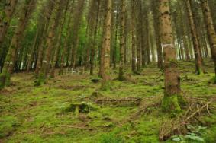 | 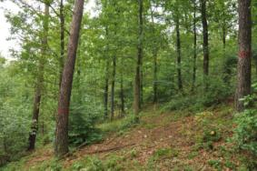

Plot 7: Uneven-aged coppice of beech | Plot 8: Even-aged coppice of spruce
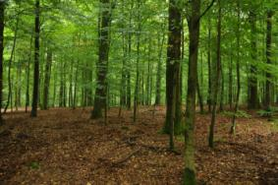 | 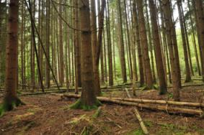
Plot 9: Even-aged coppice of spruce | Plot 10: Uneven-aged coppice of beech
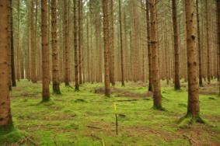 | No image

Table S1. Summary of experimental design, scanner settings, and methodologies of previous studies on automatic stem detection and DBH extraction from TLS data for forest inventory. The number of trees in brackets in the column Tree is the number of trees used for DBH comparison (m=measured). The tree forest types are broadleaves (B), coniferous (C), and mixed (M). The shape of the plots is in bracket in the column Size (r: rectangle, s: square, and c: circle). NHA is the number of trees per hectare. Mode is the scanning method (MS: multiscan, SS: single scan, PLS: personal mobile laser scanning, and HMLS: hand-held mobile laser scanning). Occl. is the rate of trees detected without occlusion and Occl. + missed is the proportion of trees automatically detected.
Study | Plot  (n) | Tree  (n) | Forest type | Terrain | Size  (ha) | NHA | Mode | Detection |  |  | DBH
 |  |  |  |  |  |  |  | Process | Occl. | Occl+  Missed | Process | Bias  (cm) | RMSE  (cm)
Simonse et al. 2003 | 1 | 28 | C | / | ~0.12 (r.) | ~233 | 4 MS | Filter+2D-SliceHough transform+ fitting circle | / | 93 | 1.3m circle fitting | 1.7 | /
Thies and Spiecker, 2004 | 1 | 50 (11m) | B (UEA) | Slope  (41%) | ~0.09 (s) | 555.6 | SS | Simonse et al. [6] method | / | 22 | Circle fitting | -0.75 | 3.48
 |  |  |  |  |  |  | 5 MS |  | / | 52 |  | 0.32 | 3.22
Hopkinson et al., 2004 | 2 | 138 | C & B | / | 0.12 (s) | 465–  661 | 5 MS | 2D-Slice between 1 and 7 m + manual detection | 97.1 | / | Manual extraction and cylinder fitting (1.25 and 1.75 m) | / | /
Bienert et al. 2006 | / | 65 | / | / |  | / | 2 MS | XY cluster at 1.3 m+ fitting circle | 97-  100 | / | 1.3m circle fitting | 0.9 | 1.5
Bienert et al. 2007 | 21 | 547 | M & B |  | 0.07 (c.) | / | SS | Similar to [48] + point density raster analysis | / | 97.4 | / | / | /
Maas et al., 2008 | 4 | 82 | B (1 C) | hilly/  flat | 0.07 (c.) | 212–  410 | SS | Similar to [14] | / | 97.5 | Similar to [48] | -0.67  –1.58 | 1.8–  3.25
 | 1 |  |  | slope |  |  | 3 MS |  |  |  |  | / | 1.5
Murphy, 2008 | 9 | 220 | C (EA) | Flat | 0.04 (c.) | / | 2 MS | Similar to [14] | 93 | 93 | Similar to [48] | -0.6
Strahler et al., 2008 | 1 | 102 | C (EA) | / | 0.79 (c.) | 130 | SS | Based on the range and intensity signal return | / | 40.2 | / | / | /
Brolly and Kiraly, 2009 | 1 | 213 | M | / | 0.28 (c.) | 753 | SS | 2D-Slice clustering+single circle fitting | 81 | 72.3 | Single circle fitting | -0.8 | 4.2
 |  |  |  |  |  |  |  |  | 81 | 72.3 | Multi circle fitting | -1.6 | 3.4
 |  |  |  |  |  |  |  |  | 81 | 62.9 | Cylinder fitting | 0.5 | 7
Tansey et al., 2009 | 1 | 8 m | C | Flat | 0.05 (r.) | 1131 | 4 MS | XY cluster at 1.3 m+ Hough transform detection | / | / | Hough transform | -1.6 | 2.3
 |  |  |  |  |  |  |  |  | / | / | Cylinder least square fitting | -3.4 | 3.6
 |  |  |  |  |  |  |  |  | / | / | Circle least square fitting | -1.7 | 1.9
Murphy et al., 2010 | 18 | 958 (~340 m) | C (EA) | Flat | 0.1 (r.) | 207–  570 | SS | Similar to 14 | 68 | 59 | 1.3m circle fitting or diameter profile | -0.3 –  -1.9 | /
 |  |  |  |  |  |  | 5 MS |  | 100 | 99
 | 15 |  | C (EA) | Flat | 0.03-  0.13 (c.) | 153–  326 | SS | Similar to 14 | 86 | 82
 |  |  |  |  |  |  | 2 MS |  | 99 | 98
Antonarakis, 2010 | 2 | 261 | B p  (1 Co) | / | 0.49 (s) | 255–  2340 | 5 MS | Similar to Hopkinson | 80  (100&60) | / | Cylinder fitting (similar to [10]) | 0.3 –  0.4 | /
Othmani et al., 2011 | 17 | / | Co &  EA | / | 0.07 (c.) | 56–  3600 | SS | Clustering+filtering+fitting circle |  | 90.6 | 1.3 Circle fitting +cor. with local linear diam. profile | 80%  < 5 cm | /
Lovell et al., 2011 | 2 | 157 | C | Flat | 0.13 &  0.79 (c.) | 124/  477 | SS | intensity thresholds+maximum intensity value | / | 54/68 |  | / | /
Liang et al., 2012 | 9 | / |  |  | 0.03 (c.) | 509–  1432 | SS | local 3D point density+flatness (eigenvalue)+vertical distribution | / | 73 |  | / | /
Liang et al., 2013 | 5 | 128 | C or M | / | 0.03 (c.) | 605–  1210 | SS | Similar to [53] | / | 73.4 | Cylinder fitting | 0.35 | 0.74–  2.41
 |  |  |  |  |  |  | 4 MSS | Similar to [53] + new registration method | / | 95.3 | Cylinder fitting | 0.47 | 0.9–  1.9
Pueschel et al., 2013 | 2 | 149 | B &C | Slight slope  (6&11%) | ~0.5 (s) | 579–  1032 | SS | Similar to Forsman and Alme, 2005 (neighboring difference in range image) | / | 84-85 | Circle fitting (+cor. with local linear diam. profile) | -0.07–  0.51 | 1.39–  2.43
 |  |  |  |  |  |  | 6 MS |  | / | / |  | 0 –  -0.32 | 0.64–  1.15
Trochta et al., 2013 | 8 | / | / | / | 0.03  -  0.07 (p) | / | SS | Manual | 88 | / | / | / | /
 |  |  |  |  |  |  | 4 MS |  | 94 | / | / | / | /
Schilling et al., 2014 | 18 | 995 | B p | / | 0.07 (c.) | 452–  1160 | >3 MS | Hough transform with disc+ clustering+ row filtering |  | / | / | / | /
Mengesha et al., 2014 | 7 | 268 | C | Slope  (15-25%) | 0.07 (c.) | 538–  707 | 3 MS | Similar to [14] | / | 80.7 | / | / | /
 | 9 | 388 |  |  |  | 468–  637 | 3 MS |  | / | 86.2 |  | / | /
Liang et al., 2014 | 1 | 46 | C | Slope (15%) | 0.2 (r.) | 250 | PLS | Similar to [54] for MSS | 96 | 82.6 | Cylinder fitting | 1.1 | 5.06
Ryding et al., 2015 | 3 | 171 | B | / | 0.01 (s) | (2700–  7900) | 3 MS | Manual | / | / | Cylinder fitting | 0.5 | 1.5
 |  |  |  |  |  |  | HMLS |  | / | /
This study | 10 | 331  (202m) | B & C (Co, EA and UEA) | Flat & slope | 0.07 (c.) | 113–  1344 | SS | Similar to [19] | 83 | 75 | Similar to [19] | -1.16 | 3.26
 |  |  |  |  |  |  | 5 MS |  | 99.5 | 92.8 |  | -0.17 | 1.16
 |  |  |  |  |  |  | HMLS |  | 99.5 | 89 |  | -0.05 | 1.07

