A pheromone trap monitoring system for the saddle gall midge, Haplodiplosis marginata (von Roser) (Diptera: Cecidomyiidae)
Florence Censier^{1*#}, Stéphanie Heuskin²*, Gilles San Martin y Gomez³, Franck Michels⁴, Marie-Laure Fauconnier⁴, Michel De Proft³,
Georges C. Lognay², Bernard Bodson¹
¹ Crop Science Unit, Gembloux Agro-Bio Tech, University of Liege, Passage des Déportés 2, B-5030 Gembloux, Belgium. Florence.Censier@ulg.ac.be; B.Bodson@ulg.ac.be
² Laboratory of Analytical Chemistry, Gembloux Agro-Bio Tech, University of Liege,
Passage des Déportés 2, B-5030 Gembloux, Belgium.
stephanie.heuskin@ulg.ac.be; georges.lognay@ulg.ac.be
³ Plant Protection and Ecotoxicology Unit, Life Sciences Department,
Walloon Agricultural Research Centre, Chemin de Liroux 2, B-5030 Gembloux, Belgium. g.sanmartin@cra.wallonie.be; m.deproft@cra.wallonie.be
⁴ General and Organic Chemistry Unit, Gembloux Agro-Bio Tech, University of Liege, Passage des Déportés 2, B-5030 Gembloux, Belgium.
marie-laure.fauconnier@ulg.ac.be; fmichels@ulg.ac.be

* Florence Censier and Stéphanie Heuskin contributed equally to this work as first authors.
# Corresponding author: tel.: +32 81 62 21 41; fax: +32 81 62 24 07.
Abstract: Outbreaks of saddle gall midge, Haplodiplosis marginata (von Roser) (Diptera: Cecidomyiidae) have been reported in Belgium and other European countries since 2010. Because of the sporadic nature of this pest, which can sometimes be very harmful to cereal crops, an effective monitoring tool is required, both to determine the optimal timing for insecticide applications, and to understand the enigmatic population dynamics of this insect. Following the recent identification of the major sex pheromone component of the saddle gall midge, non-2-yl butanoate, a slow-release dispenser was developed using rubber septa. The release rates of 5 mg and 10 mg-loaded dispensers were initially measured under laboratory conditions, and their effectiveness in terms of pheromone loading and use duration was assessed in the field. The experiments showed that sticky traps baited with 5 mg pheromone-loaded rubber dispensers, renewed every 6 weeks, are suitable for accurately monitoring male H. marginata flights.
Keywords: baited lures; cereal pest; non-2-yl butanoate; rubber septa; semiochemicals; slow-release dispenser.
Highlights:
- A slow-release dispenser for H. marginata, using rubber septa, was developed.
- Dispensers were loaded with 5 mg or 10 mg of non-2-yl butanoate.
- Dispenser release rates were initially measured under laboratory conditions.
- Pheromone loadings and use durations of the dispensers were assessed in the field.
- Specifically baited traps attracted large numbers of H. marginata males in the field.
- Introduction
Between 2010 and 2012, outbreaks of saddle gall midge, Haplodiplosis marginata (von Roser, 1840) (Diptera; Cecidomyiidae) occurred in Belgium and several other countries, including France, The Netherlands and the United Kingdom (Roberts et al., 2012; Censier et al., 2014a). The population dynamics of this European pest of cereals are rather enigmatic, with outbreak periods being interrupted by latency phases that can sometimes last up to several decades. In Belgium, for example, prior to 2010, damage by H. marginata had not been reported since the 1970s (De Clercq and D’Herde, 1972; Latteur, 1972; Skuhravý et al., 1983). As this insect is inconspicuous and its population levels are quite low most of the time, only a few studies have been conducted to date. It is usually detected only when there are heavy infestations and at these times, it can cause severe crop damage. Recent studies in Belgium have shown that damage levels of nearly 900 galls per 100 stems induced mean yield losses of up to 15% (Censier et al., 2015) and in England, yield losses of about 70% were observed in some fields in 2010 (Dewar, 2012).
Although H. marginata is usually considered a minor pest in Western Europe, it is seen as a major pest in Central Europe. It affects wheat (Triticum aestivum L.) mainly, and can also damage spelt (Triticum spelta L.), rye (Secale cereale L.) and barley (Hordeum vulgare L.) but not oats (Avena sativa L.). Generally, the lifespan of adult midges does not exceed 5 days. Emergence, followed immediately by mating, occurs in one or several waves between mid-April and early June, generally during stem elongation in cereals (BBCH Growth Stages [GS] 30-39). Females lay eggs on the uppermost leaves of cereal plants, after egg hatching, the young larvae crawl down to the elongating stem and feed under the leaf sheath, causing the plant to develop saddle-shaped galls about 5-10 mm long. After the feeding phase, the fully grown larvae leave the stems after rainfall, between mid-June and mid-July, and burrow into the soil. There they form chambers inside clods of earth which provide them with protection as they enter into diapause until the following spring, when most of them move up to the surface to pupate and emerge as adults 14-25 days later (Barnes, 1956; Nijveldt and Hulshoff, 1968; De Clercq and D’Herde, 1972; Golightly, 1979; Skuhravý et al., 1983; Skuhravý et al., 1993; Darvas et al., 2000).
When faced with heavy infestations, chemical control with pyrethroid-based insecticides has proved, so far, to be the best way to protect cereal crops from stem damage and yield loss (Mölck, 2007; Censier et al., 2012). Insecticide spraying(s) should be synchronized with flight peak(s) if effectiveness is to be achieved and the egg hatching period targeted. At this stage, young larvae crawling onto the treated leaves will be exposed to insecticides, whereas at later stages they will be protected from insecticide contact under the leaf sheaths (Mölck, 2007; Censier et al., 2012). A specific tool is therefore required for monitoring H. marginata flights in order to (i) determine the optimal moment for insecticide treatment(s) if necessary, (ii) better understand the enigmatic population dynamics and (iii) detect H. marginata and monitor its populations before it becomes harmful.
The female sex pheromone of H. marginata was identified and synthetised by Censier et al. (2014b) as (R)-1-methyloctyl butanoate (non-2-yl butanoate), and initial field experiments showed that the racemic compound was highly attractive to males.
For monitoring and integrated pest management (IPM) strategies, three groups of slow-release dispensers can be distinguished: liquid formulations for spraying; formulation reservoirs (including polyethylene sachets and membrane dispensers) and solid matrix dispensers (including polyethylene vials, rubber septa, polymer films and wax formulations) (Heuskin et al., 2011). Rubber septum dispensers are currently used mainly for Lepidoptera species, such as the codling moth, Cydia pomonella (L.) (Kehat et al., 1994) and the diamondback moth, Plutella xylostella (L.) (Môttus et al., 1997). These rubber septa have also proved to be more suitable than other dispenser types for several Cecidomyiidae species, such as the raspberry cane midge, Resseliella theobaldi (Barnes) (Hall et al., 2009), the apple leaf midge, Dasineura mali (Kieffer) (Cross and Hall, 2009), and the orange wheat blossom midge, Sitodiplosis mosellana (Géhin), a gall midge closely related to H. marginata (Bruce et al., 2007).
This paper describes the laboratory and field experiments that led to the development of a pheromone trap using rubber septa slow-release dispensers, loaded with (±)-non-2-yl butanoate, for monitoring H. marginata populations.
- Materials and Methods
2.1. Chemicals
Racemic non-2-yl butanoate was synthesized from butyryl chloride and commercial racemic nonan-2-ol (Sigma-Aldrich BVBA, Diegem, Belgium) (as described by Censier et al. [2014b]). The purity of (±)-non-2-yl butanoate was determined using GC-FID (98.6%).
Diethylether and n-hexane of analytical grade were purchased from VWR International Europe BVBA (Leuven, Belgium).
2.2. Preparation of slow-release pheromone-loaded dispensers
Rubber septa (7.1 mm I.D.; VWR International Europe BVBA, Leuven, Belgium) were loaded with 25 µL or 50 µL of non-2-yl butanoate solution at 200 µg.µL⁻¹ in diethylether for the preparation of dispensers containing 5 mg or 10 mg of pheromone, respectively. A second rubber septum was placed on top of the first one as a plug after 2 or 4 min (for the 5 mg or 10 mg pheromone-loaded dispenser, respectively) to give time for the solvent to evaporate.
2.3. Slow-release experiment: volatile collection of pheromone, GC-FID analysis and pheromone quantification
In order to measure the release of the pheromone from the dispensers over time, they were put in a ventilated hood where the wind speed was 0.37 m.s⁻¹ (when the hood window was 30 cm open), a speed close to those used in previous studies on pheromone release from rubber dispensers (Bruce et al., 2007; Cross and Hall, 2009). The pheromone release rate was measured by volatile sampling at t₀+1day (t₀ corresponds to the time when the dispenser was loaded with the pheromone solution), then twice a week over 30 days for both rates of pheromonal dispensers (n = 50 samples per dispenser type). For a complementary analysis, the dispenser loaded with 5 mg of pheromone was then sampled every 10 days up to t₀+84 days (n = 25 samples). A ThermoPuce® (Waranet Solutions SAS, France) was left beside the dispensers for 30 days in each experiment in order to measure the temperature and relative humidity (RH) every 30 min. The experiments were conducted at 22.9 ± 2.0°C with an RH of 39.3 ± 4.7% for the 5 mg pheromone-loaded dispensers and at 24.0 ± 1.4°C with an RH of 55.7 ± 4.0% for the 10 mg pheromone-loaded dispensers. The temperature and RH conditions differed in the two experiments because they were conducted at different times.
Sampling the non-2-yl butanoate from the rubber septum dispensers was done by Solid-Phase MicroExtraction (SPME) (50/30 µm DVB/CAR/PDMS, Stableflex; Supelco, Bellefonte, PA, USA). Each dispenser was deposited in an SPME vial (internal volume 20 mL, VWR International Europe BVBA, Leuven, Belgium) placed in a water bath at 25.0 ± 0.2°C. After the vial had been in the water bath for 1 min, the SPME fiber was exposed for 10 min to sample the volatile compound released in the headspace of the vial (the sampling time was fixed after verifying that equilibrium had not been reached and the fiber was not saturated; in these conditions, the amount of sampled volatile compound was proportional to sampling duration; unpublished data). The fiber was then desorbed in the injection port of a GC-FID system at 225°C.
GC-FID analyses were performed on a Thermo Trace GC Ultra gas chromatograph (Thermo Scientific, Interscience, Louvain-la-Neuve, Belgium) equipped with an Optima-5-Accent (30 m x 0.25 mm I.D., 0.25 µm film thickness; Macherey Nagel, Düren, Germany) capillary column. The temperature program was as follows: the initial temperature was fixed at 40°C for 2 min; it was then increased at 10°C.min⁻¹ to 230°C and held at this final value for 5 min. The carrier gas was helium, provided at a constant flow rate of 1.00 mL.min⁻¹. Injection was conducted in splitless mode (splitless time: 2.00 min). The temperature of the injector was fixed at 225°C. Detection was performed with a 300 Hz FID detector at 240°C. The flame composition of the detector was: 350 mL.min⁻¹ air and 35 mL.min⁻¹ hydrogen. The data were processed using ChromCard software (V. 2.7). The retention time of non-2-yl butanoate in the specified analytical conditions was 14.6 min.
The sampled non-2-yl butanoate was quantified by comparing the integrated peak area with calibration curves obtained by external standardization, as described by Ruiz-Montiel et al. (2009). Calibration solutions containing known increasing amounts of synthetic non-2-yl butanoate dissolved in n-hexane (from 0.0 to 200.0 ng.µL⁻¹ and from 0.0 to 400.0 ng.µL⁻¹ for the quantification of the 5 mg and 10 mg loaded dispensers, respectively) were analyzed using GC-FID under the same analytical conditions as the SPME analyses.
2.4. Field-trapping experiment 1
The first field trial was set up at Bossière (lat. 50.52°N, long. 4.69°E, 154 m asl) in a winter wheat (Triticum aestivum L.) field that was slightly infested with saddle gall midge (larval density in soil; 20 larvae/m² on 24 March 2014).
The experimental design consisted of 20 white delta traps with sticky inserts (Pherobank BV, Wageningen, The Netherlands) suspended 20 cm above ground level and 15 m apart from each other. The trap catches of four dispenser treatments, with different pheromone loadings and dispenser use duration, were compared with unbaited traps in a complete randomized block design with four replicates. The lures were 5 mg or 10 mg pheromone-loaded dispensers, either maintained in traps throughout the H. marginata flight season (S) or renewed every third week (R). The traps were checked and the sticky inserts were replaced each afternoon from 3 April to 25 June 2014 (i.e., four periods of 3 weeks). Haplodiplosis marginata adults were identified using the Cecidomyiidae identification key developed by Skuhravá (1997) and they were counted by sex using a stereomicroscope.

2.4.1. Statistical analyses
All the statistical analyses were performed with R 3.0.1. (R Development Core Team, 2015). In order to compare the different trapping treatments, two-way ANOVA was initially performed. The square root of the total number of individuals captured throughout the season was used as a dependent variable. Pheromone loading (5 or 10 mg), use duration in the field (lures renewed or not) and their interaction were used as explanatory variables. A block random effect was initially added in the ANOVA, but because its estimated variance component was 0, this effect was removed in order to simplify the model. All pairwise comparisons were then made between the four combinations of treatments, using the default one-step p value correction method for post-hoc tests from the multicomp package (Bretz et al., 2010). In all the analyses, the test assumptions (homoscedasticity, normality) were checked via residual plots. The daily catches (total daily catches of the four replicates) were also compared for each of the four dispenser treatments, using Pearson correlation coefficients and after square root transformation in order to prevent the highest values having undue influence. These correlations were calculated for the whole flight season and for each 3-week period.
2.5. Field-trapping experiment 2
The second field trial was carried out at Sauvenière (lat. 50.58°N, long. 4.75°E, 152 m asl) in a winter barley (Hordeum vulgare L.) field that was slightly infested with H. marginata (larval density in soil; 35 larvae/m² on 24 March 2014).
The aim of this trial was to compare the capture efficacy of pheromone-baited delta sticky traps with unbaited traps, either delta traps with sticky inserts or yellow water traps. The experiment had a 3 x 3 Latin square design, with a minimum trap spacing of 15 m. All the traps were 20 cm above ground level. For pheromone-baited traps, 10 mg pheromone-loaded dispensers were used as lures and renewed every third week. The water traps were Flora® yellow traps (Signe Nature, La Chapelle d’Armentières, France) filled with 1 L of soapy water, renewed twice a week. Trapped insects were collected and the sticky inserts were replaced each afternoon, from 3 April to 25 June 2014. Saddle gall midge adults were then counted by sex.
- Results
3.1. Slow-release experiment
The release rate was assessed over 31 days under laboratory conditions on five replicates of 5 and 10 mg (±)-non-2-yl butanoate-loaded rubber dispensers (Fig. 1a and Fig. 1b). Sampling experiments were conducted twice a week (n = 50 SPME analyses for each dispenser type). The amounts sampled during 10 minutes on SPME fiber were between (mean ± SD, n = 5 replicates) 3.6 ± 2.21 ng and 49.6 ± 42.68 ng for the 5 mg dispenser and between 11.2 ± 1.95 ng and 223.1 ± 121.88 ng for the 10 mg dispenser.
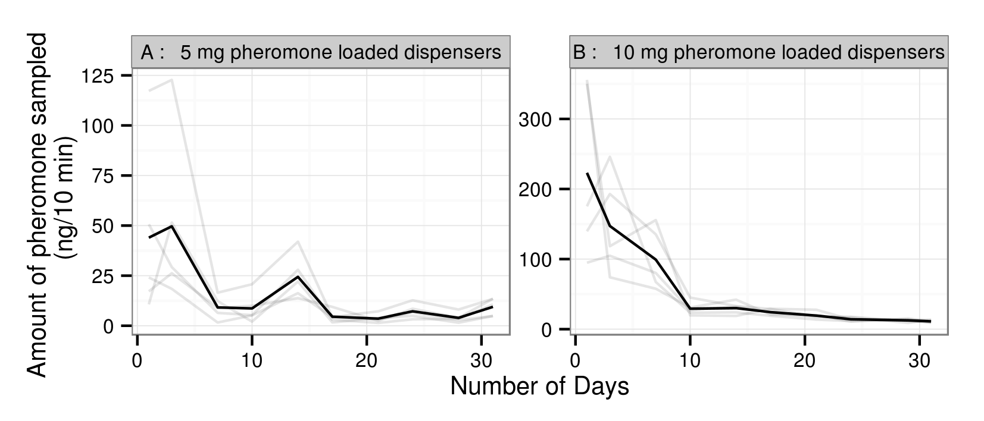
Fig. 1 Quantity of non-2-yl butanoate sampled over 10 min on SPME fiber from the 5 mg (A) and 10 mg (B) pheromone-loaded dispensers under laboratory conditions. The light grey lines represent the observed values for the five replicates and the black line represents their mean.
Based on Fig. 1 and raw data, the amounts of pheromone collected from both dispensers were initially high: 46.8 ± 40.82 ng/10 min (n = 10) from day 1 to day 3 for the 5 mg dispensers; and 156.5 ± 94.80 ng/10 min (n = 15) from day 1 to day 7 for the 10 mg dispensers. After these periods, the amounts collected were much lower, with a mean quantity of 8.9 ± 8.22 ng/10 min from day 7 to day 31 (n = 40) and of 20.1 ± 9.13 ng/10 min from day 10 to day 31 (n = 35) for the 5 mg and 10 mg pheromone dispensers, respectively.
For the 5 mg-loaded dispensers, sampling was conducted every 10 days from day 31 to day 84 in order to ensure that the dispensers were still releasing the pheromone throughout the field experiment period. The mean sampled quantities of pheromone were between 2.4 ± 0.56 ng and 12.8 ± 10.36 ng (n = 25).
3.2. Comparison of pheromone loadings and dispenser use durations in field
The initial field-trapping trial was conducted in order to assess the capture efficacy of sticky traps with lures baited with 5 mg or 10 mg of non-2-yl butanoate and maintained throughout the season or renewed every third week in traps, compared with unbaited traps. The unbaited trap controls did not capture any male midges and were therefore removed from the analyses in order to simplify the model and avoid trivial analyses. Fig. 2 shows the capture patterns for the different dispenser treatments. The analysis of the total male midge numbers caught in baited traps revealed a highly significant difference between pheromone loading (F_{1,12} = 15.01; p = 0.002), regardless of dispenser use duration. Significantly fewer male midges were caught in traps with lures maintained throughout the season than in those where pheromone dispensers were regularly renewed (F_{1,12} = 84.29; p < 0.0001), after accounting for the pheromone loadings. The pheromone loading x use duration interaction was not significant (F_{1,12} = 3.61; p = 0.242), indicating that the difference between 5 mg and 10 mg-baited trap catches was the same, whatever the dispenser use duration. In traps with renewed lures, the mean number of male midges per trap reached, on average, 216 ± 36.4 for the 5 mg pheromone dispensers, and 349 ± 70.8 for the 10 mg pheromone dispensers. Only the total catches for the 5S and 10S traps did not differ significantly, as shown in the post-hoc comparisons (t = 1.87; p = 0.291) with, on average, 75 ± 30.0 and 113 ± 23.0 male H. marginata midges per trap, respectively (Fig. 2).
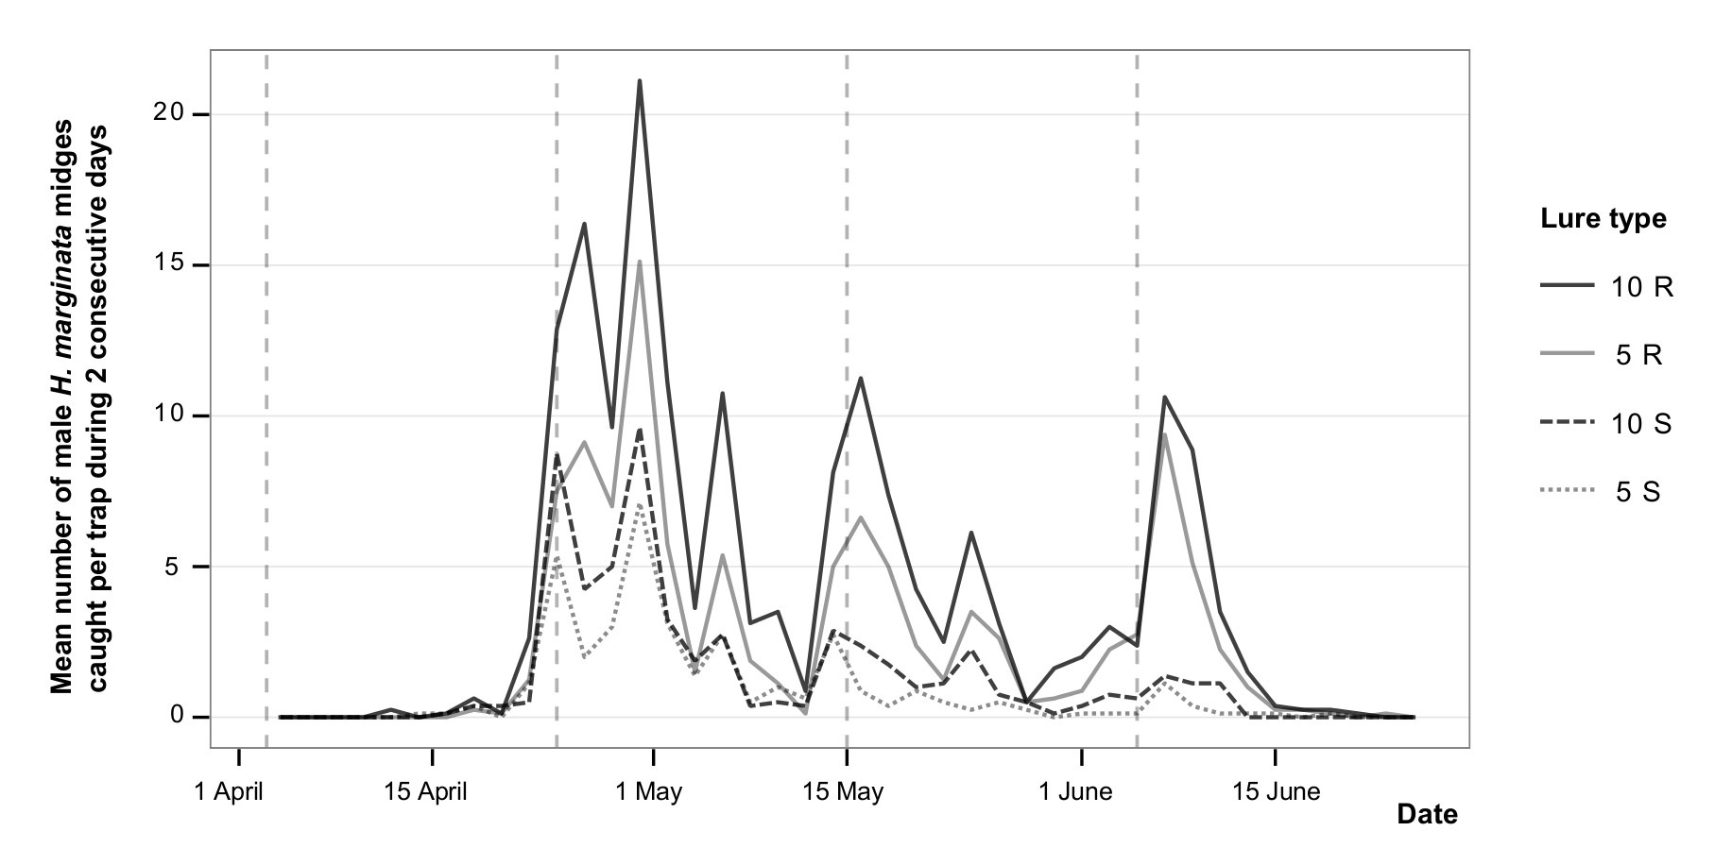
Fig. 2 Male Haplodiplosis marginata catches at Bossière between 3 April and 24 June 2014. Comparison of pheromone loadings and dispenser use durations in the field. The mean of 2 consecutive days is displayed in order to smooth the curves and improve the readability of the graph. Dotted vertical lines indicate when lures were renewed.
In order to assess which dispenser treatment was the most appropriate for current use in the field, the correlations between daily trap catches of all the baited trap types were established (Fig. 3). Whatever the lure type, and taking the whole experiment period into account, the H. marginata capture patterns were very similar among the four dispenser treatments, with correlation coefficients between 0.80 (for 5S and 5R trap catches) and 0.95 (for 5R and 10R trap catches).
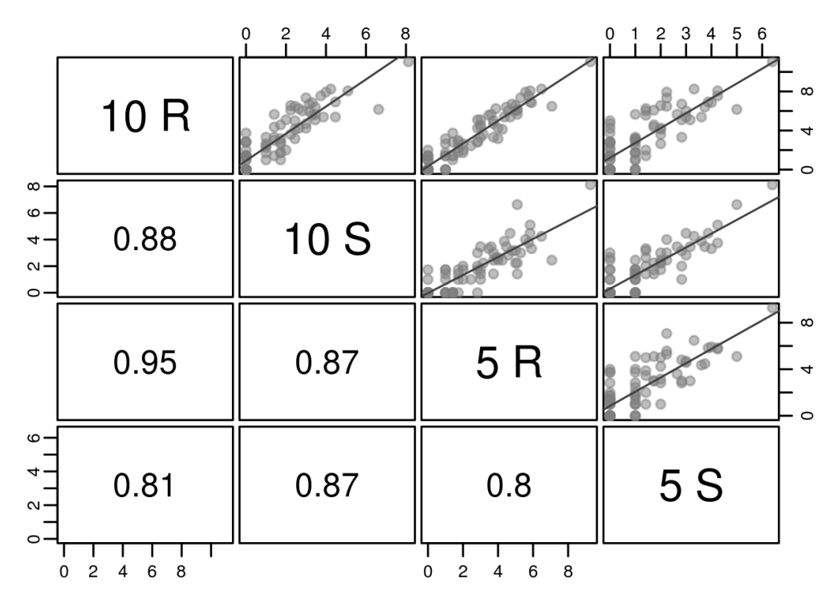
Fig. 3 Scatterplot matrix comparing the daily male Haplodiplosis marginata catches (square root transformed) among the four treatments of baited traps at Bossière throughout the season (3 April to 24 June 2014). In the upper triangle of the matrix, each point represents the square root of the daily mean catches of the four replicates of each dispenser treatment. The lines represent the corresponding linear regression. The lower triangle gives the Pearson correlation coefficients.
The correlation coefficients were also calculated for each 3-week period separately (Fig. 4). During the first two capture periods of the experiment, all the correlation coefficients between treatments remained high and quite close, whatever the pheromone loadings and whether the dispensers were renewed or not, ranging between 0.86 and 0.95 in the first period and between 0.88 and 0.97 in the second one. From the third period onwards, the correlation coefficients became much more variable, fluctuating from 0.60 to 0.91. This was probably due to the decreasing release rate of the dispensers maintained in traps throughout the season, as observed in the laboratory study. This hypothesis was also supported by the capture patterns of the final experiment period (Fig. 2), where the total mean number of male midges caught in traps with renewed lures (5R: 41 ± 11.0; 10R: 54 ± 16.4) was far higher than in those with dispensers maintained throughout the trapping experiment (5S: 4 ± 2.9; 10S: 8 ± 2.6).
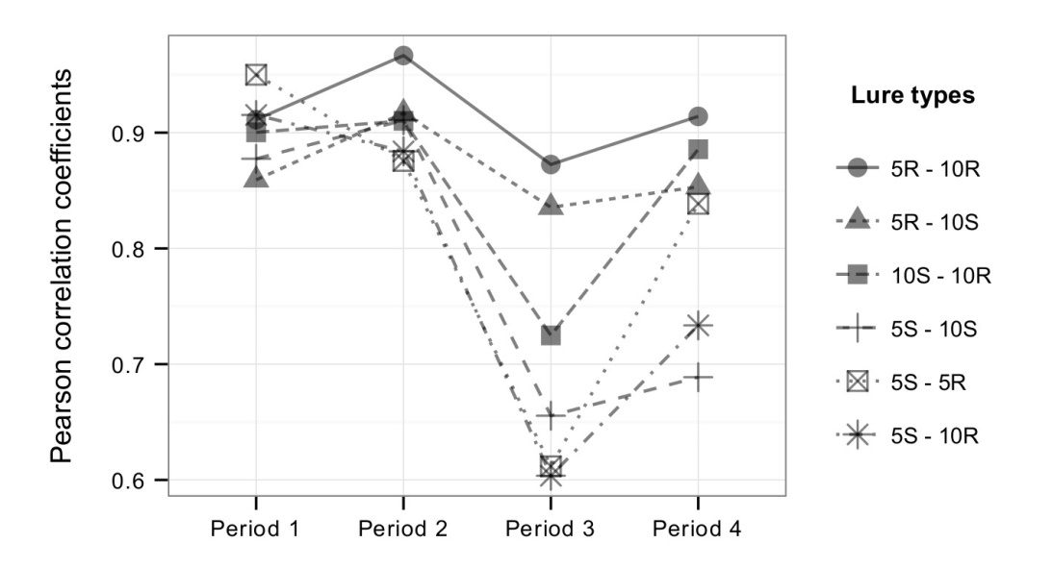
Fig. 4 Pearson correlation coefficients between daily mean male Haplodiplosis marginata catches for each pair of dispenser treatments and for each 3-week period separately at
Bossière between 3 April and 24 June 2014.
At the end of the larvae’s feeding phase, 300 stems were randomly sampled from an area of 1-5 m around each trap on 26 June 2014 (BBCH GS 75) in order to correlate the capture numbers with damage levels, but these appeared to be very low in this field, ranging between 0.04 and 0.07 galls per stem.
3.4. Comparison of pheromone-baited sticky trap catches, unbaited sticky trap catches and yellow water trap catches
The second field experiment (Fig. 5) clearly demonstrated that traps with 10 mg pheromone-loaded dispensers were far more efficient than the passive traps, taking the whole trapping season into account, with 1910 male H. marginata midges caught in the three baited traps as opposed to only 1 and 2 males in the three sticky traps without lures and in the three water traps, respectively. Baited traps therefore appeared to be the only traps suitable for obtaining accurate male H. marginata flight patterns.
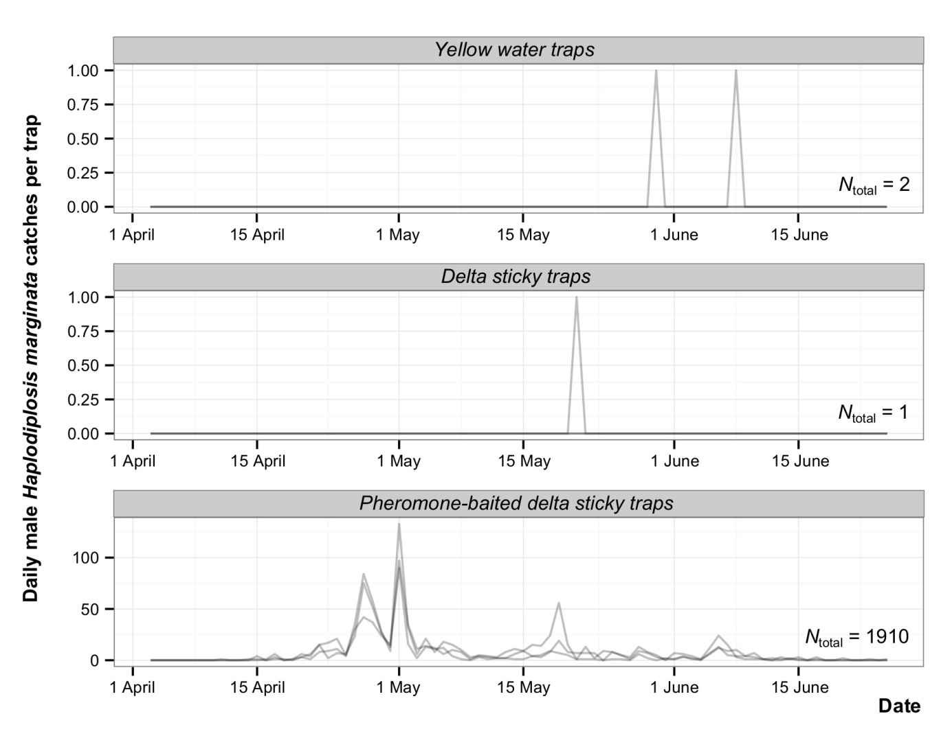
Fig. 5 Daily male Haplodiplosis marginata catches per trap at Sauvenière
between 3 April and 24 June 2014
- Discussion
This study on monitoring the saddle gall midge, Haplodiplosis marginata, demonstrated the effectiveness of traps baited with slow-release pheromone dispensers prepared from rubber septa, compared with unbaited sticky traps and yellow water traps (Fig. 5). In conditions of low infestation, as was the case in both trial fields at Sauvenière and Bossière, only baited traps caught H. marginata males. No females were caught in any traps, baited or unbaited.
Several pheromone dispenser treatments were tested in the experiment at Bossière in order to determine suitable pheromone loading and use duration of these lures in field conditions. As expected, the release rates measured under laboratory conditions were higher for the 10 mg than for the 5 mg-loaded dispensers. In the field, dispenser loading had a significant effect on capture levels. Taking the whole trapping season into account, however, the correlation coefficients calculated showed that the capture patterns were all very similar (Fig. 3), indicating that both pheromone loadings allowed good flight monitoring and good detection of flight peaks. This suggests that loading rubber dispensers with 5 mg of non-2-yl butanoate would be sufficient, which presents two advantages: (i) using less pheromone reduces the manufacturing cost; and (ii) the potential bias in capture levels when setting up the dispenser would be lower, as the over-release effect observed in the laboratory tests was shorter and proportionally less important for the 5 mg than for the 10 mg pheromone-loaded dispensers (Fig. 1).
With regard to the use duration of the dispensers, the capture patterns showed marked reductions in catches with the non-renewed lures compared with those replaced at 3-week intervals. This phenomenon was particularly noticeable in the final trapping period (Fig. 2), when the total number of male midges caught in traps with renewed lures was far higher than in traps without dispenser renewals. This finding was also supported by the analysis of the Pearson correlation coefficients per 3-week period (Fig. 4). With these coefficients remaining high and stable during the two first periods of the trial, the dispensers could be maintained in traps for 6 weeks without affecting the quantitative flight assessment. Renewing the dispensers less frequently would not only be cheaper and more practical, it would also restrict the potential impact of the initial high release rate when setting up the dispenser.
In order to determine the capture threshold at which the pest became harmful for the crop, it would be necessary to correlate damage with the number of insects captured, which was not possible in our trial, due to very low damage levels. Establishing such a threshold would require testing baited traps in a large number of fields, with various population densities in a year with high numbers of larvae and galls.
In conclusion, the laboratory and field experiments showed that sticky traps baited with 5 mg pheromone-loaded rubber dispensers renewed every 6 weeks constitute an effective and accurate tool for monitoring male H. marginata flights. These baited traps could be used to detect the occurrence of the saddle gall midge, study this pest and monitor its populations before it becomes harmful to cereal crops. In order to determine whether it is necessary to manage an infestation and if so, when to do it, however, it would be necessary to establish the capture threshold that represents a risk for a crop. It is also important to take into account the moment of abundant flights because of the harm that insecticides applied late in the season can bring to beneficial insects present in the crops.
Acknowledgements
The authors wish to thank the staff of the Walloon Agricultural Research Centre (CRA-W, Belgium), especially S. Chavalle and J. Denayer, for their technical assistance. We also thank A. Delplace and P. Dujardin, the farmers who allowed us to carry out the field experiments on their land. F. Censier was financially supported by a PhD grant from the Fonds pour la formation à la Recherche dans l’Industrie et l’Agriculture (FRIA, Belgium).

References
Barnes, H.F., 1956. Gall Midges of Economic Importance. Volume VII. Gall Midges of Cereal Crops, Crosby Lockwood & Son Ltd, London, UK.
Bretz, F., Hothorn, T., Westfall, P., Westfall, P.H., 2010. Multiple comparisons using R, CRC Press.
Bruce, T.J.A., Hooper, A.M., Ireland, L., Jones, O.T., Martin, J.L., Smart, L.E., Oakley, J., Wadhams, L.J., 2007. Development of a pheromone trap monitoring system for orange wheat blossom midge, Sitodiplosis mosellana in the UK. Pest Manag. Sci. 63, 49-56. http://dx/doi.org/10.1002/ps.1307.
Censier, F., Chavalle, S., Wittouck, D., De Proft, M., Bodson, B., 2012. Chemical control of Haplodiplosis marginata von Roser (Diptera: Cecidomyiidae). Comm. Appl. Biol. Sci. 77 (4), 667-675.
Censier, F., Chavalle, S., Knor, S., De Proft, M., Bodson, B., Skuhravá, M., 2014a. Unusual occurrence of cocoons in population of H. marginata (Diptera: Cecidomyiidae) in Belgium. J. Insect Sci. 14 (239). http://dx/doi.org/10.1093/jisesa/ieu101.
Censier, F., Fischer, C.Y., Chavalle, S., Heuskin, S., Fauconnier, M.-L., Bodson, B., De Proft, M., Lognay, G.C., Laurent, P., 2014b. Identification of 1-methyloctyl butanoate as the major sex pheromone component from females of the saddle gall midge, Haplodiplosis marginata (Diptera: Cecidomyiidae). Chemoecology 24, 243-251. http://dx/doi.org/10.1007/s00049-014-0167-0.
Censier, F., Chavalle, S., San Martin y Gomez, G., De Proft, M., Bodson, B., 2015. Targeted control of the saddle gall midge, Haplodiplosis marginata (von Roser) (Diptera: Cecidomyiidae), and the benefits of good control of this pest on winter wheat yield. Pest Manag. Sci. http://dx/doi.org/10.1002/ps.4046.
Cross, J.V., Hall, D.R., 2009. Exploitation of the sex pheromone of apple leaf midge Dasineura mali Kieffer (Diptera: Cecidomyiidae) for pest monitoring: Part 1. Development of lure and trap. Crop Prot. 28, 139-144. http://dx/doi.org/10.1016/j.cropro.2008.09.008.
Darvas, B., Skuhravá, M., Andersen, A., 2000. Agricultural dipteran pests of the Palaearctic region. In: Papp L, Darvas B (ed) Contributions to a Manual of Palaearctic Diptera. Vol 1. General and Applied Dipterology. Science Herald, Budapest, Hungary, pp 565-650.
De Clercq, R., D’Herde, J., 1972. Bijdrage tot de Studie van de Biologie, de verspreiding, de Pathogeniteit en de Bestrijding van de Tarwestengelgalmug Haplodiplosis marginata (von Roser 1840) Rübsaamen 1911. Rijkstation voor Nematologie en Entomologie, Merelbeke, Belgium.
Dewar, M., 2012. Ecology and control of saddle gall midge, Haplodiplosis marginata von Roser (Diptera; Cecidomyiidae). HGCA Research Review No. 76. http://publications.hgca.
com/publications/documents/RR76.pdf (10/06/2015).
Golightly, W.H., 1979. Saddle gall midge. Ministry of Agriculture, Fisheries and Food, Leaflet. 657.
Hall, D.R., Farman, D.I., Cross, J.V., Pope, T.W., Ando, T., Yamamoto, M., 2009. (S)-2-acetoxy-5-undecanone, female sex pheromone of the raspberry cane midge, Resseliella theobaldi (Barnes). J. Chem. Ecol. 35, 230-242. http://dx/doi.org/10.1007/s10886-009-9588-6.
Heuskin, S., Verheggen, F.J., Haubruge, E., Wathelet, J.-P., Lognay, G., 2011. The use of semiochemical slow-release devices in integrated pest management strategies. Biotechnol. Agron. Soc. Environ. 15 (3), 459-470.
Kehat, M., Anshelevich, L., Dunkelblum, E., Fraishtat, P., Greenberg, S., 1994. Sex pheromone traps for monitoring the codling moth: effect of dispenser type, field aging of dispenser, pheromone dose and type of trap on male captures. Entomol. Exp. Appl. 70, 55-62.
Latteur, G., 1972. Importance des populations larvaires de la Cécidomyie équestre (Haplodiplosis marginata von Roser = H. equestris Wagner, Diptera, Cecidomyiidea) dans les froments des principales zones céréalières du Sud de la Belgique en 1970 et 1971. Parasitica 28 (1), 16-24.
Mölck, G., 2007. Bekämfung von Sattelmücken und Weizengallmücken. Landpost, pp. 18-23.
Môttus, E., Nômm, V., Willians, I.H., Liblikas, I., 1997. Optimization of pheromone dispensers for diamondback moth Plutella xylostella. J. Chem. Ecol. 23 (9), 2145-2159.
Nijveldt, W., Hulshoff, A.J.A., 1968. Waarnemingen inzake de tarwestengelgalmug (Haplodiplosis equestris Wagner) in Nederland. Centrum voor landbouwpublikaties en landbouw-dokumentatie, Wageningen, The Netherlands.
R Development Core Team, 2015. R: a language and environment for statistical computing. R Foundation for Statistical Computing. Vienna, Austria. http://www.R-project.org (20/01/2015).
Roberts, D.A., Harris, D., Corr, I., Corrigan, W., 2012. Saddle gall midge (Haplodiplosis marginata) in winter wheat. Asp. Appl. Biol., 117, 97-103.
Ruiz-Montiel, C., Rojas, J.C., Cruz-López, L., González-Hernández, H., 2009. Factors affecting pheromone release by Scyphophorus acupunctatus (Coleoptera: Cucurlionidae). Environ. Entomol. 38 (5), 1423-1428.
Skuhravá, M., 1997. Family Cecidomyiidae. In: Papp L, Darvas B (ed) Contributions to a manual of Palaearctic Diptera, Vol. 2. Science Herald Budapest, Hungary, pp 71-204.
Skuhravý, V., Skuhravá, M., Brewer, J.W., 1983. Ecology of the saddle gall midge Haplodiplosis marginata (von Roser) (Diptera, Cecidomyiidae). Z. Angew. Entomol. 96 (1-5), 476-490.
Skuhravý, V., Skuhravá, M., Brewer, J.W., 1993. The saddle gall midge Haplodiplosis marginata (Diptera: Cecidomyiidae) in Czech Republic and Slovak Republic from 1971-1989. Acta Soc. Zool. Bohem. 57 (2), 111-137.

