Adiabatic Decoupling of the Reaction Coordinate
J. C. LORQUET
Department of Chemistry, University of Liège, Sart-Tilman B6, B-4000 Liège 1, Belgium

Abstract
When the dynamics is constrained by adiabatic invariance, a reactive process can be described as a one-dimensional motion along the reaction coordinate in an effective potential. This simplification is often valid for central potentials and for the curved harmonic valley studied in the reaction path Hamiltonian model. For an ion-molecule reaction, the action integral 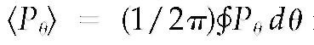is an adiabatic invariant. The Poisson bracket of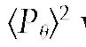with Hamiltonians corresponding to a great variety of long-range electrostatic interactions is found to decrease with the separation coordinate r, faster than the corresponding potential. This indicates that the validity of the adiabatic approximation is not directly related to the shape of the potential energy surface. The leading role played by the translational momentum is accounted for by Jacobi's form of the least action principle. However, although the identification of adiabatic regions by this procedure is limited to a specific range of coordinate configurations, equivalent constraints must persist all along the reaction coordinate and must operate during the entire reaction, as a result of entropy conservation. The study of the translational kinetic energy released on the fragments is particularly appropriate to detect restrictions on energy exchange between the reaction coordinate and the bath of internal degrees of freedom.

Keywords : adiabatic invariance; ion-molecule reactions; maximum entropy; translational energy distributions.

1. Adiabatic Invariance in Molecular Bound States
It is well known in classical mechanics that the presence of invariants greatly simplifies the description of dynamics. How does this apply to chemistry? Adiabatic invariance first appeared in molecular physics as the Born-Oppenheimer separation of electronic and nuclear motion and was justified by the fact that electrons are lighter and faster than the heavy nuclei.
This simplification has been transferred with great success to the study of molecular systems containing both weak and strong bonds, i.e., to van der Waals complexes [1-3]. Advantage is taken of a well-known theorem of classical mechanics, concerning the properties of a periodic system slightly perturbed by a slowly varying external force [4-7]. If a fast q-motion is periodical and if p denotes its conjugate momentum, then the vibrational action of the fast mode,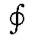pdq, which represents the area bounded by the path of the representative point in the p, q phase space during one cycle (and which is linearly related to the corresponding quantum number), is shown to be an adiabatic invariant (i.e., an approximate constant of the motion). The fast intramolecular mode is only slightly perturbed by the slow intermolecular motion. Morales [3] used this technique to justify the observation that energy transfer in van der Waals complexes is restricted by a propensity to minimize the change of intramolecular quantum numbers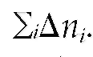 He showed the rule to be related to the quantum adiabatic theorem derived by Born and Fock [8] : A slow change of an external parameter changes the energy, but restricts the change in the wave function to a multiplication by a phase factor. As a result, the quantum numbers (i.e., the number of nodes in the wave function) do not change and are adiabatic invariants [9].
Caution is needed, however. Similar attempts to separate stretching from bending in spectroscopic problems [10-12] have led to incompletely understood results. Intuitively, one would favor a description where the slow bending motion experiences an effective force due to averaging over the faster stretching modes. Surprisingly, the counterintuitive adiabatic approximation where the reverse procedure is carried out is found to give sometimes good results, at least in special cases.

2. Adiabatic Invariance in Reactive Processes
The suggestion that the adiabatic decoupling of the reaction coordinate should be used to simplify the dynamics of chemical reactions goes back to Hirschfelder and Wigner [13]. This proposal has been extensively developed by Troe and coworkers in their statistical adiabatic channel model (SACM) [14-18].
In agreement with the previous discussion of bound states, adiabatic invariance is to be suspected when two different kinds of motions coexist. The latter are expected to be characterized by different time scales, e.g., a slow reaction coordinate versus fast bending modes.
To get a better insight into the problem, several restrictions will be introduced into the model considered here.
i. Obviously, cases where the potential energy surface assumes locally a very simple mathematical expression provide an ideal starting point. Several such instances will be examined. First, we will consider ion-molecule reactions. Their study is especially interesting because of the simplicity of the long-range electrostatic potentials. The point charge-induced dipole is characterized by a central potential and leads to separable equations of motion. The ion-dipole or ion-quadrupole interactions are of great practical interest. As a further example, we examine the case where the potential energy surface can be locally described as a harmonic valley along a slightly curved reaction path. Such a situation is described by the so-called reaction path Hamiltonian [19].
ii. The study is limited to two-dimensional models with a total angular momentum assumed to be equal to zero.
iii. Classical mechanics is used because we want to study the validity of the adiabatic approximation at different points along the reaction path and, more generally, in different regions of phase space. This requires simultaneous specification of position and momentum.

3. The Central Force Interaction
When the interaction potential between the two fragments is spherically symmetrical and can be denoted as V(r), the presence of cyclic coordinates in the Hamiltonian results in a considerable simplification of the problem: the motion is constrained to take place in a plane [4-6]. Such a constraint is exact, because it results from the conservation of the angular momentum. However, additional simplifications must be introduced to develop a really useful theory.
Consider a standard problem in physical chemistry where a linear or spherical charged fragment interacts with a polarizable atom [20-23]. Let B denote the rotational constant of the fragment, j its rotational quantum number, 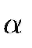the polarizability of the atom, q the electronic charge, and m_{red} the reduced mass of the system. The central potential V(r) can then be expressed as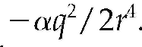 To calculate a capture cross section, or the rate constant of a unimolecular dissociation, or the translational kinetic energy release distribution (henceforth, denoted as the KERD), an additional assumption is made. The orbiting energy at the top of the centrifugal barrier is assumed to be adiabatically converted into translational energy carried by the fragments, which is denoted as ε. In other words, both the orbital and the rotational quantum numbers ( and j) are required to be conserved in the whole range extending from the top of the centrifugal barrier to infinity. The condition of validity of an adiabatic separation requires that the translational motion be much slower than rotation. It can be expressed in terms of a Massey parameter [17, 18, 20, 24]:
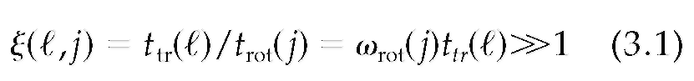
where t_{tr}() is the time required to travel through a distance characteristic of the range of the effective radial potential, while t_{rot}(j) = ω_{rot}(j)⁻ is the rotational period of the fragment. The following estimate has been derived [24] in the simple case of zero total angular momentum (i.e., when j = ):
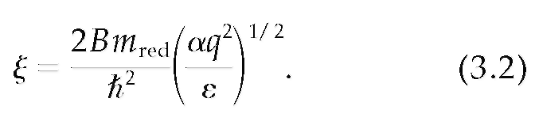
(An estimate is also available [24] when the total angular momentum is nonzero.)
When1, the radial motion can be described as a one-dimensional problem in an effective potential obtained by adding a centrifugal term to the original V(r). Then, the calculation by the so-called orbiting transition state phase space theory [20-24] of a capture cross section, or of the rate constant of the reverse reaction (which leads to disappointing results), or of the KERD (which is much more successful [21, 24]), becomes possible. It follows from Eq. (3.2) that the lower the energy and the more polarizable the atomic fragment, the more reliable is the calculation of a KERD.

4. Ion-Molecule Reactions in a Anisotropic Potential
Consider now a situation where a neutral fragment characterized by a nonzero dipole or quadrupole moment interacts with a point charge. At large enough values of the separation coordinate r, the neutral fragment undergoes free rotation in the field of the ion. If, furthermore, the total angular momentum is assumed to be zero, the Hamiltonian of a two-dimensional system writes [25-27]
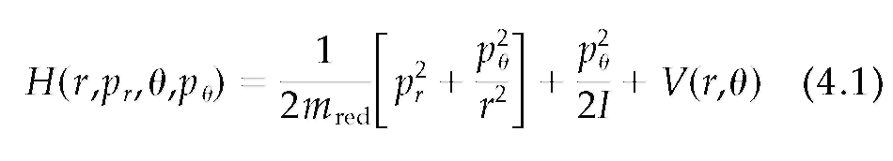
where I denotes the moment of inertia of the neutral fragment and m_{red} is the reduced mass of the ion-neutral pair. Three commonly used electrostatic potentials have been examined:
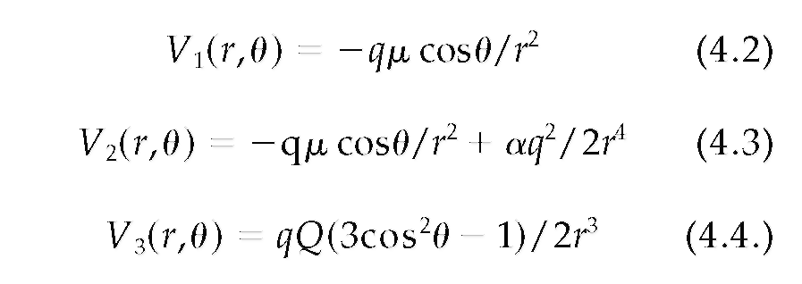
where q denotes the charge of the ion,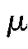, the magnitude of the permanent electric dipole of the neutral fragment,its orientation,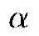its polarizability, and Q its quadrupole moment.
It has been suggested by Bates [28] and by Kern and Schlier [25] that the dynamics of an ion-dipole complex is dominated by the invariance of the action integral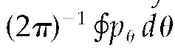. To calculate the cyclic integral, the value of 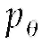 is extracted from the equation H(r,p_{r}, p_{q}) = E, and then averaged over a full rotation of the angle The result is denoted 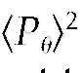. Its exact expression involves elliptic functions, which, to simplify the mathematics, are expanded in the 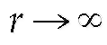 limit. To show that it is an adiabatic invariant of the problem, the Poisson bracket of with the Hamiltonian is calculated. It is found not to vanish. However, interestingly enough, it is seen in each case to decrease faster with r than the relevant electrostatic potential. The Poisson bracket is found [27] to be proportional to µIp_{r} /m_{red} r³ for the ion-dipole interactions V₁(r, ) and V₂(r, ), and to QIp_{r}/m_{red} r⁴ for the ion-quadrupole potential V₃(r, ). Therefore, the quality of the adiabatic approximation can be expected to be quite good in each case, at least at asymptotically large values of r. However, since the Poisson bracket also increases linearly with the translational momentum p_{r}, the validity of the adiabatic separation becomes questionable at high translational energies, as expected from the usual argumentation on adiabatic invariance [4-7].
The value of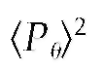in the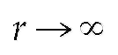limit is quite simply evaluated [27]:
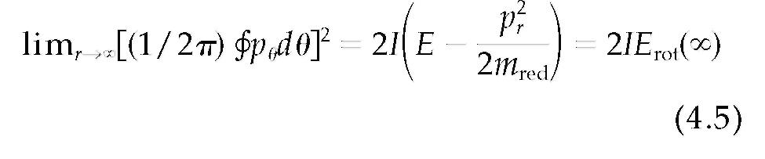
These results show that in the asymptotic range of practically all ion-molecule reactions, the quantity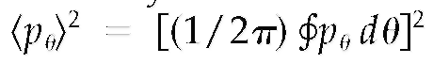is an invariant, which, to a good approximation, can be replaced by its asymptotic value, i.e., by 2IE_{rot}().

5. Effective Potentials
When the adiabatic approximation is valid, a Born-Oppenheimer-like separation is possible. The dynamics then reduces to a one-dimensional motion in an effective potential. This is found to be the case in all of the examples studied before.
For isotropic potentials, V_{eff}(r) is simply obtained by adding a diatomic-like centrifugal term to the original spherical potential.
For anisotropic potentials, we use a method originally developed by Kern and Schlier [25, 27]. The Hamiltonian (4.1) can be rewritten as
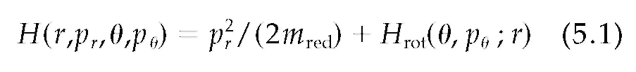
The last term of Eq. (5.1) can be seen as a partial Hamiltonian describing the fast rotational subsystem 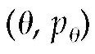 for a fixed value r of the slow coordinate:
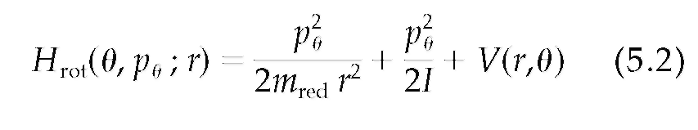
The translational motion is then described by an adiabatic Hamiltonian
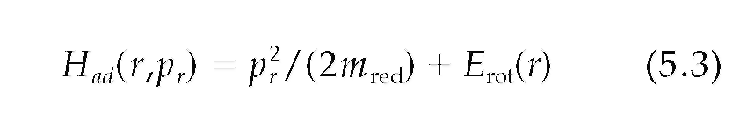
where the r-dependent rotational energy E_{rot}(r) is defined by the equation H_{rot} = E_{rot} under the constraint that the cyclic integral 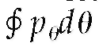 be a constant of the motion [25, 27]. This means that the value of is extracted from the equation H_{rot} = E_{rot}(r) and is integrated over a full cycle of. The result is divided by 2π, and squared. Its expression, which contains E_{rot}(r), is equated to its asymptotic value for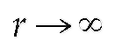(which is equal to 2I E_{rot}() and solved for E_{rot}(r). The function E_{rot}(r) obtained in this way can be used as an effective potential in the adiabatic Hamiltonian (5.3). Explicit expressions can be found in Ref [27].

6. The Curved Harmonic Valley and the Reaction Path Hamiltonian
A region of the potential energy surface where the reaction path is characterized by a strong curvature
(i.e., by a small value of its radius of curvature) leads to a strong coupling between the translational motion along the reaction path and the vibrational modes orthogonal to it. Miller et al. derived an action-angle Hamiltonian [19], where the potential energy surface can be described as a (3N — 7)-dimensional harmonic valley about the reaction coordinate s. They showed that the energy transfer between s and each vibrational mode is determined by the magnitude of a coupling parameter σ equal to
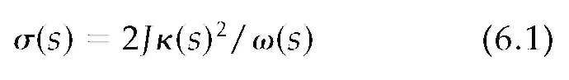
where J is the classical action while κ (s) and ω(s) denote the curvature of the reaction path and the harmonic vibrational frequency at point s, respectively.
In the range where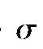is small, adiabatic invariance decouples the reaction coordinate from the perpendicular degrees of freedom. Energy exchange between translation along the reaction coordinate and the perpendicular vibrations is prohibited. Insight into the physical significance of the coupling parameter can be obtained as follows [29].
The vibrational energy can be expressed either as 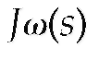 or as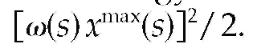Equating these two quantities leads to an alternative expression of
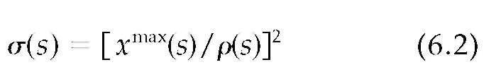
where ρ = κ⁻¹ denotes the radius of curvature of the reaction path.
Thus, the adiabatic approximation can only be valid if the amplitude of the vibrations normal to the reaction path is much smaller than its radius of curvature (both being expressed in mass-weighted units).
In the range where the coupling parameteris much smaller than one, the dynamics again reduces to a one-dimensional motion in an effective potential. Its expression can be found in Refs. [19] and [29].

7. The Relevant Constraint
When the dynamics can be described by a one-dimensional Hamiltonian, the use of Jacobi's form of the least action principle is particularly simple. This very general principle of classical mechanics asserts [5, 6] that the actual trajectory between two points r₁ and r₂ minimizes the integral 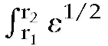 dr. It is thus closely analogous to Fermat's principle for the motion of a ray of light and can be restated by saying that the square root of the translational energy (or the translational momentum p_{r}) plays a fundamental role in reaction dynamics: the same as the index of refraction in optics.
The major importance of the translational momentum when the translational motion is adiabatically decoupled has been known for a long time. It is of central importance in the study of the lifetimes of van der Waals complexes, where it is known as the momentum gap rule [1, 2]. It has also been shown to be closely related to the Franck-Condon principle in energy-transfer processes [23].

8. The Maximum Entropy Method
We now consider another way of looking at constraints. Statistical mechanics can be reformulated in terms of the basic concepts of information theory [30]. Entropy, which "has a deeper meaning, quite independent of thermodynamics,"[30] plays a fundamental role in this formulation.
There are two reasons that make this approach especially appealing for our purposes. First because in its effort to improve on a pure statistical estimate, dynamical constraints are introduced from the very start into the formalism. Probability distributions are required to maximize the entropy subject to known constraints. The rationale is that the recognition of a constraint implies information while entropy is synonymous with uncertainty [30]. Second, because the study of nonequilibrium processes by information theory has shown that the time evolution of an observable is dictated by the conservation of entropy [31-33].
The maximum entropy method (MEM) starts from the postulate that the state of the system is as statistical as possible (i.e., is of maximal entropy subject to constraints) throughout the entire time evolution (i.e., all along the reaction path) [34-37]. This basic assumption is supported by quantum dynamical calculations of reactive scattering, where the population of internal states is calculated as a function the reaction coordinate [38]. The entropy of the calculated distributions is found to maintain its maximum value, subject only to dynamical constraints throughout the entire reaction process and not just in the asymptotic region, thereby confirming the basic postulate of the MEM.
As analytically demonstrated by Levine and coworkers [32, 33], the MEM converges to an exact solution of the equations of motion. It exploits the fact that the entropy of a distribution is a constant of the motion, because the properties of the exact quantum evolution operator (or of the classical equations of motion) have been introduced into the formalism.

9. Connection With Experiment
The applications of the MEM to chemical physics have been especially useful in the study of product energy distributions, which are particularly informative on energy partitioning in a chemical reaction.
Levine and coworkers have developed the point that the distribution of product states is characterized by a certain "information content" and by an entropy, defined as the "missing information." The information content is defined as the difference between the maximal and the actual values of the entropy of the distribution. For this reason, it is also referred to as the "entropy deficiency" [34, 38].
In particular, as already seen in Section 3, the study of KERDs conveys information on the interplay between translation and vibration during the last part of the reaction coordinate, which meets our purposes.
Consider a situation where two fragments separate with a total energy E, measured above the reaction threshold. This excess energy is partitioned among the different degrees of freedom. Some part of it, denoted, flows into translation, while the remainder, E-, goes into the vibrotarional degrees of freedom. The experimentally measured KERD is denoted as 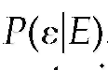
If no dynamical constraints operated, then all of the possible final quantum states would be populated with equal probabilities. The corresponding KERD is termed the prior distribution, denoted as 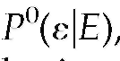 and is used as a reference. The prior distribution is given by a histogram, where each bin groups together those states that have the same translational energy. It is a purely statistical estimate and can be expressed as the product of two densities of states: that of the translational motion and that of the bath of internal degrees of freedom of the two separating fragments [34-37, 39].
The MEM then demonstrates that the actual distribution function is obtained by multiplying the prior distribution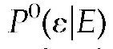by a sequence of corrective factors, each of which is associated with a particular dynamical constraint.
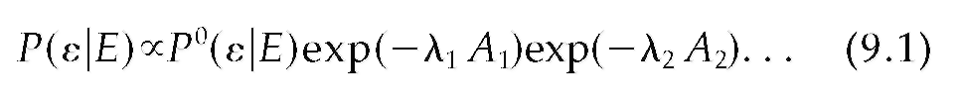
where the A_{r} is the physical property that constrains the dynamics. The quantities λ_{r} are Lagrange multipliers in a process that consists in maximizing the entropy (i.e., in making the dissociation dynamics as statistical as allowed by the constraints) Thus, among all possible distributions, the prior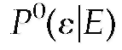is the most probable one because its entropy is as large as possible, whereas the actual distribution is the one of maximal entropy consistent with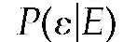 me constraints.
When the dynamics can be described as a one-dimensional motion in an effective potential, the use of Jacobi's form of the least action principle accounts for the fact that the constraint is unique and equal to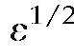. as shown in Section 7. This means that if the KERD is represented as a histogram, then all the states characterized by the same value of the constraint are equally probable and must be grouped together in the same bin. Then, the KERD is expressed by the simple MEM equation.
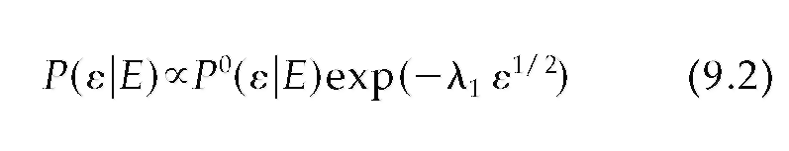
(with λ₁ positive for a barrierless reaction). This equation has been found to be valid in many experimental studies [39]. It is a consequence of adiabatic decoupling, which prevents energy transfer from the bath of oscillators to the reaction coordinate.
Note that the prior distribution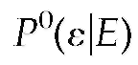results from purely statistical considerations. The exponential factor in Eq. (9.2) is purely dynamical: it contains the constraint multiplied by a Lagrange parameter. Thus, in the MEM formalism, statistics is neatly separated from dynamics.
Equation (9.2) provides a further example where the dynamics is dominated by the translational momentum, as has been found to be the case in van der Waals complexes [1, 2].

10. Entropy as a Constant of the Motion
The invariance of the entropy leads to unexpected conclusions.
In Sections 3 and 4, the search for dynamical constraints) has been limited to asymptotic regions of the potential energy surface. Levine and coworkers have demonstrated that, surprising as it may seem, their influence persists throughout the entire reaction process, as a result of entropy conservation [32, 33]. If a constraint is found to operate in a certain range of the reaction coordinate, e.g., at very large values, (equivalently, if it operates at asymptotically long times), then the reactive process must be nonstatistical throughout the entire collision (or semi-collision). Even if the information is analyzed in the asymptotic region, the derived value of the entropy deficiency concerns the entire reaction path.
However, the nature of the constraint(s) may change and will presumably be less simple and less conspicuous outside the range where the potential energy surface assumes its simple shape. For an ion-molecule reaction, the constraint is simple when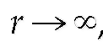 but the restrictions to phase space sampling and to energy randomization act everywhere along the reaction coordinate.
If the entropy of the actual KERD is less than that of the prior, then the entire evolution will be characterized by a nonzero entropy deficiency. In particular, at small values of the reaction coordinate, close to the bottom of the potential energy surface, the oscillators cannot freely exchange their energy. Thus, in contradistinction to summary sketches of the RRKM theory, the system never forgets its previous history, but its memory readjusts as the reaction proceeds.

11. Discussion

11.1. ROLE OF DYNAMICAL CONSTRAINTS
Dynamical constraints play a double role in chemical dynamics. More properly, their role is ambiguous and even paradoxical. On the one hand, they introduce restrictions to energy transfer among degrees of freedom, i.e., they prevent phase space from being ergodically sampled. From that point of view, dynamical constraints can be seen as a real nuisance because they prevent the application of statistical methods in chemical kinetics. On the other hand, the existence of an adiabatic invariant greatly simplifies the problem. The reactive process can then be described as a one-dimensional motion along the reaction coordinate in an effective one-dimensional potential, as in the SACM [14-18].
As explicitly demonstrated by the MEM [40, 41], the great success and usefulness of the Rice-Ramsperger-Kassel-Marcus theory [20-23] in the study of unimolecular reactions should not be interpreted as a definite proof of the basic assumption of free energy flow among a set of coupled degrees of freedom prior to dissociation. The success of its equation
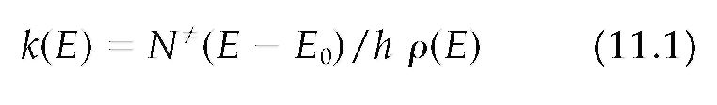
(where E₀ denotes the reaction threshold, ρ(E) is the density of internal states of the reactant, and N≠(E - E₀) represents the number of reactive states of the transition state) results from a mechanism of cancellation of errors. Constraints would reduce the value of both the numerator and the denominator [40, 41]. As a result, their ratio remains largely insensitive. By contrast, KERDs are directly related to the numerator of Eq. (11.1) only. Therefore, their study is particularly appropriate to detect the presence of constraints that restrict energy exchange between the reaction coordinate and the bath of internal degrees of freedom.

11.2. CONDITIONS OF VALIDITY
What are the necessary and sufficient conditions of validity of an adiabatic separation? There does not appear to be a simple answer to that question.
If a molecule consists of two subsystems characterized by very different time scales, as in van der Waals complexes, then the adiabatic approximation is in principle applicable. It is likely, however, that a comparison between two time scales, precious as it is, gives only a first clue. A real understanding can only result from an estimate of the strength of the couplings.
The first justification of the validity of the Born-Oppenheimer approximation was based on the smallness of the ratio between electronic and nuclear masses and between time scales. However, a much better analysis was later on given in terms of the properties of the matrix elements of 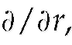 of
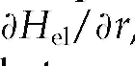 and of the magnitude of the energy gap between two neighboring electronic states [20, 23].
Note also that the nonadiabaticity parameter σ [Eqs. (6.1) and (6.2)] that determines the range of validity of the reaction path Hamiltonian is not a Massey parameter: it cannot be expressed either as a ratio between two different time scales, or in terms of distance traveled during a vibrational period multiplied by the range of a potential.
Similarly, the counterintuitive and sometimes erratic nature of the attempts to separate stretching from bending in spectroscopic problems should be recalled [10-12]. The adiabatic approximation was found to be sometimes applicable even when applied in a counterintuitive way. A possible explanation might be found in the concept of extreme-motion states. These states can be described as consisting of a highly excited anharmonic oscillator (in our case, the reaction coordinate) accompanied by a set of harmonic oscillators in their ground vibrational state. Hose and Taylor could show that they are generally not strongly coupled to other zero-order states characterized by a more uniform distribution of the vibrational quantum numbers [42]. They are found to exist even in the continuum above dissociation. Their existence is supported by experimental evidence [43, 44].

11.3. SHAPE OF THE POTENTIAL
The coupling parameter σ that determines the validity of the reaction path Hamiltonian [Eqs. (6.1) and (6.2)] is found to be totally independent of the profile V(s) of the potential energy along the reaction path s. The same remark can be made for the ion-molecule reactions: the conditions of validity of the adiabatic approximation are very similar for each of the three potentials given in Eqs. (4.2-4.4): they require large values of the reaction coordinate, small translational momentum, and a small value of the dipole or quadrupole moment, whatever the shape of the interaction potential V(r,.
To investigate further this point, we have also calculated the Poisson brackets for very general potentials devoid of physical significance:
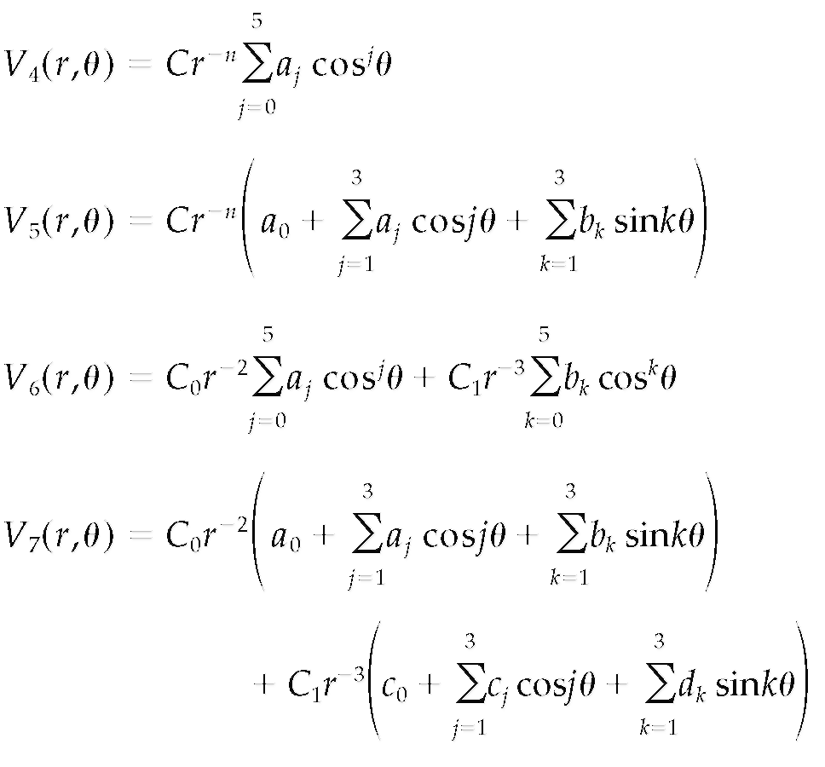
where n is an integer ranging between 2 and 7, and C, C₀, and C₁ are constants The Poisson brackets of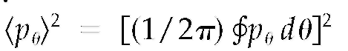 with the Hamiltonians corresponding to V₄ and V₅ were found to be proportional to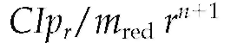while those corresponding to the nonseparable potentials V₆, and V₇ were found to be proportional to 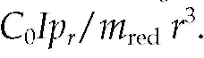 Thus, in a multitude of cases, the bracket decreases with r faster than the potential. Clearly, adiabatic invariance can exist even if the anisotropy function is complicated and even if the variables r and θ are not separated in the potential. The detection of an invariant requires the calculation of a Poisson bracket. The needed mathematical operations are easy or untractable depending on the expression of the potential. The question is to know whether the mathematical simplicity of the potential is responsible for adiabatic invariance or whether it simply allows its study. In our examples, once the presence of an adiabatic invariant has been established, the shape of the potential is found not to be directly related to the validity of the adiabatic approximation. This leads to the suspicion that adiabatic invariance might exist for more complicated potentials, where it cannot be conveniently studied. In particular, it might exist for any dissociation (or association) reaction, even those involving neutral species. Further investigation of this point is planned.

Acknowledgements
The author thanks Professors R.D. Levine and B. Leyh for many fruitful discussions.

References
1. Ewing, G. E. J Chem Phys 1980, 72, 2096.
2. Ewing, G. E. J Chem Phys 1979, 71, 3143.
3. Morales, D. A. Chem Phys 1989, 132, 165.
4. Landau, L. D.; Lifshitz, E. M. Mechanics; Pergamon Press: Oxford, 1960.
5. Goldstein, H.; Poole, C; Safko, J. Classical Mechanics; Addison Wesley: San Francisco, 2002.
6. Corben, H. C; Stehle, P. Classical Mechanics; Wiley: New York, 1950.
7. Tomonaga, S. Quantum Mechanics; North-Holland: Amsterdam, 1968.
8. Born, M.; Fock, V. Z Phys 1928, 51, 165.
9. Gozzi, E.; Phys Lett B 1985, 165, 351.
10. Johnson, B. R.; Skodje, R. T.; Reinhardt, W. P. Chem Phys Lett 1984, 112, 396.
11. Johnson, B. R.; Reinhardt, W. P. J Chem Phys 1986, 85, 4538.
12. Ohja, P. C; Berry, R. S. Mol Phys 1988, 63, 909.
13. Hirschfelder, J. O.; Wigner, E. J Chem Phys 1939, 7, 616.
14. Quack, M.; Troe, J. Ber Bunsenges Phys Chem 1974, 78, 240.
15. Troe, J. J Chem Phys 1987, 87, 2773.
16. Troe, J. Adv Chem Phys 1997, 101, 819.
17. Maergoiz, A. I.; Nikitin, E. E.; Troe, J.; Ushakov, V. G J Chem Phys 1996, 105, 6263.
18. Maergoiz, A. I.; Nikitin, E. E.; Troe, J.; Ushakov, V. G J Chem Phys 2002, 117, 4201.
19. Miller, W. H; Handy, N. C; Adams, J. E. J Chem Phys 1980, 72, 99.
20. Nikitin, E. E. Theory of Elementary Atomic and Molecular Processes in Gases; Clarendon: Oxford, 1974.
21. Baer, T.; Hase, W. L. Unimolecular Reaction Dynamics. Theory and Experiments; Oxford University Press; New York, 1996.
22. Forst, W. Unimolecular Reactions. A Concise Introduction; Cambridge University Press: Cambridge, 2003.
23. Levine, R. D. Molecular Reaction Dynamics; Cambridge University Press: Cambridge, UK, 2005.
24. Gridelet, E.; Lorquet, J. C; Leyh, B. J Chem Phys 2005, 122, 094106/1.
25. Kern, K.; Schlier, C. Z Phys D 1986, 1, 391.
26. Child, M. S.; Pfeiffer, R. Mol Phys 1986, 57, 967.
27. Lorquet, J. C. J Phys Chem A 2007, 111, 8050.
28. Bates, D. R. Chem Phys Lett 1981, 82, 396.
29. Pavlov-Verevkin, V. B.; Lorquet, J. C. J Chem Phys 2005,123, 074324/1.
30. Jaynes, E. T. Phys Rev 1957, 106, 620.
31. Jaynes, E. T. Phys Rev 1957, 108, 171.
32. Alhassid, Y.; Levine, R. D. J Chem Phys 1977, 67, 4321.
33. Levine, R. D. Adv Chem Phys 1981, 47, 239.
34. Bernstein, R. B.; Levine, R. D. Adv Atom Mol Phys 1975, 11, 215.
35. Levine, R. D.; Bernstein, R. B. In Dynamics of Molecular Collisions, Part B; Miller, W. H., Ed.; Plenum: New
York, 1976; p 323.
36. Levine, R. D.; Kinsey, J. L. In Atom-Molecule Collision Theory. A Guide for the Experimentalist; Bernstein, R.
B., Ed.; Plenum: New York, 1979; p 693.
37. Levine, R. D. In Theory of Chemical Reaction Dynamics; Baer, M., Ed.; CRC Press: Boca Raton, FL, 1985.
38. Nesbet, R. K. In Theoretical Chemistry: Advances and Perspectives, Vol. 6B; Academic Press: New York,
1981; p 79.
39. Leyh, B.; Gridelet, E.; Locht, R.; Lorquet, J. C. Int J Mass Spectrom 2006, 249/250, 330.
40. Levine, R. D. Ber Bunsenges Phys Chem 1974, 78, 111.
41. Lorquet, J. C. Mass Spectrom Rev 1994, 13, 233.
42. Hose, G.; Taylor, H. S. Chem Phys 1984, 84, 375.
43. Choi, Y. S.; Moore, C. B. J Chem Phys 1991, 94, 5414.
44. Jacobson, M. P.; O'Brien, J. P.; Silbey, R. J.; Field, R. W. J Chem Phys 1998, 109, 121.

