Modelling of the permability evolution in the excavation
disturbed zone around underground excavations

Séverine LEVASSEUR, Université de Liège, department ArGenCo,
Chemin des chevreuils 1, 4000 Liège, Belgium – severine.levasseur@ulg.ac.be

Frédéric COLLIN, Université de Liège, department ArGenCo,
Chemin des chevreuils 1, 4000 Liège, Belgium – f.collin@ulg.ac.be

Robert CHARLIER, Université de Liège, department ArGenCo,
Chemin des chevreuils 1, 4000 Liège, Belgium – Robert.Charlier@ulg.ac.be

Keywords: hydro-mechanical coupling; strain localisation; hydraulic conductivity; underground excavation.

Abstract:

The formation of an EDZ (excavation disturbed zone) is a phenomenon that occurs in the most rock masses as a consequence of underground excavation. The EDZ appears as an area around the underground openings where geotechnical and hydrogeological properties are altered. This is of particular interest in the context of host suitable for nuclear waste disposal. Typically, these rocks are characterised by a very low hydraulic conductivity which may increase by several orders of magnitude in the vicinity of underground openings.

In this paper, we propose to study the EDZ along a borehole in the Opalinus Clay (Selfrac experiment at the Mont Terri Rock Laboratory – Bernier et al. 2004, Bossart et al. 2002). In this experiment, it was aimed to study the hydro-mechanical coupled effect of the EDZ along a borehole. A zone with higher axial transmissivity along the borehole is expected to be formed after drilling as a result of stress release and stress redistribution. In Selfrac experiment a dilatometer probe is combined with two inflatable packers and installed in a newly drilled borehole as shown on figure 1. The dilatometer is positioned at the lowest part of the multipacker system. Pressure in the dilatometer probe increases step by step during the experiment. For each step, active hydraulic tests are carried out in the deepest interval (I1). Pressure reactions are then observed in the interval test itself as well as in the intervals above the dilatometer (I2). This experiment clearly shows that the pressure changes are transmitted through the EDZ along the borehole. And as a consequence, the hydraulic conductivity of the EDZ evolves. Then it is assumed that the hydraulic conductivity of the EDZ can be controllable as a function of the inflation pressure of the dilatometer (Bühler 2005).

The objective of this study is to model these modifications of the hydraulic conductivity in EDZ along borehole. More exactly, it concerns the improvement of finite element modelling of strain localization, with hydromechanical coupling by taking into account the permeability evolution with strain modifications. The permeability evolution is derived from a strain cubic law at macroscopic scale (Liu et al. 1999, Snow 1965). The first results on the Selfrac experiment show that this phenomenological approach permits to reproduce the decrease of the hydraulic conductivity in the EDZ with the dilatometer pressure increase observed in situ.

Alert Workshop 2008 - Session number 3 – Abstract
Figure
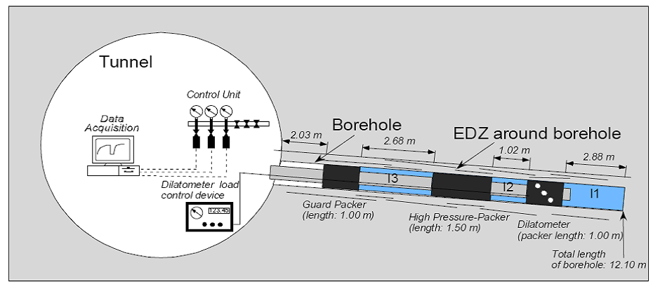

Figure 1: Experiment layout long term dilatometer experiment

References

F. Bernier, X.L. Li, W. Bastiaens, L. Ortiz, M. Van Geet, L. Wouters, B. Frieg, P. Blümling, J. Desrues, G. Viaggiani, C. Coll, S. Chanchole, V. De Greef, R. Hamza, L. Malinsky, A.Vervoort, Y. Vanbrabant, B. Debecker, J. Verstraelen, A. Govaerts, M. Wevers, V. Labiouse, S. Escoffier, J.-F. Mathier, L. Gastaldo, Ch. Bühler (2004) Selfrac: fractures and self-healing within the excavation disturbed zone in clays. Final technical publishable report, 5th EURATOM Framework Programme.
P. Bossart, P.M. Meier, A. Moeri, Th. Trick, J.C. Mayor (2002) Geological and hydraulic characterization of the excavation disturbed zone in the Oplinus clay of the Mont Terri Rock Laboratory, Engineering Geology, vol. 66, pp. 19-38.
Ch. Bühler (2005) Selfrac (SE) Experiment: long term dilatometer experiment. Mont Terri Project - Technical Note, TN 99-03.
J. Liu, D. Elsworth, B.H. Brady (1999) Linking stress-dependant effective porosity and hydraulic conductivity fields to RMR. International Journal of Rock Mechanics and Mining Sciences, vol. 36, pp. 581-596.
D.T. Snow (1969) Anisotropic permeability of fractured media. Water Resources Research, vol. 5(6), pp. 1273-1289.

