Anti-E6/E7/MCL1 pegylated lipoplexes for a vaginal treatment of cervical cancer
Anna Lechanteur^{1,2}, Tania Furst¹, Brigitte Evrard¹, Philippe Delvenne², Géraldine Piel¹, Pascale Hubert²

¹ University of Liege, Laboratory of Pharmaceutical Technology and Biopharmacy-CIRM, Liège, Belgium, email: anna.lechanteur@ulg.ac.be, geraldine.piel@ulg.ac.be
² University of Liege, Laboratory of Experimental Pathology, GIGA-CANCER, Liège, Belgium, email: p.hubert@ulg.ac.be

INTRODUCTION
In the field of nanoparticles, cationic liposomes are promising strategy to protect and transport siRNA into the cytoplasm. The resultant cationic nanovectors built with siRNA and liposomes are called lipoplexes¹. In this study, lipoplexes are developed in the context of cervical cancer². Human Papillomaviruses (HPV16 essentially) are responsible for this cancer by the over expression of two oncoproteins, E6 and E7. They are essential players in order to immortalize keratinocytes by decreasing tumor suppressor genes (p53 and pRb). Moreover, MCL-1 an anti-apoptotic protein is also over expressed in cervical lesion compared to normal cervix.
The aim of this study is to develop pegylated lipoplexes with appropriate physico-chemical properties in order to use them by vaginal application. In this case, the addition of a hydrophilic polymer (polyethylene glycol) is essential to decrease adhesive interaction with cervico-vaginal mucus³. Then, these lipoplexes must cross the anionic cellular membrane and release siRNAs into the cytoplasm to target mRNA E6/E7/MCL-1 and finally, induce the re-expression of p53 protein and apoptosis of HPV16 cells.

EXPERIMENTAL METHODS

Liposomes and lipoplexes formulations
DOTAP/Chol/DOPE (molar ratio 1/0.75/0.5) liposomes were prepared using the hydratation of lipidic film method. Liposome and siRNA were used at a N/P ratio of 2.5 (based on previous studies). Both were simply mixed together to a final siRNA concentration of 100nM and left at room temperature for 30 minutes. Polyethylene glycol 750 and 2000 (DSPE-PEG) were added by post insertion technique (30 % of DOTAP in molar ratio) at 37°C during one hour. Lipoplexes were then characterized (size and ζ potential, Quant-iT™ RiboGreen® RNA reagent).

Transfection assays
SiHa cells (HPV16 positive cells) were transfected with lipoplexes during 1 day and then analyzed with flow cytometry (FACS Canto II, Becton Dickinson) and confocal microscopy (Leica SP5). siRNA labeled with fluorescein was used at a final concentration of 100nM.

qRT-PCR on mRNA E6 and mRNA E7
Total cellular RNA was prepared using Macherey-Nagel protocol. For reverse transcription, SuperScript®III (InvitrogenTM) was employed and qPCR analysis (SYBR Green detection) was performed with E6 and E7 primers and GAPDH primer for the normalization. We analyzed the efficiency of siRNA anti-E6 and anti-E7 two days post transfection in comparison to inactive siRNA.

Western blot analysis: p53 protein
Two days after the transfection, Western Blot analysis was performed to detect the re-expression of p53 protein. The proteins extraction was performed by RIPA lysis and extraction buffer (Pierce biotech, Rockford IL, USA). Primary antibody was anti-p53 mouse monoclonal antibody (Santa Cruz Biotechnology, INC) and secondary antibody was rabbit anti-mouse HRP (Dako, Carpinteria, US). Actin protein level was used as a control for equal protein loading.

Proliferation and apoptosis assay
Three days after transfection, alamar Blue® (AbD serotec, Oxford, UK) proliferation assay was performed. 200µL of reagent were added in cell medium during 1-2 hours and 100µL were analyzed by fluorescence spectroscopy in triplicate. Then, to detect apoptosis, cells were collected and treated with FITC Annexin V Apoptosis Detection kitI (BD Pharmingen, Calif, USA) and analyzed by flow cytometry (FACS Calibur, BD biosciences, Calif, USA). These experiments were performed on HPV 16 positive keratinocytes (SiHa) and on immortal human keratinocytes (Hacat).

Results and discussion

Lipoplexes characterization
The size of lipoplexes at a N/P ratio of 2.5 is ±200nm, the polydispersity index (PDI) is 0.2, ζ potential is +45mV and complexation efficiency is high. The addition of 30 % of PEG₇₅₀ and PEG₂₀₀₀ does not modify the size and the complexation efficiency. However, the addition of 30 % of PEG750 and PEG₂₀₀₀ influences the ζ potential which slightly decreases to +30mV and increases the PDI to 0.3.

Transfection potential
Flow cytometry assays show that ± 90 % of cells are transfected with high mean fluorescence intensity (MFI). These results are confirmed with confocal microscopy images where green spots represent fluorescent siRNA. The fluorescent siRNA is present into the cytoplasm and not in the nucleus (represented in blue). Same results were observed for pegylated lipoplexes (figure1).
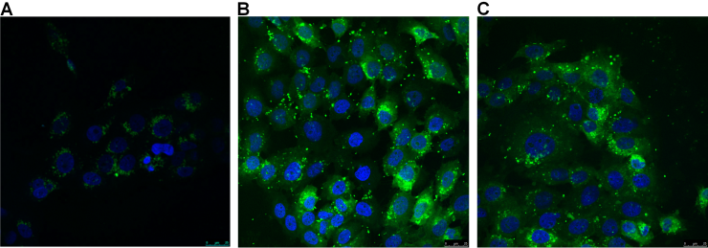
Figure 1. Confocal microscopy images of SiHa cells treated with empty liposomes (A), lipoplexes (B) and lipoplexes with 30% of DSPE-PEG₂₀₀₀ (C). Nucleuses are represented in blue (DAPI) and fluorescein labeled-siRNA in green (final siRNA concentration 100nM).

Lipoplexes induce the re-expression of p53 protein
Two days after transfection, pegylated lipoplexes anti-E6 or anti-E7 turned off mRNA E6 and mRNA E7 compared to inactive siRNA (qRT-PCR assay). Both 750 and 2000 pegylated lipoplexes also induce the re-expression of the p53 protein (figure 2).
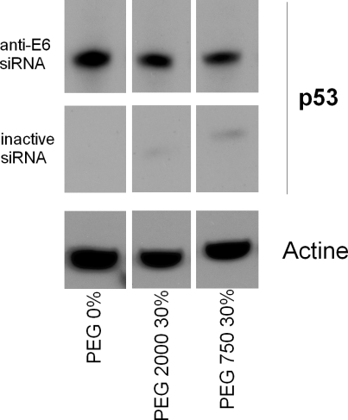
Figure 2. Expression of p53 protein after the transfection of anti-E6 lipoplexes compared to inactive siRNA.

Combination of anti-E6/E7/MCL-1 siRNA induce apoptosis and decrease proliferation of HPV16 cells
Lipoplexes containing a combination of three different siRNA (siE6+siE7+siMCL-1) at a final concentration of 150nM were added in cell medium during three days. Compared to inactive siRNA, anti-E6/E7/MCL-1 siRNA reduce significantly the proliferation of SiHa cells and activate the apoptosis (figure3). Moreover, same combination of three effective siRNA does not reduce the proliferation and does not induce apoptosis on Hacat cells. It proves that lipoplexes formulations effective on cancer cells do not have any effect on healthy cells.
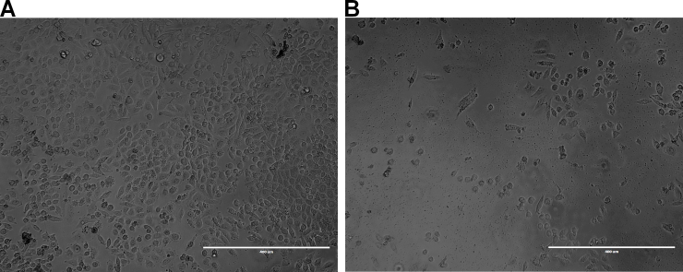 Figure 3. SiHa cells treated with lipoplexes containing inactive siRNA (A) and lipoplexes containing the combination of anti-E6/E7/MCL-1 siRNA (B) three days post transfection (final siRNA concentration 150nM).

Conclusion
siRNA complexed with DOTAP/Chol/DOPE (molar ratio 1/0.75/0.5) pegylated lipoplexes show appropriate properties in terms of size, polydispersity, ζ-potential and complexation for vaginal application. These pegylated lipoplexes cross easily the cellular membrane and release-siRNA into the cytoplasm. siRNA anti-E6 and anti-E7 induce a high re-expression of p53 protein in cervical cancer positive cell line (SiHa). Moreover, the combination with a third siRNA against the anti-apoptotic protein MCL-1, decreases significantly the proliferation and induce the apoptosis of HPV16 cancer cells unlike healthy cells. These pegylated lipoplexes seems to be an appropriate delivery system in order to fight cervical cancer by vaginal application.

RefeRences
1. Patil SD, urgess D J, Kapoor M, Physicochemical characterization techniques for lipid based delivery system for siRNA, International Journal of Pharmaceutics, 427 (2012) 35-57
2. Einstein M H, Stern P, et al, Therapy of Human Papillomavirus-Related Disease, Vaccine, 30S (2012) F71-F82
3. Hanes J, Wang Y-Y,Lai S K, Mucus-penetrating nanoparticles for drug and gene delivery to mucosal tissues, Advanced Drug Delivery Reviews, 61 (2009) 158-171

