

*Global Biogeochemical Cycles*

Supporting Information for

**The age of river-transported carbon: a global perspective**

Trent R. Marwicka,1, Fredrick Tamooha, Cristian R. Teodorua, Alberto Vieira Borgesb, François Darchambeaub & Steven Bouillona

aDepartment of Earth and Environmental Sciences, Katholieke Universiteit Leuven (KU Leuven), Celestijnenlaan 200E, B-3001 Leuven, Belgium

bChemical Oceanography Unit, University of Liège (ULg), Institut de Physique (B5), 4000 Liège, Belgium

1Corresponding author:

Trent R. Marwick. Department of Earth and Environmental Sciences, Katholieke Universiteit Leuven (KU Leuven), Celestijnenlaan 200E, B-3001 Leuven, Belgium. Phone: +61 416 735 405. Email: [trent.marwick@gmail.com](mailto:trentrichard.marwick@gmail.com)

**Contents of this file**

Figure S1

Tables S1 to S2

Caption for Data Set S1

**Additional Supporting Information (Files uploaded separately)**

Marwicketal-ds01.xls

**Introduction**

This file contains (i) a Supplementary Figure showing the distribution of sampling localities for the new African river and stream ∆14C data for organic carbon presented in the main text, (ii) two Supplementary Tables referred to in the main text, and (iii) the captions for Data Set S1, comprising the new data from Africa presented here and the full literature ∆14C dataset (which can be found in an associated excel file).

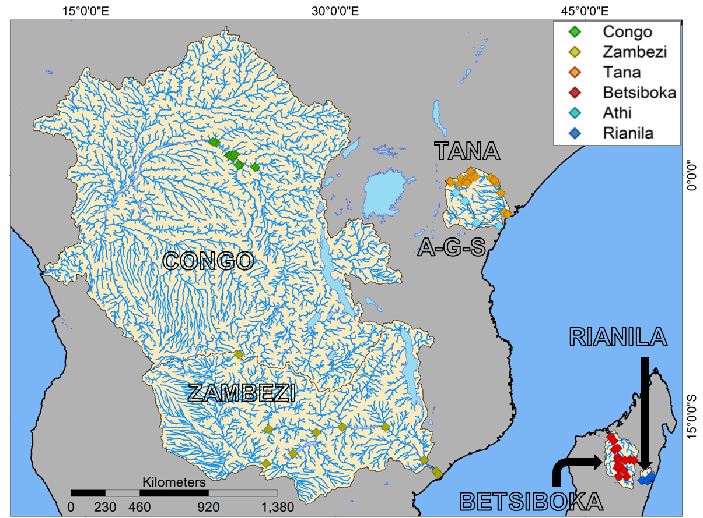

Figure S1. Site locations of the new riverine 14C data for POC and DOC in six African river basins. Site settings vary from small headwater and major tributaries to the primary artery of the river basin, including repeat measurements during variable flow conditions (low to high discharge) related to the typical seasonality (dry and wet season) of each region, encompassing the δ13C gradient from C3- to C4-dominant vegetation cover, and ranging in altitude from ~0-2000 m.a.s.l.



**Table S1.** Basin δ13C and ∆14C of POC and DOC range and average (± 1 SD where appropriate) for the six African basins presented in the main text. The full dataset is available in Data Set S1 Table 1.



**Table S2.** Total suspended matter (TSM) classes and their contribution to the global particulate organic carbon (POC) flux (from *Mayorga et al.*, 2010). These values were employed for estimating the median global riverine ∆14CPOC signature of −203‰ (~1800 yr BP).

Data Set S1. Table 1. New radiocarbon (14C) and ancillary data for the six African river basins presented in the main text. The dataset includes names of the drainage basin and site where samples were gathered, the site ID, the climatic season and date of sampling, as well as the site co-ordinates in decimal degrees and altitude in meters above seas level (m a.s.l.). In order, biogeochemical parameters are: the bulk concentrations of total suspended matter (TSM) and particulate organic C (POC), stable- and radio-C isotopes ratios for POC (δ13CPOC and ∆14CPOC, respectively), the bulk concentration of dissolved organic C (DOC), and stable- and radio-C isotopes ratios for DOC (δ13CDOC and ∆14CDOC, respectively).

Data Set S1. Table 2. Full dataset for the literature compilation of radiocarbon (14C) measurements and ancillary parameters for riverine carbon (C) pools. The dataset includes names of the drainage basin and river or site where samples were gathered, and the date of sampling. In order, biogeochemical parameters are: the bulk concentrations of total suspended matter (TSM) and particulate organic C (POC), percent contribution of POC to the TSM load (%POC), stable- and radio-C isotopes ratios for POC (δ13CPOC and ∆14CPOC, respectively), the bulk concentration of dissolved organic C (DOC), stable- and radio-C isotopes ratios for DOC (δ13CDOC and ∆14CDOC, respectively), the bulk concentration of dissolved inorganic C (DIC), the stable- and radio-C isotopes ratios for DIC (δ13CDIC and ∆14CDIC, respectively), and the shorthand literature citation for the data source. Full data source citations are provided in the adjoining spreadsheet. The new African data in Data Set S1 Table 1 has also been included here for ease-of access. The compilation represents our best attempt to integrate the available information, yet nomenclature for study sites varies considerably and at times little or no information is provided in the literature (e.g. site names, sampling dates etc.). Regardless, we believe there is sufficient information for readers and future users to re-trace the origin of specific data points, and expand on missing parameters where feasible.