Multi-scale model of the cardiovascular system
S. Kosta¹, A. Pironet¹, J.A. Negroni², E.C. Lascano², P.C. Dauby¹
¹ University of Liege, GIGA-Cardiovascular Sciences, Liege, Belgium
² Department of Physiology, Pharmacology and Biochemistry, Favaloro University, Buenos Aires, Argentina

Abstract
A multi-scale model of the cardiovascular system (CVS) is presented. Baseline results are provided and discussed.

Keywords: biomechanics – biophysics
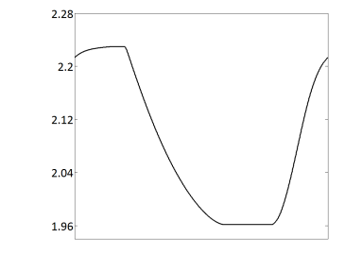
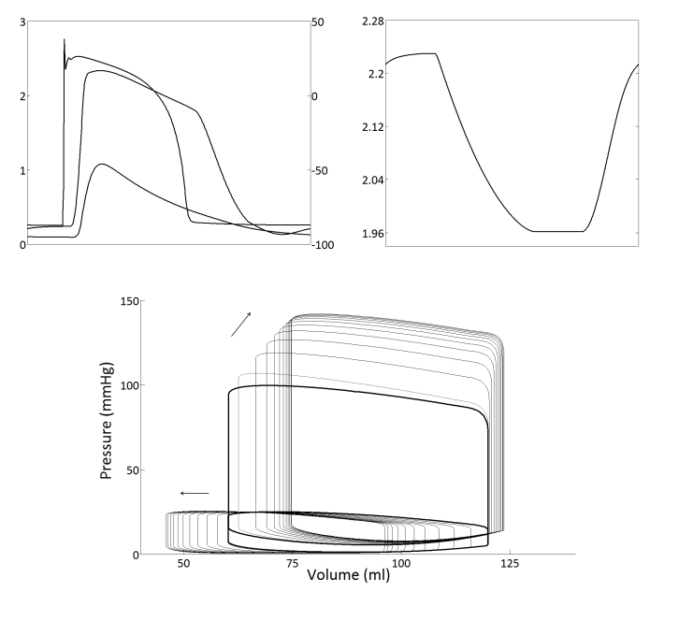
Action potential

Introduction
Sarcomere length
Force

Mathematical models of biological systems have become a powerful tool for cardiovascular sciences. They allow for a variety of studies that are generally difficult to implement experim-entally. Many CVS models describe the heart contraction at the organ scale with pheno-menological models (like the varying elastance model). In this work a more realistic model of the CVS is presented, where the detailed biophysics of heart contraction is alternatively described at the cellular scale.
mV
µm
mN/mm², µM
Calcium
- Methods
The CVS is described with a 6-chamber model, 2 of which being able of active contraction (the left and right ventricles).
The contraction is described at the cellular scale with two mathematical models:
Fig. 1
- The electrophysiology of the cardiac cell is described by the Ten Tusscher et. al model [1].
- The mechanical contraction of the sarcomeres is described by the Negroni and Lascano model [2].
The cellular and the organ scales are connected by assuming spherical ventricles. Thus cellular (microscopic) properties (force and length) are connected to organ (macroscopic) properties (pressure and volume).
Particular attention was paid to the sarcomere length during a heartbeat. Model parameters were adjusted so that this length varies between physiologically relevant extremes, i.e. between 1.96 and 2.24 µm.
- Results
Results obtained for one beat are presented on Fig.1. Action potential (mV), calcium concentra-tion (µM), force (mN/mm²) and sarcomere length (µm) are shown in the first two panels (left ventricle only). The corresponding pressure-volume (PV) loops (left and right ventricles) are depicted in bold black in the last panel. PV loops resulting from increasing the systemic resistance are also shown in gray.
- Conclusion
Previous studies have shown the importance of models based on the microscopic scale in order to reproduce a wide range of experimental macroscopic behaviours. Our multi-scale model of the CVS can account for baseline results like those presented on Fig.1. We can now consider the study of pathologic behaviours (like heart failure) both at the cellular and the hemodynamic scales.

Acknowledgment P.C.D. acknowledges travel financial support from F.R.S.-FNRS.
[1] K. H. ten Tusscher and A. V. Panfilov, American Journal of Physiology-Heart and Circulatory Physiology 291, H1088 (2006).
[2] J. A. Negroni and E. C. Lascano, Journal of molecular and cellular cardiology 45, 300 (2008).

