Interaction between dietary protein content and the source of carbohydrates along the gastrointestinal tract of weaned piglets

Robert Pieper^{a1}, Christelle Boudry^{b}, Jérôme Bindelle^{b}, Wilfried Vahjenª, Jürgen Zentekª

ª Institute of Animal Nutrition, Department of Veterinary Medicine, Freie Universität Berlin, Königin-Luise-Str. 49, 14195 Berlin, Germany
^{b} Animal Science Unit, Gembloux Agro-Bio Tech, University of Liège, Passage des Déportés 2, 5030 Gembloux, Belgium

¹ Corresponding address: Institute of Animal Nutrition, Department of Veterinary Medicine, Freie Universität Berlin, Königin-Luise-Strasse 49, D-14195 Berlin, Germany
robert.pieper@fu-berlin.de

Interaction between dietary protein content and the source of carbohydrates along the gastrointestinal tract of weaned piglets
Although fermentable carbohydrates (CHO) can reduce metabolites derived from dietary protein fermentation in the intestine of pigs, the interaction between site of fermentation and substrate availability along the gut is still unclear. The current study aimed at determining the impact of two different sources of carbohydrates in diets with low or very high protein content on microbial metabolite profiles along the gastrointestinal tract of piglets. Thirty-six piglets (n=6 per group) were fed diets high (26%, HP) or low (18%, LP) in dietary protein and with or without two different sources of carbohydrates (12% sugar beet pulp, SBP, or 8% lignocellulose, LNC) in a 2 x 3 factorial design. After 3 weeks, contents from stomach, jejunum, ileum, cecum, proximal and distal colon were taken and analysed for major bacterial metabolites (D/L-lactate, short chain fatty acids, ammonia, amines, phenols and indols). Results indicate considerable fermentation of CHO and protein already in the stomach. HP diets increased the formation of ammonia, amines, phenolic and indolic compounds throughout the different parts of the intestine with most pronounced effects in the distal colon. Dietary SBP inclusion in LP diets favoured the formation of cadaverine in the proximal parts of the intestine. SBP mainly increased CHO derived metabolites such as SCFA and lactate and decreased protein-derived metabolites in the large intestine. Based on metabolite profiles, LNC was partly fermented in the distal large intestine and reduced mainly phenols, indols and cadaverine, but not ammonia. Multivariate analysis confirmed more diet-specific metabolite patterns in the stomach, whereas the CHO addition was the main determinant in the cecum and proximal colon. The protein level mainly influenced the metabolite patterns in the distal colon. The results confirm the importance of CHO source to influence the formation of metabolites derived from protein fermentation along the intestinal tract of the pig.

Key words: pig, dietary protein, carbohydrates, gastrointestinal tract, short chain fatty acids, biogenic amines, phenols

1. Introduction
The porcine gastrointestinal tract (GIT) harbours a highly diverse and dynamic microbial ecosystem, that plays an important role in maintenance of intestinal health, contributes to nutrient utilization and modulation of the immune system (Willing and Van Kessel 2010). Dietary manipulation of the intestinal microbiota in pigs has received increasing attention by researchers and the feed industry during the past decades (Heo et al. 2013). Nutrient composition in the basal diet, feed additives as well as endogenous secretions can serve as substrate for the indigenous microbiota and thus may alter their composition and activity with implications for the host. For example, the fermentation of undigested dietary protein and proteins of endogenous origin entering the large intestine yields putatively toxic metabolites such as ammonia, biogenic amines, hydrogen sulphide, indols and phenolic compounds (Blaut and Clavel 2007; Rist et al. 2013). Some of these products can impair epithelial integrity and promote inflammatory reactions (Hamer et al. 2012; Windey et al. 2012). Thus, it is not surprising that, for example, high amounts of dietary protein or low quality proteins have been associated with increased risk for enteric diseases caused by enteropathogens in piglets (reviewed by Rist et al. 2013). The inclusion of specific carbohydrates (CHO), that are non-digestible by host enzymes but fermentable by the GIT bacteria, into swine diets has been shown as a promising approach to reduce the concentration of protein-derived fermentation end products in the large intestine (Bikker et al. 2006; Heo et al. 2012; de Lange et al. 2010; Pieper et al. 2012a; Rist et al. 2013). On the other hand, microbial colonisation is not only restricted to the large intestine and a highly diverse and abundant microbial community can be found already in the stomach, jejunum and ileum of pigs (Castillo et al. 2007; Pieper et al. 2008; Vahjen et al. 2010; Zentek et al. 2013). As a result, considerable bacterial fermentation can already occur in the stomach of pigs with the formation of CHO- and protein-derived metabolites, such as lactic acid, short chain fatty acids and ammonia (Clemens et al. 1975; Regina et al. 1999; Nyachoti et al. 2006; Mair et al. 2010; Zentek et al. 2013). Thus, whereas interactions of protein and carbohydrate fermentation patterns have been intensively studied in the pig large intestine, there is limited information available about such interactions along the entire GIT in swine. Bacterial substrate utilisation depends on the chemical composition, physical form, solubility and amount of the available substrates in the different sites of the GIT. Thus, dietary inclusion of either soluble (e.g. pectin-rich) or hardly soluble (e.g. cellulose-rich) substrates may determine to which extend and where in the porcine GIT they may be mainly utilised to contribute to a reduction of protein-derived metabolites.
The current study aimed at studying the influence of dietary protein level and the source of carbohydrates on the formation of microbial metabolites along the GIT of weaned piglets as a basis for future diet formulations facilitating reduced formation of protein derived metabolites with subsequent implications for host health.

2. Material and Methods
The study followed the institutional and national guidelines for the care and use of animals, and the study was approved by the State Office of Health and Social Affairs ‘Landesamt für Gesundheit und Soziales Berlin’ (LaGeSo Reg. #0389/12).

2.1 Animals and housing
A total of 36 piglets (Euroc x Piétrain) with a mean body weight of 7.4 ± 1.0 kg was weaned at 25 d of age and placed in commercial flat deck pens (n = 2 piglets/pen) balancing for gender and body weight (BW). Pens were assigned to one of six treatment groups in a 2 x 3 design. Water and feed were provided ad libitum. Room temperature was maintained at 26 ˚C on the day of weaning and reduced at regular intervals to achieve 22 ˚C during the first week post weaning. The lighting program was maintained at 14 h light, 10 h dark with lights switched on at 05:00 h. Feed intake and BW of pigs were recorded weekly. Health status including behaviour, appearance and faecal consistency was checked daily.

2.2 Diets
Six diets were formulated to provide a high (HP) or low (LP) level of dietary protein in combination with a high or low level of two different sources of fermentable CHO as shown in Table 1.

Place Table 1 approximately here

Piglets were fed the respective diets for 3 weeks before euthanasia and subsequent sampling of digesta and tissues. Diets were formulated to meet or exceed nutrient requirements of the weaning pig (GfE 2006). The source of excess protein in HP diets was a combination of soybean meal, fishmeal and potato protein. Non-digestible but fermentable carbohydrates were supplied as sugar beet pulp (SBP) or a mixture of lignin and cellulose (lignocellulose, LNC, Arbocel, containing approximately 70% cellulose from birch wood) to replace corn and wheat. Thus, the term “low CHO” was used for the two diets containing low levels of non-digestible but fermentable CHO although they contained higher amounts of starch than diets containing SBP or LNC. Supplemental lysine and tryptophane were added to the LP diets to balance for similar essential amino acid contents according to requirements among the diets.

2.3 Sampling
Piglets were euthanized on day 21 ± 1 after the weaning by intracardial injection of 10 mg/kg BW of tetracaine hydrochloride, mebezonium iodide and embutramide (T61®, Intervet, Unterschleißheim, Germany) after sedation with 20 mg/kg BW of ketamine hydrochloride (Ursotamin®, Serumwerk Bernburg AG, Germany) and 2 mg/kg BW of azaperone (Stresnil®, Jansen-Cilag, Neuss, Germany). Following euthanasia, the entire intestinal tract was removed from the peritoneum; intestinal segments were clamped to avoid digesta mixing and digest contents from stomach, ileum, caecum, colon ascendens, colon descendens, and rectum were taken and immediately stored at -80°C until further analysis.

2.4 Chemical analyses
Weende proximate nutrients (ash, crude fibre, crude protein, ether extract) and starch were determined using standard procedures (Naumann and Bassler 2004). Total dietary fibre was analysed using a commercial kit (Megazyme K-TDF, Megazyme, Bray, Ireland). Trace mineral content in feedstuff was determined by atomic absorption spectrometry in an AAS vario 6 spectrometer (Analytik Jena, Jena, Germany) after hydrolysis of samples in concentrated hydrochloric acid.
For determination of D- and L-lactate, ileal samples were treated with 0.5 M CuSO₄ prior to analysis by high performance liquid chromatography on an Agilent 1100 chromatograph equipped with a Phenomenex C18 (4.0 x 2.0 mm) guard column followed by a Phenomenex Chirex 3126 (D)-penicillamine column (150 x 4.6 mm) and a UV detector at 253 nm. The carrier was CuSO₄ in a gradient from 0.5 to 2.5 mmol/L with a flow rate of 1.0 ml/min at 35 °C and the injection volume was 20 µl.
Ammonia was analysed colorimetrically using the Berthelot-Reaction as described previously (Pieper et al. 2012a). Briefly, 20 µl of a sample was chlorinated with 100 µl of 0.2 % alkaline hypochloride (Sigma Aldrich, Deisenhofen, Germany) to convert NH₃ to chloramine (NH₂Cl) following reaction with thymol to N-chlor-2-isopropyl-5-methyl chinon-monoimin and further to indophenol using 100 µl of 5 % phenol nitroprusside (Sigma Aldrich, Deisenhofen, Germany). Samples were incubated in microtitration plates for 100 min and extinction was measured at 620 nm in a Tecan Sunrise™ microplate reader (Tecan Austria GmbH, Grödig, Austria).
Biogenic amines (putrescine, cadaverine, tyramine, histamine, spermidine and spermine) were analysed as described previously (Pieper et al. 2012b) with ion-exchange chromatography on a Biochrom 30 Amino Acid Analyzer (Biochrom Ltd., Cambridge, UK). Briefly, samples (0.5 g) were treated with trichloro acetic acid (10 %), homogenized and filtered through 0.2 µm membranes. Samples (25 µL injection volume) were separated on a 10 cm polyamine ion-exchange column (Laborservice Onken GmbH, Gründau, Germany). Sodium citrate buffer (pH 7.2) was used as eluent and the amines were quantified after post-column ninhydrin derivatisation by photometric detection at 570 nm.
Short chain fatty acids (SCFA), phenols and indols were determined by gas chromatography on an Agilent 6890 gas chromatography system with flame ionization detector and autosampler (Agilent Technologies, Böblingen, Germany). For SCFA analysis, digesta samples were acidified with oxalic acid, centrifuged for 3 min at 14,000 g followed by addition of the internal standard (caproic acid). Individual SCFA were separated on a polyethylene glycol column (30 m by 530 µm by 1.00 µm; HP-INNOWax). Hydrogen was used as carrier gas and the injection volume was 1 µl. The flow rates of hydrogen and air were 20 and 400 ml/min, respectively. The initial oven temperature was 70 °C, followed by an increase at a rate of 15 °C/min and then a final temperature of 190 °C for 4 min.
Phenols and indols (i.e. phenol, 4-methylphenol (p-cresol), 4-ethylphenol, indole, 2-methylindole, 3-methylindole (skatole), 7-methylindole, 2,3-dimethylindole) were double extracted from the samples with methanol after addition of 5-methyindole as internal standard followed by centrifugation at 29,000 x g for 20 min. Phenols and indols were separated on a high polarity 88% cyanopropyl 12% arylpolysiloxane column (60 m x 250 µm, film thickness0.2 µm, HP-88). Hydrogen was used as carrier gas and the flow rates of hydrogen and air was 40 and 400 ml/min, respectively. The initial oven temperature was 130 °C and the final temperature was 220 °C for 2 min.

2.5 Statistical analysis
Principle component analysis (PCA) was performed using the programme CANOCO (Ter Braak and Šmilauer 2002) for each part of the GIT using square root transformed values for metabolite patterns to illustrate the association of patterns with the experimental diets along the pig GIT. Data were then analysed using generalised linear model procedures in SPSS (version 19.0, Chicago, IL, USA) with dietary protein level (HP or LP), SBP and LNC as main factors. Additionally, Pearson correlation analysis was performed. Differences at p < 0.05 were considered significant.

3. Results
3.1 Performance
After the first experimental week, piglets receiving the LNC diets showed significantly reduced body weight (7.2 ± 1.5 and 7.0 ± 1.3 kg for both LNC groups, respectively) as compared to their initial weight and the other feeding groups (8.6 ± 2.1, 8.3 ± 1.9, 8.6 ± 1.5 and 7.4 ± 1.3 kg for LP/low CHO, LP/SBP, HP/low CHO and HP/SBP groups, respectively). This was mainly due to the fact that piglets had lower feed intake and thus, body weight gain (data not shown). Piglets adapted to LNC diets after approximately 10 days but still showed numerically lower feed intake and did not catch up in body weight (p < 0.05) as compared to the other experimental groups until the end of the experimental period. Mean body weight after 21 days was 12.9 ± 2.2, 12.8 ± 2.4 and 11.3 ± 1.9 kg for groups fed LP and low CHO, SBP or LNC, respectively; and 14.2 ± 1.8, 12.8 ± 2.1, and 11.1 ± 1.2 for groups fed HP and low CHO, SBP or LNC, respectively.

3.2 Correlation analysis
The PCA plots to illustrate the interaction between metabolites in the different sites of the intestine are given in Figure 1A-E. In the stomach (Figure 1A), metabolite profiles of piglets fed diets containing LP/low CHO levels formed a separate cluster (open circles) as compared to diets containing LP and SBP (grey circles) or LNC (black circles), and diets with HP (triangles). Interestingly, most profiles from piglets fed HP/low CHO diets (open triangles) formed a separate cluster, whereas this was not as clear for HP diets with SBP or LNC.
No obvious clustering of metabolite profiles was observed in the ileum (Figure 1B), although mainly the profiles from piglets fed HP diets with LNC (black triangles) were more distinct from the other profiles.
In the cecum (Figure 1C), three main clusters could be observed. One cluster was formed by metabolite profiles of piglets fed HP/ low CHO diets (open triangles), whereas a grouping of most profiles from pigs fed high SBP (grey circles and triangles) or LNC (black circles and triangles) could be observed irrespective of dietary protein content.
The picture of carbohydrate-dependent clustering of metabolite profiles became more obvious in the proximal colon (Figure 1D). Three main clusters based on low CHO (open circles and triangles), SBP (grey circles and triangles) or LNC (black circles and triangles) supply could be observed in this site of the GIT.
In the large intestine (Figure 1E), only one distinct cluster based on HP diets (open, grey and black triangles) could be observed, whereas the other profiles showed no clear or distinct clustering patterns.

3.3 Intestinal metabolite patterns along the GIT
In the stomach, pH was not affected by dietary treatment (Table 2). Total SCFA, acetate, and D-lactate were significantly increased with SBP and L-lactate with LNC, without an effect of dietary protein level. Total SCFA, acetate, propionate and butyrate were increased with SBP (p < 0.05) as compared with the other diets. Both CHO sources (SBP and LNC) increased propionate and butyrate molar ratio at the expense of acetate (p < 0.05). Ammonia was significantly elevated by HP as compared to LP diets (p < 0.05), but not affected by CHO level and source. Significantly higher concentration of total amines was determined with diets containing high levels of SBP as compared with the other diets. Cadaverine was significantly higher with LP diets, and highest cadaverine levels were determined in diets containing SBP in both LP and HP diets, respectively. A tendency towards higher histamine levels was determined with LP diets, and towards increased values with high LNC diets. Similarly,a higher level of phenol (p < 0.05) as well as a tendency towards reduced concentration of p-cresol was determined with LP as compared to HP diets. Other phenolic compounds or indols were not detectable in stomach digesta.

Place Table 2 approximately here.

In the ileum, pH, D-, L-lactate, acetate, butyrate and total SCFA were not altered by dietary treatment (Table 3). Propionate was only detected occasionally. However, HP diets and HP diets with LNC reduced (p < 0.05) acetate molar ratio and increased (p < 0.05) propionate (HP and LNC) and butyrate (HP). HP diets increased (p < 0.05) ammonia in ileal digesta compared to LP diets. HP also increased (p < 0.05) total amine and putrescine concentration and reduced phenol in the ileum. No influence of SBP was determined on ileal metabolites.

Place Table 3 approximately here.

Caecal pH and lactate levels were unaffected by dietary treatment (Table 4). Total SCFA levels were increased by HP diets and reduced by LNC diets, whereas BCFA were reduced by SBP (p < 0.05). Total concentration of acetate was increased by both HP and SBP, and reduced by LNC diets (p < 0.05). In contrast, propionate was reduced (p < 0.05) by SBP and LNC. Acetate molar ratio was increased (p < 0.05) and tended to increase (p < 0.10) with SBP and LNC, respectively. Propionate and butyrate molar ratios were increased (p < 0.05) by dietary HP level, whereas propionate level was reduced (p < 0.05) with SBP. Ammonia levels were higher with HP (p < 0.05) and reduced by SBP diets (p < 0.05). Similarly, dietary SBP inclusion reduced (P<0.05) total amine and histamine concentration, whereas HP diets led to increased histamine in caecal digesta. Spermidine concentration was reduced with LNC diets and a tendency towards reduced levels of spermine and spermidine was also observed for SBP diets (p < 0.10). Dietary SBP inclusion decreased (p < 0.05) p-cresol and indole levels, whereas HP diets increased (p < 0.05) 4-ethylphenol and tended to increase indol.

Place Table 4 approximately here.

In the proximal colon, both HP and SBP tended (p < 0.10) to increase total SCFA levels (Table 5). D-/L-lactate and pH were not affected. Total acetate and acetate molar ratio was increased and propionate molar ratio decreased (p < 0.05) with SBP diets. Dietary LNC decreased (p < 0.05) propionate concentration and a tendency towards decreased propionate was determined with SBP diets. Butyrate also tended to be higher (p < 0.10) with HP diets. The HP diets also increased (p < 0.05) ammonia concentration whereas SBP significantly decreased ammonia levels. The sum of all measured amines was increased with HP, whereas both SBP and LNC led to decreased levels (p < 0.05). This was mainly due to changes in cadaverine concentrations, whereas the other amines were not significantly altered by diet. Both SBP and LNC inclusion decreased (p < 0.05) p-cresol concentrations and SBP tended to decrease (p < 0.10) indole concentration. The level of 3-methylindole (skatole) was significantly decreased with LNC.

Place Table 5 approximately here.

The pH values of pigs fed HP diets were significantly lower in the distal colon (Table 6). SBP inclusion increased both D- and L-lactate and total SCFA levels (p < 0.05), whereas protein level and LNC had no effect. Total acetate and acetate molar ratio were also increased and propionate molar ratio decreased with SBP diets, whereas acetate molar ratio was decreased with HP diets (p < 0.05). A tendency towards increased cadaverine levels was observed with HP diets as compared to LP diets, and this was reversed by SBP (p < 0.10) and LNC (p < 0.05). None of the other measured amines were significantly changed by dietary treatment. Phenol, p-cresol and 3-methyindole (skatole) were increased (p < 0.05) with HP diets. SBP diets tended (p < 0.10) to decrease p-cresol and indole concentration, whereas LNC decreased phenol (p < 0.10), 4-ethylphenol (p < 0.05) and 3-methylindole levels (p < 0.05).

Place Table 6 approximately here.

4. Discussion
Dietary protein level and the targeted use of dietary fibre in diets for piglets have been discussed intensively and controversially during the past decade (e.g. Bindelle et al. 2008; Metzler and Mosenthin 2008; Bach Knudsen et al. 2012; Heo et al. 2013; Rist et al. 2013; Molist et al. 2014). The focus of most previous studies has directed towards the large intestine. In the current study, a 2 x 3 factorial design was used to study the formation of bacterial metabolites along the entire GIT of pigs fed two different protein levels and with or without addition of two different sources of soluble (SBP) or insoluble (LNC) carbohydrates.

4.1 Influence of dietary protein level and dietary fibre on piglet performance
It is well established that increased inclusion of dietary fibre reduces the energy concentration of the diet, may decrease digestibility of other nutrients, reduce palatability, increase digesta viscosity, and transit through the GIT (Molist et al. 2014). In the current experiment, the inclusion of LNC into the diet significantly decreased feed intake and thereby growth rates, especially during the first experimental week. Similarly, a tendency towards reduced growth rates was observed for SBP during the second week. This is in good agreement with previous studies where the inclusion of guar gum or cellulose reduced feed intake and daily weight gain in piglets, likely through reduced energy and protein digestibility (Owusu-Asiedu et al. 2006). In the current study, ileal and total tract nutrient digestibility was not determined. Thus, it cannot be clarified whether the effect were due to reduced palatability, nutrient digestibility or other factors such as digesta transit and satiety.

4.2 Impact of dietary protein level on intestinal metabolite profiles
Increased dietary protein supply or poorly digestible proteins are supposed to increase the formation of putatively toxic compounds in the large intestine such as ammonia, biogenic amines, hydrogen sulphide, phenols and indols (Blaut and Clavel 2007; Windey et al. 2012; Rist et al. 2013). The current study shows that the bacterial degradation of proteins starts already in the stomach as indicated by an increased formation of ammonia and, to a lesser extent, amines and, phenol and p-cresol. Reasons for higher level of cadaverine with LP diets are not entirely clear but might be related to free lysine in these diets as discussed below. Generally, the concentration of protein-derived metabolites was low in the proximal GIT and most significant differences were determined in the distal parts. Supporting this, the multivariate analysis of fermentation patterns in the different gut compartments shows that the carbohydrate source was the main factor in the proximal colon and that protein level determined metabolite patterns in the distal colon. This supports the idea that bacteria would utilize fermentable carbohydrates over protein as primary energy source (Miller and Varel 2002). The higher formation of protein-derived metabolites with HP diets in the distal GIT might affect host health as metabolites such as ammonia, amines (e.g. histamine) and phenols may are toxic for intestinal enterocytes and can thereby impair barrier function and allow translocation of pathogenic bacteria (Windey et al. 2012; Rist et al. 2013). For example, in a previous study using low protein and heat-damaged protein levels, it was shown that expression of pro- and anti-inflammatory cytokines and oxidative stress response was increased in the proximal colon with higher dietary and heat-damaged protein (Pieper et al., 2012a). This finding was further supported by an increased epithelial catabolism of histamine and reduced secretory response to histamine with these diets (Kröger et al., 2013). On the other hand, only marginal changes related to barrier function were determined, likely due to a compensatory regulation of tight junction protein expression (Richter et al., 2013). In the current study, also higher levels of n-butyrate were determined with HP diets. Butyrate is considered beneficial in the GIT as it is utilised as energy source by the enterocytes, influences cell turnover and reduces pro-inflammatory cytokine expression (Blaut and Clavel 2007; Willing and Van Kessel 2010). Whether this would have beneficial effects for the animal or may counteract possible negative effect from increased ammonia, or biogenic amine concentrations is not clear and will be studied in our lab in the future.

4.3 Impact of SBP on intestinal metabolite profiles in HP or LP diets
Sugar beet pulp contains mainly soluble dietary fibre, with uronic acids and arabinose being the most predominant sugar monomers (Bach Knudsen 1997). Besides this pectin rich fraction, SBP also contains considerable amounts of insoluble cellulose (Bach Knudsen 1997). Previous studies showed that up to 37% of the pectin-rich fraction in SBP is already fermented before the ileum, and another 50% disappeared in the large intestine of pigs (Graham et al. 1986). Konstantinov et al. (2004) determined a considerable microbial activity and increase in lactobacilli populations in the pig small intestine when diets containing SBP were fed. In the stomach, SBP increased SCFA production and a shift from acetate towards propionate and butyrate, showing the relevance of bacterial fermentation in this part of the porcine GIT. This was also accompanied by an increase in D-lactate levels. This may be due to the presence of high numbers of lactic acid bacteria in the stomach of pigs (Zentek et al. 2013), but could also reflect increased bacterial fermentation of easily accessible substrates due to longer retention times. It has been shown that specific carbohydrate fractions of SBP can promote the growth of lactobacilli and bifidobacteria (Al-Tamimi et al. 2006). Interestingly, the levels of cadaverine and phenol were higher with LP/SBP as compared to the other diets. Cadaverine concentration was significantly correlated with total SCFA, acetate and propionate (R = 0.76, R = 0.75 and R = 0.79, respectively) indicating that the higher fermentation activity was linked with microbial decarboxylation of lysine in the stomach. It is known that the activation of lysine decarboxylases in bacteria due to acid stress (Kanjee et al. 2011) may be a protective reaction of bacteria against increasing acidification (Morris and Fillingame 1974; Tabor and Tabor 1985). Furthermore, certain lysine decarboxylase positive bacteria can increase cadaverine production under co-cultivation conditions with lactic acid bacteria (Kuley et al. 2012). However, the specific mechanisms behind this observation are yet not clarified in the pig.
Inclusion of SBP into the diets at 12% did not significantly change ileal bacterial metabolite profiles but led to highest levels of SCFA in the distal colon. Bacterial fermentation of pectins in the porcine large intestine yields high amounts of acetate (Drochner 2004; Anguita et al. 2007). This is in line with the current study, where SBP diets promoted a significant shift from propionate towards acetate in the cecum, proximal and distal colon. In contrast to the stomach, dietary inclusion of SBP reduced the concentration of protein-derived metabolites such as ammonia, p-cresol or biogenic amines in the cecum and proximal colon. Increased bacterial utilization of fermentable carbohydrates as energy source in the large intestine can also promote the incorporation of ammonia and free amino acids into bacterial protein to facilitate increased biomass production (Bindelle et al. 2008; 2009). Thus, a reduction of large intestinal levels of protein-derived ammonia may not be simply a result of reduced protein fermentation but could also result from increased bacterial biomass turnover in general. It is also possible that there was an increased ammonium uptake from the gut lumen in the presence of higher amounts of SCFA at low pH (Stumpff et al. 2013).

4.3 Impact of LNC on intestinal metabolite profiles in HP or LP diets
In contrast to soluble and therefore easily fermentable substrates, cellulose displays low solubility and is thus not readily attacked by pig intestinal bacteria (Metzler-Zebeli and Mosenthin 2008). As a consequence, piglets fed the diets containing LNC had lowest levels of SCFA in the cecum and proximal colon. On the other hand, there was a numerically higher fermentation activity in LNC diets as compared to the low CHO diets in the distal colon as indicated by total SCFA and a tendency towards higher acetate concentration. This is in line with reduced values for cadaverine, phenol (as a tendency), 4-ethylphenol and 3-methylindole in this part of the GIT, suggesting that this slowly fermentable carbohydrate source was at least in part used as substrate by bacteria in the distal colon. On the other hand, LNC inclusion did not reduce ammonia levels in the colon. Similarly to the distal colon, LNC also reduced p-cresol and 3-methylindole levels in the proximal colon. The reduction of these metabolites in the large intestine might be of interest as these are typical compounds of pig odour. Fermentable fibre inclusion into pig diets has been proposed to reduce skatole levels (Rideout et al. 2004; Jensen 2006; Hansen et al. 2008). However, the results have not been consistent among different fibre sources. Several hypotheses have been proposed on the reductive mode of action of dietary fibre including increased microbial metabolism and changes in endogenous losses in the small intestine due to altered viscosity and digesta transit time (Jensen 2006). Thus, the data from the current study suggest that SBP reduced some metabolites related to formation of boar taint in the proximal large intestine, whereas this reduction also occurred more in the distal colon with LNC diets. Thus, it might be of future interest to use combined soluble and insoluble fibre source to provide fermentable CHO to the intestinal microbiota along the entire GIT.

5. Conclusion
To our knowledge, this is the first comprehensive study demonstrating the complex interactions of different carbohydrate sources with dietary protein level along the GIT of pigs. The data illustrate how two different carbohydrate sources differentially influence the microbial fermentation patterns along the GIT of weaned piglets and the interaction with microbial utilisation (e.g. fermentation) patterns of dietary protein. Whether this may also influence the mucosal response in these parts of the GIT needs to be further elucidated.

Acknowledgements
The study was financially supported by the German Research Foundation (DFG) through research grant #SFB852/1. Christelle Boudry was financially supported by the National Fund for Scientific Research (FNRS) and Wallonie-Bruxelles International (WBI) (Brussels, Belgium). We are grateful to the staff of the Institute of Animal Nutrition at the Freie Universität Berlin for excellent support during the animal experiments and laboratory analyses.

References
Al-Tamimi MA, Palframan RJ, Cooper JM, Gibson GR, Rastall RA. 2006. In vitro fermentation of sugar beet arabinan and arabino-oligosaccharides by the human gut microflora. J Appl Microbiol. 100:407-414.
Anguita M, Gasa J, Nofrarias M, Martín-Orúe SM, Pérez JF. 2007. Effect of coarse ground corn, sugar beet pulp and wheat bran on the voluntary intake and physiochemical characteristics of digesta in growing pigs. Livest Sci. 107:182-191.
Bach Knudsen KE, Hedemann MS, Lærke HN. 2012. The role of carbohydrates in intestinal health in pigs. Anim Feed Sci Technol. 173:41-53.
Bach Knudsen KE. 1997. Carbohydrate and lignin contents of plant materials used in animal feeding. Anim Feed Sci Technol. 67:319-338.
Bikker P, Dirkzwager A, Fledderus J, Trevisi P, le Huërou-Luron I, Lallès JP, Awati A. 2006. The effect of dietary protein and fermentable carbohydrates levels on growth performance and intestinal characteristics in newly weaned piglets. J Anim Sci. 84:3337-3345.
Bindelle J, Leterme P, Buldgen A. 2008. Nutritional and environmental consequences of dietary fibre in pig nutrition: a review. Biotechnol Agron Soc Environ 12:69-80
Bindelle J, Buldgen A, Delacollette M, Wavreille J, Agneessens R, Destain JP, Leterme P. 2009. Influence of source and concentrations of dietary fiber on in vivo nitrogen excretion pathways in pigs as reflected by in vitro fermentation and nitrogen incorporation by fecal bacteria. J Anim Sci. 87:583-593.
Blaut M, Clavel T. 2007. Metabolic diversity of the intestinal microbiota: implications for health and disease. J Nutr. 137:751S-755S
Castillo M, Skene G, Roca M, Anguita M, Badiola I, Duncan SH, Flint HJ, Martín-Orúe SM. 2007. Application of 16S rRNA gene-targetted fluorescence in situ hybridization and restriction fragment length polymorphism to study porcine microbiota along the gastrointestinal tract in response to different sources of dietary fibre. FEMS Microbiol Ecol. 59:138-146.
Clemens ET, Stevens CE, Southworth M. 1975. Sites of organic acid production and pattern of digesta movement in the gastrointestinal tract of swine. J Nutr. 105:759-768.
Drochner W, Kerler A, Zacharias B. 2004. Pectin in pig nutrition, a comparative review. J Anim Physiol Anim Nutr. 88:367-380.
GfE 2006. Gesellschaft für Ernährungsphysiologie. Empfehlungen zur Energie- und Nährstoffversorgung von Schweinen. DLG-Verlag, Frankfurt am Main, Germany.
Graham H, Hesselman K, Aman P.1986. The influence of wheat bran and sugar beet pulp on the digestibility of dietary components in a cereal-based pig diet. J Nutr. 116:242-251.
Hamer HM, De Preter V, Windey K, Verbeke K. 2012. Functional analysis of colonic bacterial metabolism: relevant to health?. Am J Physiol Gastrointest Liver Physiol 302:G1-G9.
Hansen LL, Stolzenbach S, Jensen JA, Henckel P, Hansen-Møller J, Syriopoulos K, Byrne DV. 2008. Effect of feeding fermentable fibre-rich feedstuffs on meat quality with emphasis on chemical and sensory boar taint in entire male and female pigs. Meat Sci. 80:1165-1173.
Heo JM, Opapeju FO, Pluske JR, Kim JC, Hampson DJ, Nyachoti CM. 2013. Gastrointestinal health and function in weaned pigs: a review of feeding strategies to control post-weaning diarrhoea without using in-feed antimicrobial compounds. J Anim Physiol Anim Nutr. 97:207-237.
Hermes RG, Molist F, Ywazaki M, Nofrarías M, Gomez de Segura A, Gasa J, Pérez JF. 2009. Effect of dietary level of protein and fiber on the productive performance and health status of piglets. J Anim Sci. 87:3569-3577.
Jensen BB. 2006. Prevention of boar taint in pig production. Factors affecting the level of skatole. Acta Vet Scand. 48:S6.
Kanjee U, Gutsche I, Alexopoulos E, Zhao B, El Bakkouri M, Thibault G, Liu K,Ramachandran S, Snider J, Pai EF, Houry WA. 2011. Linkage between the bacterial acid stress and stringent responses: the structure of the inducible lysine decarboxylase. EMBO J. 30:931-944.
Konstantinov SR, Awati A, Smidt H, Williams BA, Akkermans AD, de Vos WM. 2004. Specific response of a novel and abundant Lactobacillus amylovorus-like phylotype to dietary prebiotics in the guts of weaning piglets. Appl Environ Microbiol. 70:3821-3830.
Kröger S, Pieper R, Schwelberger HG, Wang J, Villodre Tudela C, Aschenbach JR, Van Kessel AG, Zentek J. 2013. Diets high in heat-treated soybean meal reduce the histamine-induced epithelial response in the colon of weaned piglets and increase epithelial catabolism of histamine. PLoS One. 8:e80612.
Kuley E, Balıkcı E, Özoğul I, Gökdogan S, Ozoğul F. 2012. Stimulation of cadaverine production by foodborne pathogens in the presence of Lactobacillus, Lactococcus, and Streptococcus spp. J Food Sci. 77:M650-M658.
de Lange CFM, Pluske J, Gong J, Nyachoti CM. 2010. Strategic use of feed ingredients and feed additives to stimulate gut health and development in young pigs. Livest Sci. 134:124-134.
Mair C, Plitzner C, Domig KJ, Schedle K, Windisch W. 2010. Impact of inulin and a multispecies probiotic formulation on performance, microbial ecology and concomitant fermentation patterns in newly weaned piglets. J Anim Physiol Anim Nutr. 94:e164-177
Metzler-Zebeli BU, Mosenthin R. 2008. A review of interactions between dietary fiber and the gastrointestinal microbiota and their consequences on intestinal phosphorus metabolism in growing pigs. Asian-Aust J Anim Sci. 21:603-615.
Miller DN, Varel VH. 2002. An in vitro study of manure composition on the biochemical origins, composition, and accumulation of odorous compounds in cattle feedlots. J Anim Sci. 80:2214-2222.
Molist F, van Oostrum M, Pérez JF, Matoes GG, Nyachoti CM, van der Aar PJ. 2014. Relevance of functional properties of dietary fibre in diets for weanling pigs. Anim Feed Sci Technol. 189:1-10.
Morris DR, Fillingame RH. 1974. Regulation of amino acid decarboxylation. Annu Rev Biochem. 43:303-321.
Naumann K, Bassler R. 2004. Methodenbuch Band III: Die Chemische Untersuchung von Futtermitteln. Neumann-Neudamm, Melsungen, Germany.
Nyachoti CM, Omogbenigun FO, Rademacher M, Blank G. 2006. Performance responses and indicators of gastrointestinal health in early-weaned pigs fed low-protein amino acid-supplemented diets. J Anim Sci. 84:125-134.
Owusu-Asiedu A, Patience JF, Laarveld B, Van Kessel AG, Simmins PH, Zijlstra RT. 2006. Effects of guar gum and cellulose on digesta passage rate, ileal microbial populations, energy and protein digestibility, and performance of grower pigs. J Anim Sci. 84:843-852.
Pieper R, Kröger S, Richter JF, Wang J, Martin L, Bindelle J, Htoo JK, von Smolinski D, Vahjen W, Zentek J, Van Kessel AG. 2012a. Fermentable fiber ameliorates fermentable protein-induced changes in microbial ecology, but not the mucosal response, in the colon of piglets. J Nutr. 142:661-667.
Pieper R, Vahjen W, Neumann K, Van Kessel AG, Zentek J. 2012b. Dose-dependent effects of dietary zinc oxide on bacterial communities and metabolic profiles in the ileum of weaned pigs. J Anim Physiol Anim Nutr. 96:825-833.
Pieper R, Janczyk P, Zeyner A, Smidt H, Guiard V, Souffrant WB. 2008. Ecophysiology of the developing total bacterial and lactobacillus communities in the terminal small intestine of weaning piglets. Microb Ecol. 56:474-483.
Regina DC, Eisemann JH, Lang JA, Argenzio RA. 1999. Changes in gastric contents in pigs fed a finely ground and pelleted or coarsely ground meal diet. J Anim Sci 77:2721-2729.
Richter JF, Pieper R, Zakrzewski SS, Günzel D, Schulzke JD, Van Kessel AG. 2014. Diets high in fermentable protein and fibre alter tight junction protein composition with minor effects on barrier function in piglet colon. Br J Nutr 111:1040-1049.
Rideout TC, Fan MZ, Cant JP, Wagner-Riddle C, Stonehouse P. 2004. Excretion of major odor-causing and acidifying compounds in response to dietary supplementation of chicory inulin in growing pigs. J Anim Sci 82:1678-1684.
Rist VTS, Weiss E, Eklund M, Mosenthin R. 2013. Impact of dietary protein on microbiota composition and activity in the gastrointestinal tract of piglets in relation to gut health: a review. Animal 7:1067-1078.
Stumpff F, Lodemann U, Van Kessel AG, Pieper R, Klingspor S, Wolf K, Martens H, Zentek J, Aschenbach JR. 2013. Effects of dietary fibre and protein on urea transport across the cecal mucosa of piglets. J Comp Physiol B. 183:1053-1063.
Tabor CW, Tabor H. 1985. Polyamines in microorganisms. Microbiol Rev. 49:81-99.
Ter Braak CJF, Šmilauer P. 2002. CANOCO reference manual and CanoDraw for Windows user’s guide: software for canonical community ordination (version 4.5). Microcomputer Power. Ithaca, NY.
Vahjen W, Pieper R, Zentek J. 2010. Bar-coded pyrosequencing of 16S rRNA gene amplicons reveals changes in ileal porcine bacterial communities due to high dietary zinc intake. Appl Environ Microbiol. 76:6689-6691.
Windey K, De Preter V, Verbeke K. 2012. Relevance of protein fermentation to gut health. Mol Nutr Food Res. 56:184-196.
Willing B, Van Kessel AG. 2010. Host pathways for recognition: Establishing gastrointestinal microbiota as relevant in animal health and nutrition. Livest Sci. 133:82-91.
Zentek J, Ferrara F, Pieper R, Tedin L, Meyer W, Vahjen W. 2013. Effects of dietary combinations of organic acids and medium chain fatty acids on the gastrointestinal microbial ecology and bacterial metabolites in the digestive tract of weaning piglets. J Anim Sci. 91:2100-2110.
Table 1. Ingredients and chemical composition of the experimental diets.
 | LP* |  |  |  |  | HP†
 | Low CHO# |  | SBP‡ |  | LNC¶ |  | Low CHO | SBP | LNC
Ingredients [g/kg as fed]
Corn | 450 | 341 |  | 355 |  |  | 300 | 300 | 300
Wheat | 335 | 300 |  | 300 |  |  | 352 | 222 | 218
Soybean meal [49% CP] | 110 | 120 |  | 120 |  |  | 140 | 140 | 155
Fish meal | 30 | 30 |  | 40 |  |  | 100 | 110 | 110
Potato protein | 30 | 30 |  | 30 |  |  | 75 | 75 | 75
Sugar Beet Pulp | - | 120 |  | - |  |  | - | 120 | -
Arbocel®§ | - | - |  | 80 |  |  | - | - | 80
Monocalcium Phosphate | 9 | 9 |  | 9 |  |  | 5 | 5 | 5
Limestone | 9 | 8 |  | 9 |  |  | 5 | 3 | 4
FU Vitamin/Mineral Premix◊ | 12 | 12 |  | 12 |  |  | 12 | 12 | 12
Salt | 1 | 1 |  | 1 |  |  | 1 | 1 | 1
Soy oil | 5 | 20 |  | 35 |  |  | 5 | 7 | 35
Lysine HCl | 3 | 3 |  | 3 |  |  | - | - | -
Tryptophan | 1 | 1 |  | 1 |  |  | - | - | -
TiO₂ | 5 | 5 |  | 5 |  |  | 5 | 5 | 5
ME [MJ/kg] | 13.4 | 13.2 |  | 13.1 |  |  | 13.5 | 13.3 | 13.4
Analysed composition [g/kg DM]
Ash | 52 | 55 |  | 49 |  |  | 53 | 60 | 60
Crude Protein | 183 | 179 |  | 189 |  |  | 256 | 255 | 262
Ether extract | 33 | 38 |  | 39 |  |  | 29 | 33 | 43
Crude fibre | 24 | 51 |  | 68 |  |  | 25 | 62 | 76
Total dietary fibre | 192 | 273 |  | 268 |  |  | 216 | 315 | 315
Insoluble dietary fibre | 143 | 215 |  | 231 |  |  | 169 | 244 | 262
Soluble dietary fibre | 48 | 58 |  | 36 |  |  | 47 | 71 | 52
Starch | 450 | 376 |  | 360 |  |  | 350 | 308 | 292
Calcium | 8.7 | 8.6 |  | 8.3 |  |  | 8.7 | 8.5 | 8.5
Phosphorus | 5.8 | 5.5 |  | 5.4 |  |  | 6.5 | 6.5 | 6.8
Magnesium | 1.8 | 2.1 |  | 1.5 |  |  | 1.7 | 2.0 | 1.6
Sodium | 2.0 | 2.0 |  | 1.9 |  |  | 2.1 | 2.2 | 2.2
[mg/kg DM]
Zinc | 103 | 98 |  | 85 |  |  | 85 | 93 | 92
Manganese | 97 | 99 |  | 93 |  |  | 90 | 95 | 92
Copper | 15 | 12 |  | 12 |  |  | 11 | 11 | 15
Iron | 203 | 365 |  | 173 |  |  | 157 | 358 | 176
Calculated composition [g/kg DM]
Lysine | 12.5 | 13.0 |  | 13.0 |  |  | 17.4 | 18.1 | 17.9
Methionine | 3.6 | 3.6 |  | 3.6 |  |  | 5.7 | 5.8 | 5.7
Threonine | 7.6 | 7.8 |  | 7.6 |  |  | 11.9 | 12.2 | 11.9
Tryptophan | 3.0 | 3.1 |  | 3.1 |  |  | 3.3 | 3.3 | 3.3
Notes: *LP, low dietary protein; †HP, high dietary protein; #CHO, carbohydrates; ‡SBP, sugar beet pulp; ¶LNC, lignocellulose; §Arbocel® (containing approximately 65% Lignocellulose, J. Rettenmaier & Söhne GmbH & Co. KG, Rosenberg, Germany); ◊Mineral and Vitamin Premix (Spezialfutter Neuruppin GmbH, Neuruppin, Germany), containing per kg dry matter: 130 g Sodium (as sodium chloride), 55 g Magnesium (as magnesium oxide), 210 mg Retinol, 3,000 µg, Vitamin D3, 8,000 mg DL-α-Tocopherol, 300 mg Menadione, 250 mg Thiamine, 250 mg Riboflavine, 400 mg Vitamin B6, 2,000 µg Vitamin B12, 2,500 Nicotinic acid, 100 mg Folic acid, 25,000 µg Biotin, 1,000 mg Pantothenate, 80,000 mg Choline chloride, 5,000 mg Iron (as Iron-(II)-carbonate), 1,000 mg Copper (as Copper-(II)- sulfate), 5,000 mg Zinc (as Zinc oxide), 6,000 mg Manganese (as Manganese-(II)-oxide), 45 mg Iodine (as Calcium-iodate), 35 mg Selenium (as Sodium-selenite).

Table 2. Microbial metabolites in the stomach of piglets fed diets containing low (LP) or high (HP) dietary protein, with or without sugar beet pulp (SBP) or lignocellulose (LNC) as soluble or insoluble carbohydrate (CHO) sources, respectively.
 | Dietary treatment
 | LP* |  |  | HP† |  |  |  | p-Value♦
 | Low CHO# | SBP‡ | LNC¶ | Low CHO | SBP | LNC | SEM | Protein | SBP | LNC
pH | 3.75 | 4.12 | 4.05 | 3.59 | 3.96 | 4.03 | 0.34 | 0.75 | 0.33 | 0.33
D-lactate [mmol/L] | 3.0 | 8.7 | 8.8 | 5.2 | 6.7 | 10.6 | 2.0 | 0.58 | < 0.05 | 0.07
L-lactate [mmol/L] | 0.8 | 1.1 | 3.4 | 1.3 | 3.7 | 1.6 | 1.9 | 0.44 | 0.07 | < 0.05
SCFA [mmol/L]§ | 6.5 | 28.6 | 12.7 | 5.7 | 18.3 | 14.2 | 5.8 | 0.50 | < 0.05 | 0.26
BCFA [mmol/L]◊ | n.d. | n.d. | n.d. | n.d. | n.d. | n.d. | - | - | - | -
Acetate [mmol/L] | 5.0 | 17.7 | 8.9 | 4.2 | 12.3 | 8.5 | 3.4 | 0.43 | < 0.05 | 0.28
Propionate [mmol/L] | 1.6 | 7.8 | 3.0 | 1.4 | 3.4 | 4.2 | 1.7 | 0.38 | < 0.05 | 0.26
Butyrate [mmol/L] | 0.1 | 2.4 | 0.7 | 0.1 | 2.2 | 1.3 | 0.9 | 0.84 | < 0.05 | 0.36
Ammonia [mmol/L] | 2.3 | 2.4 | 2.4 | 2.7 | 3.1 | 3.2 | 0.3 | < 0.05 | 0.49 | 0.38
Acetate [% of SCFA] | 86.3 | 65.9 | 76.6 | 89.3 | 80.9 | 68.2 | 4.8 | 0.48 | < 0.05 | < 0.05
Propionate [% of SCFA] | 13.1 | 25.7 | 18.5 | 9.0 | 13.8 | 23.1 | 3.9 | 0.30 | < 0.05 | < 0.05
Butyrate [% of SCFA] | 0.5 | 6.8 | 3.9 | 1.8 | 4.5 | 9.5 | 1.9 | 0.35 | < 0.05 | < 0.05
Total amines [µmol/L] | 182 | 279 | 145 | 124 | 159 | 135 | 148 | 0.32 | < 0.05 | 0.26
Putrescine [µmol/L] | 32 | 55 | 23 | 78 | 78 | 68 | 49 | 0.31 | 0.21 | 0.44
Cadaverine [µmol/L] | 127 | 198 | 137 | 37 | 63 | 17 | 96 | < 0.05 | < 0.05 | 0.89
Histamine [µmol/L] | 16 | 71 | 23 | 9 | 23 | 88 | 40 | 0.06 | 0.24 | 0.06
Spermine [µmol/L] | 16 | 14 | 13 | 13 | 16 | 13 | 2 | 0.85 | 0.84 | 0.37
Spermidine [µmol/L] | 46 | 49 | 45 | 40 | 55 | 42 | 7 | 0.94 | 0.26 | 0.94
Phenol [µmol/L] | 66 | 42 | 76 | 31 | 33 | 11 | 15 | < 0.05 | 0.49 | 0.74
p-cresol [µmol/L] | 71 | 53 | 61 | 32 | 52 | 8 | 18 | 0.10 | 0.98 | 0.40
Notes: *LP, low dietary protein; †HP, high dietary protein; #CHO, carbohydrates; ‡SBP, sugar beet pulp; ¶LNC, lignocellulose; §SCFA, short chain fatty acids. ◊BCFA, branched chain fatty acids
♦The p-values indicate diet (protein, SBP or LNC) effects. Only effects of the main factors are given
Table 3. Microbial metabolites in the ileum of piglets fed diets containing low (LP) or high (HP) dietary protein, with or without sugar beet pulp (SBP) or lignocellulose (LNC) as soluble or insoluble carbohydrate (CHO) sources, respectively.
 | Dietary treatment
 | LP* |  |  | HP† |  |  |  | p-value♦
 | Low CHO# | SBP‡ | LNC¶ | Low CHO | SBP | LNC | SEM | Protein | SBP | LNC
pH | 6.47 | 6.90 | 6.90 | 7.08 | 6.90 | 6.88 | 0.17 | 0.49 | 0.52 | 0.56
D-lactate [mmol/L] | 4.2 | 3.7 | 1.8 | 0.7 | 2.8 | 3.0 | 3.1 | 0.45 | 0.35 | 0.43
L-lactate [mmol/L] | 3.8 | 3.6 | 3.5 | 1.3 | 5.1 | 3.7 | 2.5 | 0.44 | 0.14 | 0.50
SCFA [mmol/L]§ | 5.4 | 2.4 | 0.4 | 2.1 | 5.9 | 5.5 | 3.5 | 0.17 | 0.95 | 0.73
BCFA [mmol/L]◊ | n.d. | n.d. | n.d. | n.d. | n.d. | 0.1 | - | - | - | -
Acetate [mmol/L] | 5.2 | 2.1 | 0.4 | 2.0 | 4.8 | 3.3 | 2.8 | 0.32 | 0.79 | 0.31
Propionate [mmol/L] | n.d. | 0.3 | n.d. | 0.0 | 1.0 | 1.8 | - | - | - | -
Butyrate [mmol/L] | 0.2 | 0.1 | 0.1 | 0.1 | 0.2 | 0.5 | 0.2 | 0.08 | 0.74 | 0.30
Ammonia [mmol/L] | 6.0 | 6.8 | 5.1 | 9.5 | 7.4 | 9.7 | 1.0 | < 0.05 | 0.56 | 0.73
Acetate [% of SCFA] | 98.7 | 96.9 | 100.0 | 99.1 | 96.5 | 78.9 | 3.1 | < 0.05 | 0.53 | < 0.05
Propionate [% of SCFA] | 0.0 | 2.8 | 0.0 | 0.5 | 3.0 | 14.0 | 2.6 | < 0.05 | 0.36 | < 0.05
Butyrate [% of SCFA] | 1.3 | 0.3 | 0.0 | 0.5 | 0.5 | 5.8 | 1.1 | < 0.05 | 0.67 | 0.11
Total amines [µmol/L] | 562 | 1152 | 364 | 1038 | 990 | 1413 | 180 | < 0.05 | 0.18 | 0.66
Putrescine [µmol/L] | 126 | 252 | 89 | 234 | 250 | 484 | 71 | < 0.05 | 0.37 | 0.19
Cadaverine [µmol/L] | 172 | 609 | 116 | 316 | 328 | 567 | 106 | 0.33 | 0.06 | 0.41
Histamine [µmol/L] | n.d. | 24 | n.d | 59 | 35 | 48 | - | - | - | -
Spermine [µmol/L] | 64 | 62 | 3 | 7 | 22 | 21 | 13 | 0.77 | 0.79 | 0.57
Spermidine [µmol/L] | 37 | 21 | 13 | 19 | 19 | 9 | 20 | 0.90 | 0.19 | < 0.05
Phenol [µmol/L] | 123 | 94 | 83 | 83 | 43 | 19 | 21 | < 0.05 | 0.14 | < 0.05
p-cresol [µmol/L] | 6 | 7 | 2 | 9 | 6 | 12 | 5 | 0.43 | 0.88 | 0.91
Notes: *LP, low dietary protein; †HP, high dietary protein; #CHO, carbohydrates; ‡SBP, sugar beet pulp; ¶LNC, lignocellulose; §SCFA, short chain fatty acids. ◊BCFA, branched chain fatty acids
♦The p-values indicate diet (protein, SBP or LNC) effects. Only effects of the main factors are given
Table 4. Microbial metabolites in the caecum of piglets fed diets containing low (LP) or high (HP) dietary protein, with or without sugar beet pulp (SBP) or lignocellulose (LNC) as soluble or insoluble carbohydrate (CHO) sources, respectively.
 | Dietary treatment
 | LP* |  |  | HP† |  |  |  | p-value♦
 | Low CHO# | SBP‡ | LNC¶ | Low CHO | SBP | LNC | SEM | Protein | SBP | LNC
pH | 5.62 | 5.60 | 5.69 | 5.52 | 5.58 | 5.90 | 0.13 | 0.64 | 0.88 | 0.12
D-lactate [mmol/L] | 4.8 | 3.5 | 9.7 | 1.5 | 2.0 | 3.7 | 3.4 | 0.24 | 0.91 | 0.33
L-lactate [mmol/L] | 4.8 | 3.2 | 9.9 | 1.4 | 1.8 | 3.9 | 3.3 | 0.26 | 0.88 | 0.31
SCFA [mmol/L]§ | 98.6 | 103.8 | 72.4 | 120.2 | 113.8 | 93.5 | 7.1 | < 0.05 | 0.94 | < 0.05
BCFA [mmol/L]◊ | 0.9 | 0.0 | 0.2 | 1.3 | 0.0 | 0.8 | 0.2 | 0.12 | < 0.05 | 0.09
Acetate [mmol/L] | 54.0 | 61.2 | 42.1 | 60.7 | 73.8 | 53.3 | 3.9 | < 0.05 | < 0.05 | < 0.05
Propionate [mmol/L] | 32.5 | 32.7 | 20.3 | 41.0 | 26.0 | 26.5 | 3.1 | 0.61 | < 0.05 | < 0.05
Butyrate [mmol/L] | 9.5 | 8.8 | 8.6 | 14.6 | 13.0 | 10.9 | 1.5 | < 0.05 | 0.50 | 0.17
Ammonia [mmol/L] | 8.4 | 5.2 | 8.5 | 12.7 | 7.7 | 14.0 | 1.1 | < 0.05 | < 0.05 | 0.56
Acetate [% of SCFA] | 55.5 | 58.9 | 57.3 | 50.8 | 65.5 | 56.7 | 1.8 | 0.40 | < 0.05 | 0.07
Propionate [% of SCFA] | 32.2 | 31.6 | 29.9 | 34.3 | 22.2 | 28.3 | 2.1 | < 0.05 | < 0.05 | 0.18
Butyrate [% of SCFA] | 9.6 | 8.4 | 11.1 | 11.9 | 11.5 | 11.9 | 1.2 | < 0.05 | 0.55 | 0.58
Total amines [µmol/L] | 1314 | 618 | 811 | 1232 | 942 | 1329 | 206 | 0.11 | < 0.05 | 0.38
Putrescine [µmol/L] | 382 | 168 | 221 | 293 | 293 | 338 | 72 | 0.25 | 0.17 | 0.47
Cadaverine [µmol/L] | 604 | 232 | 270 | 468 | 341 | 548 | 138 | 0.33 | 0.10 | 0.41
Histamine [µmol/L] | 39 | 9 | 87 | 177 | 73 | 161 | 29 | < 0.05 | < 0.05 | 0.61
Spermine [µmol/L] | 41 | 27 | 31 | 29 | 22 | 26 | 5 | 0.14 | 0.06 | 0.23
Spermidine [µmol/L] | 225 | 182 | 195 | 247 | 204 | 177 | 20 | 0.74 | 0.06 | < 0.05
Phenol [µmol/L] | 39 | 85 | 70 | 114 | 36 | 50 | 22 | 0.53 | 0.51 | 0.49
p-cresol [µmol/L] | 116 | 56 | 132 | 137 | 50 | 70 | 23 | 0.28 | < 0.05 | 0.31
4-ethylphenol [µmol/L] | 25 | 37 | 26 | 68 | 49 | 45 | 7 | < 0.05 | 0.73 | 0.18
indole [µmol/L] | 41 | 3 | 58 | 173 | 41 | 120 | 39 | 0.07 | < 0.05 | 0.68
3-methylindole [µmol/L] | 191 | 97 | 231 | 304 | 212 | 203 | 55 | 0.27 | 0.14 | 0.62
Notes: *LP, low dietary protein; †HP, high dietary protein; #CHO, carbohydrates; ‡SBP, sugar beet pulp; ¶LNC, lignocellulose; §SCFA, short chain fatty acids. ◊BCFA, branched chain fatty acids
♦The p-values indicate diet (protein, SBP or LNC) effects. Only effects of the main factors are given
Table 5. Microbial metabolites in the proximal colon of piglets fed diets containing low (LP) or high (HP) dietary protein, with or without sugar beet pulp (SBP) or lignocellulose (LNC) as soluble or insoluble carbohydrate (CHO) sources, respectively.
 | Dietary treatment
 | LP* |  |  | HP† |  |  |  | p-value♦
 | Low CHO# | SBP‡ | LNC¶ | Low CHO | SBP | LNC | SEM | Protein | SBP | LNC
pH | 5.70 | 5.63 | 5.71 | 5.73 | 5.55 | 6.01 | 0.11 | 0.37 | 0.30 | 0.25
D-lactate [mmol/L] | 4.5 | 5.9 | 9.6 | 3.9 | 2.9 | 4.6 | 2.8 | 0.18 | 0.95 | 0.32
L-lactate [mmol/L] | 6.7 | 9.2 | 10.9 | 4.5 | 4.3 | 5.6 | 2.6 | 0.10 | 0.71 | 0.40
SCFA [mmol/L]§ | 94.0 | 101.2 | 83.5 | 99.7 | 115.3 | 90.6 | 5.6 | 0.08 | 0.07 | 0.12
BCFA [mmol/L]◊ | 1.3 | 0.4 | 0.8 | 1.6 | 0.5 | 0.9 | 0.3 | 0.72 | < 0.05 | 0.07
Acetate [mmol/L] | 53.0 | 61.9 | 49.4 | 50.1 | 74.6 | 53.3 | 4.7 | 0.18 | < 0.05 | 0.98
Propionate [mmol/L] | 27.9 | 28.1 | 22.1 | 34.2 | 24.9 | 24.2 | 2.2 | 0.69 | 0.07 | < 0.05
Butyrate [mmol/L] | 9.8 | 9.1 | 9.3 | 11.3 | 14.1 | 9.6 | 1.6 | 0.06 | 0.49 | 0.48
Ammonia [mmol/L] | 10.9 | 7.5 | 9.8 | 15.9 | 11.5 | 14.6 | 1.4 | < 0.05 | < 0.05 | 0.44
Acetate [% of SCFA] | 56.5 | 61.3 | 58.8 | 55.3 | 64.5 | 58.6 | 1.8 | 0.55 | < 0.05 | 0.18
Propionate [% of SCFA] | 29.4 | 27.5 | 27.3 | 31.0 | 22.0 | 27.0 | 1.9 | 0.28 | < 0.05 | 0.17
Butyrate [% of SCFA] | 10.5 | 9.1 | 10.8 | 10.3 | 11.9 | 10.5 | 1.1 | 0.34 | 0.92 | 0.83
Total amines [µmol/L] | 1571 | 957 | 1206 | 2171 | 1852 | 1543 | 203 | < 0.05 | < 0.05 | < 0.05
Putrescine [µmol/L] | 285 | 250 | 319 | 338 | 588 | 347 | 59 | 0.69 | 0.55 | 0.95
Cadaverine [µmol/L] | 864 | 247 | 394 | 1177 | 587 | 502 | 166 | 0.07 | 0.07 | < 0.05
Histamine [µmol/L] | n.d. | 18 | 97 | 125 | 147 | 114 | 39 | - | - | -
Spermine [µmol/L] | 36 | 35 | 40 | 29 | 49 | 44 | 9 | 0.70 | 0.85 | 0.71
Spermidine [µmol/L] | 386 | 447 | 422 | 479 | 444 | 497 | 44 | 0.54 | 0.66 | 0.94
Phenol [µmol/L] | 42 | 71 | 51 | 83 | 78 | 65 | 20 | 0.37 | 0.60 | 0.83
p-cresol [µmol/L] | 305 | 72 | 163 | 339 | 113 | 169 | 26 | 0.45 | < 0.05 | < 0.05
4-ethylphenol [µmol/L] | 28 | 28 | 88 | 50 | 71 | 22 | 25 | 0.84 | 0.71 | 0.57
indole [µmol/L] | 75 | 6 | 63 | 96 | 58 | 98 | 26 | 0.12 | 0.07 | 0.87
3-methylindole [µmol/L] | 245 | 387 | 180 | 548 | 243 | 189 | 79 | 0.93 | 0.36 | < 0.05
Notes: *LP, low dietary protein; †HP, high dietary protein; #CHO, carbohydrates; ‡SBP, sugar beet pulp; ¶LNC, lignocellulose; §SCFA, short chain fatty acids. ◊BCFA, branched chain fatty acids
♦The p-values indicate diet (protein, SBP or LNC) effects. Only effects of the main factors are given
Table 6. Microbial metabolites in the distal colon of piglets fed diets containing low (LP) or high (HP) dietary protein, with or without sugar beet pulp (SBP) or lignocellulose (LNC) as soluble or insoluble carbohydrate (CHO) sources, respectively.
 | Dietary treatment
 | LP* |  |  | HP† |  |  |  | p-value♦
 | Low CHO# | SBP‡ | LNC¶ | Low CHO | SBP | LNC | SEM | Protein | SBP | LNC
pH | 6.72 | 6.57 | 6.59 | 6.36 | 6.42 | 6.41 | 0.09 | 0.54 | < 0.05 | 0.92
D-lactate [mmol/L] | 0.9 | 2.8 | 0.9 | 0.5 | 1.2 | 2.3 | 0.7 | 0.73 | < 0.05 | 0.12
L-lactate [mmol/L] | 1.0 | 3.5 | 0.9 | 0.5 | 1.6 | 2.7 | 0.5 | 0.78 | < 0.05 | 0.15
SCFA [mmol/L]§ | 58.5 | 80.8 | 71.8 | 70.7 | 84.8 | 77.7 | 6.6 | 0.30 | < 0.05 | 0.17
BCFA [mmol/L]◊ | 3.8 | 3.1 | 4.5 | 5.2 | 4.1 | 5.1 | 0.5 | 0.13 | 0.21 | 0.67
Acetate [mmol/L] | 32.6 | 50.9 | 40.8 | 35.1 | 52.9 | 41.8 | 3.5 | 0.60 | < 0.05 | 0.06
Propionate [mmol/L] | 14.4 | 16.7 | 15.2 | 17.3 | 14.3 | 18.7 | 1.9 | 0.53 | 0.88 | 0.58
Butyrate [mmol/L] | 6.4 | 8.8 | 9.5 | 11.0 | 11.8 | 10.0 | 1.0 | 0.08 | 0.28 | 0.48
Ammonia [mmol/L] | 10.4 | 13.1 | 12.3 | 10.7 | 12.1 | 16.0 | 1.7 | 0.50 | 0.27 | 0.07
Acetate [% of SCFA] | 55.5 | 63.3 | 56.7 | 50.5 | 62.4 | 54.1 | 1.1 | < 0.05 | < 0.05 | 0.06
Propionate [% of SCFA] | 24.5 | 20.3 | 21.2 | 24.4 | 16.9 | 24.0 | 1.2 | 0.78 | < 0.05 | 0.14
Butyrate [% of SCFA] | 11.2 | 10.8 | 13.3 | 14.5 | 13.6 | 12.8 | 1.3 | 0.13 | 0.61 | 0.87
Total amines [µmol/L] | 862 | 991 | 980 | 1912 | 1109 | 1105 | 244 | 0.19 | 0.22 | 0.21
Putrescine [µmol/L] | 202 | 283 | 202 | 232 | 199 | 236 | 37 | 0.69 | 0.55 | 0.95
Cadaverine [µmol/L] | 58 | 103 | 72 | 1078 | 322 | 111 | 174 | 0.07 | 0.07 | <0.05
Histamine [µmol/L] | n.d. | 25 | 147 | 94 | n.d. | 146 | - | - | - | -
Spermine [µmol/L] | 52 | 50 | 29 | 30 | 36 | 46 | 8 | 0.70 | 0.85 | 0.71
Spermidine [µmol/L] | 551 | 530 | 504 | 423 | 513 | 482 | 71 | 0.54 | 0.66 | 0.94
Phenol [µmol/L] | 132 | 72 | 74 | 219 | 161 | 149 | 34 | < 0.05 | 0.12 | 0.09
p-cresol [µmol/L] | 437 | 365 | 725 | 1031 | 482 | 1068 | 154 | < 0.05 | 0.08 | 0.34
4-ethylphenol [µmol/L] | 92 | 69 | 35 | 127 | 125 | 36 | 29 | 0.27 | 0.69 | < 0.05
indole [µmol/L] | 91 | 70 | 195 | 196 | 82 | 123 | 31 | 0.91 | 0.06 | 0.64
3-methylindole [µmol/L] | 297 | 239 | 288 | 743 | 496 | 280 | 75 | < 0.05 | 0.22 | < 0.05
Notes: *LP, low dietary protein; †HP, high dietary protein; #CHO, carbohydrates; ‡SBP, sugar beet pulp; ¶LNC, lignocellulose; §SCFA, short chain fatty acids. ◊BCFA, branched chain fatty acids
♦The p-values indicate diet (protein, SBP or LNC) effects. Only effects of the main factors are given
Figure 1A-E. Principal component analysis (PCA) of microbial metabolite patterns in A) stomach, B) ileum, C) cecum, D) proximal colon, E) distal colon of piglets fed diets containing low dietary protein (LP)/low fermentable carbohydrates, LP/high sugar beet pulp (SBP), LP/high lignocellulose (LNC), high dietary protein (HP)/low fermentable carbohydrates, HP/ SBP, or HP/ LNC.
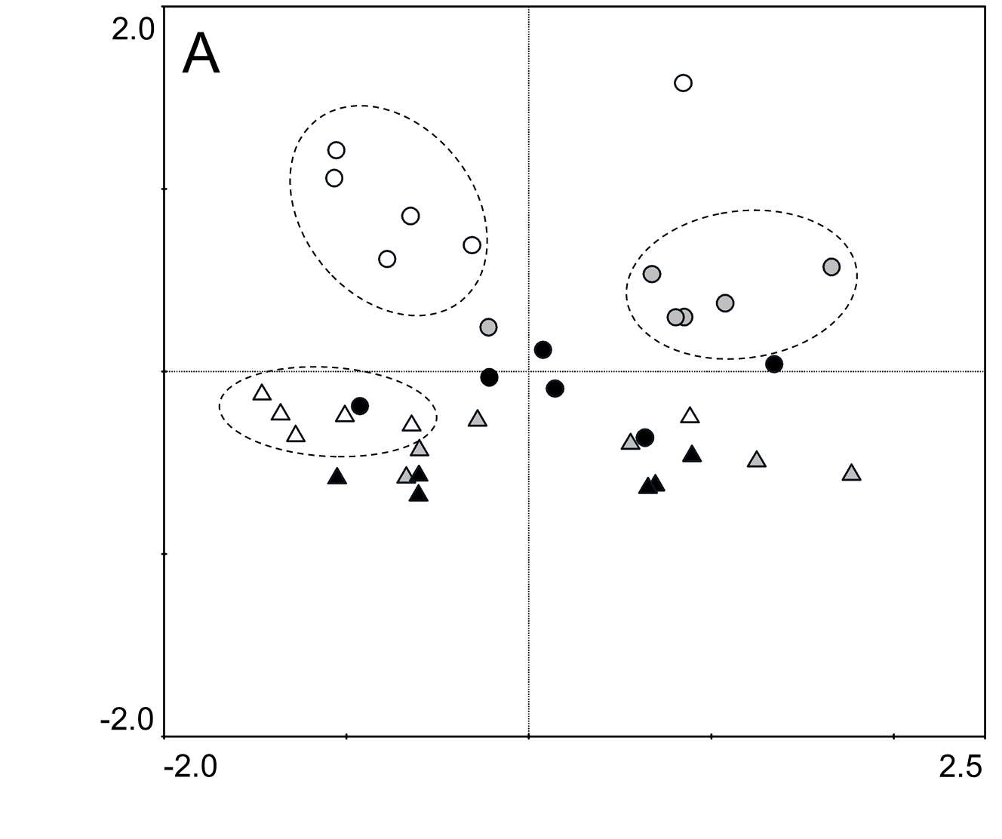 | 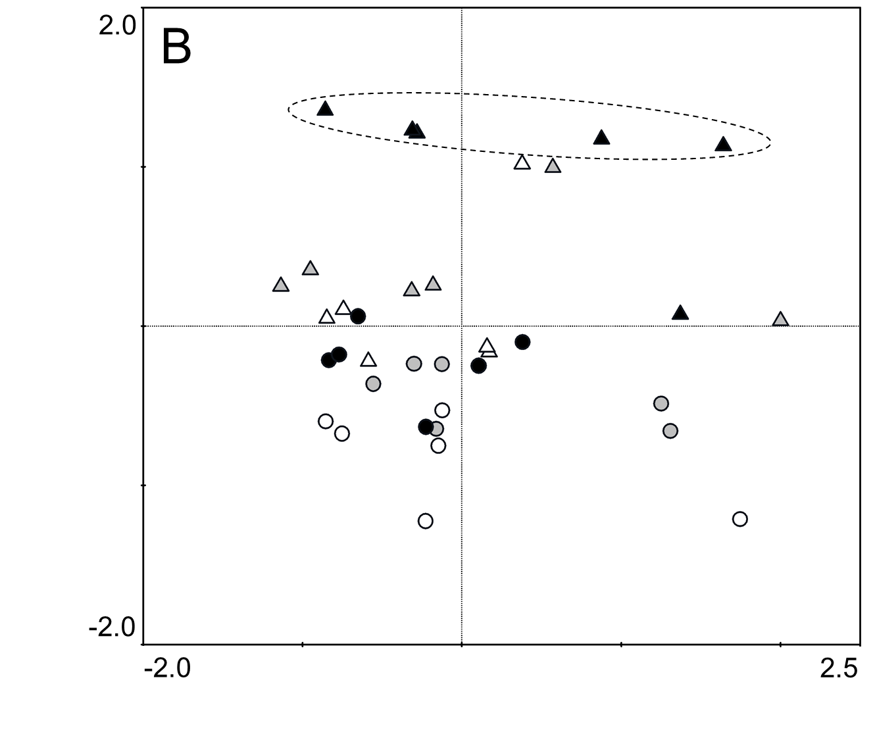
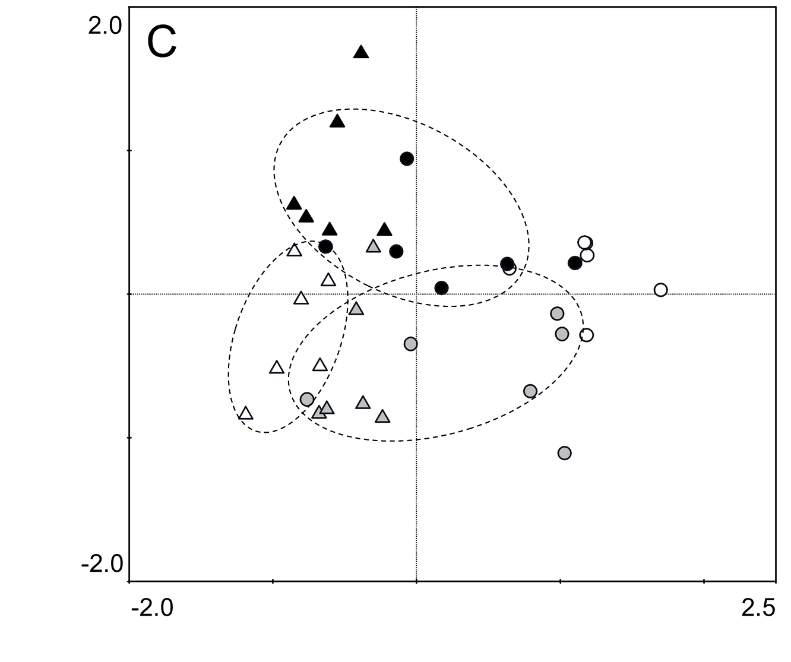 | 