Does the achievement of an intermediate glycemic target reduce organ failure and mortality? A post-hoc analysis of the Glucontrol Trial

- Penning, Sophie (MSc)¹ : Sophie.Penning@ulg.ac.be (FRS-FNRS research fellow)
- Chase, J. Geoffrey (PhD)² : geoff.chase@canterbury.ac.nz
- Preiser, Jean-Charles (PhD)³ : Jean-Charles.Preiser@erasme.ulb.ac.be
- Pretty, Christopher G. (PhD)² : chris.pretty@canterbury.ac.nz
- Signal, Matthew (BE(Hons))² : matthew.signal@pg.canterbury.ac.nz
- Mélot, Christian (MD, PhD)⁴ : cmelot@ulb.ac.be
- Desaive, Thomas (PhD)¹: tdesaive@ulg.ac.be

Affiliations :
¹GIGA-Cardiovascular Sciences, Institut de Physique, Université de Liege, Institut de Physics, Allée du 6 Août, 17 (Bât B5), B4000 Liege, Liege, Belgium.
²Department of Mechanical Engineering, Centre for Bio-Engineering, University of Canterbury, Christchurch, Private Bag 4800, 8054, New Zealand.
³Department of Intensive Care, Erasme University Hospital, 808 route de Lennik, B1070 Brussels, Belgium.
⁴Department of Emergency Medicine, Erasme University Hospital, Brussels, Belgium.

Acknowledgements:
Financial Support:
- Fonds National de la Recherche Scientifique (F.R.S.-FNRS, Belgium).
- Department of Mechanical Engineering, Scholarship Grant, University of Canterbury, Christchurch, New Zealand.

Corresponding authors:
S. Penning, email: Sophie.Penning@ulg.ac.be; tel.: +32-4366-3650.
Dr. T. Desaive, email: tdesaive@ulg.ac.be; tel.: +32-4366-3733.
Prof J.G. Chase, email: geoff.chase@canterbury.ac.nz; tel.: +64-3-364-2987 x7224.

Abstract:
Objective: This research evaluates the impact of the achievement of an intermediate target glycemic band on the severity of organ failure and mortality.
Methods: Daily Sequential Organ Failure Assessment (SOFA) score and the cumulative time in a 4.0-7.0mmol/L band (cTIB) were evaluated daily up to 14 days in 704 participants of the multi-centre Glucontrol trial (16 centers), that randomized patients to intensive Group A (blood glucose (BG) target: 4.4-6.1mmol/L) or conventional Group B (BG target: 7.8-10.0mmol/L). SOFA evolution was measured by percentage of patients with SOFA≤5 on each day, percentage of individual organ failures (IOF), and percentage of organ failure free days (OFFD). Conditional and joint probability analysis of SOFA and cTIB≥0.5 assessed the impact of achieving 4.0-7.0mmol/L target glycemic range on organ failure. Odds ratios compare the odds risk of death for cTIB ≥ 0.5 versus cTIB<0.5, where a ratio greater than 1.0 indicates an improvement for achieving cTIB≥0.5 independent of SOFA or glycemic target.
Results: Groups A and B were matched for demographic and severity of illness data. BG differed between group A and B (p<0.05), as expected. There was no difference in the percentage of patients with SOFA≤5, IOF and OFFD between Groups A and B over days 1-14. However, 20-30% of Group A patients failed to achieve cTIB≥0.5 for all days, and significant crossover confounds interpretation. Mortality odds ratio was greater than 1.0 for patients with cTIB≥0.5 in both groups, but much higher for Group A, on all days.
Conclusions: There was no difference in organ failure in the Glucontrol study based on intention to treat to different glycemic targets. Actual outcomes and significant crossover indicate that this result may not be due to the difference in target or treatment. Odds ratios associated achieving an intermediate 4.0-7.0 mmol/L range improved outcome.

Keywords: Organ failure, glycaemia, critically ill patients, intensive care, critical care, mortality.

1.0 Introduction:

Rate, severity and lack of resolution of organ failure are strongly associated with increased morbidity and mortality in intensive care unit (ICU) patients ¹ . Organ failure is typically assessed daily by the sequential organ failure assessment (SOFA) score ²⁻⁴. Van den Berghe et al. ⁵ suggested glucose control (GC) could improve organ failure, and, recently, cumulative time in an intermediate glycemic band (4.0-7.0 mmol/L) (cTIB) was associated with improved rate and severity of organ failure, based on a different study ⁶. However, glycemic control and targets are contentious . While decreased mortality was found in some studies , others did not ¹⁰⁻¹², and many saw no difference ¹³⁻¹⁵. Therefore, moderate targets are currently recommended , despite evidence that intermediate target ranges could favorably influence organ failure rate and severity.

This study evaluates the impact and interaction of organ failure and glycemic control in the Glucontrol trial ¹⁰ that compared separate glycemic target bands, one of which is entirely within the 4.0-7.0 mmol/L band used by ¹⁸, while the other did not overlap. This randomized trial data provides a further opportunity to examine the interaction of glycemic level and organ failure, and how initial results ¹⁸ generalize over an independent cohort.

2.0 Methods:

2.1 Glucontrol:
Glucontrol was a prospective, randomized, multi-center controlled glucose control trial implemented in 19 centers (21 ICUs) from November 2004 to May 2006¹⁰. The 1078 patients were randomized to Group A (target: 4.4–6.1 mmol/L) or Group B (target: 7.8–10.0 mmol/L). Insulin infusion dosing was defined using sliding scales, with BG measured hourly when not in the target range. For limited variation (≤ 50%) of BG levels, 2-hourly and 4-hourly measurement were allowed. Details are in ¹⁰.

2.2 Organ Failure:
Daily SOFA score was used , calculated based on five of the six individual scores of 1-4. The Glasgow Coma score is excluded due to its reported lack of robustness and unreliability ¹⁸. Thus, total SOFA score ranges from 0-20. All SOFA scores were re-calculated from original clinical data to avoid bias. A total SOFA≤5 is used as a threshold to discriminate patients considered relatively well and more likely to recover.

2.3 Glycemic Outcome:
Glycemic outcome and quality of control are measured by cumulative Time In Band (cTIB) for the first 14 days of stay. It was calculated per day and per patient and is defined as the percentage of time the patient’s BG levels have been cumulatively in a specific band (4.0-7.0 mmol/L here) up to and including the considered day. This band includes the entire Group A target range and none of the Group B target range. All other glycemic results are presented for clarity, including per-patient cTIB values to measure differences in control achieved versus intended between Groups A and B, and the moderate (BG < 4.0 mmol/L) and severe (BG < 2.2 mmol/L) hypoglycemic events.

2.4 Patients and Data:
SOFA data measurement varied between centers, and patients were only included where sufficient SOFA data was available (Figure 1). All data from centers with more than 40% missing data was excluded. Per-center exclusion allows the remaining patients to be still representative of ICU population and properly randomized. Additionally, patients for whom interpolation of missing data from surrounding data can’t be performed were also removed, as detailed in Figure 1. Overall, 374 of 1078 patients were excluded and the remaining 704 patients are summarized in Table 1 by patient group. Both groups were similar for age, sex, diagnostic category and APACHE (Acute Physiology And Chronic Health Evaluation) II score. Ethical consent was obtained from ethics committee of each participating hospital and included patients have signed consent allowing the audit, analysis and publication of these data.

2.5 Analyses and Statistical Methods:
For each patient, daily SOFA score and cTIB are calculated. SOFA score improvement is measured by the evolution of the percentage of patients with SOFA≤5 dividing patients into (SOFA≤5 or SOFA>5). Proportions of SOFA≤5 are compared for each day using a Fisher Exact 2-sided test, where p < 0.05 is considered significant.

Patients are also characterized in each group by quality of control and glycemic outcome (cTIB≥0.5 or cTIB<0.5). Conditional (P(SOFA≤5 | cTIB≥0.5)) and joint probabilities (defined in Table 2) assess the link between organ failure and glycemic outcome.

To assess the impact of control quality (cTIB) independent of organ failure, the odds ratio for each group is calculated comparing the odds risk of death for cTIB≥0.5 versus cTIB<0.5 on each day, where a ratio greater than 1.0 indicates an improvement for achieving cTIB≥0.5 independent of SOFA score results.

Organ failure free days (OFFD) are defined by the number of days (percentage of total) a patient has no SOFA score component greater than 2. OFFD is a surrogate for the speed of resolution and/or prevention of organ failure ¹⁸. Individual organ (component) failures (IOF) is the percentage of individual SOFA score components equal to 3 or 4 from the maximum possible individual organ failures (maximum = 5 components x total patient days of ICU stay), and is a measure of cohort organ failure. IOF and OFFD are compared between Groups A and B using a 2-sided Fisher Exact test.

3.0 Results:

Table 3 shows initial and maximum SOFA score, and initial BG, are equivalent over groups (p ≥ 0.4). Group A have lower BG levels than patients from Group B (p < 0.05), more hypoglycemia, and greater per-patient cTIB, as in Chase et al. ¹⁸, and thus as expected.

Figure 2 shows SOFA improves slightly for both groups over the first 12-14 days. Table 4 shows patient numbers per day in each group in Figure 2. The difference in SOFA≤5 between Groups A and B is not significant for any day and underpowered (Power<0.80) for Days 13-14. OFFD are slightly higher and IOF slightly lower for Group A, but not significant (p > 0.35) in Table 3.

Figure 3 shows joint and conditional probabilities of SOFA and cTIB. The conditional probabilities in Figure 3A indicate: 1) the probability of SOFA≤5 given cTIB≥0.5 is equivalent for both groups, regardless of how the control was obtained; 2) that 20-30% of Group A patients never achieved cTIB≥0.5 despite this range containing the entire Group A protocol target range; and 3) that 20-30% of Group B patients had cTIB≥0.5 despite its target range explicitly excluding the 4.0-7.0 mmol/L range. Thus, 20-30% of all trial patients had BG outcomes that did not match their respective target range, as measured by cTIB.

Hence, in Figure 2, there is no clear separation between Groups A and B, where the results in Figure 3A delineate the reason for this lack of separation, and are supported by the results of Figure 3B. Finally, examining the steady joint probabilities of Figure 3B it is evident that the odds of SOFA≤5 given cTIB≥0.5 are approximately 2:1 for both Groups A and B over all the days. Similarly, the odds of SOFA≤5 given cTIB<0.5 are 1.3-1.6:1 for Group B, but only 1:1 for Group A. This latter result indicates that there was greater risk of organ failure for Group A patients who could not achieve cTIB ≥ 0.5 for the 4.0-7.0 mmol/L range.

Figure 4 shows the odds ratio (of survival) for Groups A and B for achieving cTIB≥0.5. Achieving cTIB≥0.5 resulted in improved outcomes for both groups that increased each day, but greater benefit and improvement was seen for Group A. Interestingly, this result occurs despite the much higher incidence of moderate and severe hypoglycemia for Group A (Table 3), which is counter to some recent results²⁰. Overall, Figure 4 shows OR>1.0 and improving for those achieving cTIB≥0.5 regardless of protocol used.

4.0 Discussion:

The results show no clinically significant difference in the evolution of organ failure severity or rate between Groups A and B) from Glucontrol. SOFA≤5 is not significant for any of Days 1-14, although low patient numbers under-power the comparison on Days13-14 (Table 4). These results are supported by the OFFD and IOF results. Glycemic outcome was examined independently for its impact on mortality. Patients in Groups A and B who achieved cTIB≥0.5 had improved odds of survival on all days after Day 3 (all days for Group A).

Importantly, Chase et al.¹⁸ had effectively no crossover from the tightly controlled SPRINT cohort to the conventionally controlled cohort. Thus, differences in organ failure between cohort could be associated with the outcome of its treatment as all SPRINT patients (~100%) achieved cTIB≥0.5 by Day 2-3.

However, in this analysis, conditional and joint probability results indicate significant failure to achieve the desired target bands for 20-30% of all patients in Groups A and B. In particular, Group A patients had 40% [IQR: 30, 50]% of BG in its 4.4-6.1 mmol/L target band, and Group B had only 30% [IQR: 20, 50]% within its 7.8-10.0 mmol/L target band. Hence, there was significant failure to ensure the intensively treated Group A patients all received safe and tight glycemic control to its target range.

Critically, at this time, no specific patient group has shown specific benefit from glycemic control. Thus, with respect to organ failure, it is necessary to at least separate the intensive group from the control group to be certain that all those who might benefit receive that care. Thus, the study of Chase et al.¹⁸ was able to show a differentiation, where no difference was able to be found here. Hence, a first important outcome of the two studies is to note that glycemic control likely has the most benefit on 15-20% of patients, but not any specific group, mandating that all patients receiving safe, effective glycemic control to ensure benefit.

As a metric, cTIB captures both level and variability of BG. It is important to note that it is independent of the insulin therapy or protocol used to achieve it and, equally, that both level and variability are also associated with outcome . In this study, cTIB≥0.5 includes the entire Group A protocol target and excludes the Group B target, clearly discriminating the two protocols as intended in the original study, and also allowing direct comparison to Chase et al.

IOF and OFFD results provide further insight. Initial and maximum SOFA scores in this study are lower than those of the medical ICU study of Chase et al. Similarly, OFFD of 55.6% and 54.4% for Groups A and B was much higher than the 36-41% of Chase et al., and IOF of 11.6-11.8% here was much lower than the 16-19% in Chase et al. Thus, Glucontrol A and B patients had much less organ failure, especially initially. However, those lower levels improved no more than 10% absolute (from 50% to 60%) over Days 1-14 (Figure 2), versus the 15-30% improvement from a similar initial value in Chase et al. Thus, cohort differences and less successful glycemic control may both have played a role in the outcome of this study.

Thus, failure to significantly separate glycemic outcomes on a per-patient basis is the major limitation of this analysis. However, this failure is a result in its own right, showing the difficulty in interpreting results without achieving consistent control across most or all patients in (at least) the intensive group. It is worth noting, in this context, that the Glucontrol study stopped early due to unintended protocol violations ¹⁰.

A final limitation and effect is the relatively rapid drop off of patients related to earlier ICU discharge or death, leaving relatively very low numbers of only 58 and 61 patients in Groups A and B on Day 12. Similarly, cardiovascular surgery (CVS) patients represent a high percentage of patients during the first days of ICU stays (37.1% in Group A and 41.5% in Group B, Table 1). Hence, the relatively lower mortality of such patients may have affected results, where was from a medical ICU and only ~20% of patients were CVS surgical patients. Thus, the results may also differ based on cohort composition, where more effect may occur for different patient groups.

5.0 Conclusions:

This study presents results from a unique analysis of a randomised glycemic control trial that evaluates the impact of glycemic control and target range in terms of daily organ failure status. Two main conclusions are drawn.

First, there was no difference in the rate or severity of organ failure between the lower intensive (Group A) and higher conventional (Group B) groups. However, significant patient crossover between groups with very low per-patient %BG in both groups target band ensures that glycemia was not effectively separated for the two groups, making interpretation of results difficult, both in general and for organ failure in specific.

Second, examining mortality independent of organ failure showed achieving cTIB in the 4.0-7.0 mmol/L band over 50%, regardless of the form of glycemic control, improved survival odds ratios on all days, and especially during the first three days of ICU stay. The joint probability analysis supported these results. Thus, results show that cTIB appears to be an effective, and novel, glycemic target for control, as well as clearly indicating that it may be cumulative control quality and level rather than median or average level that is critical to outcome.

These conclusions remain to be prospectively tested. However, the analysis highlights key outcomes with respect to the achievement of an intermediate BG levels and its assessment using SOFA score, as well as providing further insight into the glycemic level and variability, and quality of control, needed to improve outcomes.

Key messages
- There was no difference in the rate or severity of organ failure between the lower intensive (Group A) and higher conventional (Group B) treated groups.
- Examining mortality with respect to achieving a cumulative time in band over 50% had improved odds ratio (of survival) on all days of stay.
- Cohort differences may play a role in assessing the impact of glycemia on organ failure.
- cTIB seems to be an effective, and novel, glycemic target for control.

List of abbreviations
APACHE: acute physiology and chronic health evaluation.
BG: blood glucose.
cTIB: cumulative time in a 4.0-7.0mmol/L band.
CVS: cardiovascular surgery.
ICU: intensive care unit.
OFFD: organ failure free days.
IOF: individual organ failures.
IQR: interquartile range.
SOFA: sequential organ failure assessment.
SPRINT: specialized relative insulin and nutrition titration.

Competing interests
The authors declare that they have no competing interests.

Authors’ contribution
JCP and CM conducted the trial and made the acquisition of data during the Glucontrol study. All authors were involved in the analysis and interpretation of data. The manuscript was originally drafted by SP, JGC and JCP, but all authors made contributions through the entire process, including reading and final approval of this manuscript.

Authors' information
- MSc, Cardiovascular Research Centre, Institut de Physique, Université de Liege, Institut de Physics, Allée du 6 Août, 17 (Bât B5), B4000 Liege, Liege, Belgium.
- PhD, Cardiovascular Research Centre, Institut de Physique, Université de Liege, Institut de Physics, Allée du 6 Août, 17 (Bât B5), B4000 Liege, Liege, Belgium.
- PhD, Department of Mechanical Engineering, Centre for Bio-Engineering, University of Canterbury, Christchurch, Private Bag 4800, 8054, New Zealand.
- BE(Hons), Department of Mechanical Engineering, Centre for Bio-Engineering, University of Canterbury, Christchurch, Private Bag 4800, 8054, New Zealand.
- PhD, Department of Intensive Care, Erasme University Hospital, 808 route de Lennik, B1070 Brussels, Belgium.
- MD, PhD, Department of Emergency Medicine, Erasme University Hospital, Brussels, Belgium.

References:
1. Sakr Y, Vincent J-L, Ruokonen E, Pizzamiglio M, Installe E, Reinhart K et al: Sepsis and organ system failure are major determinants of post-intensive care unit mortality. Journal of Critical Care 2008, 23(4):475-483.
2. Vincent JL, Moreno R, Takala J, Willatts S, De Mendonca A, Bruining H et al: The SOFA (Sepsis-related Organ Failure Assessment) score to describe organ dysfunction/failure. On behalf of the Working Group on Sepsis-Related Problems of the European Society of Intensive Care Medicine. Intensive Care Med 1996, 22(7):707-710.
3. Vincent JL, de Mendonca A, Cantraine F, Moreno R, Takala J, Suter PM et al: Use of the SOFA score to assess the incidence of organ dysfunction/failure in intensive care units: results of a multicenter, prospective study. Working group on "sepsis-related problems" of the European Society of Intensive Care Medicine. Crit Care Med 1998, 26(11):1793-1800.
4. Vincent JL: Organ dysfunction in patients with severe sepsis. Surg Infect (Larchmt) 2006, 7 Suppl 2:S69-72.
5. Van den Berghe G, Wouters P, Weekers F, Verwaest C, Bruyninckx F, Schetz M et al: Intensive insulin therapy in the critically ill patients. The New England Journal of Medicine 2001, 345(19):1359-1367.
6. Chase JG, Shaw G, Le Compte A, Lonergan T, Willacy M, Wong XW et al: Implementation and evaluation of the SPRINT protocol for tight glycaemic control in critically ill patients: a clinical practice change. In: Crit Care. vol. 12; 2008.
7. Mesotten D, Van den Berghe G: Clinical benefits of tight glycaemic control: focus on the intensive care unit. Best practice & research 2009, 23(4):421-429.
8. Fahy BG, Sheehy AM, Coursin DB: Glucose control in the intensive care unit. Crit Care Med 2009, 37(5):1769-1776.
9. Krinsley JS: Effect of an intensive glucose management protocol on the mortality of critically ill adult patients. Mayo Clinic Proceedings 2004, 79(8):992-1000.
10. Preiser JC, Devos P, Ruiz-Santana S, Melot C, Annane D, Groeneveld J et al: A prospective randomised multi-centre controlled trial on tight glucose control by intensive insulin therapy in adult intensive care units: the Glucontrol study. Intensive Care Medicine 2009, 35(10):1738-1748.
11. Finfer S, Delaney A: Tight glycemic control in critically ill adults. Jama 2008, 300(8):963-965.
12. Brunkhorst FM, Engel C, Bloos F, Meier-Hellmann A, Ragaller M, Weiler N et al: Intensive insulin therapy and pentastarch resuscitation in severe sepsis. N Engl J Med 2008, 358(2):125-139.
13. Treggiari MM, Karir V, Yanez ND, Weiss NS, Daniel S, Deem SA: Intensive insulin therapy and mortality in critically ill patients. Crit Care 2008, 12(1):R29.
14. Griesdale DE, de Souza RJ, van Dam RM, Heyland DK, Cook DJ, Malhotra A et al: Intensive insulin therapy and mortality among critically ill patients: a meta-analysis including NICE-SUGAR study data. Canadian Medical Association Journal 2009, 180(8):821-827.
15. Marik PE, Preiser JC: Toward understanding tight glycemic control in the ICU: a systematic review and metaanalysis. Chest 2010, 137(3):544-551.
16. Moghissi ES, Korytkowski MT, DiNardo M, Einhorn D, Hellman R, Hirsch IB et al: American Association of Clinical Endocrinologists and American Diabetes Association consensus statement on inpatient glycemic control. Endocr Pract 2009, 15(4):353-369.
17. Krinsley JS, Preiser JC: Moving beyond tight glucose control to safe effective glucose control. Crit Care 2008, 12(3):149.
18. Chase JG, Pretty CG, Pfeifer L, Shaw GM, Preiser JC, Le Compte AJ et al: Organ failure and tight glycemic control in the SPRINT study. Crit Care 2010, 14(4):R154.
19. Ferreira FL, Bota DP, Bross A, Melot C, Vincent JL: Serial evaluation of the SOFA score to predict outcome in critically ill patients. JAMA 2001, 286(14):1754-1758.
20. Mackenzie IM, Whitehouse T, Nightingale PG: The metrics of glycaemic control in critical care. Intensive Care Med 2011, 37(3):435-443.
21. Krinsley JS: Glycemic variability: a strong independent predictor of mortality in critically ill patients. Crit Care Med 2008, 36(11):3008-3013.
22. Krinsley JS: Association between hyperglycemia and increased hospital mortality in a heterogeneous population of critically ill patients. Mayo Clinic Proceedings 2003, 78(12):1471-1478.

Figure captions:

Figure 1: Patient selection details.

Figure 2: Proportion of patients with SOFA score < 5 over time in Groups A and B. Values are similar (p > 0.40) for Days 1-12 and (p > 0.07) for Days 13-14 which are underpowered due to reduced patient numbers (Power < 0.75) per results in Table 4.

Figure 3: Conditional and joint probabilities of SOFA score and cTIB.

Figure 4: Odds ratio over the first 14 days of ICU stay for all patients (black curve), group A patients (red curve) and group B patients (blue curve) for cTIB ≥ 0.5

Table captions:

Table 1: Characteristics of the 704 remaining patients. The p-values are calculated using chi-squared test, except for age and APACHE 2 score for which Mann-Whitney test is used (*).

Table 2: Joint probabilities to link severity of organ failure and glycemic outcome

Table 3: Characterization of SOFA and BG data for all patients. Results are presented as median [IQR] where appropriate. P-values calculated by Mann-Whitney test for distributions and chi-squared test for proportions.

Table 4: Number of patients over ICU stay in Group A and Group B, and assessment of Fisher Exact test comparison of proportions with SOFA ≤ 5. Results are similar for all Days 1-14 but low patient numbers mean the results are underpowered for Days 13-14 (Power < 0.80)

APPENDIX A: Supplementary data on component SOFA scores.

Figures A.1 show the component SOFA scores over time in box and whisker format (median, IQR and 90% CI) including outliers. The main points to note are that there is little clinical difference between Pre-SPRINT and SPRINT on a cohort basis for most days or components. Particular differences or points of note in Figures A.1 (in the order A-E shown in the figure) including p-values where daily distributions are significantly different, are summarised:

- Respiratory function: Respiratory failure is common and the plots are little different across the days between cohorts. The SPRINT cohort shows a wider range and less failure in this component score in days 2, 4 and 5 and in the last 3 days. Day 15 has significantly different distributions between groups, p = 0.032. All other days have p > 0.05.
- Cardiovascular function: Cardiovascular function scores are common and differences in median and/or IQR are evident on days 2-5 with SPRINT having lower scores than the Pre-SPRINT cohort. All days have p > 0.05 in comparing the two groups.
- Renal function: there is very little renal failure in either cohort with the box and whiskers (0 – 95%) on the SOFA = 0 line. Outliers are shown as the red crosses. Day 9 has significantly different distributions between groups, p = 0.049. All other days have p > 0.05.
- Liver function: there is very little liver failure in either cohort with the box and whiskers (0 – 95%) on the SOFA = 0 line. Outliers are shown as the red crosses. Day 3 has significantly different distributions between groups, p = 0.026. All other days have p > 0.05.
- Coagulation: This score is similar between cohorts, with the only significant difference seen on day 7 where SPRINT median and IQR and 90% CI are all 0 and are non-zero for the SPRINT cohort. Days 8, 9 and 11-20 have significantly different distributions between groups, p < 0.020 in all cases. All other days have p > 0.05.

The overall result is that individual SOFA score components show no significant trends favouring one or another component.

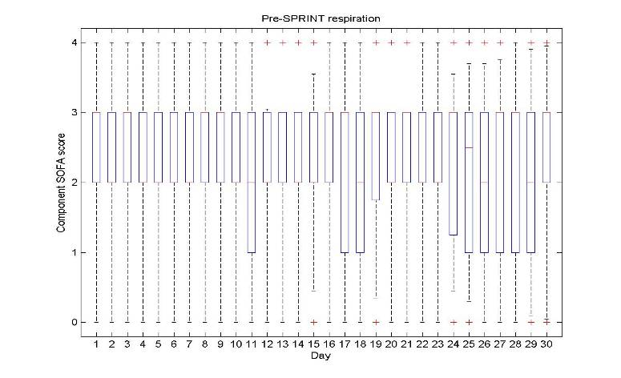
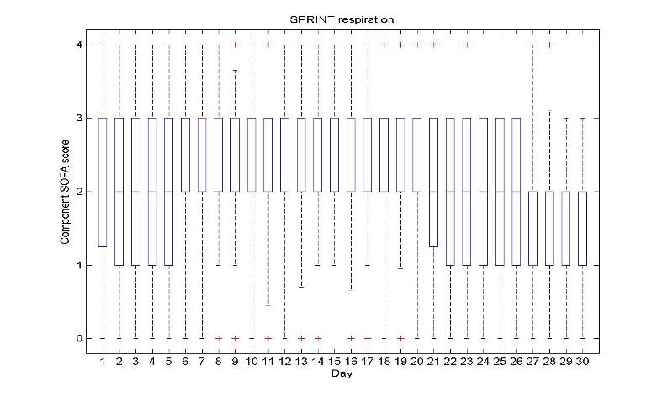
Pre-SPRINT SPRINT
A. Respiratory function score 0 – 4 for days 1 - 30

B. Cardiovascular function score 0 – 4 for days 1 - 30
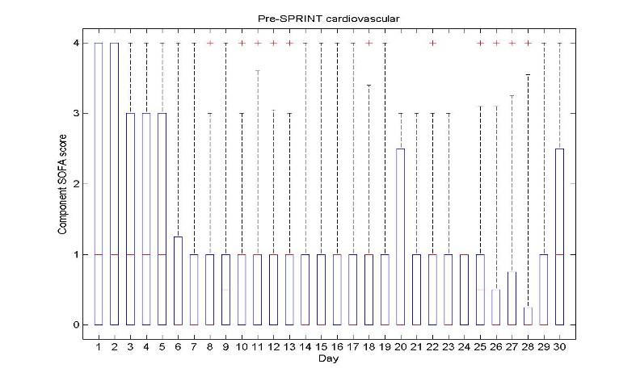
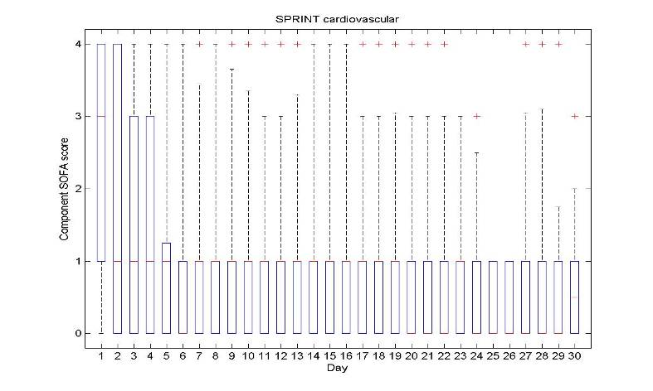

C. Renal function score 0 – 4 for days 1 - 30
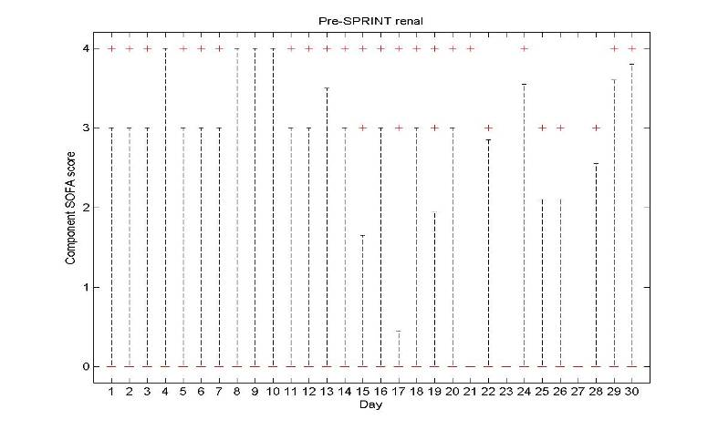
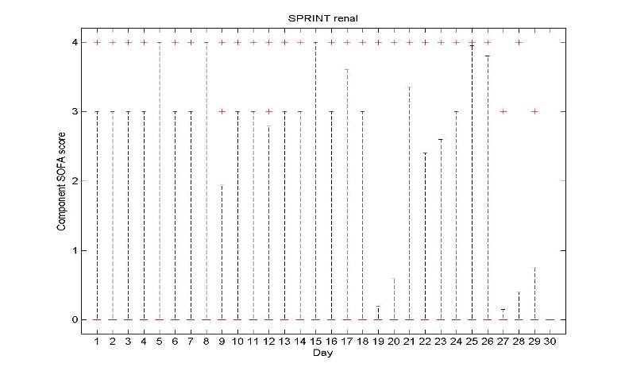

Figure A.1: SOFA score box and whisker plots for SOFA score components for the Pre-SPRINT cohort (left column) and SPRINT (right column) over time for: A) Respiratory function; B) Cardiovascular function; and C) Renal function.
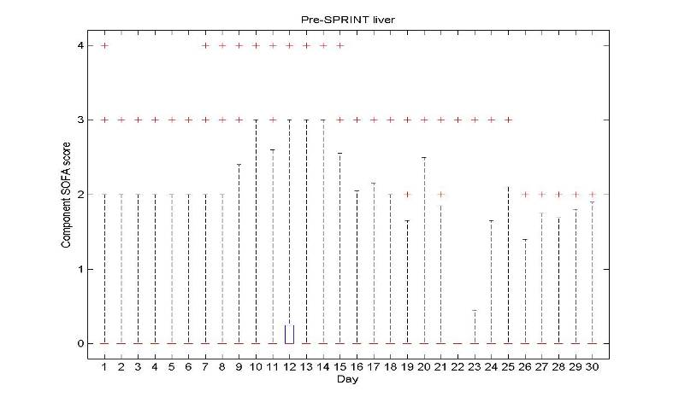
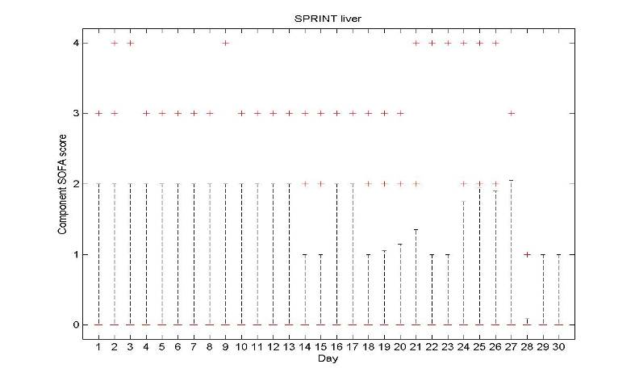
D. Liver function score 0 – 4 for days 1 - 30

E. Coagulation function score 0 – 4 for days 1 - 30
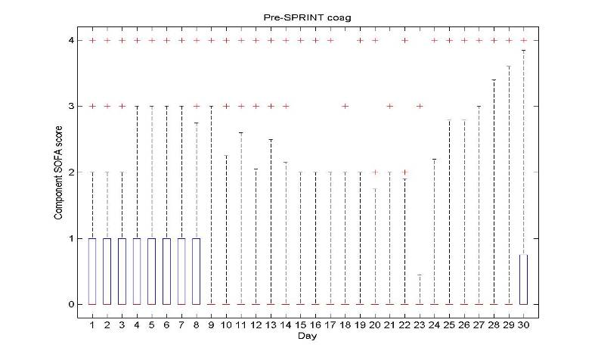
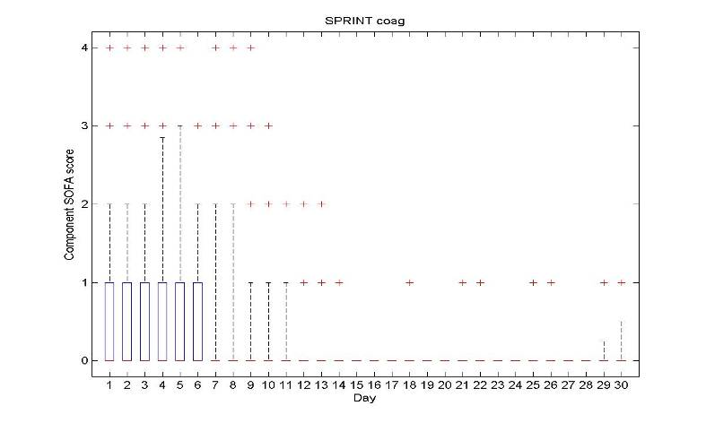

Figure A.1 (continued): SOFA score box and whisker plots for SOFA score components for the Pre-SPRINT cohort (left column) and SPRINT (right column) over time for: D) Liver function; and E) Coagulation function.

