Introduction
Impacts of future floods and low flows on the economy in the Meuse basin
B. Sinaba
R. Döring
M. Kufeld
H. Schüttrumpf
Institute of Hydraulic Engineering and Water Resources Management RWTH Aachen
A. Bauwens
Gembloux Agro-Bio Tech (ULG)
ABSTRACT: Climate change in Western Europe is projected to result in more humid winters and drier summers. Further, the severities of floods and low flows are assumed to increase in the future. The impacts of these events could lead to adverse consequences on the economy. Given this framework, within the AMICE project, the impacts of future floods and low flows will be analyzed. A flood risk analysis in the Meuse basin is conducted taking into account future climate scenarios. Further, the impacts of future droughts and low flows are analyzed for the economic sectors energy production, agriculture and navigation.

The issues of flood risk have been attracting attention in recent years and have moved up on the political and scientific agendas following increased frequency and severity of flood events. Additionally, more frequent periods of low flows in dry summer months have been observed, culminating in the 2003 dry season in Western Europe. As climate change in Western Europe is predicted to result in more humid winters and drier summers, which both are expected to be accompanied by a higher frequency of extremes, the severities of floods and low-flows are assumed to increase in the future. Due to limited natural storage capacity in the Meuse basin a direct link exists between climate evolutions and changes in high and low-flows, putting at risk the assets of the basin. Given this framework the provided study deals with methodologies to quantify the impacts of floods and low flows.
In the AMICE project future hydrological scenarios (FS) on floods (FS_{wet}) and low flows (FS_{dry}) are estimated for the time horizons 2021-2050 (FSI) and 2071-2100 (FSII). For these dry and wet future scenarios FS I and FS II, the economic consequences are examined and compared with the impacts of the hydrological scenarios of the present state PS, representing the time slice between 1971 and 2000. The future hydrological conditions of floods and low flows are presented in Drogue (2010). Due to the underlying different hydrologic and cause-effect perspectives, the impacts due to low flows and floods are studied separately. In section 2 methodologies are introduced to quantify the impacts of the future hydrological conditions. The results are presented in section 3. In consideration of the uncertainties in the overall chain of the flood and as well for the low flow impact assessment, it is avoided to present the results in absolute monetary terms but rather in percentages in all considered sectors.

Methodology

Impacts of future floods
The impacts of future floods are examined via flood risk analysis. In general, the risk is defined as the product of the probability of occurrence of an undesired event and the magnitude of its consequences (Hall et al., 2004). The undesired event is considered as the flood event and its probability of recurrence (or flood frequency) is described by the associated return period. The consequences accompanied by the flood depend on the vulnerabilities and are expressed in terms of economic damage assigned to this event. The combined information are then plotted as an exceedance probability – loss curve which is a conventional method to illustrate flood risk. According to Kaplan and Garrick (1980) this curve is called “risk curve”. Discrete values of flood damage C_{i} [€] are calculated for considered return periods T_{i} [year] and its associated flood frequency P_{i} [1/year]. In figure 1 a risk curve is depicted representing the return periods and the associated flood damages of the present state PS_{wet}.
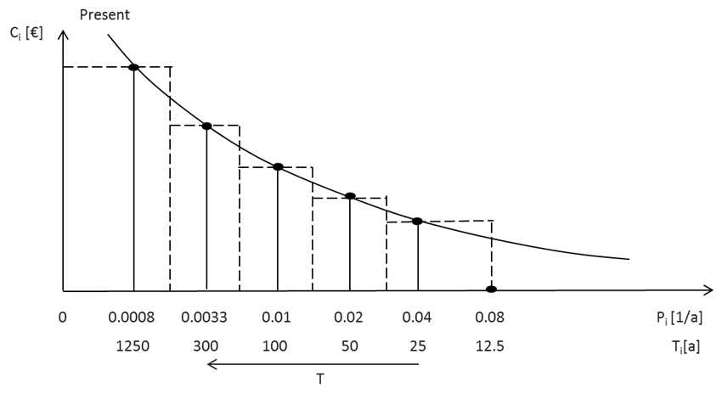
Figure1: Risk curve associated to return periods representing the present state

Mathematically, the integrated flood risk R is then approximated by the area under the risk curve. The approximation of the surface integral is conducted according to Bachmann (2012):
$R=\sum{C_{i}}⋅\left(\frac{P_{i+1}−P_{i}}{2}+\frac{P_{i}−P_{i−1}}{2}\right)=\sum{C_{i}⋅\left(\frac{P_{i+1}−P_{i−1}}{2}\right)}$ (1)
where R = integrated flood risk [€/year] ; Pi = Probability of a discrete undesirable event i [1/year]; and Ci = Consequence/Flood Damage potential of a undesirable event i [€].
According to the flood risk definition of formula (1), the risk calculation methodology is composed of an analysis of the hydraulic system and an analysis of the economic flood damage for the considered flood events. One of the inputs for the flood risk methodology is a map displaying inundated areas and flow depths in the floodplain related to a flood event and its specific return period T [year]. The hydraulic modeling and the generation of inundation maps in AMICE is described by Detrembleur, (2010). The flood damage estimation methodology is based on land use data, damage functions and specific asset values. Land use information is aggregated into 5 damage categories settlement, industry, infrastructure, agriculture and forestry. The assessment of the damage potential is then done by a superposition of the hydraulic information (inundation depth and area) and the land use data. A transformation of the inundation depth by specific damage functions which are associated with the corresponding damage category, results in the relative damage. The monetization is then realized by multiplying the relative damage by the corresponding monetary asset value. The result is the economic loss due to inundation depths in [€/m²]. The methodology of the flood damage analysis is described in Sinaba et al. (2011). Based on the damage results and the associated flood frequencies, flood risk is calculated according to formula 1 for the present state (PS_{wet}), FS I_{wet} (2021-2050) and FS II_{wet} (2071-2100) taking into account the future hydrological conditions. In avoidance of absolute monetary terms the risk estimates of the scenarios FS I_{wet} and FS II_{wet} are related to the risk estimates of the present state PS resulting in the risk increase RI_{FSI} and RI_{FSII}.

Impacts of future low flows
Whereas the approaches to calculate the impacts of floods, in terms of flood risk, are sophisticated and well established, approaches to determine the impacts of droughts and low flows do exist less frequent. In the present study, the impacts of possible future drought and low flow conditions due to climate change on the economic sectors energy, agriculture and navigation are examined. The hydrological dry future scenarios FS_{i,dry} applied in AMICE are characterized by a decrease in precipitation and river discharge and otherwise with an increase in air- and water temperature. These effects could lead to adverse impacts on the considered economic sectors. Our aim is to propose methodologies in order to quantify adverse implications of drought and low-flow conditions on these sectors.

Energy
The energy sector refers to electricity production in thermal power plants and in hydropower plants. Due to the difference in process technologies, impacts of climate change on both types of power plants are studied separately.
Thermal power plants require large water amounts for cooling purposes. During low flow periods thermal power plants are forced to operate with reduced capacity or at worst case if temperature thresholds are exceeded, the power plant has to be shut down temporarily.
The methodology applied on the thermal power plants using Meuse water, is mainly based on a study of Foerster & Lilliestam (2010). This study quantifies the reduction in electricity production via modeling of energy turnover and heat balance under changing mean annual air temperatures and thus water temperatures and river discharge. The results of this study are analyzed and adapted to the climate change projections of the AMICE future dry scenarios resulting in the correlation between discharge reduction, temperature increase and energy reduction production as shown in Table 1.

Table 1: Reduction in electricity production in [%] (Foerster & Lillistam, 2010)
____________________________________________________________________________
Stream flow water temperature increase
___________________________________________________________
Reduction [%] 0 K 1 K 2 K 3 K 4 K 5 K
____________________________________________________________________________
0 0.8 1.6 3.0 5.2 8.1 11.8
10 0.8 1.7 3.1 5.2 8.2 11.9
20 0.9 1.8 3.2 5.3 8.3 12.0
30 1.4 2.2 3.7 5.8 8.7 12.4
50 6.1 6.9 8.2 10.1 12.8 16.2
____________________________________________________________________________

Energy production in hydropower plants is determined by the discharge and the drop height. According to Strobl & Zunic (2006), the attainable output P [kW] of the turbine can be assessed with formula
$P=8⋅Q⋅H_{n}$ (2)
With P = capacity of the turbine [kW], Q = discharge [m³/s] and H_{n} net drop height [m].
In respect of equation (2) it is obvious that a variation of the future discharge will directly affect the attainable output capacity of the hydro power plants. In consequence of decreased discharge during low flow events, hydropower plants operate below full capacity.
For the gauges close to the thermal- and hydro power plants located along the Meuse, the mean annual discharge reduction and the water temperature increase due to the future dry scenarios as indicated in Drouge (2010) are calculated. For thermal power plants, these values served then as input parameters in table 1 to interpolate the mean annual energy reduction production. Further, the reduction in electricity production in hydro power plants is the difference between the capacity resulting from formula (2), on the basis of the annual mean discharge of the present state PS_{dry} and the capacity calculated under future scenarios FS_{dry}. Hereby, the drop height H_{n} is assumed to be constant.

Agriculture
Agriculture is also one of the economic sectors impacted by future climate extremes. It is commonly predicted that global warming will have effects on crop yields. These effects could be positive as well as negative in accordance with the range of predicted changes and the adaptation capacity of agricultural systems.
A modeling of the main crop yields on the Meuse basin was carried out. The model used to realize the simulations is an adaptation of the EPIC (Erosion Productivity Impact Calculator) model EPIC-Grid. The physically-based model is able to simulate water soil plant continuum, crop growth and their uptakes and water movements in the soil. For each country in the Meuse basin, yields for the three main crops (Maize, Wheat and Barley) of the catchment are calculated for the present state (PS) and for the future dry scenarios FS_{dry}. The input data required to run the EPIC-Grid model includes (1) daily weather information, (2) soil characterization data, (3) a set of parameters characterizing the crops being grown; (4) and crop management information such as emerged plant population, air CO₂ concentration, row spacing, seeding depth and date, harvest date and fertilizer schedules (Bauwens et al. 2011).

Navigation
The Meuse is navigable over a substantial part of its total length. The flow regime in the Meuse is strongly influenced by weirs, canalization and lateral withdrawals. Weirs regulation permits to guarantee minimum water levels most of the time. And in general, navigation will not encounter problems due to insufficient water depth. Ships pass weirs via navigation locks. Problems for navigation then start to occur when the water loss due to the locking process is such that water levels and discharges cannot be guaranteed anymore.
Measures can be implemented to reduce water losses during locking process, causing extra costs. These measures consists in reducing the number of locking cycles per day and diminishing the water loss in a lock cycle by pumping (AVV, 2002). The extra costs due to future low flows are assessed for three Dutch lock complexes at Born, Maasbracht and Heel on the basis of simulations in AVV (2002). In AVV (2002), scenarios with a normal locking process are compared to scenarios with different locking strategies using the software package SIVAK. SIVAK simulates the total time and costs for each individual ship that passes the lock, and computes water losses. The simulations required the following input parameters:
the number and size of the lock chambers, the water level difference between upstream and downstream of the lock, shipping intensity for the lock waiting and sailing costs per ship class.

Results

Impact of floods
The increase in flood risk due to the future scenarios is depicted in Table 2.

Table 2: Flood risk increase in [%] of the future scenarios related to the present state PS
________________________________________________________ ______________________
FS I_{wet} (2021-2050) FS II_{wet} (2071-2100)
______________________________________________________________________________
Flood risk increase [%] 150 390
______________________________________________________________________________

In order to get a more detailed view of flood risk, the normalized flood risk is calculated for several reaches. Sensitive areas under future scenarios are thus identifiable. Flood risk per reach is estimated for the present state PS_{wet}, FS I_{wet} and FS II_{wet}. These risk estimates are then related to the present state (PS) flood risk of the whole basin. Results are shown in figure 2. Even in the upstream and the middle part of the Meuse, several reaches show a noticeable contribution to the flood risk, such as the Sedan-Aiglemont reach in France, which includes the city of Charleville-Mézières. In the Walloon region the reach between Andenne and Ampsin is found as the most sensitive. This reach includes the city Huy and several industrial areas. Although, the reach Sedan - Aiglemont is very significant, an increase in the contribution to the total future flood risk from upstream to downstream can be observed. Thus, the reaches in the lowlands of the Netherlands and along the Dutch Flemish border are showing the largest contribution to the total flood risk increase.
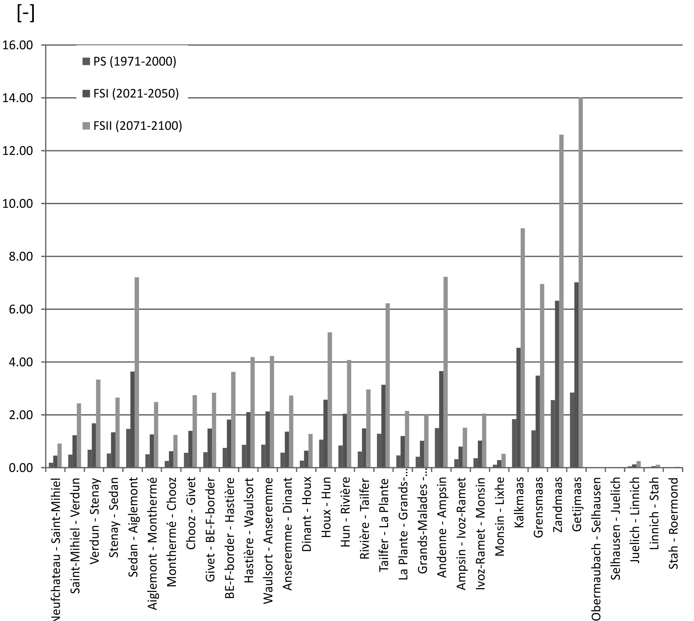
Figure 2: Normalized flood risk for several reaches

Impacts of low flows

Energy
The reduction in energy production in thermal power plants is calculated to approximately 2 % for the thermal power plants for the dry future scenario I FS I_{dry} as Table 3 shows. This trend worsens for the future time period from 2071 – 2100 as the consequence of further discharges decreases and temperature increases.

Table 3: Reduction in electricity production in [%] (Thermal power plants)
____________________________________________________________________________
Power plant annual reduction in energy production [%]
________________________________ __________________________
FS I_{dry} (2021-2050) FS II_{dry} (2071-2100)
____________________________________________________________________________
Chooze 1.9 8.2
Tihang 2.0 7.5
Clauscentrale 2.0 5.8
Buggenum 3.0 8.6
Amercentrale 2.0 5.8
Dongecentrale 2.0 5.8
__________________________________________________________________________

The reduction in energy production in hydropower plants is depicted in Table 4. For all hydro power stations, except Grands-Malades and Hun, the approximated reduction in energy production for future scenario FS I_{dry} is more than 35 %. For the future scenario FS II_{dry} for these hydro power stations the reduction is higher than 60 % compared to the present state PS. For the hydro power stations of Grands-Malades and Hun is no energy reduction predicted according to FS I_{dry}, the discharge value is still higher than the possible maximum discharge value of the turbines.

Table 4: Reduction in electricity production in [%] (Hydro power plant)
_______________________________________________________________________________
Power plant annual reduction in energy production [%]
________________________________ ___________________________
FS I_{dry} (2021-2050) FS II_{dry} (2071-2100)
_______________________________________________________________________________
Lixhe 43.0 64.0
Monsin 57.0 73.0
Ivoz-Ramez 39.0 62.0
Ampsin-Neuville 35.0 60.0
Andenne 45.0 66.0
Grands-Malades 0 36.0
Hun 0 11.0
_______________________________________________________________________________

Agriculture
The variation of the future yields compared to the yield related to the present state PS is shown in Table 5. It is observed that maize crop is negatively affected by climate change in the context of the dry future scenarios despite the CO₂ fertilization effect. The decrease in maize yield is of approximately 3-4 % for FS II_{dry} (only France sees a small yield increase of 2 %). For the future scenario FS II_{dry}, the decrease reaches 20 % and Flanders will suffer the greatest losses with 30 %.
Wheat and barley have similar behaviors and are positively affected by climate change and CO₂ fertilization effect. The increase in wheat yield is from 8-15 % for the future scenario FS I_{dry} and reaches 16-28 % for the future scenario FS II_{dry}. The increase in barley yield is from 6 to 20 % for the future scenario FS I_{dry} and from 9 to 21 % for the future scenario FS II_{dry}. However, in all cases, yield variability will increase.

Table 5: Evelution of yield in [%] related to the present state (1971-2000)
_____________________________________________________________________________________________________
Region FS I_{dry} (2021-2050) FS II_{dry} (2071-2100)
____________________________________________________________________________________
Maize Wheat Barley Maize Wheat Barley
______________________________________________________________________________________________________
France +2.0 +16.4 +20.3 -17.5 +27.8 +21.4
Wallonia -3.0 +8.4 +18.5 -18.9 +17.5 +18.0
Flanders -18.0 +7.9 +16.4 -29.3 +16.1 +18.0
Netherlands -3.4 +12.7 +12.2 -18.8 +23.3 +11.0
Germany -5.4 +8.4 +6.7 -21.8 +17.8 +8.8
______________________________________________________________________________________________________

Navigation
The water savings of the present state, which is assumed as an average year, are related to the extra costs occurring in a dry year, representative for the future scenario FS I_{dry} and a very dry year representing the conditions of the future scenario FS II_{dry}. A description of the calculation methodology is given exemplary for the lock in Maasbracht in Sinaba et al. (2011). The conducted calculation procedure indicates that the extra costs increase with 36 % for FS I_{dry} and by 1520 % for FS II_{dry} as depicted in Table 6.

Table 6. Increase of extra costs due to water savings in [%]
________________________________________________________ ______________________
FS I (2021-2050) FS II (2071-2100)
______________________________________________________________________________
Increase [%] 36.0 1520
______________________________________________________________________________

Conclusions
The economic impacts of future floods and low flows have been assessed. The results have shown that an increase of flood risk due to future climate is expected. Considering the whole Meuse basin, the flood risk increase under future scenario FS I_{wet} (2021-2050) is 150 % and 390 % under future scenario FS II_{wet} (2071-2100).
While the economic impacts of floods are well assessable by means of sophisticated hydraulic models and economic damage approaches, the impacts of droughts and low flows are less studied in European countries. This document has provided a brief overview of drought and low flow impacts on the energy-, agricultural- and navigation sectors in the Meuse basin. It is shown that a decrease in discharge and a water temperature increase will affect the electricity production in thermal- and hydro power plants. Agriculture is also strongly affected by climate change, but impacts can be positive or negative depending on the considered crop. In the navigation sector, a decrease in discharge can cause economic losses due to water saving lock strategies applied during low flow periods.
Solutions will have to be studied and implemented at the local level as well as at international level. In this context of the changing climate, it can be concluded, that there is a need for an improvement to assess the impacts of drought and low flows.

References
AVV (2002): Scheepvaartaspecten Laagwaterbeleid Julianakanaal en Lateraalkanaal. Rijkswaterstaat Adviesdienst Verkeer en Vervoer (in Dutch).
BACHMANN, D. (2012): Beitrag zur Entwicklung eines Entscheidungsunterstützungssystems zur Be-wertung und Planung von Hochwasserschutzmaßnahmen. Dissertation. Aachen: Institut für Wasserbau und Wasserwirtschaft, RWTH Aachen.
BAUWENS A., SOHIER C., DEGRÉ A., (2011): Hydrological response to climate change in the Lesse and the Vesdre catchments: contribution of a physically based model (Wallonia, Belgium). Hydrology and Earth System Sciences, 15, 1745-1756 pp. CUCULEANU V., MARICA A., SIMOTA C., (1999): Climate change impact on agricultural crops and adaptation options in Romania. Climate Research, 12, 153-160 pp.
Detrembleur et al. (2012): Effect of climate change on river Meuse, Hydraulic modelling from spring to mouth. AMICE – WP1 – Action 6 – technical report, (unpublished).
Drogue et al: (2010): Analysis of climate change, high-flows and low-flows scenarios on the Meuse basin. AMICE - WP1 – Action 3 – technical report.
FOERSTER, H. & LILLIESTAM, J., 2010: Modeling thermoelectric power generation in view of climate change, Regional Environmental Change, pp. 327-338
HALL, J.; DAWSON, R.; SAYERS, P.; ROSU, C.; CHATTERTON, J. U.; DEAKIN, R. (2004): A methodologyfor national-scale flood risk assessment. In: Water & Maritime Engineering,Vol. 156, No. WM3, pp. 235-247. - ISSN 1472-4561.
KAPLAN, S. & GARRIK, J.B. (1981): On the Quantitative Definition of Risk. In: Risk Analysis, Vol. 1, No.1.
Sinaba et al. (2011): Quantification of the impacts of future floods on the economy in the international Meuse basin. AMICE – WP1 – Action 7 – technical report (unpublished)
STROBL, T. & ZUNIC, F., 2006: Wasserbau, Aktuelle Grundlagen – Neue Entwicklungen, Springer, Berline Heiderlberg New York.

