A MODEL FOR THE PREDICTION OF FORM ERRORS IN FACE MILLING AND TURNING

Luc Masset¹, Jean-François Debongnie², Sylvie Foreau³, Thierry Dumont⁴
¹Research Assistant, Manufacturing Laboratory, University of Liège, 21 rue E. Solvay, B-4000 Liège, Belgium
²Professor, ASME Member # 2949832, Manufacturing Laboratory, University of Liège, 21 rue E. Solvay, B-4000 Liège, Belgium
³Research Engineer, Renault Powerstrain Structural Analysis Department, Rueil-Malmaison, France
⁴Research Engineer, Renault Powerstrain Structural Analysis Department, Rueil-Malmaison, France

ABSTRACT
A method is proposed for predicting form errors due to both clamping and cutting forces in face milling and turning. It allows complex tool trajectories and workpiece geometries. Error computation is performed by the finite element method. An experimental validation of the model for face milling is presented. Two industrial applications are produced in order to demonstrate the capabilities of the method.

- INTRODUCTION
Narrow tolerances are common in automotive engineering, in order to ensure functionality, assembling capabilities or reliability of components such as cylinder heads or transmission casings. To obtain such tolerances, an empirical procedure - trial-and- error method - is generally adopted. This turns out to be a very expensive way to solve tolerance problems. Significant savings can be expected from simulation processes in many engineering situations. Different solutions can be compared in order to find out the best one, avoiding expensive actual tests. Simulations also contribute to a better understanding of the machining processes behavior. They can be used to optimize an existing process by finding the best clamping configuration, the best cutting conditions and so on.
Among the published works on the subject, let us cite the following ones. Kops et al. (1993) and Debongnie (1994) studied the form error due to cutting forces on a cylindrical bar machined on a lathe. Both works present an analytical model where the stiffness variation of the workpiece is taken into account. In addition, Debongnie (1995) examined the effects of the back center flexibility on the surface error. Kakade and Chow (1993) and Subramani et al. (1993) developed models for predicting cylinder bores cylindricity using the finite element method. Schulz and Bimschas (1993) improved a milling process by modifying parameters such as tool trajectory and feed. Their method uses simultaneously CAD and FEM techniques.
Recently, Gu et al. (1997) have developed a flatness error prediction model in face milling. It takes into account the workpiece and tool deflections and the spindle axis tilt. When analyzing their results on an experimental case, it can be seen that the effect of the axis tilt is predominant so that the other effects are concealed.
The present paper describes a method for computing the form error of a machined workpiece due to both clamping and cutting forces. Only lathe works and face milling, which are the most usual processes, are considered. An ideal fixture should not generate any form error. However, in many cases, the workpiece is deformed when clamped because of bad design or manufacturing of the fixture. The workpiece presents a form error which can be significant when it is released. This happens in several fixture configurations where clamping forces are not strictly aligned with supports.
The form error due to cutting forces is however unavoidable. It is in fact the minimum error when machining conditions are perfect - no clamping deformations, no vibrations, … When the measured error of a workpiece is not close to the predicted error (due to cutting forces), a fixture problem is to be suspected. For this reason, it is equally important to predict errors due to both clamping and cutting forces.

- MODEL FOR FORM ERROR PREDICTION
  - Hypotheses
It is assumed that the machine-tool and tool are perfectly rigid in the simulation. However some flexibility is allowed in the fixture elements such as back center, screws, supports, ... Thermal and dynamic aspects are not included in the study. Roughness is also discarded since it is generally lower than other defects and can be controlled by a proper choice of the feed.
For milling operation, the machined surface is supposed to be flat, and the tool trajectory parallel to the surface. The spindle axis is perpendicular to the machined surface. Tool inserts are assumed to be identical and equally spaced. Spindle axis tilt, which is sometimes used to avoid back cutting, is not considered. Nevertheless, the corresponding form error can be computed with a simple analytic formula.
  - Fundamental principle
The proposed method is based on a very simple assumption, that is, for any point of the machined surface, the defect is generated at that point when the tool is cutting through it. The error of that point is then the opposite of its displacement in the normal direction to the machined surface (Figure 1).

Figure 1: Generation of form errors due to clamping and cutting
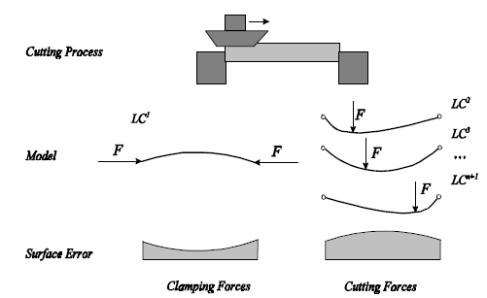

  - Numerical model
The workpiece is discretized by the finite element method (FEM). Defects are computed at each node of the machined surface. The simulation of form error requires a single finite element analysis (FEA) with n + 1 load cases, where n is the number of nodes of the machined surface. The first load case (LC ¹ on Figure 1) corresponds to the clamping forces. The n other ones (LC² to LC^{n + 1}) correspond to the cutting forces applied by the tool when passing on each node of the machined surface. In most cases, the workpiece bends under the cutting forces, which leads to a material excess (Figure 1).
  - Further approximations

A lathe tool is modeled by a point corresponding to its nose and a milling cutter by Z points, corresponding to the noses of the Z inserts, equally spaced on a circle of radius R. Cutting forces are applied on these points. The model is based on the assumption that each node of the machined surface lies on the tool trajectory. This is not necessarily the case if the tool follows the idealized trajectory (Figure 2). In the worst case, the position error is half of the feed (feed per tooth in milling). Actually, the cutting forces are distributed on the cutting edge (Figure 3). The resultant force passes through some point PA ^{real} which differs from the tool nose (PA^{mod}) from a length depending on the depth of cut and the tool cutting edge angle.

Figure 2: Idealized tool trajectory

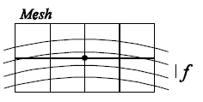

Figure 3: Error on the resultant force application point
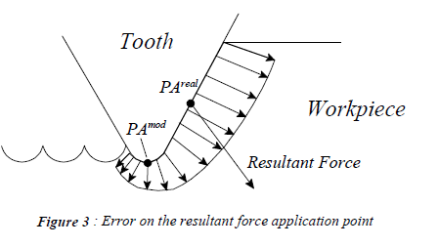

- COMPUTED FORCES FOR THE FEA
  - Mesh definition
In the present method, the workpiece can be modeled by any finite element mesh, provided the machined surface is discretized only with surface elements or faces of volume elements. Boundary conditions must include supports and clamping forces.
  - Tool description and cutting conditions
The tool is defined by the following parameters
- for a lathe tool, the tool cutting edge angle K_{r},
- for a milling tool, the radius R, the number of teeth Z and the angle K_{r}.
The tool trajectory is composed of successive rectilinear and circular parts on which cutting conditions (N, ƒ) are specified. Variable depth of cut is allowed, a feature which is useful for cast blanks. In this case, nodal depths of cut are computed from a CAD description of the workpiece.

  - Cutting force model
A lot of cutting force models are available in the literature, both for turning and milling. Almost all of them are based on formulae where the forces are related to a power law of the chip thickness. A sophisticated model including parameters such as spindle axis tilt and cutter
run-out was developed by Gu et al. (1997) for face milling.

Figure 4 : Chip description
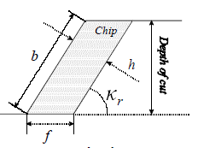

In this work, Kienzle's model [9] is used. Denoting
- F_{c} the main cutting force, which acts along the main cutting velocity direction,
- F_{ƒ} the feed force, acting in the working plane and orthogonal to F_{c},
- F_{p} the passive force, which is orthogonal to the working plane,
Kienzle's formulae are as follows
where b is the width of cut, h, the thickness of cut (Figure 4) and k_{i} the nominal cutting pressure which is obtained using experimental data by
µ
where k_{i} _{1.1} is the specific cutting pressure and m_{i} is the pressure exponent. One can note that for milling, the thickness of cut for one tooth depends on the angle ɵ between the feed direction and the position of the tooth (Figure 5), i. e.,
The main advantage of Kienzle's model is that a great amount of experimental data on current materials have been given by König and Essel [10]. If no data is available, material characteristics can be computed from cutting forces measurements [11].

Figure 5: Engaged teeth positions
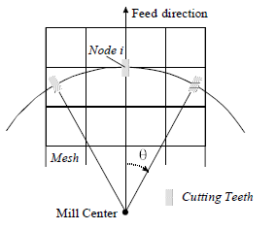

  - Application of forces on the mesh
The clamping forces (load case no. 1) are part of the data since they are given with the mesh. The n other load cases corresponding to cutting forces are computed differently for turning and for milling. Let us examine the determination of load case no. i + 1 associated with node no. i.
In turning, since the cutter is supposed to be on node no. i , the load case is determined by the following way : first, the cutting forces are computed using formulae (1) and (2) with the cutting conditions corresponding to position (x_{i},y_{i},z_{i}); then the cutting forces are projected onto the workpiece axes; and finally the forces(F_{x} ,F_{y} ,F_{z} ) are applied to node no. i .

Figure 6: Repartition of forces on the element nodes
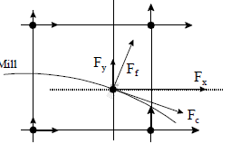

In milling, there are generally several teeth working at a same time. There is a tooth located at the position (x_{i} , y_{i} , z_{i})when computing the defect of node no. i . Knowing this and the trajectory of the mill, it is possible to determine the position of its center and the positions of the other engaged teeth (Figure 5). Cutting forces are then computed from (1), (2) and (3) for each engaged tooth. For the tooth on node no. i, the projected forces (F _{x},F _{y} ,F _{z}) are directly applied to the node. However, the other engaged teeth are generally applied onto points that do not correspond to mesh nodes. Consequently, one first has to determine on which element face the considered tooth lies, and then one has to apply the projected forces (F _{x},F _{y} ,F _{z}) on the adjacent nodes by the classical energetic equivalence (Figure 6).
  - Implementation
The developed software is composed of a pre-processor generating the necessary files for the finite element analysis and a post-processor which collects the results and restores the form error of the machined surface. This scheme is illustrated on Figure 7. The finite element model is obtained through an I-DEAS file. FEA are performed with NASTRAN.

Figure 7: Model implementation
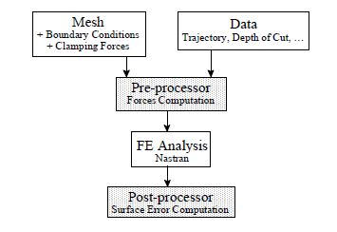

- EXPERIMENTAL VALIDATION OF THE MODEL IN FACE MILLING
  - Choice of the validation case
The purpose of the validation is to find an experimental milling process that generates a form error only due to the cutting forces. The experimental case must satisfy the following conditions
- Small effects due to vibration problems or residual stress,
- 2. No error due to the clamping forces,
- No axis tilt and no back-cutting,
- Small roughness.
In order to generate a measurable error, it is necessary either to have a flexible workpiece - which can lead to dynamics problems - or to produce heavy cutting forces by increasing the feed or the depth of cut - which leads to a high roughness. Satisfying all these conditions is not easy to achieve. After a few trials we have chosen to validate the model on the following experimental case: the milling of a thin plate of aluminium in fly cutting. Two tests are defined based on two different geometries of the workpiece (Figures 8 and 9).

Figure 8: Workpiece geometry - test no. 1

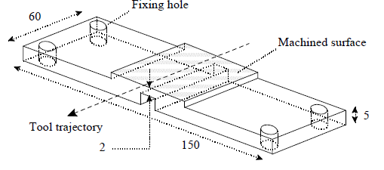

Figure 9: Workpiece geometry - test no. 2
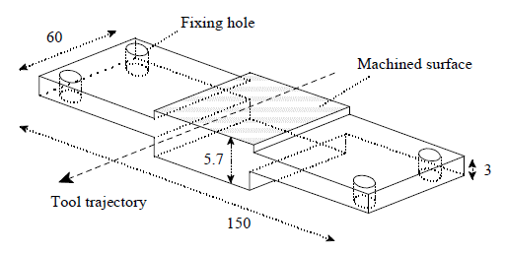

  - Fixture and cutting conditions
The workpiece is put on four local supports and attached with four screws (Figure 10). The supports are made of steel and grinded to avoid any deflection of the workpiece when clamped. The jig is mounted on the cutting force dynamometer which is screwed onto the machine table.

Figure 10: Jig and workpiece Fixture
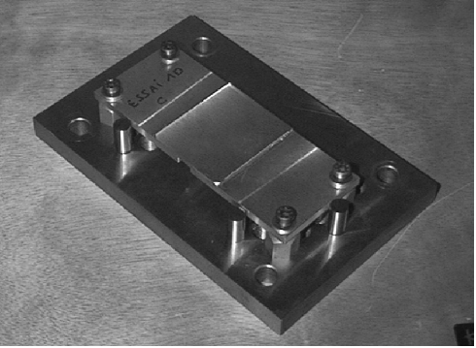
The milling machine is a MIKRON WF21D. The tool is a six-tooth mill of diameter 80 mm with square carbide inserts (grade GH1K10) and a tool cutting edge angle K_{r} of 45°. The cutting conditions are
- the rotation speed N = 200 rpm,
- the feed per tooth ƒ_{z} = 0.1mm/tooth.
The depth of cut is 1.5 mm for test no.1 and 2.3 mm for test no. 2. The tool trajectory is centered as shown on Figures 8 and 9.

  - Surface measurements
Workpiece surface is measured with a roughness-measuring machine SOMICRONIC SURFASCAN 3D. The roughness must be filtered in order to compare experimental data and simulation results. This is achieved with a filter specifically developed for this application and based on a convolution process. The smoothing effect of the filter is controlled by the parameter R_{f} (radius of the filter) that defines its influence region. The higher R_{f}, the smoother the measure. The smoothing must be strong enough to keep only the form error due to the cutting forces and remove the roughness and undulations due to side effects such as slight vibrations of the workpiece during the process.
  - Cutting forces measurements
Since material characteristics are unknown, we compute them from cutting force measures on a Kistler 3-axes dynamometer 9265A. This leads to the following material characteristics
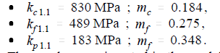
These values are inserted in the model to compute the nominal pressures according to (2).

  - Simulations
The FE models are composed only of volume elements. Two types of boundary conditions are considered.
- Constrain of nodes lying on the contact surfaces between the supports and the workpiece (denoted BC1). This almost simulates a rigid-fixing of the plate and is too stiff compared with the actual behavior of the workpiece;
- Constrain of only one node per fixing hole (denoted BC2). These boundary conditions turn out to be too flexible because the displacements of the workpiece are restrained by the screws.
It is assumed that the BC1 and BC2 models lead respectively to a lower and an upper bound of the measured form error.

  - Results presentation
In order to compare the measured and simulation results, flatness errors are computed with the P-norm method (PN) [12]. Unlike the classic least squares method (LS), the P-norm method allows to find the true value of form errors according to the standards, i. e., the minimum distance between two planes framing the surface in the case of the flatness error.
Figures 11 to 16 show the surface points distances to the plane computed by the PN method. Coordinate axes delimit the whole machined surface (60*50 mm). The points lie within the measured surface 48*47 mm).

  - Measures and simulation results
For test no. 1, we obtain by simulation a topology of the form error that conforms with the measurements (Figures 11 to 14). As expected, the error amplitude is lower than the measured values when using the boundary conditions BC1 and greater with the boundary conditions BC2.
For test no. 2, the boundary conditions influence only the amplitude of the error. We obtain very similar topologies with BC1 and BC2. The simulation results fit quite well the measurements (Figures 15 and 16). The topology differences between tests 1 and 2 are mainly due to the presence of the groove on the lower side of the workpiece (Figure 8).

Figure 11: Test 1 - measured workpiece no. 3
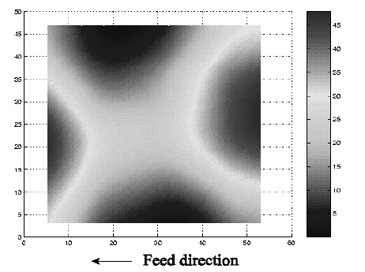

Figure 12: Test 1 - simulation BC1
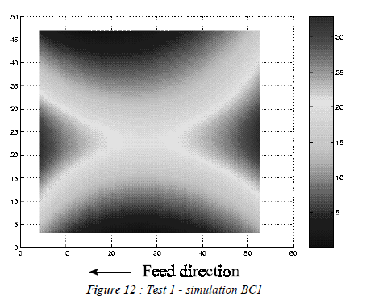

Figure 13: Test 1 - measured workpiece no. 2
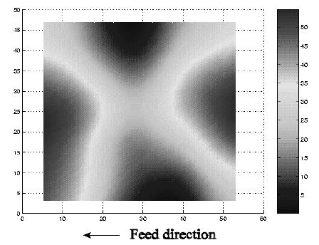

Figure 14: Test 1 - simulation BC2
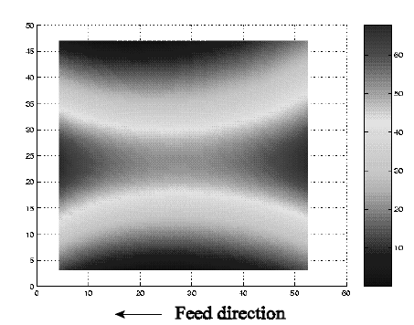

Figure 15: Test 2 - measured workpiece
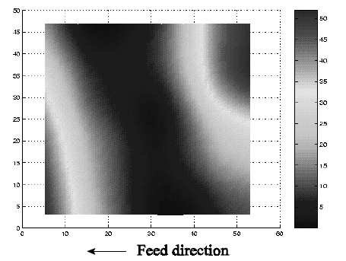

Figure 16: Test 2 - simulation BC1
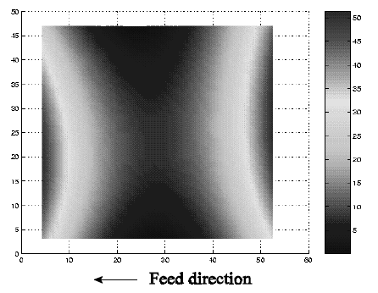
The flatness error for the measured plates is given in Table 1 for two values of the filter radius R_{ƒ}. Differences between LS and PN methods are also shown. Simulation results for tests 1 and 2 are given in Table 2. The characteristics of the mesh and the computational time for test no. 1 are given in Table 3. The FEA was performed on a CRAY C90.

Table 1: Flatness of measured plates for tests 1 and 2
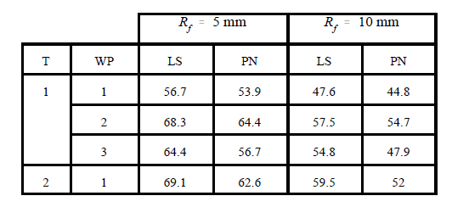

Table 2: Flatness obtained with simulations for tests 1 and 2
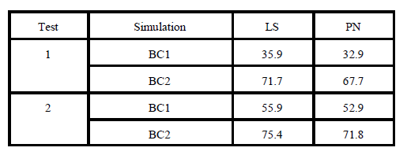

Table 3: Characteristics of FEA for test no.1

- INDUSTRIAL APPLICATIONS
Figure 17: Gear box part
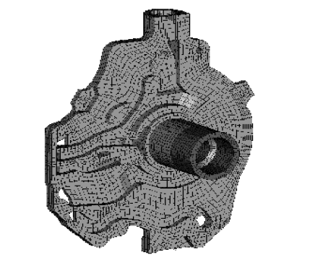

  - Transverse turning of a gear box part
The operation consists in turning the face of a gear box part (Figure 17). The gear box is the new Pro-Active model. The workpiece is held with 3 strap clamps. On the assembly drawing, one of them is not aligned with its respective support but the shift is not dimensioned. The error due to the bad fixture design can be simulated by applying the actual clamping force (given by the assembly drawing) on a node located near the approximate strap clamp location. A comparison of the two simulation results and the measurement (Figure 18) shows that the error in area A is due to the clamping force and the error in areas B and C to the cutting forces. The measured form error is obtained by adding the two computed errors with a weighting factor due to the approximation of the strap clamp location.

Figure 18: Simulation and experimental results for the gear box part

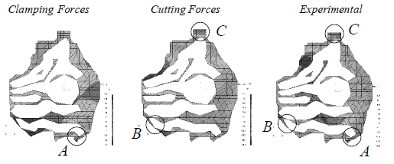

  - Milling of a 4-cylinder block
The lower side of an 4-cylinder block (new model 1600 cc gasoline) is face milled. It is made of cast iron (GL04). The actual characteristics of the material have not been determined. The characteristics of a similar material (GG-30) are used for the simulations. The computed errors due respectively to the clamping and cutting forces are shown in Figure 19. Adding the two contributions, the obtained error is quite similar to the measured one except on the upper left side of the machined surface.

Figure 19: Form errors of the 4-cylinder block
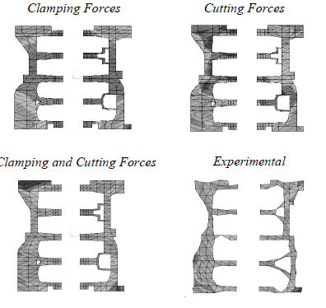

- CONCLUSIONS
A simple method for predicting form errors in face milling and turning has been developed. Both errors due to clamping and cutting forces can be computed. The model takes into account complex tool trajectories and workpiece geometries. A software has been developed with special care to reduce the computational cost so that industrial applications can be performed.
The main advantage of the method is that nodal values of the form error are computed directly in the most simple and the most natural way, without any interpolation or restitution process as in
other works ([6], [7]). This means that, in the frame of a given finite element mesh, these nodal values are strictly exact.

ACKNOWLEDGMENT
The authors gratefully acknowledge the financial and technical support of the Renault Department of Powerstrain Structural Analysis, Rueil-Malmaison, France. We would also thank the other Renault team members, J.-J. Droux, J. Duysens and P. Le Roy, and P. Beckers (Professor, Aerospace Laboratory, University of Liège, Belgium) for their help.

REFERENCES
- Kops, L., Gould, M., Mizrach, M., 1993, Improved Analysis of the Workpiece Accuracy in Turning, Based on the Emerging Diameter, ASME Journal of Engineering For Industry, Vol. 115, pp. 253-257
- Debongnie, J.-F., 1994, Prévision analytique des défauts d’usinage en chariotage, Rapport interne LMF/D37
- Debongnie, J.-F., 1995, Effet de la souplesse de la contre- pointe sur le défaut de cylindricité des pièces tournées, Rapport interne LMF/D38
- Kakade, N. N., Chow, J. G., 1993, Finite Elements Analysis of Engine Bore Distorsions During Boring Operation, ASME Journal of Engineering For Industry, Vol. 115, pp. 379-384
- Subramani, G., Kapoor, S. G., DeVor, R. E., 1993, Improve Analysis of the Workpiece Accuracy in Turning, Based on the Emerging Diameter, ASME Journal of Engineering For Industry, Vol. 115, pp. 15-22
- Schulz, H., Bimschas, K., 1993 Optimization of precision Machining by Simulation of the Cutting Process, Annals of the CIRP, Vol. 42/1, pp. 55-58
- Gu, F., Melkote, S. N., Kapoor, S. G., DeVor, R. E., 1997, A Model for the Prediction of Surface Flatness in Face Milling, ASME Journal of Manufacturing Science and Engineering, Vol. 119, pp. 476-484
- Gu, F., Kapoor, S. G., DeVor, R. E., Bandyopadhyay, P., 1997,
An Enhanced Cutting Force Model for Face Milling With Variable Cutter Feed Motion and Complex Workpiece Geometry, ASME Journal of Manufacturing Science and Engineering, Vol. 119, pp. 467-475
- Dubbel, 1990, Taschenbuch für den Maschinenbau, 17. Neubearbeitete Auflage, Herausgegeben von W. Beitz und K.- H. Küttner, Springer-Verlag, Berlin
- Konig, W., Essel, K., 1973, Spezifische Schnittkraftwertefur die Zerspanung Metallischer Werkstoffe, Herausgegeben von Verein Deutscher Eisenhüttenleute, Verlag Stahleisen M. B. H., Düsseldorf
- Debongnie, J.-F., 1994, Sur la mesure des pressions de coupe lors du fraisage en bout, Rapport interne LMF/D36
- Debongnie, J.-F., Masset, L., 1998, Sur l’évaluation des défauts de forme à partir de mesures tridimensionnelles, European Journal of Mechanical Engineering, Vol. 43 n°1, pp. 13-21

