Dual analysis with general boundary conditions

J.F. Debongnie^{a,}, H.G. Zhong^{b}, P. Beckers^{b}
ªManufacturing Laboratory. University of Liège, 21 rue E. SOLVAY, 4000 Liège, Belgium
^{b}Aerospace Laboratory, University of Liège, 21 rue E. SOLVAY, 4000 Liège, Belgium

ABSTRACT
The dual analysis concept was introduced by Fraeijs de Veubeke [1] as a consequence of upper and lower bounds of the energy. As such bounds exist only in those cases where one type of condition is homogeneous, it is commonly admitted that a dual error measure does not exist with general boundary conditions. This paper presents a re-examination of the dual error measure by a way which avoids any use of upper and lower bounds of the energy. It is found that such an error measure holds whatever the boundary conditions be. Furthermore, it is not necessary to obtain the approximate solutions by a Rayleigh-Ritz process, so that the second analysis, which seemed necessary in the original dual analysis concept, may be replaced by any admissible approximation. This implies the possibility of a dual error measure at a simple post-processor level.

- Introduction
Let us consider a linear elastic body whose volume will be denoted V. Its boundary S may be splitted in two parts S₁ and S₂, with prescribed displacements $\overline{u}$_{i}, on S₁ and imposed surface tractions t_{i}, dS on S₂. Moreover, volumic forces ƒdV are applied inside the body. In what follows, it is always assumed that fixations are sufficient to ensure displacement unicity.
The equations between the stress field σ, the strain field ε, the displacement field u and the data are then as follows
Compatibility relations

Constitutive relations
Equilibrium equations

Finite element methods often consist in approximating any of these equations in the frame of variational principle. Excluding a priori approximations on constitutive relations, which seem not to be very useful (if one excepts, perhaps, a way to analyse the effect of numerical integration), there subsists a choice between compatibility approximations, equilibrium approximations, or both. Pure models are those where the approximation is restricted on one type of equations. If compatibility is verified exactly, one obtains a displacement model. The opposite situation, where equilibrium is satisfied a priori is called equilibrium model. As pointed by Fraeijs de Veubeke [1], displacement models are always too stiff and equilibrium models, always too flexible. Consequently, if the non-zero data only consist in forces, i.e. $\overline{u}$_{i} = 0, the elastic energy will be underestimated by any displacement model and overestimated by any equilibrium model. The difference between the two values of the energy constitutes then an energetic measure of the cumulated error of both analyses. The situation is reversed in the case of zero forces, with a non-zero prescribed boundary displacement. These conclusions form the basis of the so-called dual analysis which was widely used by himself and his co-workers [2-6],
Unfortunately, their theoretical approach was focused on upper and lower bounds of the energy. This is probably the reason why they failed to realize that dual analysis, in the sense of an error measure, remains valid with a very slight modification in the case of general boundary conditions. The purpose of the present paper is to show this useful extension.

- The displacement approach
Admissible displacement fields are those displacement fields that satisfy a priori the boundary condition u_{i} = $\overline{u}$_{i} on S₁. An admissible displacement variation δu is then defined as the difference between two admissible fields. Consequently, one must have
The displacement approach consists in finding, among ail admissible displacement fields, the particular field m that minimizes the total potential energy
Where
is the strain energy, and

is the potential of the prescribed loads. Varying the functional (5) with respect to u leads to equilibrium equations. In other words, the exact equilibrated solution u of the elastic problem verifies the condition
for any admissible displacement variation δu.
The displacement finite element method consists in minimizing the total potential energy, not over ail admissible displacement fields, but only over those fields that are contained in the finite element model. In a strict displacement model, the approximate displacement field u* has to satisfy exactly the kinematical condition
In other words, u* has to be strictly admissible. This is the only property of the approximate solution that we will use. In particular, it is not necessary for our developments that u* should be a Rayleigh-Ritz approximation.
The value of the total potential energy for such an approximate displacement field may be computed as follows. Let us write

Then, the total potential energy admits the development
Where
is the second variation of . But condition (9) implies that Δu is an admissible displacement variation, so that the first variation δvanishes and
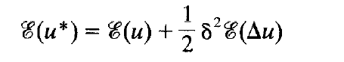
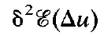 is an energetic measure of the approximation error, namely, twice the energy of the variation Δu. This fact will be reflected by adopting the norm notation ||Δu ||². The result is thus

- The equilibrium approach
Statically admissible stress fields are those stress fields σ that satisfy the equilibrium equations (3) on V and S₂. A statically admissible stress variation δσ is defined as the difference between two statically admissible stress fields. This implies
The equilibrium approach consists in choosing, among ail statically admissible stress fields, the particular stress field σ that minimizes the total complementary energy
Where
is the complementary strain energy and
is the potential of the prescribed displacements. It is well known that this principle leads to compatibility conditions. The exact solution σ thus verifies the condition
for any statically admissible stress variation δσ.
The equilibrium finite element method consists in minimizing the total complementary energy on a finite element subspace. In a strict equilibrium model, equilibrium equations (3) have to be verified exactly by the approximate stress field σ*. In the same manner as in displacement models, this is the only property that we will require, and it is by no means necessary that σ* will be a Rayleigh-Ritz approximation.
Setting
leads to the following development of 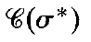
with

As both σ and σ* satisfy the equilibrium equations (3), their difference Δσ is a statically admissible stress variation, so that the first variation vanishes and
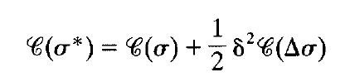
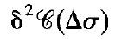 is an energetic measure of the approximation error, that we may note ||Δσ||², from which results

- The general dual analysis
Displacement and equilibrium approaches lead both to the same exact solution
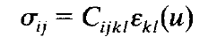
so that
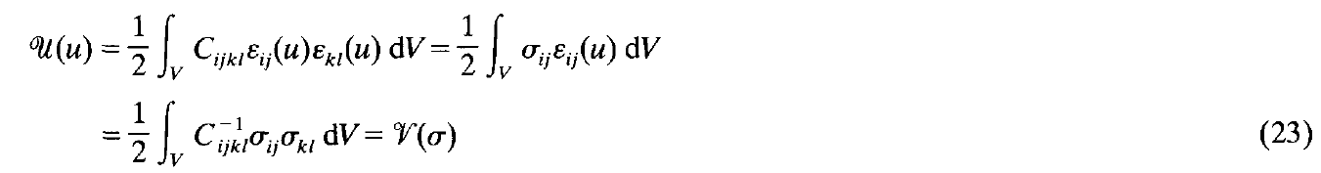
Furthermore, an integration by parts leads to the relation
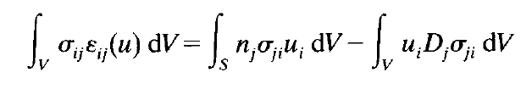
and, taking into account Eqs. (1) and (3),
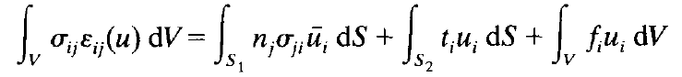

The first member of this relation may be re-written in the following form
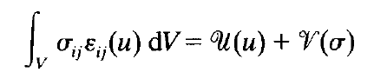
so that the true solution verifies
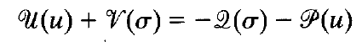
or, equivalently,
From this, it is now sufficient to add relations (13) and (22) to obtain the fundamental resuit of dual analysis
A more refined analysis [7] allows to show that this sum of square errors is also the square of the energetic distance between the two approximations, but this result is of less practical interest.
From a practical point of view, it is preferable to work with the square root of (25) and to compare it to the energetic norm of the true solution
so as to obtain a relative error measure
It is interesting to note that the evaluation of this relative error only requires very simple computations from the results. One may naturally object that two finite element analyses are necessary to obtain such an error measure. But our proof never made use of the assumption that u* and a* should be Rayleigh-Ritz approximations. The only requirement is that u* and σ* are admissible. Therefore, all the conclusions remain valid if the approximate fields are obtained by any way guaranteeing nothing more than the admissibility. As an example, Ladevèze and Oden [8-11] proposed a method to find a statically admissible stress field in a post-processor scheme after a displacement approach. With such a field, results (25) and (26) remain true.

- Fraeijs de Veubeke’s particular cases
The classical dual analysis, such as proposed by Fraeijs de Veubeke, was derived with the following supplementary assumptions which guarantee the existence of upper and lower bounds of the energy
- One type of boundary conditions is homogeneous
- The approximate homogeneous field is obtained by a Rayleigh-Ritz procedure.
There are thus two cases that have to be considered separately.
- Homogeneous prescribed displacements, $\overline{u}$_{i} = 0
In this case, the solution u is itself an admissible displacement variation, from which follows
The same is true of the Rayleigh-Ritz approximation u*
As a consequence,
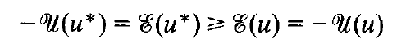
In the equilibrium model, the potential of the prescribed displacements vanishes, so that, for any statically admissible stress field σ*
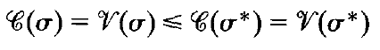
Applying the relation (24) gives
that is upper and lower bounds of the elastic energy, and the error measure becomes
In this case, the error is thus measured by the difference between the two obtained values of the elastic energy.
- Homogeneous equilibrium, ƒ_{i} = 0 and t_{i} = 0
In this case, the solution σ is itself a statically admissible stress variation. The same is true of the Rayleigh-Ritz approximation σ*, so that
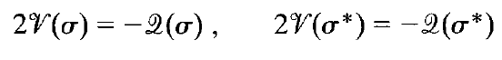
from which follows
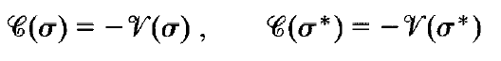
And
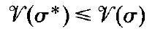
As the potential of the prescribed loads vanishes, any admissible displacement field u* verifies
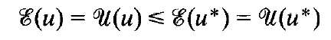
This leads to the following upper and lower bounds of the elastic energy
and the cumulative error is given by
The error is also measured by the difference between computed elastic energies, but with the reversed sign.

- Numerical examples
  - Plate bending problem
This first example is designed to show dual analysis in plate bending problems, in a situation where upper and lower energy bounds results do not apply because of the non homogeneous boundary conditions.
Consider a square plate loaded at the center. It is clamped on one edge, the opposed edge being loaded with a prescribed non-zero transversal displacement (Fig. l(a)). Numerical data are: edge length L = 10, thickness t = 0.1, Young’s modulus E = 2.05x10¹¹, Poisson’s ratio v = 0.3, point load $\overline{F}$= -1000, prescribed displacement $\overline{w}$= -0.01.
Two different plate bending elements are used for the analyses. The first one is the HCT conforming triangle with three degrees of freedom (D.O.F.) per node [12]. The other one is the Morley equilibrium triangle with 1 D.O.F. per node and 1 D.O.F. per edge [13].
As shown in Fig. l(b), an initial coarse mesh is created with 6 triangles. It is uniformly refined so as to obtain meshes 2, 3 and 4. Results of the finite element primal and dual analyses are shown in Table 1

Fig. 1. Plate bending, boundary conditions (a) and meshes (b).
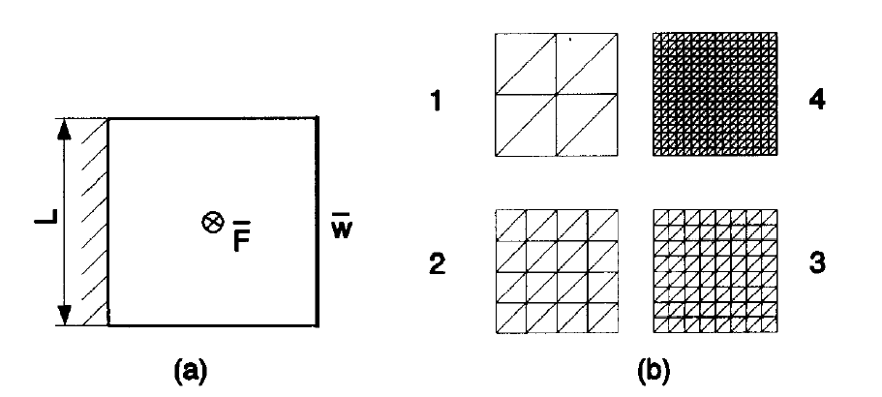

Table 1 - Plate bending problem: convergence of the energies and errors
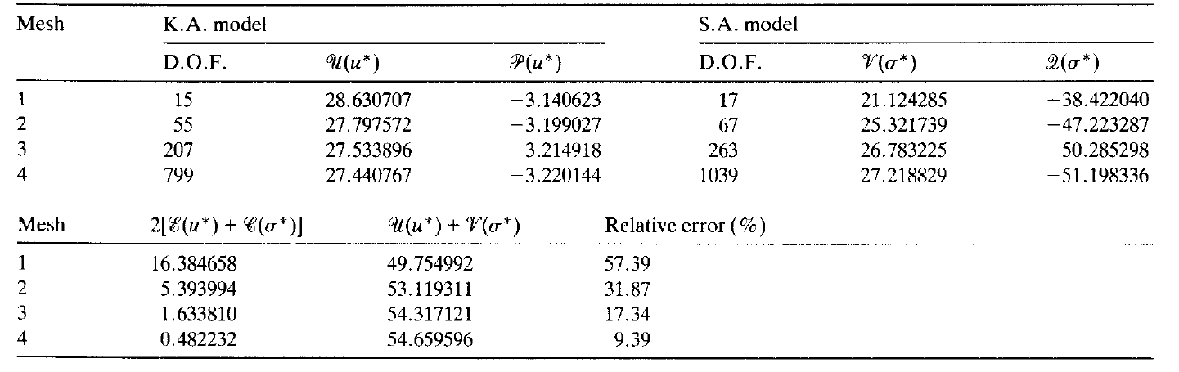
.
  - Plane stress problem
The second example is designed to illustrate the use of a statically admissible field constructed by post-processing in order to compute energy and error norms. In this case, no dual analysis is performed.
The structure is the same as in the preceeding example but it is subject to plane stress conditions (Fig. 2(a)). The prescribed displacements are , $\overline{u}$ = 0.01 and the imposed tractions t= -1.0 x 10⁸.
Four-noded conforming elements are used for the analyses. For each conforming element solution u*, a statically admissible stress field is constructed by post-processing, using the method proposed by Ladevèze [10].
An initial course mesh is created with quadrilaterals. It is uniformly refined so as to obtain meshes 2, 3 and 4 (see Fig. 2(b). Results of the finite element and dual analyses are shown in Table 2.
  - Potential flow problem
The last example illustrates a solution of Laplace equation. Dual analysis is performed through the stress function approach [5,14]. Convergence is analyzed using a process of adaptative mesh refinement [15].
The domain and initial mesh are shown in Fig. 3(a). The boundary conditions are shown in Fig. 3(b) under the potential flow formulation

Fig. 2. Plane stress problem, boundary conditions (a) and meshes
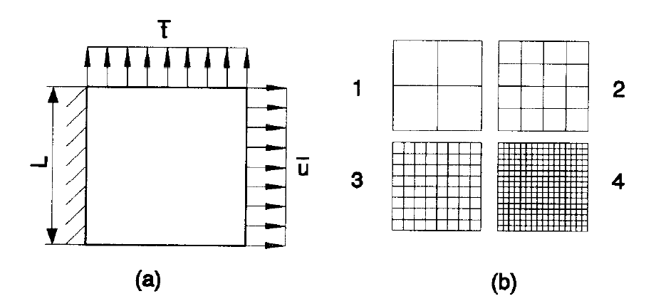

Table 2 - Plane stress problem—Convergence of the energies and errors
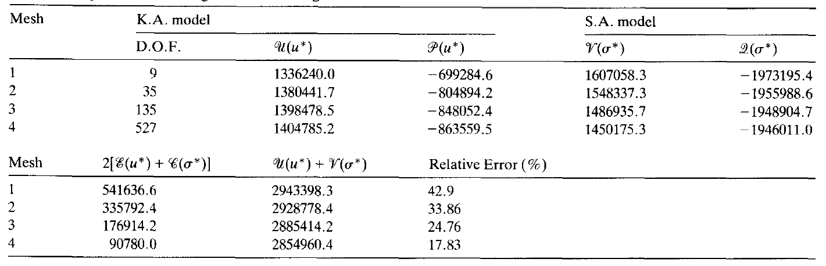

Fig. 3. Potential flow, boundary conditions.
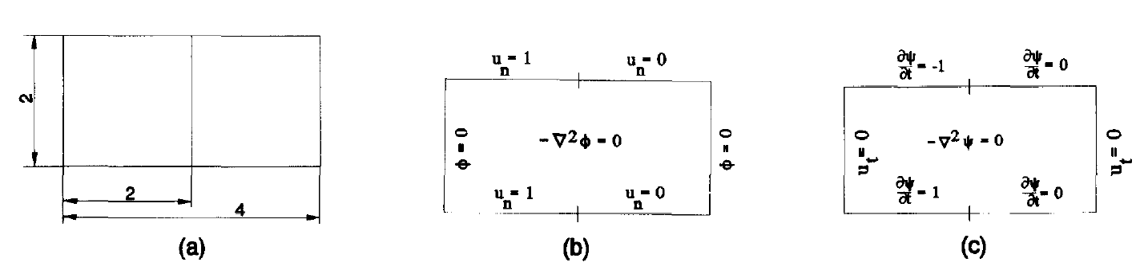
It is well known that this formulation can be transformed into another one using the stream function
Note that the initial boundary conditions must also be transformed accordingly, as shown in Fig. 3(c).
Three-noded and four-noded conforming elements are used in the analyses. If boundary conditions corresponding to (31) are used, the obtained solution is kinematically admissible. On the other hand, if boundary conditions corresponding to (32) are used, the obtained solution is statically admissible.
From the initial mesh, two meshes are obtained by an adaptative mesh refinement procedure by imposing a prescribed precision of 10% and 3.3%, respectively (Figs. 4 and 5). Results of the finite element analyses and dual analyses are shown in Table 3.

Fig. 4. Adaptive mesh with a 10% prescribed précision.
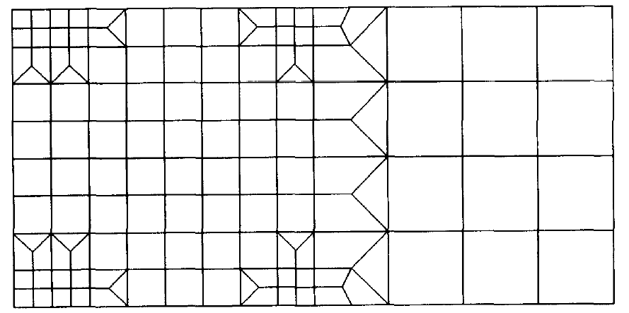

Fig. 5. Adaptive mesh with a 3.3% prescribed precision.
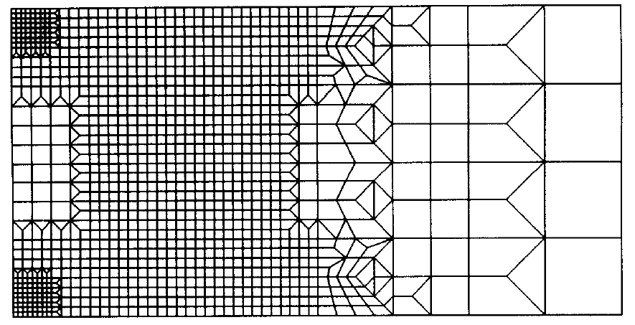

Table 3 - Potential flow problem—Convergence of the energies and errors
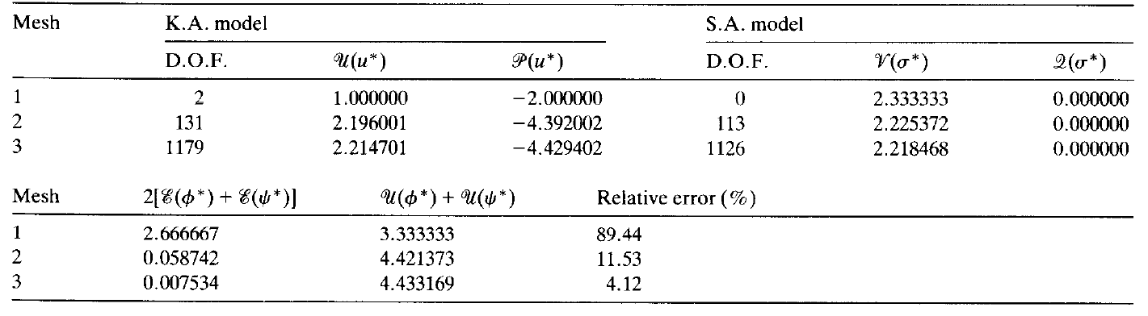
- Conclusions
Upper and lower bounds of the strain energy disappear with general boundary conditions, but the dual analysis concept, conceived as a way to measure the errors, remains valid in all cases. This seems to be the most interesting property of the method.
As explained by Ladevèze [8-10], the only requirement of the dual comparison solution is its admissibility. For this reason, it can be obtained as in the second example by a post-processing procedure. This approach can be interpreted as a local dual method applied on a single element or on a patch of elements. Finally, an important result of the present development is to give another way to interpret the global error estimator introduced for a long time by Ladevèze as the error on the constitutive relations.

References
- B. Fraeijs de Veubeke, Sur certaines inégalités fondamentales et leur généralisation dans la théorie des bornes supérieures et inférieures en élasticité, Revue Universelle des Mines, XVII, n°5, 1961.
- B. Fraeijs de Veubeke, Upper and lower bounds in matrix structural analysis, AGARDograph 72, 165, Pergamon Press, 1964.
- B. Fraeijs de Veubeke, Duality in structural analysis by finite elements, NATO advanced studies institute—Lecture series on finite element methods in continuum mechanics, Lisbon, 1971.
- G. Sander, Application of the dual analysis principle, Proc. IUTAM, Liège, Belgium, August, 1970.
- P. Beckers, Les fonctions de tension dans la méthode des éléments finis, Doctoral thesis, University of Liège, Belgium, 1972.
- M. Geradin, Computational efficiency of equilibrium models in eigenvalue analysis, Proc. IUTAM, Liège, Belgium, August, 1970.
- J.F. Debongnie, A general theory of dual error bounds by finite éléments, University of Liège, Belgium, report LMF/D5. 1983.
- P. Ladeveze, Comparison de Modèles de milieux continus, Doctoral thesis, University P & M Curie, Paris, 1975.
- P. Ladeveze and D. Leguillon, Error estimate procedure in the finite element method and applications, SIAM J. Numer. Anal. 20(3) (1983) 483-509.
- P. Ladeveze, J.P. Pelle and P. Rougeot, Error estimation and mesh optimization for classical finite éléments, Engrg. Comput. 8 (1991) 69-80.
- M. Ainsworth and J.T. Oden, A procedure for a posteriori error estimation for h-p finite element methods, Comput. Methods Appl. Mech. Engrg. 101 (1992) 73-96.
- R.W. Clough and C.A. Fclippa, A refined quadrilateral element for analysis of plate bending, Proc. 2nd. Conf. Matrix Methods in Structure Mechanics, Air Force Inst, of Tech., Wright Patterson Air Force Base, Ohio, 1968.
- L.S.D. Morley, The triangular equilibrium element in the solution of plate bending problems, Aero Quart. 19 (1968) 149-169.
- B. Fraeijs de Veubeke and O.C. Zienkiewicz, Strain energy bounds in finite element analysis by the slab analogy, J. Strain Anal. Inst, of Mechanical Engrg. 2(4) (1967).
- H.G. Zhong, Estimateurs d’erreur a posteriori et adaptation de maillages dans la méthode des éléments finis, Doctoral thesis. University of Liège, Belgium, 1991.

Corresponding author

