Sylvain Paile

8.4 European Initiative for the Exchange of Young Officers inspired by
Erasmus

A specific task given to the ESDC is to provide support for exchange programmes of the national training institutes.

In the second half of 2008, the then French Presidency launched a reflection on the means for allowing greater integration of initial academic and professional training of the European young officers through mobility. The initiative was born in November 2008 from a declaration of the Council. Beyond its words, the declaration proposed a series of measures which sets the ground for enhanced interoperability and, through it, paves the way for the emergence of a European culture of security and defence among these future actors of the CSDP:

- Measures aimed at increasing the number of exchanges, such as the generalisation of the Bologna process, the mutual recognition of the outcomes of exchanges in professional training, the greater use of Erasmus mobility for students and personnel, the opening of national pedagogical offer to the European young officers, etc.

- Measures aimed at teaching/learning about Europe and its defence, such as the creation of a common module on CSDP, the promotion of the learning of several foreign languages, etc.

An Implementation Group was created in February 2009 as a task-oriented structure of the ESDC’s Executive Academic Board, charged with implementing the initiative.

Relying on the contributions and support from the Member States and their institutes, the Implementation Group reached sustainable progress on various aspects of the initiative, including the conduct of a common module on CSDP based on the standard curriculum developed by the ESDC, which was organised for the first time in the Portuguese academies in 2009. After a year of existence, these modules had allowed more than 400 young officers to become familiar with the role they may be called to play in the future European defence.

In 2010, a detailed stocktaking of the European officers’ initial training has been finalised, which supports the interested institutes in their identification of partners with whom they organise exchanges and a dedicated forum for communication of the institutes on their demands and offers of exchanges has been set up.

In 2011, a Compendium of the European Military Officers Basic Education has been published by the Polish Presidency, which is conceived to compare the basic educational systems of equivalent branches/services in all Member States. This Compendium represents a further conceptual step towards stronger and closer co-operation between national academies and training centres.

Furthermore, a framework arrangement has been agreed by all 27 Member States, setting the conditions under which the exchanges between Member States willing to participate take place, as well as recognition procedures of the outcomes of exchanges in military professional training.

Meanwhile, common curricula on issues shared by the European armed forces are being developed on a constant basis and are now proposed to the young officers.

The implementation of the initiative is driven by the key idea that the exchanges of working and interpersonal qualifications at initial training level are the cornerstones for the emergence, on the longer run, of interoperability and the common culture that is needed for the European defence.

SOURCES FOR MORE AND UPDATED INFORMATION

- The European Military Higher Education Stocktaking Report, (Sylvain Paile, DG F Council General Secretariat ed., Brussels, May 2010) available on: http://esdc.mil-edu.be/index.php/networking-news or on: http://www.emilyo.eu

- The Compendium of the European Military Officers Basic Education (edited by Sylvain Paile, Polish Ministry of National Defence - Department of Science and Military Education, Warsaw, 2011) available on: http://www.emilyo.eu/images/Uploaded_Documents/EU_Academies/compendium.pdf

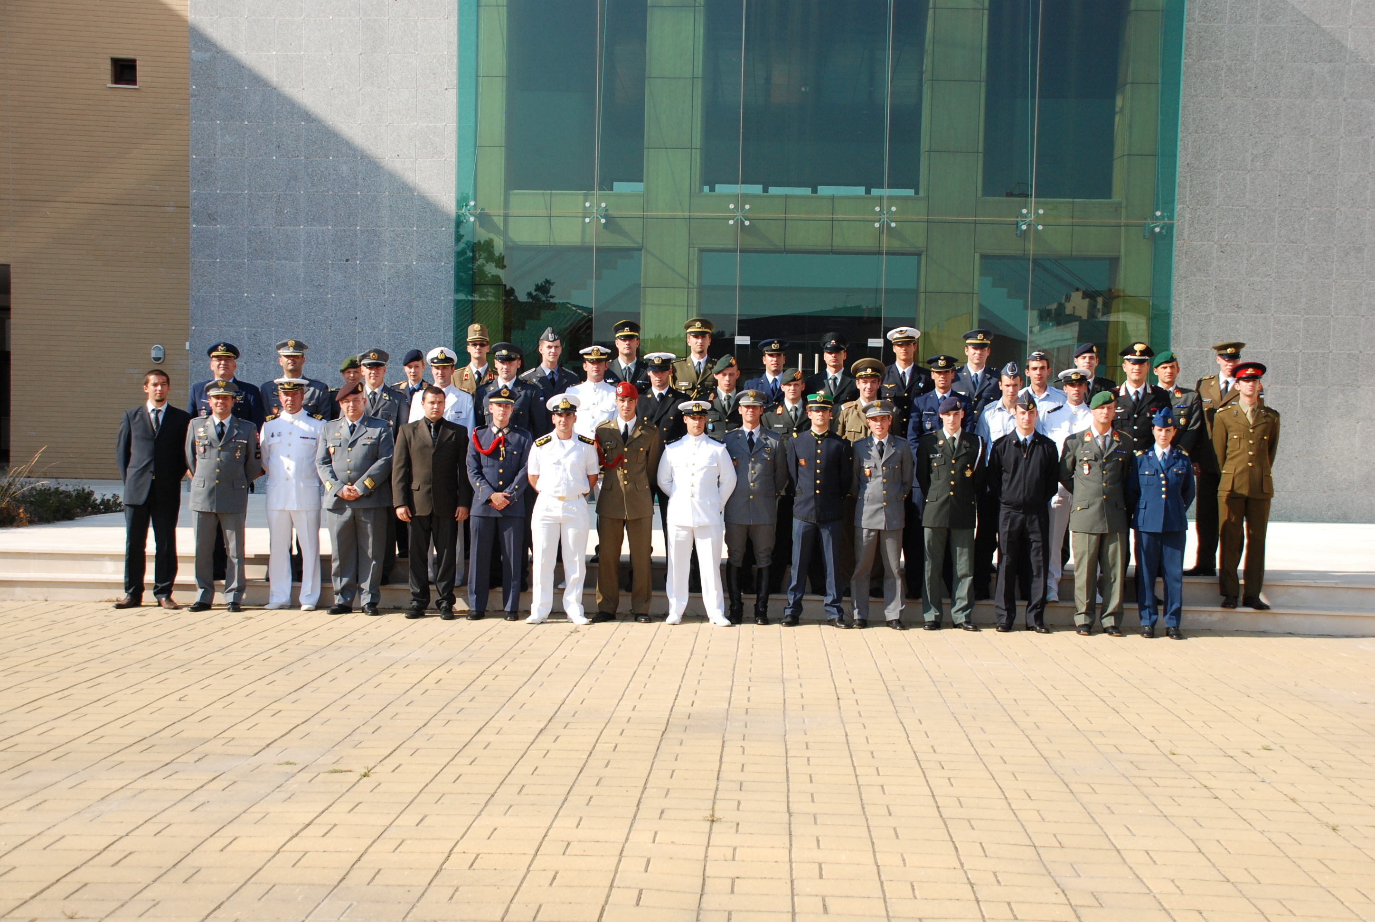

First CSDP module for young officers, Lisbon 2009

