Modeling wastewater sludge drying
with determination of diffusivity moisture

L. Bennamoun, L. Fraikin, T. Salmon, M. Crine, A. Léonard

Laboratory of Chemical Engineering Processes and Sustainable Development, University of Liège, Belgium
E-mail of the corresponding author: Lyes.Bennamoun@ulg.ac.be

Abstract

Convective drying of two different types of wastewater sludges is investigated. Experiments are realised in a micro-dryer, for air temperatures of 80 °C, 140 °C and 200 °C, the velocity and humidity remaining the same. The product drying kinetics presents, for all studied cases, three main phases, which are: adaptation phase, constant drying rate phase and falling drying rate. A comparison between two mathematical approaches allows determination of the diffusion coefficient. The value of this coefficient depends on the origin of the wastewater sludge and the operating temperatures. Physical changes such as shrinkage are introduced into the mathematical model.

Keywords: Convective drying – Micro-dryer – Diffusion Equation – Analytical solution – Shrinkage – Operating conditions – Sludge origin

introduction

Due to the increase of the world population demand in water and the non-availability of this crucial source in some regions, novel solutions are required. This explains the important development of wastewater treatment plants around the world (WWTP). However these facilities are at the origin of the production of sludge which has to be managed, i.e. in order to be valorized at its best organic and mineral content or energy content. Among preferred solutions incineration and use in agriculture are found, with relative importance depending on the country, region …
Drying is a non-avoidable step for the transformation of the sludge. It permits the decrease of the cost of its handling, transport and storage, by the reduction in mass and volume, or its use as a combustible due to the increased calorific value. In this way, several scientific works, with the help of mathematical modelling and simulation, are directed to know more about the fundamental aspect of wastewater sludge behaviour during drying and the parameters influencing this process. It allows having optimum results with better control.
Léonard et al. [1] studied the influence of the operating conditions which are temperature, humidity and superficial velocity of the air, on the behaviour of several wastewater sludges during convective drying and after mechanical dewatering. A clear dominance is registered for the air temperature. The determination of the coefficients of heat and mass transfer and water evaporation capacity are also done by the authors using the drying kinetics results. The origin of the sludge is found as another parameter that influences the general behaviour of the sludge during convective drying [2]. Shrinkage and cracks are two phenomena that appear during convective drying of wastewater sludge and evidently observed using X-ray microtomography [3-5]. The non-introduction of these phenomena during modelling and simulation [6-7] can lead to an over-estimation of heat and mass parameters, as it is found by Rahman and Kumar [8] for a food application.
In a different way, drying wastewater sludge is explored using indirect agitated technique. Mainly, the product passes through three phases (from respectively wetted to dried product) pasty, lumpy and granular [9, 10]. Generally, during this method the influences of the system pressure, temperature heating, stirrer speed and particle size are studied. Modelling and simulation permit following the variation of heat transfer coefficient, heat transfer and penetration resistance... [10-12].
Experimental results of convective drying of two different types of wastewater sludges are presented in this paper. The work is reinforced with modelling and simulation part which permits the determination of the diffusion coefficient for these sludges. The variations of the physical changes of the product represented essentially by shrinkage are introduced in the model.

materials and methods

Sample preparation

This study focuses on two very different sludges: an activated sludge (AS) from the WWTP of Grosses Battes, Liège and a thermolysed and digested sludge (TDS) from WWTP of Bruxelles-Nord, Brussels. To produce AS, water to be purified undergoes a primary treatment, an anaerobic phase and alternating aerobic and anoxic phase. Finally, phosphate is precipitated by ion chloride and biomass in excess is dewatered using a belt filter. TDS undergoes the same treatments except that dehydration is carried out by centrifugation. Afterward, TDS is subjected to a temperature of 160°C and a pressure of 6 bars during 30 min, then the sludge is flashed and digested to produce biogas.
Sludge was collected after the mechanical dewatering step at the “Grosses Battes” wastewater treatment plant located near Liège (Belgium).The sample initial dry matter content was close to 14.5%. Before drying, the sludge is store the sludge, in tightly closed jar, at a temperature of 4°C.

Instrumentation and measurements

Before drying, sludge samples are extruded in shape of cylinder (diameter = height = 15 mm). The drying experiments are carried out in a discontinuous pilot-scale dryer (Figure 1) reproducing most of the operating conditions prevailing in a full-scale continuous belt dryer. Ambient air is heated up to the required temperature by an electrical heating device, and can be humidified by adding steam.

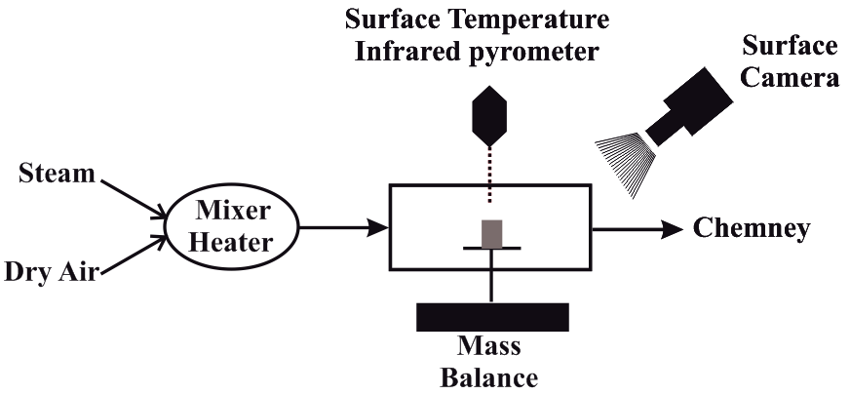
Figure 1: Simplified schema of the convective drying system

Three operating conditions are controlled throughout the drying process: the temperature (50 - 200°C), the superficial velocity (1 - 3 m/s) and the humidity of the air (0.005 - 0.5 kg_{water}/kg_{dry air}). Air humidity is checked on-line with a cooled mirror dew point hygrometer. The initial mass of the sample is 2.5 g and its evolution with time is followed on-line via continuous weighing. Data points are recorded every 30s.
The surface change and the product surface temperature are registered using respectively the surface camera and infrared pyrometer.

mathematical modeling

The mathematical modelling treatment is divided into two parts; first the experimental results are fitted and semi-theoretical models are proposed (Table 1). As a second approach, we use the analytical solution of the equation of diffusion represented by Fick’s second law. The comparison between the two results permits determination of the diffusion coefficient.

Table 1. Semi-theoretical fitted models
n° | Model equation | Name of the model
1 | M* = exp(-k.t) | Newton
2 | M* = exp(-k.t^{n}) | Page
3 | M* = a + b.t + c.t² + d.t³ + e.t⁴ | 4th degree polynomial
4 | M* = a.exp(-k.t) | Henderson and Pabis

Semi-theoretical models

The drying curves obtained with experimental results are fitted using Curve-Expert software. The best models are those presenting best correlation coefficient (r) and lowest value of the standard error (χ²). The results show that 4th degree model presents better results. However, this model has not a real physical analysis, like Page model with the correction factor (n). Henderson and Pabis model presents good fitting results and it is considered as closer to the diffusion approach. The fitting results of sludge (AS) are presented in Table 2.

 | Temperature 80 °C |  |  | Temperature 140 °C |  |  | Temperature 200 °C
n° | Parameters | (r) | (χ²) | Parameters | ® | (χ²) | Parameters | ® | (χ²)
1 | k = 0.02932 | 0.99647 | 0.02337 | k = 0.07450 | 0.99529 | 0.02754 | k = 0.08077 | 0.98904 | 0.04482
2 | k = 0.01769  n = 1.13480 | 0.99908 | 0.01198 | k = 0.04435  n = 1.18455 | 0.99953 | 0.00871 | k = 0.03567  n = 1.30239 | 0.99927 | 0.01165
3 | a = 1.01599  b = -0.02748  c = 0.00033  d = -2.13842×10⁻⁶  e = 5.96414×10⁻⁹ | 0.99997 | 0.00221 | a = 1.01062  b = -0.06395  c = 0.00155  d = -1.77418×10⁻⁵  e = -8.65103×10⁻⁸ | 0.99989 | 0.00434 | a = 1.02349  b = -0.06399  c = 0.00108  d = 3.48503×10⁻⁶  e = -1.68941×10⁻⁷ | 0.99987 | 0.00508
4 | a = 1.05158  k = 0.03077 | 0.99767 | 0.01901 | a = 1.06258  k = 0.07891 | 0.99702 | 0.02204 | a = 1.10004  k = 0.08836 | 0.99368 | 0.03429
Table 2. Fitting results of the different semi-theoretical models for sludge (AS)

(c)
(b)
(a)
(c)
(b)
(a)

Figure 2: Comparison between experimental results and Henderson and Pabis model. (a): 80 °C, (b): 140 °C, (c): 200 °C
The comparison between experimental results and theoretical ones (based on fitting results) for sludge (AS) are shown in Figure 2. The model shows great agreement with a small divergence at high temperatures. TDS sludge has shown the same general affinity.

Diffusion model

Water distribution inside the product could be described by considering Fick’s law. For the unsteady state and one dimensional case, the equation of diffusion is written in the following form:

$$\frac{∂X}{∂t}=D_{ eff}\left(\frac{1}{y^{n}}\right)\left(\frac{∂}{∂y}\right)\left[y^{n}\frac{∂X\left(y,t\right)}{∂y}\right]$$

(1)

Where n takes the value of “0” for a plate, “1” for a cylinder and “2” for a sphere
Considering convective conditions, Eq. (1) is solved by assuming:
- Distribution of the initial moisture is uniform thought the solid.
- The surface of the solid is at equilibrium with the air for a considered time.
Crank [14] proposes for multiple dimensional studies and various applied conditions the analytical solution of every case. Nevertheless, according to the complexity of the proposed solutions; the users have tendency to simplify the treated problem to infinite one dimensional case, which is not always giving correct results, as confirmed by Rahman and Kumar [8].
In our case, the studied sample has a cylindrical shape with an equal diameter and height of 15 mm.
It is evident that we cannot consider the sample as an infinite cylinder.
The analytical solution of the equation of diffusion for a finite cylindrical shape was also proposed by Crank [13] and used by Usub et al. [14], McMinn and Magee [15]. It takes the following form:
$$X^{*}=\frac{X}{X_{0}}=\frac{8r^{2}}{l^{2}}\sum_{i=1}^{∞}{\sum_{j=1}^{∞}{\frac{1}{{}_{i}^{2}β_{j}^{2}}exp\left(-\left({}_{i}^{2}{+β}_{j}^{2}\right)\frac{D_{eff}t}{r^{2}}\right)}}$$
(2)
(b) Second (9pt)
(a) First
Figure 1: Legend of figure - a) first sub-legend – b) second one

With:
$$β_{j}=\frac{\left(2j-1\right)πr}{2l}$$
$β_{j}=\frac{\left(2j-1\right)πr}{2l}$ (3)

λ_{i} is the th root of the Bessel function.
For long drying times (M*<0.6) only the first term of the series solution is taken into account, which gives:
$X^{*}=\frac{32}{{}_{1}^{2}π^{2}}exp\left(-\left({}_{i}^{2}{+β}_{j}^{2}\right)\frac{D_{eff}t}{r^{2}}\right)$
(4)
$M^{*}=\frac{32}{{}_{1}^{2}π^{2}}exp\left(-\left({}_{i}^{2}{+β}_{j}^{2}\right)\frac{D_{eff}t}{r^{2}}\right)$

The plot of the experimental results in term of ln(X*) versus drying time gives a straight line with a slope:
$$slope=\left(5.7831{+β}_{1}^{2}\right)\frac{D_{eff}}{r^{2}}$$
(5)

Introduction of shrinkage

In this study, shrinkage is introduced by calculation of the instant variations of the physical characteristics of the sample. So, the mass of the product can be presented as function of the moisture content, as written in Eq. 6:
m = (X+1) m_{dry}
(6)
The surface and the volume of the particle take respectively the following form:
(7)
S(X) = 2πR(X)((R(X)+L(X))
V(X) = πR²(X)L(X)

(8)
The dimension variations are easily calculated. In addition, in precedent study it is found that these variations happen in an isotropic manner [5]. Consequently, density, shrinkage (Eq. 9) and characteristic dimension (Eq. 10) can be obtained.
(9)
Shrinkage = 1-V(X)/V₀
δ(X) = (2/L(X)+2/R(X))⁻¹
(10)
Figure 3 puts in evidence the observation of the decrease in the volume with the product moisture content decrease. This decrease takes a linear form and depends on the type of sludge, as the final normalized volume of the TDS sludge attains 0.4, and it is around only 0.55 for AS sludge.

Figure 3: Experimental results of the volume decrease for AS and TDS sludges during drying at 80 °C

results and discussion
Experiments are realized, for both sludges, under constant operating conditions, shown in Table 3.

Table 3. Applied operating conditions
Temperature (°C) | Velocity (m.s⁻¹) | Hymidity (kg_{water}/kg_{dry air})
200 | 1 | 0.005
140 | 2 | 0.05
80 | 1 | 0.005

The activated sludge (AS) has initial moisture near 2 kg/kg (dry basis) and around 5 kg/kg for the TDS sludge.
Precedent studies have shown that convective sludge drying passes through three main phases; adaptation phase, constant drying rate phase and falling drying rate phase [1-2, 6]. However, other studies with representation of the moisture content loss rate confirm the absence of the constant drying rate phase [7]. As shrinkage occurs with an important reduction of the volume that reaches more than 60%, as shown in Figure 3, it is more adequate to represent the evaporation rate per unit of surface than simple evaporation rate. Figure 4 represents the experimental results obtained for both sludges. The figure shows: in one hand, the existence of a short first phase of adaptation and also a short constant drying rate period and a long falling drying rate phase. On the other hand, it gives information about influence of the operating conditions, in particular temperature of the air; as increasing temperature increases the flux rate of evaporation. The origin of the sludge is also upsetting the flux evaporation and it is evident to find that TDS with more moisture content has more important evaporated quantities with higher maximal values of flux than AS.
Figure 5 illustrates the evolution of the surface temperature obtained by the infrared pyrometer at application of air temperature of 200 °C. The figure shows that required energy, for all phases, does not serve only to the evaporation of the product moisture but also to the temperature increase, which starts from the beginning of the application of the drying condition. With the moisture decrease, the augmentation of the temperature is more important. Furthermore, the origin of the sludge influence the temperature increase (as shown in Figure 5) and product temperature of AS sludge that contains less water is more important than TDS sludge.

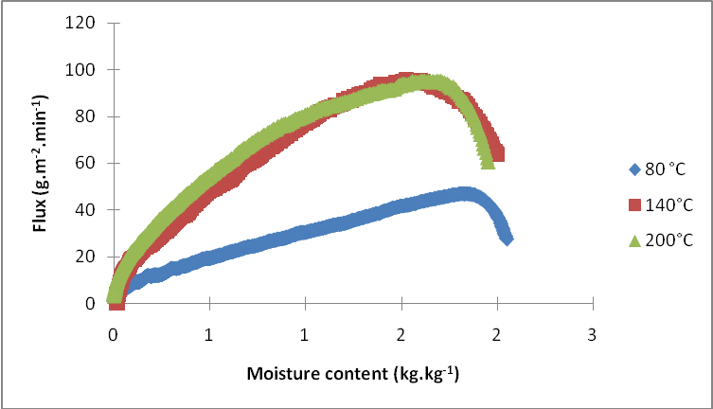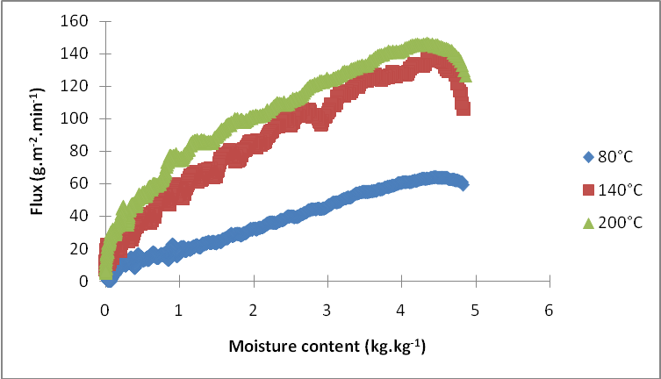
(b)
(a)
Figure 4 : Illustration of the evaporation flux vs. Moisture content of the samle. (a): AS, (b): TDS

Figure 5: Evolution of the surface product temparature vs. moisture content

Determination of the diffusion coefficient

The diffusion coefficient is obtained by comparing the fitting results and slope obtained by the graphical representation of ln(X*) vs. time. However, a parametric study, done by Rahman and Kumar [8], shows an overestimation of the value of diffusion coefficient by neglecting shrinkage phenomena or by considering the sample having infinite geometry. So, diffusion equation with finite geometry represented by equations 4 and 5 is considered in our simulation treatment, with a recalculation of the physical parameters of the sample for every time step.
The value of the diffusion coefficient depends on the origin of the wastewater sludge and the operating temperatures. At the same temperature of 80°C, it has an average mean value of 4.46 10⁻⁹ m².s⁻¹ for AS sludge and decreases to 3.62 10⁻⁹ m².s⁻¹ for TDS sludge. These coefficients increase to a value of 13.47 10⁻⁹ m².s⁻¹ for the AS sludge and 9.67 10⁻⁹ m².s⁻¹ TDS sludge, at 200 °C.
Figure 6 represents the variation of the mean value of diffusion coefficient with air temperature. It is written in the Arrhenius relation and the constant D₀ and Activation energy (E) are deduced. The results of both sludges are shown in table 4.

Table 4. Determination of diffusion coefficient parameters

Sludge type | D₀ (m².s⁻¹) | E (kJ.mol⁻¹)
AS | 4.5181×10⁻⁷ | 13.21
TDS | 2.3120 × 10⁻⁷ | 11.97

(b)
(a)
Figure 6: Influence of the air temperature on the mean value of diffusion coefficient. (a): AS, (b): TDS

Conclusions

The results have shown that wastewater sludge is affected by the applied operating conditions, in particular temperature of the air but also by the origin of the sludge. The comparison between AS and TDS drying results show that TDS attains more important maximal values of evaporated flux with less important diffusion coefficient. The increase of the product temperature was more important for AS sludge than for TDS. The obtained diffusion coefficients were less important than obtained by Reyes et al. [6] and higher than those obtained by Léonard et al. [16]. A comparison of the values of the diffusion coefficient with ones obtained by considering an infinite shape and without considering shrinkage has also shown an over-estimation of the diffusion coefficient. As an example, the diffusion coefficient has doubled its value with 7.42. 10⁻⁹ m².s⁻¹ at 80°C and 22.87 . 10⁻⁹ m².s⁻¹ at 200°C for TDS sludge, when shrinkage is not considered.

References

- Léonard, A., Blacher, S., Marchot, P., Pirard, J. P., Crine, M., “Convective drying of wastewater sludges: influence of air temperature, superficial velocity, and humidity on the kinetics, Drying Technology, Vol. 23, No. 8, 2005, pp. 1-13.
- Léonard, A., Vandevenne, P., Salmon, T., Marchot, P., Crine, M., “Wastewater sludge convective drying: Influence of sludge origin”, Environmental Technology, Vol. 25, No. 9, 2004, pp. 1051-1057.
- Léonard, A., Blacher, S., Pirard, R., Marchot, P., Crine, M., “Multiscale texture characterization of wastewater sludges dried in a convective rig”, Drying Technology, Vol. 21, No. 8, 2003, pp. 1507-1526.
- Léonard, A., Blacher, S., Marchot, P., Crine, M., “ Use of X-ray microtomography to follow the convective heat drying of wastewater sludges”, Drying Technology, Vol. 20, No. 4-5, 2002, pp. 1053-1069.
- Tao, T., Peng, X. F., Lee, D.J., “Thermal drying of wastewater sludge: change in drying area owing to volume shrinkage and crack development”, Drying technology, Vol. 23, No. 3, 2005, pp. 669-682.
- Reyes, A., Eckholt, M., Troncoso, F., Efremov, G., “Drying kinetics of sludge from a wastewater treatment plant”, Drying technology, Vol. 22, No. 9, 2004, pp. 2135-2150.
- Font, R., Gomez-Rico, M. F., Fullana, A., “Skin effect in the heat and mass transfer model for sewage sludge drying”, Separation and Purification Technology, Vol. 77, No. 1, 2011, pp. 146-161.
- Rahman, N., Kumar, S., “Evaluation of moisture diffusion coefficient of cylindrical bodies considering shrinkage during natural convection drying”, International Journal of Food Engineering, Vol.7, No.1, 2011, Article 4.
- Deng, W. Y., Yan, J. H., Li, X. D., Wang, F., Lu, S. Y., Chi, Y., Cen, K. F., “Measurement and simulation of the contact drying of sewage sludge in a Nara-type paddle dryer”, Chemical Engineering Science, Vol. 64, No. 24, 2009, pp. 5117-5124.
- Ferrasse, J. H., Arlabosse, P., Lecomte, D., “Heat, momentum, and mass transfer measurements in indirect agitated sludge dryer”, Drying Technology, Vol. 20, No. 4-5, 2002, pp. 749-769.
- Yan, J. H., Deng, W. Y., Li, X. D., Wang, F., Chi, Y., Lu, S. Y., “Experimental and theoretical study of agitated contact drying sewage sludge under partial vacuum conditions”, Drying Technolgy, Vol. 27. No. 6, 2009, pp. 787-796.
- Arlabosse, P., Chitu, T., “Identification of the limiting mechanism in contact drying of agitated sewage sludge”, Drying Technolgy, Vol. 25. No. 4, 2007, pp. 557-567.
- Crank, J. 1975. The mathematics of diffusion, Oxford, England.
- Usub, T., Lertsatitthankorn, C., Poomsa-ad, N., Wiset, L., Siriamornpun, S., Soponronnarit, S., “Thin layer solar drying characteristics of silkworm pupae”, Food and Bioproducts Processing, Vol. 88, No. 2-3, 2010, pp. 149–160.
- McMinn, W. A. M., Magee T. R. A., “Principals, methods and applications of the convective drying of foodstuffs”, Food and Bioproducts Processing, Vol. 77, No.3, 1999, pp175-193.
- Léonard, A., Blacher, S., Marchot, P., Pirard, J. P., Crine, M., “Moisture profiles determination during convective drying using X-ray microtomography”, The Canadian Journal of Chemical Engineering, Vol. 83, No. 1, 2005, pp. 127-131.

